Product Detection Using Blockchain

Swaraj Raikar¹, Ankita Ningadali², Swanandi Sadavarte³, Aditya Pawar⁴, Prof. Sunita Velapure

*Computer Technology, SVCP, Pune, Maharashtra-411046*

# Abstract

The rise of counterfeit products poses a significant threat to businesses, consumers, and the overall market. Fake goods not only damage brand reputation and cause financial losses but also endanger consumer safety. To combat this issue, blockchain technology provides a decentralized and secure solution for tracking and verifying product authenticity. This project proposes a **Fake Product Detection System** that leverages blockchain to record and authenticate genuine products, ensuring transparency and security in the supply chain.

The system integrates AngularJS for efficient product registration and administration, while Flutter enables a user-friendly interface for consumers to verify product legitimacy. By creating an immutable record of transactions, blockchain makes it nearly impossible for counterfeit products to enter the market. This solution enhances consumer trust, protects brand value, and strengthens market stability by offering a reliable and secure verification method, ultimately contributing to a safer and more transparent marketplace.

# Introduction

In product development, some of the generic risks like fakes and copies always stand there with a dark cloud over the name, reputation, revenues, and customer satisfaction of the company. The today's markets have big over-rising counter- problem products which are posing a more and more dangerous threat to businesses and consumers alike. In order to address such an important issue and ensure needed identification and tracking of counterfeit goods, we propose a fully functional blockchain system. This new way gives a chance to businesses, needing little work from them while taking away the ongoing fear about fake goods hurting their brand's good name. Fake goods cause big harm to makers, not just with loss of money but also with damage to their company's image.

Customers take these fakes for real products and leave reviews based on this false premise, which

only helps in piling up the damages further. To overcome this challenge, the implementation of a blockchain-based system comes forth as an optimal solution. Blockchain technology operates based on a distributed and decentralized model where data is stored in blocks inside a secure database and immutably linked to the immediately preceding block. Equally important is the fact that once data gets onto the blockchain, it is immutable; no user can change or delete that data. The tamper-proof nature of blockchain and the strong mechanisms it has for data protection are some promising avenues toward fighting counterfeit product scourge.

This architecture of blockchain can therefore be leveraged to build against counterfeiting so impenetrable a barrier that no one can question whether the authenticity of each and every product can be verified with absolute certainty by companies and consumers.

This revolutionary method will not only help protect a business's good name but also allow consumers to have faith in the products they buy, creating a much safer and better marketplace for everyone. Essentially, blockchain comes forward as the solution that will lift the long-standing issue of fake goods and thus bring about an era of clarity and safety in trade.

# Blockchain

Blockchain is a decentralized, distributed ledger system that securely records transactions across multiple computers, preventing unauthorized alterations. Each block in the chain contains transaction data, a timestamp, a unique cryptographic hash, and the hash of the previous block, ensuring a secure and immutable link between records. Once data is added to the blockchain, it cannot be altered or deleted, making it highly resistant to fraud and hacking.

Unlike traditional centralized systems, blockchain operates on a peer-to-peer network, where multiple nodes validate transactions through consensus mechanisms such as Proof of Work (PoW) or Proof of Stake (PoS). This ensures transparency, security, and trust without requiring intermediaries. Blockchain technology is widely used in cryptocurrencies, supply chain management, financial services, and counterfeit detection, offering a tamper-proof solution for verifying product authenticity, tracking assets, and securing digital transactions.

# Use of Blockchain for product detection

Blockchain technology offers a secure, decentralized, and transparent solution for detecting and preventing counterfeit products. By

leveraging immutable record-keeping and decentralized verification, blockchain ensures that every product is assigned a unique digital identity that cannot be altered or forged. Through QR codes, RFID tags, or NFC chips, products can be authenticated at every stage of the supply chain, allowing businesses and consumers to verify their legitimacy in real-time. Additionally, smart contracts can automate validation processes and trigger alerts if counterfeit goods are detected. Unlike traditional centralized databases, blockchain's distributed nature prevents unauthorized modifications, ensuring tamper- proof security. This system not only safeguards brand reputation and protects consumers from fake products but also strengthens market trust and transparency, making it a powerful tool in the fight against counterfeiting.

# Literature Review

**Eduard Daoud et al [4]** In their paper, "Enhancing Fake Product Detection Using Deep Learning Object Detection Models," Eduard Daoud and team tackle a critical menace plaguing economies worldwide: counterfeit products. They lay bare the staggering truth—with losses in the trillions owing to these fakes. Despite the heroic efforts of regulators, the scope of this challenge leaves them gasping for breath. With this backdrop, the authors champion the power of consumer involvement in this battle against counterfeit wares. They unveil an avant-garde approach, leveraging machine learning’s might. This innovative solution blends image recognition, text analysis, and classification techniques, giving rise to a user-friendly platform that empowers consumers. Armed with this tool,

consumers can stealthily identify counterfeit goods, all with simplicity and precision. Emphasizing core concepts like anti- counterfeiting, deep learning, and image recognition, the paper encapsulates its mission. It underscores a resolute commitment to wielding cutting-edge technology against this urgent issue. The implications span far beyond academia, resonating through the socioeconomic landscape as a mighty force against counterfeit proliferation.

**Joni Salminen et al [5]** Fueled by a burning desire for integrity in e-commerce, Joni Salminen and his team dive into a pressing dilemma: the explosion of fake product reviews. In their paper, "Creating and Detecting Fake Reviews of Online Products," they confront the essence of consumer trust, vital to online marketplaces. They take a holistic approach, scrutinizing both human and machine-generated phony reviews. The researchers peel back the layers on text generation algorithms, revealing their uncanny ability to spin persuasive, deceptive feedback. This insight sparks urgent calls for robust mechanisms to detect these insidious fabrications. Next, they evaluate the efficacy of crafty machine classifiers versus human raters, illuminating both strengths and weaknesses. This research not only enriches our grasp of these digital challenges but also guides future policy development. Their findings spotlight the need for vigilant safeguards, ensuring consumers are shielded from misleading information and maintaining the credibility of online spaces—essential for anyone navigating this complex e-commerce landscape.

**Kunal Wasnik et al [4]** In the enlightening paper, "Detection of Counterfeit Products using

Blockchain," Kunal Wasnik and his co-authors explore a dilemma impacting supply chains, economies, and consumer welfare—the relentless rise of product counterfeiting. They propose an ingenious solution rooted in blockchain technology, illuminating its unique features for spotting counterfeit products. The authors shine a spotlight on blockchain's transformative power, allowing for meticulous tracking of product supply chains. With its decentralized and secure architecture, they craft a tamper-proof system that heightens transparency and accountability, accessible to multiple stakeholders at once. Their work serves as a clarion call about the extensive repercussions of counterfeit goods, from consumer safety to brand reputations. The proposed blockchain system stands as a promising beacon, ready to tackle these multifaceted issues head-on. This research underscores the revolutionary potential of blockchain technology, forging a path toward solidifying supply chain trust while defending consumer interests in the fierce global marketplace.

**Aadeesh Bali et al [3]** In "Fake Product Detection System Using Blockchain," Aadeesh Bali and colleagues address the pressing issue of counterfeiting in the retail arena. They clearly outline how counterfeit products—subpar knock- offs of genuine brands—jeopardize businesses, reputations, and customer satisfaction. While previous attempts to tackle the problem leveraged RFID tags and AI, many methods falter under pressure, such as QR codes being effortlessly replicated. A holistic solution remains elusive. Enter their innovative blockchain-based system designed for counterfeit detection. By meticulously recording the supply chain history of

products via QR codes, blockchain emerges as a game-changer, establishing a decentralized and secure platform. The brilliance of blockchain lies in its security: once data is recorded, it’s immune to tampering. This paper poignantly portrays the counterfeit menace and vividly highlights its impact on all stakeholders. With their blockchain framework, Aadeesh Bali et al reveal a robust solution, promising transparency and authenticity in product tracking. They empower consumers to make savvy purchasing decisions and forge a promising avenue to combat counterfeiting, benefiting both manufacturers and consumers alike in this modern retail landscape.

**Kishan Tiwari et al [5]** This paper dives into the digital fortress of blockchain technology, tackling the counterfeit conundrum that plagues businesses and consumers alike. Imagine a decentralized digital ledger, steadfast and unyielding; that’s blockchain, offering unparalleled transparency and security for product transactions. Our mission? To forge a crystal-clear system for verifying product identity and authenticity. At the heart of the proposed system, manufacturers register their products on the blockchain, birthing unique digital identities for each item. A simple scan of a product’s QR code grants consumers access to its authentic digital fingerprint. This paper champions several crucial objectives: shielding consumers and brands alike, fortifying company revenue, ensuring regulatory compliance, and advocating for ethical practices. The benefits of this ingenious system are numerous—think heightened transparency, traceable supply chains, and enhanced consumer protection. Take cosmetics, for instance; each product’s journey unfolds on the blockchain,

easily accessible through a quick QR scan. However, challenges linger in the shadows, such as scalability and interoperability snags. Yet, blockchain technology stands ready to revolutionize how businesses fight against counterfeit products, heralding a win for both companies and consumers. This paper lays out a visionary blockchain-based system for detecting counterfeit goods, detailing its potential rewards and pitfalls while promoting blockchain as the key to unlocking product authenticity and consumer confidence.

# Propose System

Counterfeiting has become a major global issue, affecting businesses, consumers, and supply chains. To tackle this, a blockchain-based fake product detection system provides a secure, decentralized, and transparent solution. Based on the analysis of existing approaches, we propose a hybrid system that integrates blockchain technology, QR code authentication, Firebase for real-time data storage, and smart contracts for automated validation.

The proposed system consists of three main components: Manufacturers, Retailers, and Consumers. Manufacturers register their products using an AngularJS-based web interface, where they enter product details, batch numbers, and unique serial codes. These details are stored in Firebase and linked to a unique QR code, which is then printed on product packaging. Retailers and supply chain participants update product movement data, ensuring real-time tracking of genuine products. Consumers use a Flutter-based mobile application to scan QR codes, retrieve product details, and verify authenticity by cross-

referencing with blockchain records. If any discrepancies or unknown entries are detected, the system flags the product as counterfeit.

To ensure data integrity and security, the system utilizes Ethereum blockchain and smart contracts. Every product transaction is recorded on the blockchain, making it immutable and tamper- proof. Unlike traditional QR code-based systems that are vulnerable to duplication, blockchain- stored QR codes provide verifiable transaction history, ensuring authenticity throughout the supply chain. Additionally, Firebase real-time synchronization enhances scalability and enables instant counterfeit detection.

This system addresses key challenges in counterfeit detection by combining the security of blockchain with the efficiency of cloud-based authentication. Unlike conventional methods, which rely on centralized databases or QR codes susceptible to replication, the proposed system ensures trust, transparency, and reliability. By empowering consumers with instant verification and providing manufacturers with real-time counterfeit alerts, this approach strengthens supply chain security and minimizes fraudulent activities.

## System Model

This system comprises a web application and a mobile app, both intricately linked to a central database. The web application serves as the gateway for authorized users to manage and update product details, as well as add new products. The central database acts as the hub for storing comprehensive product information, ensuring a unified and organized repository. On the mobile app front, there are two critical

functionalities. First, product owners and manufacturers can register their products, inputting specific details such as serial numbers or unique identifiers. This registration data is securely stored in the central database. The second mobile app feature is scam detection, which empowers users, including both consumers and manufacturers, to verify product authenticity. By cross-referencing products with the registered entries in the database, this feature can detect potential scams and alert users. It may also provide mechanisms for reporting and investigating suspicious product listings. The seamless interaction between these components hinges on efficient data flow and robust data management. It's essential to emphasize secure data transmission and storage to maintain data integrity, with user authentication and authorization measures in place to safeguard against misuse and fraudulent activity.

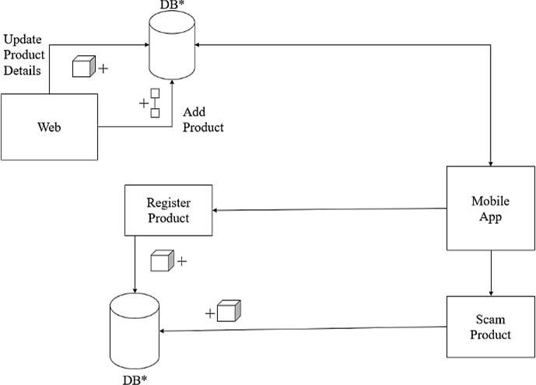

Figure 1: System Architecture

## Flow of Proposed System

The proposed Blockchain-Based Fake Product Detection System consists of three key modules: Manufacturer, Supplier, and User (Consumer). The system ensures product authenticity by

utilizing QR codes linked to a blockchain-based verification mechanism.

In the Manufacturer Module, the process begins when the manufacturer logs into the system and enters product details, such as batch number and serial number. The system validates this information and either requests corrections or proceeds to generate a unique QR code. This QR code is then stored securely in the system and made available for download. The manufacturer downloads and prints the QR code onto the product packaging before distribution. This ensures that each product has a unique identifier that can later be verified by suppliers and consumers.

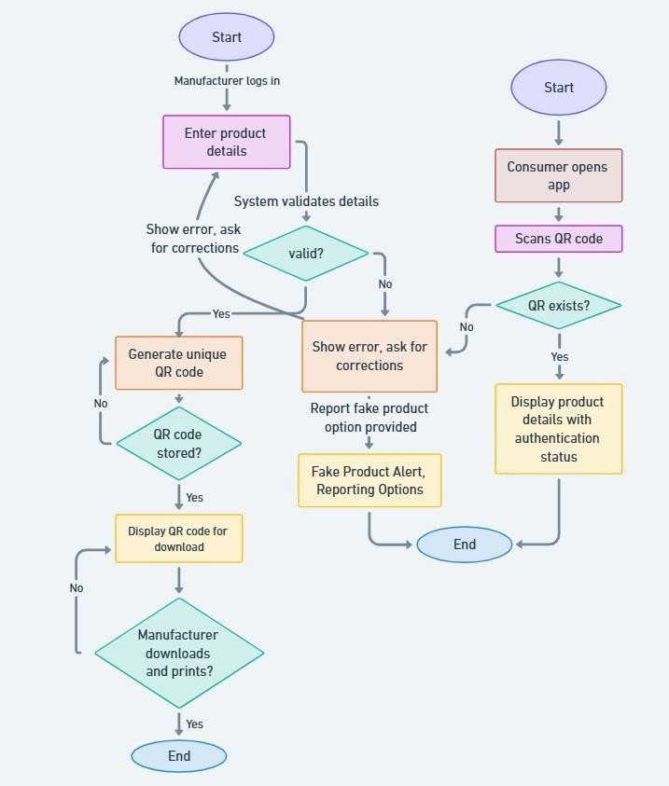

Figure 2: Work Flow Diagram

The Supplier Module acts as an intermediary between the manufacturer and the end consumer. While not explicitly shown in the flowchart, suppliers play a crucial role in verifying product

authenticity before distribution. They can scan the QR code to check its validity in the blockchain database. If any discrepancies are found, they can report the product as potentially counterfeit. This step helps ensure that only genuine products reach retailers and consumers.

In the User (Consumer) Module, the consumer interacts with the system to verify product authenticity. The consumer opens a mobile application and scans the QR code on the product. The system checks whether the QR code exists in the blockchain database. If the code is valid, the system retrieves product details and displays an authentication status. However, if the QR code does not exist, the system alerts the consumer and provides an option to report the product as fake. This approach not only enhances trust and transparency but also enables manufacturers and regulatory authorities to take immediate action against counterfeit products. By integrating blockchain technology, the system ensures tamper-proof, decentralized, and reliable authentication of products in the supply chain.

## Result

The launch of our innovative Fake Product Detection System, integrating AngularJS, Firebase, and Flutter, marks a significant leap forward in the fight against counterfeiting. This seamless connection between web platforms and mobile applications has created a transparent and reliable digital marketplace, enhancing consumer trust and brand integrity. On the web platform, manufacturers can effortlessly upload product data and generate unique QR codes, ensuring that every item is accurately represented and easily identifiable. With AngularJS, dynamic

interactions and an intuitive user interface allow administrators to manage product entries with efficiency and ease, streamlining operations while ensuring real-time accessibility.

At the core of the system, Firebase provides a robust backend infrastructure, offering secure data storage, real-time synchronization, and seamless accessibility. This tamper-proof digital fortress safeguards product authenticity, preventing counterfeit entries and enabling instant verification. The Flutter-powered mobile application further enhances the user experience by allowing consumers to authenticate products on the go. A quick QR code scan using their device’s camera instantly retrieves product details from Firebase, delivering swift and reliable authentication. Advanced algorithms process verification requests in real time, ensuring that consumers receive instant and accurate authenticity results. With Flutter’s cross-platform capabilities, both iOS and Android users can access the system effortlessly, reinforcing trust in every transaction.

By leveraging cutting-edge technologies and intelligent security measures, this project has significantly reduced the circulation of counterfeit products, making shopping experiences safer and more reliable. Businesses now have a powerful tool to protect their brand integrity, while consumers enjoy unparalleled transparency in their purchases. As this digital marketplace continues to grow, it becomes an impenetrable shield against counterfeiting, ensuring that every product is verified, secure, and authentic. With this system in place, the battle against

counterfeiting is no longer just a challenge—it is a clear and decisive victory.

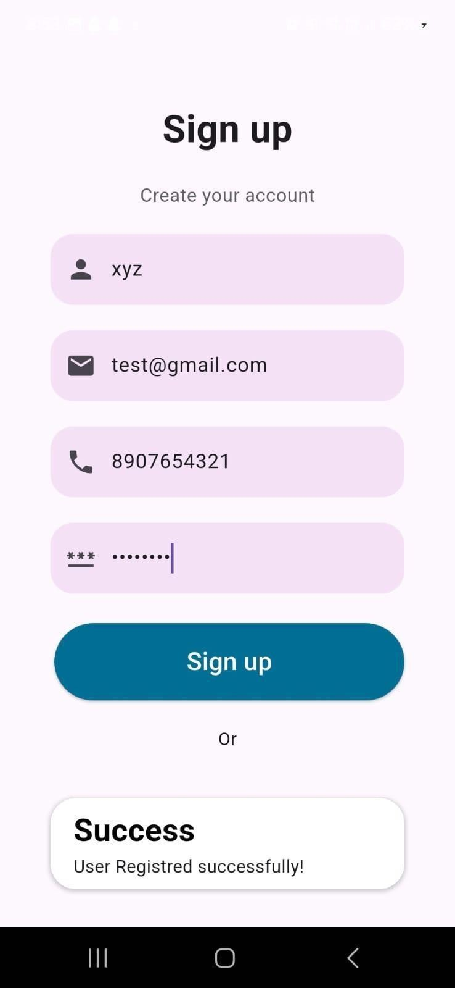

Figure 3: Sign-up Page

This screenshot displays the user registration page, allowing users to create an account by entering a username, email, and phone number. After successful registration, a confirmation message is displayed. This step ensures that only authenticated users can register products or verify their authenticity using the system and an option to switch to the login screen if the user already has an account. It provides a seamless onboarding experience for new users wanting to access the Fake Product Detection system.

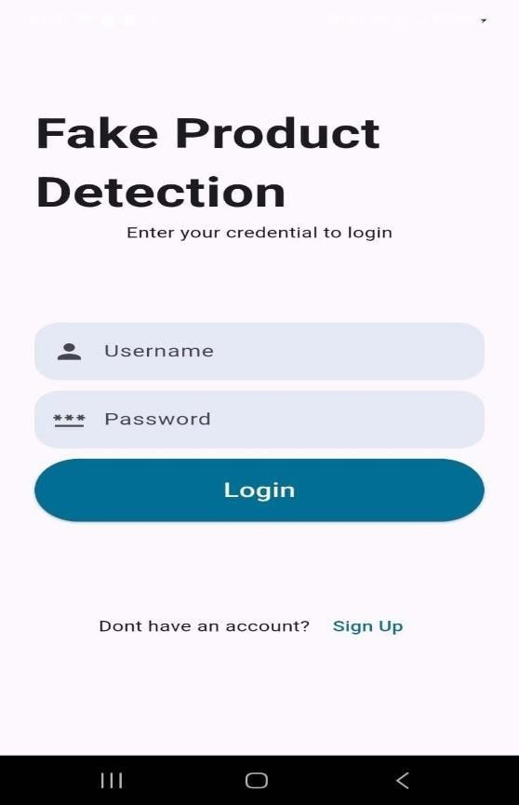

Figure 4: Login Page

This is the login interface where users enter their credentials (email and password) to access the system. This login system is backed by Firebase Authentication, ensuring secure access. A “Sign Up” option is also provided for new users who want to create an account and start using the Fake Product Detection system.

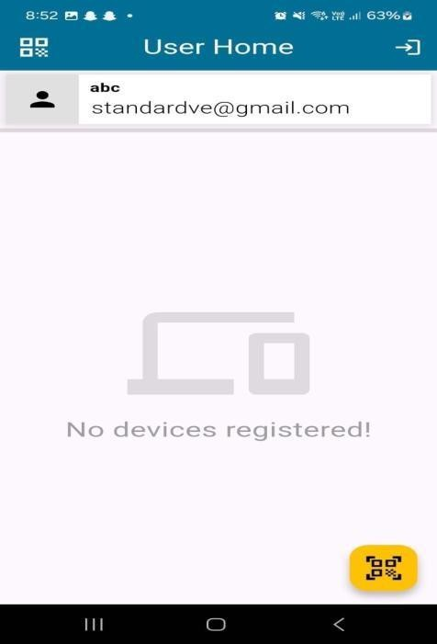

Figure 5: User Home

This screenshot shows the main user dashboard after a successful login. The user’s registered email is displayed, and the screen provides access to core functionalities of the system.

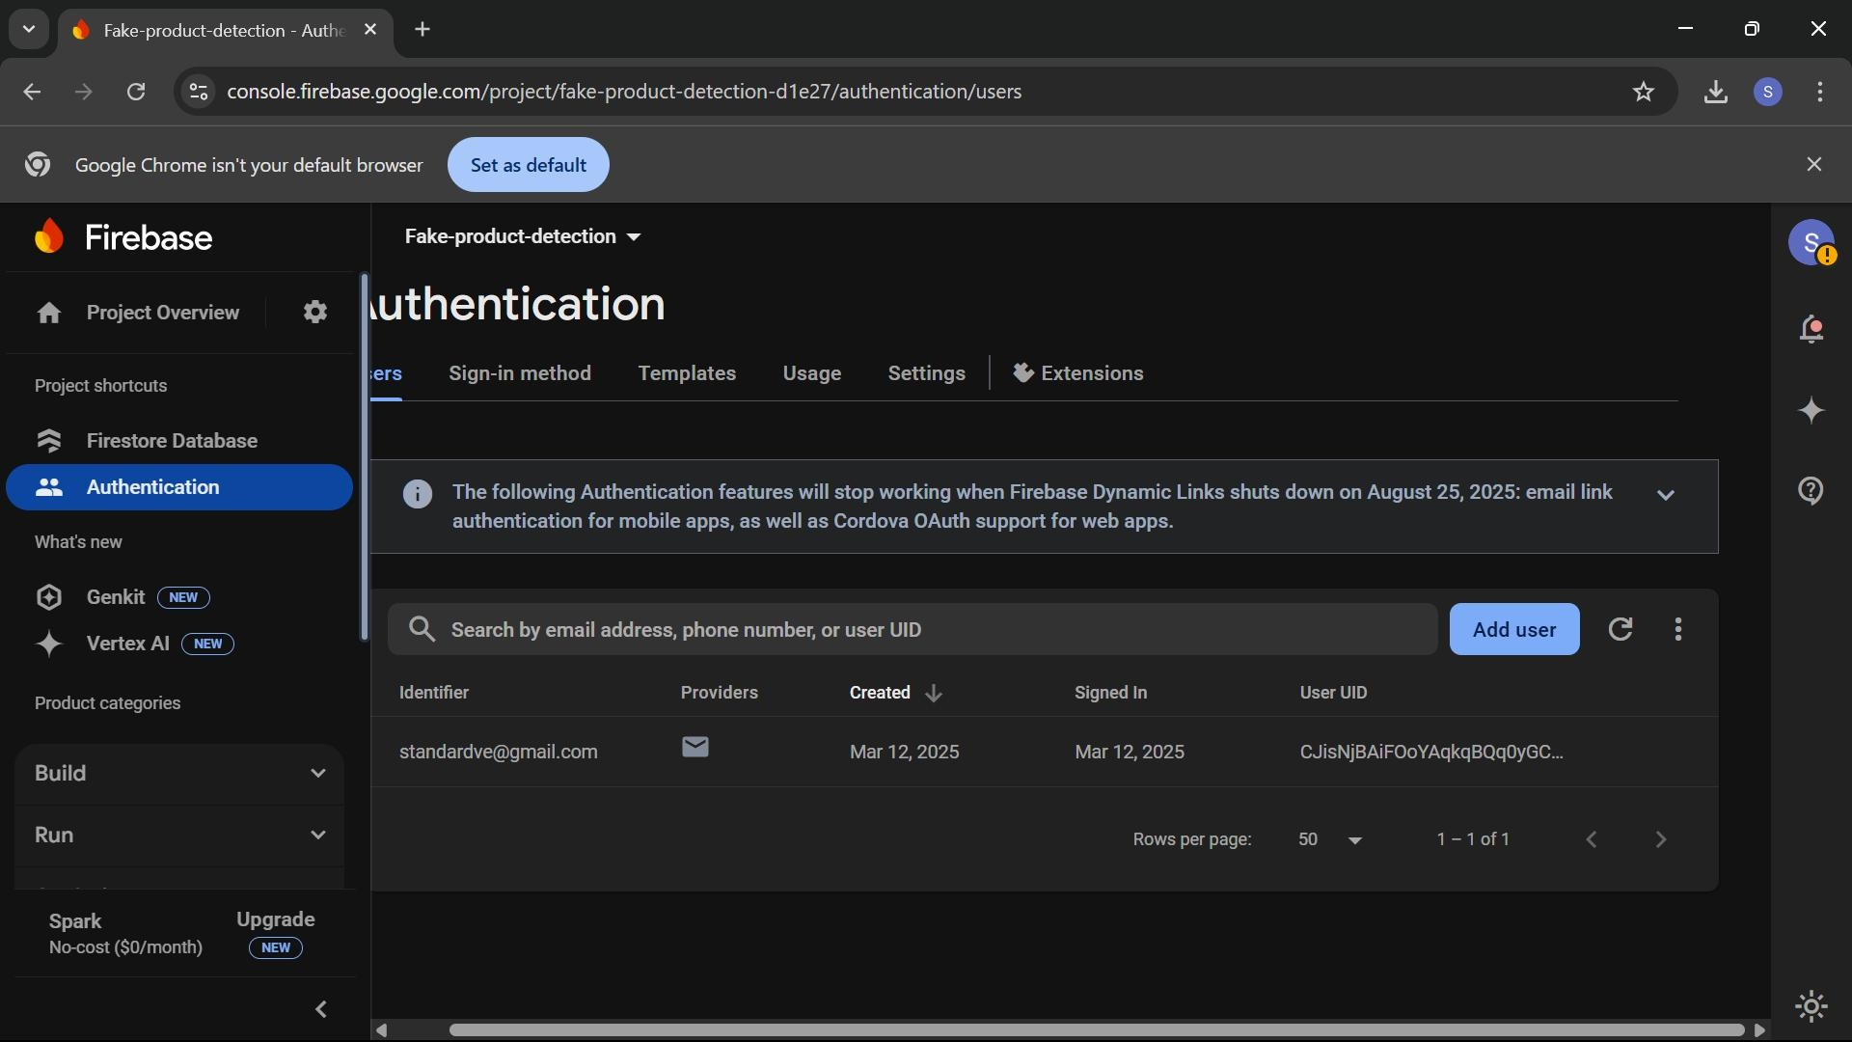

Figure 6: Firebase Authentication Dashboard

This screenshot shows the Firebase Authentication panel, which is used to manage user authentication for the Fake Product Detection system. The panel lists registered users and provides options to add, remove, or modify authentication settings. Firebase authentication ensures that only verified users can access the system, preventing unauthorized access. This feature enhances security and ensures that product verification is only performed by legitimate users.

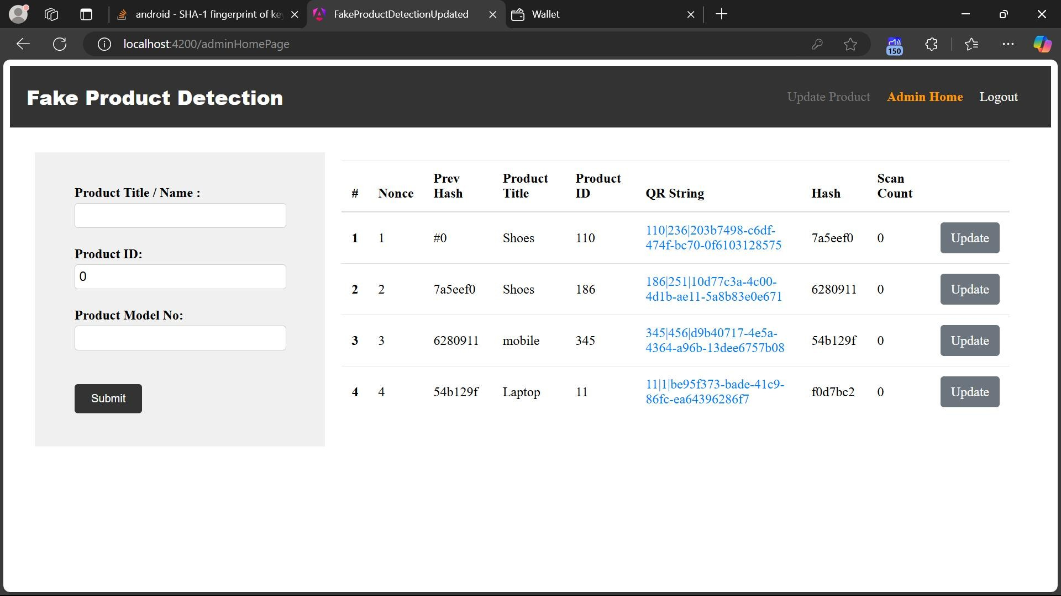

Figure 7: Admin Dashboard – Fake Product Detection

This screenshot shows the admin interface of the Fake Product Detection System, where administrators can add and manage product records. The left panel allows product registration

by entering details like Product Title, Product ID, and Model Number, while the right panel displays a list of registered products along with blockchain- related data such as Previous Hash, QR String, and Hash. Each product has a unique QR code for verification, ensuring authenticity and preventing counterfeiting. The Update button allows modifications to existing entries.

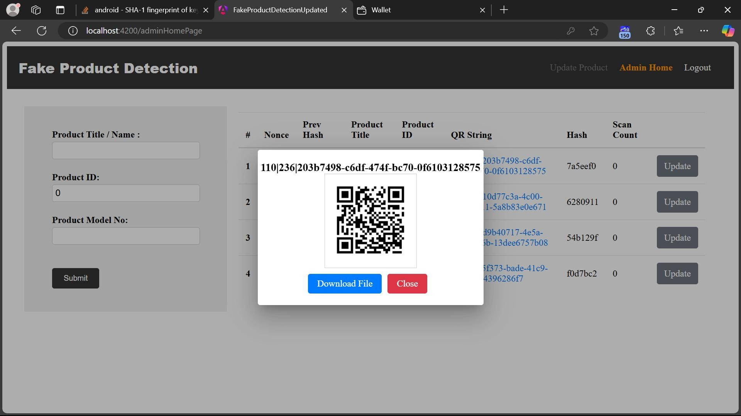

Figure 8: QR Code Popup

This screen confirms that the product has been successfully registered and assigned a unique QR code. The QR code acts as the product’s digital identity, allowing users to verify authenticity by scanning it. When scanned, it retrieves product information stored on the blockchain, ensuring secure and tamper-proof validation. This feature helps customers and stakeholders track the product’s source and legitimacy, reducing the risk of counterfeiting.

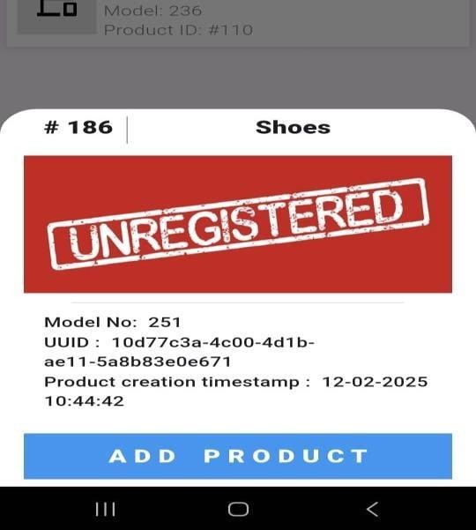

Figure 9: After Scanning QR Code

This screenshot shows the process of registering a product into the Fake Product Detection system. The system records the following:-

Model Number :251

a unique UUID: 10d77c3a-4c00-4d1b- ae11- 5a8b83e0e671

Product Creation Timestamp : 12-02-2025, 10:44:42

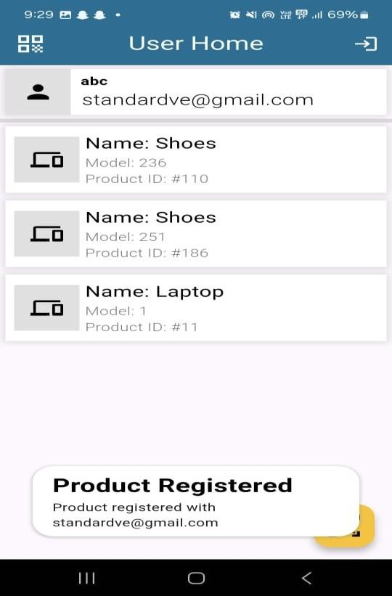.The UUID ensures that each product has a distinct digital identity, preventing duplication and counterfeiting. This feature is crucial for adding products securely to the blockchain database. By clicking "Add Product," users can securely store product information in the blockchain. This step is essential for manufacturers and authorized sellers to ensure the legitimacy of their product.

Figure 10: Products Registered Screen

This screenshot shows the User Home Page of the Fake Product Detection System, where registered users can view their authenticated products. The interface displays the user’s email address at the top, followed by a list of verified products. Each product entry includes the Product Name, Model

Number, and Product ID. A confirmation message at the bottom indicates a successful product registration associated with the user’s email.

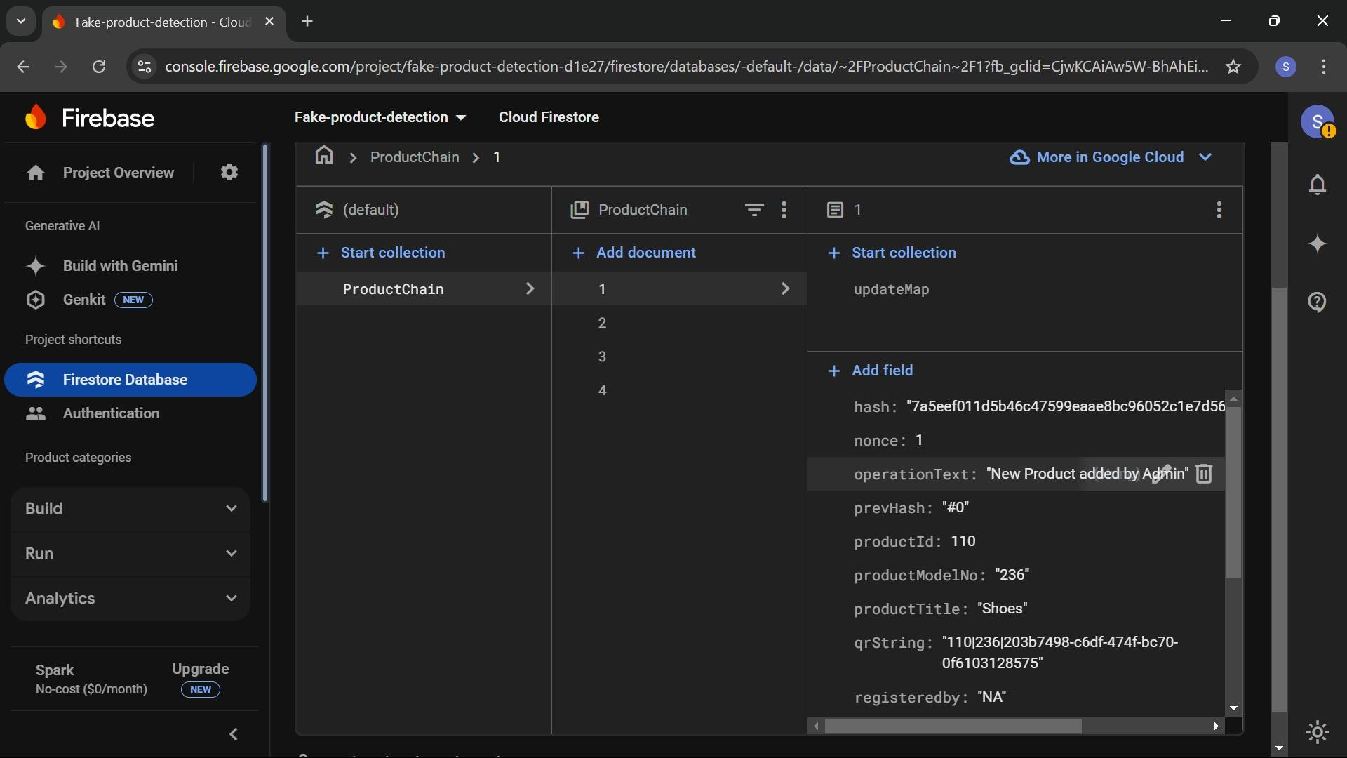

Figure 11: Blockchain Data Storage in Firestore

This screenshot displays the Cloud Firestore Database used in the Fake Product Detection System. The ProductChain collection stores product details, with each document representing an entry in the blockchain. The selected document contains fields such as hash, nonce, previous hash (prevHash), product ID, model number, title, and QR string, ensuring secure product registration. The operationText field logs actions performed by the admin, enhancing traceability. This structured storage method ensures product authenticity and prevents counterfeiting.

# Conclusion

Counterfeit products pose a significant threat to businesses and consumers, eroding trust and affecting brand integrity. Our project provides an effective solution by integrating AngularJS, Firebase, and Flutter, creating a secure and transparent system for product authentication. The web platform allows manufacturers to register products, generate unique QR codes, and store crucial product details in Firebase, ensuring real- time updates and data integrity. Meanwhile, the Flutter-based mobile app enables consumers to

instantly verify a product's authenticity with a simple QR code scan, offering a seamless and user-friendly experience.

With Firebase acting as a robust and scalable backend, real-time synchronization ensures that both manufacturers and consumers have immediate access to verified product data. Additionally, Flutter’s cross-platform capabilities make the authentication process accessible to both Android and iOS users, ensuring widespread adoption. The integration of advanced algorithms enhances the accuracy of counterfeit detection, providing consumers with confidence in their purchases.

This initiative not only strengthens supply chain security but also empowers consumers by giving them an active role in identifying fake products. By leveraging modern technology, we have created a solution that is efficient, scalable, and adaptable to future challenges. Moving forward, we aim to enhance this system with additional features such as AI-driven anomaly detection and blockchain integration, further fortifying the fight against counterfeiting. Through continuous innovation, we strive to create a safe, reliable, and trustworthy marketplace for businesses and consumers alike.

# References

1. Eduard Daoud, Dang Vu, Hung Nguyen and Martin Gaedke,” Enhancing Fake Product Detection using Deep Learning Object Detection Models”, IADIS International Journal on Computer Science and Information Systems Vol. 15, No. 1, pp. 13-24, 2020.
2. products Joni Salminen, Chandrashekhar Kandpal, Ahmed Mohamed Kamel, Soon-gyo Jung, Bernard J. Jansen,” Creating and detecting fake reviews of online”, Journal of Retailing and Consumer Services 64 (2022)

102771, 2022.

1. Kunal Wasnik, Isha Sondawle, Rushikesh Wani and Namita Pulgam, “Detection of Counterfeit Products using Blockchain”, ITM Web of Conferences 44, 03015 (2022), <https://doi.org/10.1051/itmconf/20224403015>.

Journal of Recent Technology and Engineering (IJRTE) ISSN: 2277-3878, Volume-10 Issue-1, May 2021.

9. Miguel A. Prada-Delgado, Gero Dittmann, Ilie Circular, Jens Jelte “A blockchain- based crypto-anchor platform for interoperable product authentication”, IEEE International Symposium on Circuits and Systems (ISCAS),2021.

1. Richu Jacob Varghese, Shilpa Shaji Nellikkakunnel, and Sruthy Sunilkumar, “An

|  |  |  |  |
| --- | --- | --- | --- |
| AI-Based | Fake | Products | Identification |
| System”, |  | 2022, | DOI: |

10.13140/RG.2.2.18607.61601.

1. Aadeesh Bali, Amrit Singh and Sunandan Gupta,” Fake Product Detection System Using Blockchain”, research gate publication,2022.
2. Kishan Tiwari, Nikita Patil, Akshay Gupta, Akash Sabale and Vina Lomte, “Fake Product Detection Using Blockchain Technology”, International Research Journal of Engineering and Technology (IRJET), Volume: 10, Issue: 03, March 2023.
3. G. Vidhya Lakshmi, Subbarao Gogulamudi, Bodapati Nagaeswari, Shaik Reehana, “Blockchain Based Inventory Management by QR Code Using Open CV”, International Conference on Computer Communication and Informatics (ICCCI -2021) Coimbatore, INDIA, Jan. 27 – 29, 2021.
4. Abhinav Sanghi, Aayush, Ashutosh Kata war, Anshul Arora, Aditya Kaushik, “Detecting Fake Drugs using Blockchain”, International