**HYGROTHERMAL AGING AND MICROSTRUCTURAL ANALYSIS OF RAMIE AND FLAX HYBRID COMPOSITES EPOXY FILLED WITH NANO SIO2 USING VACUUM ASSISTED RESIN TRANSFER MOLDING**

Kedarnath Mahapatro M*1,Maneendra P V V S*2 Vivek K*3,Durga Prasad R*4,

Veerendra M*5

Department Of Mechanical Engineering, Godavari Institute Of Engineering & Technology, Rajahmundry, Andhra Pradesh, India.

**Abstract**

Over the past two decades, there has been a remarkable surge in the utilization of composites, with fiber-reinforced polymer composites gaining significant traction owing to their commendable structural performance. Concurrently, extensive research has been conducted to assess the behaviour of composite materials, focusing on various parameters such as fiber type, lamination order, matrix type, and the inclusion of filler materials. In this study, we investigated the hygrothermal analysis and mechanical properties of flax (F)/ramie (R) epoxy hybrid composites pretreated with NaOH filled mixed with nano SiO2, specifically exploring the effects of different weights of nano SiO2 mixed with epoxy hybrid composite. Three distinct weighing of nano particles with same sequence of FRFRF was choosen:0.5 %,1.5 %,2.5%. The composites were fabricated using vacuum assisted resin transfer molding techniques, adhering to ASTM standards for the evaluation of mechanical properties including tensile strength, flexural strength and interlaminar shear strength. The most favourable results were observed with 2.5 % Nano SiO2 composite, boasting a tensile strength of 28.06 MPa, interlaminar shear strength of 8.13 MPa and flexural strength at 84.6 MPa. Additionally, Hygrothermal analysis was conducted to investigate moisture absorption of the composite.

**Keywords :**

Composite Manufacturing, VARTM, Ramie fiber, Flax fiber, Fabrication Techniques

# **1.Introduction**

The utilization of biowaste as a reinforcing material in materials science has accumulated significant attention from researchers over the past two decades [1]. Owing to their appealing intrinsic properties, societal demands, and environmental responsibilities, bio-fiber composites are increasingly being considered in the automotive industry. Anticipated factors such as improved fuel efficiency, end-of-life cycle requirements, and governmental regulations are expected to further drive the adoption of bio-composites. Natural fibers such as jute, flax, sisal, and hemp find applications in manufacturing automotive components like package trays, headliners, door panels, dashboards, seat backs, and trunk liners.

Despite their advantages, natural fibers face several limitations that affect their widespread application in the automotive industry, including high moisture absorption, low temperature tolerance, susceptibility to microbial degradation, inadequate fire resistance, inferior mechanical properties and durability, quality variations, and price fluctuations due to seasonal crop production. Researchers have adopted various approaches such as hybridization of composites, fabrication methods, and the use of natural fillers to enhance binding action and strength [2].

A considerable number of studies had6 been conducted to quantify the mechanical properties of natural fiber-reinforced polymer composites. For instance, Umit Huner et al [3] demonstrated that NaOH surface treatment of flax fibers enhances their mechanical and adhesion properties. Javanshour et al [4] investigated the impact of graphene oxide-coated flax epoxy composites, reporting significant improvements in shear and transverse strength. Prabhakaran et al [5] explored the feasibility of producing composite laminates with improved acoustic and vibration damping capabilities using natural fiber-based materials, noting superior properties compared to glass fiber composites. Vinayagam Mohanavel et al [6] examined the reinforcement impact on hybrid composites using mechanical and thermogravimetric analysis, observing positive trends with continuous fiber composites.

Furthermore, research by Vijay Chaudary et al [7] highlighted the significant effect of moisture absorption on reducing tensile and flexural strength in jute/hemp/epoxy composites. Cavalcanti et al [8] investigated the mechanical properties of intra-laminar hybrid composites made of sisal, jute, and curaua fibers as reinforcements, noting significant improvements attributed to natural fibers and variations in fiber treatment methods. Mohanavel et al [9] explored the impact of fiber composition, layering patterns, and sequencing on the mechanical properties of hybrid composites, emphasizing the beneficial effects of adding jute fiber to glass fiber composites.

Moreover, Naveen Jesuarockiam et al [10] presented research on enhancing the thermal and dynamic mechanical properties of Kevlar/Cocosnucifera sheath (CS)/epoxy composites with graphene nanoplatelets (GNP), demonstrating the effective use of CS in structural applications. The investigation into the mechanical properties of flax/ramie hybrid epoxy composites with variations in stacking sequence suggests potential applications in automotive settings [11]. Considerable outcomes have also been achieved in the field of natural fiber-reinforced composites using numerical methods [12–14].

The current understanding of hybridizing two distinct natural fibers, Flax and Ramie, and the consequent impact of their stacking sequence on mechanical properties remains limited. A comprehensive exploration of these factors is crucial for suggesting potential applications of natural fiber-reinforced materials in automotive settings. A detailed investigation into hybridization dynamics and stacking sequence effects will contribute to advancing knowledge in composite material science and optimizing the use of these materials in automotive applications.

Furthermore, Karimzadeh et al [15] investigated how the mechanical and moisture absorption characteristics deviate with changes in the stacking sequence of PALF/glass fiber epoxy composites, highlighting improvements in mechanical properties and water absorption characteristics with alternative stacking sequences. Similar investigations were conducted by Jafrey Daniel James D et al [16] and Venkata sudhahar et al [17], demonstrating the positive impact of stacking sequence variations on mechanical properties in bagasse/ sisal and carbon/jute/banana hybrid composites, respectively.

The objective of the present research is to analyze the effect of mixing of nano particles to improve the the mechanical properties of hybrid (flax/ramie) epoxy composites, including tensile, flexural, impact, and interlaminar shear strength. Hygrothermal analysis will be conducted to study the water absorption and degradation of natural fibers.

**2. Materials and Methods**

This section describes about the materials and fabrication methods that are used to prepare the composite laminates pretreated with NaOH with sequence of FRFRF and the procedures of tests carried out to evaluate the mechanical properties of the laminates. The research article uses three laminates for a comprehensive exploration of effecting weighing of nano particles, allowing for systematic testing of various configurations. This approach balances comprehensiveness and feasibility. The use of a limited number of laminates provides valuable insights into the design space of hybrid composites

**2.1. Materials Used**

Hybrid composites were synthesized using flax and ramie fibers as reinforcing agents, in conjunction with an epoxy resin matrix. Pretreated with a NaOH solution to increase the moisture absorption of laminates Procured from Fiber Region, Chennai, the raw materials, visually depicted in figures 1(a) and (b), exemplify the raw materials utilized in the composite manufacturing process.

The compositions, along with the physical and mechanical properties, of both flax and ramie fibers are thoroughly outlined in tables 1 and 2, respectively.

**2.2 Method of Fabrication**

Six distinct percentages of nano particle hybrid composites were carefully fabricated with same lamination order, employing the vacuum assisted resin transfer molding technique. Each composite assembly comprised three layers of flax fiber (F) and two layers of ramie fiber (R).

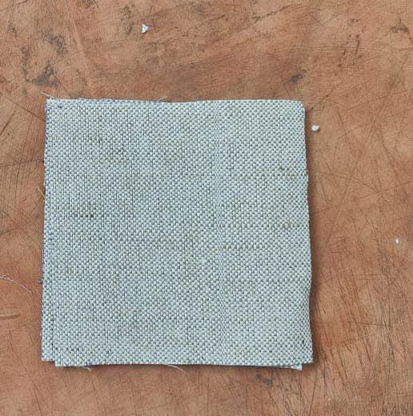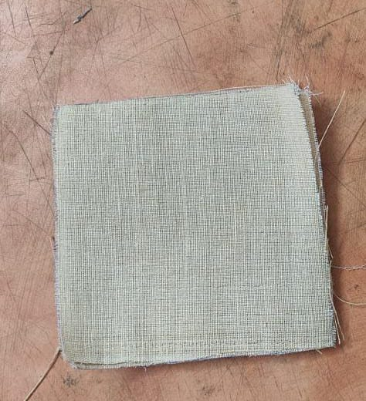

1. (b)

Figure 1. (a) ramie fiber mat and (b) flax fiber mat

|  |  |  |
| --- | --- | --- |
| Element | Flax fiber mat | Ramie fiber mat |
| Cellulose | 60–81 | 68.6–76.2 |
| Hemicellulose | 14–20.6 | 13–16.7 |
| Lignin | 2–3 | 0.6–1 |
| Pecting | 1.8–5 | 1.9–2 |
| Wax | 1.7 | — |

Table 1. composition of ramie and flax fibers

|  |  |  |  |
| --- | --- | --- | --- |
| Property | Flax Fiber Mat | Ramie Fiber Mat | Epoxy Resin |
| Density (g/cc) | 1.5–1.54 | 1.5–1.56 | 1.14–1.18 |
| Tensile Strength (MPa) | 345–1500 | 400–1000 | 68–80 |
| Youngs Modulus (GPa) | 27.6 | 27–128 | 2.9–3.2 |
| Elongation at Break (%) | 2.7–3.2 | 1.2–3.8 | 5–7 |

Table 2. mechanical and physical properties of flax and ramie fibers

intertwined with two layers of ramie fiber (R). The fabrication process involved the utilization of a 300 mm×300 mm MS mold. A matrix material blend of epoxy and hardener was prepared at a weight ratio of 10:1 and mixed with nano SiO2 percentages of 0.5 %, 1%, 1.5%, 2%, and 2.5% .

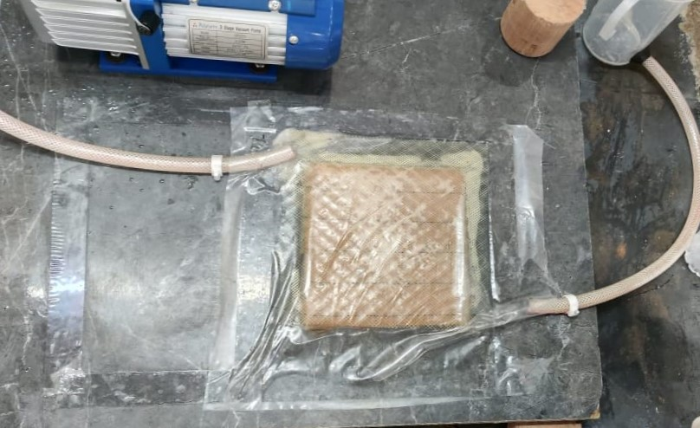 Following this vacuum to draw resin into a dry fiber preform. The process begins with placing the fiber reinforcement in a mold, which is then covered with a vacuum bag. A vacuum is applied to remove air and create a pressure differential, pulling resin through the fiber network. The resin infusion continues until complete saturation is achieved, ensuring uniform distribution. After curing, the vacuum bag is removed, and the final composite part is extracted from the mold.

Figure 2. Vacuum assisted resin transfer molding setup

|  |
| --- |
|  |
|  |
|  |
|  |
|  |

|  |
| --- |
|  |
|  |

|  |
| --- |
| Flax (F) |
| Ramie (R) |

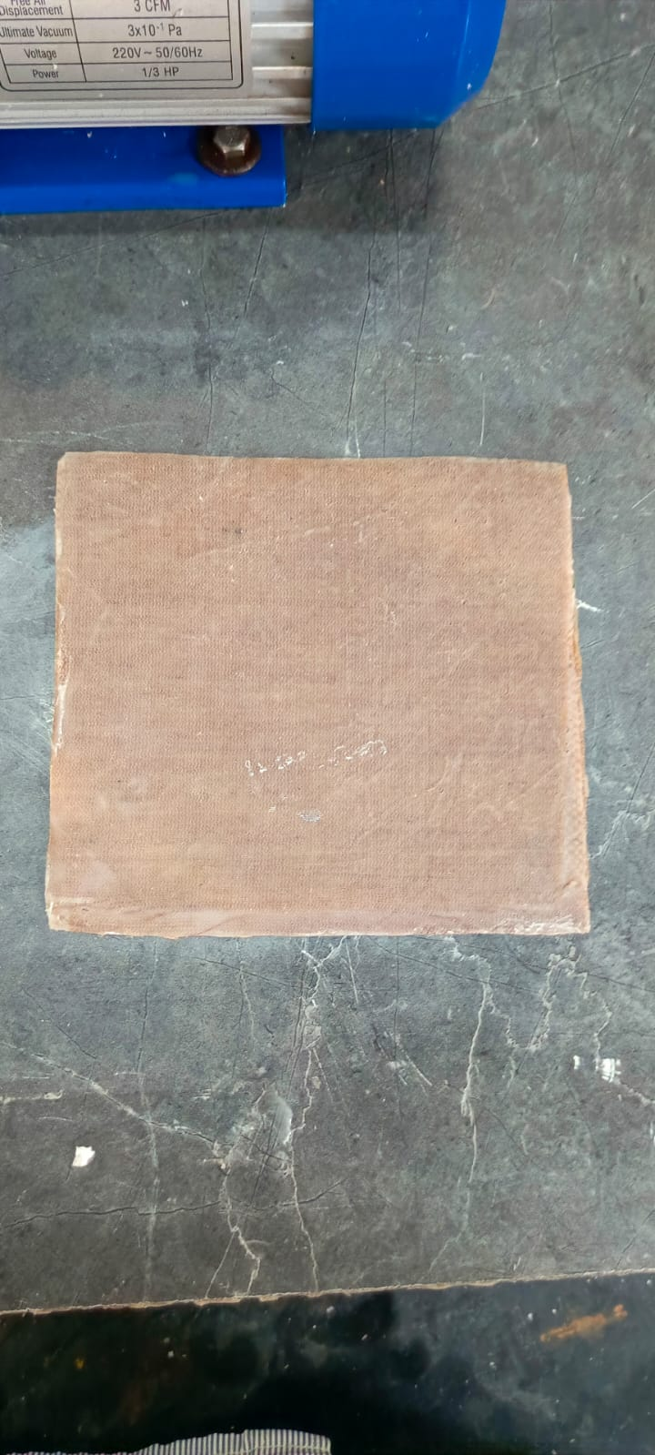 Figure 3. Lamination sequence followed to fabricate the composite laminate

*Figure 4. Final Hybrid Composite Slab*

Prior to commencing the process, the fibers underwent treatment with a 5% wt. solution of NaOH and were subsequently dried for a duration of 24 h. In all considered composite materials, the fiber orientation and sequence remained consistent, aligned along the longitudinal direction. The lamination sequence employed during the manufacturing process is depicted in figure 3.

It was widely acknowledged that the capability of flax fiber to absorb moisture is significantly augmented through chemical and physical treatments, thereby elevating the potential of the resulting composites. Furthermore, it is observed that the increasing of percentage of nano SiO2 in hybrid fiber composite, it influencing the water absorption behavior and mechanical properties of fiber composite due to the stress distribution, degree of crystallinity in the fiber, leading to improved stiffness, toughness and Nano SiO₂ can interact with the hydroxyl (-OH) groups in natural fibers, reducing their affinity for water.

The details of the fabricated hybrid composites are furnished in table 3.

|  |  |  |  |  |
| --- | --- | --- | --- | --- |
| S. no. | % of Nano SiO2 | % Weight of Flax | % Weight of Ramie | % Weight of Epoxy |
| 1 | 0.5% | 0.20 | 0.20 | 0.100 |
| 2 | 1% | 0.20 | 0.20 | 0.100 |
| 3 | 1.5% | 0.20 | 0.20 | 0.100 |
| 4 | 2% | 0.20 | 0.20 | 0.100 |
| 5 | 2.5% | 0.20 | 0.20 | 0.100 |

Table 3. The details of the fabricated hybrid composites

**2.3 TENSILE TEST**

The specimens for the tensile test were prepared in accordance with ASTM D 638 guidelines, as illustrated in figure 4. Tensile testing was conducted using the Universal Testing Machine DXT at varchu Marc LLP Labs, Hyderabad, with a loading rate of 10 mm min−1. Tensile loads were applied in the longitudinal direction of the fibers. For each percentage of nano SiO2, five specimens were subjected to testing, and the resulting averages were recorded.

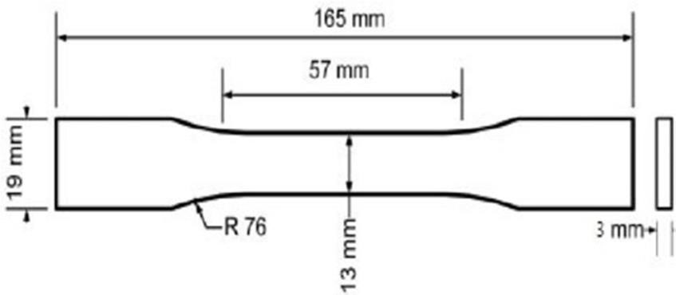

Figure 5. Tensile specimen as per ASTM D638

**2.4 FLEXURAL TEST**

The flexural test was also conducted using the same Universal Testing Machine (UTM), following the test method and specimen preparation outlined in ASTM D 790, as depicted in figure 5. Specimens measuring 130 mm in length and 12.7 mm in width were prepared and subjected to three-point bending, adhering to the recommended span-to-depth ratio of 16:1. A load cell of 10 kN capacity was employed, and the test was executed at a speed of 2 mm min−1. Five specimens underwent testing for each lamination sequence, and the average results were recorded.

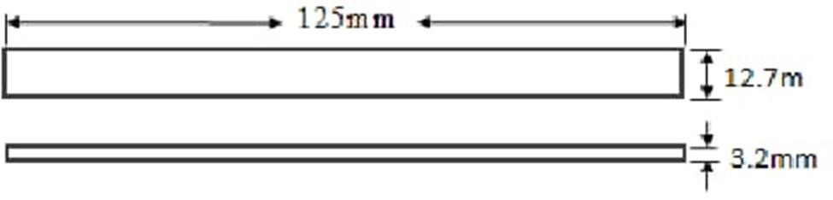

Figure 6. Flexural specimen as per ASTM D790

* 1. **SHORT BEAM STRENGTH TEST**

The interlaminar shear strength (ILSS) was assessed following the ASTM D2344-84 standard. A small beam, 45 mm in length with a square cross-section, was cut and subjected to three-point bending load at a rate of 1.3 mm min−1. During testing, the specimen experienced both normal (bending) and transverse shear stresses as the loading cylinder applied downward force. Utilizing a short beam helps minimize the influence of bending loads on interlaminar shear failure, ensuring that cracking occurs predominantly along a horizontal plane between the laminates.

**3. Results and Discussions**

In this section, the detailed results of the experiments were presented and dicussed.

**3.1 Tensile Strength**

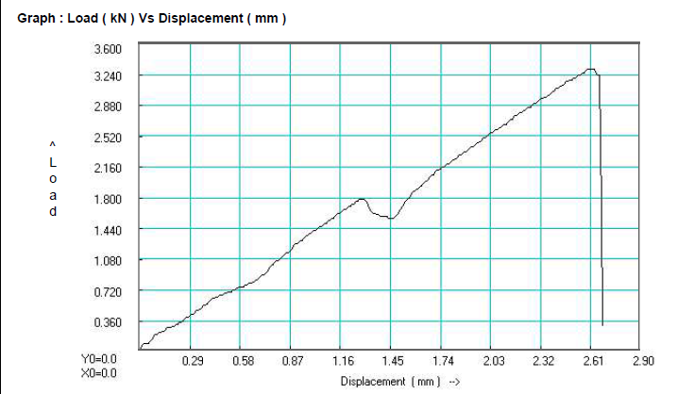The tensile strength of specimens varied with different Nano SiO₂ concentrations, showing an initial increase followed by a decline beyond an optimal level. Specimen 1 (0.55 g) had a tensile strength of 12.177 MPa, which improved to 16.88 MPa in Specimen 2 (1 g) and 20.98 MPa in Specimen 3 (1.65 g). The highest strength of 31.5 MPa was observed in Specimen 4 (2.2 g), but further increase to 2.75 g in Specimen 5 led to a decline to 28.98 MPa, likely due to nanoparticle agglomeration. These results suggest that 2.2 g of Nano SiO₂ is the optimal concentration for maximizing tensile strength, emphasizing the importance of controlled nanoparticle dispersion for optimal mechanical performance

*Figure 7.Tensile strength Graph of Load vs Displacement*

*Figure 8. Tensile strength of 5 specimens*

**3.2 Short Beam Strength**

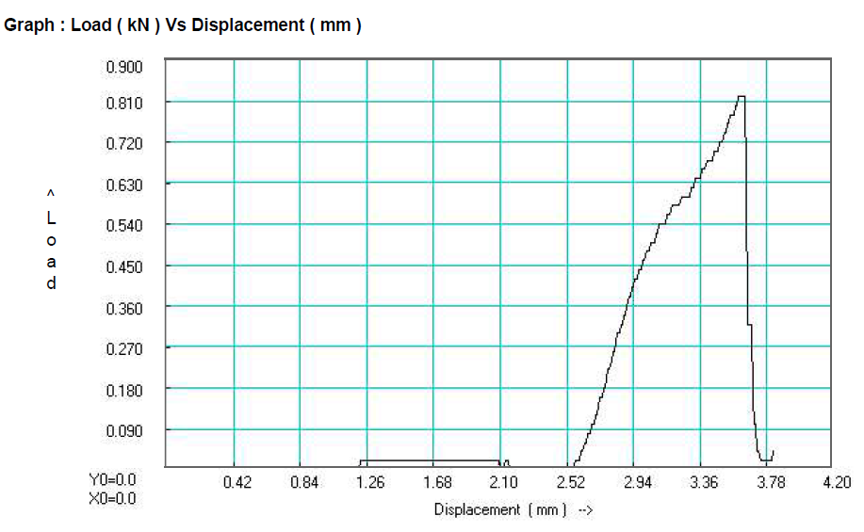The short beam strength of specimens with varying concentrations of Nano SiO₂ was evaluated to determine its effect on flexural performance. The results indicate that the strength initially decreases as the Nano SiO₂ content increases. Specimen 1, with 0.55g of Nano SiO₂, exhibited the highest short beam strength at 9.31 MPa. As the Nano SiO₂ content increased to 1.1g and 1.65g, the strength reduced to 7.84 MPa and 7.64 MPa, respectively. Further increments to 2.2g and 2.65g resulted in additional decreases to 7.52 MPa and 6.58 MPa, respectively. This trend suggests that while small additions of Nano SiO₂ may contribute to strength improvement, excessive amounts can lead to a decline in mechanical performance, possibly due to agglomeration or poor dispersion within the matrix. These findings highlight the need for optimizing Nano SiO₂ content to achieve the best mechanical properties in composite materials.

*Figure 9. SBS graph of load vs displacement*

*Figure 10. Short Beam Strength of 5 specimens*

**3.3 Flexural Strength**

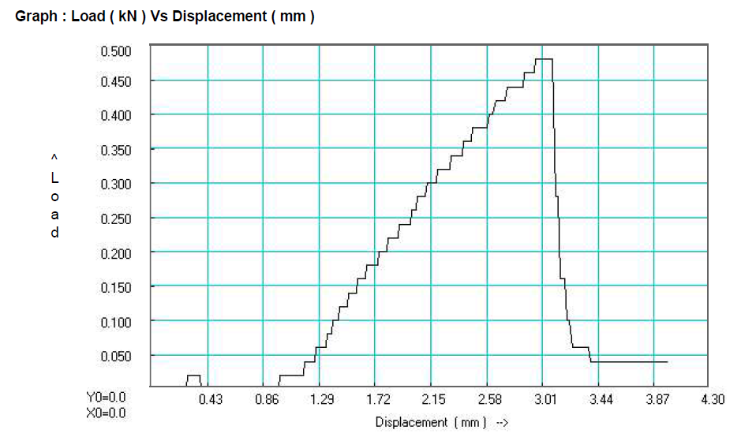The flexural strength of the specimens varied with different percentages of Nano SiO₂ mixed into the material. Specimen 1, with 0.55% Nano SiO₂, exhibited a flexural strength of 78.89 MPa. As the Nano SiO₂ content increased to 1.1% and 1.65%, the flexural strength decreased to 75.35 MPa and 70.05 MPa, respectively. However, at 2.2% Nano SiO₂, the flexural strength recovered to 78.52 MPa. The highest flexural strength of 84.76 MPa was observed in Specimen 5, which contained 2.65% Nano SiO₂. This suggests that while an initial increase in Nano SiO₂ content may reduce flexural strength, higher concentrations can enhance it, indicating a possible threshold effect where optimal dispersion and reinforcement occur.

*Figure 7.Tensile strength Graph of Load vs Displacement*

*Figure 8. Flexural Strength graph of load vs displacement*

**3.4 Hygrothermal Analysis**

Over the course of four weeks, the weight variations of a hybrid composite were systematically recorded for five different specimens to assess material behavior over time. In Week 1, the initial weights of the specimens ranged from 7.84 g to 7.93 g, serving as the baseline for comparison. By Week 2, a progressive increase in weight was observed, with specimens weighing between 7.94 g and 8.04 g, suggesting potential moisture absorption, resin curing, or structural adaptation. This trend continued in Week 3, where the recorded weights ranged from 8.10 g to 8.25 g, indicating a consistent upward trajectory in mass accumulation, likely due to continued material interaction with environmental conditions. However, by Week 4, the weight gain appeared to stabilize, with values between 8.10 g and 8.21 g, signaling a possible equilibrium state. This stabilization phase suggests that the hybrid composite underwent an initial phase of weight augmentation, potentially due to absorption dynamics or internal structural reinforcement, before reaching a plateau. These findings provide valuable insights into the long-term behavior of hybrid composites, influencing their applications in structural and material science fields.

*Figure 9. Weights of five specimens in 4 weeks*

**4. CONCLUSION**

1. The current study investigates the mechanical and hygrothermal analysis of Ramie fiber and Flax fiber pretreated with NaOH solution mixed with Nano SiO2 reinforced epoxy hybrid composites utilizing VARTM.
2. The mechanical characteristics of Ramie and Flax fiber pretreated with NaOH solution mixed with Nano SiO2 reinforced epoxy hybrid composites, such as tensile strength, SBS and flexural strength, are based on a 50/50 weight ratio.
3. Hybrid composites with a 50/50 weight ratio have improved flexural, short beam strength and tensile characteristics.
4. The following conclusions are drawn:

* The Tensile strength 28.98 Mpa was found at 2.5 % of Nano SiO2 in Ramie and Flax hybrid composite, which is 17% higher than the 50:50 hand layup hybrid composite.
* The Flexural strength 84.76 Mpa was found at 2.5 % of Nano SiO2 in Ramie and Flax composite, which is 3.1% higher than the 50:50 hand layup hybrid composite.
* The Short Beam Strength 9.31 Mpa was found at 0.5 % of Nano SiO2 in Ramie and Flax composite, which is 2.7 % higher than the 50:50 hand layup hybrid composite.
* From Hygrothermal analysis test, we have noted the weight of the all nano SiO2 hybrid composite is increased by a average of 0.03 grams in all 4 weeks gradually.

**REFERENCES**

* Gujjala R, Ojha S, Acharya S and Pal S 2013 Mechanical properties of woven jute–glass hybrid-reinforced epoxy composite J. Compos. Mater. 48 3445–5
* Ahmad F, ChoiHS and ParkMK2014 A review: natural fiber composites selection in view of mechanical, light weight, and economic properties Macromol. Mater. Eng. 300 10–24
* HunerU2017 Effect of chemical surface treatment on flax-reinforced epoxy composite J. Nat. Fibers 15 808–21
* Mohanavel V, Raja T, Yadav A, RavichandranMand Winczek J 2021 Evaluation of mechanical and thermal properties of jute and ramie reinforced epoxy-based hybrid composites J. Nat. Fibers 19 8022–32
* Chaudhary V, Bajpai PKand Maheshwari S 2018 Effect of moisture absorption on the mechanical performance of natural fiber reinforced woven hybrid bio-composites J. Nat. Fibers 17 84–100
* Kedari V R, Farah B I and Hsiao K 2011 Effects of vacuum pressure, inlet pressure, and mold temperature on the void content, volume fraction of polyester/e-glass fiber composites manufactured with VARTM process J. Compos. Mater. 0 1-16
* Moudood A, Rahman A, Öchsner A, IslamMand FrancucciG2018 Flax fiber and its composites: an overview of water and moisture absorption impact on their performance J. Reinf. Plast. Compos. 38 323–39
* Anil K C, Girisha K G and Sreenivas Rao K V 2015 Effect of fiber orientation on specific gravity, hardness and flexural strength and tensile property of jute/hemp hybrid laminate composite Appl. Mech. Mater. 766 75-78
* Gholampour A. Hu RH, Sun M, young, Lim JK, (2010) Moisture absorption, tensile strength and microstructure evolution of short jute fiber/polylactide composite in hygrothermal environment. Mater Des 31:3167–3173Ozbakkaloglu T. A review of natural fiber composites: Properties, modification and processing techniques, characterization, applications. J. Mater. Sci. 2020;55:829–892.
* attegazzore D, Alongi J, Duraccio D, Frache A (2018) All natural high-density fiber- and particleboards from hemp fibers or rice husk particles. J Polym Environ 26:1652–1660.
* Chavhan GR, Wankhade LN (2020) Improvement of the mechanical properties of hybrid composites prepared by fibers, fiber-metals, and nano-filler particles—a review. Mater Today Proc 27:72–82.
* Fiore V, Scalici T, Badagliacco D et al (2017) Aging resistance of bio-epoxy jute-basalt hybrid composites as novel multilayer structures for cladding. Compos Struct 160:1319–1328.
* Jin P, Wang D, Tan X (2012) Review of hygrothermal effects on carbon fiber-reinforced composite materials. Adv Mater Res 490–495:3611–3615.