**Investigating the Thermo-Mechanical Performance of Natural Fiber Composites Reinforced with Sea Shell Powder**

**Dr. G. Rama Krishna1, K. Vasu 2, Anshu Kumar upadhyay3, M. Vamsi Naga Satya Sai4,**

**P. Sai Praveen5**

1Associate Professor, Department of Mechanical Engineering

Godavari Institute of Engineering & Technology, Rajahmundry, Andhra Pradesh, India.

2,3,4,5 Department of Mechanical Engineering students, Godavari Institute of Engineering & Technology, Rajahmundry, Andhra Pradesh, India.

E-mail: [ggkrishna999@giet.ac.in](mailto:ggkrishna999@giet.ac.in)1

**ABSTRACT**

This study explores the thermo-mechanical behavior of natural fiber composites (NFCs) reinforced with sea shell powder (SSP), a biogenic waste rich in calcium carbonate (CaCO₃). The aim is to assess the impact of SSP on thermal stability, mechanical strength, and microstructural properties. Results show that SSP enhances mechanical performance up to an optimal content, beyond which agglomeration and poor adhesion reduce effectiveness. Thermal analysis indicates improved heat resistance, making these composites suitable for high-temperature applications. Scanning electron microscopy (SEM) confirms uniform SSP dispersion at lower concentrations, improving load transfer and structural integrity. However, excessive SSP causes stress concentrations and defects. The presence of CaCO₃ enhances flame retardancy and thermal insulation. SSP’s use promotes waste valorization while offering a cost-effective reinforcement alternative. This sustainable approach supports greener material development. These findings contribute to high-performance, eco-friendly NFCs.

Keywords : Sea shell powder, Natural fiber composites, Thermal strength, Mechanical strength,

1. **INTRODUCTION**

This research contributes to the advancement of sustainable composite materials by leveraging waste-derived reinforcements like sea shell powder. The findings will provide insights into the feasibility of utilizing SSP in high-performance NFRCs, enhancing their thermal resistance and mechanical strength. Additionally, the study promotes the circular economy by repurposing sea shell waste, reducing environmental impact, and offering cost-effective solutions for industries seeking eco-friendly material alternatives. This research significantly advances the field of sustainable composite materials by exploring the potential of waste-derived reinforcements, specifically sea shell powder (SSP). By incorporating SSP into natural fiber - reinforced composites (NFRCs), the study aims to enhance the thermal resistance and mechanical strength of these materials, potentially opening new avenues for their application in high-performance settings. The utilization of sea shell waste not only addresses environmental concerns but also aligns with the principles of a circular economy, offering a sustainable solution to waste management while creating value-added products.

The implications of this research extend beyond material science, touching on economic and environmental aspects. By repurposing sea shell waste, which is often discarded in large quantities by the seafood industry, the study demonstrates a practical approach to reducing environmental impact. This approach could potentially lead to cost-effective solutions for industries seeking eco-friendly material alternatives, thereby bridging the gap between sustainability goals and economic feasibility. Furthermore, the success of this research could inspire similar initiatives in utilizing other types of waste materials, contributing to a broader shift towards sustainable practices in material development and manufacturing processes.

1. **FABRICATION METHODS**
   1. **Hand Layup Method**

The fabrication method is ‘hand layup’ process which involves manually laying down individual layers or ‘plies’ of a form of reinforcement known as ‘prepreg’. This consists of thousands of fibers, which are pre-impregnated with resin and bundled into tows and arranged either in a single unidirectional ply or woven together. The layup process involves manipulating each ply into shape by hand and then firmly stuck to the previous layer or mold surface leaving no air pocket between plies

1. **MATERIALS**

3.1 **Sea Shell Powder**

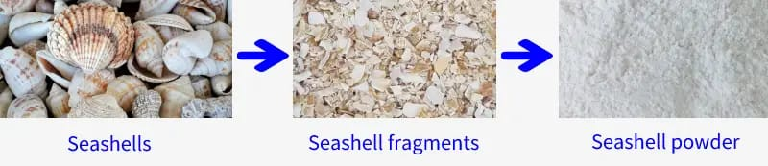Sea shells, which are resilient exoskeletons of marine mollusks, are predominantly composed of calcium carbonate, which exists as either calcite or aragonite. This natural composition renders them a valuable resource. Their diverse forms, ranging from intricate spirals to robust bivalves, reflect the vast array of mollusk species and their adaptations to various marine environments. They serve as vital habitats, contribute to coastal stability, and participate in the calcium carbonate cycle of the ocean. Human utilization spans centuries, from ornamental uses and historical currency to modern industrial applications, including their recent exploration as sustainable fillers for polymer composites. However, the increasing pressures of overharvesting and ocean acidification threaten these vital components of marine ecosystems and demand responsible management and conservation efforts.

Fig 3.1 Sea Shell Powder

* 1. **Sisal Fiber**

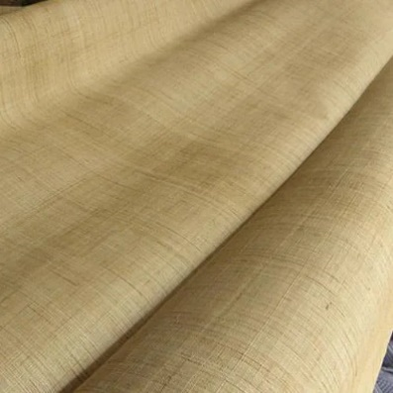Sisal fiber mats are a promising, eco-friendly way to produce strong, durable materials. Think of them like nature's reinforcement. They boost properties such as tensile strength and impact resistance, making them useful in cars, buildings, and even furniture. While they have some disadvantages, such as soaking up moisture and not being super-fire-resistant, scientists have found ways to fix those issues with special treatments. Essentially, sisal mats are a sustainable and cost-effective alternative to traditional materials, helping to build a greener

future.

Fig 3.2 Sisal Fiber

* 1. **Hemp Fiber**

Hemp fiber mats offer a compelling sustainable reinforcement option for composites, providing a robust and flexible alternative to synthetic fibers. Their high tensile strength and durability make them ideal for diverse applications ranging from automotive interiors to aerospace components.

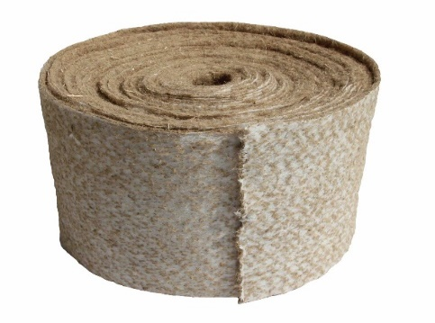Naturally UV-resistant, biodegradable, and offering excellent thermal and acoustic insulation, hemp mats are aligned with eco-conscious manufacturing. While moisture absorption poses a challenge, impacting fiber-matrix bonding, surface treatments such as alkali and silane coupling, along with resin modifications, effectively mitigate this issue

Fig 3.3 Hemp Fiber

* 1. **Resin & Hardener**

The Araldite-Standard Hardner HY 917 epoxy resin (Araldite LY556) is commonly used to strengthen structural fibers such as hemp and sisal because of its exceptional mechanical properties, adhesion characteristics, and moisture resistance

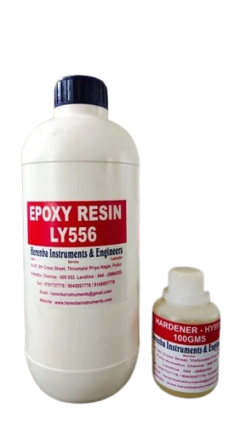This reinforcement process improves the inherent qualities of natural fibers, resulting in composites with enhanced strength, stiffness, and dimensional stability. The epoxy resin acts as a matrix, enclosing the fibers and effectively distributing the applied stress. However, it is crucial to carefully select and modify the resin system to achieve an optimal performance. Factors such as viscosity, flexibility, and compatibility with the fiber surface chemistry play a significant role in the adhesion and transfer of stress between the fiber and the matrix. Ероху-reinforced natural fiber composites provide a sustainable alternative to conventional materials due to the biodegradability, low energy consumption during processing, and potential for utilizing recycled fibers. With continuous research and development, these environmentally friendly composites hold great promise for a wide range of applications in automotive, construction, and aerospace industries.

Fig 3.4 Resin & Hardener

1. **COMPOSITION**

To evaluate the mechanical properties of natural fiber-reinforced epoxy composites filled with coconut shell ash, follow these steps:

* 1. **Selecting the Type of Natural Fiber**: The selection of natural fiber depends on the required mechanical properties, processing method, and availability. Different fibers, such as hemp and sisal, offer varying strengths, stiffness, and toughness, influencing the final composite properties.
  2. **Choosing the Epoxy Resin**: The choice of epoxy resin is influenced by the type of natural fiber and the coconut shell ash filler, as well as the chosen processing method. The percentage of epoxy resin used will be based on the fiber content and the desired mechanical properties. For this evaluation, Epoxy Resin LY 556 and Hardener HY917 are considered.
  3. **Determining the Percentage of Natural Fiber**: The percentage of natural fiber depends on the desired mechanical properties and the processing method. The fiber length and orientation are set at 150 mm x 150 mm, with 5 layers of hemp fiber and 5 layers of sisal fiber, totaling 10 layers weighing 104 grams.
  4. **Determining the Percentage of Epoxy Resin:** The epoxy resin percentage is determined based on the fiber content, as it affects the composite’s toughness, durability, and weight. Typically, the resin-to-fiber ratio is 2:1 by weight, with a resin-to-hardener ratio of 10:1. The total weight of the resin is 150 grams, and the hardener is 15.0 grams.
  5. **Deciding on the Percentage of Sea Shell Powder**: The filler percentage of coconut shell ash is chosen based on the desired fiber weight. The sea shell powder is considered at 5%, 10%, and 15%, with the goal of optimizing dispersion and bonding with the fiber and resin matrix.
  6. **Preparing the Composite Material**: The natural fibers, epoxy resin, and sea shell powder filler should be mixed thoroughly by hand to ensure uniform distribution of the components. The composite material is then shaped into the required form (150 mm x 150 mm) and cured according to the resin manufacturer’s guidelines.

|  |  |  |  |  |  |
| --- | --- | --- | --- | --- | --- |
|  | Fibers  (no of layers)  A | Fiber weight  (in grams)  B | Sea shell powder  (in grams)  C=x%B  (x=5,10,15) | Resin & Hardener  (in grams)  D=2 X B | Ratio |
| **Specimen 1** | 10 | 104 | 0 | 150 + 15.0 =165.0 | 10:1 |
| **Specimen 2** | 10 | 104 | 5 | 150 + 15.0 =165.0 | 10:1 |
| **Specimen 3** | 10 | 104 | 10 | 150 + 15.0 =165.0 | 10:1 |
| **Specimen 4** | 10 | 104 | 15 | 150 + 15.0 =165.0 | 10:1 |

Table 4.1 Composition

1. **MECHANICAL TESTS**
   1. **Tensile Test**

The tensile test is performed using a universal testing machine, which gradually applies an increasing load to a standardized specimen until it fractures. Throughout the test, the machine records both the applied force and the specimen's deformation, specifically the change in its length.

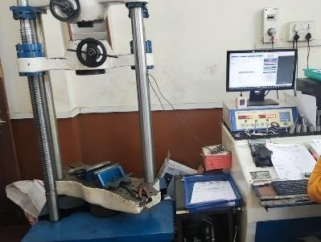

Fig 5.1 Universal Testing Machine

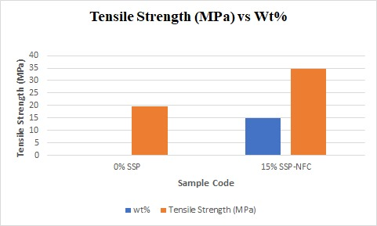

|  |  |  |  |  |  |
| --- | --- | --- | --- | --- | --- |
| **Sl.No** | **Sample Details** | | **Test Parameter** | **Units** | **Results** |
| 1 | SEA SHELL POWDER | Sample - 0% | Tensile Strength | MPa | 19.675 |
| 2 | Sample – 15% | 34.851 |

**TABLE 5.2** Tensile strength readings

* 1. **Flexural Test**

The flexural test is carried out using a flexural testing machine or bending machine, which applies a gradually increasing load to the midpoint of the specimen. During the test, the machine measures the deflection or deformation at the center while simultaneously recording the applied load. These values are then used to determine the flexural modulus and flexural strength of the material.

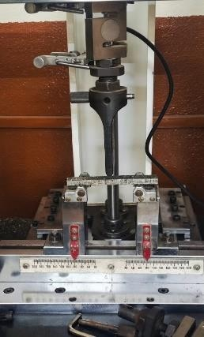

Fig 5.2 Flexural Testing Machine

|  |  |  |  |  |  |
| --- | --- | --- | --- | --- | --- |
| **Sl.No** | **Sample Details** | | **Test Parameter** | **Units** | **Results** |
| 1 | SEA SHELL POWDER | Sample - 0% | Flexural Strength | MPa | 43.25 |
| 2 | Sample – 15% | 71.52 |

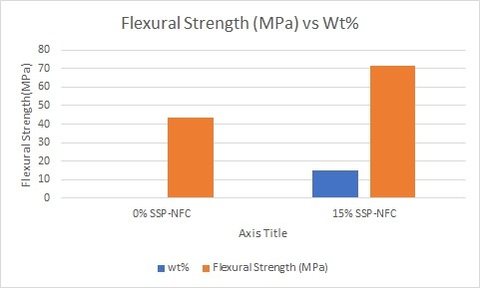

**Table 5.2** Flexural strength readings

**5.3 THERMAL TEST**

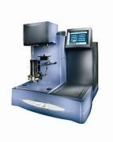  **Thermogravimetric Analysis (TGA**): Thermogravimetric Analysis is an analytical technique used to measure changes in the mass of a sample as it is heated, cooled, or held at a constant temperature. It helps in studying material properties such as thermal stability, composition, and decomposition behavior.

Fig 5.3 Thermogravimetric Analysis

|  |  |  |  |  |  |  |
| --- | --- | --- | --- | --- | --- | --- |
| **Sl.No** | **Sample Details** | | **Test Parameter** | | **Units** | **Results** |
| 1 | SEA SHELL POWDER | Sample - 5% | TGA | | % | Base Material: 94.391  Filler Material: 5.609 |
| 2 | Sample – 10% | Base Material: 90.613  Filler Material: 9.387 |
|  | | | |  | | |

**Table 5.3** Thermogravimetric Analysis Readings

**CONCLUSION**

The experimental investigation demonstrated that the incorporation of coconut shell ash into epoxy composites significantly influences their mechanical properties. The optimal performance was observed at a 4% addition of coconut shell ash, yielding the highest tensile strength (5.540 kn, 29.604 MPa), impact strength (12.0 Joules), and hardness (average of 98.00). Additionally, a 3% inclusion provided the best flexural strength (50.51 MPa, with an ultimate load of 605 N). The scanning electron microscopy (SEM) analysis revealed that mechanical performance was affected by factors such as poor bonding between fibers and the matrix, the presence of voids, and areas rich in resin, indicating potential areas for improvement in composite formulation and processing to enhance overall material performance.

**REFERENCES**

1. FA, F., Siregar, J. P., & Tezara, C., 2016. Investigation of thermal behavior for natural fibers reinforced epoxy using thermogravimetric and differential scanning calorimetric analysis. MATEC Web of Conferences, Vol. 78.
2. N Poddar, P., Islam, M.S., Sultana, S., Nur, H.P., & Chowdhury, A.M.S., 2016. Mechanical and thermal properties of short arecanut leaf sheath fiber reinforced polypropylene composites: TGA, DSC, and SEM analysis. J. Material Sci Eng. (270), pp. 2169-0022.
3. Ramakrishna, G. & Selokar, G.R., 2019. Advancement of Mechanical Assets of Hemp Fiber Reinforced Epoxy Composites Loaded with Groundnut Shell Cinder. International Journal of Mechanical and Production Engineering Research and Development (UMPERD), 9(5), pp. 1215-1230.
4. Ramakrishna, G. & Selokar, G.R., 2020. Mechanical Conduct on Hemp Fiber Fortified Polymer Composite with the Effect of Fiber Stacking and Length of Fiber on the Properties of Composites. International Journal of Innovative Technology and Exploring Engineering (UITEE), 9(5).
5. Ramakrishna, G., Vardhan, V.S.S.H., Babu, K.R.P., Kumar, B.R., 2020. Mechanical Characterization of E-Glass Fibre Reinforced Composite with Graphene Nanoparticles as Filler. International Journal of Emerging Trends in Engineering Research, 39.
6. Ramakrishna, G., Swamy, B.R., Babu, K.S., Sai, P.R., Kishore, K.N., 2020. Improving of Tensile and Compression Strengths by Hemp and Sisal Fibre Reinforced Epoxy Composites Filled with Groundnut Shell Ash. Journal of Information and Computational Science, 13(2).
7. Ramakrishna, G., Akhil, M., Krishna, G.B.G., Krishna, M.Y., Dora, T.V., 2020. Improving of Hardness and Impact Strengths by Hemp and Sisal Fibre Reinforced Epoxy Composites Filled with Groundnut Shell Ash. Journal of Information and Computational Science, 13(2).
8. Ramakrishna, G., Rao, M.S., Balaji, C.S.N., Siva, G., Sandeep, P., Sai, V., 2020. Mechanical Assets of Jute and Sisal Fiber Reinforced Epoxy Composites Loaded up with Coconut Shell Cinder. Journal of Information and Computational Science, 13(2).
9. Ramakrishna, G., Kumar, D.A., Manikanta, S., Kumar, N.A., Prasad, K.S.S.V., Yogiraju, U.M.V.K., 2020. Improvement of Mechanical Properties of Epoxy Composites Filled with Coconut Shell Ash Using Jute and Sisal Fiber Reinforcement. Journal of Information and Computational Science, 13(2).
10. Kumaran, P., Mohanamurugan, S., & Madhu, S., 2020. Investigation on thermo-mechanical characteristics of treated/untreated Portunus sanguinolentus shell powder-based jute fabrics reinforced epoxy composites. Journal of Industrial Textiles.
11. Ramakrishna, G., Maneendra, P.V.V.S., Manikanta, T.V., Satya, P., Kumar, Y.P., Praveen, U., 2022. Determination and Analysis of Tensile Strength for Epoxy Retined Jute Fiber Composite Reinforced with Sawdust and Rice Hulls. International Journal of Mechanical Engineering, 7(5).
12. Dr. G.Ramakrishna , Dr. M. Sreenivasa Rao , G. Prabath , D.Sri Charan Raju, L.Pavan Kishore ,

P.Satya Sai,. 2024. Thermal Performance and Study of Hemp-Flax Fiber Reinforced with Rice Husk.