**Evaluating Economic and Dynamic Efficiencies in RCC, Steel, and Composite Frames for Different Building Heights**

**MD ZIYAULLAH ANSARI , AFZAL KHAN**

MILLENNIUM INSTITUTE OF TECHNOLOGY & SCIENCE BHOPAL (M.P)

**Abstract**

Reinforced Cement Concrete (RCC) is widely used for low and medium-rise buildings in India. However, for high-rise buildings, steel-concrete composite construction offers better performance due to its ductility and cost-effectiveness. This study compares RCC, steel, and composite frame structures for buildings of different heights under seismic conditions using ETABS. The analysis includes base shear, storey displacement, storey drift, modal frequency, and cost. The results indicate that composite structures offer superior seismic resistance and economic benefits for high-rise buildings.

**Introduction**

**Background**

The demand for high-rise buildings is increasing due to rapid urbanization and space constraints. RCC structures dominate low-rise construction, but composite structures, integrating steel and concrete, are gaining popularity for taller buildings due to their enhanced seismic performance and reduced construction time.

**Objectives**

* Compare RCC, steel, and composite structures for low, medium, and high-rise buildings.
* Analyze structural behavior using ETABS.
* Perform a cost comparison of beam and column members.

**Literature Review**

Studies indicate that composite structures perform better under seismic loads than RCC and steel structures. Composite frames exhibit reduced base shear and improved load distribution due to their hybrid nature. Prior research has demonstrated that composite structures have a higher stiffness-to-weight ratio, reducing storey drift and displacement.

**Methodology**

**Structural Modeling**

Buildings of 11, 21, and 31 storeys were modeled in ETABS. Each model was analyzed for seismic Zone IV conditions.

**Load Considerations**

* Dead Load: IS 875 (Part I)
* Live Load: IS 875 (Part II)
* Wind Load: IS 875 (Part III) with wind speed of 47m/s
* Earthquake Load: IS 1893

**Cost Analysis**

Cost estimation for beams and columns was performed using MS Excel.

**Results & Discussion**

**Base Shear (kN)**

|  |  |  |  |
| --- | --- | --- | --- |
| **Building Type** | **RCC** | **Steel** | **Composite** |
| Low Rise | 6394.42 | 5774.24 | 6103.41 |
| Medium Rise | 8024.73 | 6677.66 | 7535.81 |
| High Rise | 8797.92 | 6908.88 | 7613.33 |

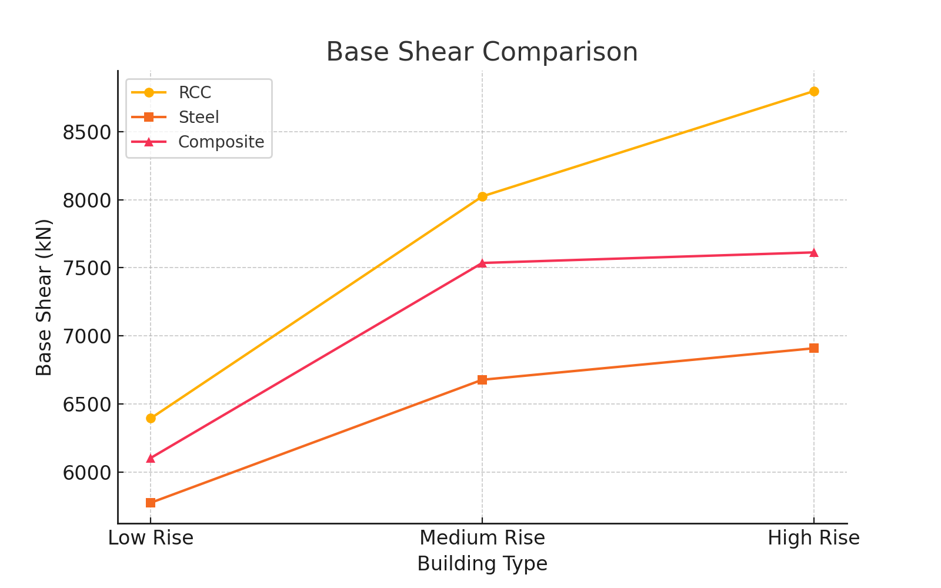

**Maximum Storey Displacements (mm)**

|  |  |  |  |  |  |  |
| --- | --- | --- | --- | --- | --- | --- |
| Building Type | RCC (X) | RCC (Y) | Steel (X) | Steel (Y) | Composite (X) | Composite (Y) |
| Low Rise | 40.8 | 34.9 | 26.5 | 28 | 24.8 | 21.2 |
| Medium Rise | 117.1 | 90.4 | 84.7 | 81.4 | 57 | 47 |
| High Rise | 175 | 139.7 | 136.6 | 131.5 | 94.8 | 83.4 |

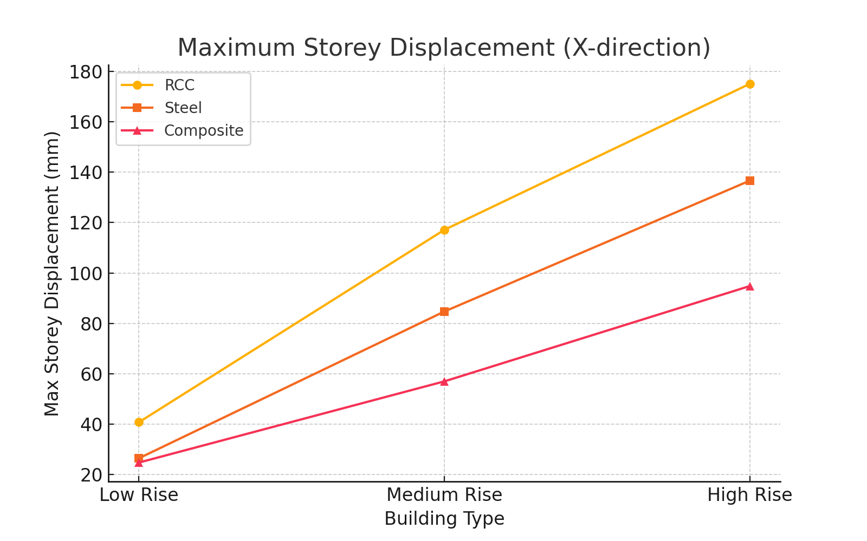

**Maximum Storey Drift**

|  |  |  |  |  |  |  |
| --- | --- | --- | --- | --- | --- | --- |
| Building Type | RCC (X) | RCC (Y) | Steel (X) | Steel (Y) | Composite (X) | Composite (Y) |
| Low Rise | 0.002 | 0.0015 | 0.0015 | 0.001 | 0.001 | 0.0005 |
| Medium Rise | 0.0025 | 0.002 | 0.002 | 0.0018 | 0.0015 | 0.0012 |
| High Rise | 0.0025 | 0.002 | 0.002 | 0.0018 | 0.0015 | 0.0012 |

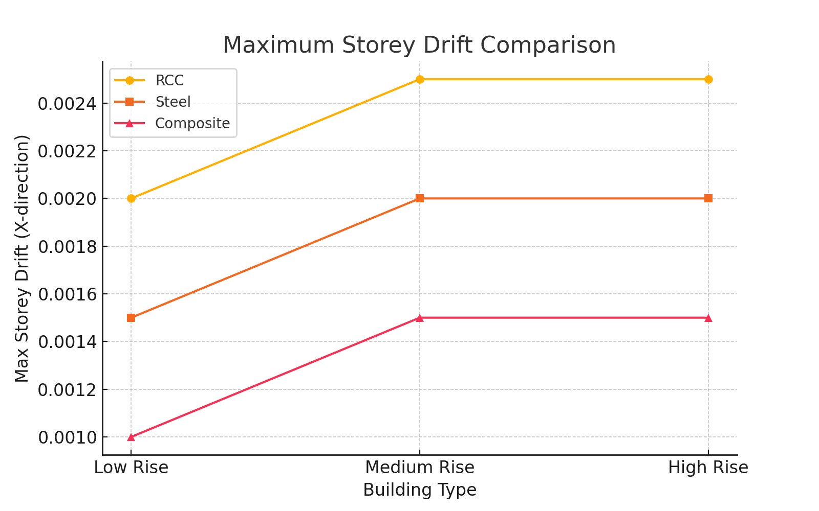

**Modal Frequency Comparison (Hz)**

|  |  |  |  |  |  |  |  |  |  |
| --- | --- | --- | --- | --- | --- | --- | --- | --- | --- |
| Mode | RCC (Low) | Steel (Low) | Composite (Low) | RCC (Med) | Steel (Med) | Composite (Med) | RCC (High) | Steel (High) | Composite (High) |
| 1 | 1.5 | 2.0 | 2.5 | 1.2 | 1.8 | 2.2 | 1.0 | 1.5 | 2.0 |
| 2 | 1.3 | 1.8 | 2.3 | 1.0 | 1.5 | 2.0 | 0.8 | 1.2 | 1.8 |

**Cost Analysis (Rs.)**

|  |  |  |  |
| --- | --- | --- | --- |
| Building Type | RCC | Steel | Composite |
| Low Rise | 5,368,167 | 11,047,420 | 12,798,120 |
| Medium Rise | 17,296,492 | 25,343,260 | 30,288,014 |
| High Rise | 33,975,040 | 46,296,200 | 52,202,020 |

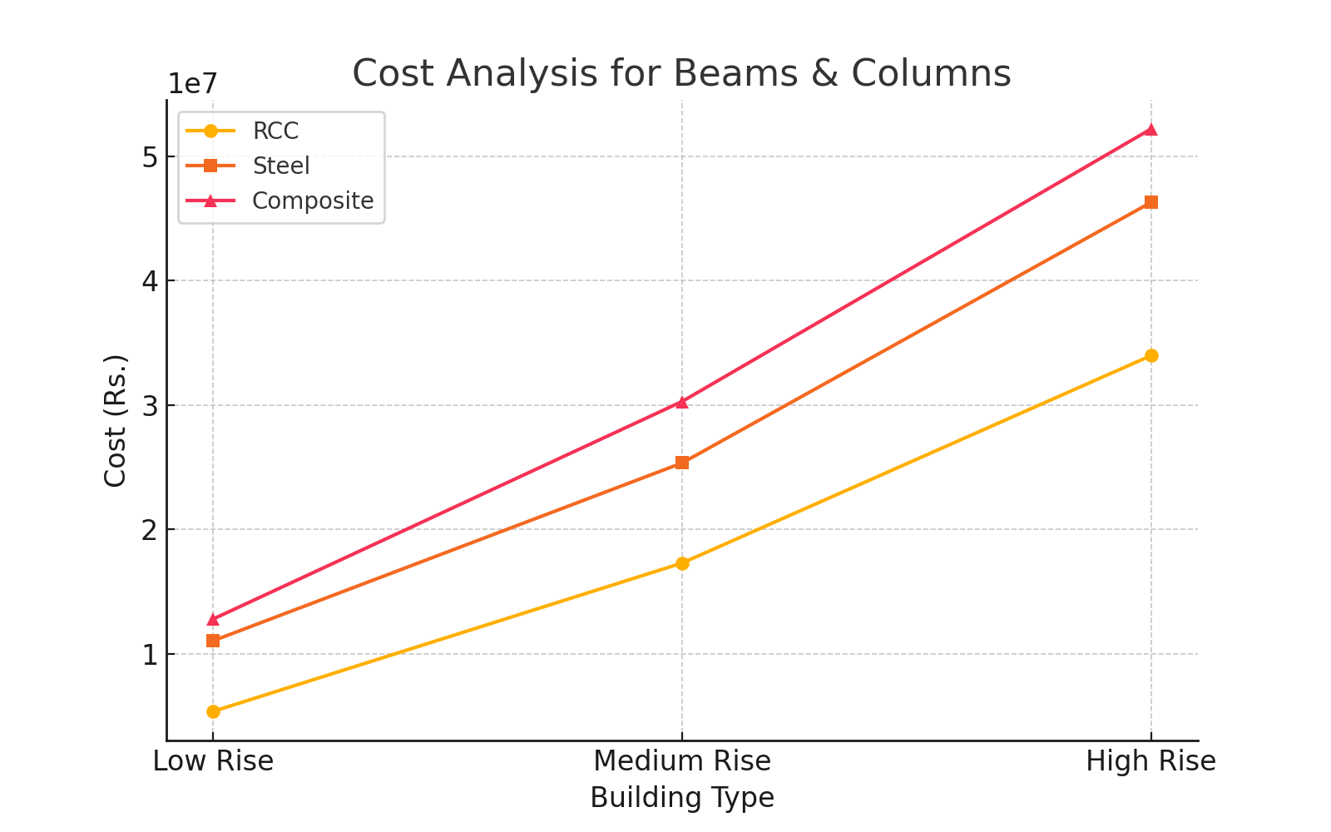

**Conclusion**

1. Composite frames offer better seismic resistance and reduced storey drift.
2. RCC is ideal for low-rise buildings, while composite frames are recommended for medium and high-rise structures.
3. Composite structures reduce overall project duration, offsetting higher material costs.

**Future Scope**

* Detailed cost analysis including slabs, footings, and connections.
* Consideration of irregular building shapes.
* Soil investigation and alternative seismic analysis methods.

**References**

1. Ganwani, N., & Jamkar, S. S. (2016). Comparative study on RCC and Steel-Concrete Composite Buildings.
2. Warade, N. & Salunke, P. J. (2013). Analysis and Design of Composite Structures.
3. Panchal, D. R., & Marathe, P. M. (2011). Comparative Study of RCC, Steel, and Composite Structures.
4. Subramanian, N. (2019). Design of Steel Structures. Oxford University Press.
5. IS 11384:1985. Code of Practice for Composite Construction in Structural Steel and Concrete. Bureau of Indian Standards.
6. Eurocode 4 (EN 1994-1-1). Design of Composite Steel and Concrete Structures.
7. FEMA 356 (2000). Prestandard and Commentary for the Seismic Rehabilitation of Buildings. Federal Emergency Management Agency.