**Assessment of PM2.5 and PM10 Trends: Environmental Impacts and Influencing Factors**

DR. SANTOSH SINGH1,OMKAR SINGH2, RUTUJA SHINDE3, PRATIBHA JAISWAR4*1H.O.D, Department of IT, Thakur College of Science and Commerce,Thakur Village, Kandivali (East), Mumbai, Maharashtra, India*

*2Assistant professor, Department of IT, Thakur College of Science and Commerce,Thakur Village, Kandivali (East), Mumbai, Maharashtra, India*

*3,4PG student, department of IT, Thakur College of Science and Commerce,Thakur Village, Kandivali(East), Mumbai, Maharashtra, India*

Keyword: SVM, CNN, Trend analysis , PM2.5 , PM10

**Abstract:**

Particulate Matter (PM) pollution, specifically PM2.5 and PM10, has become a critical environmental issue worldwide due to its adverse effects on human health and ecosystems. This study conducts a trend analysis of PM2.5 and PM10 concentrations based on various parameters such as meteorological conditions, industrial activities, vehicular emissions, and geographical factors. Utilizing data collected from air quality monitoring stations over a specified period, statistical techniques including regression analysis and time series modeling are employed to discern patterns and trends. The research aims to investigate the relationships between PM2.5 and PM10 concentrations and the influencing factors, thus providing insights into pollution dynamics. By analyzing temporal and spatial variations, the study seeks to identify key contributors to PM pollution and understand the underlying mechanisms driving its fluctuations. Furthermore, the environmental impacts of elevated PM levels are thoroughly examined. These impacts encompass respiratory and cardiovascular diseases in humans, degradation of air quality, visibility reduction, deposition on surfaces leading to corrosion, and detrimental effects on vegetation and ecosystems. The study also explores the economic ramifications associated with PM pollution, including healthcare costs and productivity losses. In conclusion, this research contributes to a comprehensive understanding of PM pollution dynamics, facilitating the development of effective mitigation strategies and policy interventions. This study provides important insights for policymakers, urban planners, and environmental scientists by providing an understanding of the complex interactions between particle concentrations and a variety of parameters.

**INTRODUCTION:**

Particulate Matter (PM) pollution, comprising particles of varying sizes suspended in the air, poses a significant threat to public health and the environment globally. Among the diverse range of particulate pollutants, PM2.5 (particles with a diameter of 2.5 micrometers or smaller) and PM10 (particles with a diameter of 10 micrometers or smaller) are of particular concern due to their ability to penetrate deep into the respiratory system, causing adverse health effects. Understanding the trends and dynamics of PM2.5 and PM10 concentrations is crucial for effective air quality management and environmental protection. This study focuses on conducting a trend analysis of PM2.5 and PM10 concentrations based on various parameters to elucidate the factors influencing their levels in the atmosphere. By examining these parameters comprehensively, including meteorological conditions, industrial activities, vehicular emissions, and geographical factors, we aim to gain insights into the complex dynamics of PM pollution. The need for such analysis arises from the growing recognition of the multifaceted nature of air pollution and its impact on human health, ecosystems, and socio-economic well-being. Rapid urbanization, industrialization, and population growth have exacerbated air quality concerns, making it imperative to identify the drivers of PM pollution and develop targeted strategies for mitigation and control. Previous studies have highlighted the intricate interplay between PM concentrations and various factors, indicating the importance of considering a wide range of parameters in trend analysis. Meteorological factors such as temperature, humidity, wind speed, and atmospheric stability influence the dispersion and accumulation of particulate matter, affecting local and regional air quality patterns. Industrial emissions, including combustion processes, industrial activities, and construction, contribute significantly to PM pollution levels, especially in urban and industrialized areas. Vehicul are missions from automobiles , trucks , and transportation sources are another major contributor to PM pollution, particularly in urban centers with high traffic densities. Moreover, geographical factors such as topography, land use patterns, and proximity to pollution sources play a crucial role in determining PM concentrations in different regions. Urban areas often experience higher levels of PM pollution due to the concentration of anthropogenic activities and limited dispersion opportunities. By conducting a comprehensive trend analysis incorporating these diverse parameters, this study aims to provide a nuanced understanding of the temporal and spatial variations in PM2.5 and PM10 concentrations. Such insights are essential for formulating evidence-based policies and interventions to mitigate air pollution, protect public health, and safeguard the environment. Through this research, we seek to contribute to the ongoing efforts aimed at improving air quality and promoting sustainable development.

**LITERATURE REVIEW:**

The study conducted in Tabriz city from 2006 to 2017 examined long-term trends and spatial variations in PM10, PM2.5, and O3 concentrations, alongside their health impacts. Findings revealed decreasing PM levels but consistent O3 concentrations. A substantial portion of the population exceeded WHO and EPA standards for PM, with peak concentrations observed in May, December, and June. Health assessments linked PM exposure to infant mortality, bronchitis, and cardiovascular diseases. The study underscored the lack of effective pollution control measures and urged urgent policy interventions to safeguard public health in Tabriz.Barzeghar V, Sarbakhsh P, Hassanvand MS, Faridi S, Gholampour A. Long-term trend of ambient air PM10, PM2. 5, and O3 and their health effects in Tabriz city, Iran, during 2006–2017. Sustainable Cities and Society. 2020 Mar 1;54:101988.[1]

The study conducted in Shimla city, India, from 2011 to 2017 aimed to evaluate long-term trends in PM10 concentrations at urban and background monitoring stations. The highest daily mean concentrations were found to be 176 μg/m3 and 152 μg/m3 at the urban and background locations respectively, with annual mean concentrations of 59 μg/m3 and 45 μg/m3. Exceedance factors indicated 'moderate to high' levels at the urban station and 'moderate' levels at the background station. Seasonal analysis revealed higher concentrations in summer compared to winter, with the lowest during the monsoon season. Regression analysis showed a positive correlation between PM10 and NO2/SO2, as well as with wind speed and temperature, while negative correlations were observed with precipitation and relative humidity. The study discusses the need for additional monitoring sites to better represent ambient air quality conditions in Himachal Pradesh.Ganguly R, Sharma D, Kumar P. Trend analysis of observational PM10 concentrations in Shimla city, India. Sustainable Cities and Society. 2019 Nov 1;51:101719.[2]

The study investigates PM2.5 trends in the Po Valley, an area with high atmospheric pollutant concentrations. Analysis of PM2.5 and PM10–2.5 data across the region indicates a significant decreasing trend, particularly in winter. Weekly periodicity suggests the influence of primary anthropogenic emissions, while cluster analysis reveals moderate variability in PM2.5 distribution. The decrease in PM2.5 and PM10 is attributed to reductions in both primary and secondary aerosol emissions, primarily from vehicular traffic. However, increased biomass burning emissions in winter and modest decreases in NH3 may counteract these improvements.Bigi A, Ghermandi G. Trends and variability of atmospheric PM 2.5 and PM 10–2.5 concentration in the Po Valley, Italy. Atmospheric Chemistry and Physics. 2016 Dec 21;16(24):15777-88.[3]

The study examines the spatial distribution of PM2.5 pollution in China from 1999 to 2016, aiming to assist policymakers in strategic decision-making. Results indicate that 87.9% of China experienced an increasing trend in PM2.5 concentration, with particularly severe increases in the Beijing-Tianjin-Hebei region, Shandong province, and the Three Northeastern Provinces. Additionally, high PM2.5 concentrations in the Tarim Basin are linked to oil exploration. The study underscores the importance of controlling coal energy consumption and emphasizes the need for energy structure reconstruction to address PM2.5 pollution effectively.Zhao J, Wang X, Song H, Du Y, Cui W, Zhou Y. Spatiotemporal trend analysis of PM2. 5 concentration in China, 1999–2016. Atmosphere. 2019 Aug 12;10(8):461.[4]

The study investigates trends and variability in PM10, PM2.5, and PMcoarse concentrations at urban and rural background stations across five European countries from 1998 to 2010. Generalized Additive Models are used to assess the impact of meteorological variables on PM concentrations, with wind speed, wind direction, boundary layer depth, precipitation, and temperature identified as significant factors. Temperature exhibits a complex relationship with PM2.5 and PMcoarse concentrations, while wind speed generally influences PM2.5 concentrations. Meteorologically adjusted PM time series reveal decreasing trends in PM10 and PM2.5 concentrations, with PMcoarse showing smaller trends. The study suggests that targeting reductions in PMcoarse alongside PM2.5 could lead to faster decreases in overall PM10 levels. Quantile regression analysis highlights significant decreases in very high PM concentrations over time.Barmpadimos I, Keller J, Oderbolz D, Hueglin C, Prévôt AS. One decade of parallel fine (PM 2.5) and coarse (PM 10–PM 2.5) particulate matter measurements in Europe: trends and variability. Atmospheric Chemistry and Physics. 2012 Apr 3;12(7):3189-203.[5]

The paper examines 1-year PM10 and PM2.5 data from roadside and urban background monitoring stations in Athens, Madrid, and London, alongside other air pollutants and meteorological parameters. Principal component and regression analyses are used to assess the contribution of combustion and non-combustion sources to particulate pollution levels. Findings reveal frequent breaches of EU legislated PM10 and PM2.5 limit values, posing potential public health hazards. Seasonal variability patterns vary among cities, with Athens and Madrid showing higher PM10 concentrations during warm periods, suggesting a larger contribution of secondary and natural particles on hot, dry days. Non-combustion sources contribute significantly to particle levels across cities and seasons, particularly at urban background sites. The study underscores the need for mitigation measures targeting both vehicular exhaust emissions and background pollution to optimize health effects.Kassomenos PA, Vardoulakis S, Chaloulakou A, Paschalidou AK, Grivas G, Borge R, Lumbreras J. Study of PM10 and PM2. 5 levels in three European cities: Analysis of intra and inter urban variations. Atmospheric Environment. 2014 Apr 1;87:153-63.[6]

The study assesses particulate matter (PM) concentrations in Bangladesh using satellite-retrieved aerosol optical depth (AOD) data. Various estimation methods were compared, with multivariate models incorporating MODIS-AOD and surface meteorology showing the highest accuracy. PM2.5 and PM10 concentrations were analyzed for 11 sites from 2013 to 2018, revealing annual mean concentrations of 76.34 ± 34.12 µg m−3 and 136.25 ± 68.94 µg m−3, respectively. Anthropogenic sources predominantly contribute to elevated pollution levels, with winter showing the highest pollution and the monsoon season exhibiting the least pollution. PM concentrations demonstrate negative correlations with air temperature, relative humidity, and rainfall. The study highlights the urgent need for regular monitoring of PM pollution in urban areas to combat the alarming situation.Gupta A, Moniruzzaman M, Hande A, Rousta I, Olafsson H, Mondal KK. Estimation of particulate matter (PM 2.5, PM 10) concentration and its variation over urban sites in Bangladesh. SN Applied Sciences. 2020 Dec;2:1-5.[7]

The study investigates PM10 and PM2.5 concentrations, associated mortality, and transport pathways in Ghaziabad, an industrial city in the Indo-Gangetic Plain. PM and meteorological data were collected from June 2018 to May 2019 at three locations. The highest daily average concentrations were around 1000 µg m−3 for PM10 and 450 µg m−3 for PM2.5. Annual mean concentrations were approximately 260 ± 150 µg m−3 for PM10 and 140 ± 90 µg m−3 for PM2.5. Spearman rank correlation analysis showed an anti-correlation between ventilation coefficient and PM concentration during post-monsoon and winter seasons. Multiple linear regression revealed that local meteorological parameters accounted for around 50% of PM variability. Cluster and concentrated weighted trajectory analyses identified long-range transport sources impacting PM levels from the Arabian Sea and South Asia. Mortality estimates attributed around 873 deaths per million individuals to ambient PM2.5 in Ghaziabad, a figure approximately 70% higher than Delhi.Gupta L, Dev R, Zaidi K, Sunder Raman R, Habib G, Ghosh B. Assessment of PM 10 and PM 2.5 over Ghaziabad, an industrial city in the Indo-Gangetic Plain: spatio-temporal variability and associated health effects. Environmental Monitoring and Assessment. 2021 Nov;193:1-21.[8]

The study evaluates the long-term spatiotemporal trend of PM2.5 concentrations across China using an integrated dataset from satellite-derived (1998–2016) and ground-measured (2015–2017) PM2.5 data. Results indicate an increase in PM2.5 concentrations before 2008 followed by a decrease, particularly in south China. The implementation of the Chinese "Air Pollution Prevention and Control Action Plan" in 2014 contributed to a notable decrease in national mean PM2.5 concentrations by about 6.5 μg/m3 from 2015 to 2017. The study provides insights into recent PM2.5 variations and offers guidance for future policy making.Bai K, Ma M, Chang NB, Gao W. Spatiotemporal trend analysis for fine particulate matter concentrations in China using high-resolution satellite-derived and ground-measured PM2. 5 data. Journal of environmental management. 2019 Mar 1;233:530-42.[9]

The study investigates the correlation between COVID-19 spread and surface air pollution in Milan, Italy. It examines daily concentrations of PM2.5, PM10, and other pollutants, alongside air quality and climate variables from January to April 2020. The findings suggest that high levels of urban air pollution and specific weather conditions may contribute to increased COVID-19 transmission rates. The analysis highlights the importance of particulate matter concentrations, which are positively associated with average surface air temperature and inversely related to air relative humidity, in driving COVID-19 outbreak in Milan. The study also raises questions about the involvement of outdoor airborne aerosols in the transmission of the virus, particularly in densely populated urban areas like Milan.Zoran MA, Savastru RS, Savastru DM, Tautan MN. Assessing the relationship between surface levels of PM2. 5 and PM10 particulate matter impact on COVID-19 in Milan, Italy. Science of the total environment. 2020 Oct 10;738:139825.[10]

The study investigates PM2.5 variability in the Klang Valley urban-industrial environment over four seasons, including haze events, in Southeast Asia. It analyzes PM2.5 mass, chemical composition, and sources using various statistical methods and meteorological data. Results show elevated PM2.5 levels exceeding WHO guidelines, influenced by temperature, wind speed, and gaseous pollutants. Primary and secondary pollutants contribute to PM2.5, with sources varying by season. Meteorological and gaseous parameters significantly affect PM2.5 sources, highlighting the complex interplay between pollution and environmental factors.Amil N, Latif MT, Khan MF, Mohamad M. Seasonal variability of PM 2.5 composition and sources in the Klang Valley urban-industrial environment. Atmospheric Chemistry and Physics. 2016 Apr 29;16(8):5357-81.[11]

The study investigates the long-term patterns of PM10 concentrations in three cities in the Ganga Basin: Delhi, Kanpur, and Jaipur, with a focus on assessing the impact of crop residue burning (CRB). It concludes that episodic CRB in certain Indian states during the post-monsoon season has worsened air quality in Delhi and Kanpur, with Jaipur experiencing the least impact. A new quantitative method is developed to detect trends in PM10 concentrations over time, showing an 80% match with traditional statistical tests like the Mann-Kendall test. Overall, the study provides insights into the effects of CRB on air quality in the region.Nagar PK, Sharma M, Das D. A new method for trend analyses in PM10 and impact of crop residue burning in Delhi, Kanpur and Jaipur, India. Urban Climate. 2019 Mar 1;27:193-203.[12]

**METHODOLOGY:**

This phase elaborates on the dataset and technique used to enforce the proposed version for . Analyzing trends in PM2.5 and PM10 levels involves gathering data on various parameters that can influence air quality, and then identifying correlations and patterns over time. Inside the proposed work, function extraction has been achieved the usage of SVM model and CNN model.

Data Collection:

Gather historical data on PM2.5 and PM10 concentrations. Data can be collected from environmental monitoring stations, government databases, or research organizations. Collect meteorological data such as temperature, humidity, wind speed, and direction, which can influence particulate matter concentrations. Additional data like traffic volume, industrial activities, and geographical features can also be useful.

Data Preprocessing: Handle missing values by imputation or removal Normalize or standardize the data to ensure all features are on a similar scale .Split the data into training and testing sets. Ensure that data from different time periods are separated to avoid data leakage.

Feature Selection: Identify relevant features that may influence PM2.5 and PM10 concentrations. This can be done using domain knowledge or statistical methods such as correlation analysis. Features can include meteorological parameters, geographical factors, and anthropogenic activities.

Model Building: Implement SVM and CNN models for prediction. SVM is effective for classification and regression tasks. It works well with both linear and non-linear data. CNN, especially deep learning models, can capture complex relationships in the data. Train separate SVM and CNN models for PM2.5 and PM10 prediction.

Model Training: Train the SVM model using the training dataset. Tune hyper parameters such as the kernel type, regularization parameter, and kernel coefficients to optimize performance. Train the CNN model using techniques like back propagation. Experiment with different architectures (number of layers, number of neurons per layer) to find the best model.

Model Evaluation: Evaluate the performance of the models using metrics such as Mean Absolute Error (MAE), Root Mean Squared Error (RMSE), and R-squared (R²). Compare the performance of SVM and CNN models to select the best-performing model.

Trend Analysis: Use the trained models to predict PM2.5 and PM10 concentrations for future time periods. Analyze trends in predicted concentrations over time. Visualize the trends using plots and charts to identify patterns and correlations with different parameters.

Model Optimization: Fine-tune the models based on insights gained from the trend analysis. Adjust model parameters or incorporate additional features to improve performance.

Validation: Validate the final models using the testing dataset to ensure generalization to unseen data.

Deployment: Deploy the optimized models for real-time prediction and trend analysis of PM2.5 and PM10 concentrations. Monitor model performance regularly and update as necessary.

### RESULT AND DISCUSSION: Correlation analysis

A correlation analysis was conducted to examine the relationship between meteorological parameters and PM2.5, PM10 levels. The outcomes of this analysis are presented in the form of a correlation heat map

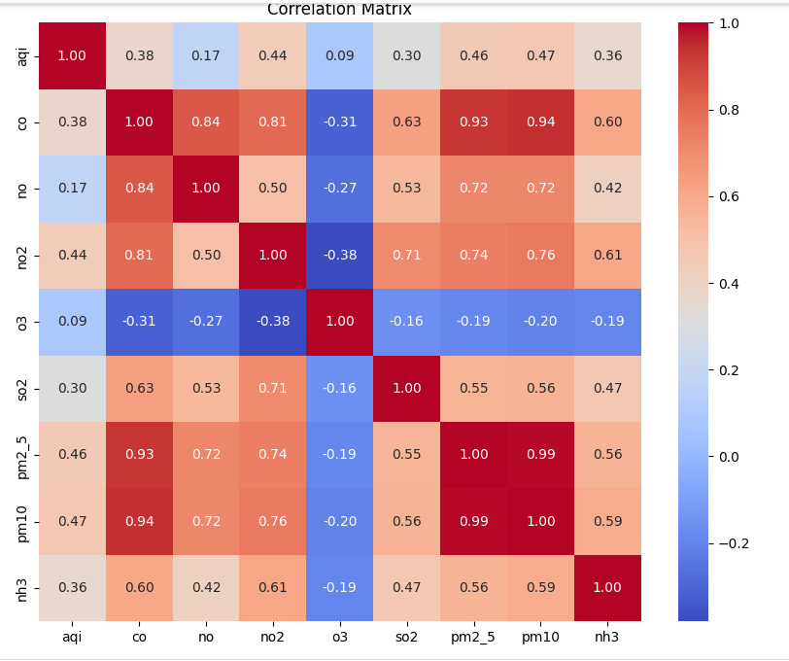

The results of SVM-based trend analysis of PM2.5 and PM10 concentrations can provide valuable insights into the relationships between various parameters and particulate matter levels. the actual AQI values graphically plotted against the predicted AQI values derived from the SVM model. The SVM model demonstrates a notable coefficient of determination (R^2) score of 0.93.

The predicted AQI values obtained from the Convolutional Neural Network (CNN) model are displayed alongside the corresponding actual AQI values. The actual AQI values juxtaposed with the predicted AQI values generated by the CNN model. Remarkably, the CNN model exhibits a high coefficient of determination (R^2) score of 0.94.

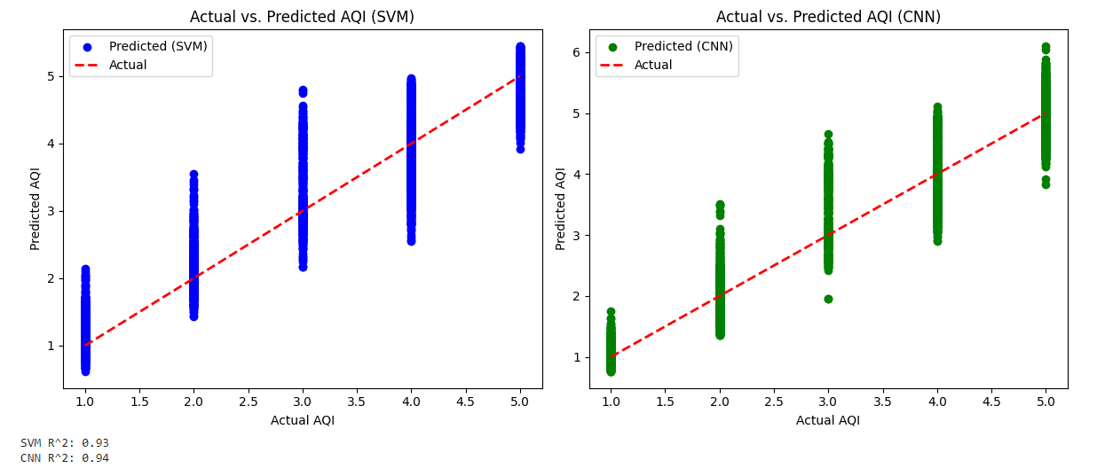

Fig2. GRAPH OF TREND USING SVM and CNN

CONCLUSION:

In conclusion, both the Support Vector Machine (SVM) model and the Convolutional Neural Network (CNN) model exhibit strong performance in predicting PM2.5 and PM10 concentrations and forecasting Air Quality Index (AQI) values. The trend analysis based on the SVM provides valuable insights into the complex relationships between various parameters and particulate matter levels, enhancing our understanding of air quality dynamics.

When comparing the actual AQI values to the predicted results from both models, the graphical representation demonstrates their effectiveness in capturing the underlying trends and patterns. The SVM model achieves a commendable coefficient of determination (R^2) score of 0.93, indicating solid predictive accuracy. In comparison, the CNN model outperforms the SVM, yielding an even higher R^2 score of 0.94, highlighting its superior predictive power.

However, it is important to acknowledge that the dataset used in this analysis may not fully reflect the variability found in real-world scenarios, which could limit the broader applicability of the results. Future research could focus on overcoming these limitations by integrating advanced deep learning techniques for automatic feature extraction and classification. By harnessing the potential of artificial neural networks (ANNs), it may be possible to uncover more informative and distinguishing features.

Ultimately, these findings emphasize the value of machine learning models, especially SVM and CNN, in predicting AQI values and understanding the complex interactions that affect air quality. Such models have the potential to significantly contribute to shaping policies, urban planning approaches, and public health strategies aimed at reducing the harmful effects of air pollution on both human health and the environment.

REFERENCES :

1. Barzeghar V, Sarbakhsh P, Hassanvand MS, Faridi S, Gholampour A. Long-term trend of ambient air PM10, PM2. 5, and O3 and their health effects in Tabriz city, Iran, during 2006–2017. Sustainable Cities and Society. 2020 Mar 1;54:101988.

2. Ganguly R, Sharma D, Kumar P. Trend analysis of observational PM10 concentrations in Shimla city, India. Sustainable Cities and Society. 2019 Nov 1;51:101719.

3. Bigi A, Ghermandi G. Trends and variability of atmospheric PM 2.5 and PM 10–2.5 concentration in the Po Valley, Italy. Atmospheric Chemistry and Physics. 2016 Dec 21;16(24):15777-88.

4. Zhao J, Wang X, Song H, Du Y, Cui W, Zhou Y. Spatiotemporal trend analysis of PM2. 5 concentration in China, 1999–2016. Atmosphere. 2019 Aug 12;10(8):461.

5. Barmpadimos I, Keller J, Oderbolz D, Hueglin C, Prévôt AS. One decade of parallel fine (PM 2.5) and coarse (PM 10–PM 2.5) particulate matter measurements in Europe: trends and variability. Atmospheric Chemistry and Physics. 2012 Apr 3;12(7):3189-203.

6. Kassomenos PA, Vardoulakis S, Chaloulakou A, Paschalidou AK, Grivas G, Borge R, Lumbreras J. Study of PM10 and PM2. 5 levels in three European cities: Analysis of intra and inter urban variations. Atmospheric Environment. 2014 Apr 1;87:153-63.

7. Gupta A, Moniruzzaman M, Hande A, Rousta I, Olafsson H, Mondal KK. Estimation of particulate matter (PM 2.5, PM 10) concentration and its variation over urban sites in Bangladesh. SN Applied Sciences. 2020 Dec;2:1-5.

8. Gupta L, Dev R, Zaidi K, Sunder Raman R, Habib G, Ghosh B. Assessment of PM 10 and PM 2.5 over Ghaziabad, an industrial city in the Indo-Gangetic Plain: spatio-temporal variability and associated health effects. Environmental Monitoring and Assessment. 2021 Nov;193:1-21.

9. Bai K, Ma M, Chang NB, Gao W. Spatiotemporal trend analysis for fine particulate matter concentrations in China using high-resolution satellite-derived and ground-measured PM2. 5 data. Journal of environmental management. 2019 Mar 1;233:530-42.

10. Zoran MA, Savastru RS, Savastru DM, Tautan MN. Assessing the relationship between surface levels of PM2. 5 and PM10 particulate matter impact on COVID-19 in Milan, Italy. Science of the total environment. 2020 Oct 10;738:139825.

11. Amil N, Latif MT, Khan MF, Mohamad M. Seasonal variability of PM 2.5 composition and sources in the Klang Valley urban-industrial environment. Atmospheric Chemistry and Physics. 2016 Apr 29;16(8):5357-81.

12. Nagar PK, Sharma M, Das D. A new method for trend analyses in PM10 and impact of crop residue burning in Delhi, Kanpur and Jaipur, India. Urban Climate. 2019 Mar 1;27:193-203.