**Design and development of a peristaltic pump for constant flow applications**

|  |
| --- |
| *Ms. Kolhe Bhagyashree Bharat*  *Lecturer ,*  *Mechanical Engg. Dept.*  *JPK Kuran, Narayangaon* [bhagyashreek191095@gmail.com](mailto:bhagyashreek191095@gmail.com) |

# Abstract - The design and development of a peristaltic pump for constant flow applications aim to provide an efficient and reliable solution for precise fluid handling in industries where accurate flow control is critical. Peristaltic pumps, utilizing a positive displacement mechanism, offer advantages such as self-priming capabilities, minimal contamination risk, and the ability to handle a wide range of fluids, including viscous, abrasive, or shear-sensitive substances. This study focuses on the design parameters influencing pump performance, including tube size, roller diameter, motor selection, and system pressure, to ensure a consistent and stable flow rate over time. The primary objective is to develop a peristaltic pump that delivers a constant flow rate with minimal pulsation, ensuring high accuracy and reliability for various applications in fields such as pharmaceutical, chemical, and food processing industries. The paper outlines the theoretical calculations for flow rate, motor torque, and power requirements, as well as practical considerations related to material selection, durability, and ease of maintenance. By addressing common challenges such as tube wear and pulsation, the study demonstrates how innovative design approaches can optimize peristaltic pump performance for constant flow applications, providing a cost-effective, low-maintenance, and versatile pumping solution.

**I. Introduction**

1. A peristaltic pump is a type of positive displacement pump that moves fluid through a flexible tube using mechanical action. The principle behind its operation mimics peristalsis, a process seen in biological systems, such as the contraction and relaxation of muscles to move food along the digestive tract.
2. In a peristaltic pump, the liquid is transported by the compression of a flexible tube, typically silicone, by rotating rollers or shoes. These rollers or shoes press down on the tube, creating a "pocket" of fluid that is pushed forward as the tube is compressed. Once the rollers move past a section of the tube, the tube returns to its original shape, and the fluid is drawn into the now-empty pocket, continuing the pumping action.
3. **LITRATURE REVIEW:** A literature review on Design and development of a peristaltic pump as given below:

(Jaffrin and Shapiro, 1971; Turton, 1994)[1] The peristaltic pump applies the principle of peristalsis.

(Weinbergetal., 1971; El-Din andRabi,2009)[2] where by the prevalence of the treated fluid is imposed by a restriction running along the pipe.

(Latham, 1966; Shapiro et al., 1969; Karassik et al., 2008)[3] the pump consists of a rotor to which two or more rollers are attached, which rotate to throttle the pipe against the case isolating a volume of fluid and transferring it from the suction to the discharge.

(Saunier et al., 2022)[4] Depending on the type of fluid, the element that chokes the pipe changes. For fluids with solid elements in suspension, skids are used while for fluids without solid particles, rollers are utilized

## 3. History

The **history of peristaltic pumps** dates back to the early 20th century and is deeply rooted in the development of **positive displacement pumps**, which are characterized by their ability to move a fixed volume of fluid with each cycle. Here's a brief overview of the evolution of peristaltic pumps:

### Invention and Development:

* **1930s - 1940s**: The **first peristaltic pump** was introduced in the 1930s, though its initial applications were quite limited. These pumps utilized a simple mechanism where rollers or shoes compressed a tube, pushing fluid through the system in a rhythmic, continuous motion.
* **1940s - 1950s**: The development of peristaltic pumps progressed, especially in sectors requiring precise fluid delivery, such as in the pharmaceutical and chemical industries. This was also a time when other types of positive displacement pumps were gaining popularity due to their reliability and efficiency.
* **1950s - 1960s**: Advances in engineering, materials science, and manufacturing allowed for better materials for tubing (such as rubber, silicone, and later more advanced polymers) and more durable rollers or shoes. As these improvements were made, peristaltic pumps became more widely used in applications where contamination needed to be minimized (such as food and pharmaceutical industries).

### Technological Advancements:

* **1970s - 1980s**: With the rise of computer technology and more advanced motor control systems, peristaltic pumps were refined for even greater precision and control. Electronic flow rate controllers, stepper motors, and digital systems allowed for more precise adjustments in flow rates, making peristaltic pumps even more versatile for industries such as biotechnology and medicine, where accuracy was critical.
* **1990s - Present**: The continued development of peristaltic pumps saw their integration into more automated and high-tech systems. Advances in materials, such as thermoplastics, and new designs (e.g., multi-roller or multi-channel pumps) further enhanced the pumps' ability to handle a wider range of fluids (including more abrasive or corrosive substances). Innovations in noise reduction and pulsation minimization have made modern peristaltic pumps quieter and more reliable.
* 1930s: Early models of peristaltic pumps developed, drawing inspiration from the human digestive system.
* 1940s - 1950s: Pumps were refined and made more practical for industrial applications.
* 1970s - 1980s: Integration of electronic controls, stepper motors, and digital systems for greater precision and control.
* 1990s - Present: Improved materials and multi-roller designs enhanced their efficiency and longevity, making them even more widely used across industries.

Types of Peristaltic Pumps:

1. Single-Roller Peristaltic Pumps
2. Multi-Roller Peristaltic Pumps
3. Shoe-Design Peristaltic Pumps
4. Tube-Only (Straight Tubing) Peristaltic Pumps
5. Gear-Driven Peristaltic Pumps
6. Variable-Speed Peristaltic Pumps
7. Hose-Peristaltic Pumps
8. Miniature Peristaltic Pumps
9. High-Pressure Peristaltic Pumps.
10. **Working and construction**:

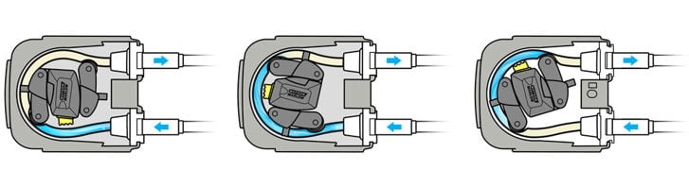

The working principle of a **peristaltic pump** is based on the action of peristalsis, which is the wave-like contraction and relaxation of muscles that moves substances through tubes in biological systems. In a peristaltic pump, a flexible tube is compressed and released by rotating rollers or shoes, creating a "pumping" effect that moves the fluid through the tube. This mechanism is quite simple yet effective for moving fluids with precise control.

### 1. Tube Setup

* The pump consists of a flexible tube, typically made from materials like silicone, PVC, or polyurethane, that carries the fluid. The tube is placed inside a pump head.
* The pump head holds the tube in place and is designed so that the tube is easily compressed and relaxed during the pumping cycle.

### 2. Rollers or Shoes

* The tube is compressed by **rotating rollers** or **shoes**. These are placed on the exterior of the tube and rotate around the tube, squeezing it as they pass over it. The number of rollers can vary—most commonly, there are 3 or more rollers, but some pumps use a single roller or a series of shoes.
* These rollers or shoes are typically mounted on a rotor, which is driven by a motor.

### 3. Compression Action

* As the **rollers or shoes rotate**, they compress the tube. This compression **forces the fluid inside the tube to move forward** through the tube, creating a pocket of fluid that gets pushed along with each rotation.
* The fluid is temporarily trapped in the section of the tube under the roller, and as the roller moves along, the fluid is pushed to the next section of the tube.

### 4. Release of Pressure

* After the roller has passed over a section of the tube, the tube **returns to its original shape** due to its inherent elasticity. This **relieves the pressure** on the fluid, creating a vacuum that draws more fluid into the tube.
* This constant cycle of compression and release creates a continuous flow of fluid through the tube, driven by the rotating rollers.

### 5. Continuous Fluid Movement

* As the rollers continue to rotate, each segment of the tube is alternately compressed and relaxed, moving the fluid in a steady, rhythmic manner. The number of rollers and their arrangement determine how smoothly and evenly the fluid is transported.
* The flow rate is determined by the speed of the roller rotation and the size of the tube. A higher speed or a larger tube will result in a higher flow rate.

### 6. Pulsation in the Flow

* **Flow pulsation** can occur because of the nature of the compression cycle. However, the pulsations can be minimized by using multiple rollers (usually 3 or more) that compress the tube at different points. This creates a smoother and more continuous flow of fluid.
* Some advanced designs use special damping mechanisms to further reduce pulsations.

### 7. Self-Priming Ability

* A key feature of peristaltic pumps is their ability to be **self-priming**, meaning they can start pumping fluid without needing to be manually primed. When the pump is activated, the compression and relaxation cycle immediately pulls fluid into the tubing, even if there is air or gas inside the pump initially.

### 8. End of the Cycle

* After the fluid has been pushed through the tube, it exits the pump and is delivered to the desired location or system.
* The cycle then continues with the next roller pass, maintaining a continuous flow until the pump is turned off or the motor speed is adjusted.

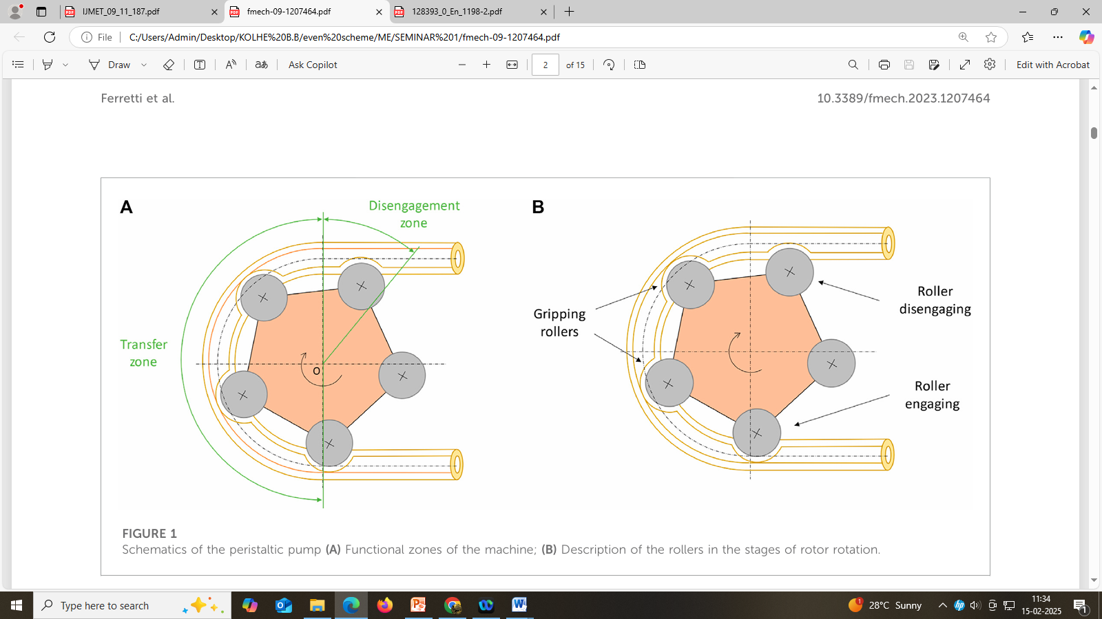

Fig. Schematics of the peristaltic pump (A) Functional zones of the machine; (B) Description of the rollers in the stages of rotor rotation.

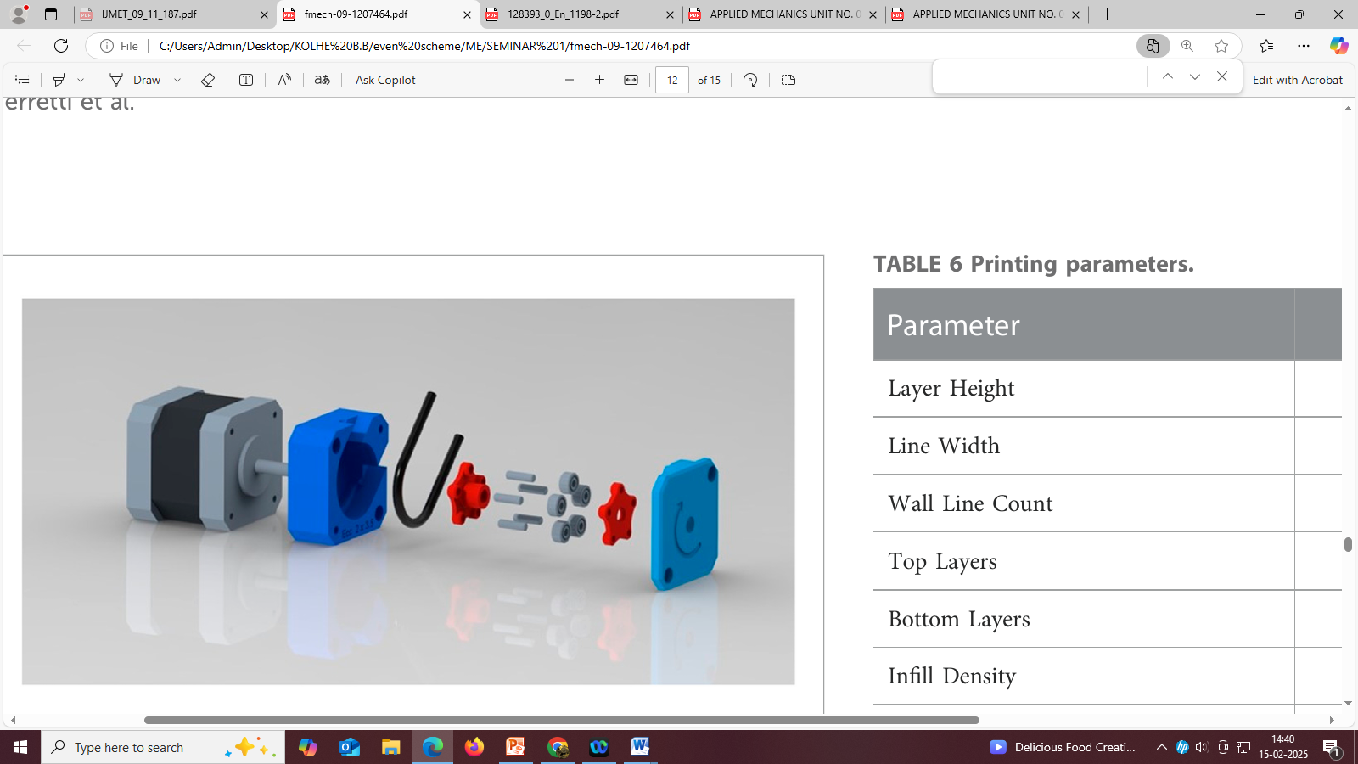

Fig. Exploded view representation of the pump.

**Actual model of peristaltic pump:**

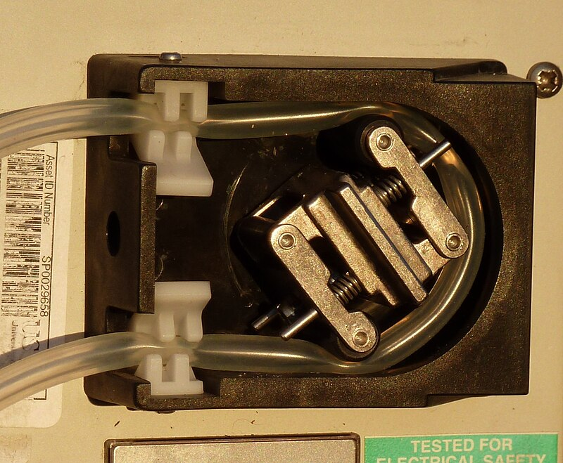

1. **Calculations:**

### 1. Flow Rate Calculation

The flow rate in a peristaltic pump depends on the **tube diameter**, **roller size**, and **roller speed**. In a peristaltic pump, the fluid is displaced by the rollers as they move around the tube, creating a pulse of fluid per revolution.

#### Flow Rate Equation:

The general formula for calculating the flow rate (Q) for a peristaltic pump is:

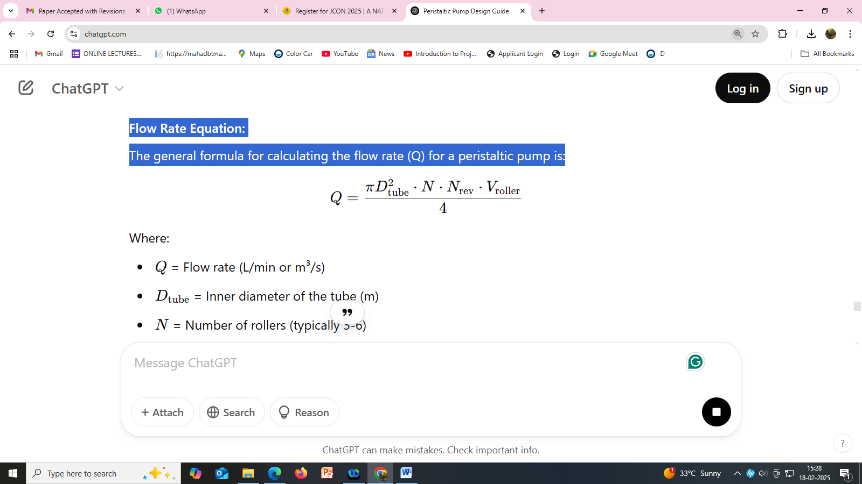

Where:

* Q = Flow rate (L/min or m³/s)
* Dtube​ = Inner diameter of the tube (m)
* N = Number of rollers (typically 3-6)
* Nrev​ = Rotational speed of the rotor (revolutions per minute, RPM)
* Vroller​ = Volume of fluid displaced per roller per revolution (m³)
* For a typical design, Vroller​ can be calculated as: 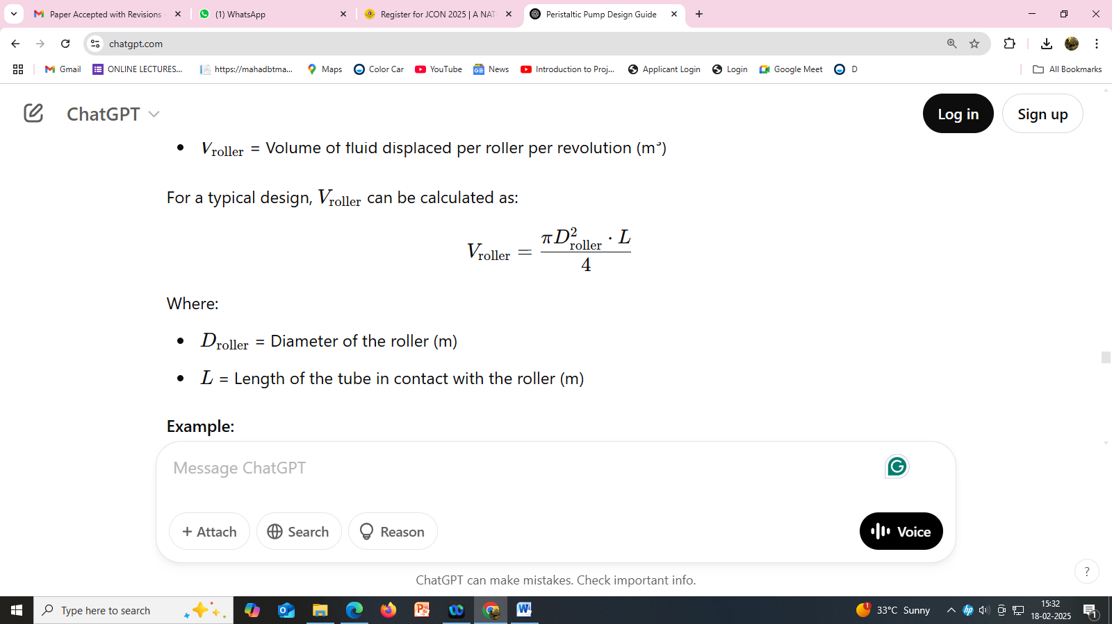

Where:

* Droller​ = Diameter of the roller (m)
* L = Length of the tube in contact with the roller (m)

### 2. Motor Torque Calculation

The motor torque is required to rotate the rollers and overcome the friction and resistance of the fluid in the tube. The torque is related to the force needed to compress the tube.

#### Torque Equation:

The torque (T) required to rotate the rollers can be calculated as:

T= F.r

Where:

* F = Force applied by the rollers to compress the tube (N)
* r = Radius of the roller (m)

The force applied by the rollers is the result of the pressure difference that the pump has to overcome and the friction between the rollers and the tubing.

• Pressure Calculation:

The pressure required to move the fluid depends on the fluid’s viscosity and the resistance to flow in the system. However, the frictional resistance of the tubing due to compression is usually the limiting factor in peristaltic pump performance.

• Force on Each Roller: If you assume the friction force per roller to be Froller you can calculate the total force and hence the torque.

### 3. Tube Length and Roller Spacing

In peristaltic pumps, the tube length in contact with the roller and the spacing between the rollers are crucial for determining the efficiency of fluid transport.

#### Roller Spacing:

The spacing between the rollers should ensure that they compress the tube effectively without excessive overlap. This is typically calculated based on the number of rollers and the tube's geometry.

For a pump with 3 rollers, the spacing between rollers can be determined by the following relationship:

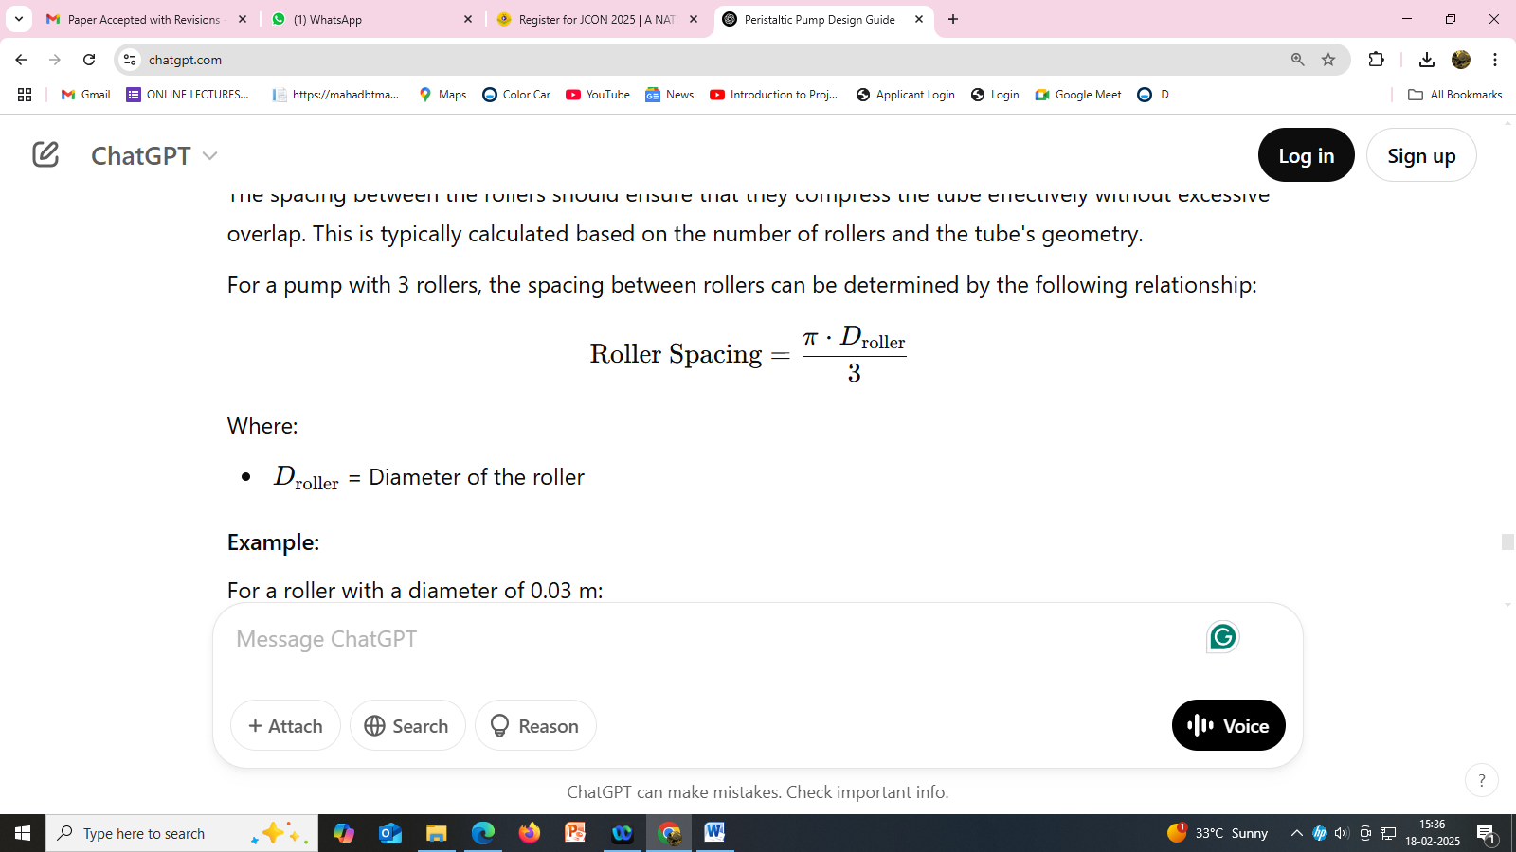

Where:

* Droller​ = Diameter of the roller

### 4. Tubing Pressure Drop

The pressure drop across the tubing depends on the **flow rate**, **tube length**, and **fluid properties** (e.g., viscosity). For peristaltic pumps, the primary cause of pressure drop is the **frictional losses** as the fluid moves through the tube. The pressure drop (ΔP) can be estimated using the Darcy-Weisbach equation for flow through pipes:

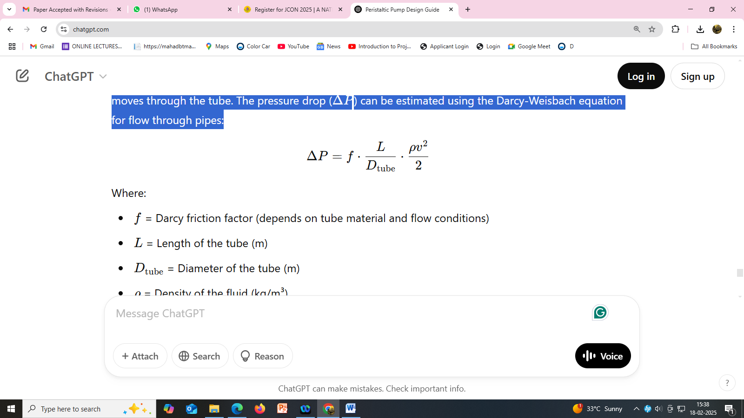

Where:

* f = Darcy friction factor (depends on tube material and flow conditions)
* L = Length of the tube (m)
* Dtube​ = Diameter of the tube (m)
* ρ = Density of the fluid (kg/m³)
* v = Velocity of the fluid (m/s)

### 5. Pump Efficiency and Power Calculation

The efficiency (η) of a peristaltic pump is influenced by the friction losses between the rollers, the tube, and the fluid. The required power P to drive the pump is given by:

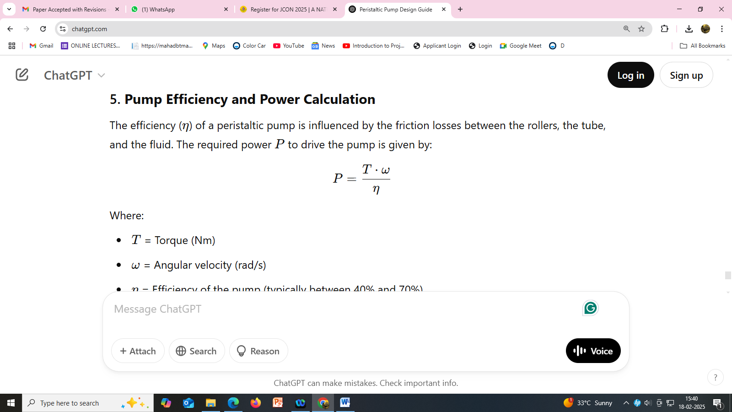

Where:

* T = Torque (Nm)
* ω = Angular velocity (rad/s)
* η = Efficiency of the pump (typically between 40% and 70%)

To convert the rotational speed from RPM to angular velocity (ω):

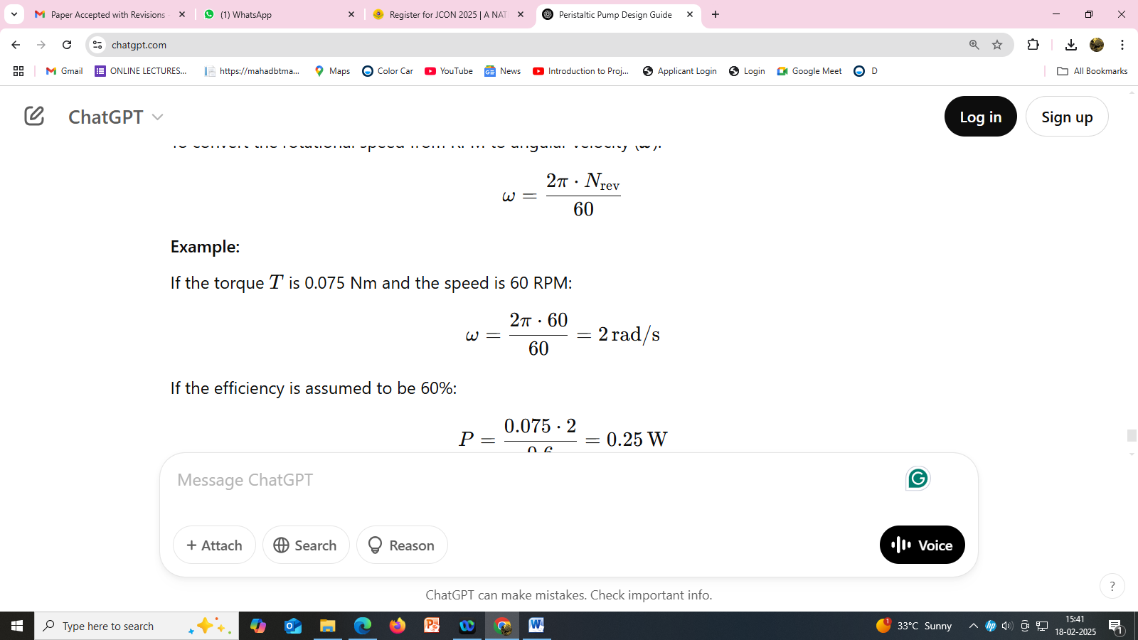

**6. Discussion:**

These design calculations form the foundation of a peristaltic pump's design. By determining the flow rate, required torque, pressure drop, and power consumption, you can tailor the pump to meet specific requirements. The exact values will depend on the specific application, the type of fluid being pumped, and the required system performance. These calculations help ensure the pump operates efficiently, with a consistent and reliable flow rollers.

## 7.Advantages

## 1. No Contamination of Fluid

## Closed System: The fluid only comes into contact with the inner surface of the tube, which means that there’s minimal risk of contamination from the pump's moving parts. This makes peristaltic pumps highly suitable for applications in industries such as pharmaceuticals, food and beverage, and biotechnology, where contamination must be avoided at all costs.

## 2. Self-Priming Capability

## No Need for Priming: Peristaltic pumps are self-priming, meaning they can start pumping fluid even if the tubing is initially empty or filled with air. This reduces the complexity of the system and ensures reliable operation, particularly in applications where the pump might not be used continuously.

## 3. Accurate and Precise Flow Control

## Positive Displacement: Peristaltic pumps are positive displacement pumps, meaning they move a fixed volume of fluid with each revolution, providing highly accurate and repeatable flow. This precision is important in dosing, chemical injection, and other applications that require controlled fluid delivery.

## 4. Gentle Handling of Fluids

## Low Shear Stress: The peristaltic pumping action is gentle and does not subject the fluid to shear stress or turbulent flow. This makes it ideal for handling shear-sensitive fluids, such as blood, cell cultures, or certain chemicals, without damaging their structure or properties.

## 5. No Valves or Seals

## Reduced Risk of Clogging: Peristaltic pumps do not use valves, which eliminates the risk of clogs or blockages that can occur in pumps with valves. This also reduces the wear and tear typically associated with seals and valves, leading to lower maintenance and longer operational life.

## 6. Ability to Handle Viscous Fluids

## Handles Viscous Fluids Well: Peristaltic pumps are capable of pumping thick, viscous fluids with ease. Fluids such as slurries, creams, or viscous chemicals that might be challenging for other types of pumps can be effectively handled by peristaltic pumps.

## 8. Disadvantages

* **1. Limited Flow Rate**
* **Lower Flow Capacity**: Peristaltic pumps are generally suited for low to medium flow rates. For high-flow applications, they may not be as efficient or cost-effective as other types of pumps, such as centrifugal or diaphragm pumps. Larger volumes of fluid are more challenging to move without increasing the size or speed of the pump.
* **Efficiency Decline at High Flow Rates**: At higher flow rates, peristaltic pumps can become less efficient, and they may experience significant wear on the tubing.
* **2. Pulsation in the Flow**
* **Flow Pulsation**: One of the main drawbacks of peristaltic pumps is the inherent pulsation caused by the roller compression cycle. Each time a roller passes over the tube, it creates a "pulse" of fluid. This can result in fluctuating pressure and inconsistent flow, which can be problematic in applications where smooth, continuous fluid movement is required (e.g., in precise dosing or where uniformity is critical).
* **Minimizing Pulsation**: While multi-roller designs can help reduce pulsation, it is often difficult to eliminate completely, which can still cause issues in some sensitive applications.
* **3. Tube Wear and Maintenance**
* **Frequent Tube Replacement**: The tube is the only part that directly contacts the fluid and the rollers, meaning it undergoes significant wear due to constant compression. Over time, this can lead to **tube degradation**, particularly if the fluid is abrasive, contains particulates, or is chemically aggressive.
* **Maintenance Costs**: The need for frequent tube replacement can be a disadvantage, as it incurs ongoing maintenance costs and downtime. Depending on the type of fluid being pumped, tubing may need to be replaced more frequently, especially if it’s exposed to high pressures or aggressive chemicals.
* **4. Size and Cost of Larger Pumps**
* **Scaling Up for High-Flow Applications**: For applications requiring higher flow rates, peristaltic pumps need to be scaled up, which may require the use of larger rollers and longer tubing. This can lead to higher costs for both the equipment and the maintenance, as larger tubing may be more expensive and harder to handle.
* **Physical Space**: Larger pumps for high-flow systems can take up more space than other types of pumps, which may not be ideal in compact environments or systems with space limitations.
* **5. Limited Pressure Handling Capacity**
* **Pressure Limitations**: Peristaltic pumps are not ideal for applications requiring high pressure. While they can handle moderate pressure levels, their performance tends to degrade as the pressure increases, especially if the pump is designed to handle high-viscosity or abrasive fluids. High-pressure applications may require alternative pump types, such as diaphragm or piston pumps, which can handle higher pressures more efficiently.

## 9.Application:

* Medicine
  + [Dialysis](https://en.wikipedia.org/wiki/Kidney_dialysis) machines
  + [Open-heart bypass](https://en.wikipedia.org/wiki/Cardiopulmonary_bypass) pump machines
  + [Medical infusion pumps](https://en.wikipedia.org/wiki/Infusion_pump)
* Testing and research
  + [AutoAnalyzer](https://en.wikipedia.org/wiki/AutoAnalyzer)
  + [Analytical chemistry](https://en.wikipedia.org/wiki/Analytical_chemistry) experiments
  + [Carbon monoxide](https://en.wikipedia.org/wiki/Carbon_monoxide) monitors
  + [Media dispensers](https://en.wikipedia.org/wiki/Media_dispenser)
* Agriculture
  + 'Sapsucker' pumps to extract maple tree sap
  + Dosers for hydroponic systems
* Food manufacturing and sales
  + Liquid food fountains (ex. cheese sauce for [nachos](https://en.wikipedia.org/wiki/Nachos))
  + Beverage dispensing
  + Food-service Washing Machine fluid pump
* Chemical handling
  + Printing, paint and pigments
  + Pharmaceutical production
  + Dosing systems for dishwasher and laundry chemicals
* Engineering and manufacturing
  + [Concrete pump](https://en.wikipedia.org/wiki/Concrete_pump)
  + Pulp and paper plants
  + Minimum quantity lubrication
  + Inkjet printers
* Water and Waste
  + Chemical treatment in [water purification](https://en.wikipedia.org/wiki/Water_purification) plant
  + [Sewage](https://en.wikipedia.org/wiki/Sewage) sludge
  + [Aquariums](https://en.wikipedia.org/wiki/Aquariums), particularly [calcium reactors](https://en.wikipedia.org/wiki/Calcium_reactor)
  + Automatic wastewater sampling for [wastewater quality indicators](https://en.wikipedia.org/wiki/Wastewater_quality_indicators)

1. **10. References:**

Jaffrin, M. Y., and Shapiro, A. H. (1971). Peristaltic pumping. Annu. Rev. Fluid Mech. 3, 13–37. doi:10.1146/annurev.fl.03.010171.000305

Weinberg, S. L., Eckstein, E.C., andShapiro,A.H. (1971).Anexperimental study of peristaltic pumping. J. Fluid Mech. 49, 461–479. doi:10.1017/ S0022112071002209

Latham, T. W. (1966). Fluid motions in a peristaltic pump. Available at: https:// dspace.mit.edu/handle/1721.1/17282 (accessed March 20, 2023).

Saunier, J., Khzam, A., and Yagoubi, N. (2022). Impact of mechanical stress on flexible tubing used for biomedical applications: Characterization of the damages and impact on the patient’s health. J. Mech. Behav. Biomed. Mater. 136, 105477. doi:10.1016/J.JMBBM. 2022.105477