**EXPERIMENTAL INVESTIGATION ON PERFORMANCE OF SUPERSONIC AIR INTAKE SYSTEMS THROUGH RAMP ANGLE OPTIMIZATION**Nayeem Shaik*1, Sreenivasa Rao M*2, Devi Sri Pavan l*3, Jagadeesh N*4, Uday Aswa Teja k*5, Nani U*6

Department Of Mechanical Engineering Godavari Institute Of Engineering & Technology, Rajahmundry, Andhra Pradesh, India. **ABSTRACT**

Supersonic inlet diffusers are crucial for the performance of air-breathing engines, particularly in ramjet engines, which are valued for their simplicity and high-speed capabilities, especially in aircraft and missile propulsion. The efficiency of a ramjet engine largely depends on the performance of the supersonic inlet diffuser. This component is responsible for slowing and compressing incoming supersonic air (Mach 3 to 5) to subsonic speeds (Mach 0.3 to 0.4) for combustion, significantly impacting overall engine performance. Enhancing the performance of a supersonic inlet diffuser can be achieved by optimizing the geometry of the ramp. This study aims to determine the optimal ramp angles for a supersonic inlet diffuser. Through numerical analysis, we examine pressure recovery and outlet Mach numbers across various first ramp angles. (θ1) 6 degrees and second ramp angles (θ2) 10 degrees. The goal is to identify the angle combinations that yield the best performance in terms of pressure recovery and outlet Mach numbers.

**Keywords:** Ramjet engine, ramp angles, Mach number, pressure recovery.

**1.INTRODUCTION**

**1.1 Supersonic intake system**



**Fig.1.1: Supersonic intake system**

A supersonic intake system is a crucial component of high-speed propulsion systems, primarily used in ramjet, scramjet, and supersonic jet engines. These intake systems are designed to efficiently slow down and compress incoming supersonic airflow before it enters the combustion chamber, ensuring optimal pressure recovery and stable operation. Unlike subsonic intakes, which rely on simple ducting, supersonic intakes incorporate shock wave management mechanisms such as ramps, cones, and variable-geometry diffusers to regulate airflow compression effectively. 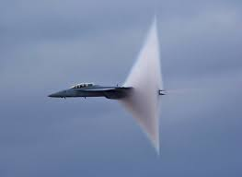

**Fig.1.2: Shock wave**

The performance of a supersonic intake system depends on various factors, including the design of its compression surfaces, the interaction of shock waves, and the prevention of flow separation. The primary goal is to minimize total pressure losses while maintaining a steady and uniform airflow into the engine. One of the key design parameters influencing intake performance is the ramp angle configuration, which governs the formation and behavior of oblique and normal shock waves inside the diffuser.

This research aims to analyze the impact of varying ramp angles in intake systems to enhance their aerodynamic efficiency. By investigating different ramp configurations, this study seeks to establish an optimal design that maximizes performance in high-speed air-breathing propulsion systems.

1.1.1 Oblique Shock Waves

* Generated by a ramp or wedge in the intake.
* Cause a gradual decrease in velocity and an increase in pressure and temperature.
* Found in external and mixed compression intakes.
* Multiple oblique shocks improve efficiency and reduce pressure losses.

1.1.2 Normal Shock Waves

* Occur when the airflow is abruptly slowed down to subsonic speeds.
* Lead to significant pressure losses but are essential for stabilizing the airflow before entering the engine.
* Typically found in internal compression intakes.

1.1.3 Bow Shock Waves

* Form in front of blunt bodies or high-speed aircraft nose sections.
* Deflects airflow around the intake, causing additional drag but helping manage incoming supersonic air.

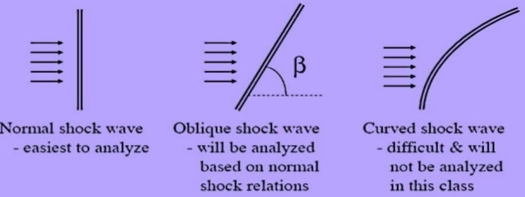

**Fig.1.3: Types of shock waves**

In a mixed compression intake, a combination of oblique and normal shockwaves is used to maximize pressure recovery while reducing total energy losses. Properly designing the ramp angles and shock interactions can lead to improved engine performance, reduced drag, and better efficiency in high-speed applications.

**1.2 Role of Wind Tunnel in Supersonic Intake Research**

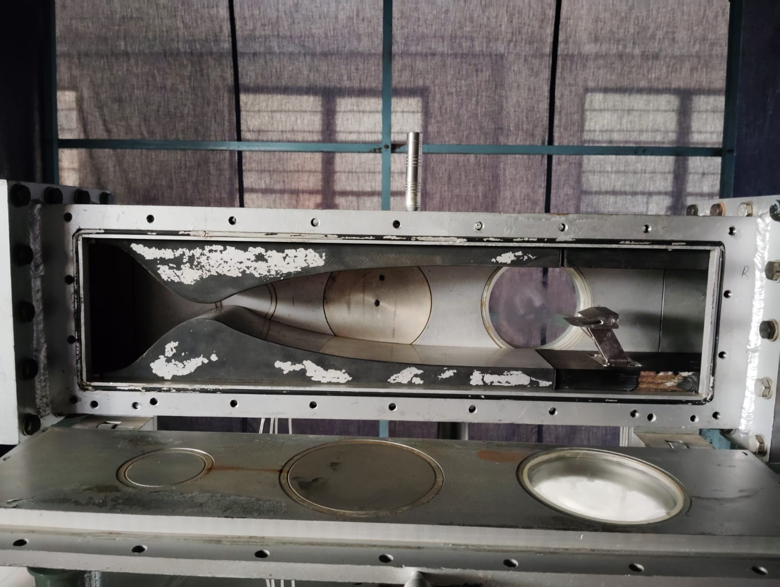

**Fig.1.4: Wind tunnel**

A wind tunnel is a vital tool for studying the behavior of supersonic intake systems. It provides a controlled environment where airflow conditions can be simulated to match the high-speed conditions experienced by aircraft and missiles. In supersonic wind tunnels, airflow is accelerated beyond the speed of sound using a convergent-divergent (C-D) nozzle, allowing researchers to study shockwave interactions, pressure variations, and aerodynamic efficiency.

The use of wind tunnels enables precise measurement of shockwave structures, pressure recovery, and flow separation. Schlieren imaging and high-speed pressure sensors allow visualization of shockwave formations, ensuring that the intake system is designed for maximum efficiency and minimal energy losses. The experimental validation of intake performance through wind tunnel testing helps optimize ramp angles, diffuser geometries, and boundary layer control techniques for real-world applications

**1.3 Research Objectives**

* To optimize ramp angles in a supersonic air intake system.
* To evaluate shockwave formation and pressure recovery through experimental testing.
* To validate the effectiveness of optimized ramp angles through performance analysis.

**2. Literature Review**

1. This paper discusses various supersonic inlet designs, emphasizing conventional methods such as external, internal, and mixed compression inlets. It references studies on optimizing inlet performance through techniques like shock-on-lip focusing, isentropic compression, and relaxed isentropic compression. Prior research explored the effects of compression surface geometry, cowl lip angle, and shock wave interactions on total pressure recovery and inlet drag. The paper builds on these foundations by introducing a relaxed isentropic compression design to improve efficiency and reduce sonic boom overpressure​.
2. By this research on air-breathing ramjets and detonation-based propulsion systems. It highlights studies from the 1950s on subsonic deflagration combustion and recent advancements in continuous detonation combustion. Prior experiments in wind tunnels at Mach 4–8 demonstrated the feasibility of detonation ramjets, but with limitations due to low stagnation temperatures. The study builds on these works by testing a detonation ramjet at Mach 5.7 with a higher stagnation temperature (1500 K) to better simulate real flight conditions​.
3. Researchers such as Fleeman and Goldsmith have analysed the integration of ramjet inlets with airframes and intake performance optimization. Studies have also focused on pressure recovery losses in high Mach number flows and the role of wedge angles in minimizing losses. Computational tools and numerical simulations have been widely used for inlet design improvements, ensuring stable operation and reducing unstart conditions​.
4. This paper highlights previous research on supersonic missile inlet design, focusing on automated optimization techniques. It discusses gradient-based and non-gradient-based optimization methods, such as Genetic Algorithms and Simulated Annealing, and their applications in aerodynamic design. The paper references past studies on hypersonic inlets, wing designs, and supersonic transport optimizations, emphasizing the challenges of achieving high total pressure recovery. It builds on these works by proposing a multi-level design strategy that combines simple physical models with sophisticated CFD-based analysis to enhance performance​.
5. This paper discusses various studies on supersonic air intake design, particularly focusing on mixed compression intakes. It references experimental and numerical research on the effects of ramp angles, sidewall geometry, and diffuser length on intake performance. Previous studies have analysed shock wave interactions, flow oscillations, and the role of isolator lengths in maintaining stable airflow. Additionally, research on cowl deflection, its impact on intake start/unstart characteristics, and comparisons with other performance-enhancing techniques like bleeding and variable geometry are highlighted​.
6. This paper discusses various studies on ramjet engine performance, particularly focusing on inlet design and flow characteristics. Verma et al. (2019) analyzed the impact of inlet isolator geometry with concavities to enhance shockwave formation and mass flow rate. Kumar et al. (2018) highlighted the role of inlets in improving compression efficiency, suggesting that perforations in the nose cone can enhance airflow and compression ratio. Akbarzadeh and Karmani (2007) conducted simulations on angled ramp inlets, showing how multiple oblique shockwaves influence pressure recovery. Thangadurai et al. (2008) studied the effects of cold air flow and heat addition, revealing how air intake geometry and heat release impact performance. These studies collectively emphasize the importance of inlet optimization in improving ramjet engine efficiency​.
7. This document provides insights into various studies related to ramjet engine inlets and their performance optimization. It references works by Fleeman and Goldsmith, who explored inlet/airframe integration and intake design principles. Azevedo et al. studied total pressure recovery losses due to shock wave systems, while Safarik and Polak analysed optimal wedge angles for minimizing pressure loss. Computational tools, such as those used by Ahsun, were also highlighted for inlet stability and design optimization​.
8. These studies on two-shock mixed compression intakes, particularly at hypersonic Mach numbers. It references research on ramjet and scramjet intake designs, highlighting the limitations of two-shock systems for achieving sufficient compression. The study builds on Kantrowitz limit constraints and analytical models for intake performance prediction. Prior work on shockwave interactions, boundary layer effects, and computational fluid dynamics (CFD) validation of intake geometries is also examined​.

**3. Materials and Methodology**

3.1 Materials Used

The materials selected for the experimental setup play a crucial role in ensuring accuracy and reliability. The primary materials used include:

* Stainless Steel: Used for constructing the ramp models due to its high strength, heat resistance, and durability in high-speed flow conditions.
* Pressure Sensors: High-precision sensors to measure static and dynamic pressure variations across the intake system.
* Wind Tunnel: A supersonic wind tunnel is used to simulate high-speed flow conditions and evaluate ramp performance.
* Solid Edge: Used for designing and optimizing the ramp angles with precise geometrical configurations.
* TIG Welding: Employed for fabricating the ramp structures to ensure high-strength and durable joints.

**3.2 Design and Fabrication Process**

The experimental setup for optimizing supersonic intake ramp angles was developed through a structured design and fabrication process:

1. **Design Phase:**
   * **Solid Edge** software was used to design the ramp structures, ensuring precise geometry and optimal ramp angles for efficient shockwave formation and airflow compression.

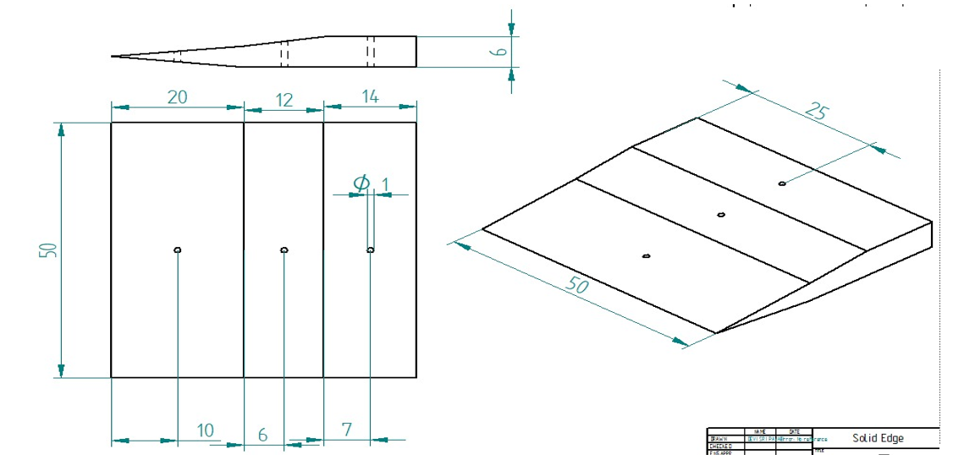

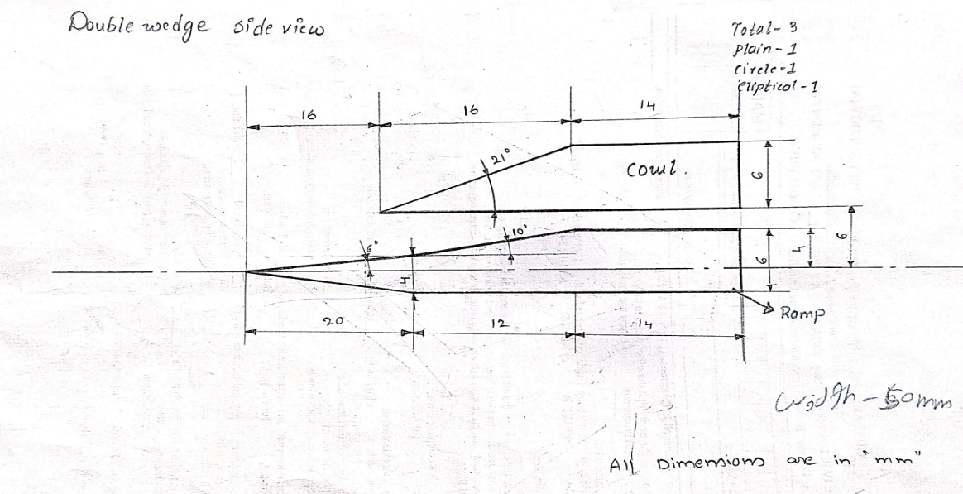

**Fig.3.1: ramp model**

* + Various ramp configurations were modeled to evaluate their aerodynamic performance in a supersonic flow environment.

1. **Fabrication Phase:**
   * The optimized ramp designs were fabricated using **stainless steel**, selected for its high strength, heat resistance, and durability.
   * **TIG (Tungsten Inert Gas) Welding** was employed to assemble the ramp structures, ensuring strong, defect-free joints that could withstand high-speed airflow conditions.
   * The fabricated ramp models were polished and inspected to minimize surface roughness and enhance aerodynamic efficiency.

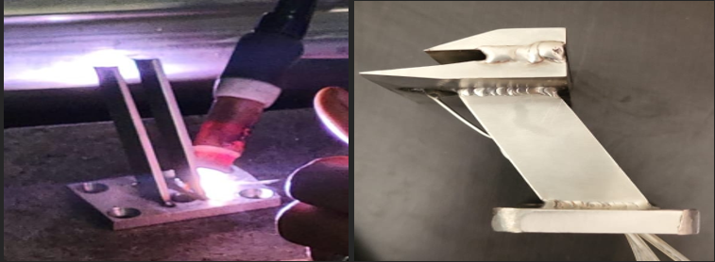

**Fig.3.2: TIG welding**

**3.3 Experimental Setup**

To validate the designed ramp configurations, a controlled testing environment was established

* A **supersonic wind tunnel** was utilized to replicate high-speed airflow conditions.
* **Pressure sensors** were strategically placed to measure static and dynamic pressure variations across the intake system.

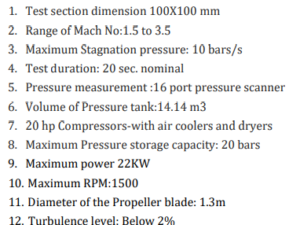

**Fig.3.3: Specifications of wind tunel**

* Tests were conducted for various **ramp angles (6 & 10°)** to determine the optimal configuration for maximizing pressure recovery and minimizing losses.

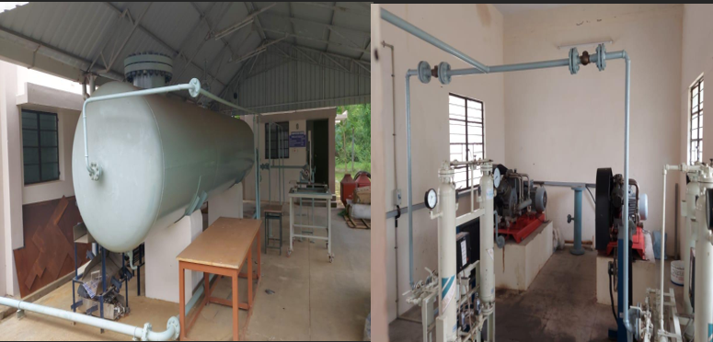

**Fig.3.4: Pressure storage tank and compressor**

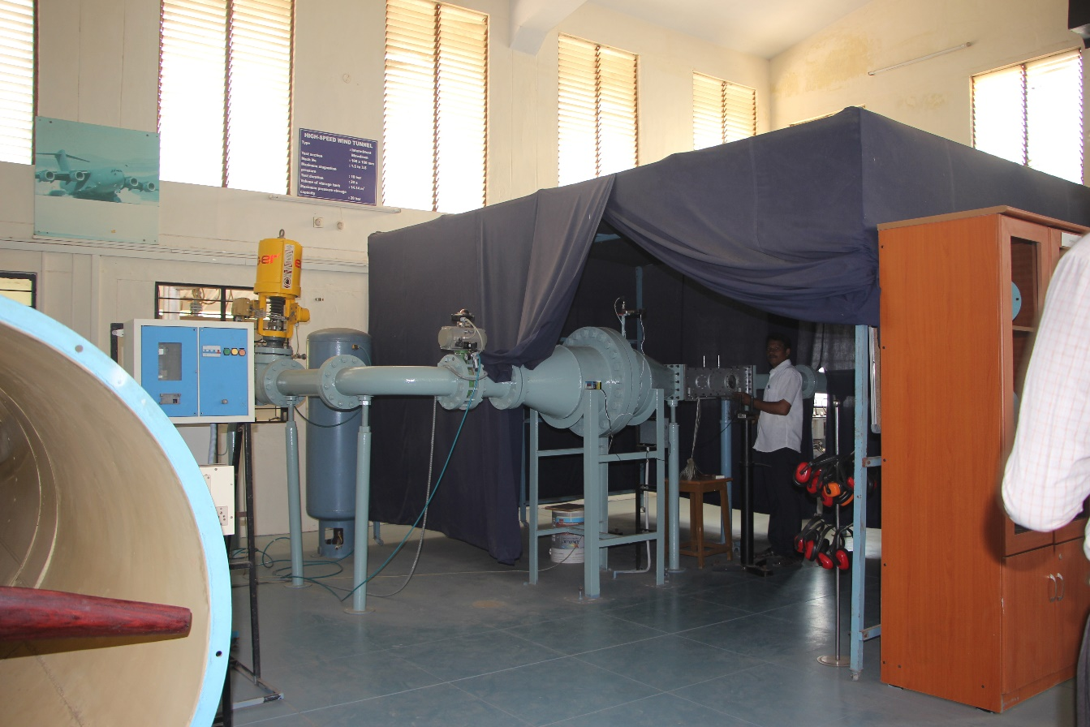

**Figure:3.5: Test section**



**Figure.3.6: Convergent Divergent nozzle**

**4. Results and Discussion**

**4.1: Settling chamber pressure and time values**

|  |  |  |
| --- | --- | --- |
| **SI.NO** | **Time** | **Settling chamber Pressure** |
| 1 | 0 | **5.3** |
| 2 | 2 | **6.2** |
| 3 | 5 | **6.3** |
| 4 | 8 | **7.0** |
| 5 | 11 | **9.2** |
| 6 | 14 | **5.5** |
| 7 | 17 | **4.0** |
| 8 | 20 | **8.6** |
| 9 | 22 | **8.2** |
| 10 | 24 | **6.8** |
| 11 | 26 | **4.8** |
| 12 | 29 | **5.7** |
| 13 | 32 | **6.3** |
| 14 | 36 | **6.7** |
| 15 | 39 | **6.9** |
| 16 | 44 | **6.6** |
| 17 | 47 | **6.2** |
| 18 | 51 | **5.7** |
| 19 | 54 | **5.2** |
| 20 | 57 | **3.7** |
| 21 | 59 | **0.4** |

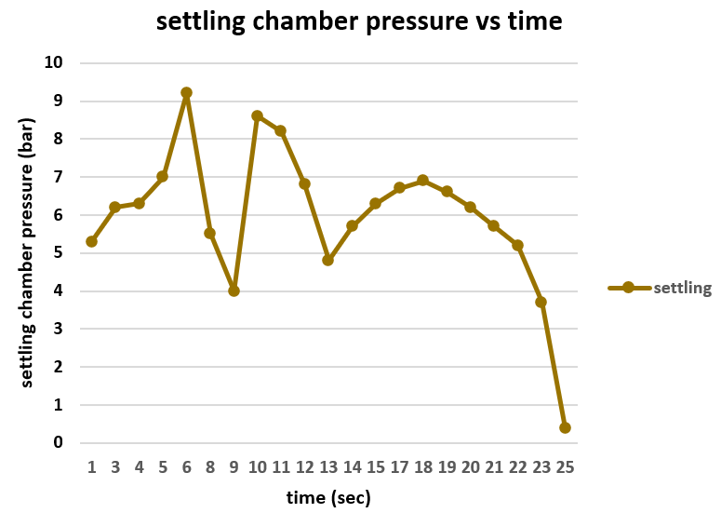

**Figure 4.1: Settling chamber pressure and Time graph**

**5.CONCLUSION**

The supersonic intake system was designed and subsequently tested in a supersonic wind tunnel. During the testing phase, the settling chamber pressure was monitored to analyze the effects of shock wave formation as the specimen encountered high-speed airflow at Mach 3.5. The recorded maximum settling chamber pressure reached 9.2 bar.

**6.Refferences**

1. A study by Paramasivam et al. (2020) explored the performance enhancement of scramjet intakes through a combination of ramp surface modifications and throat position adjustments. By altering the ramp surface angle and shifting the throat location, the study achieved reduced shockwave-boundary layer interactions, leading to improved total pressure recovery and mass capture. These modifications highlight the potential benefits of integrating ramp geometry changes with throat positioning to optimize intake performance <https://doi.org/10.2514/6.2020-3717>
2. Gounko et al. (2013) designed and experimentally modeled an innovative three-dimensional supersonic intake featuring a starting device. The intake utilized an external compression ramp in the form of a caret waverider, generating a plane oblique shock wave. Experimental results demonstrated the intake's efficiency and effective total pressure recovery, suggesting that such three-dimensional designs can offer significant performance benefits
3. <https://www.cambridge.org/core/journals/aeronautical-journal/article/abs/aerodynamic-design-and-experimental-modelling-of-an-innovative-supersonic-threedimensional-airintake/FFD14FF14B1599551A6CFE6356987674?utm_source=chatgpt.com>
4. Dr. Avinash Govindraju and Dr. Santosh Kumar; “Flow Analysis of Ramjet Engine for Optimized Nose Cone Design” Proceedings of the 2nd Indian International Conference on Industrial Engineering and Operations Management Warangal, Telangana, India, August 16-18, 2022.
5. Ronald S. Fry Johns Hopkins University; “A Century of Ramjet Propulsion Technology Evolution” JOURNAL OF PROPULSION AND POWER,Vol. 20, No. 1, January–February 2004
6. G. Raja Singh Thangadurai1, B.S. Subhash Chandran1, V. Babu2, and T. Sundararajan2; “Numerical Analysis of Integrated Liquid Ramjet Engine”. Defence Science Journal, Vol. 58, No. 3, May 2008, pp. 327-337 ,2008, DESIDOC
7. John W. Slater ,Christopher R. Gruber, Notre Dame; “Planar Inlet Design and Analysis Process (PINDAP)” .NASA/TM—2005-213866, August 2005.