**1**

**Chapter**

# INTRODUCTION



## INTRODUCTION

### Overview

The Automated Garbage Sorting System is an innovative solution aimed at addressing the growing challenge of waste management by leveraging advanced technologies for efficient and eco-friendly operations. This system utilizes a combination of sensors, motors, and computational tools to automatically identify, segregate, and manage waste into various categories such as biodegradable, non-biodegradable, and recyclable materials. At its core, the system is powered by a Raspberry Pi, serving as the central processing unit for collecting and analyzing sensor data, controlling mechanical components, and ensuring seamless operation.

**Key components of the system include:**

1. **IR Sensors**: These detect objects and classify waste based on size, material, or presence in specific zones.
2. **Proximity Sensors**: Used for precise detection of waste as it approaches the sorting mechanism, enhancing accuracy.
3. **Moisture Sensors**: Play a critical role in identifying wet or dry waste, enabling effective segregation of biodegradable materials.
4. **Servo Motors and Stepper Motors**: Facilitate the movement of sorting arms, bins, and conveyor belts, ensuring dynamic and efficient handling of waste.
5. **Buzzers**: Provide audible alerts for operational updates, warnings, or errors, improving user awareness and system monitoring.

The integration of these components enables the system to perform automated sorting tasks with high precision, minimal manual intervention, and significant time savings. The Raspberry Pi is programmed to process real-time data from the sensors, classify waste based on pre-set parameters, and control the actuators to place items in their designated bins.

This Automated Garbage Sorting System has the potential to revolutionize waste management by reducing human effort, minimizing errors in segregation, and promoting sustainable waste disposal practices. Its scalable design can be implemented in residential, industrial, and public settings, making it a versatile solution to modern waste management challenges.

### System Study

The Automated Garbage Sorting System is a modern approach to waste management, designed to streamline the segregation process through automation. Its primary purpose is to reduce human effort, enhance accuracy, and promote environmental sustainability by leveraging advanced technologies. The system integrates sensors like IR, proximity, and moisture sensors to identify and classify waste materials based on their properties. A Raspberry Pi serves as the central controller, processing data from the sensors and coordinating the operation of motors and other components to efficiently sort waste into biodegradable, recyclable, and non-recyclable categories.

The system's functionality is driven by a carefully designed workflow. Waste is fed into the system, where sensors analyze its characteristics in real time. The Raspberry Pi processes the data to determine the type of waste, triggering servo and stepper motors to direct the material to the appropriate bins. Buzzers provide audio feedback for operational updates or error notifications. This automated process ensures accurate segregation with minimal manual intervention, making it suitable for a wide range of applications, including residential complexes, public spaces, and industrial settings.

This solution offers several advantages, including increased efficiency, reduced labor costs, and improved waste segregation accuracy. By automating the sorting process, it minimizes human errors and encourages proper recycling and disposal practices. The system is scalable and adaptable, making it viable for diverse environments. However, challenges such as initial setup costs, regular maintenance, and dependency on proper calibration must be considered. Despite these limitations, the automated garbage sorting system represents a significant step toward achieving sustainable and eco-friendly waste management solutions.

### Existing System

Current waste management systems primarily rely on manual sorting processes, which are labor-intensive and prone to errors. Workers are required to segregate waste into categories such as biodegradable, recyclable, and non-recyclable, often leading to inefficiencies and improper disposal due to human oversight or lack of awareness. These systems are not only time-consuming but also expose workers to hazardous materials, posing serious health risks. Furthermore, manual sorting is limited in scalability and struggles to meet the growing demands of urbanization and industrialization.

In some urban settings, semi-automated systems have been introduced, where basic technologies like conveyor belts and manual pickers assist in sorting. While these systems reduce physical effort, they still heavily depend on human intervention for decision-making and classification. Limited use of sensors or mechanical components in these systems results in low accuracy and inconsistency in waste segregation. Additionally, the lack of real-time monitoring and feedback mechanisms further diminishes their effectiveness.

Overall, existing systems fall short in addressing modern waste management challenges. They lack the precision, speed, and scalability required to handle increasing volumes of waste efficiently. Moreover, the absence of advanced automation limits their ability to promote sustainable practices such as recycling and proper disposal. These limitations highlight the need for innovative solutions, such as automated garbage sorting systems, to overcome the drawbacks of traditional approaches and establish more effective and eco-friendly waste management strategies.

### Project Overview

The **Automated Garbage Sorting System** is an advanced waste management solution aimed at automating the segregation of waste into various categories such as biodegradable, recyclable, and non-recyclable. The system is built using a Raspberry Pi, which serves as the central control unit for processing sensor data and executing sorting commands. The integration of multiple sensors, including IR, proximity, and moisture sensors, allows the system to identify and classify waste based on its type and characteristics. This automation reduces the reliance on human effort and significantly enhances the efficiency and accuracy of the waste sorting process.

The system works by first detecting the waste using the sensors, which send real-time data to the Raspberry Pi. Based on this input, the system classifies the waste into appropriate categories and uses motors (servo and stepper) to control sorting mechanisms such as conveyor belts, arms, or flaps. The sorted waste is then directed to designated bins for further processing or disposal. A buzzer is also incorporated to notify users of the system's operational status or errors, ensuring seamless monitoring and maintenance.

This project aims to contribute to more sustainable and efficient waste management practices by automating the sorting process, reducing human error, and promoting recycling. It is designed to be scalable and adaptable, making it suitable for use in a variety of environments such as households, commercial spaces, and industrial settings. The use of affordable and widely available components like Raspberry Pi and sensors ensures that the system remains cost-effective and accessible, making it an ideal solution for modern waste management challenges.

### 

### Objective & Scope

The objective of the **Automated Garbage Sorting System** is to develop an efficient, automated solution for waste segregation using advanced sensors and motors controlled by a Raspberry Pi. The system aims to accurately classify waste into biodegradable, recyclable, and non-recyclable categories, reducing human effort, minimizing errors, and promoting sustainable waste management practices. By automating the process, the system enhances efficiency, reduces labor costs, and improves recycling rates in various settings.

* **Scope**

The scope of the **Automated Garbage Sorting System** includes integrating sensors (IR, proximity, moisture) and motors (servo, stepper) to classify and sort waste into designated categories. It is designed for scalable applications in residential, commercial, and industrial settings, with a focus on affordability and ease of use. The system aims to automate waste segregation, reduce human intervention, and promote recycling. Additionally, it features real-time feedback mechanisms and can be easily upgraded for future improvements.

* **Automation of Waste Segregation**: Uses sensors and motors to automatically classify waste into biodegradable, recyclable, and non-recyclable categories.
* **Scalability**: Suitable for implementation in various environments, including homes, industries, and public spaces.
* **Cost-Effective**: Built with affordable components like Raspberry Pi, ensuring low setup and maintenance costs.
* **Real-Time Monitoring**: Provides feedback via a buzzer for operational status and error alerts.
* **Future Expansion**: Designed for easy upgrades, such as adding new sorting categories or improving detection accuracy.
* **Sustainability**: Contributes to better recycling practices and reduces manual waste handling.

### Applying Software Engineering Approach

The **Automated Garbage Sorting System** applies a structured software engineering approach to ensure that the project is developed efficiently and meets the desired functional and non-functional requirements. The development process begins with **requirements analysis,** where the system’s objectives, scope, and constraints are clearly defined. This involves gathering input from stakeholders to ensure the system meets their needs, including waste segregation accuracy, scalability, and user-friendliness. The requirements are then documented in detail, specifying the sensor types, processing logic, user interfaces, and feedback mechanisms.

Following the requirements analysis, the **design phase** focuses on creating a detailed architectural plan for the system. This includes selecting appropriate hardware components such as the Raspberry Pi, sensors, motors, and actuators, and designing the software architecture to manage real-time data processing and control. The system design considers modularity, scalability, and error handling, ensuring that components can be easily upgraded or replaced if needed. The software is designed to handle sensor inputs, process waste classification logic, and trigger the appropriate actions using motors and feedback systems.

In the **implementation phase,** the system is built according to the design specifications, using programming languages such as Python for the Raspberry Pi. The software is tested incrementally to ensure that each component functions correctly and integrates seamlessly with the hardware. The system undergoes rigorous testing to verify its accuracy in waste classification, responsiveness of sensors, and efficiency of the sorting mechanism. The **maintenance phase** ensures that the system remains functional over time, with regular updates, bug fixes, and performance enhancements based on user feedback and operational data. By following the software engineering approach, the project achieves high-quality, reliable, and sustainable results.

**2**

**Chapter**

# LITERATURE REVIEW

# Premium Vector | Book icon vector illustrationbook icon isolated on white background book logo

## LITERATURE SURVEY

The concept of Automated Waste Sorting has gained significant attention in recent years, driven by the need for more efficient and sustainable waste management solutions. Several research studies and projects have explored the use of technologies like sensors, robotics, and machine learning to automate waste segregation processes. One of the early approaches used mechanical systems coupled with manual intervention, relying on conveyor belts and basic sorting mechanisms. However, these systems were inefficient and often required significant human involvement to ensure accuracy. Recent advancements, particularly in sensor technologies such as infrared, ultrasonic, and moisture sensors, have allowed for more automated and precise waste sorting solutions.

In recent years, studies have focused on integrating **Raspberry Pi** with sensor networks to create low-cost, scalable waste management solutions. The use of sensors such as infrared for object detection, proximity sensors for accurate positioning, and moisture sensors for classifying wet and dry waste has shown promising results in improving sorting accuracy. Additionally, stepper and servo motors are being used to automate the physical movement of waste into designated bins, which reduces labor costs and increases operational efficiency. Some research also emphasizes the application of machine learning algorithms for classifying complex waste materials, although these approaches often require more computational power and may not be as cost-effective for smaller-scale projects.

Several projects have already implemented Automated Waste Sorting Systems in real-world settings, demonstrating the practicality and benefits of such technologies. For example, smart waste bins equipped with sensors can automatically detect and segregate waste, and systems have been tested in cities for large-scale waste management. Despite this progress, challenges remain, such as the need for systems that can handle diverse waste types, operate reliably in various environmental conditions, and be easily maintained. The integration of Raspberry Pi-based systems with sensors offers a potential solution that combines affordability, efficiency, and ease of implementation, paving the way for more widespread adoption in residential, industrial, and public sectors.

**3**

**Chapter**

# Premium Vector | Book icon vector illustrationbook icon isolated on white background book logoSOFTWARE REQUIREMENTS

## REQUIREMENT SPECIFICATION

**Hardware Requirements**

1. **IR Sensor:**

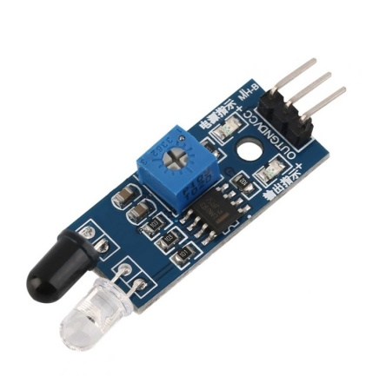

An Infrared (IR) Sensor is a device that detects infrared radiation, typically emitted by objects as heat, and converts it into an electrical signal. These sensors are often used for motion detection, temperature measurement, and proximity sensing. IR sensors work by emitting infrared light and then measuring the reflected light or detecting the variation in the infrared radiation received. They are commonly used in applications such as remote controls, security systems, temperature sensors, and even in robotics for obstacle detection. IR sensors can be categorized into active and passive types, with passive IR sensors detecting natural infrared radiation from objects without emitting any light.

1. **Proximity Sensor:**

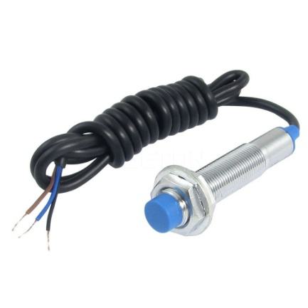\

A Proximity Sensor is a device that detects the presence or absence of an object within a specified range, without physical contact. It operates by emitting electromagnetic fields or beams (such as infrared or ultrasonic) and measuring the reflection or interruption of the signal when an object comes close. These sensors are commonly used in applications such as mobile phones, automotive systems, industrial automation, and security devices, offering benefits like improved safety, convenience, and efficiency in various settings. Different types of proximity sensors include capacitive, inductive, and ultrasonic sensors, each suited to detecting specific types of materials or objects.

1. **Moisture Sensor:**

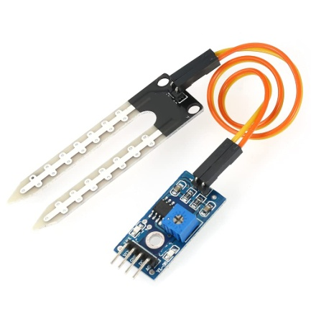

A Moisture Sensor is a device designed to measure the moisture content in a material, typically soil, air, or various substances, by detecting the amount of water present. It works by measuring changes in electrical resistance, capacitance, or other physical properties that are affected by moisture levels. Moisture sensors are commonly used in agriculture for monitoring soil moisture to optimize irrigation systems, in environmental monitoring, and in industrial applications like food processing and storage. These sensors help maintain optimal conditions by providing real-time data, which can be used to prevent over-watering, reduce energy consumption, and improve overall process efficiency.

1. **Servo Motor:**

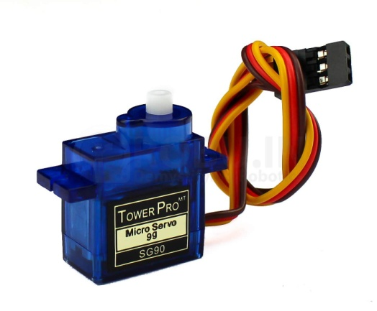

A Servo Motor is a type of motor that is designed for precise control of angular position, speed, and acceleration. It typically consists of a motor, a feedback device (such as an encoder or potentiometer), and a control circuit that works together to adjust the motor's position based on input signals. Servo Motors are widely used in applications that require precise movements, such as robotics, CNC machines, camera autofocus systems, and remote-controlled vehicles. The ability to provide accurate control over rotational movement makes them essential in tasks like steering, positioning, and automation, offering high torque and stability at low speeds.

1. **Stepper Motor:**

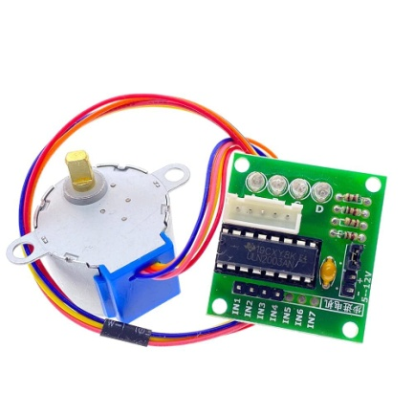

A Stepper Motor is a type of electric motor that moves in discrete steps, allowing for precise control of position and rotation without the need for feedback systems. It divides a full rotation into a series of smaller, equal steps, with each step typically ranging from 0.9 to 1.8 degrees, depending on the motor. Stepper motors are commonly used in applications requiring precise positioning, such as 3D printers, CNC machines, and robotics. They are controlled by sending a sequence of electrical pulses, which causes the motor to move incrementally, making them ideal for tasks that need high accuracy and repeatability. Stepper Motors are known for their reliability, ease of control, and ability to hold position when stationary.

1. **Buzzer:**

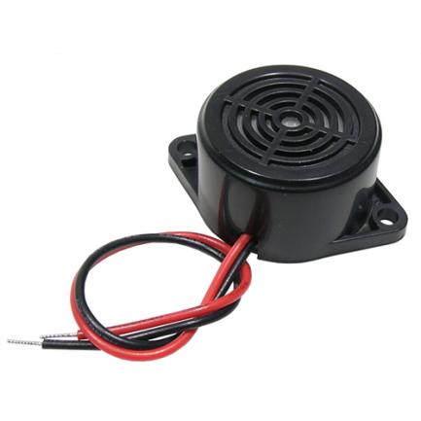

A Buzzer is a simple electronic device that produces a sound when activated by an electrical signal. It typically consists of a diaphragm or a vibrating element that generates sound waves when subjected to oscillating electrical currents. Buzzers are commonly used in various applications, such as alarms, notifications, and alerts in devices like microwaves, security systems, and industrial machines. They come in different types, including magnetic buzzers, piezoelectric buzzers, and electro-mechanical buzzers, each with distinct characteristics regarding sound frequency and power consumption. Buzzers are valuable for providing audible signals to convey important information or warn of potential hazards in both consumer electronics and industrial settings.

**Software Requirements**

1. **Python Scripts:**

For an Automated Garbage Sorting Project Using A Raspberry Pi, Python Scripts can be used to control various sensors and actuators for sorting waste. The IR sensor and proximity sensor can detect the presence and type of waste, triggering the Raspberry Pi to process the data and determine whether the material is recyclable or not. The moisture sensor can help identify wet or organic waste. Python scripts control the servo motor and stepper motor to sort materials into appropriate bins based on the detection results. Additionally, the buzzer can provide an audible alert when a sorting action is completed or when there’s an issue. The Python code integrates these components, ensuring smooth communication between sensors and motors, while automating the sorting process efficiently.

1. **Flask Web Application:**

A Flask Web Application for an Automated Garbage Sorting System Using Raspberry Pi can provide an interface to monitor and control the sorting process remotely. The web app, built using Python and Flask, can display real-time data from sensors like the IR sensor, proximity sensor, and moisture sensor, showing the status of the garbage being detected and sorted. Users can also control or adjust settings, such as motor movements (via servo and stepper motors) or set thresholds for waste classification. The app can trigger the buzzer to alert users about specific events (e.g., waste sorted or error detected). Flask enables smooth communication between the Raspberry Pi hardware and the web interface, providing an easy-to-use platform for managing the automated garbage sorting process.

1. **Position Tracking:**

Position Tracking for An Automated Garbage Sorting System Using Raspberry Pi can be implemented to ensure accurate sorting and movement of materials. The IR sensor and proximity sensor can be used to detect the position and presence of waste in the sorting area. As waste is detected, Python scripts process the sensor data to determine its type and position, triggering the servo and stepper motors to move the waste to the correct bin. The moisture sensor can be used to identify wet materials and adjust sorting accordingly. Position tracking helps ensure that the motors move accurately, and the system sorts materials efficiently. A buzzer can provide alerts if the system encounters an issue, like incorrect sorting or mechanical failure, ensuring smooth operations.

**4**

**Chapter**

# Premium Vector | Book icon vector illustrationbook icon isolated on white background book logoSYSTEM DESIGN

## \

## SYSTEM DESIGN

### Architecture Design

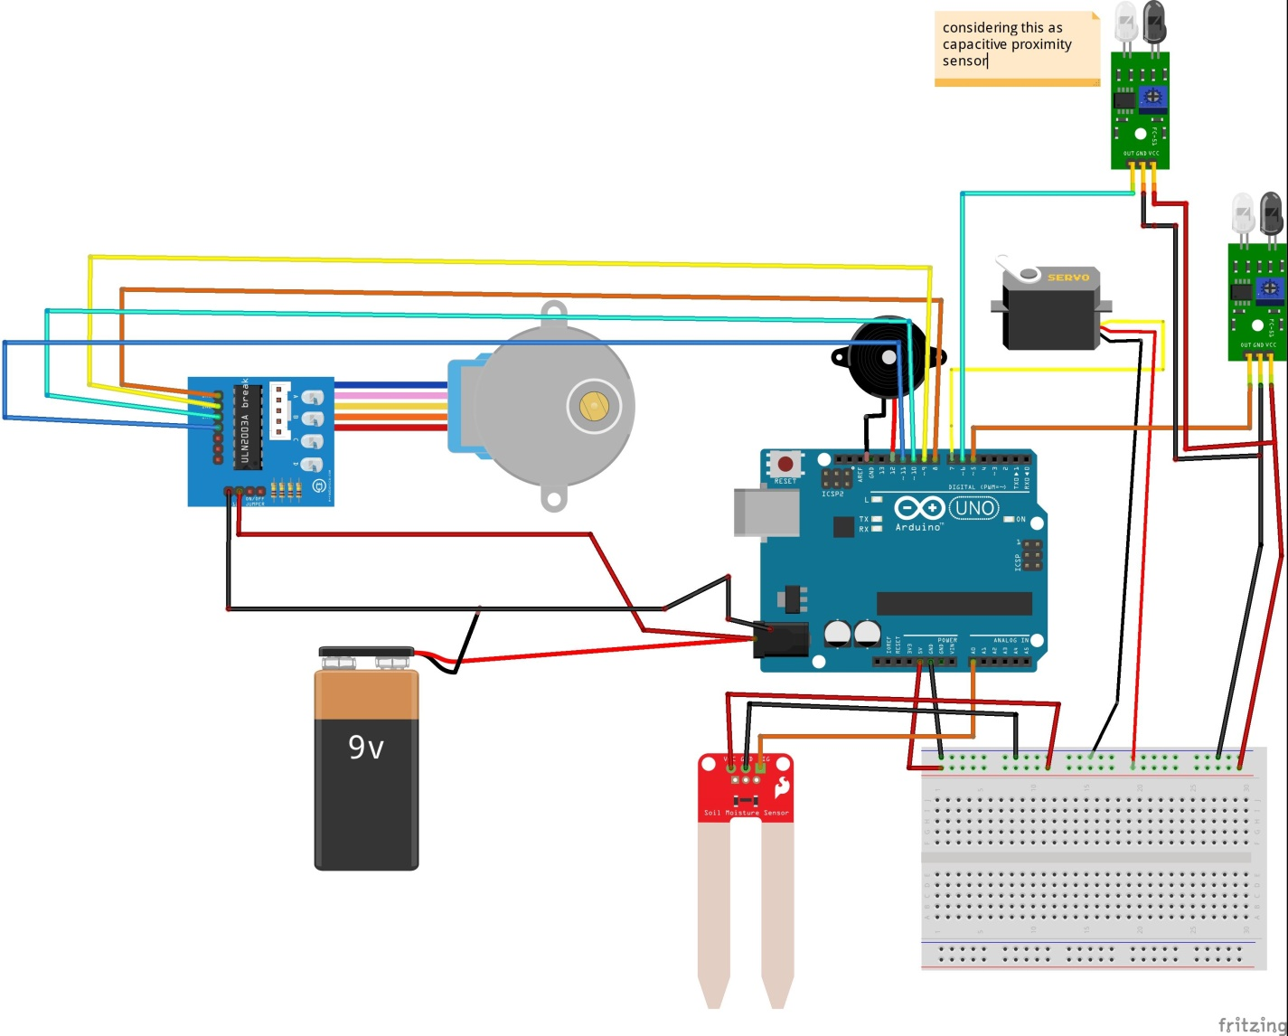

The project employs a modular architecture combining hardware and software components:

Hardware Components:

IR Sensor: Detects the presence of an object.

Proximity Sensor: Identifies whether the object is metallic.

Moisture Sensor: Detects moisture to classify waste as wet.

Servo Motor: Controls the disposal mechanism.

Stepper Motor: Rotates the disposal bins to the appropriate position.

Buzzer: Provides an audio alert.

Software Components:

Python Scripts: Handles hardware interactions and waste classification logic.

Flask Web Application: Displays system status and provides user interaction capabilities.

Position Tracking: Uses a file-based system to remember the last stepper motor position.

Integration:

The sensors feed data into the Raspberry Pi for processing.

Python scripts process sensor inputs and control hardware components.

The web application provides real-time updates and user interface.

### Data Flow Diagram

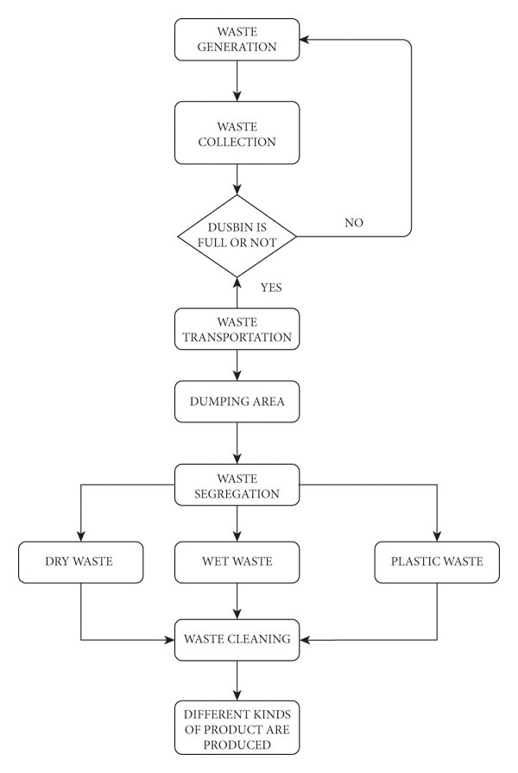

### ****Waste Generation****

* The process starts with waste being generated from households, industries, businesses, or public places.
* Waste generation is a continuous process, meaning it keeps occurring over time.

### ****Waste Collection****

* The collected waste is placed in dustbins or garbage collection points.
* This could involve municipal collection systems, waste pickup trucks, or smart waste collection technologies.

### ****3. Checking If the Dustbin is Full****

* A decision-making step checks if the dustbin is full or not.
* If the **dustbin is not full**, the process loops back to the waste generation stage (i.e., waste continues to accumulate).
* If the **dustbin is full**, the process moves forward to waste transportation.

### ****4. Waste Transportation****

* Once the dustbin is full, waste is transported to a designated dumping area.
* This is typically done by waste collection vehicles operated by municipal authorities or private waste management companies.

### ****5. Dumping Area****

* The waste is dumped at a designated disposal site or waste processing center.
* This could be a landfill, recycling plant, or waste treatment facility.

### ****6. Waste Segregation****

* The waste is separated into different categories:
  + **Dry Waste**: Includes paper, cardboard, metal, glass, textiles, etc.
  + **Wet Waste**: Includes organic waste like food scraps, vegetable peels, and garden waste.
  + **Metal Waste**: Includes Metal objects like Screw, Blade, etc.

### ****7. Waste Cleaning (for Wet Waste)****

* Wet waste undergoes a cleaning process before further processing.
* Cleaning involves removing impurities or contaminants to make it suitable for composting, biogas generation, or other uses.

### ****8. Product Formation****

* The final stage involves creating different kinds of useful products from the processed waste:
  + **Dry Waste** → Recycled paper, glass, metals, etc.
  + **Wet Waste** → Compost, biogas, organic fertilizers.
  + **Metal Waste** → Recycled Metal products or use high temperature through metal is melt & conversion.

### Sequence Diagram

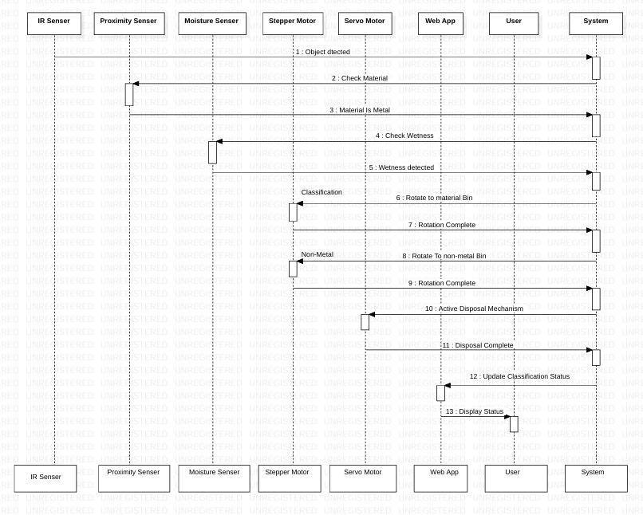

Object detected by the IR sensor.

Proximity sensor determines if the material is metal.

Moisture sensor checks for wetness.

Based on classification:

Rotate stepper motor to the corresponding bin.

Activate servo motor to open the disposal mechanism.

Update web application interface with classification status.

### Use case Diagram

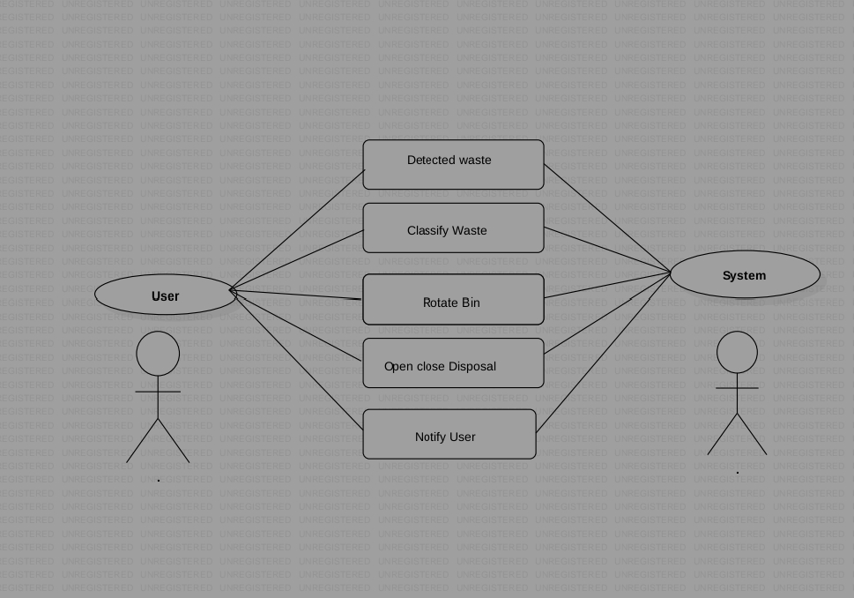

Actors:

User: Monitors the system and receives alerts.

System: Detects, classifies, and disposes of waste.

Use Cases:

Detect waste.

Classify waste.

Rotate bin.

Open and close disposal mechanism.

Notify user.

**5**

**Chapter**

# 

# TECHNICAL SPECIFICATIONS



## TECHNICAL SPECIFICATION

### 

### Operating System:Windows11

**Automated Garbage Sorting Project** using a **Raspberry Pi** and sensors like **IR**, **Proximity**, and **Moisture sensors**, **Windows 11 IoT Core** is a suitable operating system. This lightweight version of **Windows 11** is designed for IoT devices, offering compatibility with GPIO control for sensor interfacing and motor operations. It supports **UWP (Universal Windows Platform)** applications, allowing for seamless integration with your project using **C#** in **Visual Studio**, which can be helpful for controlling the sensors and motors efficiently.

Windows 11 IoT Core provides **remote management capabilities**, making it easier to manage and deploy updates to your Raspberry Pi without needing a direct connection to a monitor or keyboard. With this system, you'll be able to program GPIO pins for sensor data collection and control actuators like **servo motors** for sorting and **stepper motors** for moving bins. However, note that the OS lacks a full desktop environment, meaning it is best suited for headless operation, where you'll typically interact with the Raspberry Pi through a remote connection.

While Windows 11 IoT Core offers support for essential IoT functions like **GPIO control** and **I2C/SPI communication**, you may encounter some limitations with Python libraries compared to **Raspberry Pi OS**. If you are comfortable with **Windows development tools** and prefer working with **C#** for your UWP apps, this OS can provide a robust platform for your garbage sorting system, with scalability options for cloud integration through **Azure IoT** if required

### Development Framework

For the **Automated Garbage Sorting Project,** a suitable **Development Framework** would be a combination of **Windows IoT Core** on the Raspberry Pi and the **Universal Windows Platform (UWP)** for app development. UWP provides a robust environment for creating applications that interact with hardware components, such as sensors and motors, via APIs like **Windows.Devices.Gpio.** This framework allows you to write code in **C#**, which integrates easily with Windows development tools like **Visual Studio,** enabling you to create a smooth and efficient control interface for managing the sorting system.

In addition to the core UWP framework, you can leverage libraries for controlling peripherals. **Windows.Devices.I2C** and **Windows.Devices.Spi** can be used to communicate with sensors that use I2C or SPI protocols, such as the **moisture sensor** or **stepper motor** driver. For controlling the **servo motors** and performing tasks like object detection with the **IR sensor, Windows.Devices.Gpio** will handle GPIO pin interactions. With this integrated development environment, you can easily deploy applications directly to the Raspberry Pi using **Visual Studio.**

Furthermore, **Azure IoT** integration can serve as an extended framework if you plan to scale your system. This would allow for cloud-based monitoring, data analytics, and remote management. The Azure IoT Hub can interact with your sorting system to collect data, monitor performance, and even update the system software remotely, ensuring a scalable, robust framework for future growth.

### Integrated Development Environment (IDE)

For your **Automated Garbage Sorting Project** using **Raspberry Pi,** the recommended **Integrated Development Environment (IDE)** is **Visual Studio.** Visual Studio is well-suited for **Windows IoT Core** development, supporting languages like **C#** and **XAML** for building **UWP (Universal Windows Platform)** applications. This IDE provides a comprehensive environment to write, debug, and deploy code directly to your Raspberry Pi, making it easy to manage both hardware interactions (e.g., with sensors and motors) and software development for the sorting system.

Visual Studio integrates with essential tools such as **Windows IoT Core Dashboard and Azure IoT,** enabling you to manage your Raspberry Pi remotely. It offers rich features like IntelliSense, debugging tools, and easy deployment processes, which can significantly speed up development and troubleshooting. For GPIO control and sensor management, Visual Studio allows direct coding in **C#** and enables real-time testing of your project on the Raspberry Pi.

In addition, **Visual Studio Code (VS Code)** can be considered as an alternative for lighter development. It supports multiple programming languages like **Python** and **JavaScript**, which could be beneficial if you prefer flexibility or if you decide to use **Python** for parts of the project. With extensions for **GPIO** and remote development, **VS Code** offers an efficient environment for building and testing the sorting system, although it requires additional setup for integrating with **Windows IoT Core**. For a fully optimized workflow with **Windows 11 IoT Core, Visual Studio** remains the preferred IDE

### Web Server : Localhost

For the **Automated Garbage Sorting Project,** setting up a **Local Web Server** on the **Raspberry Pi** using **localhost** is a practical approach to manage and monitor the system. By using a local web server, you can create a simple **web interface** that allows for remote control, monitoring, and feedback of the sorting system, all within the local network. The web server can be used to display real-time data from the sensors, such as the distance from the proximity sensor or the moisture level from the moisture sensor, as well as provide a way to control motors, view alerts, or even update the system settings.

One of the most common tools to implement a local web server on a Raspberry Pi is **Flask**, a lightweight web framework in **Python**. Flask can be used to serve web pages, manage sensor data, and handle motor control through a simple, user-friendly interface. The web server will run locally on the Raspberry Pi and be accessible through the browser on any device connected to the same network. This setup can include a dashboard that shows sensor readings, logs, and control buttons to activate or deactivate certain processes, like sorting waste or triggering alarms.

Additionally, you can set up **Node.js** with **Express.js** for more complex web applications if you need features like real-time data updates using WebSockets or API endpoints for interaction with other devices. By using **localhost** for the web server, you can ensure that the system remains isolated within the local network, providing security and reliability. This method also ensures that you won’t need internet access for basic operations while allowing easy integration with other networked devices for future scalability.

### Features of Visual Studio Code

**Visual Studio Code (VS Code)** offers several powerful features that make it an ideal choice for developing the **Automated Garbage Sorting Project** on the **Raspberry Pi.** Below are key features that can enhance the development process:

1. **Lightweight and Fast**: VS Code is known for being a lightweight editor, meaning it runs smoothly on the Raspberry Pi, even with limited resources. This makes it a great tool for coding and debugging without consuming too much system performance, which is essential for small, embedded systems like the Raspberry Pi.
2. **Support for Multiple Programming Languages**: VS Code supports a wide range of programming languages, including **Python, JavaScript, HTML, CSS,** and **C#** (via extensions). This versatility allows you to use the right language for different parts of your project. For example, Python can be used for sensor readings and motor control, while HTML and JavaScript can be used for building the web interface in Flask.
3. **Integrated Terminal**: **The integrated terminal** in VS Code allows you to run commands, test Python scripts, or execute system-level commands directly within the editor. This streamlines the development process, allowing you to test changes and interact with the Raspberry Pi’s operating system without switching between different applications.
4. **Extensions for GPIO and IoT Development**: VS Code provides numerous extensions to enhance Raspberry Pi development. Extensions like **Python, Flask Snippets,** and **Raspberry Pi GPIO** can help speed up the development process by providing useful code snippets, syntax highlighting, and libraries tailored for IoT development.
5. **Debugging and Remote Development**: VS Code has built-in debugging capabilities, which help you troubleshoot code in real-time. You can set breakpoints, step through code, and inspect variables to ensure your sensor data collection and motor control are working as expected. Additionally, the **Remote Development** extension allows you to connect directly to your Raspberry Pi and edit files remotely, eliminating the need to transfer files back and forth manually.
6. **Version Control Integration**: VS Code integrates well with **Git,** allowing you to manage project versions, track changes, and collaborate with others. This is especially useful for large projects, helping you keep track of modifications and ensuring that you can revert to previous versions if necessary.
7. **Performance Profiling**: Visual Studio includes performance profiling tools to help developers analyze and optimize the performance of their applications by identifying bottlenecks and inefficiencies.
8. **Testing Tools**: It offers a suite of testing tools for unit testing, load testing, and automated testing to ensure the quality and reliability of software applications.
9. **Collaboration:** VisualStudiofacilitatescollaborationamongteammembersthroughfeatures like code review, team explorer for managing source control repositories, and support for remote development.
10. **Cross-platform Development:** Visual Studio supports development for various platforms, including Windows, macOS, and Linux. It provides tools for developing applications targeting different frameworks and platforms, such as .NET, Xamarin
11. **Azure Integration:** With built-in Azure tools, Visual Studio enables developers to easily build, debug, and deploy applicationsto Microsoft Azure cloud services directly fromtheIDE.
12. **Performance Profiling**: Visual Studio includes performance profiling tools to help developers analyze and optimize the performance of their applications by identifying bottlenecks and inefficiencies.

**6**

**Chapter**

# ALGORITHM DESCRIPTION



## ALGORITHM DESCRIPTION

* 1. **Introduction**

An algorithm is a well-defined set of step-by-step instructions or procedures designed to solve a specific problem or perform a task. In computer science, algorithms are fundamental for developing efficient and reliable software, as they provide a clear framework for data processing, decision-making, and problem-solving. Algorithms can range from simple operations, like sorting numbers or searching for specific data, to complex processes, such as machine learning, image recognition, or pathfinding.

Algorithms are classified based on their functionality, efficiency, and application. Some common types include **search algorithms** (used for finding data in a structure), **sorting algorithms** (to arrange data in a specific order), and **optimization algorithms** (which find the best solution to a problem). The effectiveness of an algorithm is often evaluated by its time complexity (how fast it performs) and space complexity (how much memory it requires), which are crucial for determining its scalability and suitability for real-world applications.

In the context of the Automated Garbage Sorting System, algorithms play a crucial role in processing sensor data, classifying waste, and controlling the sorting mechanisms. They allow the system to make decisions based on inputs from sensors and guide actuators in a precise manner, ensuring accurate waste segregation.

* 1. **System Overview**

Waste Classification Algorithm:

Detect object presence using IR sensor.

If detected:

Check proximity sensor output for metallic classification.

Check moisture sensor output for wet classification.

Assign waste to one of three categories:

Metal

Wet

Dry

Rotate stepper motor to align bin.

Open bottom cap using the servo motor.

Reset system for the next detection.

**7**

**Chapter**

**CODING**



## CODING

### Package

For the **Automated Garbage Sorting System**, various software packages and libraries are required to interface with the hardware components and manage the sensor data effectively. The main programming language used for this project is **Python,** as it is well-suited for Raspberry Pi development and supports a wide range of libraries for sensor integration and motor control. The **RPi.GPIO** library is essential for interacting with GPIO pins on the Raspberry Pi, allowing control of actuators like servo motors and stepper motors. This package is vital for creating the physical movement of waste sorting mechanisms.

Additionally, **Python libraries** such as **smbus2** or **pigpio** may be utilized for more advanced motor control and sensor integration, particularly when high precision or higher power motors are involved. For handling sensor inputs like **IR sensors,** **proximity sensors,** and **moisture sensors,** the **GPIO library** can read data from the pins connected to the sensors, which is processed to determine the type of waste. Libraries like **time** and **threading** will be used for timing and multi-threaded operations, enabling real-time sensor data collection and motor control.

For data visualization, monitoring, or user interface development, the project can integrate **Tkinter** or **Flask** for building a simple graphical user interface (GUI) or web-based interface. This interface would allow users to monitor system performance, receive alerts, or adjust settings remotely. Additionally, if machine learning or advanced data analysis is required in the future, packages like **scikit-learn** or **TensorFlow** can be incorporated to classify more complex waste materials based on sensor data. These packages, together with **Raspberry Pi**, offer an effective development environment for implementing the system and scaling it for practical, real-world applications.

### Classes Methods

The complete code is structured into three main files:

index.py: Main control logic for detection and classification.

metal.py: Simple test script to verify proximity sensor functionality.

step.py: Script to control the stepper motor.

Refer to the appended code sections for detailed implementation:

import RPi.GPIO as GPIO

import time

import os

global message

POSITION_FILE="step_position.txt";

# Pin setup

GPIO.setmode(GPIO.BCM)

GPIO.setwarnings(False)

# Pin Definitions

IR_SENSOR = 19

MOISTURE_SENSOR = 13

PROXIMITY_SENSOR = 26

SERVO = 6

BUZZER = 5

IN1 = 12

IN2 = 16

IN3 = 20

IN4 = 21

# Servo motor setup

GPIO.setup(SERVO, GPIO.OUT)

pwm = GPIO.PWM(SERVO, 50) # 50Hz frequency (standard for servos)

pwm.start(7.5) # Start PWM with 7.5% duty cycle (neutral position)

# Sensor and buzzer setup

GPIO.setup(IR_SENSOR, GPIO.IN)

GPIO.setup(MOISTURE_SENSOR, GPIO.IN)

GPIO.setup(PROXIMITY_SENSOR, GPIO.IN)

GPIO.setup(BUZZER, GPIO.OUT)

# Step Motor setup

GPIO.setup(IN1, GPIO.OUT)

GPIO.setup(IN2, GPIO.OUT)

GPIO.setup(IN3, GPIO.OUT)

GPIO.setup(IN4, GPIO.OUT)

# Define the step sequence for a 4-phase stepper motor (28BYJ-48)

STEP_SEQ = [

[1, 0, 0, 0],

[1, 1, 0, 0],

[0, 1, 0, 0],

[0, 1, 1, 0],

[0, 0, 1, 0],

[0, 0, 1, 1],

[0, 0, 0, 1],

[1, 0, 0, 1]

]

def load_last_position():

if os.path.exists(POSITION_FILE):

with open(POSITION_FILE, "r") as file:

return int(file.read())

return 0

def save_position(position):

with open(POSITION_FILE,"w") as file:

file.write(str(position))

# Function to rotate the stepper motor

def rotate_stepper(steps, delay=0.01, clockwise=True):

for _ in range(steps):

for step in STEP_SEQ:

GPIO.output(IN1, step[0])

GPIO.output(IN2, step[1])

GPIO.output(IN3, step[2])

GPIO.output(IN4, step[3])

time.sleep(delay)

def step_motor_start(current_position, steps_per_degree=512):

if current_position < 512:

rotate_stepper(current_position, delay=0.005, clockwise=False)

save_position(0)

last_position=512-load_last_position()

step_motor_start(last_position)

try:

while True:

if not GPIO.input(IR_SENSOR):

print("Object detected")

GPIO.output(BUZZER, True)

time.sleep(1)

GPIO.output(BUZZER, False)

# Check material type

is_metal = GPIO.input(PROXIMITY_SENSOR)

is_wet = GPIO.input(MOISTURE_SENSOR)

print(is_metal)

print(is_wet)

# Set servo position based on material type

if is_metal:

message = "Metal detected"

print(message)

rotate_stepper(384, delay=0.005) #Rotating to 270 degrees...

save_position(384)

elif is_wet:

message = "Wet material detected"

print(message)

rotate_stepper(256, delay=0.005) #Rotating to 180 degrees...

save_position(256) # Wet partition

else:

message = "Dry material detected"

print(message)

rotate_stepper(128, delay=0.005) #Rotating to 90 degrees...

save_position(128) # Wet partition

# Open bottom cap

pwm.ChangeDutyCycle(2.5) # Open bottom cap

GPIO.output(BUZZER, False)

time.sleep(2)

pwm.ChangeDutyCycle(7.5) # Close bottom cap

print("Material dropped")

last_position=512-load_last_position()

step_motor_start(last_position)

time.sleep(0.1)

except KeyboardInterrupt:

print("Exiting gracefully...")

pwm.stop()

GPIO.cleanup()

**8**

**Chapter**

## IMPLEMENTATION



## IMPLEMENTATION

### Installation and Preparation

**Hardware Setup:**

**Connect sensors and motors to the Raspberry Pi GPIO pins as specified in the code.**

**Securely mount the sensors and ensure alignment with waste input mechanisms.**

**Software Setup:**

* **Install required Python libraries:**
* **pip install flask RPi.GPIO**
* **Run the main script:**
* **python index.py**
* **Access the web application through the Flask server to monitor the system.**

**Output:**

**Hardware Output:**

**Waste is classified into metal, wet, and dry categories.**

**Bins rotate and open correctly for disposal.**

**Software Output:**

**Web application displays classification results.**

**Console logs provide real-time updates for system operations.**

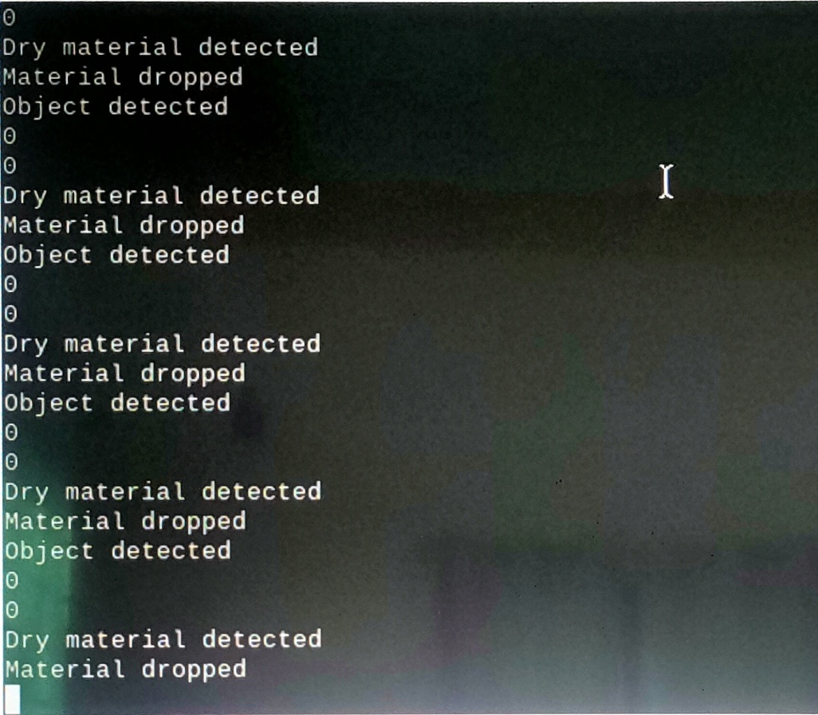

**9**

**Chapter**

**SOFTWARE TESTING**



## SOFTWARE TESTING

### Introduction

Software testing is a critical process in the software development lifecycle aimed at ensuring that software functions as expected and meets the specified requirements. It involves executing the software to identify defects, bugs, or inconsistencies that may impact the system’s functionality, performance, and user experience. The primary goal of software testing is to verify and validate that the application or system behaves correctly in all specified scenarios and under different conditions, thereby improving the quality and reliability of the product.

Testing can be performed at various levels of software development, ranging from unit testing, which checks individual components or functions, to integration testing, system testing, and acceptance testing, which verify the overall behavior of the entire system. There are two main types of software testing: **manual testing**, where testers execute test cases without automation, and **automated testing,** where testing scripts are written to run the tests automatically, offering efficiency and consistency, particularly in large-scale systems.

The importance of software testing lies in its ability to uncover potential issues early in the development process, reducing the risk of system failures, user dissatisfaction, and costly post-deployment fixes. It also ensures that software remains functional over time, adapts to new requirements, and performs well in a variety of environments. With the increasing complexity of modern software systems, effective software testing is essential for ensuring the delivery of high-quality software that meets user needs and business objectives.

### Test Cases

### IR Sensor:

### Input: Object placed in front of the sensor.

### Expected Output: Object detected message.

### Proximity Sensor:

### Input: Metal object placed.

### Expected Output: "Metal detected" message.

### Moisture Sensor:

### Input: Wet material placed.

### Expected Output: "Wet material detected" message.

### Servo Motor:

### Action: Trigger disposal mechanism.

### Expected Output: Servo motor moves to open and close bottom cap.

### Stepper Motor:

### Action: Rotate to specific bin.

### Expected Output: Correct bin alignment.

**10**

**Chapter**

**CONCLUSION**



## 10. CONCLUSION

The Automated Garbage Sorting System utilizing Raspberry Pi, IR sensors, proximity sensors, moisture sensors, servo motors, stepper motors, and a feedback mechanism provides an efficient, low-cost solution for waste segregation. By automating the sorting process, the system reduces the need for manual labor, increases accuracy in waste classification, and enhances the overall efficiency of waste management. The integration of various sensors ensures that different types of waste—biodegradable, recyclable, and non-recyclable—are sorted appropriately, minimizing contamination and promoting sustainability.

The use of Raspberry Pi as the central controller, along with its ability to process real-time sensor data and control the actuators, allows for a seamless, user-friendly experience. The system can be further enhanced by incorporating additional sensors, machine learning algorithms, or a more advanced user interface to handle a broader range of waste materials or improve the sorting accuracy. Furthermore, the modular design ensures that the system can be easily upgraded or adapted to different environments, making it a flexible solution for both residential and industrial use.

In conclusion, this project highlights the potential of combining low-cost hardware with advanced sensing and motor control technologies to address a pressing environmental issue. The Automated Garbage Sorting System not only offers a practical solution for waste management but also opens doors for future advancements in smart cities and automated waste systems, contributing to cleaner, more sustainable urban environments.

**11**

**Chapter**

## Premium Vector | Book icon vector illustrationbook icon isolated on white background book logoBIBLIOGRAPHY

## 11. BIBLIOGRAPHY

1. Raspberry Pi Documentation: https://www.raspberrypi.org/documentation/
2. RPi.GPIO Library: https://pypi.org/project/RPi.GPIO/
3. Flask Web Framework: https://flask.palletsprojects.com/en/2.0.x/