**SHOREIKAN KARATE INDIA**

**S. Yuvaraj, Dr. D. Swamydoss**

Student, Master of Computer Application, Adhiyamaan College of Engineering, Hosur, Tamil Nadu, India

HOD, Master of Computer Application, Adhiyamaan College of Engineering, Hosur, Tamil Nadu, India

**ABSTRACT**

The SHOREIKAN KARATE INDIA is a web-based application developed using PHP and MySQL to streamline the management of karate schools. This system provides an efficient solution for administrators, instructors, and students by automating routine tasks and centralizing data. Administrators can manage student enrolments, tournament schedules, results, and payment records effortlessly. Instructors can organize classes, monitor student progress, and assign grades for belt advancements. Students can access their schedules, performance reports, and payment statuses through a user-friendly interface. The system integrates secure authentication, real-time notifications, and dynamic reporting to enhance operational efficiency. By minimizing errors and reducing administrative overhead, it ensures a seamless experience for all stakeholders. The SHOREIKAN KARATE INDIA application is designed to be scalable, customizable, and accessible, catering to the unique needs of martial arts academies. It also provides a foundation for future enhancements and integration with modern technologies.

Keywords: Student Enrolment, Tournament Scheduling, Belt Advancement, Secure Authentication, Real-time Notifications, Dynamic Reporting.

**1. INTRODUCTION**

Karate schools require efficient management systems to handle student enrollments, tournament schedules, and grading processes. **SHOREIKAN KARATE INDIA** is a web-based application developed using PHP and MySQL to streamline these operations. It provides a centralized platform for administrators, instructors, and students to manage daily activities efficiently. The system includes secure authentication, real-time notifications, and dynamic reporting to enhance operational workflow. By automating routine tasks, it reduces administrative workload and minimizes errors. Designed for scalability and customization, this application meets the evolving needs of martial arts academies.

**2. METHODOLOGY**

* 1. **Tournament Module:**

This module enables the registration of individuals or teams, categorizing them by age, rank (belt), gender, and weight. It defines events like Individual Kata, Team Kata, and Individual Kumite, assigning participants based on eligibility. Real-time score recording ensures accurate competition results. After each event, the system generates results and issues certificates, streamlining tournament management.

* 1. **Performance and Grading Module:**

This module tracks student progress, achievements, and belt grading. It monitors both individual and group performance, generating detailed reports for assessment. By evaluating development and accomplishments, the system ensures accurate certification. This helps instructors certify students based on their skills and progression.

**2.3 Student Management Module:**

This module streamlines student enrolment and registration for efficient onboarding. It securely stores personal and contact information, ensuring organized records. The system tracks progress and belt advancement history, allowing instructors to monitor and assess student development.

..

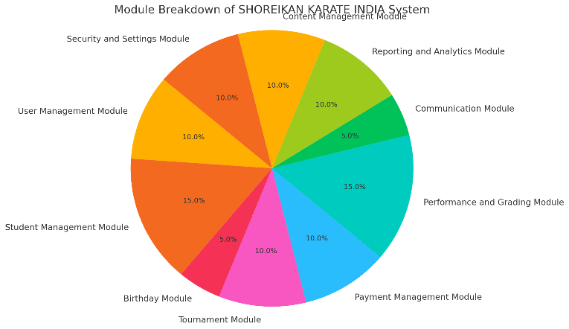

**Figure1:**

This figure illustrates the module distribution of the **SHOREIKAN KARATE INDIA System,** with the **Student Management** and **Performance & Grading Modules** having the highest share (15% each). Other modules, including **Payment, Security, Reporting, and Content Management**, contribute between 5% to 10% of the system.

**3. RESULT**

The system enhances administrative efficiency and student engagement by automating processes and centralizing data. It reduces manual effort, improves communication, and provides real-time insights. The platform ensures scalability and easy integration with modern technologies. Additionally, it minimizes errors and administrative overhead, creating a seamless experience for all stakeholders.

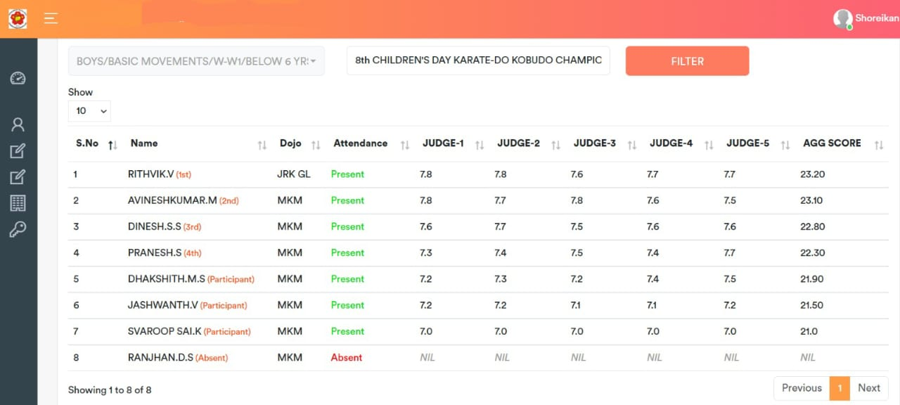

**4. CONCLUSION**

The **SHOREIKAN KARATE INDIA** system is a web-based platform that simplifies karate school management by automating key operations. It efficiently handles **student enrollment, performance tracking, tournaments, payments, and communication**. With **secure authentication, role-based access, and real-time notifications**, it enhances user experience while reducing administrative workload. The system’s **scalable and customizable** design allows for future enhancements and seamless integration with modern technologies. Overall, it provides a **centralized, efficient, and user-friendly** solution for martial arts academies.

**5. ACKNOWLEDGEMENTS**

This journal paper was truly prepared by my itself I agree the terms and conditions.

**6. REFERENCES**

[1] L. Welling and L. Thomson, PHP & MySQL Web Development, 4th ed. Pearson Education, 2016.

[2] D. Stuttard and M. Pinto, Web Security Essentials. Wiley Publishing, 2011.

[3] A. Freeman, Modern Web Technologies for Dynamic Applications. Apress, 2020.

[4] J. Smith, Martial Arts School Management Best Practices. Martial Arts Business Success, 2018.