## **DESIGN AND EXPERIMENTAL STUDY OF PRESSURE DISTRIBUTION ON A SYMMETRICAL AIRFOILS IN A LOW-SPEED WIND TUNNEL**

## Dr.P.M.M.S. SARMA1, MOHAMMED ABDUL SHAFEEQ2, PRAVEEN M3a, HARISH VARDHAN REDDY M3b, DINESH KUMAR3c,VINAY SAI SANKAR M3d

## 

Department of Mechanical Engineering

Godavari Institute of Engineering & Technology, Rajahmundry, Andhra Pradesh, India.

**Abstract**

This study investigates the pressure distribution over a symmetrical airfoil, specifically the NACA 66(2)-015, at varying angles of attack. The analysis aims to enhance the understanding of aerodynamic performance characteristics and flow behavior around the airfoil, which is crucial for applications in aerospace engineering and design optimization. were employed to model the airflow around the airfoil at angles of attack ranging from -10° to 15°.

Results indicate a significant variation in pressure distribution with changes in angle of attack. At low angles, the flow remains attached, resulting in a relatively uniform pressure distribution along the upper and lower surfaces. As the angle of attack increases, a notable increase in suction on the upper surface is observed, leading to enhanced lift generation. However, at higher angles, flow separation occurs, causing a dramatic shift in pressure distribution and a decrease in lift efficiency.

This study provides valuable insights into the aerodynamic characteristics of the NACA 66(2)-015 airfoil, highlighting the critical relationship between angle of attack and pressure distribution. The findings contribute to the broader field of aerodynamics by informing design strategies that optimize airfoil performance across various flight conditions. Further research is recommended to explore the impact of surface modifications and Reynolds number variations on pressure distribution and overall aerodynamic efficiency.

* **Keywords:** Pressure distribution,Symmetrical airfoil,NACA 66(2)-015,Angle of attack,Aerodynamic performance,Aerospace engineering,Design optimization,Flow separation,Lift generation,Suction effect,Reynolds number

1. **Introduction:**

**1.1 WIND TUNNEL:**

Wind tunnel is a facility for creating a uniform wind of known value in a duct where fluid flow phenomena can be investigated. It is also very highly useful for training and teaching students in fluid mechanics/aerodynamics. The facility can also be used for testing aircraft models to obtain their performance characteristics and flow features around it. It is also highly useful in industrial aerodynamic testing and simulation studies related to many problems in fluid mechanics. The wind tunnel facility could be specific to the major application required. Actual aircraft model testing may require a high Renold's number facility. A smoke flow visual station tunnel could be a small tunnel.Wind tunnel is "an apparatus for producing a controlled stream of air for conducting aerodynamic experiments". The experiment is conducted in the test section of the wind tunnel and a complete tunnel configuration includes air ducting to and from the test section and a device for keeping the air in motion, such as a fan. Wind tunnel uses include assessing the effects of air on an [aircraft](https://en.wikipedia.org/wiki/Aircraft" \o "Aircraft) in flight or a ground vehicle moving on land, and measuring the effect of wind on [buildings](https://en.wikipedia.org/wiki/Building" \o "Building) and bridges. Wind tunnel test sections range in size from less than a foot across, to over 100 feet (30 m), and with air speeds from a light breeze to hypersonic.

The earliest wind tunnels were invented towards the end of the 19th century, in the early days of aeronautical research, as part of the effort to develop heavier-than-air flying machines. The wind tunnel reversed the usual situation. Instead of the air standing still and an aircraft moving, an object would be held still and the air moved around it. In this way, a stationary observer could study the flying object in action, and could measure the aerodynamic forces acting on it.

The development of wind tunnels accompanied the development of the airplane. Large wind tunnels were built during World War II, and as supersonic aircraft were developed, supersonic wind tunnels were constructed to test them. Wind tunnel testing was considered of strategic importance during the Cold War for development of aircraft and missiles.Advances in [computational fluid dynamics](https://en.wikipedia.org/wiki/Computational_fluid_dynamics" \o "Computational fluid dynamics) (CFD) have reduced the demand for wind tunnel testing, but have not completely eliminated it. Many real-world problems can still not be modeled accurately enough by CFD to eliminate the need for wind tunnel testing. Moreover, confidence in a numerical simulation tool depends on comparing its results with experimental data, and these can be obtained, for example, from wind tunnel tests.

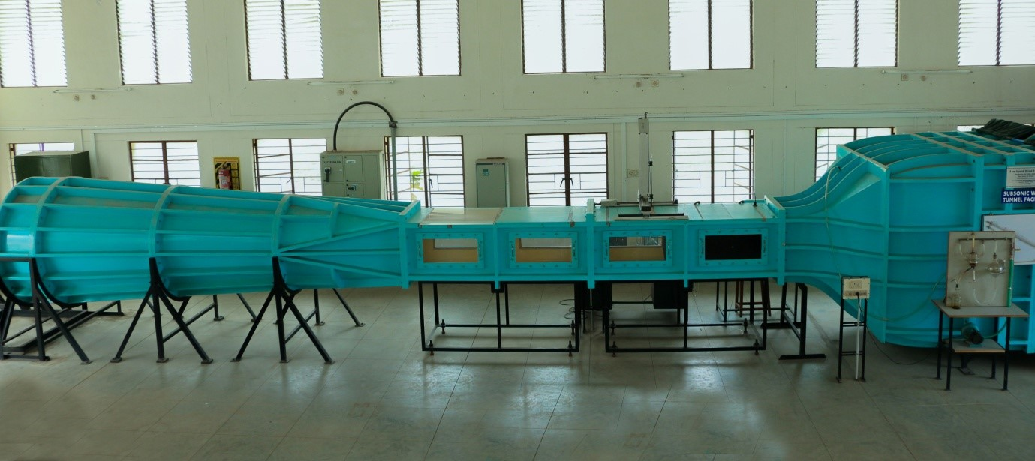

**Figure1.1: SUBSONIC WIND TUNNEL**

**1.1.2 CLASSIFICATIONS**:

There are many different kinds of wind tunnels. They are typically classified by the range of speeds that are achieved in the test section, as follows:

* Low-speed wind tunnel
* [Subsonic and transonic wind tunnel](https://en.wikipedia.org/wiki/Subsonic_and_transonic_wind_tunnel" \o "Subsonic and transonic wind tunnel)
* [Supersonic wind tunnel](https://en.wikipedia.org/wiki/Supersonic_wind_tunnel" \o "Supersonic wind tunnel)
* [Hypersonic wind tunnel](https://en.wikipedia.org/wiki/Hypersonic_wind_tunnel" \o "Hypersonic wind tunnel)
* High enthalpy wind tunnel

Wind tunnels are also classified by the orientation of air flow in the test section with respect to gravity. Typically they are oriented horizontally, as happens during [level flight](https://en.wikipedia.org/wiki/Level_flight" \o "Level flight). A different class of wind tunnels are oriented vertically so that gravity can be balanced by drag instead of lift, and these have become a popular form of recreation for simulating [sky-diving](https://en.wikipedia.org/wiki/Sky-diving" \o "Sky-diving):

**1.1.3 Applications**

* **Aircraft Design** – Testing supersonic jets like fighter aircraft and commercial supersonic planes.
* **Missile and Spacecraft Development** – Studying high-speed projectiles and space re-entry vehicles.
* **Aerodynamic Research** – Understanding shock waves, drag, and heat effects at supersonic speeds.

**1.2 SUBSONIC WIND TUNNEL:**

**1.2.1 WHAT IS SUBSONIC WIND TUNNEL?**

A **subsonic wind tunnel** is a low-speed tunnel where airflow velocity remains below Mach 1. It is used for testing aircraft, automobiles, buildings, and bridges under controlled conditions to study aerodynamic properties like lift, drag, and pressure distribution.

A subsonic wind tunnel is a controlled environment used to study the aerodynamic properties of objects at speeds below the speed of sound (subsonic), typically involving a test section where models or prototypes are exposed to controlled airflow.

**1.2.2 PURPOSE :**

Subsonic wind tunnels are essential for research and development in various fields, including:

* Aerodynamics of aircraft, including wings, fuselages, and control surfaces.
* Studying the flow of air around objects, such as vehicles, buildings, and other structures.
* Testing and optimizing designs for low-speed performance.

#### ****1.2.3**.**Components of a Subsonic Wind Tunnel****

**Contraction Section**

1..Narrows the incoming air to increase velocity smoothly.

2.Helps in maintaining uniform and streamlined flow.

**Test Section**

1.The main area where models are placed for experiments.

2.Usually rectangular or circular in shape.

3.Transparent walls allow visual observation.

**Diffuser**

* 1. Expands the airflow after it leaves the test section, reducing velocity and increasing pressure.
  2. Helps in preventing excessive pressure loss.

**Fan and Motor Assembly**

* 1. Generates airflow through the tunnel.
  2. Placed downstream of the test section to reduce turbulence.

**Honeycomb and Screens**

* 1. Used at the tunnel entrance to straighten the airflow and reduce turbulence.

**1.2.4 APPLICATIONS:**

**Airfoil and Wing Testing:**

* Analyzing **lift, drag, and pressure distribution** on aircraft wings.
* Studying **flow separation and stall characteristics** at different angles of attack.

**Aircraft Design and Optimization:**

* Testing complete aircraft models to improve **stability and control**.
* Evaluating new designs for **efficiency and fuel consumption**.

**Propeller and Rotor Blade Analysis:**

* Studying **propeller aerodynamics** for aircraft and drones.
* Optimizing **helicopter rotor blades** for improved lift and efficiency

**1.3 AIRFOIL:**

An airfoil is the shape of a wing, which when moved through a fluid produces an aerodynamic force. There are various ways to describe an airfoil. The NACA - terminology is a well-known standard, which defines the following airfoil properties.

* Leading Edge: The part of the airfoil which meets the airflow first.
* Upper Chamber: Also called Up wash. It is the deflection of the oncoming airstream upward and over the wing.
* Lower Chamber: Also called down wash. Its the downward deflection of the airstream as it passes over the wing and moves towards the trailing edge

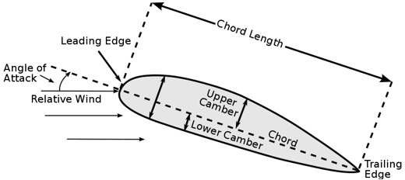

Figure 1.3 .Airfoil nomenclature

* Trailing Edge: The portion of the airflow where the airflow over the upper surface re-joins the lower surface airflow.
* Mean Chamber: The curves of the upper and lower body of the airfoil.
* Chord c: It is an imaginary line drawn through the airfoil starting from the leading edge going up till the trailing edge.
* Angle of attack: This is the relative angle formed by the wing. This is the angle formed between an airfoil and the oncoming wind. The chord lines and relative wind is called the angle of attack. As air circulates around the wings surface where the pressure is less than atmospheric, and regions where the pressure is greater than atmospheric. This specific pressure distribution varies the angle of attack. As the angle of attack grows larger, the lift reaches a maximum at some angle; increasing the angle of attack beyond this critical angle of attack causes the air to become turbulent and separate from the wing; there is less deflection downward so the airfoil generates less lift. The airfoil is said to be stalled.

1. **LITERATURE REVIEW**
2. The study of **pressure distribution on airfoils** has been a fundamental area in aerodynamics, with early theoretical models developed to predict airflow behavior. **Gareick (1933)** explored the theoretical pressure distribution for various airfoils using potential flow theory, providing essential insights into lift characteristics and aerodynamic efficiency. Theodorsen and Jacobs contributed significantly by extending theoretical frameworks to analyze real-world airfoil behavior. Experimental studies in subsonic wind tunnels have since validated these theoretical models, emphasizing the effects of **angle of attack, Reynolds number, and flow separation** on airfoil performance. This study builds on past research by focusing on the **NACA 66(2)-015 airfoil**, analyzing its pressure distribution at different angles of attack to improve design optimization in aerospace applications.
3. he study by McDevitt and Okuno (1985) presents an experimental investigation of static and dynamic pressure measurements on a NACA 0012 airfoil at high subsonic speeds within the Ames High Reynolds Number Facility. The research aims to provide aerodynamic data for evaluating numerical flow codes by minimizing wall interference effects through boundary-layer suction and adaptive wall contouring. Previous studies, such as those by McDevitt et al. (1976, 1983), have explored transonic flows over different airfoils, but the current study refines techniques to ensure high-accuracy aerodynamic testing. The findings contribute to the understanding of shock-induced separation and buffet onset at various Mach numbers and Reynolds numbers, supporting computational fluid dynamics (CFD) advancements.
4. Harris (1981) presents experimental data on the aerodynamic characteristics of the NACA 0012 airfoil in the Langley 8-Foot Transonic Pressure Tunnel. The study focuses on obtaining reliable two-dimensional wind tunnel data for evaluating computational methods and analyzing transonic flow behavior. Previous research has emphasized the importance of minimizing wall interference and providing accurate lift, drag, and moment coefficients for airfoil performance validation. This study contributes to the growing database of airfoil aerodynamics by examining the effects of Reynolds and Mach numbers on pressure distribution and force coefficients.
5. Ladson et al. (1987) conducted a high Reynolds number transonic wind tunnel test on an NACA 0012 airfoil in the Langley 0.3-Meter Transonic Cryogenic Tunnel as part of the Advanced Technology Airfoil Test (ATAT) program. The study provides detailed pressure distributions, integrated force, and moment coefficients across a Mach number range of 0.30 to 0.82 and Reynolds numbers from 3.0×1063.0 \times 10^63.0×106 to 45.0×10645.0 \times 10^645.0×106. Unlike previous studies that faced wall interference limitations, this work contributes to tunnel comparison efforts and supports wall correction methodologies, enriching the database for aerodynamic assessments.
6. Allen (1939) presents a simplified method for calculating airfoil pressure distribution, enhancing previous studies by providing a rapid technique that integrates normal-force distribution and base-profile pressure coefficients. The approach refines prior models by improving accuracy while maintaining computational efficiency. Compared to traditional methods, which require extensive calculations, this method offers a practical solution for engineers designing airfoils with various cambers and thicknesses. The results validate the method’s effectiveness, particularly for thin, moderately cambered airfoils.
7. Briggs and Dryden (1927) conducted an extensive study on the pressure distribution over airfoils at high speeds, expanding upon previous research in NACA Technical Report 207. Using a high-speed air stream and small-scale airfoil models, their work confirmed earlier findings and provided a deeper understanding of compressibility effects. Their results highlighted sudden changes in lift coefficients due to airflow separation at transonic speeds. The study offers valuable data for propeller designers and contributes to understanding aerodynamic behavior at high Reynolds numbers.
8. Pinkerton (1936) conducted a comprehensive experimental and theoretical investigation into the pressure distributions over the midspan section of the NACA 4412 airfoil. Using a variable-density wind tunnel, the study measured pressures at multiple points along the airfoil surface across a range of angles of attack, allowing a comparison between experimental results and potential-flow theoretical predictions. The research highlighted significant deviations due to viscous effects and developed a modified theoretical approach to better predict actual pressure distributions. The study contributes valuable data for aerodynamic design and computational fluid dynamics (CFD) validations.
9. Yousefi and Razeghi (2018) investigated the critical Reynolds number for laminar-to-turbulent transition over symmetric NACA 0012, 0015, and 0018 airfoils using computational fluid dynamics (CFD). Their study employed a hybrid viscous-inviscid interaction method and the eNe^NeN transition model to predict boundary layer flow behavior. The results demonstrated that the transition location strongly depends on Reynolds number and shifts downstream as Reynolds number decreases. This work provides valuable insights for aerodynamic applications, particularly in low Reynolds number regimes relevant to micro air vehicles and model aircraft.

**4.METHADOLOGY:**

* Design of specimen.
* Testing.

**4.1 Design of Specimen:**

To draw the required geometry of specimen we have used a software called CATIA

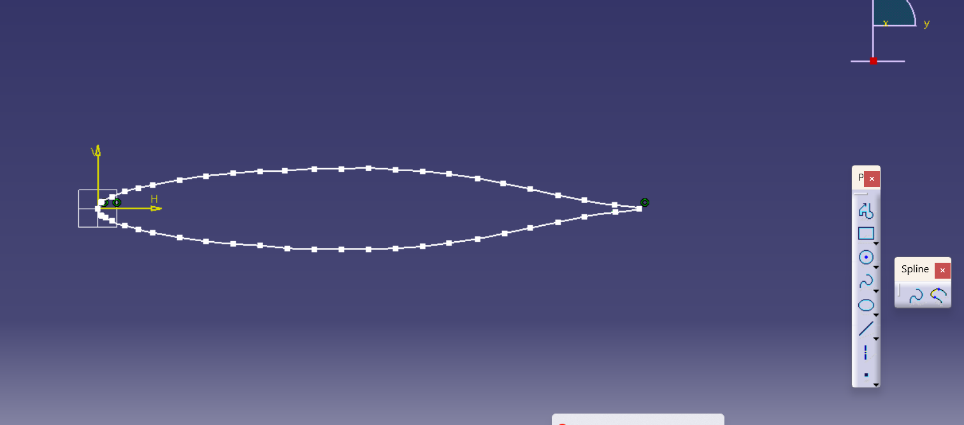

**Fig. AIRFOIL DESIGN**

**4.2 Testing:**

The study of aerodynamic characteristics of airfoils is crucial for aerospace applications. A subsonic wind tunnel is an essential tool for investigating the pressure distribution over an airfoil at different angles of attack (AoA). This experiment focuses on analyzing the NACA 66(2)-015 airfoil, a symmetric airfoil, to understand how pressure distribution varies with AoA and its effect on lift generation and flow behavior.

**5.EXPERIMENTATION:**

**5.1 SUBSONIC WIND TUNNEL TEST**

Subsonic wind tunnel testing is widely used in **aerodynamics and fluid dynamics** to analyze and optimize the performance of airfoils, vehicles, and structures

· **Lift and Drag Measurements**: Evaluates how airflows over objects to determine aerodynamic efficiency.

· **Pressure Distribution**: Measures pressure variations along surfaces to study airflow behavior.

· **Flow Separation and Stall Analysis**: Identifies critical angles where airflow detaches, causing stall

Subsonic wind tunnels are essential for **aerospace, automotive, and engineering applications**, ensuring optimized designs and improved performance before full-scale deployment

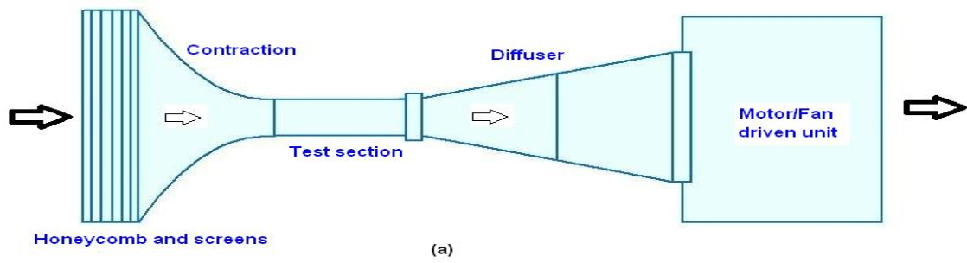

**Figure 5.1.1: subsonic wind tunnel test**

**5.2 Specifications**

1.Test Section Size : Cross Section: 600mm×600mm.

2.Maximum Speed : Length: 4000mm.

3.Fan : 45m/sec.

4.Axial Flow fan of Diameter: 1.3 meter.

:Maximum rpm: 1500

:Number of Blades: 12

:Hub Diameter: 500mm.

:Spinner is provided.

5.Contraction Ratio : 6:1

6.Contraction length : 1.8m

7.Settling chamber : 1.8mx1.8m

8.Entry section : Bell mouthed entry.

9. Honey Comb Size : 50mm×50mm×450mm.

10. Screens : Two screens 8mesh and 16mesh stainless steel.

11. Provision to put smoke rake: provided in the contraction cone.

12. Power :22 KW/30HP AC motor, with speed control drive

1. **RESULT AND DISCUSSION:**

1.UPPER SURFACE Pressure distribution on a symmetrical airfoil at “10” degrees Angle of Attack.

|  |  |
| --- | --- |
| x/c values | Coefficient of pressure (Cp) |
| 0 | -1.791 |
| 0.1 | -2.7761 |
| 0.2 | -2.671 |
| 0.4 | -2.5373 |
| 0.8 | -2.0149 |
| 1.5 | -1.0447 |
| 2.7 | -0.8208 |
| 3.9 | -0.6716 |
| 5.2 | -0.5373 |
| 6.5 | -0.3283 |
| 7.8 | -0.1492 |
| 9 | -0.0149 |
| 10 | 0.0149 |

**Table 6.1: x/c and coefficient of pressure(cp) values**

**Fig 6.2: Pressure Distribution (Cp vs. x/c) graph**

2. LOWER SURFACE Pressure distribution on a symmetrical airfoil at “10” degrees Angle of Attack

|  |  |
| --- | --- |
| X/C | Coefficient of pressure(cp) |
| 0.4 | 0.8059 |
| 0.8 | 0.5074 |
| 1.5 | 0.3432 |
| 2.7 | 0.1492 |
| 3.9 | 0 |
| 5.2 | -0.0895 |
| 6.5 | -0.0746 |
| 7.8 | 0 |
| 9 | 0.049 |

**Table 6.3: x/c and coefficient of pressure(cp) value**

**Fig 6.4: Pressure Distribution (Cp vs. x/c) graph**

**Pressure Distribution (Cp vs. x/c) graph** The **Pressure Coefficient (Cp) vs. x/c** graph provides critical insights into **airfoil aerodynamics**, including **lift generation, flow behavior, and stall characteristics**. The results obtained from this graph help engineers analyze **airfoil performance** at different angles of attack (AoA).

· **Upper Surface:**

* A **low-pressure (high suction) region** is observed near the **leading edge** due to flow acceleration.
* The suction pressure **gradually recovers** towards the trailing edge.
* As AoA increases, the suction peak shifts forward, increasing lift.

· **Lower Surface:**

* Pressure remains relatively higher, with gradual variation along the chord.
* At higher AoA, the pressure difference between the upper and lower surfaces increases, leading to more lift.

**7.CONCLUSION:**

This experiment provides critical insights into how **pressure distribution** varies with AoA for a **NACA 66(2)-015** symmetric airfoil. Results highlight **flow separation** effects at high AoA, crucial for airfoil design optimization. Future studies can explore **Reynolds number variations** and **surface modifications** to enhance aerodynamic efficiency

**8.References**

1. McDevitt, J. B., & Okuno, A. F. (1985). Static and Dynamic Pressure Measurements on a NACA 0012 Airfoil in the Ames High Reynolds Number Facility. NASA Technical Paper 2485.
2. McDevitt, J. B., Levy, L. L., Jr., & Deiwert, G. S. (1976). "Transonic Flow About a Thick Circular-Arc Airfoil," AIAA Journal, 14(5), 606-613.
3. McDevitt, J. B., Polek, T. E., & Hand, L. A. (1983). "A New Facility and Technique for Two-Dimensional Aerodynamic Testing," AIAA Journal of Aircraft, 20(6), 543-551
4. Harris, C. D. (1981). Two-Dimensional Aerodynamic Characteristics of the NACA 0012 Airfoil in the Langley 8-Foot Transonic Pressure Tunnel. NASA Technical Memorandum 81927.
5. Barnwell, R. W. (1979). A Similarity Rule for Compressibility and Sidewall Boundary-Layer Effects in Two-Dimensional Wind Tunnels. AIAA Paper 79-0108.
6. Experimental Data Base for Computer Program Assessment. (1979). Report of the Fluid Dynamics Panel Working Group 04. AGARD-AR-138.
7. Ladson, C. L., Hill, A. S., & Johnson, W. G. Jr. (1987). Pressure Distributions from High Reynolds Number Transonic Tests of an NACA 0012 Airfoil in the Langley 0.3-Meter Transonic Cryogenic Tunnel. NASA Technical Memorandum 100526.
8. Ladson, C. L., & Ray, E. J. (1981). Status of Advanced Airfoil Tests in the Langley 0.3-Meter Transonic Cryogenic Tunnel. NASA CP-2208.
9. Jacobs, E. N., Ward, K. E., & Pinkerton, R. M. (1933). The Characteristics of 78 Related Airfoil Sections from Tests in the Variable-Density Wind Tunnel. NACA Report 460.
10. Allen, H. J. (1939). A Simplified Method for the Calculation of Airfoil Pressure Distribution. NACA Technical Note 708.
11. Theodorsen, T. (1931). Theory of Wing Sections of Arbitrary Shape. NACA Technical Report 411.
12. Pinkerton, R. M. (1936). Calculated and Measured Pressure Distributions over the Midspan Section of the NACA 4412 Airfoil. NACA Technical Report 563.
13. Jacobs, E. N., & Rhode, R. V. (1938). Airfoil Section Characteristics as Applied to the Prediction of Air Forces and Their Distribution on Wings. NACA Technical Report 631.
14. Wenzinger, C. J., & Delano, J. B. (1938). Pressure Distribution over an NACA 23012 Airfoil with a Slotted and a Plain Flap. NACA Technical Report 633.