**ANALYSIS OF MIG WELDED MATERIAL WITH ENHANCED**

**MECHANICAL PROPERTIES**

**Mr. N. Kawin 1,S. Bavanandhan 2,G. Chandru 2,R. Indhiran 2**

1Assistant Professor, Mechanical Engineering, Kongunadu College of Engineering and Technology, Trichy, Tamil Nadu, India

2Student, Mechanical Engineering, Kongunadu College of Engineering and Technology, Trichy, Tamil Nadu, India

**ABSTRACT**

Analysis of the Material of Metal Inert Gas (MIG) welding with improved mechanical properties, i.e., mild steel, to ascertain whether it is well-suited for the production of air compressors. The study entails proper selection of material and welding wire to attain maximum weld quality and mechanical strength. Mild steel was selected because it has good weldability, is inexpensive, and has mechanical properties that are ideal for industrial use. The welding wire was chosen to match the base material and improve joint strength. To determine the performance of the welded joints, several tests were carried out, such as tensile, bend, and radiographic tests. The tensile test was used to measure the strength and load-carrying capacity of the weld, while the bend test was used to test its ductility and resistance to cracking. Radiographic testing was also carried out to detect any internal defects like porosity or inclusions. The findings proved that MIG-welded mild steel, when welded in controlled conditions, has high strength, good ductility, and low internal defects, thus being a safe option for air compressor production. The research proves the significance of welding parameter optimization to improve mechanical properties, ensuring durability and efficiency in industrial use.

**Keywords:** MIG welding, mild steel, tensile test, bend test, radiographic test, air compressor manufacturing.

1. **INTRODUCTION**

Metal Inert Gas (MIG) welding, or Gas Metal Arc Welding (GMAW), is one of the most common types of welding methods in the different industries because it is efficient, versatile, and easy to employ. It employs a continuously fed electrode wire and an inert gas, which is usually argon or a combination of argon and carbon dioxide, to shield the weld pool from atmospheric contamination. The technique is characterized by the production of excellent quality welds with little spatter and good mechanical properties. Optimal mechanical properties in welded materials can, however, be achieved if there is a thorough appreciation of welding parameters, filler metals, shielding gases, and post-weld thermal treatments. Improvement of MIG-welded material mechanical properties is essential to applications in aerospace, automotive, building, and manufacturing industries where strength, durability, and resistance to exterior forces are highly valued.

The properties of a MIG-welded joint are a function of several parameters such as voltage, current, wire feed rate, and travel speed. These parameters affect the heat input, depth of penetration, and microstructure of the weld, which together determine its mechanical behaviour. The choice of base metal and filler metal also is critical in deciding the ultimate properties of the weld. New methods like pulse welding and nanostructured filler material have been implemented to enhance strength, ductility, and toughness. Proper post-weld processing and heat treatment techniques like stress-relief annealing and surface hardening also help to improve mechanical properties.

This research will examine the mechanical properties of MIG-welded materials and investigate methods of improving their performance. Through investigations into different welding parameters, material content, and post-weld treatments, this research hopes to gain insights into how high strength, hardness, and durability of the welded joints can be achieved. Insights into these elements are critical to realizing high-performance welded structures that can withstand harsh working conditions.

1. **METHODOLOGY**

The methodology involves selecting mild steel for its weldability and strength, along with ER70S-6 welding wire for superior fusion and defect-free joints. Mechanical testing includes tensile, bend, and radiographic tests to evaluate strength, ductility, and internal defects. The results help optimize MIG welding parameters, enhancing mechanical properties for industrial applications like air compressor manufacturing.

**2.1 Materials Selection**

Mild steel was chosen as the base material due to its excellent weldability, cost-effectiveness, and mechanical properties suitable for industrial applications, particularly in air compressor manufacturing.

**2.2 Selection of Welding Wire**

The appropriate welding wire was selected based on compatibility with mild steel to ensure strong weld joints with minimal defects. The selection criteria included wire composition, diameter, and shielding gas requirements to optimize mechanical properties.

**2.3 Welding Parameters and Setup**

The welding process was set up by optimizing key parameters such as voltage, current, welding speed, and shielding gas flow rate. These parameters were adjusted to minimize defects such as porosity, cracking, and incomplete fusion.

* 1. **Mechanical Testing**

The welded samples underwent mechanical testing to evaluate their strength and quality:

* Tensile Test: Performed to assess the weld joint’s tensile strength and load-bearing capacity.
* Bend Test: Conducted to check ductility and resistance to cracking under deformation.
* Radiographic Test: Used to inspect internal weld defects such as porosity, cracks, or inclusions.

1. **MODELING AND ANALYSIS**

The modeling and analysis of MIG-welded mild steel focus on evaluating weld quality through material selection, welding wire selection, and mechanical testing. Mild steel was chosen for its excellent weldability and strength, making it suitable for air compressor manufacturing. ER70S-6 welding wire was selected due to its high fusion efficiency and minimal defect formation. Mechanical tests, including tensile, bend, and radiographic tests, were conducted to assess strength, ductility, and internal defects. The results confirmed that optimized MIG welding enhances mechanical properties, ensuring durability and reliability. Statistical analysis helped in refining welding parameters for improved performance. A diagram of a gas flow

**Figure 1:** MIG Welding Setup

1. **RESULTS AND DISCUSSION**

To evaluate the **mechanical properties** of MIG (GMAW) welds, various tests are performed. These tests ensure the weld meets the required strength, toughness, and durability for its intended application. Here are the main types of tests:

**4.1 Tensile Testing**

**Table 1.** Tensile Test Reading

|  |  |  |  |  |  |  |
| --- | --- | --- | --- | --- | --- | --- |
| S.No | Identification | Specimen size | | | Specification Value  MPa | UTS MPa |
| Thick (mm) | Width (mm) | Area (mm²) |
| 1 | SDE W 02-TT2 | 15.90 | 19.87 | 315.93 | 410 Min | 235.49 |

**Figure 2:** Tensile tested material

**4.2 Bend Testing**

|  |  |  |  |  |  |  |
| --- | --- | --- | --- | --- | --- | --- |
| S. No | Workpiece | Position | Thick  (mm) | Width  (mm) | Bending angle in degree | Results |
| 1 | SDE W 02 SB3 | Side | 10.80 | 15.92 | 180 | Open Discontinuity Acceptable |
| 2 | SDE W 02 SB4 | Side | 10.78 | 15.94 | 180 | Open Discontinuity Acceptable |

**Table 2.** Bent Test Reading

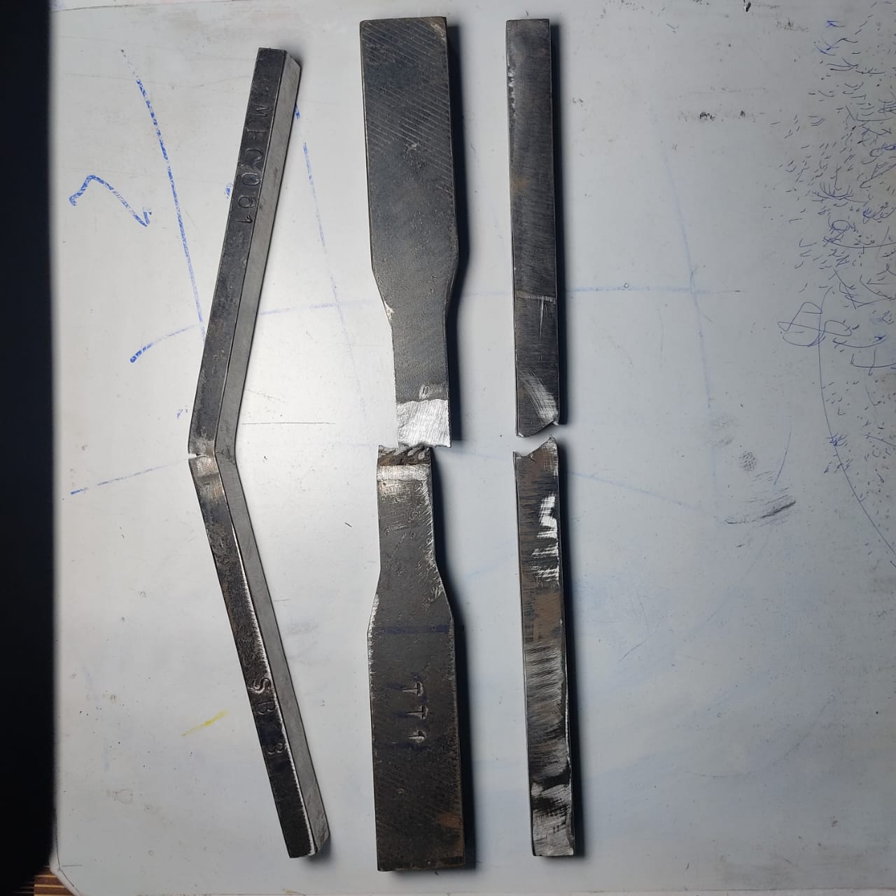

**Figure 3:** Bend tested material

**4.3 Radiographic Testing**

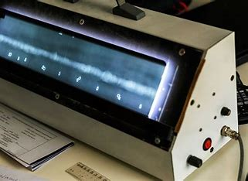

**Figure 4:** Radiographic Testing Machine

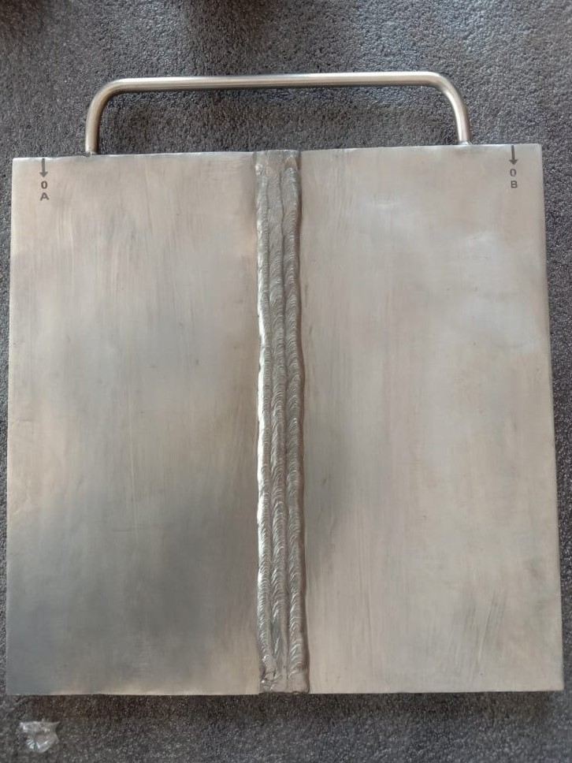

**Figure 5:** Radiographic Tested Material

**CONCLUSION**

The study of MIG-welded mild steel for making air compressors shows that maximization of welding parameters has a remarkable impact on mechanical properties. Tensile, bend, and radiographic tests were performed to assess weld quality. The tensile test results proved that the welded joint was very strong, maintaining durability in operational stresses. The bend test also confirmed the material's ductility since there were no cracks or defects visible, which would attest to its ability to flex and resist deformation. In addition, the radiographic test indicated that there were very few internal defects, such as porosity or inclusions, which affirmed a high-quality weld. The main goal of this research was to improve the mechanical behavior of MIG-welded mild steel for air compressor applications through optimization of heat input, filler material, and welding methods. The research indicates that under controlled welding parameters, the weld components' strength, structural integrity, and reliability can be drastically improved to qualify them for use in industries.

**5.** **REFERENCES**

[1] Abdul wahab H. Khuder and Esam J. Ebraheam, “Study the factors effecting on welding joint of dissimilar metals”, Al-Khwarizmi engineering journal, April (2011), Vol. 7, No. 1, pp. 76-81.

[2] Amit Kumar, Dr. R. S. Jadoun and Ankur Singh Bist, “Optimization of MIG welding parameters using Artificial Neural Network (ANN) and Genetic Algorithm (GA)”, International journal of engineering sciences & research technology, July (2014), Vol. 3, No. 7, pp. 614-620.

[3] Ajit Hooda, Ashwani Dhingra and Satpal Sharma, “Optimization of MIG welding process parameter to predict maximum yield strength in AISI 1040”, International journal of Mechanical engineering and Robotics research, October (2012), Vol. 1, No. 3, pp. 203-213.

[4] Balasubramanian V., Ravisankar V. and Madhusudhan Reddy G., “Effect of pulsed current welding on mechanical properties of high strength aluminum alloy", International Journal of Advanced Manufacturing Technology, (2008), Vol. 36, No. 2, pp. 254-262.

[5] C. N. Patel and Chaudhary, S., “Parametric Optimization of Weld Strength of Metal Inert Gas Welding and Tungsten Inert Gas Welding by using Analysis of Variance and Grey Relational Analysis”, International Journal of Research in Modern Engineering and Emerging Technology, (2013), Vol. 1, No. 3, pp. 125-154.

[6] Ghazvinloo H.R., Honarbakhsh-Raouf A. and Shadfar N., " Effect of arc voltage, welding current and welding speed on fatigue life, impact energy and bead penetration of AA6061 joints produced by robotic MIG welding". Indian Journal of Science and Technology, (2010), Vol. 3, No. 1, pp. 214-241.