Investigation of Mechanical Properties of

Aluminium Alloy 7075 Metal Matrix Composite

Reinforced With Silicon Carbide by Stir Casting

## Shaik Avinash Kapil1*, B.Jai Tej1, B.Sai Kotesh[1](#_bookmark2) , K.Dora Babu1, S.Vamsi1

Department of Mechanical Engineering

Godavari Institute of Engineering & Technology, Rajahmundry, Andhra Pradesh, India

*E-mail: avinashkapil343@gmail.com@gmail.com

**Abstract**

This paper deals with the comparison of mechanical properties of a metal matrix composite of AA7075 with SiC reinforcement, processed by the stir casting technique under 700°C with continuous stirring. The composites are cast, and the specimens are made using con-venational machining processes as per ASTM standards, followed by various mechanical tests.

The microstructural behaviour, tensile strength, compression strength, impact (Izod) test, the composites were tested for different reinforcement compositions of 0%, 5%, and 10%. The tensile strength, impact strength and Hardness have been observed to improve with an in-crease in the reinforcement percentage when compared to the base alloy. The 10% SiC+AA7075 gets the better values as compared to other compositions by the Mechanical Testing’s and their Results.

**Keywords**: Aluminium Alloy 7075 (AA7075), Silicon Carbide, Reinforcement, Metal Matrix Composites, Tensile test, Impact test, Hardness Test.

**1. Introduction**

Composite materials are engineered materials composed of two or more different constituents that combine to enhance the properties of the base matrix. In metal matrix composites (MMCs), the base material, which is typically a metal alloy, acts as the matrix, while the other constituent serves as reinforcement to improve mechanical properties. MMCs are widely used in aerospace, automobile, marine, and structural applications due to their superior strength, wear resistance, and high-temperature stability.

AA7075 is an aluminium alloy known for its high strength, excellent fatigue resistance, and superior corrosion resistance. It is primarily composed of aluminium, zinc, magnesium, and copper, making it one of the strongest aluminium alloys available. AA7075 is widely used in aerospace and high-performance automotive applications due to its exceptional strength-to-weight ratio.

Silicon carbide (SiC) is a ceramic material commonly used as a reinforcement in MMCs due to its high hardness, excellent thermal stability, and outstanding wear resistance. The incorporation of SiC particles into the AA7075 matrix enhances mechanical properties such as hardness, tensile strength, and wear resistance, making it an ideal choice for high-performance applications.

The reinforcement plays a crucial role in determining the mechanical properties, cost, and overall performance of the composite material. The SiC particles act as strengthening agents, improving the load-bearing capacity and stiffness of the composite. Additionally, SiC enhances thermal stability, making the composite suitable for applications requiring high-temperature resistance.

Composite materials consist of two distinct phases: the matrix phase and the reinforcement phase. The matrix phase provides ductility and toughness, while the reinforcement phase imparts strength and rigidity. The discontinuous phase, such as SiC particles, is harder and stronger than the continuous phase, which is the AA7075 matrix.

Stir casting is one of the most popular and widely used techniques for fabricating MMCs, including AA7075/SiC composites. In this process, the metal alloy is melted, and the reinforcement particles are introduced into the molten metal while stirring continuously to ensure uniform dispersion. The mixture is then poured into a Mold to solidify into the desired shape. Stir casting is preferred due to its simplicity, cost-effectiveness, and suitability for large-scale production.

Our specimen under goes Stir casting which is one of the most popular and widely used method in which material formation (mainly Metal Alloys and Metal Matrix Composites) and has been completed by melting metals and casting them into suitable shapes and sizes by pouring them into the mould cavities. It is also called as liquid metallurgy. After the stir casting process, the casted material goes for Mechanical Testing’s. And the Testing’s are tensile test, Hardness test and impact test. These testing’s are done with the American Society for testing and Materials (ASTM) Standards.

AA7075 reinforced with SiC is an advanced metal matrix composite with superior mechanical properties, making it highly suitable for demanding applications in aerospace, automotive, and structural industries. The stir casting process ensures a uniform distribution of reinforcement particles, leading to enhanced strength, durability, and performance of the composite material.

**2.1. Materials:**

**2.1. Aluminium Alloy 7075**

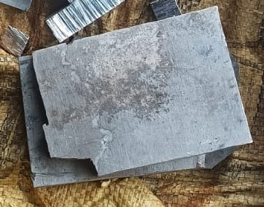In our present work, we used AA7075, a high-strength aluminium alloy known for its excellent mechanical properties and corrosion resistance. AA7075 is primarily composed of aluminium, with zinc as the primary alloying element, along with magnesium and copper for enhanced strength (Al-Zn-Mg-Cu). It is widely used in aerospace, automotive, and structural applications due to its high strength-to-weight ratio. The alloy is commonly processed through heat treatment to achieve superior hardness and durability. We procured AA7075 from Choudary Metal Industries Hyderabad (India) ensuring high-quality material for our research.

**Fig 1**. Aluminium Alloy 7075 Rectangular Plates

|  |  |  |  |  |  |  |  |  |  |  |
| --- | --- | --- | --- | --- | --- | --- | --- | --- | --- | --- |
| Element | Al | Mg | Si | Fe | Cu | Cr | Zn | Ti | Mn | Others |
| % by weight | 87.1-91.4 | 2.1- 2.9 | 0 –  0.4 | 0-  0.50 | 1.2-  2 | 0.18-  0.28 | 5.1-  6.1 | 0-  0.15 | 0-  0.2 | 0.05-  0.15 |

**Table 1.** Chemical Composition of Aluminium Alloy 7075(AA7075)

**2.1.2 Silicon Carbide**

In our present work, we used Silicon Carbide (SiC) with 99% purity, a high-performance ceramic material known for its exceptional hardness, thermal conductivity, and wear resistance. Silicon Carbide is a compound of silicon and carbon (SiC) and is widely used in applications requiring high strength, thermal stability, and resistance to chemical degradation. It is commonly utilized in abrasives, cutting tools, and reinforcement in composite materials. Due to its excellent mechanical and thermal properties, SiC is an ideal choice for high-performance engineering applications. We procured Silicon Carbide (99% purity) from Vedayukt India Pvt.Ltd in Jharkhand, ensuring high-quality material for our research.

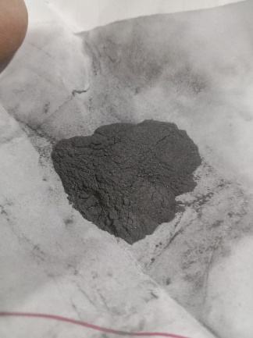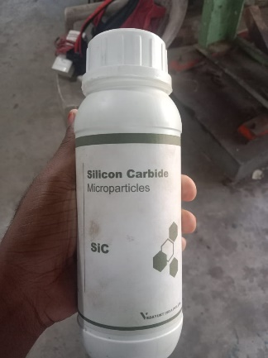

**Fig 2. Silicon Carbide Microparticles**

|  |  |  |
| --- | --- | --- |
| **Tensile Property** | **Value Range** | **Description** |
| Tensile Strength (MPa) | 200 – 500 MPa (bulk), up to 1 GPa (fiber) | High resistance to tensile loads, depending on form and processing. |
| Elastic Modulus (GPa) | 330 – 450 GPa | Provides high stiffness and rigidity under tension. |
| Fracture Toughness (MPa·m¹/²) | 3 – 5 MPa·m¹/² | Moderate resistance to crack propagation under tensile stress. |
| Poisson’s Ratio | 0.14 – 0.19 | Describes the material’s lateral strain response to tensile loading. |
| Tensile Strength (MPa) | 200 – 500 MPa (bulk), up to 1 GPa (fiber) | High resistance to tensile loads, depending on form and processing. |

**Table 2.** Properties of Silicon Carbide (SiC)

**3. Methodology**

**3.1 Die Preparation**

The present work, I had used Mild Steel Die for the Casting Process to get the moulds. Die casting is a metal casting process that is characterized by forcing molten metal under high pressure into a mould cavity. The die preparation plays a major role in casting process and also some of the properties of the material may depends on the material of the die and the dimensions of the die.Mild steel was chosen for the die material due to its good machinability, durability, and cost-effectiveness.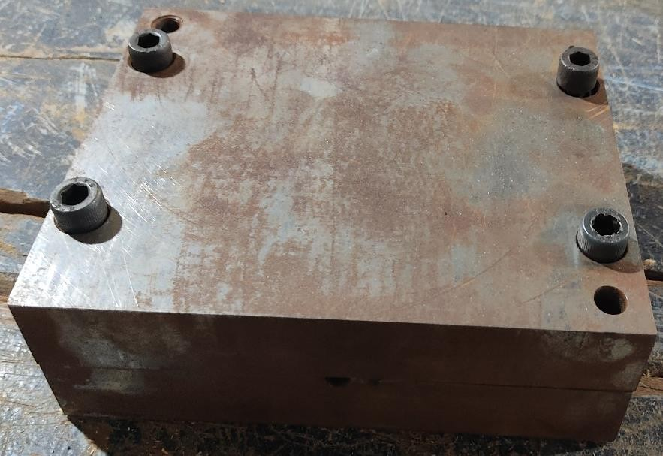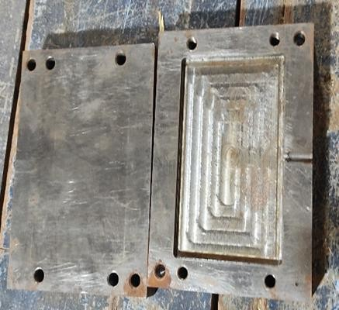

**Fig. 3**. Metallic Die

**3.2 Pre Heating of Reinforcement Material**

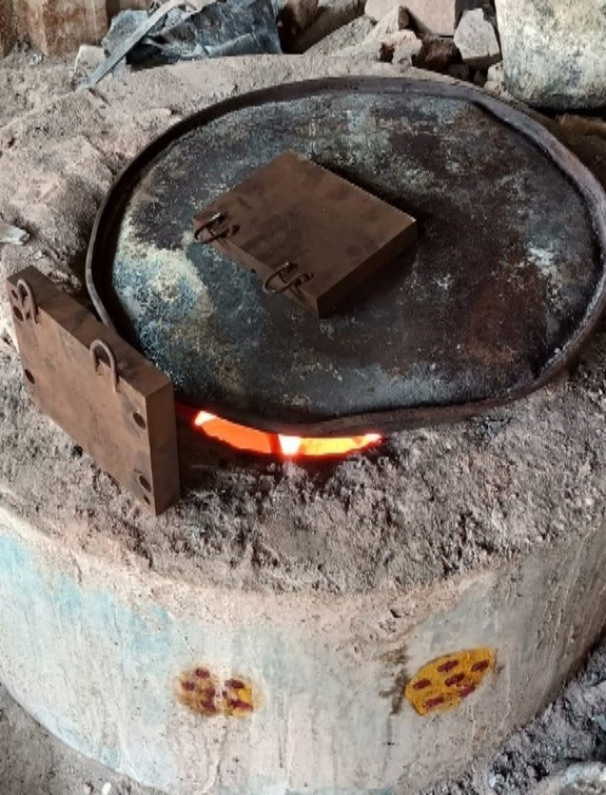I had Preheated the reinforcement material (SiC) to 500°C for 60 minutes is to enhance its compatibility with the molten metal matrix, ensuring improved bonding and uniform dispersion within the composite. Preheating eliminates moisture, volatile impurities, and surface contaminants, preventing defects such as porosity and weak interfacial adhesion.

**Fig. 4**. Preheating of Reinforcement Material (SiC)

**3.3. Melting of Matric Material**

AA 7075 metal has to be melted under melting temperature of 5500C to 7000C for the phase change of solid state to molten or liquid state.

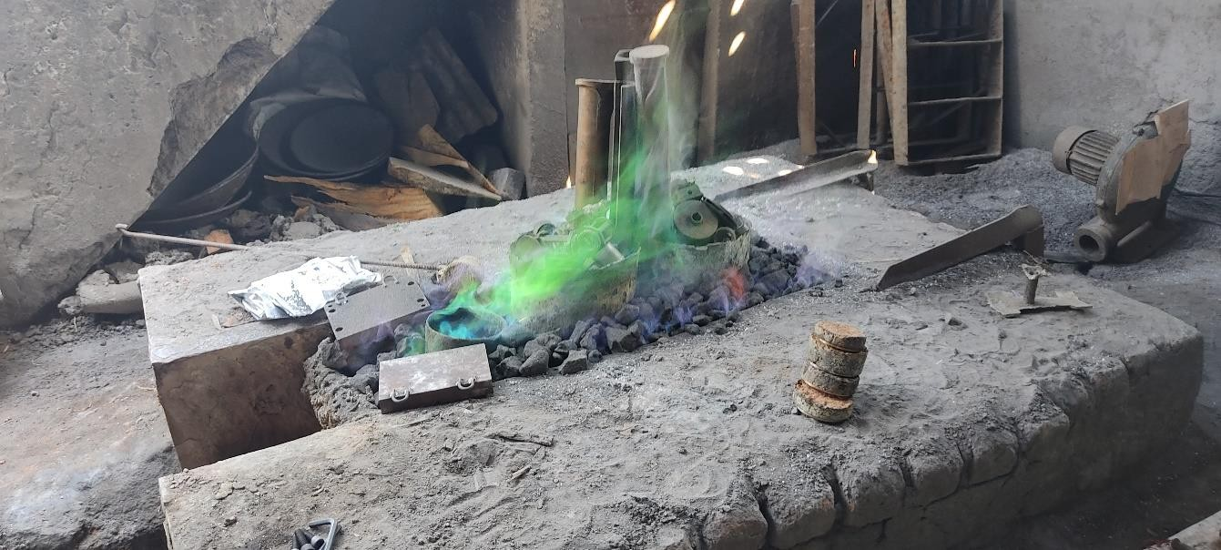**Fig.5.**Melting of Matrix Material

**3.3 Stirring of Reinforcement Material by using Stirrer**

After the melting of the molten metal, the molten metal has to stirred by means of the stirrer for mixing of all the compositions in the AA7075, it should be done co continuously throughout the process for less solidification rate. continuously through throughout the process for less solidification rate. out the process for less solidification rate.

**3.4 Feeding of Reinforcement Material**

In the continuous stirring process, the Preheated reinforcement has to be feeded by varying the percentages for a composite material.

**3.5 Pouring of Molten Metal with Stirred Reinforced Material in the Mould**

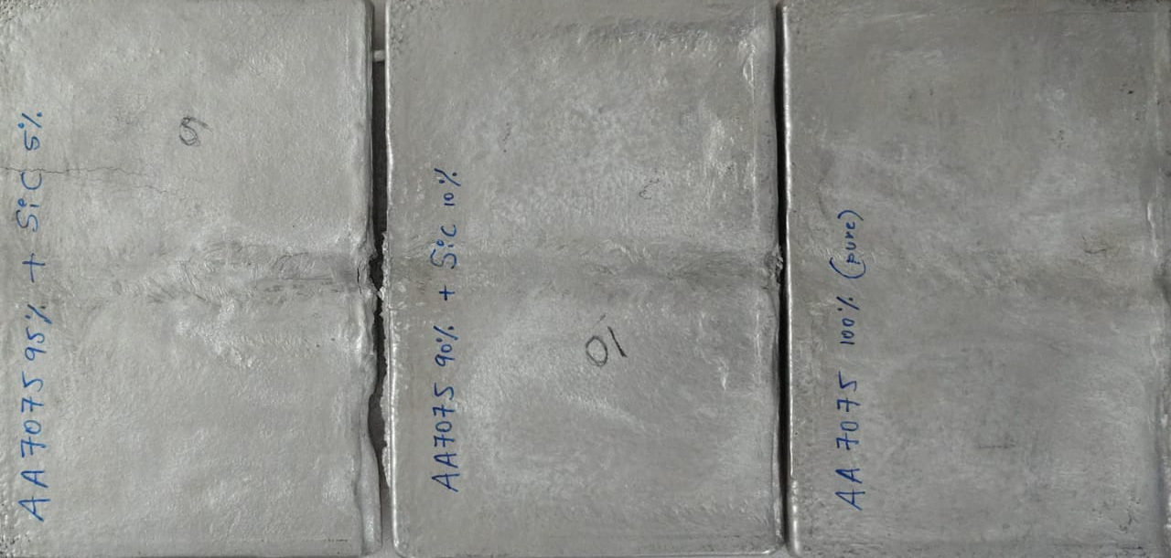After proper stirring of molten metal containing the reinforcement, then the mixture is transferred to die to get the required shape and get solidified.

**3.6 Extraction of Plates**

After the solidification the plates takes place then the plates have to be extracted, repeat this process for different compositions as 0% ,5% and 10% for finding of the required values.

**Fig. 6**. Extraction of Plates (0%,5% and 10%)

**3.7 Specimens Making**

After the completition of the Stir Casting process, there have to prepare specimens for making of necessary tests on the certain specimen by Converting the casted plate into the ASTM Standards to do the required test to get the physical properties and microscopic analysis of the materials.

**5. Results & Discussion**

The project work progress is started with mould (die) making (completed) followed by stir casting and then specimen is made out. Testings on the Specimens are completed, the mechanical test i.e. Tensile test, Impact test and hardness test values are listed below.

**5.1 Tensile Test Report**

|  |  |  |  |
| --- | --- | --- | --- |
| TENSILE TEST REPORT | | | |
| Specimen | Tensile strength (N/mm2) | Percentage Elongation (%) | Yield Strength (N/mm2) |
| AA7075 + 0% SiC | 84.959 | 1.24 | 79.618 |
| AA7075 + 5% SiC | 10.474 | 2.66 | 9.951 |
| AA7075 + 10% SiC | 103.290 | 1.08 | 93.967 |

Table 3 shows the Tensile Test Report, Percentage elongation, Yield strength of the Specimens with different compositions which has done the tensile testings of ASTM standards.

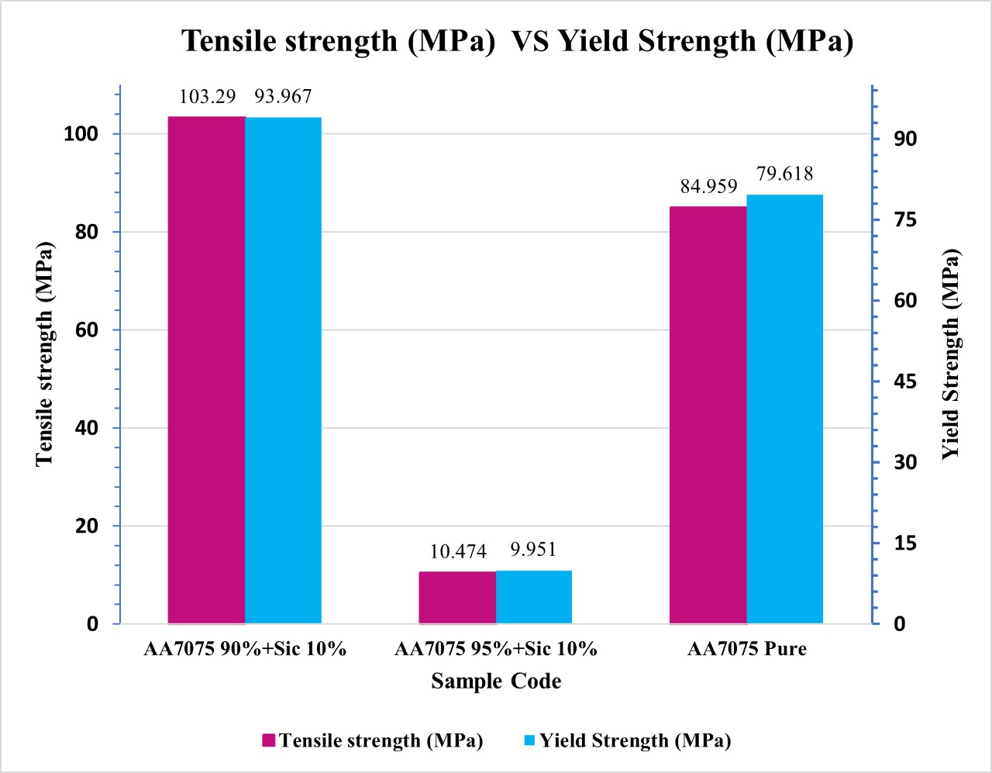**Table 4:** Tensile Test report

**Fig7:** Graphical Representation of Tensile Strength vs Yield Strength

**5.1 Impact Test Report**

Table 3 shows the Impact (Charpy) Test Report, Impact Strength (J) of the Specimens with different compositions which has done the Impact Test of ASTM standards.

|  |  |
| --- | --- |
| IMPACT TEST REPORT | |
| **Specimen** | **Impact Strength (J)** |
| AA6061 + 0% SiC | 0.8 |
| AA7075 + 5% SiC | 0.6 |
| AA7075 + 10% SiC | 0.8 |

**Table 3:** Impact Test Report

**5.1 Hardness Test Report**

Table 3 shows the Hardness Test Report, Percentage elongation, Yield strength of the Specimens with different compositions which has done the Impact Test of ASTM standards.

|  |  |  |  |
| --- | --- | --- | --- |
| HARDNESS TEST REPORT | | |  |
| S.NO. | AA7075 + 0% SiC | AA7075 + 5% SiC | AA7075 + 10% SiC |
| HARDNESS VALUE [HV 5] | HARDNESS VALUE [HV 5] | HARDNESS VALUE [HV 5] |
| 1 | 123 | 104 | 111 |
| 2 | 122 | 106 | 112 |
| 3 | 121 | 105 | 110 |
| AVG | 122 | 105 | 111 |

**Table 4:** Hardness Test Report

**6. Conclusions**

By this present work on Metal matrix composite of AA7075+SiC reinforcement, the following conclusions has been obtained

* By comparing the Compositions done with the stir casting process, the Tensile properties have been increased.
* The Impact test properties has been varying with respect to the percentage of reinforcement.
* In this the hardness test properties have been varying with respect to the percentage of reinforcement.
* At last, I conclude that 10% SiC+AA7075 has the better results compared to other compositions as per the testings and their Results. And the Tensile test Value for 10% is 103.290 Mpa, Impact test values is 0.8 and Hardness value is 111.

**References**

1. Xing, S., Sun, J., Zhang, C., Shou, H., Jia, L., & Lv, N. (2025). Effect of joining material direction on material flow, microstructure and mechanical properties of dissimilar AA2024/7075 joints fabricated by friction stir welding. *Journal of Materials Research and Technology*. <https://doi.org/10.1016/j.jmrt.2025.02.007>.
2. Laghari, R. A., Jamil, M., Laghari, A. A., & Khan, A. M. (2025). Material characteristics and machinability of metal matrix composite materials: A critical review on recent advances and future perspectives. *Measurement*, *242*, 115839. <https://doi.org/10.1016/j.measurement.2024.115839>.
3. Sravanthi, C., Gajanana, S., Krishnaiah, A., & Venkateswarlu, C. (2024). Mechanical, microstructure and machining characteristics of alloying elements optimized Al 7075 alloy modified with reinforcement-Silicon Carbide. *Advances in Materials and Processing Technologies*, 1-21. <https://doi.org/10.1080/2374068X.2024.2307249>.
4. Khan, F., Hossain, N., Mim, J. J., Rahman, S. M., Iqbal, M. J., Billah, M., & Chowdhury, M. A. (2024). Advances of composite materials in automobile applications–A review. *Journal of Engineering Research*. <https://doi.org/10.1016/j.jer.2024.02.017>.
5. Ren, Q., Yue, Z., Soyarslan, C., Tan, Z., Yuan, F., & Li, Z. (2024). A coupled ductile damage model for metal matrix composites: Development and application. *Composites Part B: Engineering*, *272*, 111229. <https://doi.org/10.1016/j.compositesb.2024.111229>.
6. Fenny, A. S. D., Anand, T., & Mayekar, N. B. Manufacturing and characterization of mechanical characteristics of stir casting method produced aluminium based metal matrix composite AA6061/ZrO2/SiC. *Materials Today: Proceedings*. <https://doi.org/10.1016/j.matpr.2024.04.002>
7. Udensi, S. C., & Anioke, M. A. (2024). An In-Depth Investigation Of Factors Responsible For Optimal Performance In Stir-Cast Aluminium Metal Matrix Composites. *Scientific African*, e02452. <https://doi.org/10.1016/j.sciaf.2024.e02452>.
8. Gurmaita, P. K., Pongen, R., & Gurmaita, S. K. (2024). A7075 alloy reinforced metal matrix composites fabricated through stircasting route: A review. *International Journal of Cast Metals Research*, *37*(3), 208-255. <https://doi.org/10.1080/13640461.2024.2355634>.
9. Raj, R. A., Sekar, S., Jayakumar, K. S., Prakash, K., & Prabu, D. A. (2024). Optimization on stir casting process parameters of Al7050 based composites using Taguchi technique. *Materials Today: Proceedings*. <https://doi.org/10.1016/j.matpr.2024.03.035>.
10. Sharma, S. K., Saxena, K. K., Salem, K. H., Mohammed, K. A., Singh, R., & Prakash, C. (2024). Effects of various fabrication techniques on the mechanical characteristics of metal matrix composites: A review. *Advances in Materials and Processing Technologies*, *10*(2), 277-294. <https://doi.org/10.1080/2374068X.2022.2144276>.
11. Marode, R. V., Lemma, T. A., Sallih, N., Pedapati, S. R., Awang, M., & Hassan, A. (2024). Research progress in friction stir processing of magnesium alloys and their metal matrix surface composites: evolution in the 21st century. *Journal of Magnesium and Alloys*. <https://doi.org/10.1016/j.jma.2024.06.007>.
12. Nandal, R., Jakhar, A., & Duhan, R. K. (2023). Review on synthesis of AA 6061 metal matrix alloy using stir casting method. *Materials Today: Proceedings*, *78*, 462-468. <https://doi.org/10.1016/j.matpr.2022.10.268>.
13. Mishra, A. K., Kumar, V., & Pathak, B. N. (2023). Al 6061hybrid metal matrix composites with SiC & Al2O3 using stir casting: A review. *Materials Today: Proceedings*. <https://doi.org/10.1016/j.matpr.2023.05.165>.
14. Bhanuprakash, L., Manikandan, N., Varghese, L., & Joseph, J. (2023). Study on aluminium metal matrix composites reinforced with SiC and granite powder. *Materials Today: Proceedings*. <https://doi.org/10.1016/j.matpr.2023.06.246>.
15. Deshmukh, S., Ingle, A., & Thakur, D. (2023). Optimization of stir casting process parameters in the fabrication of aluminium based metal matrix composites. *Materials Today: Proceedings*. <https://doi.org/10.1016/j.matpr.2023.08.023>.
16. Mishra, D., & Nanda, A. K. (2023). Experimental investigation on mechanical properties of stir casted aluminum SiC metal matrix composites. *Materials Today: Proceedings*, *74*, 1023-1027. <https://doi.org/10.1016/j.matpr.2022.11.412>.
17. Singh, B., Kumar, I., Saxena, K. K., Mohammed, K. A., Khan, M. I., Moussa, S. B., & Abdullaev, S. S. (2023). A future prospects and current scenario of aluminium metal matrix composites characteristics. *Alexandria Engineering Journal*, *76*, 1-17. <https://doi.org/10.1016/j.aej.2023.06.028>.
18. Youssef, H. A., El-Hofy, H. A., & Ahmed, M. H. (2023). *Manufacturing technology: materials, processes, and equipment*. Crc Press. <https://doi.org/10.1201/9781003373209>.
19. Khalid, M. Y., Umer, R., & Khan, K. A. (2023). Review of recent trends and developments in aluminium 7075 alloy and its metal matrix composites (MMCs) for aircraft applications. <https://doi.org/10.1016/j.rineng.2023.101372>.
20. Sun, J., Ye, D., Zou, J., Chen, X., Wang, Y., Yuan, J., ... & Bai, J. (2023). A review on additive manufacturing of ceramic matrix composites. *Journal of Materials Science & Technology*, *138*, 1-16. <https://doi.org/10.1016/j.jmst.2022.06.039>.
21. Kirubakaran, J., Divahar, S. R., Dhas, J. E. R., Lewise, K. A. S., & Anand, A. V. (2022). Wear behavior analysis of aluminium composites using Taguchi approach. *Materials Today: Proceedings*, *64*, 345-351. <https://doi.org/10.1016/j.matpr.2022.04.694>.