**DECENTRALIZED VOTING APPICATION**

**K. Laxmidhar Reddy1 , K. Sai Kumar2, MD. Zaid Aiyan3, M. Vasavi4**

1UG Scholar, CVR College of Engineering/Cybersecurity Department, Hyderabad, India

Email: kothakapu.laxmidhar@gmail.com

2UG Scholar, CVR College of Engineering/ Cybersecurity Department, Hyderabad, India

Email: ksaikumart123@gmail.com

3UG Scholar, CVR College of Engineering/ Cybersecurity Department, Hyderabad, India

Email: zaidaliyan26@gmail.com

4Sr.Asst. Professor, CVR College of Engineering/ Cybersecurity Department, Hyderabad, India

Email: m.vasavi@cvr.ac.in

**ABSTRACT**

Conventional voting systems have several security and transparency problems such as vote tampering, non-anonymity of the voters, and cost of operation. A decentralized voting application based on blockchain provides a transparent, tamper-proof, and secure voting process. Smart contracts ensure that votes are immutably stored in a distributed ledger, minimizing fraud and manipulation risks. This paper proposes a decentralized electoral process that elevates the integrity of elections by relying on cryptography authentication, transparency, and automation. The proposed solution excludes centralized powers, rendering the electoral process trustless and unbiased.

**Keywords:** Blockchain, Ethereum, Smart Contracts, Voting, Cybersecurity.

**I. INTRODUCTION**

Elections are the foundation of democracy because they provide citizens with an opportunity to select their representatives and dictate the policies of government. Nevertheless, the purity of electoral systems has been questioned worldwide because votes are said to have been manipulated, tampered with, and conducted without transparency. Such old-fashioned methods of voting such as paper-based systems and electronic voting machines (EVMs) have many limitations that raise suspicions about the integrity of electoral outcomes. Paper voting is generally ineffective, error-prone, and tamperable, whereas EVMs are hackable or suffer from design failures. Furthermore, centralized internet-based voting systems have the weakness of being vulnerable to data compromise, unauthorized access, and dependency on a trusted third party, who might not always be impartial.

A decentralized voting system using blockchain offers a revolutionary solution to these problems. Blockchain, a distributed ledger technology, offers immutability, transparency, and security by recording transactions in a decentralized way. Blockchain is tamper-evident and resistant to unauthorized modification, unlike other databases, making it a strong contender for election security. Through the utilization of smart contracts on the Ethereum blockchain, the proposed new voting system is able to record votes automatically, verify them, and count them independently of human interference. This eliminates the potential for fraud, boosts the trust of the voters, and delivers verifiable real-time results.

One of the largest advantages of using blockchain in voting is that it can provide verifiability transparently without compromising the anonymity of the voters. The vote is saved securely as a transaction such that no one can alter or remove it after voting. Cryptography boosts security to voter authentication to ensure that unauthorized parties are unable to vote during an election. Decentralization in blockchain also gets rid of a single governing authority, reducing susceptibility to prejudice or system failure.

interference capable of corrupting the election.

This paper will discuss a blockchain-based voting system that surpasses the shortcomings of existing systems with a reliable, open, and secure voting process. The system that is suggested here is scalable and will be able to be implemented in most election scenarios, like government elections, business decision-making, and social voting. In addition, this article will discuss the issues with blockchain voting, including scalability, transaction fees, and user adoption challenges. By solving these challenges, the research hopes to help develop a more secure and reliable digital voting system for the future.

**II. LITERATURE REVIEW**

**2.1 Current Voting Systems**

Traditional voting systems have been the backbone of democratic elections for decades. Among them are paper-based voting, electronic voting machines (EVMs), and internet-based voting systems. However, each of them possesses its own weakness. Paper ballots, as ubiquitous as they are, are prone to physical tampering, ballot stuffing, and counting errors. EVMs, while more efficient, have come under attack for potential security breaches, hacking hazards, and non-verifiability. Internet-based voting systems, especially the centralized ones, are prone to hacking, unauthorized use, and data tampering.

Several research papers have identified the drawbacks of these systems. Such systems have been described to be affected by the flaw of requiring one to have faith in the authority in power over them, and punishment for being manipulated or biased. In e-voting platforms, anonymity for voters is easily compromised, open to monitoring and privacy invasion. The inefficacy of the system necessitates an improved system that is safer, more transparent, and non-tamperable, and this is what blockchain technology is positioned to provide.interface and proper education to implement on a large scale.

• Security Issues: Blockchain itself is secure but vulnerabilities in smart contracts can be exploited against it if not audited properly. Proper security measures should be followed to prevent attacks.

•Regulatory Problems: Strong laws in most countries regarding electronic voting systems would mean that using blockchain-based voting would require policy and legal directives.

•Transparency vs. Confidentiality: Even though blockchain allows transparency, the creation of secrecy for voters while preventing the revelation of individual ballots is a highly complex task requiring highly advanced cryptographic techniques like zero-knowledge proofs (ZKPs).

Despite these constraints, research has started to address these challenges, and blockchain voting continues to evolve as an effective solution to secure and verifiable elections. The following sections will present the proposed methodology and implementation details of our blockchain-based decentralized voting system.

**2.2 Voting Systems with Blockchain**

Blockchain technology has revolutionized several sectors and its adoption in voting systems is gaining crucial attention. A blockchain voting system employs distributed ledger technology to record votes irreversibly, ensuring security and transparency. Smart contracts simplify essential procedures such as vote verification, authentication, and counting, minimizing the use of intermediaries.

Previous research has shown the potential of blockchain voting systems to prevent fraud and enhance voter confidence. For example, a research on Ethereum-based voting systems demonstrated how decentralized smart contracts make election authorities redundant, thereby making elections more trustless. Another research demonstrated the benefits of using cryptographic techniques to maintain voter anonymity while providing public verifiability of election results.

While its advantages, blockchain voting is not without issues. Some of the most important issues are high gas costs/transaction fees, non-scalability due to network congestion, and potential weaknesses in smart contract coding. Researchers have suggested employing Layer 2 solutions such as rollups and sidechains to circumvent these issues. In addition, integrating biometric authentication procedures into blockchain can facilitate more secure voter identification without sacrificing decentralization.

**2.3 Disadvantages of Existing Solutions**

While blockchain voting systems are potentially revolutionary in terms of disrupting how things are typically done, there are also a number of challenges that must be addressed:

•Scalability Challenges: Public blockchain networks such as Ethereum suffer from congestion when heavily used, resulting in the delay of processing votes and higher transaction costs.

• Adoption by Users: Users are unaware of blockchain, hence difficult to implement on a large scale. It needs to have a user-friendly

**III. IMPLMENTATION AND TESTING**

**4.1 Technology Stack**

The Decentralized Voting Application is developed by integrating blockchain technology, smart contracts, and web technologies for providing an immutable and secure voting solution. The major technologies used in the project are:

•Frontend: React.js for an interactive and dynamic voting interface.

•Backend: Node.js and Express.js for API request processing and server logic.

•Blockchain: Ethereum network with Solidity smart contracts for vote verification and vote storage.

• Storage: IPFS for distributed storage, MongoDB for storage of other metadata.

• Smart Contract Development: Solidity contracts for vote authentication, casting, and result computation.

**4.2 Smart Contract Deployment**

Smart contract guarantees persistence and immutability of the voting process. It is deployed in the Ethereum test network (e.g., Rinkeby) and guarantees:

• Safe and transparent voting.

• Prevention of attempts of double voting.

• Automatic vote calculation and result announcement.

The contract is deployed on Solidity and tested with tools such as Truffle and Ganache. The functionality implemented on the contract is as follows:

• RegisterVoter(): Signs up prospective voters on the blockchain.

• CastVote(): Allows a registered member to cast a vote.

• CountVotes(): Tallies votes and decides on election outcomes.

**4.3 System workflow**

1.Voter Registration: They register and validate their identity securely with cryptographic verification.

2.Voting: Their votes stored permanently in the blockchain can be cast by authenticated users.

3. Voting checking: Smart contract checks every one of the voters whether he voted once.

4. Result calculation: Results are calculated and displayed immediately at the end of the vote.

5. Verification and Transparency: Results can be independently verified by anyone of the interested parties using blockchain explorers.

**4.4 Security Measures**

Security and integrity are ensured using:

• Public-Key Cryptography: Secures voter authentication and avoids identity theft.

• Decentralized Ledger: Avoids single points of failure and unauthorized vote tampering.

• Hashing Mechanisms: Keeps votes encrypted and safely stored.

**4.5 Test Strategy**

The system is well-tested both functionally and for security:

• Unit Testing: Truffle framework utilized for executing smart contract function tests.

• Security Testing: MythX vulnerability scanning to determine potential exploits.

• Functional Testing: Frontend interactions are tested using Cypress for a seamless user experience.

**4.6 Challenges and Improvements**

Although the implementation shows dramatic improvements over existing voting systems, there are some challenges:

• Scalability Challenges: Ethereum gas prices can escalate during times of high network demand.

• User Awareness: The majority of users are not aware of blockchain transactions, and additional learning is required.

• Confirmation Latency of Transactions: Blockchain confirmation duration can cause minimal latency in registering votes. In the future, Layer 2 scaling solutions, biometric identification, and cross-blockchain interoperability will be added to improve scalability and user-friendliness.

**IV. RESULTS AND DISCUSSION**

**Figure 5.1**: Front Page of the Decentralized Voting Application. This page serves as the entry point for users, providing essential navigation elements for voter authentication and interaction with the system. The interface includes options for User Registration, Login, and Election Information, ensuring a seamless user experience.

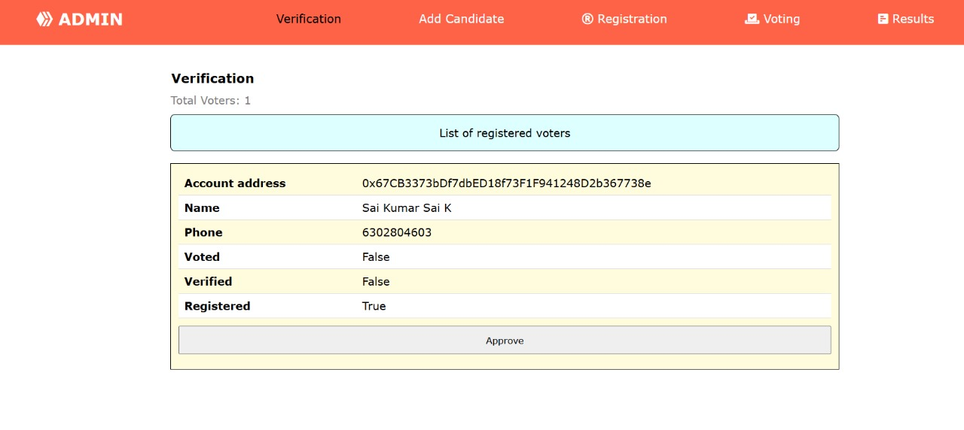

**Figure 5.2:** Adding New Candidates functionality in the Decentralized Voting Application. This feature allows election administrators to register candidates securely on the blockchain before the voting process begins. The system ensures that only authorized personnel can add candidates, preventing unauthorized modifications and ensuring election integrity.

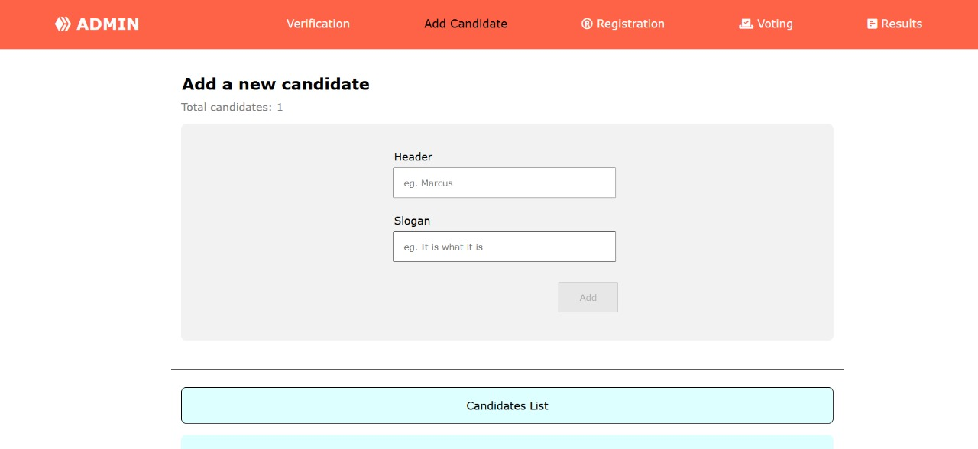

**Figure 5.3**: Voter Registration process in the Decentralized Voting Application. This feature ensures that only eligible voters are registered, maintaining the integrity of the election process while leveraging blockchain security.

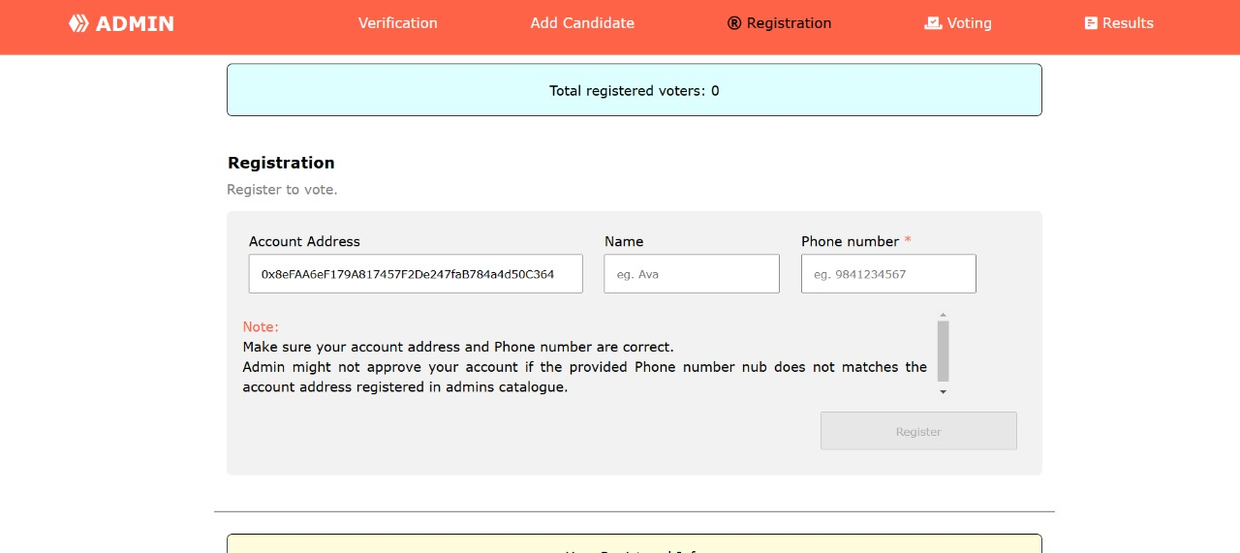

**Figure 5.4:** The Result Page in the Decentralized Voting Application displays the final election outcomes in a secure, transparent, and verifiable manner. Once the voting period concludes, smart contracts automatically compute and publish the results on the blockchain, ensuring no human interference in the process.

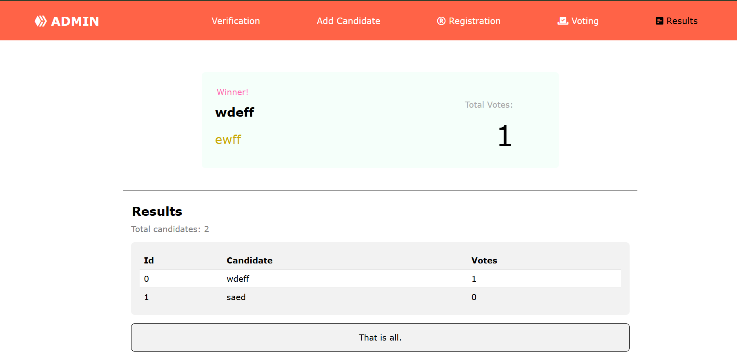

**Figure 5.5:** The Result Page in the Decentralized Voting Application displays the final election outcomes in a secure, transparent, and verifiable manner. Once the voting period concludes, smart contracts automatically compute and publish the results on the blockchain, ensuring no human interference in the process.

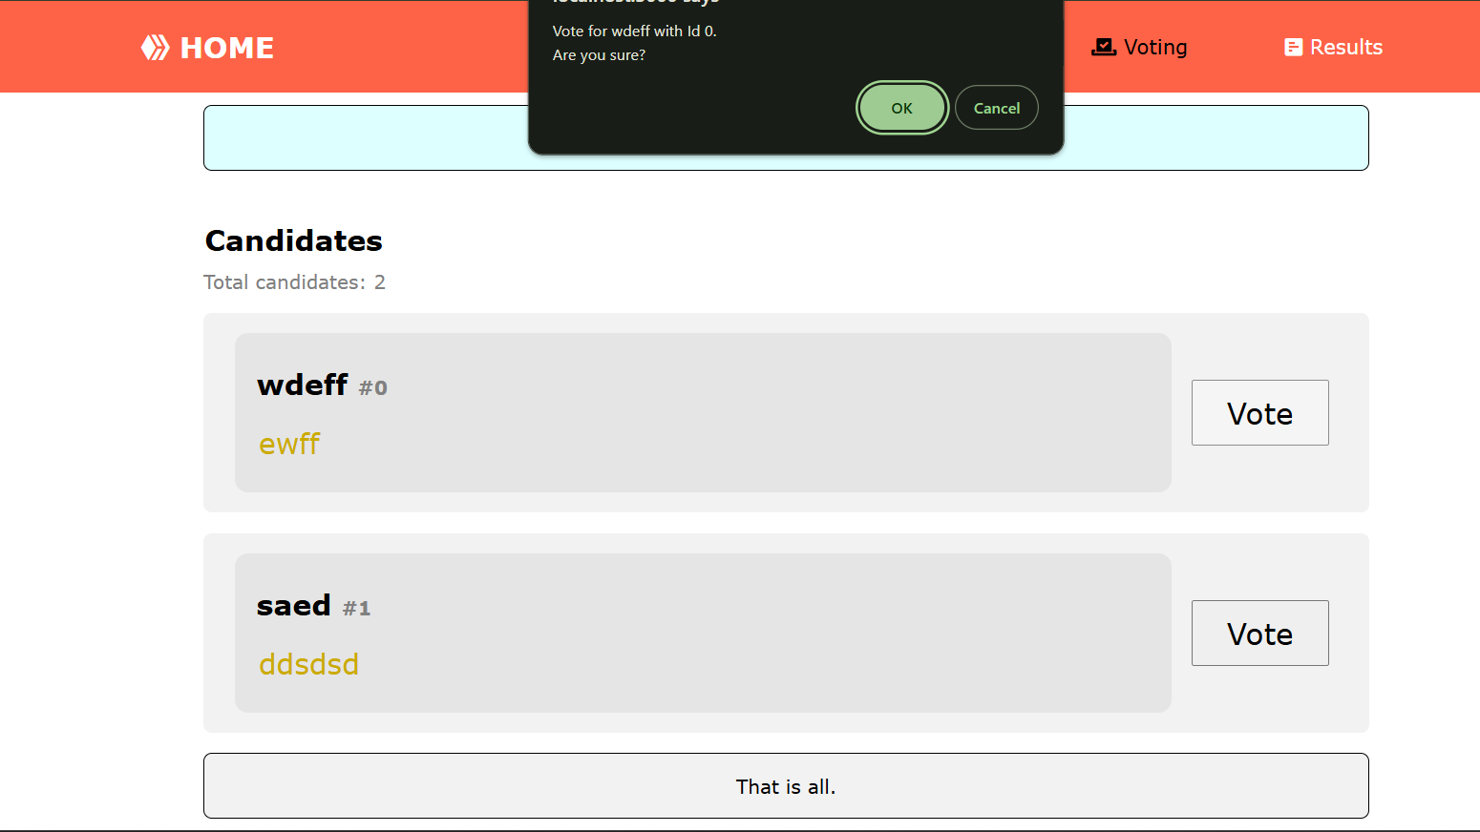

**V. CONCLUSION**

Blockchain technology has proven its potential to transform many industries, and its use in voting systems is a huge step towards ensuring secure, transparent, and tamper-proof elections. The decentralized voting application envisioned in this paper is well placed to solve the most important issues of conventional voting systems, such as vote tampering, transparency, and security issues. Leveraging Ethereum smart contracts, the system automatically logs, authenticates, and counts votes while removing intermediaries. This boosts voter assurance and enables a trustless voting mechanism.

Furthermore, the unchangeable nature of the blockchain prevents any illegal modifications, and the votes are checked and logged. The cryptography techniques of the system preserve the anonymity of voters while upholding the open and transparent nature of the voting process.

While the system enjoys its advantages, it is not without flaws either, some of which are scalability, fees for transactions, and potential entry barriers to adoption by users. But with future advancements in blockchain technology, such as Layer 2 scaling solutions and zero-knowledge proofs, such issues can be solved and blockchain-based voting can be made more feasible for mass-scale deployment.

Future Scope

Though the system is able to effectively improve the security and transparency of elections, there is room

for improvement:

**• Scalability Improvements:** Applying Layer 2 solutions such as rollups to lower gas fees and latency in transactions.

• **Biometric Authentication Integration:** Integrating blockchain with biometric authentication (e.g.,

fingerprint or face recognition) for improving voter security.

• **Cross-Blockchain Compatibility:** Adding support for various blockchain networks within the system to

improve flexibility.

• **Mobile Voting:** Creating a decentralized mobile voting application for easier accessibility.

**• Election Monitoring Using Artificial Intelligence:** Adopting AI-powered fraud detection algorithms to

detect fraudulent voting patterns.

Through ongoing research and improvement in technology, blockchain-based voting systems can reimagine electoral processes in the world, providing democratic elections that are verifiable, secure, and fair.

**VI. REFERENCES**

[1] Nakamoto, S. (2008). "Bitcoin: A Peer-to-Peer Electronic Cash System." Available: https://bitcoin.org/bitcoin.pdf

[2] Buterin, V. (2013). "Ethereum Whitepaper: A Next-Generation Smart Contract and Decentralized Application Platform." Available: https://ethereum.org/en/whitepaper/

[3] Moubarak, M., Filiol, E., & Chamoun, M. (2018). "Blockchain-Based Electronic Voting System." International Conference on Cyber Security.

[4] Yavuz, E., Kaan Koc, A., Kaya, M., & Dalkilic, G. (2018). "Towards Secure E-Voting Using Ethereum Blockchain." IEEE Computer Society.

[5] Hirano, T., & Fujiwara, H. (2018). "A Secure and Transparent E-Voting System using Blockchain Technology." Journal of Information Security.