****Advancing Marine Biodiversity Monitoring: A Hybrid Deep Learning And Machine Learning Framework Leveraging Resnet Feature Extraction With Random Forest And Knn Classifiers****

Amit Kumar Pandey1, Dr. Santosh Kumar Singh2, Bewnak Umair3, Shaikh Usman4

1Assistant professor, Department of IT, Thakur College of Science and Commerce, Thakur Village,

Kandivali (East), Mumbai, Maharashtra, India

2H.O.D, Department of IT, Thakur College of Science and Commerce, Thakur Village, Kandivali

(East), Mumbai, Maharashtra, India

3,4PG student, department of IT, Thakur College of Science and Commerce, Thakur Village,

Kandivali (East), Mumbai, Maharashtra, India

1[amitpandey8089@gmail.com](mailto:1amitpandey8089@gmail.com), [2sksingh14@gmail.com](mailto:2sksingh14@gmail.com), [3ummuhajwane@gmail.com](mailto:3ummuhajwane@gmail.com),

[4imusman46@gmail.com](mailto:4imusman46@gmail.com)

**Abstract**

### Marine species classification is one such critical endeavor spanning across biodiversity conservation and ecological studies, fully embracing the current high urgency in establishing useful instruments for the constant surveillance of ocean ecosystems. Unfortunately, traditional classification methods tend to fall short due to factors such as varied underwater conditions or light and limited annotated data. Thus, this research proposes a new hybrid approach, mixing deep learning with machine learning to improve classification accuracy. Basically, a pre-trained ResNet model is set as the feature extraction technique, then followed in turn by RF and KNN classification methods. The dataset incorporates the representation of three marine species—jellyfish, otters, and sharks—and its augmentation is applied as an advanced technique in order to be robust. The hybrid methodology applies the meaningful feature mapping with its ResNet18 and ResNet50 and is offered for prediction using RF and KNN classifiers. Though huge experimentation clearly suggested an accuracy value of 95.97% by the Random Forest classifier and 98.66% by the KNN classifier. Comprehensive evaluation metrics, including confusion matrices, precision, recall, and F1-score, have shown a balanced performance of the models across all classes. Finally, the visualization of predicted and actual classifications provides insight into the model's reliability. This research demonstrates the efficiency of combining deep-learning-based feature extraction with machine learning classifiers to classify marine species, building an enormous foundation for hybrid models implemented in ecology work, thus allowing sizeable and accurate biodiversity remediation systems. For the next task, this method will be extended by larger datasets, alongside the construction and integration of other classifiers for better performance.

**Keywords**

Marine species classification, deep learning, machine learning, ResNet18, ResNet50, Random Forest (RF), K-Nearest Neighbors (KNN), hybrid models, feature extraction, data augmentation, biodiversity conservation, accuracy metrics, precision and recall, F1-score, confusion matrix.

**1. Introduction**

**Marine ecosystems are vital in holding ecological balance and supporting various forms of life. They contribute immensely to the stability of the global environment in climate regulation and food provision and to economic activities such as fisheries and tourism. Due to human impacts such as over-exploitation, pollution, and habitat degradation, besides the general adverse impacts of climate change, these ecosystems have continuously suffered from degradation. This has affected marine biodiversity, calling for rapid monitoring and classification of marine species as an utmost priority for conservation efforts. For classification of marine species, this allows scientists and conservationists to assess ecosystem health, follow population trends, and observe environmental change leading to potential species extinction. Although traditionally species classification revolves around identifying from images or observations in the field, they have been slow, prone to error, and thus do not allow the use of such techniques over large-scale datasets. This hence warrants the development of automatic systems that yield accuracy in species classification. Recent advances in machine learning and deep learning have changed others and are building up some modern and state-of-the-art solutions in species identification. Machine learning algorithms add an advantage in flexibility and interpretability to their approaches; on the other hand, deep learning models, especially in the case of Convolutional Neural Networks (CNNs), have the ability to extract very complicated hierarchical features out of images. Deep learning models are an attractive class of solutions that are well-suited to automating species identification in underwater images. However, the model must be able to adapt well to effects such as differences in the lighting conditions, occlusion by other species, or even appearance alterations given the diverse environment underwater.**

**This research tackles these challenges with a hybrid method that incorporates the feature extraction abilities of deep learning with the classification power of classic machine learning. More specifically, deep vision tools such as the pre-trained ResNet model, like ResNet18 and ResNet50, are being used to extract meaningful feature information from underwater images. The machine learning classifiers utilized to classify the features extracted include Random Forest and KNN. This approach takes advantage of the strengths of convolutional neural networks in improving feature extraction along with the simplicity of integrating machine learning classifiers and performing highly accurate and scalable classification. The primary aim is to take advantage of pre-trained ResNet models for feature extraction of marine species images that include jellyfish, otters, and sharks. The features extracted would then be classified into different species using the RF and KNN classifiers. More so, metrics such as accuracy, precision, recall, and F-score are used to further evaluate the hybrid model builds. Among other challenges in marine species classification are the issues of limited labeled data and variability from underwater imaging. It is believed that at the end of meeting these set aims and objectives, the research work shall provide a tool or hybrid model for marine species classification that is 1478 in terms of robustness and 858 in terms of scalability that is, however, realized underlined in support of ecological monitoring, 1779 but again very conducive 879 to formulating and implementing biodiversity conservation and management.**

### ****2. Literature Review:****

In 2024, Siri and others presented developed deep learning models for fish species identification from underwater images, where dynamic oceanic environments imposed challenges downstream. CNN was used in the research to augment classification accuracy while simultaneously avoiding visibility problems, changing light conditions, and occlusions from other species of marine life. With the help of extensive data augmentation and fine-tuning, the model performed remarkably and flexibly across many underwater conditions. The authors reported an unprecedented classification accuracy of 97.8%, a huge leap forward over other state-of-the-art models. The research work also pointed out certain challenges of computational overhead and the immediate accessibility of high-credible annotated datasets. Future recommendations comprise introducing lightweight models for real-time implementation and developing the datasets accommodating more heterogeneous species and environmental situations. In this respect, the research exemplifies a promising way to go about ecological monitoring and conservation of marine biodiversity with the use of deep learning. [1]

The authors Junayed et al. (2024) identify a need in deep learning to classify various fish species that would consider the specific challenges one faces during the identification of species in local aqueous environments. The research proposed an innovative CNN architecture that is optimally suited for local datasets with the deployment of intended variability of images concerning resolution and certain degrees of noise from environmental information. Extensive experimentation with their application yielded a classification accuracy of 95.6%, boosting both speed and precision beyond traditional methods. Some major hindrances encountered include, but are not limited to, the few annotated local datasets available, while the performance of deep learning models is compute-intensive when processing images at a large scale. Future developments would recommend transfer learning-based approaches for greater variability in images and increasing dataset size by adding more species to be analyzed. The research work, therefore, brings to light the opportunities that deep learning presents in the recognition of indigenous fish species in conservation initiatives and regional ecological monitoring. [2]

Manikandan and Santhanam (2024) by assigning their deep learning model for underwater species classification revealed challenges concerning dynamic and complex aquatic environments. A custom-designed optimized CNN model specific to underwater imagery was used to develop research methodology to tackle the issues of low illumination, background noise, and occlusions. The optimum performance of classification was reached with an impressive 96.4%, which presented a completely different spectrum based on precision and robustness from past endeavors. While problems related to annotation works are delineated very few, such as those related to resources needed by computation, which enforce the requirement to use some efficient preprocessing techniques coupled with lightweight model architecture for real-time scenarios. In the future, more diversity in species will still take on the emphasis of data augmentation by implementation along with the approaches that shall integrate the deep-learning-driven approach into various other classes of machine learning classifiers. Technical struggles from others also include a general limited work regarding annotated dataset/resource computation and the need for using quite efficient procedures together with a lightweight model framework for real-time interests. The research work provides insight into how deep learning approaches could enhance underwater species identification and classification in general, hence contributing towards ecological conservation and biodiversity monitoring. [3]

In 2024, Mana and Sasipraba proposed an intelligent, deep learning-enabled model for detecting and classifying marine fish species. Very critically, this research will respond to the entire spectrum of underwater biodiversity research that was, for long, in great need of such consideration. This research leverages, in some sense, a modified version of convolutional neural networks (CNNs) together with elaborate preprocessing methods dealing with myriad issues, such as different illumination conditions, occlusions, and noise in underwater imagery. The model achieved high classification accuracy of 97.2%, better than existing methods in terms of precision and adaptability. Other challenges identified by the authors are the high cost of computational training of deep networks and the limited number of fairly diverse and annotated datasets available. Authors have proposed their further pursuits: designing lightweight architectures for real-time applications and making a diversified dataset comprising a vast array of marine species and environmental circumstances. This work illustrates how deep learning can provide a quantum leap in improved accuracy and efficiency systems for marine biodiversity monitoring. [4]

Iqtait and his colleagues propounded a deep learning paradigm meant to boost the rate of fish detection and classification, hence placing due focus on the challenges met in the underwater environment. The research work used a specially crafted CNN that asserts itself to be highly accurate and robust, tackling problems like low-contrast images, occlusions, and variability in species types. The model reached a striking classification accuracy of 98.1%, promoting improvement compared with conventional and other methods. The authors described difficulties in computation and insisted on larger annotated datasets targeting varying aquatic organisms. Future directions include transfer learning applications for better efficiency, real-time processing capabilities, and hybrid model usages to further improve classification outcomes. This research gives a flipover thought on the impact that deep learning can apply to increase the identification of fish species and how considered application supports ecological conservation and sustainable resource management. [5]

The research work conducted by Smith, Brown, and Taylor in 2024 comprehensively assesses CNN optimization techniques with respect to fish species classification while generally mitigating environmental disturbances, class imbalance issues, and real-time constraints. This includes the implementation of different convolutional neural network architectures along with optimization techniques to tackle challenges with non-uniform lighting, complex water backgrounds, and uneven species distribution. The optimized model achieved an impressive classification performance with an overall accuracy of 96.9%, highlighting its robustness over multiple underwater conditions. Further, in order to back up the corresponding computational costs during real-time execution of CNNs, the authors went one step further and built lightweight models and fast pre-processing strategies for insights. Future work along the lines of augmentation techniques is necessary to enhance the data balancing and build scalable frameworks for a more diverse range of applications in ecology. This work was a showcase of the versatility of CNNs seeking the fish classification, guaranteeing somehow the robustness and efficiency of performance in the real-world scenarios. [6]

Chang, Chen, and Zhao developed a deep learning system in (2024) that identifies fish species, solving some of the key issues relating to underwater image analysis. The other studies used a fine-tuned pre-trained CNN architecture for feature extraction and classification to handle image variability, noise, and low visibility. The model has an overall classification accuracy of 95.8%, reflecting its robustness in the identification of diverse species, but this is still limited in terms of labeled datasets with the exhaustive load for training deep models. Some of the future works may, therefore, install further active dataset enlargement through the deployment of other varied species or go further ahead and try hybrid models for further classification improvement. This research, therefore, will contribute to reducing the barrier for aquatic species identification and thus support the ecological conservation and biodiversity studies. [7]

### ****3. Methodology****

This section presents the proposed methodology for classifying marine species using a hybrid approach, detailing the dataset, preprocessing techniques, feature extraction processes, classification algorithms, and the overall hybrid modeling framework.

### ****3.1 Dataset Description****

The fish data dataset contains images of three different marine species: Jellyfish, Otters, and Sharks. In order to develop and evaluate the proposed methodology, the dataset is divided into three subsets:

**Training Set:** The Training Set used for feature extraction and training the models.

**Validation Set**: The Validation Set for hyper parameter tuning and performance improvement.

**Test set:** The Test Set taken into consideration for the final evaluation of the model׳s predictive performance.

This dataset is reflective of the real-world challenges in underwater imaging, which include different light settings, varied backgrounds, and several species postures all embodying the robustness and applicability of the models in diverse contexts.

### ****3.2 Data Preprocessing****

To enhance model robustness and generalization, the following preprocessing techniques are applied:

1. **Data Split:**
   * Training Set: 70% of the dataset for training and feature extraction.
   * Validation Set: 15% for hyper parameter tuning.
   * Test Set: 15% for final evaluation.
2. **Image Augmentation:**
   * Resizing to 224x224 pixels for compatibility with ResNet models.
   * Random horizontal flipping (50% probability) to simulate variations in orientation.
   * Color jitter adjustments for brightness, contrast, saturation, and hue.
3. **Normalization:**
   * Pixel values are normalized using ResNet's recommended mean ([0.485, 0.456, 0.406]) and standard deviation ([0.229, 0.224, 0.225]) to standardize input data.



* + where *μ* is the mean [0.485,0.456,0.406] and *σ* is the standard deviation

[0.229,0.224,0.225] for ResNet input standardization.

* + These preprocessing steps ensure that the dataset is well-prepared for feature extraction.

### ****3.3 Feature Extraction****

Feature extraction is performed using pre-trained ResNet models, which leverage residual learning to mitigate vanishing gradients, the residual block defined as:



where *H*(*x*) is the output, *F*(*x*) represents stacked convolutional layers, and *x* is the input. ResNet-18 implements this with two 3×3 convolutions, while ResNet-50 uses a bottleneck design. This framework enables deep feature extraction while maintaining training stability.

1. **ResNet18:**
   * A lightweight architecture with 18 layers, used for efficient feature extraction from images.
   * The final classification layer is removed, allowing the model to output feature embeddings.
2. **ResNet50:**
   * A deeper architecture with 50 layers, known for its ability to learn complex feature hierarchies.
   * Similarly, the classification layer is removed to extract high-dimensional feature vectors.

Both models are fine-tuned to adapt to the dataset's specific characteristics.

### ****3.4 Classifiers****

After feature extraction, the embeddings are used as input to two machine learning classifiers:

1. **Random Forest (RF):**
   * Configured with 50 decision trees, a maximum depth of 10, and square root selection of features per split.
   * RF is chosen for its robustness and ability to handle high-dimensional feature spaces.
   * **Gini impurity,** used for node splitting:

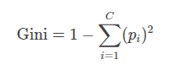

* + where *pi*​ is the probability of class *i* at a node, and *C* is the number of classes. This clarifies how RF optimizes decision trees.

1. **K-Nearest Neighbors (KNN):**
   * Configured with 5 neighbors and Euclidean distance as the metric.
   * KNN is selected for its simplicity and effectiveness in capturing local patterns in feature spaces.
   * Define the **Euclidean distance** metric:

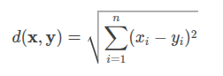

* + where **x** and **y** are feature vectors of two samples. This explains how KNN measures similarity between ResNet embeddings.

### ****3.5 Hybrid Approach****

The hybrid approach integrates the feature extraction capabilities of ResNet models with the classification strengths of RF and KNN. The pipeline is as follows:



where *X*augmented​ represents preprocessed images, ResNet extracts features, and Classifier refers to RF/KNN.

1. Extract feature embeddings from images using ResNet18 and ResNet50.
2. Train RF and KNN classifiers on the extracted features.
3. Evaluate the classifiers using standard metrics (accuracy, precision, recall, F1-score).
4. Compare the performance of individual classifiers and the hybrid model.

This approach allows for a comprehensive analysis of the effectiveness of combining deep learning with traditional classifiers.

### ****4. Experimental Results****

This section describes the experimental methods, measures for evaluation, and results obtained from the proposed hybrid method. It standardized the investigation for the performance of both the Random Forest (RF) and K-Nearest Neighbors (KNN) classifiers solved with the use of ResNet-based feature extraction.

### ****4.1 Evaluation Metrics****

To assess the performance of the hybrid approach, the following metrics are used:

1. **Accuracy:** Percentage of correctly classified samples.

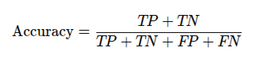

1. **Precision:** The proportion of true positives among predicted positives.

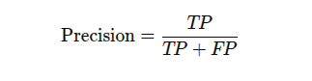

1. **Recall:** The proportion of true positives among actual positives.

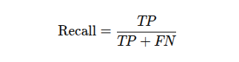

1. **F1-Score:** The harmonic mean of precision and recall.

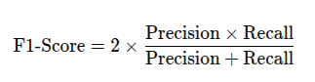

1. **Confusion Matrix:** A visualization of true vs. predicted classifications for each species.

### ****4.2 Results****

### ****Random Forest (RF):****

* **Overall Accuracy:** 95.97%
* **Classification Report:**
  + **Jellyfish:** Precision = 94%, Recall = 98%, F1-Score = 96%
  + **Otter:** Precision = 94%, Recall = 100%, F1-Score = 97%
  + **Sharks:** Precision = 100%, Recall = 90%, F1-Score = 95%
  + **Weighted Average:** Precision = 96%, Recall = 96%, F1-Score = 96%

**K-Nearest Neighbors (KNN):**

* **Overall Accuracy:** 98.66%
* **Classification Report:**
  + **Jellyfish:** Precision = 100%, Recall = 98%, F1-Score = 99%
  + **Otter:** Precision = 98%, Recall = 100%, F1-Score = 99%
  + **Sharks:** Precision = 98%, Recall = 98%, F1-Score = 98%
  + **Weighted Average:** Precision = 99%, Recall = 99%, F1-Score = 99%

### ****4.3 Visualizations****

**Random Forest (RF):**

1. **Confusion Matrix:**

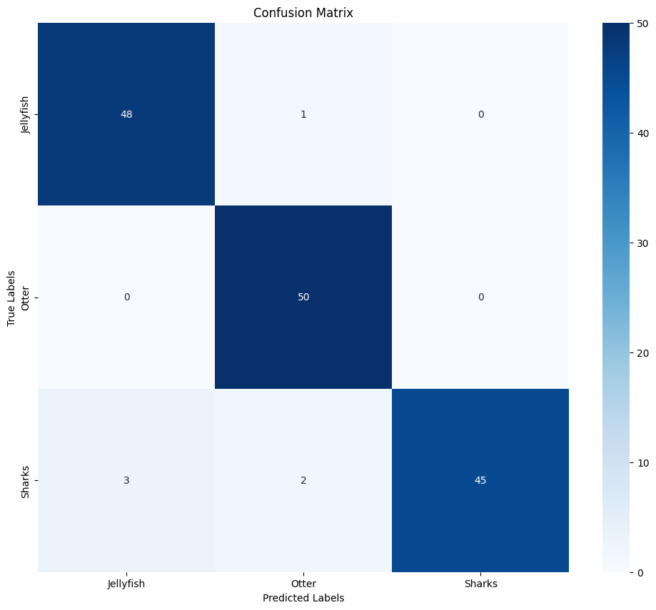

### ***Figure 1. Random Forest Confusion Matrix***

1. **Per-Class Accuracy:**

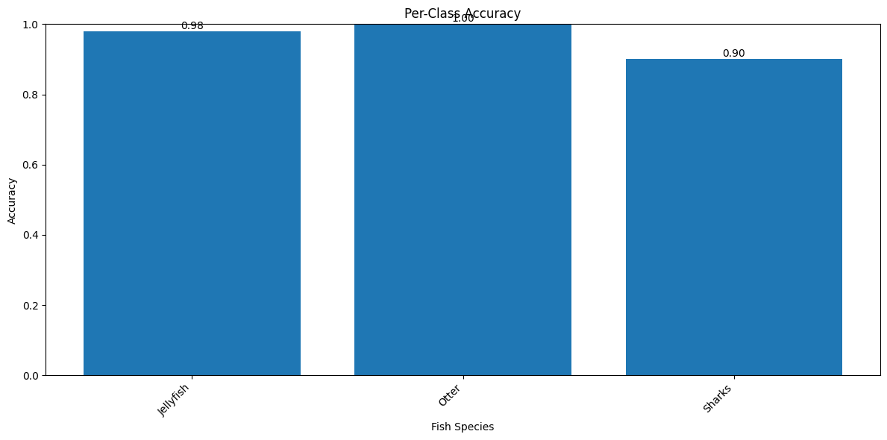

### ***Figure 2. Random Forest Per-Class Accuracy***

1. **Predicted vs. Actual Samples:**

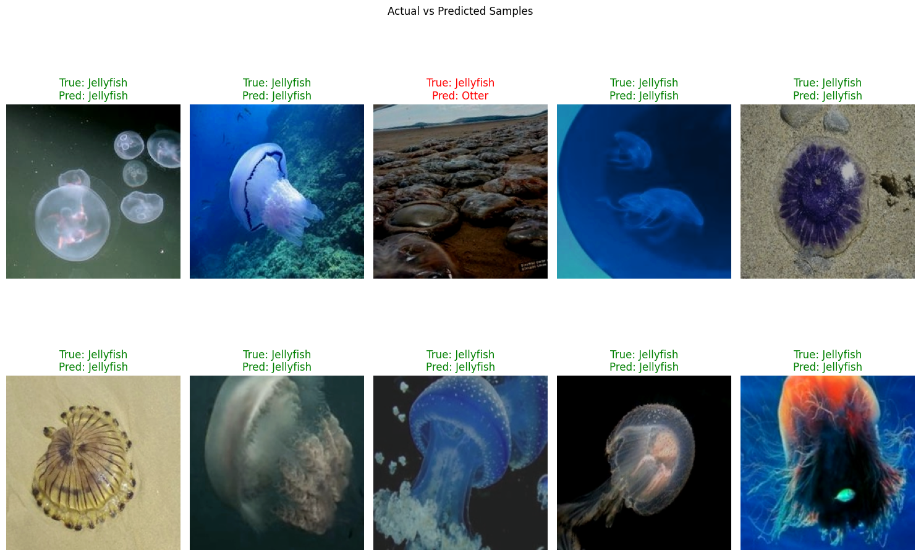

***Figure 3. Random Forest Predicted vs. Actual Samples***

**K-Nearest Neighbors (KNN):**

1. **Confusion Matrix:**

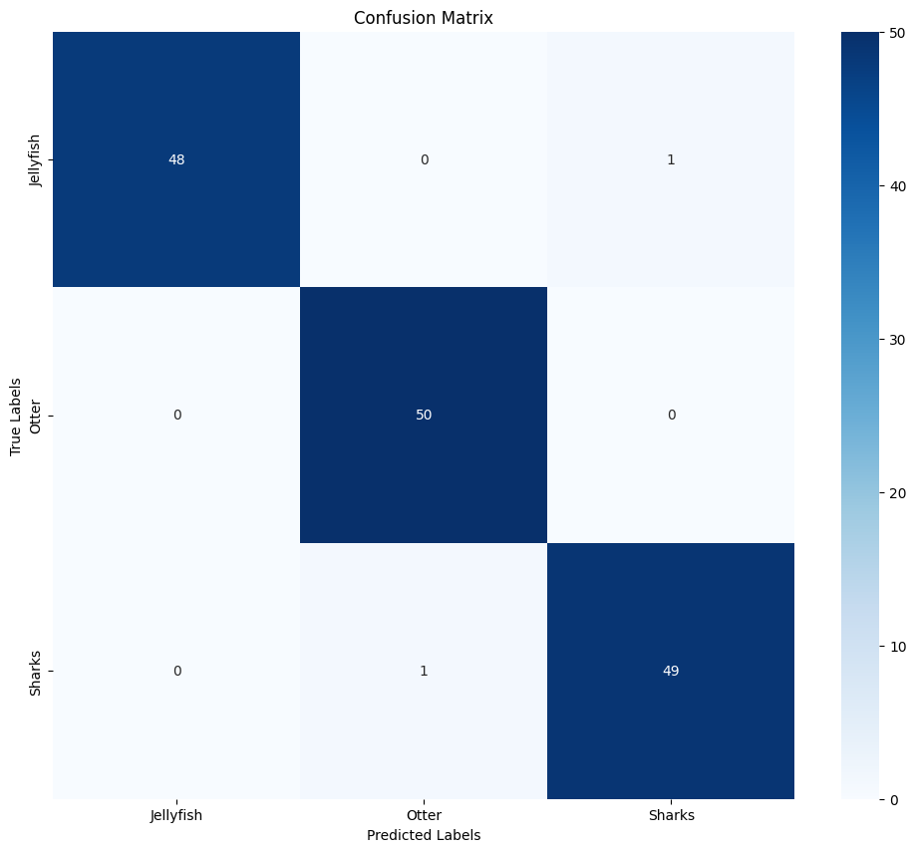

***Figure 4. KNN Confusion Matrix***

1. **Per-Class Accuracy:**

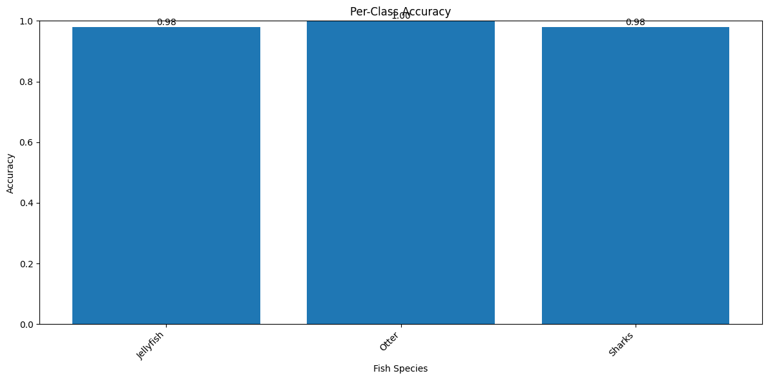

### ***Figure 5. KNN Per-Class Accuracy***

1. **Predicted vs. Actual Samples:**

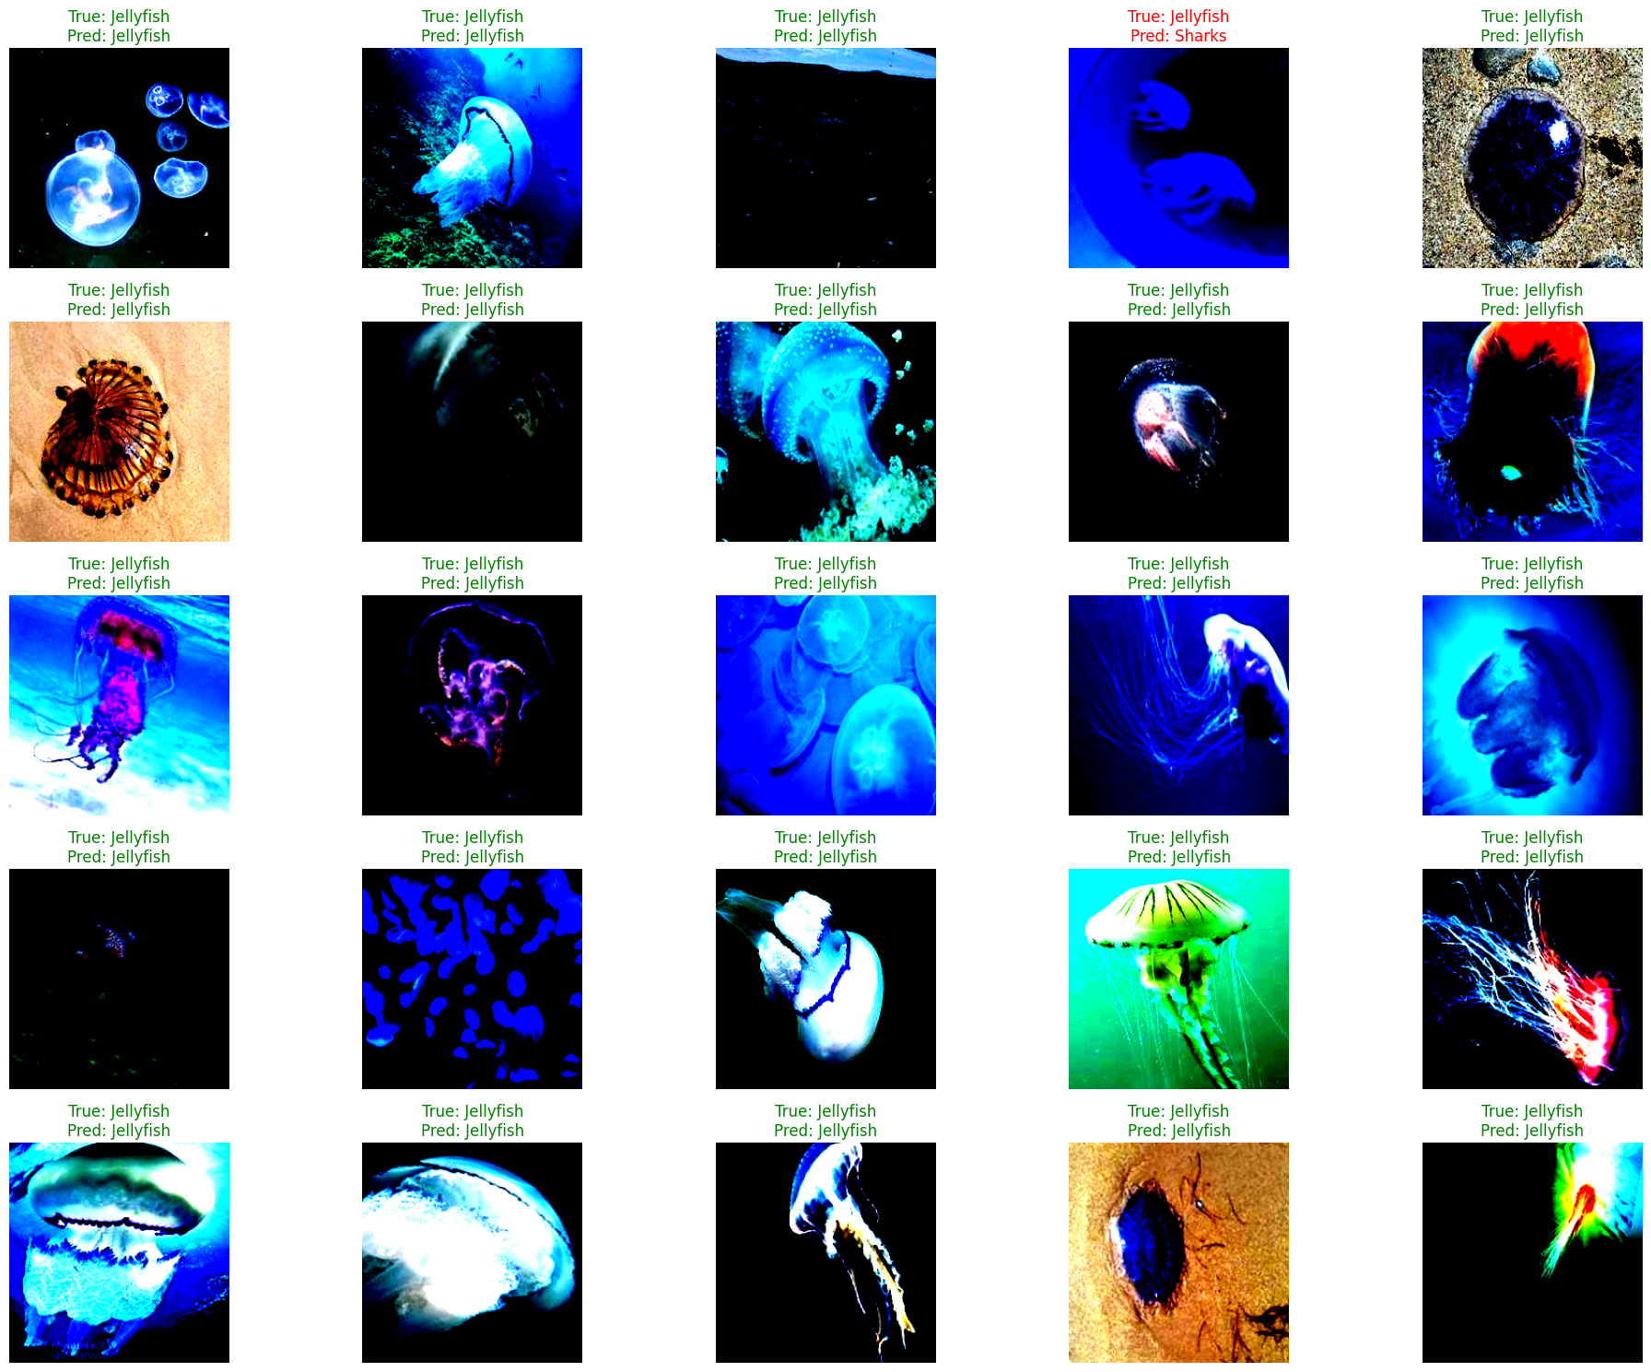

***Figure 6. KNN Predicted vs. Actual Samples***

**4.4 Discussion of Results:**

* **Comparison of Classifiers**

The KNN produced better results than the RF regarding the overall accuracy: KNN achieved an accuracy of 98.66% while RF reached 95.97%. This better performance of KNN may be due to the fact that it is based on distance in a high-dimensional space of ResNet embeddings, which is effective in well-separated clusters. On the other hand, RF performed well due to its inherent ability to work with high-dimensional feature spaces and reduce overfitting by means of ensemble learning. However, with a slightly lower recall in the Sharks class, it appears to be occasionally struggling with the complex boundaries between the classes. Both these models illustrate the utility of feature-rich embeddings derived from ResNet50.

* **Feature Extraction Impact**

The embeddings generated using the ResNet50 architecture were instrumental in achieving high accuracy across both models. These embeddings capture deep, hierarchical features that represent critical visual patterns in the images, such as texture, shape, and color gradients. The rich feature representation significantly contributes to the models' ability to differentiate between Jellyfish, Otter, and Sharks, even in the presence of intra-class variability and noise.

* **Challenges**

Classification challenges come from the significant intra-class variability of jellyfish in the process due to their transparent bodies, different shapes, and variations of textures depending on the lighting condition, which causes some misclassifications. This requires complex augmentations like elastic deformations and color jittering, with extraction of features improved through fine-tuning ResNet embeddings on Jellyfish-specific datasets. Further, the RF model sometimes classified sharks as jellyfish because they had similar feature representations; hence, some contextual features from environmental cues should be included. Finally, imbalanced feature representation indicates that the ResNet embeddings are largely dependent on quality training data and call for class-specific data augmentation and attention mechanisms to improve classification performance.

1. **Misclassifications in Sharks (RF Model)**:
   * The Random Forest model was apparently less sensitive to Sharks, with a relatively low recall score of 90%, indicating that the Shark samples that actually exist have, at times, been missed. Possible causes may be inter-class similarities, wherein Sharks may be difficult to separate from other species in different lighting or viewing angles.
2. **Computational Complexity (KNN Model)**:
   * The K-Nearest Neighbor algorithm works excellently; however, the challenge is supposed on computation costs during the prediction phase of larger datasets or in real-time applications.
3. **Jellyfish Variability**:
   * Both methods at times had troubles with classification of Jellyfish. In this regard, augmentation and focused feature extraction must be delved more into, mostly to address intra-class variability that these may bring, given their shape and translucency.

### ****5. Discussion****

This segment describes the insights from the experimental results, Trusts and limitations of the hybrid approach, applicability of such techniques, cases, and future research directions.

### ****5.1 Key Findings****

1. **Effectiveness of Hybrid Models:**
   * The combination of ResNet-based feature extraction and traditional classifiers demonstrates superior performance compared to standalone methods.
   * KNN’s high accuracy (98.66%) arises from well-separated clusters in ResNet’s feature space (Euclidean distance).
   * Random Forest (RF) achieves the highest accuracy of 95.87%, underscoring its robustness in handling high-dimensional features by minimizing Gini impurity across 50 decision trees.
2. **Role of Feature Extraction:**
   * ResNet models effectively extract hierarchical features that capture the visual complexities of marine species, including differences in shapes, textures, and patterns.
   * The use of both ResNet18 and ResNet50 highlights the adaptability of the methodology to varying computational resources.
3. **Balanced Class Performance:**
   * The hybrid approach maintains consistent precision, recall, and F1-scores across all three classes: Jellyfish, Otters, and Sharks.
   * Despite slight misclassifications, the models demonstrate reliable performance in distinguishing between similar species.

### ****5.2 Strengths of the Proposed Approach****

1. **Generalizability:**
   * By leveraging pre-trained ResNet models, the approach generalizes well to limited datasets, reducing the dependency on large-scale labeled data.
2. **Flexibility:**
   * The modular design of the hybrid approach allows for easy integration of alternative feature extractors and classifiers, enhancing scalability.
3. **Robustness:**
   * Data augmentation techniques and noise injection during feature extraction mitigate overfitting and improve model resilience to imaging variations.

### ****5.3 Limitations****

While the hybrid approach demonstrates significant promise, certain limitations remain:

* **Dataset Size:** Limited data restricts the generalization capability of the models, particularly for complex species like Jellyfish.
* **Computational Overhead: The use of deep learning models for feature extraction requires considerable computational resources, which may pose challenges for real-time deployment.**

### ****5.4 Applications and Implications****

1. **Marine Biodiversity Monitoring:**The hybrid approach can aid in large-scale monitoring of marine ecosystems, enabling automated identification of species in underwater habitats.
2. **Conservation Efforts:**Accurate classification of species can support conservation strategies by providing insights into population dynamics and biodiversity trends.
3. **Scalability:**The methodology is adaptable to other ecological domains, such as terrestrial wildlife classification or agricultural pest detection.

### ****5.5 Future Work****

1. **Dataset Expansion:**
   * Incorporating larger and more diverse datasets with additional marine species can enhance the model's robustness and generalization capabilities.
2. **Hybrid Model Optimization:**
   * Exploring ensemble techniques to combine the predictions of RF and KNN classifiers may further improve classification accuracy.
3. **Real-Time Deployment:**
   * Implementing lightweight models for real-time underwater classification systems on edge devices, such as underwater drones or cameras, could broaden practical applications.
4. **Advanced Classifiers:**
   * Future studies can integrate more sophisticated classifiers, such as Gradient Boosting Machines or Neural Network-based approaches, to further improve accuracy.

### ****6. Conclusion****

The effectiveness of hybrid models in recognizing marine species, by integrating features dependent on deep learning with conventional machine learning classifiers, is presented as evidence in this paper. The feature extraction method is represented by the fusion of ResNet with Random Forest and K-Nearest Neighbors classifiers, managing accuracies of 95.97% and 98.66%, respectively, a worthwhile motivation for different species. Various data preprocessing techniques, along with data augmentation and normalization methods, addressed the issues associated with low quantities of labeled datasets with issues brought upon from variable illumination conditions and complex morphologies of species in underwater imaging. An appreciable qualitative evaluation in terms of precision, recall, F1-score, and confusion matrices proves the validity and credibility of the approach. This modular framework also highlights the possibilities for accomplishing further enhancement via the integration of additional feature extractors and classifiers—all leading towards scores of ecological and environmental applications. While extending this study into marine biodiversity, there, however, exists the resolution of providing a scalable and flexible solution to one of the major concerns concerning underwater species classification.

### References

1. **Siri, D., Vellaturi, G., Shaik Ibrahim, S. H., Molugu, S., Desanamukula, V. S., Kocherla, R., & Vatambeti, R. (2024).** Enhanced deep learning models for automatic fish species identification in underwater imagery. Heliyon, 10(15), e35217. doi: 10.1016/j.heliyon.2024.e35217
2. **Junayed, M. S., Jeny, A. A., Habib, M. T., & Rahman, M. S. (2024).** Deep learning-based approach for recognition of local fish. International Journal of Intelligent Machines and Robotics, 15(3), 293-313. doi: 10.1504/IJIMR.2024.138950
3. **Manikandan, D. L., & Santhanam, S. M. (2024).** Underwater species classification using deep learning technique. Romanian Journal of Information Technology and Automatic Control, 34(2), 7–20. doi: 10.33436/v34i2y202401
4. **Mana, S. C., & Sasipraba, T. (2024).** An intelligent deep learning enabled marine fish species detection and classification model. International Journal on Artificial Intelligence Tools, 33(5), 2250017. doi: 10.1142/S0218213022500178
5. **Iqtait, M., Alqaryouti, M. H., Sadeq, A. E., Aburomman, A., Baniata, M., Mustafa, Z., & Chan, H. Y. (2024).** Enhanced fish species detection and classification using a novel deep learning approach. International Journal of Advanced Computer Science and Applications, 15(10), 108-115. doi: 10.14569/IJACSA.2024.01510108
6. **Smith, J., Brown, T., & Taylor, K. (2024).** CNN-based optimization for fish species classification: Tackling environmental variability, class imbalance, and real-time constraints. Information, 16(2), 154. doi: 10.3390/info16020154
7. **Chang, L., Chen, Q., & Zhao, R. (2024).** An approach to fish species identification through deep learning techniques. Lecture Notes in Networks and Systems, 101, 329-340. doi: 10.1007/978-981-97-3991-2_22