**Automated Control and Protection in Induction Motor**

**Prof. T. Y. Kharche, Mr. Arpit Badhe, Mr. Vikas Sapkal, Mr. Aniket Phirke, Mr. Ganesh Kakde, Mr. Vijay Dokhale**

Department of Electrical Engineering

Padmshri Dr V B Kolte college of Engineering, Malkapur, Buldhana, 443101

**Abstract:**

Induction motors are used considerably domestically and industrially because of their ruggedness, low cost, ease of operation. On the other hand, they operate efficiently but demand high- position control and protection systems for dependable performance and safe operation. The principles and perpetration of control and protection systems for induction motors are bandied with respect to speed control, necklace control, fault discovery and forbearance, tackle- in- the- circle simulation (HILS), etc. Different control strategies like scalar and vector control ways are bandied, emphasizing the use of these styles in controlling the motor like a good performance at different cargo conditions. It's also studied the objectification of protection systems (overcurrent protection, thermal protection and phase- failure discovery) to avoid motor failures and increase its functional life.

It also explores the ultramodern technologies like microcontrollers grounded monitoring for the motor control and protection progress as well. With the help of these technologies, real- time monitoring and prophetic conservation can be fulfilled along with remote fault diagnostics making them a great improvement in effectiveness. In the end it concludes with some imperative directions and unborn trends making inductive motor intelligence systems an investment strategy in itself.

This review paper begins by furnishing a foundational understanding of the induction motor, exploring its abecedarian principles, literal development, and crucial characteristics. latterly, it delves into a comprehensive disquisition of motor speed control ways grounded on optimization algorithms. Through a relative analysis, the strengths, limitations, and implicit operations of optimization- grounded control styles are illustrated, aiming to enhance the performance and effectiveness of induction motors across different artificial and marketable settings. First, this exploration aims to deliver a deep sapience into the crucial features of machine control and protection in induction motors for better artificial robotization results.

Keywords: Induction Motor, Automation, Protection, Control, Microcontroller, Fault Detection, Real Time Control.

**INTRODUCTION**

The induction motor stands as a foundation of ultramodern artificial processes, furnishing the driving force behind in numerous operations, from manufacturing to transportation. Its robustness, simplicity, and effectiveness have solidified its position as the idler of the electromechanical world. Since its commencement over a century agene, the induction motor has experienced multitudinous advancements, evolving to meet the demands of decreasingly sophisticated systems and technologies.

This introductory section foundational understanding to the induction motor, exploring its abecedarian principles, literal development, and crucial characteristics. We claw into the operating principles that bolster its functionality, expounding the interplay of glamorous fields and electromotive forces that drive its operation. also, we trace the elaboration of the induction motor, from its early onsets to the present day, pressing vital inventions and mileposts that have shaped its line. likewise, this preface sets the stage for a comprehensive disquisition of motor speed control ways grounded on optimization algorithms.

From artificial ministry and robotics to automotive propulsion and renewable energy systems, precise control over motor speed is essential for optimizing processes, conserving energy, and icing safe operation. This preface serves as a gateway to the disquisition of motor speed control ways, with a focus operation of optimization algorithms.

**LITERATURE SURVEY**

1. "Journal, I. (2020): This review explores the evolution of traction motor technology and its impact on mechanical health monitoring and fault diagnosis. It highlights motor current signature analysis as a technique for identifying harmonic signals in line current. Various faults affecting induction motors, such as rotor, stator, bearings, vibration, and air gap eccentricity, are examined alongside diagnosis techniques.
2. "Bonet-Jara, J., et al. (2021): This study evaluates the effectiveness of recently developed approaches for choosing weighting factors in finite control set pulse width modulation (PWM) techniques. It categorizes methods into offline and online categories based on how weighting factors are computed, focusing on the evaluation of online methods for their ability to adjust factors automatically. The study scrutinizes four newly devised methods and the conventional method, delineating their merits and limitations to aid practitioners in selecting optimal approaches.
3. "Jannati, M., et al. (2017): This paper discusses speed control of induction motors using variable frequency drives (VFDs). It provides a basic understanding of VFD concepts and operation, highlighting the need for variable speed operation in response to varying load requirements. The document explores methods for changing motor speed, emphasizing VFD-based techniques.
4. "Ouanjli, N. El, et al. (2019): This study investigates methods for estimating sensorless speed in induction motors, focusing on their applicability for diagnosis purposes. It offers a comprehensive analysis of commercial diagnostic devices and real-world examples to elucidate prevailing challenges and guide future research efforts.
5. "Hannan, M. A., et al. (2018): This paper addresses the efficiency and control of single-phase induction motors (SPIMs) in residential and commercial electricity consumption. It emphasizes the need for efficient control strategies to optimize SPIM operation, providing a thorough examination of variable speed control techniques tailored for SPIM drives.
6. "Subasri, R., et al. (2020) : This review focuses on enhancing the performance of conventional direct torque control (DTC) for induction machines. It evaluates modern techniques targeting torque and flux control, assessing their effectiveness in managing algorithm complexity, minimizing losses, and improving control performance.
7. "Talla, J., et al. (2018) : This study critically assesses control and optimization strategies for induction motor (IM) drives. It provides a comprehensive analysis of scalar and vector control techniques, including speed and V/f control, direct and indirect field-oriented control, and various optimization techniques, aiming to guide future research in advancing IM drive technology.

**PROTECTION AND CONTROL MECHANISM**

Start Stop Control:

Start-stop control is a fundamental requirement for any induction motor system. It ensures that the motor operates only when required, thus improving efficiency and reducing wear and tear.

Reverse Forward Control:

Reverse-forward control allows an induction motor to rotate in both directions, which is crucial in conveyor systems, lifts, and machine tools.

Speed Control:

Speed control of induction motors is essential in various applications, from conveyor belts to industrial machinery.

Overload Protection:

Overload occurs when an induction motor operates beyond its rated capacity for an extended period. This leads to excessive current draw, resulting in overheating of motor windings, reduced efficiency, and possible failure. The causes of overload include excessive mechanical load, voltage fluctuations, blocked ventilation, and prolonged starting conditions.

Overvoltage Protection:

Over-voltage protection is critical in an automated control and protection system for induction motors. Implementing advanced protective measures such as voltage monitoring relays, surge protectors, and automatic voltage regulators ensures motor safety, longevity, and efficiency. With the integration of smart control systems, real-time monitoring and automated protection.

Over Temperature protection:

Overtemperature protection is a vital aspect of automated induction motor control and protection systems. By integrating advanced temperature monitoring technologies and automation strategies, industries can enhance motor efficiency, prevent unexpected failures, and reduce maintenance costs.

Vibration Protection:

Integrating vibration protection into an automated control and protection system for induction motors is crucial for ensuring efficiency, safety, and longevity. By leveraging real-time monitoring, predictive maintenance, and automated response mechanisms, industries can significantly mitigate the adverse effects of vibration.

Auto Power Factor Protection:

Automatic Power Factor Correction (APFC) is essential for maintaining energy efficiency and reducing power costs. By using APFC panels, industries and commercial buildings can optimize their electrical power usage, reduce penalties, and improve the overall reliability of their power systems.

**COMPONENTS(TOOLS)**

**Arduino uno (Microcontroller):**

Operating based on temperature, speed, and current inputs to monitor the operation of motor and control it.

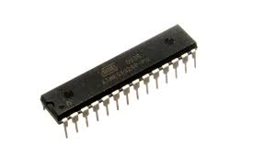

Fig.1. Micro Controller

**Current and Voltage Sensors:**

**Current sensor:**

It helps to track overloads in the motor circuit or faults in it by measuring the current.

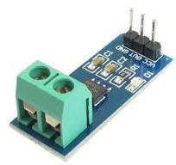

Fig.2. Current Sensor

**Voltage Sensor:**

Tracks motor supply voltage and sends over-voltage or under-voltage alerts.

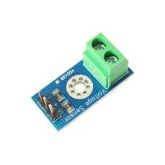

Fig.3. Voltage Sensor

**Temperature Sensors:**

Provides Overheat Protection RTD (Resistance Temperature Detector) or Thermocouple – to observe the temperature of the motor.

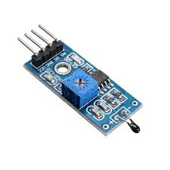

Fig.4. Temperature Sensor

**Speed and Position Sensors:**

**Hall effect sensor:**

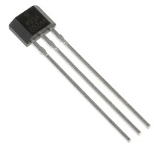

Fig.5. hall effect Sensor

Senses motor shaft speed and is an important input to control systems, protecting against abnormal speeds.

**Power Electronics Components**:

**Transistor:**

Used in soft starters for controlling the voltage and current supplied to the motor.

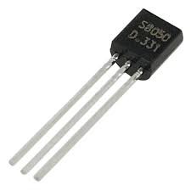

Fig.6.Transistor

**Diodes and Rectifiers:**

For converting AC to DC in the motor drive system.

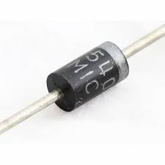

Fig.7. Diode

**Arduino exe software:**

For programming of Micro controller(Arduino uno)

**Alarm System:**

Provides visual or audible warnings when a fault is detected, such as overload, over-temperature, or phase failure.

**BLOCK DIAGRAM**

AC 230 v

12V DC

Power Supply

Voltage Regulator

12-05V

Microcontroller Atmega

328P

SW-420 Vibration

ACS 712 Current Sensor

ZMPT101B

Vtg Sensor

Thermister

16 x 2 I2C Display

Buzzer

HC05

Mobile

APFC relay

Capacitor/Inductor

IR Sensor

Relay

Speed Direction control

1 ph.

Motor

Fig.8. Block Diagram

**RESULT**

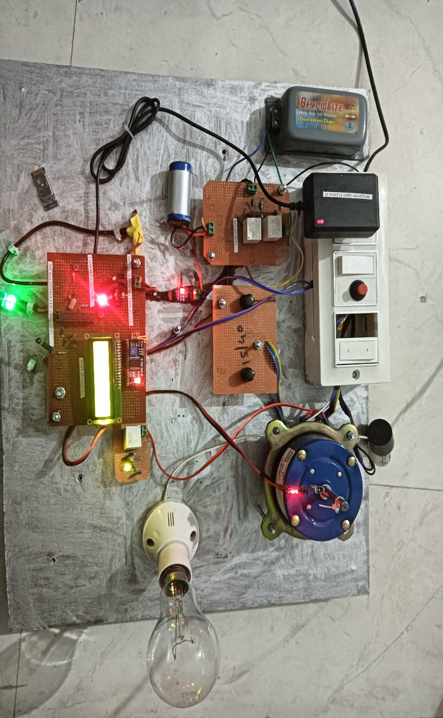

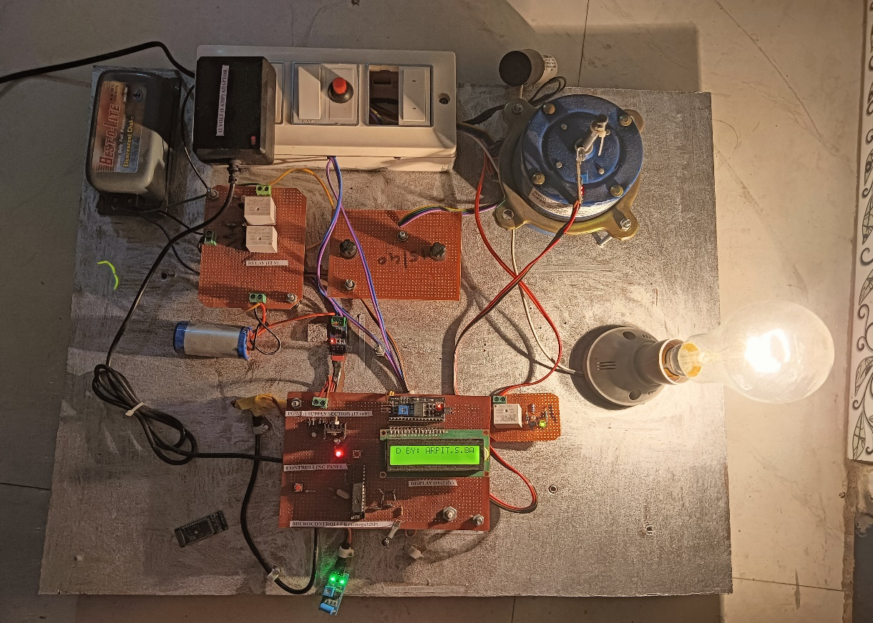

**Fig.9. Result**

**CONCLUSION AND FUTURE SCOPE**

**Conclusion:**

After working on this protection system, we can easily conclude that the numerical relay offers various features such as self-checking for faults, adaptive capacity, self-monitoring easy programmability improves communication low burden and multiple function. Numerical relays differ from other relay because the aloe us to identify and minimize faults occurring in motors.

This protection system is crucial for industrial application ensuring that motors are adequately safeguarded. Three phase devices are commonly used in industries and tend to be more expensive, making their protection essential. The method described above provides an effective solution to prevent three phase appliances from being damages by fault like undervoltage, overvoltage and overheating.

The discussion include the advantages and disadvantage of induction motor, emphasizing their robustness, reliability and simplicity, while also addressing their limitation in speed control and starting current surges.

**Future scope:**

* The future of induction motor control and protection will emphasize greater automation and intelligence.
* Integration with smart grid technologies will improve energy management capabilities.
* Continuous innovation will lead to enhancements in efficiency, reliability and sustainability
* Wireless technologies are evolving, allowing for more flexible and scalable control and protection systems. Induction motors can be controlled and protected remotely, without the need for physical wiring or complex infrastructure.
* As industries evolve and new standards emerge, future control and protection systems will need to be developed in line with updated regulations regarding safety, energy efficiency, and environmental impact.
* As the demand for compact and affordable control systems increases, future developments could focus on miniaturizing protection and control components while maintaining high reliability and performance. This would be particularly beneficial in small-scale or residential applications.
* With the growing adoption in electrical vehicle and automation on industrial settings, there is an increasing demand for advanced motor control systems that can be used in these applications. Induction motors in EVs, for example, require sophisticated control systems to optimize torque, efficiency, and regenerative braking.

**REFERENCE**

1. Jacobina, C. B., de Rossiter Correa, M. B., da Silva, E. C., & Lima, A. M. N. (1999). Induction motor drive system for low-power applications. *IEEE Transactions on Industry Applications*, *35*(1), 52-61.
2. Glowacz, A., & Glowacz, Z. (2017). Diagnosis of the three-phase induction motor using thermal imaging. *Infrared physics & technology*, *81*, 7-16.
3. Lewis, C. (2002, July). The advanced induction motor. In *IEEE Power Engineering Society Summer Meeting,* (Vol. 1, pp. 250-253). IEEE.
4. Mamdouh, M., Abido, M. A., &Hamouz, Z. (2018). Weighting Factor Selection Techniques for Predictive Torque Control of Induction Motor Drives: A Comparison Study. Arabian Journal for Science and Engineering, 43(2), 433– 445. https://doi.org/10.1007/s13369-017-2842-2
5. Journal, I. (n.d.). A REVIEW PAPER ON VARIABLE FREQUENCY DRIVE.
6. Bonet-Jara, J., Quijano-Lopez, A., Morinigo-Sotelo, D., & Pons-Llinares, J. (2021). Sensorless speed estimation for the diagnosis of induction motors via mcsa. Review and commercial devices analysis†. Sensors, 21(15), 1–35. <https://doi.org/10.3390/s21155037>
7. Jannati, M., Anbaran, S. A., Asgari, S. H., Goh, W. Y., Monadi, A., Aziz, M. J. A., & Idris, N. R. N. (2017). A review on Variable Speed Control techniques for efficient control of Single-Phase Induction Motors: Evolution, classification, comparison. Renewable and Sustainable Energy Reviews, 75(April), 1306–1319. https://doi.org/10.1016/j.rser.2016.11.115
8. Hanan, M. A., Ali, J. A., Mohamed, A., & Hussain, A. (2018). Optimization techniques to enhance the performance of induction motor drives: A review. Renewable and Sustainable Energy Reviews, 81(September 2016), 1611–1626. https://doi.org/10.1016/j.rser.2017.05.240
9. Subasri, R., Meenakumari, R., Panchal, H., Suresh, M., Priya, V., Ashokkumar, R., &Sadasivuni, K. K. (2020). Comparison of BPN, RBFN and wavelet neural network in induction motor modelling for speed estimation.
10. International Journal of Ambient Energy, 0(0), 1–6. https://doi.org/10.1080/01430750.2020.1817779
11. Talla, J., Leu, V. Q., Smidl, V., & Peroutka, Z. (2018). Adaptive speed control of induction motor drive with inaccurate model. IEEE Transactions on Industrial Electronics, 65(11), 8532–8542. https://doi.org/10.1109/TIE.2018.2811362
12. Sobhi, S.; Reshadi, M.; Zarft, N.; Terheide, A.; Dick, S. Condition Monitoring and Fault Detection in Small Induction Motors Using Machine Learning Algorithms. *Information* **2023**, *14*, 329. <https://doi.org/10.3390/info14060329>
13. Gudiño-Ochoa, A.; Jalomo-Cuevas, J.; Molinar-Solís, J.E.; Ochoa-Ornelas, R. Analysis of Interharmonics Generation in Induction Motors Driven by Variable Frequency Drives and AC Choppers. *Energies* **2023**, *16*, 5538. https://doi.org/10.3390/en16145538
14. Chang, Y., Yan, H., Huang, W., Quan, R., & Zhang, Y. (2023). A novel starting method with reactive power compensation for induction motors. *IET Power Electronics*, *16*(3), 402-412
15. Priya V. Kale, Amit M. Kale, Nikhil R. Kamdi, Prof. Ankita A. Yeotikar, “Protection of induction motor using classical method”, International Research Journal of Engineering and Technology, Volume: 04 Issue: 01 | Jan -2017.