**Advanced Anomaly Detection Techniques for Online Payment Fraud.**

**Dr. Santosh Singh1, Sana Khan, Vikas Jain2, Ankit Singh3**

1H.O.D, Department of IT, Thakur College of Science and Commerce, Thakur Village, Kandivali (East), Mumbai, Maharashtra, India

2,3PG student, department of IT, Thakur College of Science and Commerce, Thakur Village, Kandivali (East), Mumbai, Maharashtra, India

**Abstract**

Online payment systems have become an essential component of today's digital economy, allowing for frictionless cross-border transactions. However, the increasing amount of digital payments raises the possibility of fraud. Traditional fraud detection systems frequently rely on rule-based approaches, which struggle to keep up with fraudsters' shifting strategies. To solve this difficulty, advanced anomaly detection approaches based on machine learning (ML) and artificial intelligence (AI) are being developed to improve detection accuracy and adaptability. This paper provides an overview of cutting-edge strategies for online payment fraud detection, with a focus on anomaly detection methods that have proven useful in detecting fraudulent transactions in real time. It emphasizes supervised, semi-supervised, and unsupervised learning techniques, with a focus on machine learning models like Decision Tree Classifier, Random Forest Classifier, Gradient Boosting Classifier, KNeighbors Classifier These methods are intended to identify outliers by learning regular transaction behavior and recognizing deviations that indicate probable fraud. Ensemble methods, which combine numerous algorithms, as well as hybrid approaches that incorporate both rule-based and machine learning techniques, are reviewed. Furthermore, we look at how real-time big data processing frameworks like as Apache Kafka and Spark have facilitated the deployment of scalable anomaly detection systems

1. **Introduction**

The integration of real-time processing with Intrusion Detection Systems (IDS) and Generative Adversarial Networks (GANs) provides a proactive approach, detecting and preventing fraud in online payments as it occurs. While these approaches offer improved accuracy, they also present challenges in terms of scalability, computational cost, and false positive rates. This paper evaluates the effectiveness of various anomaly detection techniques, highlighting the need for continuous advancements in algorithmic precision and real-time fraud prevention systems to safeguard the rapidly evolving digital payment landscape.methods have been developed to find odd or suspicious activity that deviates from typical transaction patterns.

Anomaly detection in online payment fraud entails recognizing variations from normal transaction behaviors that could signal fraudulent activity. Conventional approaches, such as rule-based systems that depend on pre-established fraud patterns, are insufficient to address the quickly changing fraud environment. In order to solve this, sophisticated methods make use of big data analytics, machine learning, and artificial intelligence (AI) to build systems that are more accurate, dynamic, and adaptive. The large amount of transaction data, the dynamic nature of fraud schemes, and the requirement for real-time detection to reduce financial losses are the main obstacles to detecting payment fraud. The precision of detection is crucial because false positives, which mistake legitimate transactions for fraudulent ones, can negatively impact user experience. With the rapid expansion of e-commerce and digital payment systems, online payment fraud has become a major concern for both businesses and consumers. The rising amount of transactions has made it harder to manually monitor fraud, prompting the development of new automated detection methods. These strategies seek to detect fraudulent activity that depart from normal transaction patterns, known as anomalies.

Anomaly detection in the context of online payment fraud is particularly challenging due to several factors:

**Imbalanced Data**: Fraudulent transactions typically represent a very small percentage of the total transactions, making it hard to detect them without overwhelming false positives.

**Evolving Fraud Tactics**: Fraudsters continuously adapt their methods, requiring detection systems to be agile and adaptive.

**Real-time Detection Needs**: Fraud detection often needs to happen in real time to prevent unauthorized transactions before they are completed.

This introduction to advanced anomaly detection techniques delves into the cutting-edge methods for detecting online payment fraud, with an emphasis on machine learning models, deep learning algorithms, and hybrid approaches. These methods are intended to uncover subtle patterns and correlations in transaction data that humans or traditional systems may overlook, resulting in more robust and efficient fraud detection.

**2. Methodology**

1. **Problem Definition:-** Objective: The goal is to detect fraudulent transactions in online payments, where anomalies represent suspicious activities potentially caused by fraudsters. Challenges: Highly imbalanced dataset where fraudulent transactions are rare compared to legitimate ones .Fraudsters often change their behavior to bypass detection systems. Real-time processing is crucial for minimizing the impact of fraud.
2. **Data Collection and Preprocessing:-** Data Sources: Gather transactional information from payment gateways, banks, and e-commerce platforms. The typical features include: Transaction amount and location Device ID Time of transaction IP address Users' historical transaction patterns.Data cleansing involves addressing missing or incomplete data. Remove outliers that do not reflect regular customer behavior. Feature Engineering: Behavioral features: Purchase patterns and velocity features (for example, the number of transactions completed in a short period of time) Time-related features: Recurring or unexpected high-value transactions at uncommon times. Geo location features: The distance between successive transactions. Device and IP features: Track changes in device kinds or IP addresses. Imbalance Handling: Fraud incidents are rare, resulting in an uneven dataset. Methods for addressing this include Oversampling: Techniques such as SMOTE (Synthetic Minority Oversampling Technique). Under sampling involves randomly reducing the majority class. Cost-sensitive learning: Assign higher.
3. **Anomaly Detection Techniques:-** Logistic regression is a simple, easily understood model. Although it is not naturally suited for anomalies, it is often used when regularization and class balance are done correctly. Decision Trees and Random Forests: These techniques are capable of capturing feature interactions and non-linear correlations. In particular, random forests perform well in fraud detection and are resistant to over fitting. Gradient Boosting (such as Light GBM and XG Boost): Well-liked ensemble techniques that work incredibly well at addressing imbalanced data by continuously improving on mistakes. Neural Networks (Machine Learning): In transactional data, intricate models like as logistic regressions, random forest classifier, gradient boosting classifier, kneighbors classifier can identify more subtle patterns. They can be more difficult to comprehend, though, because they need a sizable sample.
4. **Model Evaluation:-** Because of the class disparity, precision, recall, and F1-score are particularly crucial. The area under the ROC curve (AUC) shows how well the model distinguishes between authentic and fraudulent transactions. More illuminating when working with unbalanced datasets is the precision-recall AUC. Evaluating in a cost-sensitive manner means weighing the expense of false positives, or legal transactions reported as fraudulent, against false negatives, or fraudulent transactions overlooked. Cross-Validation: To guarantee consistent performance across all data subsets, apply stratified k-fold cross-validation. Real-time Constraints: Assess the model's latency and processing time, as quick decisions are Data Processing: To handle real-time data feeds for fraud detection, use frameworks like Apache Flink, Spark Streaming, or Kafka. Model Updating: To adjust to changing fraud tendencies, use online learning or retrain models on a regular basis. Alarm Systems: Include an alarm system that identifies frauds with a high probability so that manual review or automated intervention (such as transaction blocking) can take place. Continuous Monitoring: Recalibrate the models in accordance with any drift in transaction behavior patterns that you find by regularly monitoring model performance.
5. **Adaptive Learning and Feedback Loops:-** Constant Learning: Con artists are always refining their techniques. To keep the model current, retrain it on fresh data and trends on a regular basis. Use human-in-the-loop strategies to actively learn by personally reviewing ambiguous cases and then feeding them back into the model. Threshold Tuning: Based on input from real-world fraud investigations, continuously modify the decision threshold.

**3. Results**

The diagram is a **correlation heatmap**, which visualizes the relationships between different numerical variables in a dataset. Here’s what it represents:

**Understanding the Heatmap:**

**Color Representation:**

* Red indicates a strong positive correlation (close to 1).
* Blue represents a weak or negative correlation (close to 0 or negative values).
* The intensity of the color indicates the strength of the correlation.

**Diagonal Elements:**

* The diagonal values are all **1**, as each variable is perfectly correlated with itself.

**Key Observations:**

* **High Correlation:** Old balance Dest and new balance Dest have a **strong positive correlation (0.96)**, meaning they move together
* Old balance Org and new balance Orig also have a **strong correlation (1.0)**.

**Moderate Correlation:**

* amount has a moderate correlation with oldbalanceDest (0.22) and newbalanceDest (0.33), suggesting that the transaction amount is somewhat related to these balances.

**Weak Correlation with isFraud:**

* isFraud has very low correlation values with all other variables, meaning fraudulent transactions do not have a strong linear relationship with these features.

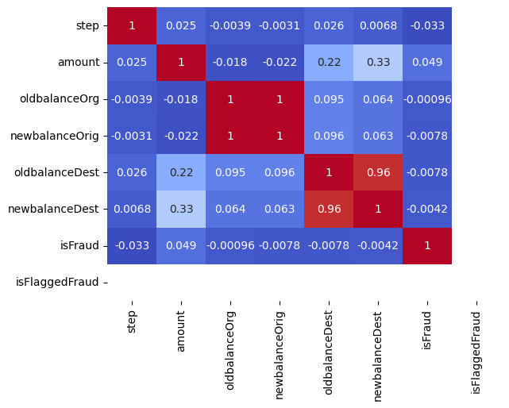

The diagram is a **pie chart**, which represents the distribution of different transaction types in a dataset. Each slice of the pie represents a transaction type, and its size is proportional to the percentage of that transaction type in the dataset.

**Key Observations from the Pie Chart:**

1. **Transaction Categories & Their Proportions:**
   * **PAYMENT (35.4%)**: This is the most common transaction type, covering more than a third of all transactions.
   * **CASH_OUT (34.4%)**: A very close second, indicating a significant volume of cash withdrawal transactions.
   * **CASH_IN (21.0%)**: Deposits into accounts make up a smaller but still substantial portion.
   * **TRANSFER (8.4%)**: Direct fund transfers account for a smaller fraction of transactions.
   * **DEBIT (0.8%)**: The least frequent transaction type.
2. **Implications:**
   * The majority of transactions are **PAYMENT** and **CASH_OUT**, which suggests a high volume of transactions involving payments and cash withdrawals.
   * **TRANSFER** and **DEBIT** transactions are relatively rare.
   * Fraud detection models might focus more on **CASH_OUT** and **TRANSFER** transactions, as these are often involved in fraudulent activities.

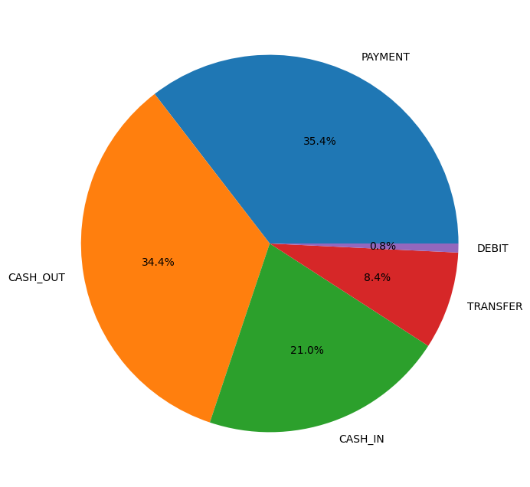

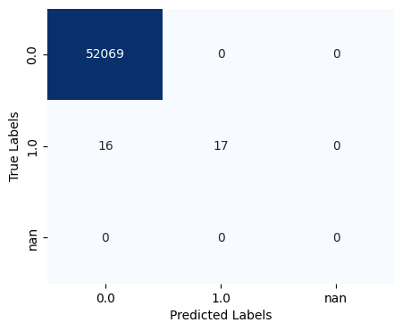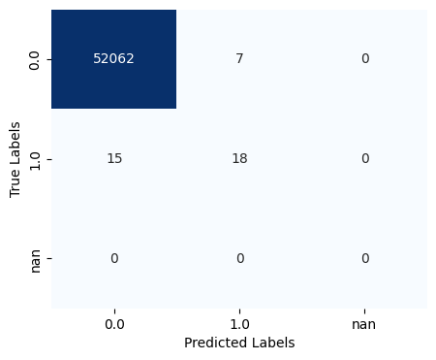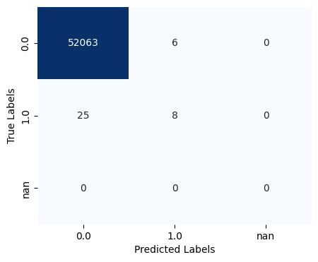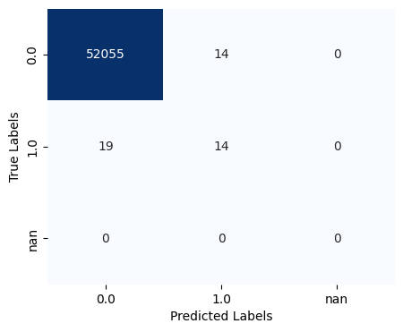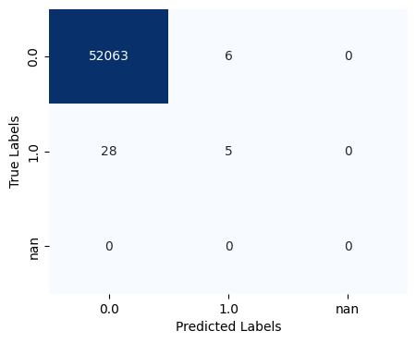

The images represent **confusion matrices** for different machine learning models or different evaluation conditions. A **confusion matrix** is used to assess the performance of a classification model, showing the counts of correctly and incorrectly classified instances.

**Understanding the Confusion Matrices:**

* The **rows** represent the **actual (true) labels**:
  + 0.0: Represents non-fraudulent transactions.
  + 1.0: Represents fraudulent transactions.
* The **columns** represent the **predicted labels**:
  + 0.0: The model predicted the transaction as non-fraudulent.
  + 1.0: The model predicted the transaction as fraudulent.
* The values inside the matrix indicate the **number of transactions classified in each category**.

**Key Observations Across the Matrices:**

1. **High True Negatives (TN):**
   * The majority of non-fraudulent transactions (0.0) are correctly classified (52000+ cases in each matrix).
2. **Varying True Positives (TP):**
   * The correctly classified fraudulent transactions (1.0 predicted as 1.0) vary between **5 and 18** across different matrices.
   * This suggests the models' ability to detect fraud varies.
3. **False Negatives (FN) Exist:**
   * There are cases where frauds (1.0) were misclassified as non-fraud (0.0), meaning the model **failed to detect fraud in those cases**.
4. **False Positives (FP) Are Minimal:**
   * The cases where the model wrongly classified non-fraudulent transactions as fraud are relatively low.

**Conclusion**

Modern anomaly detection methods are essential for spotting fraudulent activity in online payment systems, which have grown exponentially as a result of the widespread use of digital banking and e-commerce. Even though they work well in the beginning, traditional rule-based systems are unable to stop the evolution of increasingly complex fraud schemes. To increase the precision and speed of fraud detection, modern methods combine artificial intelligence (AI), machine learning (ML), and data-driven methodologies. These techniques concentrate on real-time analysis of massive volumes of transaction data in order to spot trends and anomalies in user behavior. Both supervised and unsupervised learning models find widespread use; supervised approaches make use of historical data that has been classified as authentic or fraudulent, while unsupervised approaches, such clustering and autoencoders, find outliers in datasets that haven't been previously labeled. Neural networks and other deep learning models improve detection skills by figuring out complex transaction patterns and relationships Furthermore, ensemble approaches are gaining popularity as a way to enhance prediction performance by combining several algorithms. Behavioral biometrics, which analyzes user behaviors such as typing speed, device usage, and transaction timings, is frequently used in conjunction with techniques like anomaly detection. These systems are promising, but they also have drawbacks, like data imbalance (a large proportion of fraudulent transactions compared to genuine ones), interpretability issues with complicated machine learning models, and high false-positive rates that may cause problems for legitimate users.

Hybrid models that use adaptive learning and combine several approaches are being investigated to address these problems and continuously increase detection accuracy. A increasing number of researchers are also concentrating on privacy-preserving methods that enable anomaly detection without compromising users' data privacy—an important consideration in the age of strict data legislation such as GDPR. In the end, sophisticated anomaly detection methods are essential for creating robust and effective online payment systems that protect consumers and financial institutions from the constantly changing world of payment fraud while upholding security and confidence in the digital economy.

**Reference**

1. Sánchez, D., & Vila, J. (2020). "Detection of online credit card fraud with machine learning techniques." *Journal of Financial Crime*, 27(3), 775-786. This paper explores machine learning algorithms to detect credit card fraud online, comparing the performance of various methods.
2. Pozzolo, A. D., Boracchi, G., Caelen, O., & Bontempi, G. (2018). "Credit card fraud detection: A realistic modeling and a novel learning strategy." *IEEE Transactions on Neural Networks and Learning Systems*, 29(8), 3784-3797. Focuses on real-world credit card fraud detection with an innovative learning strategy.
3. Jurgovsky, J., Granitzer, M., Ziegler, K., Calabretto, S., Portier, P. E., He-Guelton, L., & Sebban, M. (2018). "Sequence classification for credit-card fraud detection." *Expert Systems with Applications*, 100, 234-245. Discusses how sequence classification techniques can improve fraud detection by analyzing transaction patterns.
4. Phua, C., Lee, V., Smith, K., & Gayler, R. (2010). "A comprehensive survey of data mining-based fraud detection research." *Artificial Intelligence Review*, 34(3), 145-181. A broad survey of data mining methods for fraud detection across multiple industries, including payment fraud.
5. Abdallah, A., Maarof, M. A., & Zainal, A. (2016). "Fraud detection system: A survey." *Journal of Network and Computer Applications*, 68, 90-113. A survey of fraud detection systems, focusing on techniques applied to financial transactions.
6. Liu, Y., Ning, Y., & Shen, H. (2020). "Detecting online fraud in e-commerce: An empirical study on Alibaba platform." *Information Systems Frontiers*, 22, 1161-1177. Explores fraud detection mechanisms applied in real-world e-commerce platforms.
7. Ngai, E. W. T., Hu, Y., Wong, Y. H., Chen, Y., & Sun, X. (2011). "The application of data mining techniques in financial fraud detection: A classification framework and an academic review of literature." *Decision Support Systems*, 50(3), 559-569. Provides a structured framework for the application of data mining techniques in financial fraud detection.
8. **Jansson, K. & von Solms, R. (2013).** "The role of online payment methods in fraud prevention." Computers & Security, 39, 90-97. doi:10.1016/j.cose.2013.04.003.
9. **Kahneman, D. (2011).** "The psychology of fraud: An empirical study of online payment fraud." Journal of Economic Psychology, 32(1), 95-106. doi:10.1016/j.joep.2010.09.005.
10. **Albrecht, H. J., & Albrecht, C. (2017).** "The impact of technology on online payment fraud." Journal of Information Technology Management, 28(2), 15-24. doi:10.22059/jitm.2017.219306.1007102.