**APPLE’S SECRET TO INNOVATION: A UNIQUE SPIN ON DESIGN THINKING**

1Rajlaxmi .Narayan, Relekar, 2Raj Mahesh Mate, 3Rakshana R, 4Ruchitha M Koushik, 5Sanjit Srivastava

MBA Students – 2024-2026 Batch, Faculty of Management Studies, CMS Business School, JAIN (Deemed-to-be University), Bangalore

rajlaxmi_narayan24@cms.ac.in, raj_mahesh24@cms.ac.in, rakshanaa_r24@cms.ac.in, ruchitha_mkoushik24@cms.ac.in, sanjit_srivastava24@cms.ac.in

Dr. Pooja Nagpal

Associate Professor, Faculty of Management Studies, CMS Business School, JAIN (Deemed-to-be University), Bangalore

dr.pooja_nagpal@cms.ac.in

**ABSTRACT**

Apple has established a reputation for producing goods that are not only useful but also sophisticated, user-friendly, and closely aligned with user needs. Design Thinking, a method of problem-solving that places an emphasis on understanding consumers, redefining obstacles, and continuously improving solutions, lies at the core of this achievement. Although Apple doesn't call their process Design Thinking, it closely resembles the five-stage framework, i;e - Empathize, Define, Ideate, Prototype, and Test & Implement, created by Stanford's Hasso-Plattner Institute of Design (d.school). Apple's strategy is distinct due to its meticulous attention to detail, flawless hardware and software integration, and strong emphasis on the user experience. As seen by the iPhone's ground-breaking touchscreen interface and the MacBook's simple form, Apple frequently reimagines entire sectors rather than just enhancing current items. Apple develops its concepts in-house rather than mostly depending on outside testing or customer input, making sure that every aspect is thoroughly thought out before a product is released. This study explores how Apple maintains its competitive edge, fosters innovation, and improves user experience through the application of Design Thinking principles. Using secondary data to examine Apple's product development methods, this study demonstrates how the company's distinct application of Design Thinking is still influencing technology today.

***Keywords: Design Thinking, Apple, Innovation, user-centric approach, Product Development***

**INTRODUCTION**

The American multinational corporation Apple Inc, headquartered in Cupertino, California, transformed the technology industry by creating computer software, personal computers, tablets, smartphones, and computer accessories. Apple, which was founded in 1976 by Steve Jobs and Steve Wozniak, revolutionized product innovation, multiproduct integration, user-centric functionality, and design and aesthetics. Through the smooth fusion of design and technology, Apple Inc. has continuously redefined the user experience, solidifying its position as a global leader in technical innovation. Its success is rooted on a unique, in-house design philosophy that closely resembles the ideas of Design Thinking, an organized, iterative method of problem-solving that was developed by Stanford's Hasso-Plattner Institute of Design (d.school). The five-stage structure of Empathize, Define, Ideate, Prototype, and Test & Implement is reflected in Apple's methodology, even though the company does not specifically call their process Design Thinking. Apple functions within a highly controlled, closed-loop system where ideation, development, and refining take place internally, in contrast to traditional businesses that mostly rely on external user feedback and iterative public testing. Instead of reactive design, this method encourages meticulous attention to detail, smooth hardware-software integration, and the anticipation of user demands. Apple changed and expanded the possibilities of contemporary computing. To improve its position and increase the functionality of its products, Apple further reinvented the market by creating an ecosystem of marketplaces for independent application developers. Notable gadgets include Macs, iPads, and iPhones. Apple's technological impact is a story that still has resonance in today's world, from transforming smartphones with the iPhone to redefining personal computing with the Macintosh in the 1980s. Apple's most valuable brand in the world, the iPhone is still the business's flagship product, but its success encouraged the company to develop a distinctive ecosystem that includes hardware, software, and services. This ecosystem helped the company generate over 390 billion dollars in revenue in 2024.

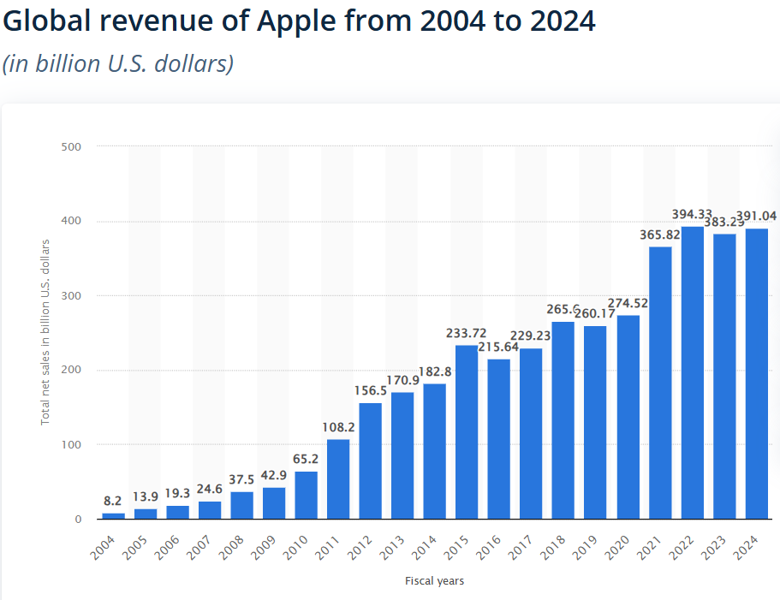

Statista 2025

**OBJECTIVES OF THE STUDY:**

* To understand how Design Thinking is used by Apple in the creation of its products.
* To explore the role of user-centered design in Apple’s customer experience and innovation approach.
* To analyze how Apple’s design-driven strategy contributes to its market success and brand loyalty.

**REVIEW OF LITERATURE**

Design Thinking is a solution-oriented method used by designers to solve complex problems, and find desirable solutions for clients. Developed by IDEO founder David Kelley , design thinking is defined as “a human-centered approach to innovation that draws from the designer’s toolkit to integrate the needs of people, the possibilities of technology, and the requirements for business success.” Thus, the method focuses on three main elements of a product or solution: people, technology, and business. All of these aspects evolve around the customer. **(Turnali, 2016).**

Pure design combines aesthetic awareness, with an in-depth aptitude for visualisation, humanistic studies and pattern development. These methods can only be employed effectively by dedicated designers who have received specialised training in the design field (**Liedtka and Ogilvie 2011)**

“The evolution from design to design thinking is the story of the evolution from the creation of products to the analysis of the relationship between people and products, and from there to the relationship between people and people.” **(Brown 2009, p.42)**

Apple's commitment to innovation is cultural, not process-driven. The most successful products at Apple started with only a few people without formal structure or hierarchy and little corporate oversight. Also, secrecy plays a big part in the company's strategy to minimize theft of proprietary information and intellectual property while maximizing its leading-edge against competitors **(Meyer, 2019).**

Apple maintains its innovation leadership position by improving its devices and business model. Apple proactively looks for ways to improvise on innovation systems to harness creativity in its people, stimulate new ideas, streamline the design process, and launch successful and profitable innovations **(Nary, 2008).**

Research suggests that Apple’s success with design thinking is rooted in a culture of innovation, curiosity, and perfectionism. According to **Amabile (1998),** an innovative culture promotes creativity by fostering intrinsic motivation, risk-taking, and collaborative problem-solving, all of which align closely with Apple’s approach. Unlike companies that heavily rely on external feedback, Apple’s internal creative teams anticipate user needs through intuition and observation, which is a distinctive application of design thinking principles.

**Maeda (2006)** introduced the concept of “Simplicity” in product design, an ideology Apple embodies in both hardware and software. This philosophy aligns with the “Define” and “Ideate” stages of design thinking by stripping products down to their essential functions while maintaining elegance and sophistication. Apple’s ability to translate complex technological capabilities into minimalist, intuitive designs offers a case study of how simplicity and innovation coexist.

Research by **Martin (2009)** discusses how companies like Apple prioritize design as a business strategy rather than a mere development phase. This approach shifts the focus from profit-driven decision-making to experience-driven innovation. Apple’s willingness to invest in aesthetic and functional perfection often results in longer development cycles but yields products that redefine industries.

**Norman (2004)** emphasizes the role of emotional design in creating meaningful user experiences. Apple’s success stems from its ability to evoke positive emotions through product interaction, whether through the satisfying click of a MacBook’s trackpad or the smooth animation of iOS. This emotional connection is an often overlooked but crucial aspect of Apple’s design thinking strategy.

Some researchers critique Apple’s approach for being too insular and less reliant on customer co-creation, a key tenet of traditional design thinking. **Verganti (2009)** argues that radical innovation often comes from interpreting market trends rather than direct user input. Apple’s ability to predict desires rather than respond to demands demonstrates an alternative form of design thinking called “Design-Driven Innovation.”

**RESEARCH METHODOLOGY**

This study is based on the secondary data collected from published articles, research papers, industry reports, and credible online sources. The data was selected based on relevance, credibility, and timeliness. The analysis involves summarizing and synthesizing the information to address the research objectives.

**ANALYSIS OF THE STUDY**

Apple adheres to an upscale adaptation of the Design Thinking methodology, drawing inspiration from IDEO and the Hasso-Plattner Institute of Design at Stanford (d.school). Adapted to Apple's own culture of invention and excellence, the Design Thinking Framework is an enhanced form of classic Design Thinking. Apple prioritizes gaining a thorough understanding of customers' behavior, frustrations, and wants rather than only adhering to what they expressly want. This allows Apple to anticipate demands before consumers ever become aware of them. Because of Steve Jobs' well-known belief that customers don't always know what they want until they see it, Apple reimagines entire product categories rather than merely solving problems.Despite not referring to its method as "Design Thinking," Apple adheres to the five steps listed below in relation to its own innovation culture and methodology:

* **Stage 1: Empathize** – Understand the needs and desires of users

Apple looks at people's use of technology outside traditional market research. Examining behaviours, annoyances, and hidden needs helps Apple to project future needs. Apple is able to find problems people might not even be aware of, using this approach. Apple shapes consumer expectations aggressively instead of reacting to them. For Apple, providing seamless, user-friendly experiences takes precedence over merely meeting present needs.

* **Stage 2: Define** – Clearly define the problem to be solved

Instead of just fixing well-known issues, Apple challenges conventional approaches to completely transform entire industries. This step includes dismantling existing solutions and rethinking their purpose from the ground up. By challenging assumptions, the company offers entirely new concepts instead of incremental improvements. Apple claims that design is a thorough process that ensures hardware, software, and the ecosystem all work together. By focusing on fundamental consumer needs, Apple is revolutionising entire product categories.

* **Stage 3: Ideate** – Generate a wide range of potential solutions

Apple has a well-organised and flexible ideation process that ensures viability while fostering innovation. Designers and engineers generate a number of concepts, which they then collaboratively refine. By ensuring that only the most compelling ideas move forward, the "10 to 3 to 1" rule helps refine concepts. This method allows for the exploration of alternative options by avoiding a hasty commitment to one. Apple integrates various perspectives to achieve a balance between innovation and viability.

* **Stage 4: Prototype** – Create tangible prototypes to test and refine ideas

Apple ensures accuracy and confidentiality through a strict internal prototype process. For the optimal user experience, every design undergoes multiple iterations to enhance the materials, textures, and interactions. Unlike companies that outsource, Apple maintains development in a controlled environment to ensure quality. Designers focus on making sure that every aspect of a product, from ergonomics to functionality, is perfect before finishing it. The goal is to deliver an intuitive, well-designed, and seemingly natural experience.

* **Stage 5: Test and Implement –** Evaluate the prototypes with users and iterate on the design

Apple prioritises internal testing and expert evaluation over open beta testing. Products go through a rigorous inspection process to ensure they meet the highest quality standards before being released. Instead of rushing to market, Apple delays releases until every detail is perfected. This methodical approach ensures hardware and software consistency, resulting in a seamless experience. Apple closely monitors testing and implementation to guarantee a flawless end product.

**DISCUSSIONS**

Apple's innovation strategy aligns with the fundamental principles of Design Thinking, focusing on intense user understanding, problem reframing, and relentless iteration. Their obsessive focus on detail, flawless hardware software integration, and human centered design differentiates them. Iconic innovations such as the iPhone's touch screen and MacBook's minimalist design embody this mindset. Rather than depending heavily on outside feedback, Apple predicts users' needs and keeps control of every stage of product development. Their dedication to simplicity guarantees that products are not only functional but also beautiful.

**CONCLUSION**

Apple's success underlines the strength of design led, user oriented strategy. Through the integration of design into its fundamental business strategy instead of as a phase, Apple routinely produces beautiful and highly functional products. This culture of innovation coupled with secretive but innovative workspaces has cemented its competitive advantage and loyal customer base providing useful lessons for other businesses seeking to drive innovation and user experience.

**REFERENCES**

* Wikipedia contributors. (2025, February 18). *The design of business*. Wikipedia. <https://en.m.wikipedia.org/wiki/The_Design_of_Business>
* SupaduDev. (2022, May 27). *2006: The Laws of Simplicity*. MIT Press. <https://mitpress.mit.edu/2006-the-laws-of-simplicity/>
* Edson, J. (2012). *Design like Apple: Seven principles for creating insanely great products, services, and experiences*. John Wiley & Sons.
* Nosyita, R. (2016b). DESIGN THINKING AND INNOVATION AT APPLE. *www.academia.edu*. <https://www.academia.edu/25672553/DESIGN_THINKING_AND_INNOVATION_AT_APPLE>
* Pooja Nagpal (2022). Airport Construction Project – A Case of Bugesera Airport Performance Analysis in Kigali, Rwanda. International Research Journal of Modernization in Engineering Technology and Science. Volume: 04(6),pp 4351-4360. June-2022. e-ISSN: 2582-5208
* Pooja Nagpal (2022) Online Business Issues and Strategies to overcome it- Indian Perspective. SJCC Management Research Review. Vol 12 (1) pp 1-10. June 2022, Print ISSN 2249-4359. DOI: 10.35737/sjccmrr/v12/il/2022/151
* Elmansy, R. (2023b, April 3). *Design Thinking Case Study: Innovation at Apple*. Designorate. <https://www.designorate.com/design-thinking-case-study-innovation-at-apple/>
* P. Nagpal, A. Pawar and S. H. M, "Predicting Employee Attrition through HR Analytics: A Machine Learning Approach," 2024 4th International Conference on Innovative Practices in Technology and Management (ICIPTM), Amity University Noida, India, 2024 on 21-23 February 2024 pp. 1-4, doi: 10.1109/ICIPTM59628.2024.10563285
* Wikipedia contributors. (2024, September 26). *Emotional design*. Wikipedia. <https://en.m.wikipedia.org/wiki/Emotional_Design>
* *Nagpal P (2023).. The Transformative Influence of Artificial Intelligence (AI) on Financial Organizations World Wide. 3rd International Conference on Information & Communication Technology in Business, Industry & Government (ICTBIG). Symbiosis University of Applied Science, Indore.*
* *Design-driven innovation : changing the rules of competition by radically innovating what things mean : Verganti, Roberto :* <https://archive.org/details/designdriveninno0000verg/page/n8/mode/1up>
* Pooja Nagpal., Kiran Kumar., A.C. & Ravindra., H.V. (2020). Employee Engagement - Impact of Demographic Variables in Indian IT Sector. Purakala31 (32), 136-142. ISSN: 0971-2143.
* Bahirat, T. (2024, May 6). Design thinking is Apple’s Success Mantra. *Great Learning Blog: Free Resources What Matters to Shape Your Career!* <https://www.mygreatlearning.com/blog/design-thinking-is-apples-success-mantra/>
* Nagpal P, Avinash Pawar, Sanjay. H.M. (2024). Sustainable Entrepreneurship: Balancing Push and Pull Factors for Customer Loyalty in Organic Product Marketing. 6 (9), 1134-1144. doi: 10.33472/AFJBS.6.9.2024.1134-1144.
* BK Kumari, VM Sundari, C Praseeda, P Nagpal, J EP, S Awasthi (2023), Analytics-Based Performance Influential Factors Prediction for Sustainable Growth of Organization, Employee Psychological Engagement, Work Satisfaction, Training and Development. Journal for ReAttach Therapy and Developmental Diversities 6 (8s), 76-82.
* Statista. (2024, November 5). *Apple revenue worldwide 2004-2024*. <https://www.statista.com/statistics/265125/total-net-sales-of-apple-since-2004/>