Impact of amine functionalized GO nanoparticles on

mechanical properties of Carbon fiber reinforced polymer composites

## Tankeshwar Prasad1*, D. Dhilleswararao1, Irfan Ahmad[1](#_bookmark2) , K Harshith1, S AkhilEswar Reddy1

Department of Mechanical Engineering

Godavari Institute of Engineering & Technology, Rajahmundry, Andhra Pradesh, India

*E-mail: tankeshwarprasadg@gmail.com

**Abstract**

Fiber Reinforced Polymer (FRP) composites have been employed widely in the last ten years to create lightweight constructions, particularly under critical loading circumstances due to its high strength-to-weight ratio. However, the brittleness of the matrix materials and the inadequate adhesion at the fiber-matrix interface caused the composite structures to break early. To encounter these issues, attempts were made to reinforced functionalized graphene oxide nanosized particles at the fiber-matrix interface. So, in the present work, carbon fiber with amine functionalized Graphene Oxide (AGO) with varying content (0 wt%, 0.25 wt%, 0.5 wt% and 1 wt%) was reinforced into epoxy resin to prepare the composites samples using hand lay-up cum compression molding process. The air bubbles from the Nano resin mixture were removed using vacuum pump. The prepared samples were tested as per ASTM Standards under Tension, Bending and impact loading conditions. There is expected to enhance all the mechanical properties at particular wt. % of GO in the selected range. Further, fractography analysis of best tensile sample was analysed using SEM to understand the failure mechanism of composites.**Keywords**: Amine Functionalized Graphene Oxide (AGO), carbon fiber, Epoxy resin, Polymer Composites, Tensile test, Flexural test.

**1. Introduction**

Amine-functionalized graphene oxide (GO) nanoparticles are being increasingly regarded as reinforcement fillers for strengthening the mechanical characteristics of carbon fiber-reinforced polymer (CFRP) composites. This research investigates the influence of varying amine modifiers on the dispersion, interfacial adhesion, and mechanical performance of CFRP composites. The results show that amine-functionalized GO enhances tensile strength, modulus, and toughness and hence is a candidate for future advanced structural applications [1]. Graphene and graphene derivatives have attracted immense interest in improving the mechanical, thermal, and electrical behaviour of fiber-reinforced polymers (FRPs). This research explores the effect of adding amine-functionalized and non-functionalized reduced graphene oxide in epoxy-based carbon fiber-reinforced polymers (CFRPs). The results show enhanced interlaminar shear strength and transverse electrical conductivity that make these modified composites of great potential for advanced structural applications like aerospace, electromagnetic interference shielding, and thermal management [2]. Amino-functionalized carbon nanotubes (ACNTs) have been used as secondary reinforcement in fiber-reinforced polymer composites for the improvement of mechanical properties. This work discusses the effect of pristine and amino-functionalized CNTs on glass fiber epoxy composites through dispersion, interfacial bonding, and load transfer. The findings indicate that chemical functionalization enhances CNT dispersion and interfacial adhesion, improving tensile and flexural strength, making ACNTs an attractive modifier for high-performance composite applications [3]. Epoxy-based nanocomposites filled with low-dimensional carbon nanomaterials like carbon nanotubes (CNTs) and graphene nanoplatelets (GNPs) possess improved mechanical properties. This research investigates the impact of melamine-functionalized CNTs (M-CNTs) and GNPs (M-GNPs) in epoxy matrices, proving enhanced dispersion, interfacial bond, and load transfer. The results demonstrate marked improvements in tensile strength, Young's modulus, and fracture toughness, with M-GNPs proving better reinforcement due to the higher interfacial area. These findings offer good insights into how high-performance polymer nanocomposites are developed [4]. GO-reinforced carbon fiber/epoxy (CF/EP) nanocomposites exhibited an enhanced mechanical property due to an improved interfacial adhesion. In this paper, the bonding strength and mechanical performance of CF/EP composites influenced by FGO using varied diamine are discussed. Results have shown that optimal FGO content greatly enhances tensile and flexural properties and may thus be a promising modifier for advanced composite applications [5]. Epoxy-functionalized graphitic nanoparticles (GrNPs) have also exhibited promising potential in the enhancement of mechanical properties of hybrid carbon fiber-reinforced polymer (CFRP) composites. In this work, the influence of silanized and epichlorohydrin-grafted GrNPs on the tensile, flexural, and interlaminar shear strength of CFRP composites is examined. The findings illustrate enhanced interfacial adhesion and stress transfer, with superior reinforcement being achieved with silanized GrNPs. The findings point towards the potential of functionalized GrNPs for the development of high-performance CFRP composites for structural and aerospace applications [6]. The research investigates the improvement of mechanical properties in epoxy composites with the addition of silanized silica nanoparticles grafted onto graphene oxide (ATGO). The functionalization enhances dispersion, interfacial adhesion, and mechanical performance. The ATGO-reinforced epoxy composites exhibit enhanced tensile strength, impact resistance, and fracture toughness at cryogenic temperatures, which makes them a potential material for aerospace, marine, and structural applications [7]. Epoxy resins are used extensively in different industries because of their superior mechanical and thermal properties, but their brittleness restricts their applications. To overcome this, scientists have attempted to reinforce epoxy with additives like graphene oxide (GO) and functionalized GO to enhance its toughness and performance. In this work, the effect of surface-modified GO with 3-aminopropyltriethoxysilane (APTES) on the mechanical and thermal properties of epoxy composites is investigated. The findings exhibit improved tensile strength, impact resistance, and dispersion properties, indicating that APTS-GO is a promising reinforcement material for high-end composite applications [8]. Graphene nanoplatelets (GNPs) have been of particular interest as promising nanofillers with remarkable mechanical, thermal, and electrical properties. This research examines the reinforcing behaviour of GNPs in carbon-epoxy composites to improve their mechanical performance. The addition of different GNP weight percentages into the epoxy matrix and carbon fabric/epoxy hybrid composites showed remarkable improvement in tensile, flexural, and impact strength. Results imply that GNP-reinforced epoxy composites have vast structural and multifunctional potential for aerospace, automobile, and other high-performance industry applications [9]. Graphene nanocomposites have been found to be next-generation materials with superior mechanical and thermal properties. In this research, the influence of amine-functionalized graphene (NH2-f-Gr) on the mechanical properties of epoxy nanocomposites is investigated. With the addition of NH2-f-Gr at various weight fractions, Young's modulus and tensile strength were enhanced, with the best performance at 0.5 wt% loading. The findings indicate the potential of functionalized graphene in improving polymer composites for structural and high-performance applications [10]. Graphene-reinforced carbon fiber-reinforced polymer (CFRP) composites possess superior mechanical properties but are usually hindered by poor interfacial adhesion. This research investigates the improvement of CFRP composites with silanized graphene, enhancing adhesion via covalent bonding. With the addition of just 0.5 wt% functionalized graphene, tensile and flexural strength improved by 17.6% and 5.4%, respectively. The findings indicate a scalable and effective process for producing high-performance composites applicable in aerospace and automotive industries [11].

**2. Experimental work:**

**2.1 Materials:**

**2.1.1 Epoxy Resin**

In our present work, I had used the Lapox-12 commonly known as L-12 as a epoxy polymer. L-12 is a liquid, unmodified epoxy resin with a medium viscosity. It’s a type of diglycidyl ether of bisphenol A (DGEBA, C21H24O4). It is commonly used with various hardeners for creating Fiber-reinforced composites. We purchased this from Solind Services Pvt. Ltd Bengaluru (India) of Atul Brand.

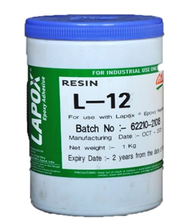

**Fig 1**. Epoxy

**Table 1.** Specification of Lapox L-12

|  |  |  |
| --- | --- | --- |
| **Property** | **Unit** | **Value** |
| Epoxide Equivalent  Epoxy Value  Viscosity at 250 C | gm/eq  eq/kg  mPa.s | 182-192  5.2-5.5  9000-12000 |

**2.1.2 Hardener**

In our present work, I had used the Hardener as Lapox K6, Lapox K-6 is a light-yellow aliphatic polyamine hardener. The chemical name of hardener is ethylene tetra amine (C6H18N4). It can cure epoxy resin at ambient temperature. Epoxy resin cures quickly, resulting in a pot life. Its low viscosity and low dosage make it ideal for applications such as adhesives, cement and casting of small physical components. We purchased this also from Solind Services Pvt. Ltd Bengaluru (India) of Atul Brand.

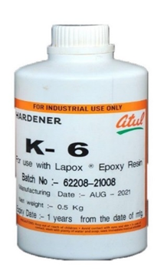

**Fig 2. Hardener**

**Table 2.** Specification of Hardener K-6

|  |  |
| --- | --- |
| **Property** | **Value** |
| **Refractive Index at 250 C Water content** | **1.4940 – 1.5000**  **1% max** |

**2.1.3 Amine Graphene Oxide (AGO)**

In our currentwork, I had used 99% pure AGO having 5 to 10 nm Thickness. Amine Graphene oxide is a remarkable substance with the features. The chemical formula of amine functionalized graphene oxide C70H21O10. Oxidizing AGO results in a multi-layer thick carbon sheet with oxygen containing groups attached. Compared to normal graphene, it disperses well in water and is lightweight, making it a promising material for composites. CFRP’s is strong bonding between carbon fibers and polymer matrix. These groups exhibit strong chemical interaction with the both fibers and the matrix, resulting in increased stress transmission and mechanical properties. Amine Graphene oxide (C, Purity 99%) was acquired from the Nano Research Laboratory in Mohanpur, Jharkhand (India).

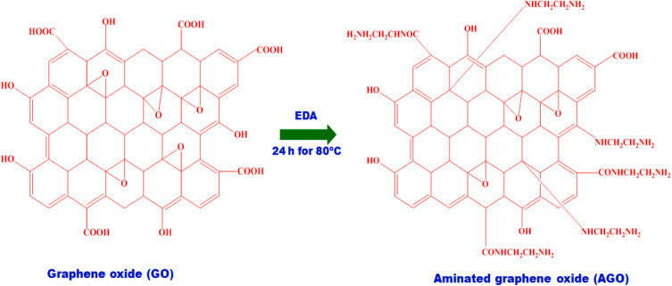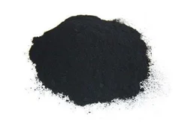

**Fig 3.** Amine Graphene Oxide (AGO)

**Table 3.** Specifications of AGO

|  |  |  |
| --- | --- | --- |
| **Property** | **Unit** | **Value** |
| Colour  No.of layers  Diameter  Thickness  Bulk Density | -  -  µ  nm  g/cc | Black/Brown  Multi layers  1-5  5-10  0.241 |

**2.1.4 Carbon fiber**

Here I had used the carbon fiber 600 GSM plain weave Bidirectional. Carbon fiber 600 GSM refers to a carbon fabric with weight of 600 grams per square meter. GSM is a typical unit of measurement for fabrics that indicates the material’s density. Simply greater GSM indicates a heavier and thicker fabric. Carbon fiber fabric material is a material composed of long, thin strands of carbon fibers. These fibers are extremely strong and stiff, yet relatively lightweight. Bidirectional fabric offers strength in two primary directions (usually 0 and 90 degrees), making it good for applications requiring multi-directional stress handling. From Aadimaata Enterprises Mumbai (India) we had acquired carbon fiber (600 GSM plain weave bidirectional).

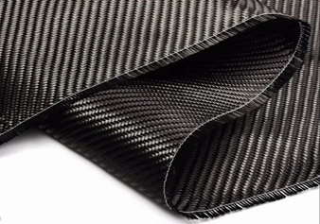

**Fig 4**. Carbon Fiber

|  |  |  |
| --- | --- | --- |
| **Property** | **Unit** | **Value** |
| Areal weight  Standard width  Dry fabric thickness  Density  Filament Diameter  Tensile Strength  Tensile Modulus  Elongation | g/m2  mm  mm  g/cm3  µm  MPa  GPa  % | 600  1000  0.5  1.8  7  4900  240  2.1 |

**Table 4.** Specification of Carbon Fiber

**3. Methodology**

**3.1 Preparing of CFRP Laminates Without AGO**

The present work, I had produced the samples using the hand layup process, I took two MS steel plates, cleaned their surfaces with ethanol, and applied the releasing agent to the surface of one plate and left it for a while. After some time, I attached plastic sheet to the plate and cut the carbon fiber down to 190mm x 170 mm measurements. After that, I took a 250 ml disposable plastic glass and placed it on the Electronic Composite Scale Weighing Machine, then pressed the Tare button to display ‘0’. After we put 100 grams of epoxy to the glass and tared it off. Then holding a spatula, add 10 grams of hardener (K6) to it (at a 1:10 ratio epoxy to hardener). Then added the 10 grams of hardener (K6) to it (which is ratio of 1:10 of epoxy to hardener) and mixed well with help of spatula.After that, I placed the infusion mesh and peel ply and poured some resin mixture and distributed it well on the peel ply with the help of a wiper, then placed the initial layer of carbon fiber and applied pressure on the carbon fiber with the help of roller, and then added some resin poured and spread it with a wiper before applying pressure with a roller by moving forward and backward. Repeat the process up layers, then add another peel ply and infusion mesh on top, then another MS plate on top, and then place the laminate under the UTM and apply mild load, allowing it to cure for up to 12 hours before removing the loads and the laminate by removing the peel ply. Finally, samples were prepared as per according to ASTM standards.

**C:\Users\admin\Desktop\Dil-1.tif**

**Fig. 5** Fabrication process of CFRP Composite Laminates**.**

**3.2 Preparing of CFRP Laminates With AGO**

I had used the hand layup method to reinforce the carbon fiber with amine graphene oxide (AGO) and resin mixture, but I used a mini stirrer ensure uniform mixing of AGO powder in epoxy and created a vacuum chamber to remove air bubbles in the AGO and epoxy resin and using a vacuum pump and vacuum desiccator prepared the MS plates in the same way that was explained before. Then, a disposable plastic glass was placed on the electronic weighing machine and set zero. Then add 120 grams of epoxy and 0.3 grams or 0.25% amine graphene oxide (AGO) and mix the mixture uniformly with a mini stirrer at 1100-1200 rpm for 10-15 minutes. After that, place the mixture in the vacuum desiccator, turn on the vacuum pump, and wait until the bubbles in the mixture have an eliminated. After that, add the hardener at a 10:1 ratio of the epoxy mixture and stir it with a spatula. The procedure for preparing laminates without AGO is the same mentioned previously. Finally, after curing, the samples were cut according to ASTM standards for tensile, flexural, SBS (short beam shear stress) and impact tests.

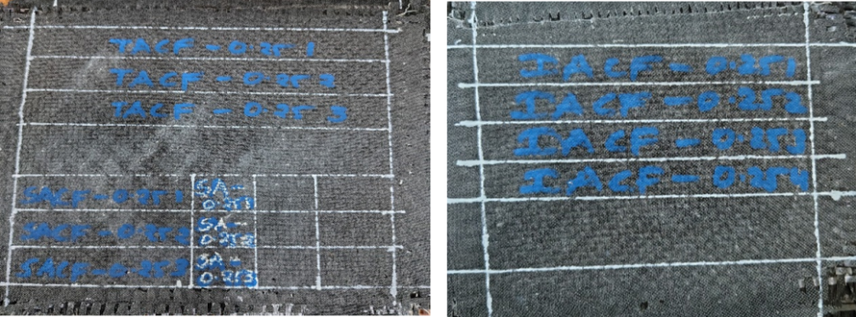

**Fig 6.** Laminated composites prepared with 0.25% AGO reinforcement.

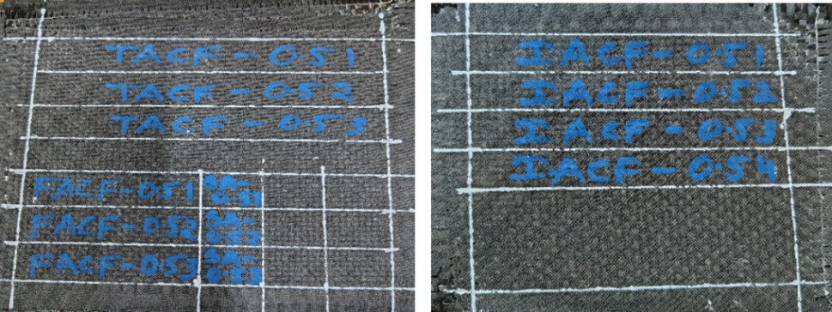

**Fig 7.** Laminated composites prepared with 0.5% AGO reinforcement.

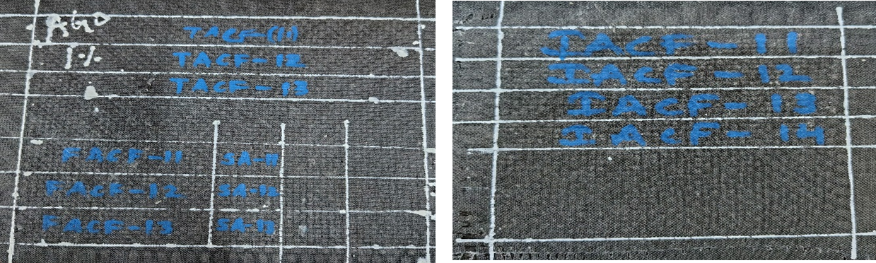

**Fig 8.** Laminated composites prepared with 1% AGO reinforcement.

**4. Mechanical Testing**

In the mechanical performance of pure epoxy and both amine graphene oxide (AGO) composites laminates are investigated from tensile, flexural and fracture tests conducted under the universal testing machine (UTM) having capacity of 200 kN load cell at a m/min.

**4.1 Flexural test**

Flexural testing is performed to determine the bending strength, stiffness, and failure behavior of composite materials under a flexural (bending) load. Since composites are flexural properties depend on fiber orientation, stacking sequence, and matrix composition. It is laminates was prepared according to the ASTM D790 with dimension of 75 mm x 15 mm x 3.0 mm.

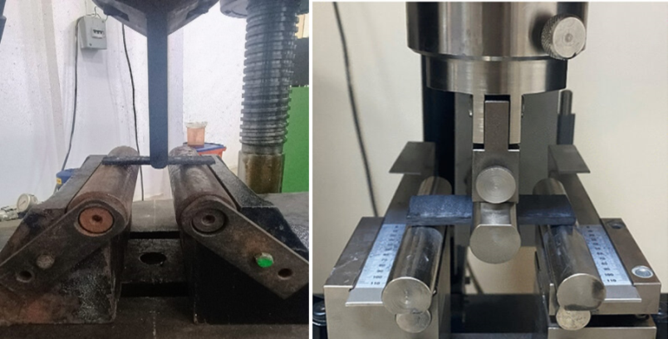

**Fig. 9** Flexural Testing of CFRP sample.

**5. Results & Discussion**

The Flexural properties of AGO/Epoxy reinforced composites prepared using different quantities were investigated to compare the role of AGO nanofiller for the CFRP composites preparation. The flexural properties of with and without AGO reinforced composites are summarized in Table 5. The reprehensive Flexural stress vs sample code plots of samples are shown in Fig 13. It has to be found that the sample reinforced with the 1% of AGO had given the maximum Flexural strength and maximum percentage was found at neat epoxy. It is also found that addition specific quantity of AGO with epoxy as reinforcement, uplifts the mechanical performance of composites as compared to NE. The 1% AGO CFRP sample shows the high Flexural strength, showing around 11% enhancement with respect to NE sample and 0.25%AGO reinforced composites. It is worth noting that 0.25%AGO reinforced composites show better performance than other AGO reinforced composites.

**5.1 Flexural Property**

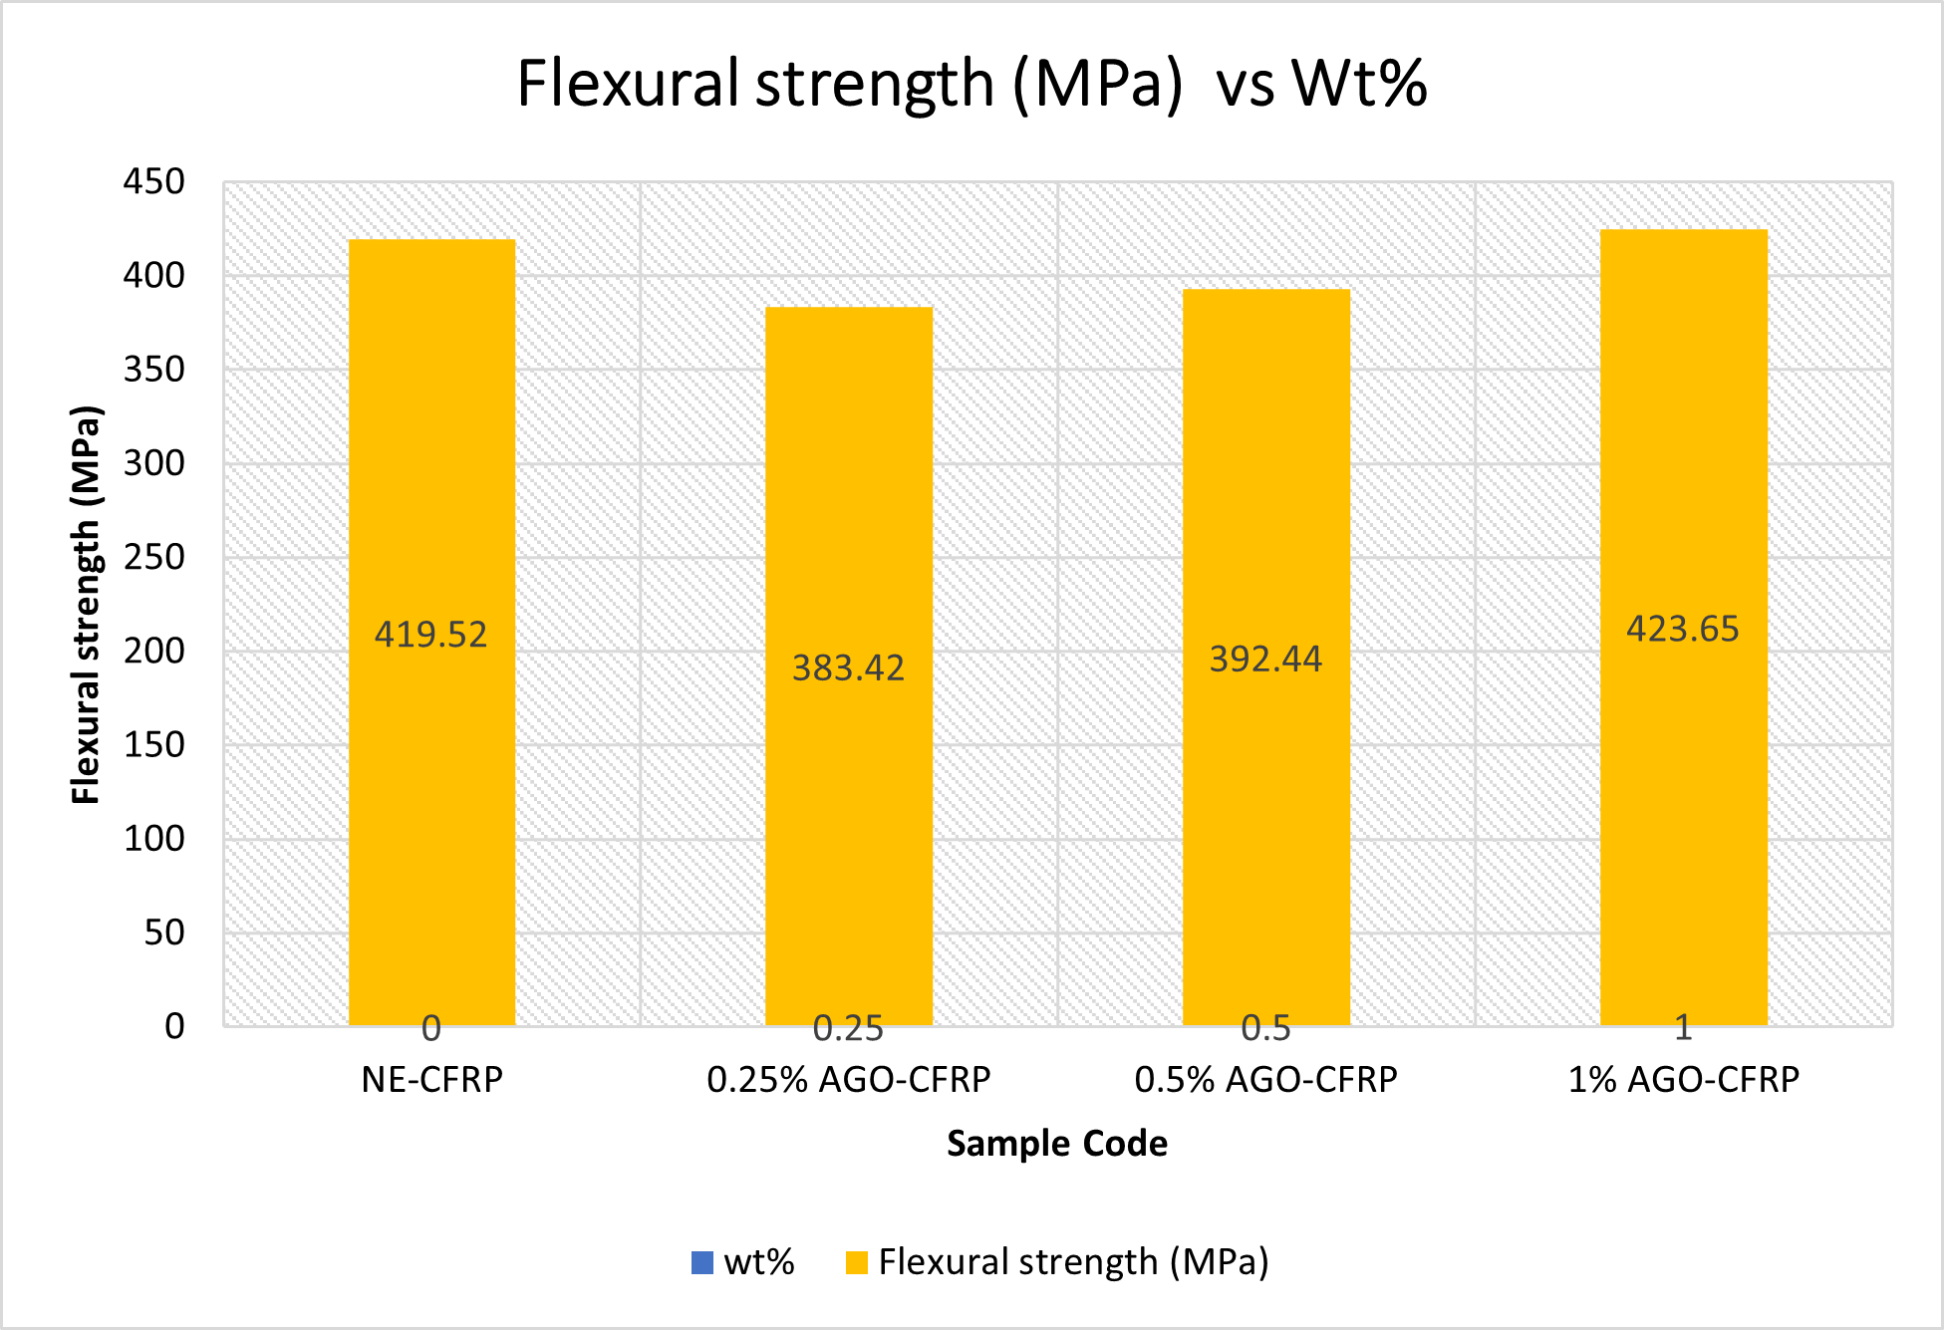Fig.13 shows the graph between maximum flexural strength vs Flexural modulus was observed for 1% AGO CFRP is 423.65 MPa and minimum for 0.25% AGO CFRP is 383.42 MPa.

**Fig.10**: showing variation in Flexural strength of CFRP composites at varying contents of AGO

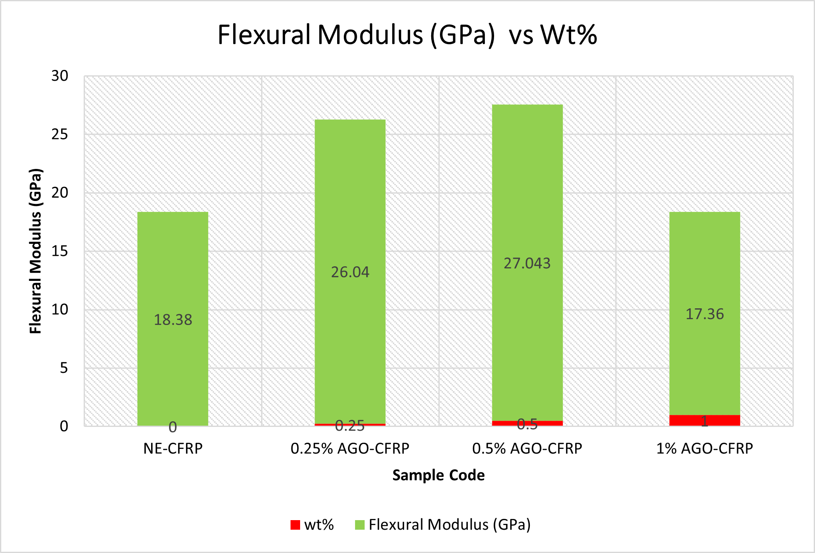

**Fig.11**: showing variation in Flexural modulus of CFRP hybrid composites at varying contents of AGO

**Table 5:** Flexural Property of CFRP hybrid composites at varying content of AGO

|  |  |  |  |  |  |  |  |
| --- | --- | --- | --- | --- | --- | --- | --- |
| **Sl. No.** | **Sample code** | **Flexural Load (kN)** | **Strain (mm)** | **Flexural strength (MPa)** | **%**  **Increase** | **Flexural Modulus (GPa)** | **%**  **Increase** |
| 1 | CFRP-AGO (0) | 1.20 | 17 | 419.52 | - | 18.38 | - |
| 2 | CFRP- AGO (0.25) | 1.1 | 11 | 383.42 | -0.085 | 26.04 | 41.6 |
| 3 | CFRP- AGO (0.5) | 1.35 | 13 | 392.44 | -0.06 | 27.043 | 47.1 |
| 4 | CFRP- AGO (1) | 1.20 | 18 | 423.65 | 0.011 | 17.36 | -0.055 |

**6. Conclusions**

I had prepared the CFRP composites by using the Amine Graphene Oxide (AGO) as nanofiller. The Flexural Strength and Modulus were enhanced 8.55% and 41.6% AGO reinforced composite with respect to NE. The flexural strength and modulus were decreased by 6% and 47.1% AGO reinforced composite, 11% and 55% for 1% AGO reinforced composite with respect to NE. The maximum flexural strength was observed as 423.65 MPa for 1% AGO reinforced composite. However, comparing the mechanical properties of AGO reinforced composite with NE, the 1% AGO reinforced composite are preferable for the place were high Flexural strength application.

**References**

[1] Madhab Bera, Arjun Prabhakar, Pradip K. Maji, Nano tailoring of thermoplastic polyurethane by amine functionalized graphene oxide: Effect of different amine modifier on final properties, 2020.

[2] Annika C. Ackermann, Martin Demleitner, Jajnabalkya Guhathakurta, Stefan Carosella, Mechanical, thermal, and electrical properties of amine- and non-functionalized reduced graphene oxide/epoxy carbon fiber-reinforced polymers, 2023.

[3] Mohit Garg1, Shruti Sharma and Rajeev Mehta, Pristine and amino functionalized carbon nanotubes reinforced glass fiber epoxy composites, 2015.

[4] Jaemin Cha, Joonhui Kim, Seongwoo Ryu, and Soon H. Hong, Comparison to Mechanical Properties of Epoxy Nanocomposites Reinforced by Functionalized Carbon Nanotubes and Graphene Nanoplatelets, 2018.

[5] Alireza Ashori, Hossein Rahmani, Reza Bahrami, Preparation and characterization of functionalized graphene oxide/carbon fiber/epoxy nanocomposites, 2015.

[6] Nazrul Islam Khan, Sudipta Halder, Subhankar Das, Manjeet S. Goyat, Graphitic nanoparticles functionalized with epoxy moiety for enhancing the mechanical performance of hybrid carbon fiber reinforced polymer laminated composites, 2020.

[7] Tongwu Jiang, Tapas Kuila, Nam Hoon Kim, Bon-Cheol Ku, Joong Hee Lee, enhanced mechanical properties of silanized silica nanoparticle attached graphene oxide/epoxy composites, 2013.

[8] Parul Malik, Bhasha and Purnima Jain, Influence of Surface modified Graphene Oxide on Mechanical and Thermal Properties of Epoxy Resin, 2018.

[9] Hadimani Shiva kumar, N. M. Renu kappa, K. N. Shiva kumar, B. Suresha, The Reinforcing Effect of Graphene on the Mechanical Properties of Carbon-Epoxy Composites, 2020.

[10] Anurag Yadava, Amit Kumar, Kamal Sharma, Manoj K Shukla, Investigating the Effects of Amine Functionalized Graphene on the Mechanical Properties of Epoxy Nanocomposites, 2019.

[11] Xudan Yao, Jason H. Hui, Ian A. Kinloch, and Mark A. Bissett, Improved Mechanical Properties of Graphene/Carbon Fiber Composites via Silanization, 2024.