# DESIGN AND OPTIMIZATION OF A CUTTING TOOL FOR MACHINING TIME REDUCTION

# Dr. Saravanan G1, Dinesh V2, Jaisurya P3, Karthick K4

1Associate Professor, Mechanical Engineering, Kongunadu College of Engineering & Technology, Trichy, Tamil nadu, India.

2,3,4Student, Mechanical Engineering, Kongunadu College of Engineering and Technology, Trichy, Tamil nadu, India.

# ABSTRACT

The design and optimization of cutting tools for machining time reduction focus on improving the efficiency of manufacturing processes by enhancing tool performance. This study explores various design parameters such as tool material, geometry, coating, and cutting conditions to minimize machining time while maintaining product quality. Through advanced simulation and experimental methods, the tool's cutting efficiency is optimized, considering factors like tool wear, heat generation, and surface finish. The research aims to identify the optimal combination of parameters that reduce machining time, lower production costs, and extend tool life, ultimately contributing to sustainable and cost-effective manufacturing practices.

# INTRODUCTION

The continuous demand for higher productivity, reduced manufacturing costs, and improved quality in modern industries has significantly increased the need for innovative solutions in machining processes. Machining is an essential part of manufacturing, involving the removal of material from a work piece using various cutting tools. The machining process is energy-intensive and requires efficient utilization of resources such as time, energy, and materials. One of the key factors in enhancing manufacturing productivity is the reduction of machining time while maintaining or improving product quality and tool life. The design and optimization of cutting tools play a crucial role in achieving this goal. Cutting tools are essential components of the machining process, and their performance has a direct impact on machining efficiency, cost-effectiveness, and product quality. The cutting tool’s design material geometry coating and cutting conditions all influence machining time, tool life, and surface finish. In an industrial setting, the objective is to maximize material removal rate (MRR) while minimizing the time and energy required for the machining process. Achieving this balance often requires optimizing multiple factors simultaneously, which makes the design and optimization of cutting tools a challenging yet essential area of study in manufacturing engineering. Cutting tool optimization involves modifying the tool’s design and machining parameters to achieve higher efficiency, longer tool life, better surface finish, and reduced cycle time. In the context of machining, time reduction is often synonymous with cost reduction, as shorter machining times result in increased throughput, lower energy consumption, and reduced labor costs. However, achieving optimal cutting tool performance involves more than just reducing time. A cutting tool that reduces machining time too aggressively may lead to excessive tool wear, poor surface finish, or premature tool failure, which can ultimately result in higher operational costs and waste. The reduction of machining time involves several factors, with cutting tool design being one of the most impactful. By optimizing the geometry, material, coating, and cutting parameters of the tool, it is possible to increase cutting speeds, enhance tool life, and minimize the wear and tear that occurs during machining. Optimizing cutting tools for time reduction also requires considering the interaction between the tool, work piece material, and machining conditions. The design and optimization of cutting tools are critical elements in improving the efficiency and performance of manufacturing processes. Cutting tools, whether used in turning, milling, drilling, or other machining operations, play a crucial role in determining the overall machining time, tool life, and surface finish quality of the work piece. With the growing demand for higher productivity, precision, and cost-effectiveness in modern manufacturing, reducing machining time while maintaining or improving part quality has become an important challenge.

# METHODOLOGY

The methodology for designing and optimizing a cutting tool to reduce machining time involves several key steps. First, the problem is defined by setting clear objectives, such as minimizing machining time while maintaining tool life and part quality. This includes selecting the machining process and understanding the material being cut. A comprehensive literature review follows, analyzing cutting tool materials, geometries, and cutting conditions. The next step involves designing the cutting tool's geometry, considering critical factors like rake angle, clearance angle, nose radius, and material selection. Modeling the machining process, using analytical models or finite element analysis (FEA), helps predict cutting forces, temperature distribution, and tool wear. Optimization techniques, such as genetic algorithms, particle swarm optimization, or response surface methodology, are employed to find the best combination of tool geometry and cutting parameters. Simulation tools and experimental testing are used to validate the optimization results, adjusting tool design based on real-world performance. Tool wear and longevity are also evaluated, ensuring the cutting tool remains effective throughout its lifecycle. The process concludes with scaling up the optimized design for practical production and integrating it into manufacturing systems, continuously refining the design based on performance feedback. This iterative approach ensures that machining time is minimized while achieving optimal tool life and surface finish.

# OPTIMIZATION OF CUTTING TOOL

Optimization of cutting parameters is a vital step in the design and optimization of a cutting tool for machining time reduction. Key cutting parameters such as cutting speed, feed rate, and depth of cut directly influence material removal rates, cutting forces, tool wear, and overall machining efficiency. Increasing the **cutting speed** can improve machining time by increasing the material removal rate, but it also generates more heat and can lead to higher tool wear. The **feed rate,** which determines how quickly the tool advances through the material, should be optimized to balance between fast material removal and the stability of the machining process, as excessive feed rates can increase cutting forces and affect part quality as shown in figure 1.

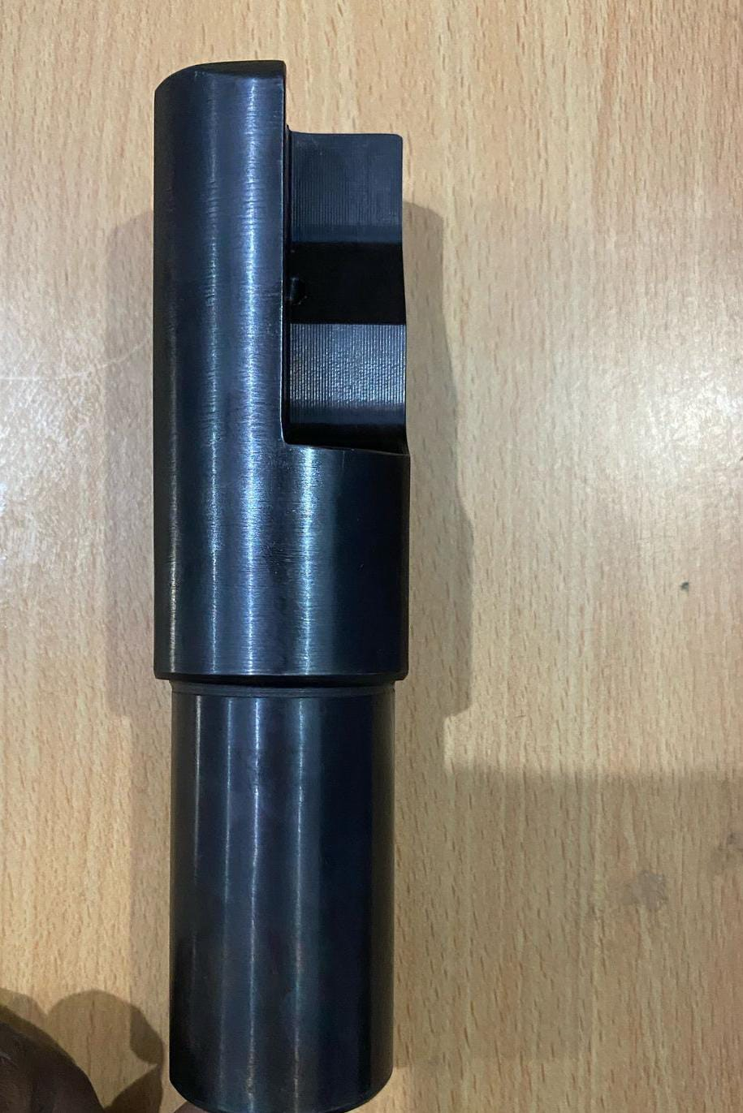

**Figure 1 New Cutting Tool**

Tool geometry design is a critical factor in the optimization of a cutting tool for machining time reduction. The key geometric parameters that influence machining performance include the rake angle, clearance angle, nose radius, and the overall shape of the tool. The rake angle determines the cutting forces and chip flow; a higher rake angle reduces cutting forces and heat generation but may reduce tool strength, making it suitable for softer materials. The clearance angle ensures that the tool does not drag on the workpiece, reducing friction and wear, and contributes to smoother cutting as shown in figure 2.

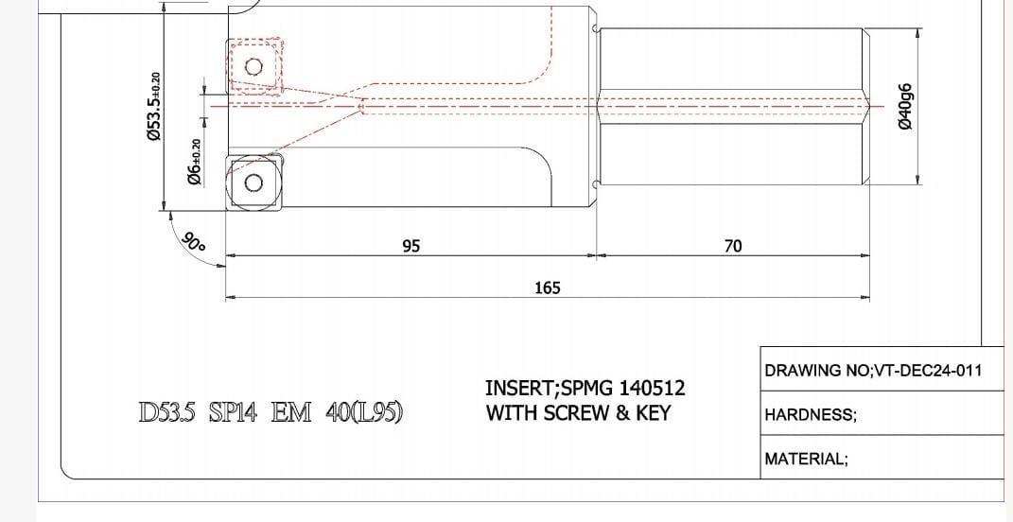

**Figure 2 Tool Drawing**

The measurement of machining time as shown in figure 4.3 is a critical factor in the design and optimization of cutting tools aimed at reducing machining time and improving the overall efficiency of manufacturing processes. Machining time refers to the total amount of time taken to complete a machining operation, from the start of the cutting process to the completion of the desired shape on the workpiece. The goal of reducing machining time is to improve productivity, reduce costs, and ensure high-quality production. Achieving this requires a detailed understanding of the various factors influencing machining time, which can be controlled or optimized through advanced cutting tool design and performance monitoring is show in the figure 3.

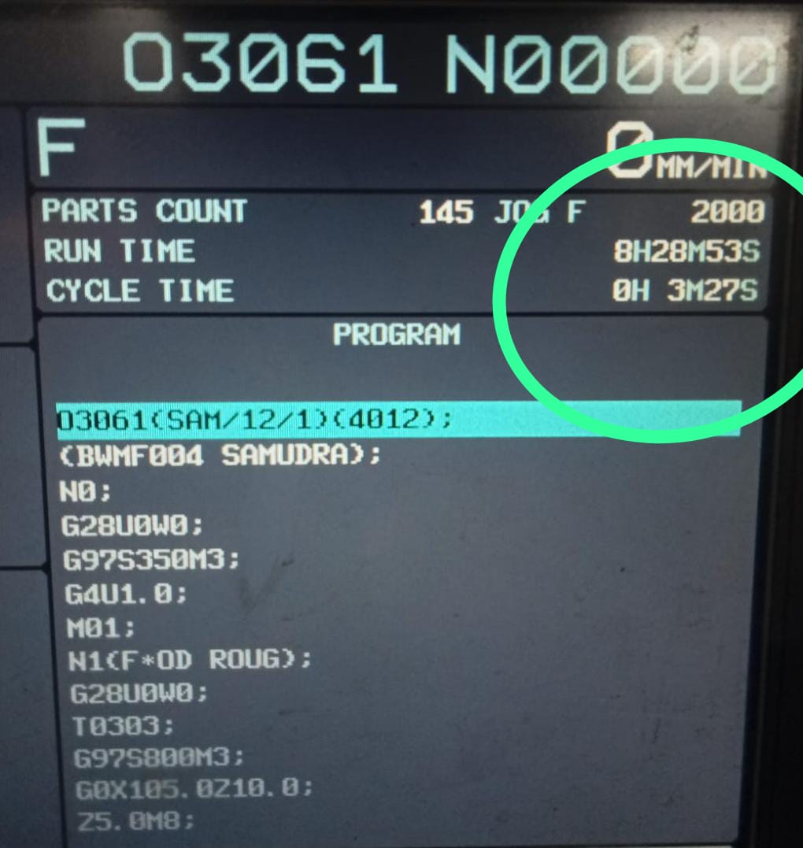

**Figure 3 New Tool Cycle Time**

Cutting time is the period spent actively removing material and is influenced by cutting speed, feed rate, and depth of cut. Tool changing time includes the time taken to replace worn or broken tools, while idle time accounts for non-productive activities such as machine setup or waiting for material. Auxiliary time involves tasks like tool alignment and coolant system checks. By accurately measuring these components, manufacturers can identify inefficiencies and focus on optimizing factors as shown in figure 4.

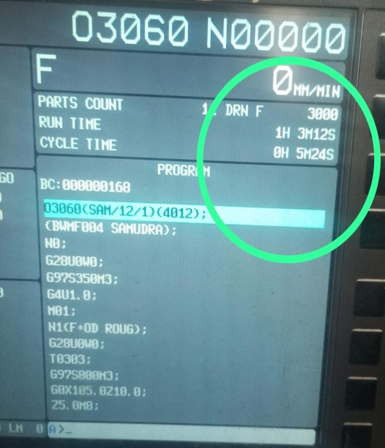

**Figure 4 Old Tool Cycle Time**

Additionally, improving tool geometry and optimizing tool paths and process strategies can help reduce non-cutting time, further streamlining the machining process. Effective monitoring and control of machining time enable manufacturers to enhance productivity, reduce costs, and ensure high-quality production.

# CONCLUSION

The **design and optimization of cutting tools for machining time reduction** play a crucial role in enhancing the efficiency and cost-effectiveness of modern manufacturing processes. With industries constantly striving for higher productivity, reduced operational costs, and improved product quality, optimizing cutting tools has become a key strategy for achieving these goals. The primary benefit of optimizing cutting tools is the **reduction in machining time**. Shortening the time required for each machining operation directly impacts the overall cycle time of production, leading to increased throughput and better utilization of manufacturing resources. The ability to produce more parts in less time not only improves the efficiency of the production line but also allows manufacturers to meet growing demands in shorter lead times. The **cost savings** derived from reducing machining time are significant. By lowering the time spent per part, manufacturers can cut down on machine hours, which reduces energy consumption and operational expenses. Moreover, **labour costs** are also reduced as fewer hours are required to complete the same number of parts. In high-volume production environments, these savings can accumulate rapidly, leading to substantial reductions in overall production costs. While the upfront cost of designing and implementing optimized cutting tools may be higher due to the use of advanced materials and engineering, the **long-term benefits** outweigh the initial investment.

1. **REFERENCES**
2. Chen, L., Zhang, Z., & Lin, Z. (2019). Ceramic and cermet cutting tools for high-performance machining of titanium alloys. International Journal of Machine tools and Engineering, Vol 25, No.4, pp. 142, 1-15.
3. Dhanasekaran, R., Ramesh, N., & Chockalingam, R. (2019). Application of genetic algorithms for optimization of machining parameters. International Journal of Advanced Manufacturing Technology, Vol 38, No.5, pp. 102 (9-12).
4. Gupta, M., & Choudhury, A. (2020). Influence of cutting fluids and coatings on tool performance in machining. Wear, Vol 42, No.7-9, pp. 448-449, 203-211.
5. Jain, P., & Yadava, V. (2018). Study on the application of TiAlN coating for high-speed machining. Surface and Coatings Technology.,Vol.53, No.3, pp. 347, 284-295.
6. Kapoor, D., Soni, A., & Gupta, V. (2018). Tool wear monitoring and its impact on machining time in turning operations. Precision Engineering, Vol 142, 75-88. pp. 52, 1-8.
7. Kumar, M., & Ghosh, A. (2021). Adaptive machining strategy for tool wears reduction in high-speed turning. CIRP Journal of Manufacturing Engineering Science and Technology, Vol.140, No.8, pp. 34, 1-14.
8. Patel, D., Sharma, R., & Bhattacharya, B. (2018). Investigation of edge radius on tool performance in turning operations. Journal of Materials Processing Technology, Vol.18, No.25-38, pp. 255, 1-11.
9. Pradhan, S., Rout, R., & Dash, S. (2019). Multi-objective optimization of turning parameters using genetic algorithms. Journal of Manufacturing Science and Engineering, Vol.129, No.55-68, pp. 141(12), 121015.
10. Sahoo, S., Mohanty, S., & Sahu, R. (2016). Influence of cutting tool geometry on machining performance. International Journal of Manufacturing Technology, Vol.12,No.58, pp.83(9-12), 2097-2111.
11. Singh, S., Gupta, R., & Kumar, A. (2017). Effect of carbide cutting tools on machining time in high-speed machining. Journal of Manufacturing Processes, Vol.135, No.88, pp.29, 134-145.
12. Singh, R., Sharma, N., & Soni, S. (2020). Application of RSM for optimization of Slicing parameters in turning. Journal of Manufacturing Science and Engineering,Vol.65.No.32,pp.142(4), 041016.
13. Zhang, X., Li, Q., & Wang, J. (2020). Hybrid optimization model for machining time and tool life improvement. Journal of Manufacturing Processes,Vol.86.No.98,pp. 56, 205-217.