**Analysis of Concrete with addition of RedMud to improve Hydration and Strength**

Akshay Malviya1, **Shaifali Sehgal**2

1, 2 Department of Mechanical Engineering, NRI Institute of Research and Technology, Bhopal, India

***Abstract*—** **In Present Investigation with concrete block with different admixtures i.e. Biodegradable Ash + RedMud and wooden crumb are prepared superately in M-20 block also wooden crumb and Biodegradable Ash + RedMud mixed together as a admixture in a concrete block with a percentage of 8%, 10%, 20% the compression test were perform on 12 block and found that the concrete block of M20 with a proportion of mixture 8% with Biodegradable Ash + RedMud and wooden crumb+ RedMud imposes less CO2and high compression strength is predicted. It was analyzed that RedMud mixed concrete and Biodegradable Ash + RedMud shows comparatively high compressive strength compare to other admixture cube samples.**

***Keywords—*** ***Compressive Strength, Column, Concrete, Rubber Crumb, Wooden Crumb, biodegradable ash, RedMud.***

# Introduction

With the commissioning of the Aluminum Corporation of India's facility in 1938, aluminum manufacturing began in India. Red mud output has grown in tandem with the increase in aluminum production during the past 20 years. Among the top 5 nations in the world producing red mud, India came in fifth. Thus, the appropriate use of red mud is currently a major issue for both India and other nations. It is now impossible to use red mud to its full potential without negatively impacting the ecosystem. India possesses around 5 billion tons of bauxite reserves. India is the fifth-largest producer of aluminum in the world. Red mud is typically a waste product left over after the Bayer process, which produces alumina from bauxite. Its crimson color is a result of 60% iron content. Red mud, a combination of contaminants carrying both solid and metallic oxides, is one of the major disposal issues facing the aluminum industry.

# Application of Red Mud

There are several applications for red mud on building sites. It is also useful in a variety of ways. Numerous studies have been conducted to improve the use of red mud in the field and as a substitute material for building. Bricks may be manufactured using red mud.

* Red mud and fly ash is be mixed to manufacture
* Bricks of various colours and textures. It is also used as partial replacement with cement.
* The researchers have reported that red mud can replace cement up to 10% in mortars and 5% in concrete to obtain better strength. Red mud with PVC is used to make a Red Mud
* Plastics it is also called RMP. These plastics are used to produce various plastic products. Chiefly in the corrugated roofing sheets, these redmud plastic have shown remarkably improve properties over PVC in terms of weather resistance. Red mud is also use as adsorbent in industry, because in industry there are more pollution occur and it is very harmful for environment, so it is use for cleaning the industrial gases. Red mud can also be used as a base for growing plants.

# C:\Users\HCL\Desktop\Rebarbeams.jpg

# METHODOLOGY

**PREPARATION OF CUBE**

* Weighing & Batching
* Mixing
* Placing
* Compacting
* Curing

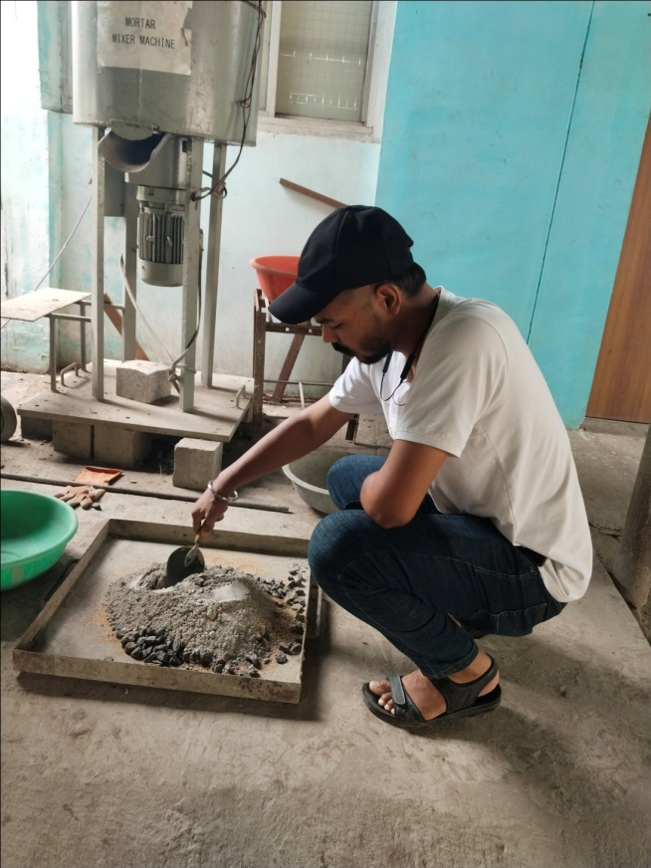

Figure: batching of materials

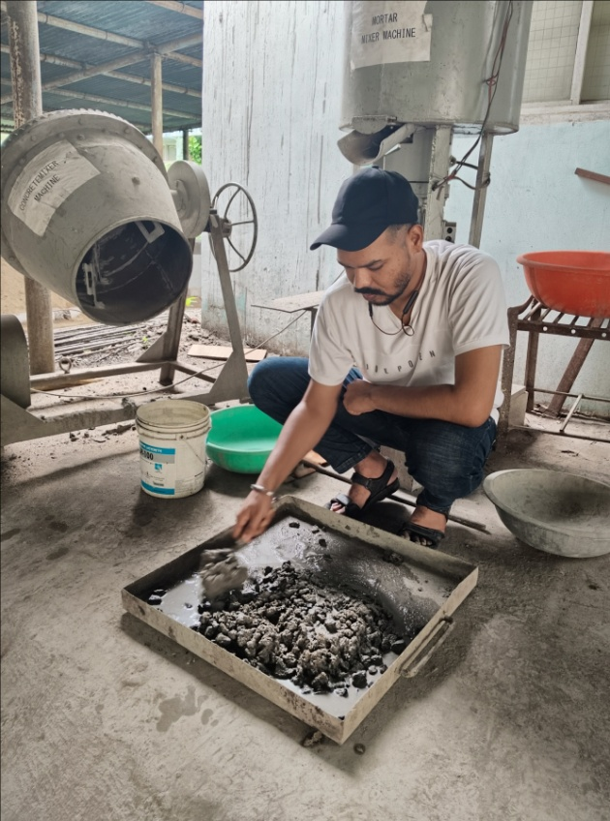

Figure: mixing of materials

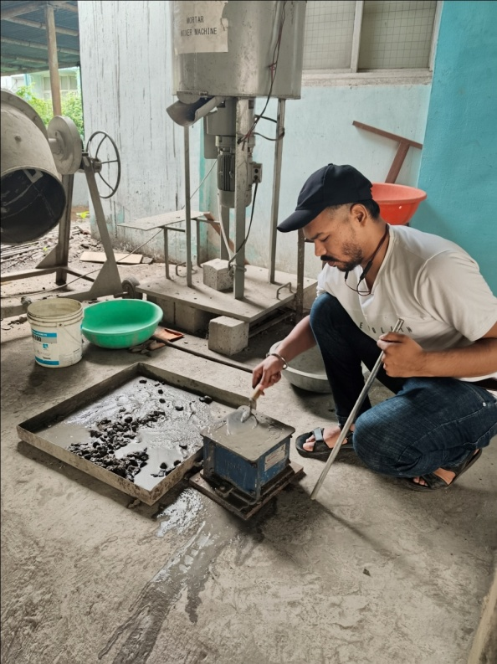

Figure: placing of concrete in mould

**Objective**

* To investigate load resistance of concrete by adding admixture.
* To analyze compressive strength by adding Redmud, Wooden crumb, Biodegradable Ash, Rubber crumb.
* To minimize effect of CO2 with addition of Biodegradable Ash + RedMud.
* To improve load resistance of mixture addition of redmud including biodegradable ash, rubber crumb and wood crumbs could be used.

# RESULTS

Table 4.1 Results of compressive strength test of BiodegradableAsh % (replacement by wt. of cement)

|  |  |  |  |  |  |
| --- | --- | --- | --- | --- | --- |
| **S. No.** | **Biodegradable Ash + RedMud% (replacement by wt. of cement)** | **Compressive Strength of Cubes N/mm2** | | | |
| 7Days | 14 Days | 21 Days | 28 Days |
| **1** | 8% | 34.5 | 39.2 | 43.2 | 44.5 |
| **2** | 10% | 23.5 | 28.1 | 34 | 35.4 |
| **3** | 20 % | 20.2 | 25.4 | 30.3 | 31.6 |

Figure: Graph shows Results of compressive strength test of Biodegradable Ash + RedMud% (replacement by wt. of cement)

Table : Result of Compressive Strength of Wooden Crumb% (replacement by wt. of cement)

|  |  |  |  |  |  |
| --- | --- | --- | --- | --- | --- |
| **S. No.** | **Wooden Crumb + RedMud % (replacement by wt. of cement)** | **Compressive Strength of Cubes N/mm2** | | | |
|
| 7Days | 14 Days | 21 Days | 28 Days |
| **1** | 8% | 37.5 | 41.6 | 48 | 49.4 |
| **2** | 10% | 25.2 | 30.5 | 36 | 37.5 |
| **3** | 20 % | 20.1 | 23.6 | 30 | 31.4 |

Figure : Graph shows of Result of Compressive Strength of Wooden Crumb% (replacement by wt. of cement)

CONCLUSIONS

* The compressive strength of the concrete decreases about 56% when 15% of sand is replaced by wooden crumb. The compressive strength of the concrete decreases about 25% when 15% of sand is replaced by biodegradable Ash+ RedMud. With the addition of the both mixture, the reduction in strength cannot be avoided. However, these data provides only preliminary guideline for the strength-loss of locally produced modified concrete in comparison with the conventional concrete of 600KN targeted strength.
* The reduced weight qualities of Biodegradable Ash + RedMud concrete as compared to conventional concrete may be of great use for architectural application for example false facade, stone baking, interior construction, can be used in buildings.
* We observed that RedMud mixed concrete gives better compressive strength in curing of 28 days compare to other mixed cube sample.

##### References

1. Dr Singh et al. “Effects of fly ash on the properties of fresh and hardened slag paste and mortar”, Advance Construction Mater,Iranian Journal of science and technology (IJST), volume 1, issue 7, 2018.
2. Akarsh. N. K, “Characterization of coarse fraction of red mud as a civil engineering construction material” International Research Journal of Engineering and Technology (IRJET) e-ISSN: 2395 -0056, volume 5, issue 9, February 2017.
3. McLaren et al. “Development of the Self Compacting Concrete by Industrial Waste (fly ash), Research and Applications”, International journal of engineering and advanced technology (IJEAT) e-ISSN: 2249-8958, Volume 2, issue 1, February 2016.
4. Kushwaha et al. Proposal for resources, utilization and processes of red mud in India, International Journal of Mineral Processing (IJMP), volume 118, issue 8, 1 st April 2016.
5. Kusum Deelwal et al. “Technological options for effective utilization of bauxite residue (Red Mud)” –a review of International Seminar on Bauxite Residue (Red Mud), Goa, India, October 2015.
6. Rout et al. “Evaluation of the properties of red mud concrete”, advance construction materials, International Journal of inventive engineering and science (IJIES) e-ISSN: 2319-9598, volume 6, issue 8, March 2015.
7. Singh et al., “Trends in red mud utilization –a review,” Mineral Processing & Extractive Metallurgy Review, International journal of Innovation in Engineering & technology (IJIET) Volume 26, issue. 1, 2014.
8. Zhen He Xiaorun Chen, Xinhua Cai; Influence and mechanism of micro/nano-mineral admixtures on the abrasion resistance of concrete, Construction and Building Materials 197 (2019) 91–98.
9. Cristina V. Silva, Janete E. Zorzi, Robinson C.D., Experimental Evidence that Micro and Macrostructural Surface Properties Markedly Influence on Abrasion Resistance of Concretes. https://doi.org/10.1016/j.wear.2019.01.063.
10. Lei Yu, Cuiying Zhou Zhen Liu , FengXu, Wenxiang Liu, HuanyanZeng, Chunhui LiuScouring abrasion properties of nanomodified concrete under the action of chloride diffusionConstruction and Building Materials 208 (2019) 296–303