## **Performance Analysis of Supersonic Intake with Elliptical Bleeding in Ramjet**

## Sreenivasa Rao M1, Nayeem shaik2, Uma Mahesh M3a, Vijay Kumar M3b, Anil Kumar M3c

Department of Mechanical Engineering

Godavari Institute of Engineering & Technology, Rajahmundry, Andhra Pradesh, India.

**Abstract**

This study investigates the performance of a supersonic intake system for a ramjet engine, focusing on the impact of a elliptical bleeding process. By manipulating airflow and pressure conditions, we analyse how bleed mechanisms enhance engine efficiency and stability during supersonic flight. Experimental tests reveal variations in thrust and fuel efficiency, highlighting the critical role of bleed air in managing shock waves and improving combustion dynamics. Results indicate optimal bleed configurations that maximize performance across various flight conditions. This research contributes to the design of advanced ramjet systems, offering insights into balancing intake performance with engine operability in high-speed environments.

**Keywords:** Bleeding process, Supersonic intake system, Ramjet engine, Fuel efficiency, Shock waves, High-speed environments.

**1.Introduction**

Jet propulsion is a propulsion system based on **Newton's Third Law of Motion**, where an object moves forward by expelling gas or fluid in the opposite direction. It generates thrust by accelerating gases through a nozzle.

* **Combustion engines** burn fuel with air to produce high-pressure gas for thrust.
* **Rocket engines** carry both fuel and oxidizer, burning them together to create thrust.
* **Ramjet engines** use the forward motion of the engine to compress air without a mechanical compressor before mixing it with fuel and igniting it.

Jet propulsion is widely used in **aircraft, spacecraft, and missiles**, enabling high-speed travel and space maneuvering. It plays a crucial role in **modern transportation and exploration** technologies.

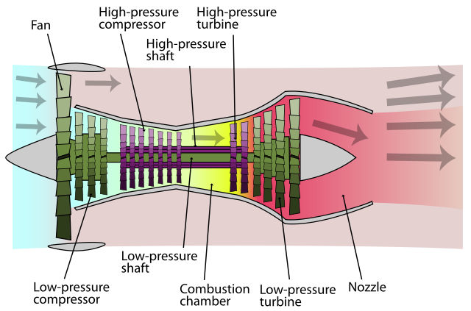

**Figure1.1: Jet Propulsion**

### **JET PROPULSION TYPES**

Jet propulsion systems can be classified based on several factors, such as the type of engine, the mode of operation, and the application. Here are some common classifications of jet propulsion systems:

**Based on the type of engine**:

1. Gas turbine engines: These engines use a gas turbine to compress air, mix it with fuel, and ignite it to produce thrust. Turbojet, turbofan, and turboprop engines are examples of gas turbine engines.
2. Rocket engines: These engines carry both fuel and oxidizer and burn them together to produce thrust.

**Based on the mode of operation:**

1. Continuous jet propulsion: These engines produce a continuous stream of exhaust gases to generate thrust. Turbojet, turbofan, and turboprop engines are continuous examples of co jet propulsion system.
2. Pulse jet propulsion: These engines generate thrust through a series of intermittent pulses of exhaust gases. Pulse detonation engines are an example of pulse jet propulsion.

**Based on the application:**

1. Aircraft propulsion: Jet propulsion systems are commonly used in aircraft propulsion, ranging from small business jets to large commercial airliners.
2. Missile propulsion: Jet propulsion systems are used in missiles to provide thrust and control during flight.
3. Spacecraft propulsion: Rocket engines are commonly used in spacecraft propulsion, including launch vehicles and spacecraft propulsion systems for interplanetary missions.

### **RAMJET ENGINE**

A ramjet engine is a type of air-breathing jet engine that uses the forward motion of the engine itself to compress air without the need for a compressor. This makes it different from other types of jet engines that rely on a mechanical compressor to compress the air before it enters the combustion chamber.

The ramjet engine is designed to operate at high speeds, typically above Mach3(2,300 mph; 3,700 km/h) and can operate up to speeds of Mach 6 (4,600 mph; 7,400 km/h). It works by taking in air from the front of the engine and accelerating it through a diffuser, which slows the air down and increases its pressure. The pressure and temperature are further increases due to combustion.

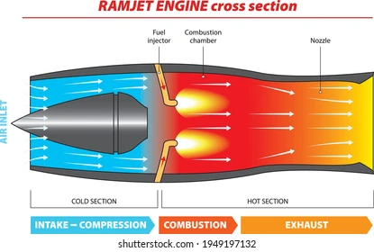

Figure1.2: Ramjet Engine

**Applications of ramjet engine:**

* Due to its high thrust at high operational speed, it is widely used in high-speed aircrafts and missiles.
* Subsonic ramjets are used in target weapons, in conjunction with turbojets or rockets for getting the starting torque.
* The ramjet used in the RIM-8 Talos missile

**Wind Tunnel:**

Wind tunnel is "an apparatus for producing a controlled stream of air for conducting aerodynamic experiments".[1] The experiment is conducted in the test section of the wind tunnel and a complete tunnel configuration includes air ducting to and from the test section and a device for keeping the air in motion, such as a fan. Wind tunnel uses include assessing the effects of air on an aircraft in flight or a ground vehicle moving on land and measuring the effect of wind on buildings and bridges. Wind tunnel test sections range in size from less than a foot across, to over 100 feet (30 m), and with air speeds from a light breeze to hypersonic.

The earliest wind tunnels were invented towards the end of the 19th century, in the early days of aeronautical research, as part of the effort to develop heavier-than-air flying machines. The wind tunnel reversed the usual situation. Instead of the air standing still and an aircraft moving, an object would be held still and the air moved around it. In this way, a stationary observer could study the flying object in action and could measure the aerodynamic forces acting on it.

The development of wind tunnels accompanied the development of the airplane. Large wind tunnels were built during World War II, and as supersonic aircraft were developed, supersonic wind tunnels were constructed to test them. Wind tunnel testing was considered of strategic importance during the Cold War for development of aircraft and missiles.

Advances in computational fluid dynamics (CFD) have reduced the demand for wind tunnel testing but have not eliminated it. Many real-world problems can still not be modelled accurately enough by CFD to eliminate the need for wind tunnel testing. Moreover, confidence in a numerical simulation tool depends on comparing its results with experimental data, and these can be obtained, for example, from wind tunnel tests.

CLASSIFICATIONS:

There are many kinds of wind tunnels. They are typically classified by the range of speeds that are achieved in the test section, as follows:

* Low-speed wind tunnel
* Subsonic and transonic wind tunnel
* Supersonic wind tunnel
* Hypersonic wind tunnel
* High enthalpy wind tunnel

Wind tunnels are also classified by the orientation of air flow in the test section with respect to gravity. Typically, they are oriented horizontally, as happens during level flight. A different class of wind tunnels are oriented vertically so that gravity can be balanced by drag instead of lift, and these have become a popular form of recreation for simulating skydiving.

**Supersonic wind tunnel:**

A **supersonic wind tunnel** is a specialized testing facility used to study the aerodynamics of objects moving at **supersonic speeds** (Mach 1 to Mach 5). It helps engineers analyze airflow behaviour, pressure distribution, and shock waves around aircraft, missiles, and spacecraft traveling faster than the speed of sound.

**Working Principle**

* Air is first **compressed** and stored at high pressure.
* It is then passed through a **C-D nozzle**, where it accelerates to supersonic speeds.
* The **test section** experiences high-speed airflow, allowing scientists to observe shock waves and aerodynamic forces.
* After testing, the **diffuser** slows the air down before it exits.

**Components of a Supersonic Wind Tunnel**

1. **Settling Chamber** – Conditions the airflow by reducing turbulence before entering the test section.
2. **Converging-Diverging (C-D) Nozzle** – Accelerates the airflow to supersonic speeds using the Venturi effect.
3. **Test Section** – The area where models are placed for aerodynamic testing under controlled supersonic conditions.
4. **Diffuser** – Slows down the high-speed airflow before it exits the tunnel.
5. **Vacuum or Exhaust System** – Helps maintain a steady airflow by removing air efficiently.

**Applications**

* **Aircraft Design** – Testing supersonic jets like fighter aircraft and commercial supersonic planes.
* **Missile and Spacecraft Development** – Studying high-speed projectiles and space re-entry vehicles.
* **Aerodynamic Research** – Understanding shock waves, drag, and heat effects at supersonic speeds.

**2. LITERATURE REVIEW**

1. Design and Analysis Tools for Supersonic Inlets" discusses past research on supersonic inlet aerodynamics, including flow compression, deceleration, shock wave interactions, and boundary layer effects. It highlights various computational tools developed over decades, such as IPAC, Inlet MOC, and LAPIN, for inlet design and analysis. The review examines existing methodologies for maximizing pressure recovery, minimizing distortion, and reducing inlet drag. Additionally, it references efforts to integrate low-order analysis methods with higher-fidelity CFD simulations. The study emphasizes the need for updated computational tools to support advanced inlet designs​.
2. Analysis of Buzz in a Supersonic Inlet" discusses previous research on inlet buzz, an aerodynamic instability in supersonic inlets. It references early experimental studies by Oswatitsch (1942) and Dailey (1954), which identified shock-boundary layer interactions as key contributors to buzz onset. The review highlights Ferri and Nucci’s work on vortex sheets in ramjet inlets and Fisher et al.’s distinction between "big" and "little" buzz. It also covers computational studies using CFD methods to model unsteady shock oscillations in supersonic intakes. Additionally, the paper discusses Shang and Hankey’s theoretical framework for self-excited fluid oscillations and its relevance to buzz phenomena​.
3. "Ramjet Intakes" discusses the evolution of supersonic intake design, highlighting research from NASA, DTIC, RTO, and AERADE. It references historic intake experiments conducted between the 1940s and 1970s, detailing the challenges and solutions applied during previous testing of isolated intakes. The review examines different intake types based on compression methods, flow characteristics, and geometric configurations. It also explores the impact of shockwave management, boundary layer control, and pressure recovery on ramjet performance. Additionally, the study discusses the role of computational and experimental approaches in refining intake designs for modern supersonic and hypersonic applications​.
4. "Effect of Cowl Deflection Angle in a Supersonic Air-Intake" examines previous studies on mixed compression supersonic air intakes, focusing on geometric modifications for performance enhancement. It references experimental research on intake design by Neale and Lamb, as well as computational studies on shockwave interactions, boundary layer effects, and intake start/unstart characteristics. The review highlights CFD applications in analysing cowl deflection, isolator length, and shock oscillations. It also discusses previous work on intake stability, flow separation, and performance improvements through techniques such as bleeding and variable geometry adjustments​.
5. "Design and Analysis of an Air Intake System of Ramjet Engine Using CFD Simulations" explores previous research on supersonic air intakes and total pressure recovery optimization. It references studies on shockwave interactions, boundary layer separation, and intake unstart phenomena. The review highlights computational and experimental approaches for analysing mixed-compression inlets, emphasizing variable geometry and flow control techniques. Prior research on numerical simulations, such as CFD-based studies of oblique shocks and backpressure effects, is also discussed. The study builds upon existing findings to improve inlet efficiency and stability in high-speed ramjet engines​.
6. "Numerical Simulations of Inviscid Airflows in Ramjet Inlets" discusses previous research on ramjet inlet design and flow characteristics. It highlights the O swatitsch principle for optimizing supersonic inlet compression and references studies on shockwave interactions and pressure recovery. The review covers computational approaches, including Roe and MacCormack schemes, for numerical simulations of ramjet inlets. Additionally, it explores the influence of backpressure and heat addition on normal shock positioning in the inlet. Prior research on CFD validation using Fluent software is also discussed, ensuring accuracy in simulating airflow behaviour in ramjet engines​.
7. This paper discusses various studies on ramjet engine performance, particularly focusing on inlet design and flow characteristics. Verma et al. (2019) analyzed the impact of inlet isolator geometry with concavities to enhance shockwave formation and mass flow rate. Kumar et al. (2018) highlighted the role of inlets in improving compression efficiency, suggesting that perforations in the nose cone can enhance airflow and compression ratio. Akbarzadeh and Karmani (2007) conducted simulations on angled ramp inlets, showing how multiple oblique shockwaves influence pressure recovery. Thangadurai et al. (2008) studied the effects of cold air flow and heat addition, revealing how air intake geometry and heat release impact performance. These studies collectively emphasize the importance of inlet optimization in improving ramjet engine efficiency​.
8. This document provides insights into various studies related to ramjet engine inlets and their performance optimization. It references works by Fleeman and Goldsmith, who explored inlet/airframe integration and intake design principles. Azevedo et al. studied total pressure recovery losses due to shock wave systems, while Safarik and Polak analysed optimal wedge angles for minimizing pressure loss. Computational tools, such as those used by Ahsun, were also highlighted for inlet stability and design optimization​.
9. This paper discusses various studies on supersonic missile inlets, highlighting key contributions in inlet/airframe integration, shock wave losses, and inlet performance optimization. Fleeman and Goldsmith examined design criteria and flow characteristics in pitot intakes, while Azevedo et al. quantified pressure losses due to shock wave interactions. Safarik and Polak investigated wedge angle optimization for minimizing total pressure loss. Additionally, computational tools such as those used by Ahsan were explored for inlet stability and performance enhancement​.
10. This paper discusses various research contributions related to ramjet engine intake design and performance optimization. It references studies on air intake integration, total pressure recovery, and computational tools for performance estimation. Key works include investigations into optimizing wedge angles for minimum pressure loss and the use of CFD and semi-empirical methods for inlet stability and shockwave analysis. Additionally, past research on reducing inlet buzz and improving flow regulation is highlighted​.

**3. MATERIAL:**

For the supersonic intake system, we have used ‘stainless-steel’ material for our specimen for its excellence mechanical properties and strength. It is a highly versatile and widely used material known for its durability and corrosion resistance. Here are some key characteristics of stainless steel:

1. **Corrosion Resistance** – Contains chromium (at least 10.5%), which forms a protective oxide layer, making it resistant to rust and corrosion.

2. **High Strength & Durability** – Strong and tough, capable of withstanding heavy loads and harsh environments.

3. **Heat Resistance** – Maintains strength and integrity at high temperatures, making it suitable for applications involving heat.

4. **Hygienic & Easy to Clean** – Non-porous surface prevents bacteria buildup, making it ideal for medical, food, and pharmaceutical industries.

5. **Aesthetic Appeal** – Shiny, smooth surface with various finishes (matte, polished, brushed) for decorative and industrial uses.

**4.METHADOLOGY:**

* Material selection.
* Design of specimen.
* Fabrication work.
* Testing.

**4.1 Material Selection:**

The material used for the specimen design is stainless-steel 304.

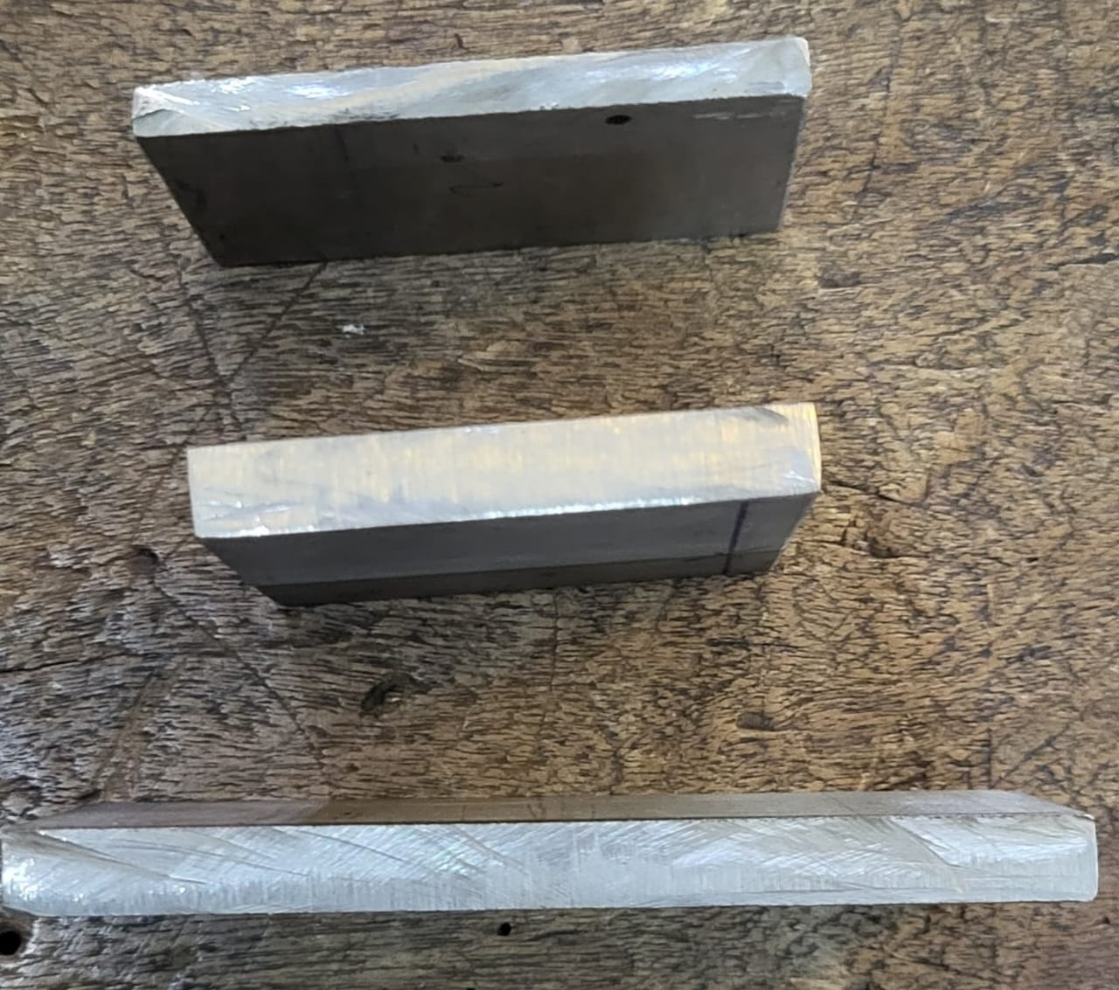

**Figure4.1.1: stainless-steel raw material**

**4.2 Design of Specimen:**

To draw the required geometry of specimen we have used a software called Solid Edge.

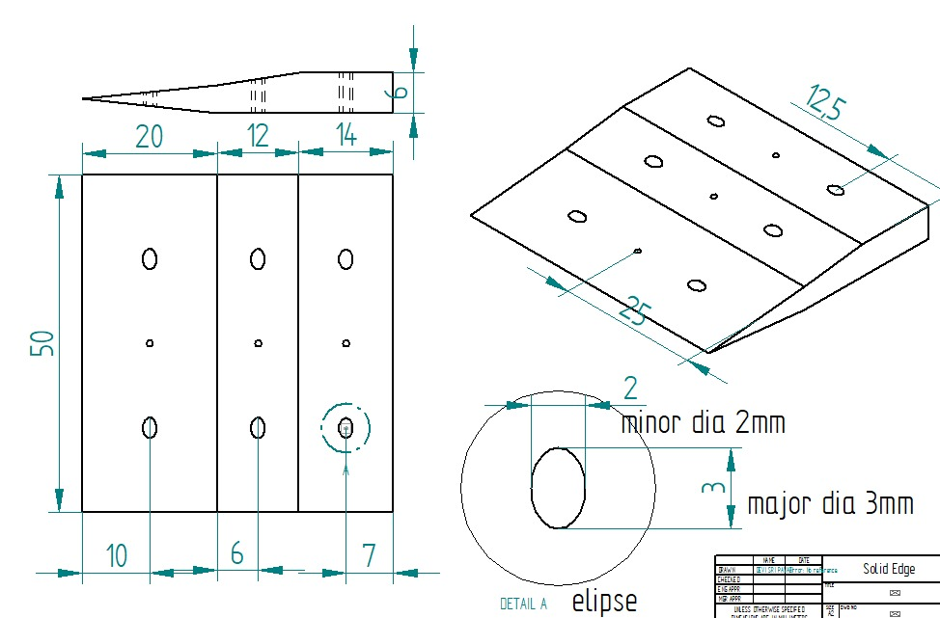

**Figure4.2.1: Specimen Design**

**4.4 Testing:**

The test has performed on the supersonic wind tunnel. Testing in a **sup**ersonic wind tunnel is crucial for evaluating the aerodynamic performance of objects moving at Mach 1 to Mach 5. It helps in studying airflow characteristics, shock waves, drag, lift, and pressure distribution on high-speed vehicles like fighter jets, missiles, and space vehicles.

**5.EXPERIMENTATION:**

**5.1 SUPERSONIC WIND TUNNEL TEST**

A supersonic wind tunnel is a specialized test facility used to simulate and study the behaviour of objects moving at supersonic speeds (Mach 1 to Mach 5). These wind tunnels are crucial for aerospace engineering, allowing researchers to test aircraft, missiles, space vehicles, and other high-speed aerodynamics applications before real-world deployment**.** It is a type ofIntermittent Blowdown Wind Tunnels which uses a pressurized storage tank that releases air for a short duration.

Blow down type supersonic wind tunnel, operates in the range of Mach number (M = 1.5 to 3.5). A 14.14 cubic meter storage tank delivers air at 20 Bar. Desired Mach number in the test section is obtained by varying the nozzles. Schlieren and Shadowgraph techniques are used to demonstrate/understand the dynamics of shock waves for varying Mach numbers for flow past a wedge and the blunt nose of cylindrical cone.

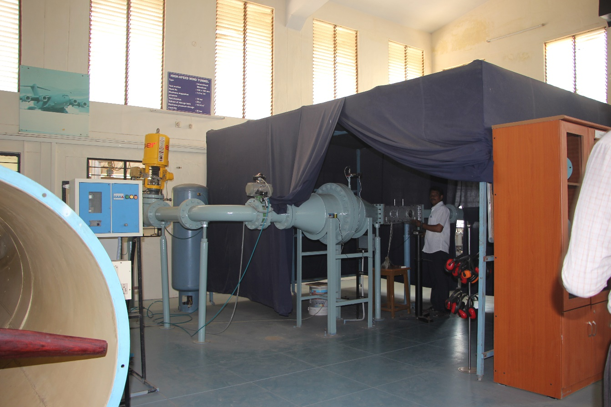

**Figure 5.1.1: supersonic wind tunnel test**

**5.2 Specifications**

1. Test section dimension 100X100 mm
2. Range of Mach No:1.5 to 3.5
3. Maximum Stagnation pressure: 10 bars/s
4. Test duration: 20 sec. nominal
5. Pressure measurement :16 port pressure scanner
6. Volume of Pressure tank:14.14 m3
7. 20 hp Compressors-with air coolers and dryers
8. Maximum Pressure storage capacity: 20 bars
9. Maximum power 22KW
10. Maximum RPM:1500
11. Diameter of the Propeller blade: 1.3m
12. Turbulence level: Below 2%

**6.RESULT AND DISCUSSION:**

|  |  |  |
| --- | --- | --- |
| **Sl.No** | **Time** | **Settling chamber Pressure** |
| **1** | 0 | 4.8 |
| **2** | 3 | 6.3 |
| **3** | 10 | 6.9 |
| **4** | 13 | 6.5 |
| **5** | 18 | 7.2 |
| **6** | 21 | 7 |
| **7** | 24 | 4.8 |
| **8** | 25 | 0.5 |
| **9** | 27 | -0.1 |

**Table 6.1: Time and Settling chamber pressure values**

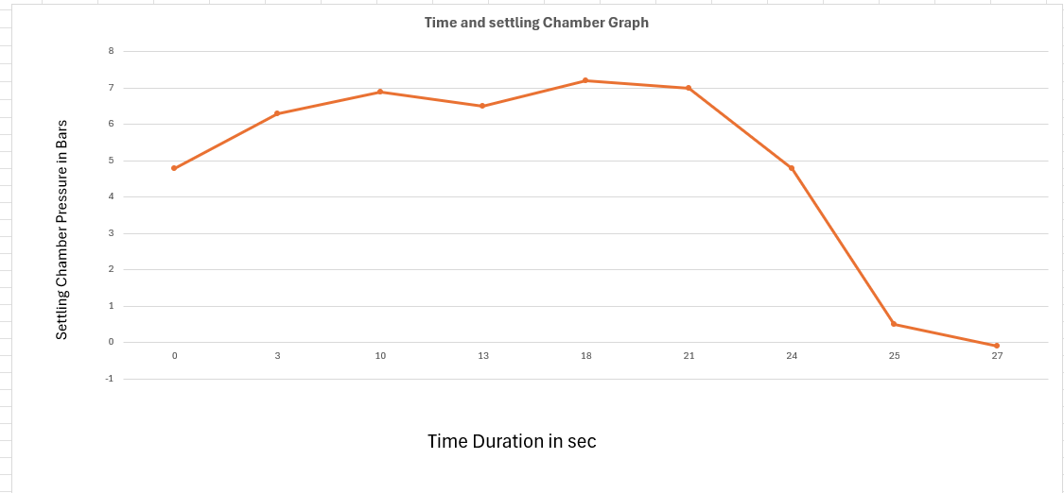

**Figure6.2: Settling chamber pressure and Time graph**

With the increase of test duration settling chamber pressure increases and reaches design value i.e. 7 bar at 14 sec. At this design pressure the convergent divergent nozzle exit reaches Mach number 3.5.

**7.CONCLUSION:**

We have designed the supersonic intake system and the design has tested on the supersonic wind tunnel test. Through that test, we have analyzed the settling chamber pressure during the shock wave formation at which the specimen experiences high speed velocity (Mach number 3.5).The maximum settling chamber pressure is 7.2bar

**8.References**

[1] Subrat Partha Sarathi Pattnaik, N.K.S. Rajan, NuAmerical investigation of impact of fixed-exit boundary-layer bleed on supersonic intake performance, 2022.

[2] Julian Giehler, Thibault Leudiere, Robert Soares Morgadinho, Pierre Grenson, Reynald Bur, Experimental and numerical investigation of porous bleed control for supersonic/subsonic flows, and shock wave/boundary-layer interactions, 2024.

[3] Kyung Jin Ryu, Seol Lim, Dong Joo Song, A computational study of the effect of angles of attack on a double-cone type supersonic inlet with a bleeding system, 2011.

[4]Min Oua, Li Yana, Jing-feng Tangb, Wei Huanga , Xiao-qian Chenc; “Thermodynamic performance analysis of ramjet engine at wide working conditions”.Science and Technology on Scramjet Laboratory, National University of Defense Technology, Changsha, Hunan 410073, People's Republic of China,Harbin Institute of Technology, Harbin 150001, People's Republic of China,College of Aerospace Science and Technology, National University of Defense Technology, Changsha, Hunan 410073, People's Republic of China. Acta Astronautica.

[5] G. Dinesh Kumar, Syed Afraaz, Srinjoy Dasgupta, et al; “Numerical evaluation of a varying area inlet in a Ramjet engine”Cite as: AIP Conference Proceedings 2516, 030004 (2022); <https://doi.org/10.1063/5.0109071> ,Published Online: 30 November 2022.

[6] Ronald S. Fry Johns Hopkins University; “A Century of Ramjet Propulsion Technology Evolution” JOURNAL OF PROPULSION AND POWER,Vol. 20, No. 1, January–February 2004.

[7] Dr. Avinash Govindraju and Dr. Santosh Kumar; “Flow Analysis of Ramjet Engine for Optimized Nose Cone Design” Proceedings of the 2nd Indian International Conference on Industrial Engineering and Operations Management Warangal, Telangana, India, August 16-18, 2022.

[8] G. Raja Singh Thangadurai1, B.S. Subhash Chandran1, V. Babu2, and T. Sundararajan2; “Numerical Analysis of Integrated Liquid Ramjet Engine”. Defence Science Journal, Vol. 58, No. 3, May 2008, pp. 327-337 ,2008, DESIDOC.

[9] G. Raja Singh Thangadpai and B.S. Subhash Chandran; “Numerical Investigation of the Intake Flow Characteristics for a Ramjet Engine with and without Heat Addition in the Combustion Chamber”. Defence Science Journal, Vol. 54, No. 1, January 2004, pp. 3-16

Q 2004, DESIDOC.

[10]John W. Slater ,Christopher R. Gruber, Notre Dame; “Planar Inlet Design and Analysis Process (PINDAP)” .NASA/TM—2005-213866, August 2005.