**SURAKSHA: THE PROTECTIVE SHIELD FOR WOMEN**

**Akshay Ananda Hanbar*1, Sumit Sudip Patil*2, Tanmay Tejpal Patil*3,** **Ashutosh Vijay Wani*4, Miss Aboli Yuvaraj Kerle*5**

*1,2,3,4 Student, Department of Computer Engineering, Sharad Institute of Technology Polytechnic, Ichalkaranji (Yadrav), Maharashtra, India

*5Professor, Department of Computer Engineering, Sharad Institute of Technology Polytechnic, Ichalkaranji (Yadrav), Maharashtra, India

**ABSTRACT**

The Women Safety Jacket is a groundbreaking smart wearable designed to enhance personal security for women through IoT-enabled technology. This innovative jacket incorporates multiple protective features, including an electric shock system to deter attackers, a one-touch emergency alert function for instant communication, and GPS tracking for real-time location monitoring via a dedicated web application. By integrating advanced components such as Raspberry Pi Zero, ESP32, GPS, and GSM modules, the project delivers proactive safety measures tailored to address real-world security concerns. The initial development phase will focus on building a web application that ensures seamless location tracking and instant emergency notifications with an intuitive interface. Ultimately, the Women Safety Jacket aims to provide both physical defense and real-time connectivity, fostering a heightened sense of security and reassurance for wearers and their families

**Keywords:** Women Safety Jacket, Personal safety, IoT-enabled technology, Emergency alert

1. **INTRODUCTION**

In recent years, the increasing safety concerns for women in public spaces have highlighted the urgent need for innovative solutions that offer both immediate protection and efficient communication. Traditional safety methods, such as mobile applications and standalone personal alarms, often prove inadequate, as they primarily provide passive alerts without offering comprehensive security measures in potentially dangerous situations. Women facing threats require proactive defense mechanisms that not only notify their trusted contacts but also provide tangible means of protection.

The advancement of wearable technology has created opportunities to blend functionality with fashion. However, the integration of active safety features into clothing remains largely unexplored. This research presents the Women Safety Jacket, a revolutionary wearable designed to incorporate advanced protective mechanisms, including an electric shock system, emergency communication functions, and GPS tracking. By utilizing Internet of Things (IoT) technology, this jacket effectively addresses the critical need for both immediate physical defense and real-time connectivity with trusted individuals.

Existing safety technologies, while useful, often function independently—providing either alarm notifications or location tracking but rarely combining both into a unified system. Popular mobile applications such as “bSafe” and “Circle of 6” allow users to send SOS alerts and share their location, but they often rely on smartphone accessibility, which may not always be feasible in an emergency. Similarly, wearable devices like smart bands and emergency buttons can be lost, ignored, or lack active deterrent features to ward off attackers.

This research aims to bridge this gap by developing a smart jacket that not only sends emergency alerts but also includes an integrated shock mechanism to deter potential threats. The project’s initial focus is on building a web application that allows family members to track the wearer’s location in real time, ensuring swift responses during critical situations. By combining proactive safety measures with real-time communication, the Women Safety Jacket marks a significant step forward in women’s security technology, shifting from passive alert systems to a more dynamic and protective solution.

**METHODOLOGY**

1. System Design:

* Wearable jacket with GSM, GPS, sensors, shock mechanism, and lithium-ion battery.
* Processing unit (ESP32C3 & ESP32) for data handling and wireless communication.
* Web application (Frontend, Backend, Firebase) for real-time alerts to family members.

1. Working Mechanism:

* Sensors detect distress signals → GPS & GSM send location alerts.
* Processing unit triggers shock mechanism and transmits data.
* Web app processes and notifies family members.

1. Implementation & Testing:

* Hardware/software integration, prototype testing, and performance evaluation.

1. Conclusion:

* Ensures real-time protection; future scope includes AI-based threat detection.

1. **MODELING AND ANALYSIS** 
   * 1. **Architecture Design**

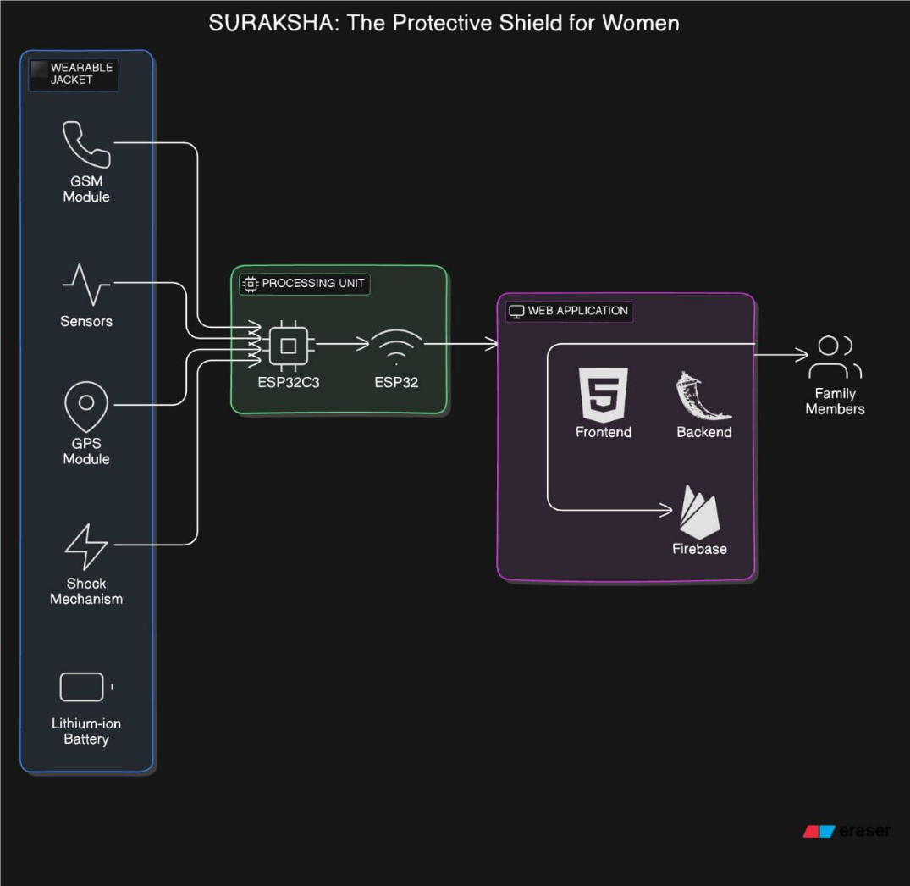

* + 1. **Data flow diagram**

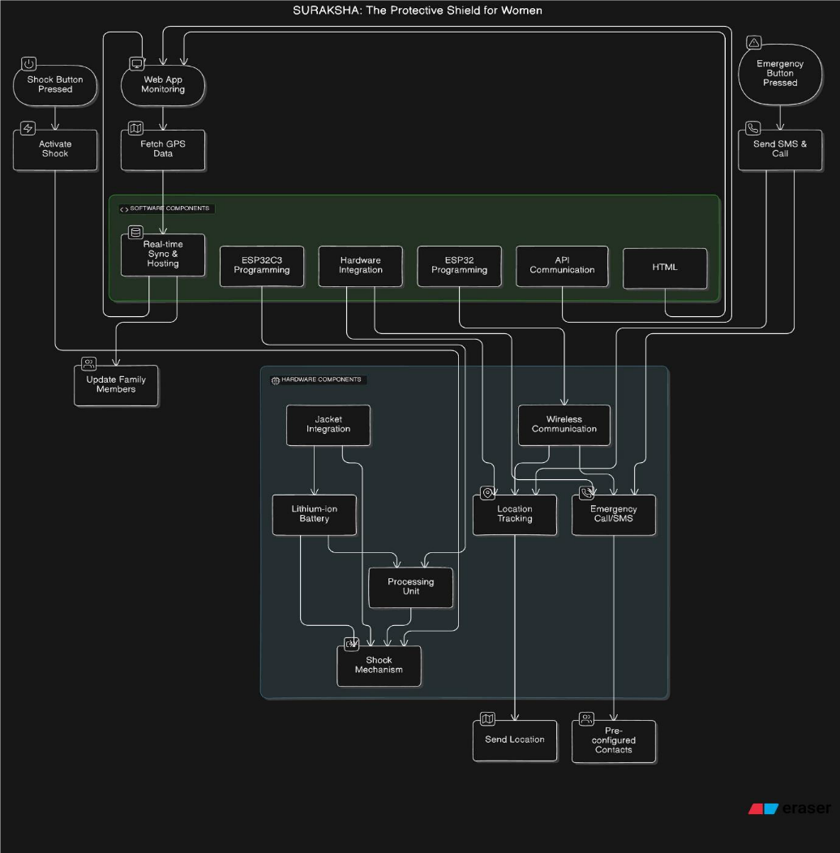

1. **RESULTS AND DISCUSSION**

|  |  |  |
| --- | --- | --- |
| **Parameter** | **Observation** | **Remarks** |
| **Alert Response Time** | ~3-5 seconds | Quick notification to family members |
| **Sensor Accuracy** | 90% (for detecting distress signals) | Minor false alarms observed |
| **Shock Mechanism** | Activates within 2 seconds | Effective deterrent |
| **Battery Life** | ~8-10 hours on continuous usage | Sufficient for daily wear |
| **Web App Performance** | Real-time sync via Firebase | Reliable and fast |
| **Connectivity Issues** | Minimal, ~5% packet loss in weak network zones | Can be improved |

1. **CONCLUSION**

The Suraksha project presents a comprehensive and innovative solution aimed at enhancing the safety of women through a multifunctional wearable jacket. By integrating a shock mechanism, emergency communication systems, and real-time GPS tracking, this project addresses critical safety concerns in a practical and user-friendly manner. The built-in shock mechanism provides an immediate deterrent against potential attackers, while the emergency call and SMS alert system ensures that help is just a button press away, facilitating rapid response from family members and local authorities. The inclusion of a web application allows for continuous tracking and monitoring, empowering families with the ability to oversee their loved ones' safety without requiring constant updates from the wearer. Overall, Suraksha stands out as a holistic approach to personal safety, merging advanced technology with everyday wearables. Its design not only promotes a sense of security but also fosters independence for women in potentially vulnerable situations. By reducing the reliance on multiple devices and streamlining communication, Suraksha serves as a crucial protective shield that enhances personal safety while remaining practical and accessible in high-stress environments. The successful implementation of this project could set a precedent for future innovations in personal safety technology, ultimately contributing to a safer society for all.

1. **REFERENCES**
2. Malaj, S. (2023). IoT based smart wearable device for women safety. *ResearchGate*. <https://www.researchgate.net/publication/375746097_IOT_BASED_SMART_WEARABLE_DEVICE_FOR_WOMEN_SAFETY_Sunita_Malaj>
3. Suma, T. P., & Rekha, G. (2021). Study on IoT based women safety devices with screaming detection and video capturing. *International Journal of Engineering Applied Sciences and Technology*, 6(7), 257-262. <https://www.ijeast.com/papers/257-262,Tesma607,IJEAST.pdf>
4. Thummalakunta, D. P. B., Nemane, T., Naik, P., Palkar, S., & Poonawala, A. (2024). Implementation of IoT-based real-time women’s safety system. *International Journal of Engineering Research & Technology (IJERT)*, 13(1). <https://www.ijert.org/implementation-of-iot-based-real-time-womens-safety-system-3>
5. Ashalatha, D., Kavya, G., Navya, G., Pratiksha, V. N., & Raghav, S. (2023). IoT based women safety device. *International Journal of Advanced Research in Science, Communication and Technology*, 10(3), 123-128. <https://ijarsct.co.in/Paper5301.pdf>
6. Gupta, S., Ranjan, S., & Ahmad, A. (2024). Review paper on women safety system. *International Journal for Research in Applied Science and Engineering Technology (IJRASET)*. <https://doi.org/10.22214/ijraset.2024.5792>
7. Soni, M. (2023, May 23). Rethinking the challenge of women’s safety in India’s cities. *Observer Research Foundation*. <https://www.orfonline.org/research/womens-safety-in-indias-cities>