**ANALYSIS AND DESIGN OF MULTISTOREY BUILDING BY USING STAAD PRO**

**REGADI SANTHOSH KUMAR1,Mr R.Rajkumar2**

1,M.Tech Student, Department of Civil Engineering, Viswam Engineering College,Madanapalli,

2Assitant Professor, Department of Civil Engineering, Viswam Engineering College,Madanapalli,

--------------------------------------------------------***------------------------------------------------------------------

**ABSTRACT**

Tall or multi-story buildings have become increasingly important in recent decades because to the rapid population growth and land scarcity in metro areas. Most individuals need safe, comfortable, and aesthetically pleasing accommodations. That is the cause of the rise in multi-story building construction. Taller buildings will be more severely affected by earthquakes than smaller ones. Asymmetrical buildings will sustain greater damage from earthquakes than symmetrical ones. STAAD Pro is used to assess the study and design of a multi-story building. AutoCAD is used for planning, load calculations are done by hand, and STAAD Pro is used for structure analysis. The structure is subjected to the calculated dead load, imposed load, and wind load with load combination. In general, the ideas and methods for creating the fundamental elements of a multistorey building are explained. Each structural element's shear force, bending moment, and torsion values that fall within IS code bounds are also provided in detail by the STAAD Pro software.

**KEY WORDS:** Staad pro, multi-storey building, shear force, bending moment.

**1.INTRODUCTION**

Tall or multi-story structures are getting to be progressively critical in metro centres, where populace development is outpacing accessible arrive. Everybody requires satisfactory housing, aesthetics, consolation, and security. That is the cause for the expanded improvement of multi-storey buildings. The auxiliary plan of multi-story structures is basically concerned with security amid ground development, serviceability, and the plausibility for budgetary misfortune. Plan of structures utilizing the Constrain State Strategy The individuals are built for the constraining twisting minute and serviceability limitations, taking off the structures with a least save vitality. Taller buildings will be more seriously influenced by an seismic tremor than littler buildings. Hilter kilter buildings are more likely to be harmed by seismic tremors than symmetrical structures. People are moving from country to urban ranges due to the enormous populace development and arrive deficiency, and multi-story buildings are regularly developed in compact spaces these days. Building utilitarian plan has developed in significance, and each building has distinctive necessities. Each respectful build ought to be mindful of how the buildings are utilized by talking with the tenants and understanding the basics of R.C.C. structure plan. The objective of this extend is to utilize STAAD Professional V8i and STAAD ETC to analyze and plan a multi-story building. We utilized the constrain state strategy of investigation in this venture, and we utilized STAAD.PRO.V8i and STAAD to physically plan the basic parts.

**1.1OBJECTIVES**

• Generating structural framing plan.

• Creating model in STAAD PRO.

• Analysis of the structure.

• Design the structure

**2.LITERATURE REVIEW**

• **Mr K. Prabin Kumar, et.al (2018)**: A Consider on Plan of Multi-Storey Private Building: They utilized STADD Master. to buttcentric- ysis and planning all structure part and calculate amount of fortification required for concrete area. Different structure activity is considered as individuals such as pivotal, flexure, shear and pressure. Column are depicted for pivotal powers and biaxial closes at the closes. The building was arranged as per IS: 456- 2000.

**Deevi Krishna Chaitanya, et.al (January, 2017)**: Examination and Plan of a (G+6) Multi-Storey Building Utilizing STAAD Pro: They utilized inactive indeterminacy strategies to calculate numbers of obscure strengths. Distributing known settled and minutes to fulfill the condition of compatibility by Cycle strategy. Kanis strategy was utilized to disseminate minutes at sucessire joints in outline and proceeds bar for solidness of individuals of building structure. They utilized the planning computer program STADD Master. which diminished parcel of time in plan, gives accuracy.

**3.METHODOLOGY**

The structure may be generated from the input file or mentioning the co-ordinates in the GUI.

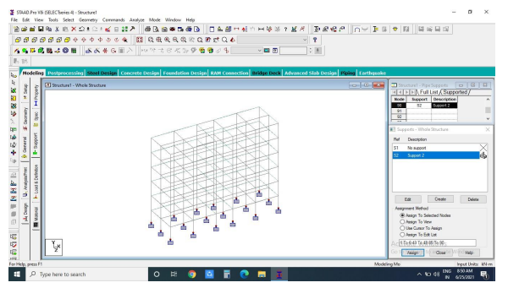

**3.1 ANALYSIS OF G+5 RCC FRAMED BUILDING USING STAAD.PRO**

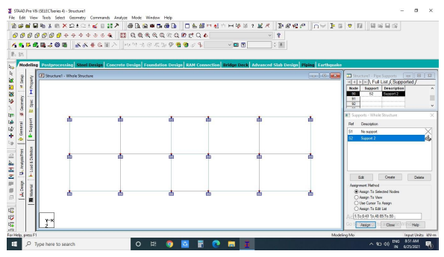

**Figure 3.2: Plan of the G+5 story**

Building

All columns = 0.40 * 0.60 m

All beams = 0.3 * 0.5 m

All slabs = 0.125 m thick

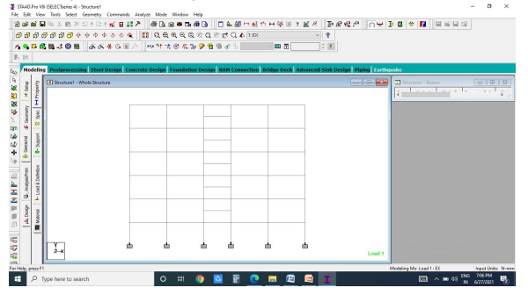 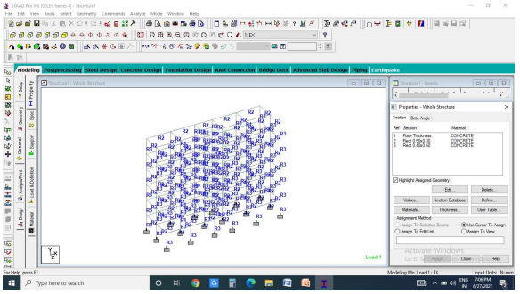

**Figure 3.3: Elevation of the G+5 story building Figure 3.4: Generation of member property**

The live stack considered in each floor was 2.0 KN/sq m and for the patio level it was considered to be 1.5 KN/sq m. The live loads were created in a comparable way as done in the prior case for dead stack in each floor. This may be done from the part stack button from the stack case column.

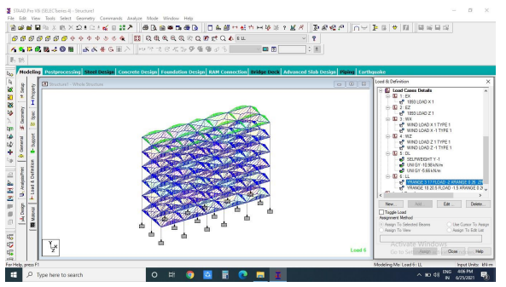 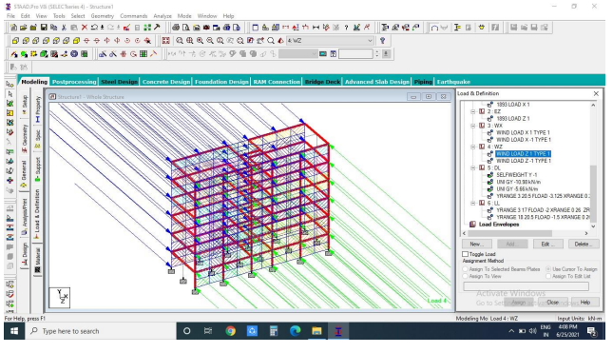

**Figure 3.5: Live load Figure 3.6: Wind load effect on structure**

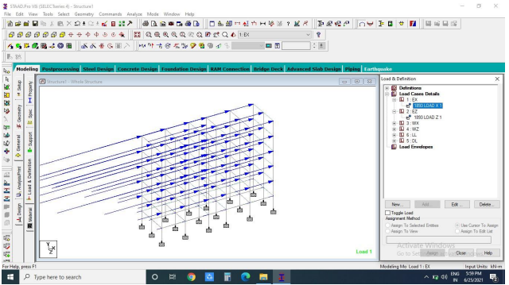 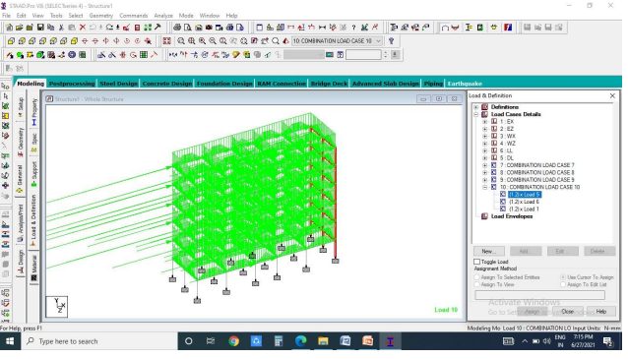

**Figure 3.7 seismic load Figure 3.8 Combination under seismic load**

**3.2 Design of G+5 RCC Building**

3.2.1 Beam Design

The bar is planned in Staadpro computer program by utilizing IS code 475 There are two sorts of fortified concrete beams 1. Single fortified bars 2. Twofold fortified beams.

1. Single strengthened pillars: In independently strengthened basically upheld pillars steel bars are put close the foot of the bar where they are viable in standing up to in the malleable bowing stress.

2. Double fortified bars: It is fortified beneath compression pressure locales. The necessities of steel of compression locale emerge due to two reasons. When profundity of bar is confined. The quality accessibility separately fortified bar is in satisfactory.

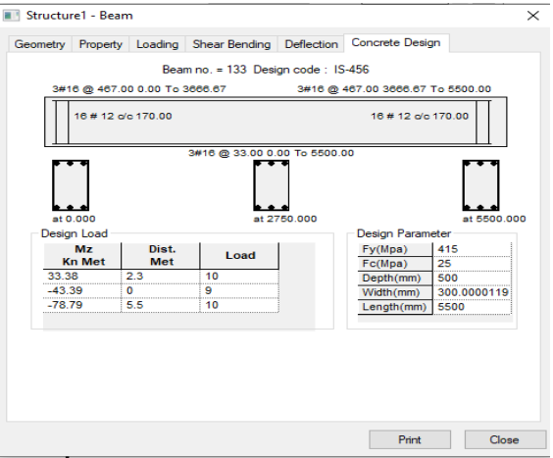

**Figure 3.9: Beam Design**

3.2.2 Column Design

A column may be characterized as an component utilized primarly to back hub compressive loads and with a stature of a slightest three times its horizontal measurement. The quality of column depends upon the quality of materials, shape and estimate of cross area, length and degree of relative and dedicational limits at its closes.

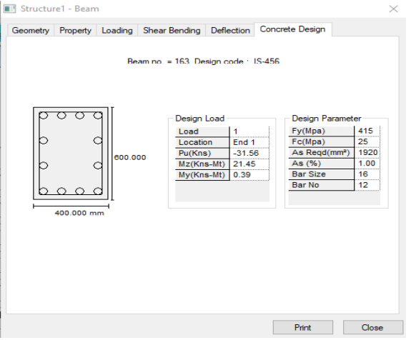

**Figure 3.10: Column Design**

**4.ANALYSIS RESULTS**

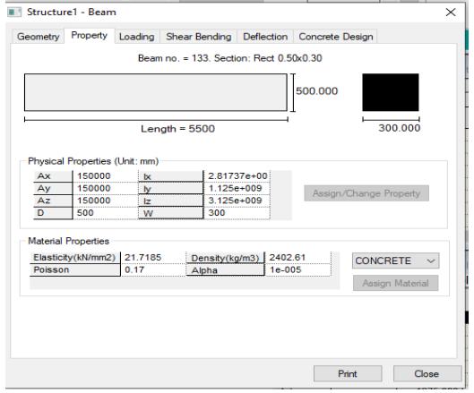 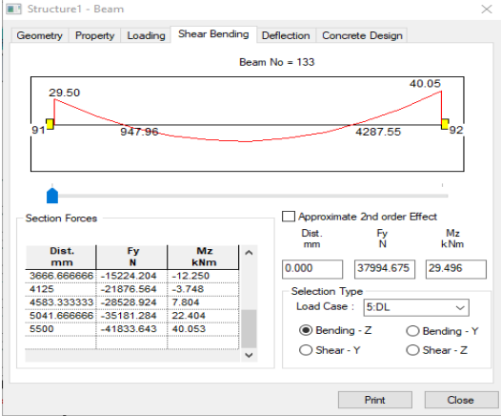

**Figure 4.1: Property of beam Figure 4.2: Shear bending of beam**

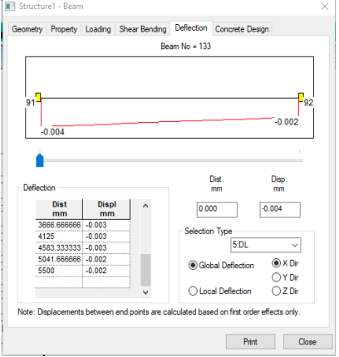 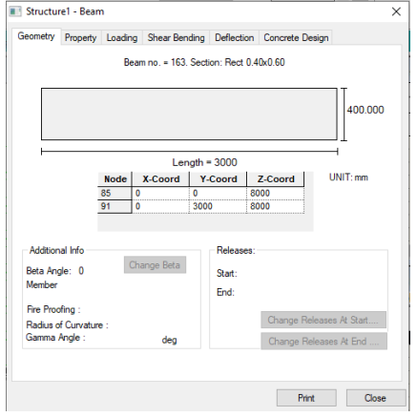

**Figure 4.3: Deflection of beam Figure 4.4: Geometry of column**

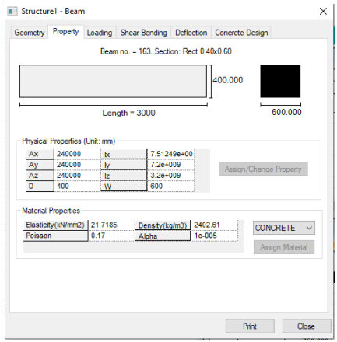 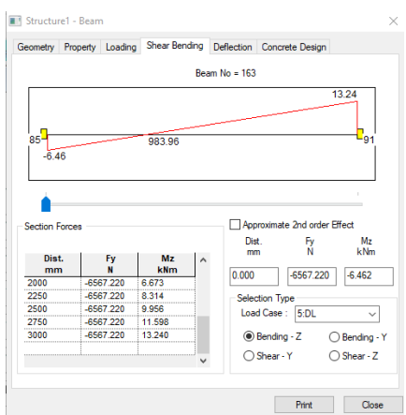

**Figure 4.5: Property of column Figure 4.6: Shear bending of column**

**POST PROCESSING MODE**

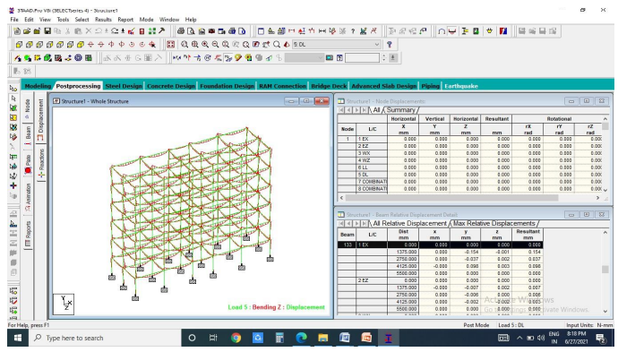 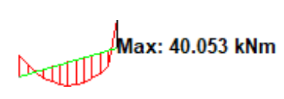 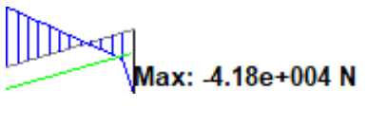

**Fig 4.7 Bending in Z, Bending moment diagram,Shear force diagram**

**5.DESIGN RESULTS**

BEAM NO.133 DESIGN RESULTS M25 Fe415 (Main) Fe415 (Sec.)

LENGTH: 5500.0 mm

SIZE: 500.0 mm X300.0 mm COVER: 25.0 mm

**Summary of Reinforcement Area (Sq.mm)**

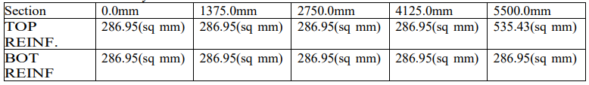

**Summary of Provided Reinforcement beam no.133**

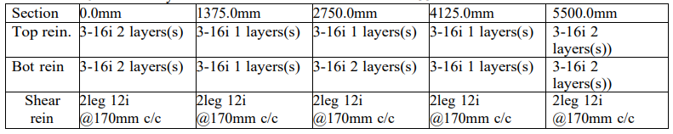

**6.CONCLUSION**

1. By Utilizing STADD Master., examination and plan of multistorey building is simpler and speedy prepare than manual process.

2. Proposed measure of the pillar and coloumn can be securely utilized in the structure.

3. The structure is secure in shear twisting and deflection.

4. There is no unsafe impact on the structure due to wind stack and seismic stack on the structure.

5. The structure we taken is steady and basically characterized utilizing different loads and combination. 6. The diversion esteem is more in WL (Wind Stack) combination than the SL (Seismic Stack) combination. 7. To know the behavior of the structure by applying different loads like dead stack, live stack, wind stack and seismic stack by utilizing staad.pro. And moreover discover out the Shear strengths, uprooting, twisting and responses of structure.

8. By utilizing staadpro ,we performed energetic investigation. So that, the comes about gotten in staadpro is more compelling as compared to examination and plan performed by hypothetical strategy

**REFERENCES**

1. Design and Analysis of Residential Building(G+4), Ibrahim, et.al (April 2019).

2. Planning, Analysis and Design of Residential Building(G+5) By using STAAD Pro,Dunnala Lakshmi Anuja, et.al (2019).

3. A Study on Design of Multi-Storey Residential Building, Mr K. Prabin Kumar, et.al(2018).

4. Analysis and Design of a (G+6) Multi-Storey Building Using STAAD Pro, DeeviKrishna Chaitanya, et.al (January, 2017).

5. R. D. Deshpande, et.al (June, 2017): Analysis, Design and Estimation ofBasement+G+2 Residential Building.

6. IS 456-2000, Design of RCC elements

7. IS 1893(part 1):2002 - for earthquake design

8. IS 875 part1 - dead loads

9. IS 875 part2 - live loads 10.sp-16