**IOT Based Greenhouse Monitoring and Controlling System**

**G Dheeraj Reddy1, B. Mounika2**

1PG Student, ECE, MJR COLLEGE OF ENGINEERING AND TECHNOLOGY, Piler, Andhra Pradesh, India

2Asst. Prof, ECE, MJR COLLEGE OF ENGINEERING AND TECHNOLOGY, Piler, Andhra Pradesh, India

**ABSTRACT**

Greenhouses are controlled environments for growing plants. Due to their inherent limitations, the greenhouse plants of today cannot be operated automatically and instead need direct intervention using a variety of forms. For plants to thrive in the proposed system, environmental factors like temperature, wetness, soil humidity, light intensity, etc. must be constantly monitored and adjusted. The study presented above demonstrates an IoT-based nursery management technique. The humidity, soil submersion, temperature, fire proximity, light intensity, etc. are all things the System may test for. The ESP32 transmits all characteristics of its surrounding environment to the cloud. The related actuator is activated if a parameter goes over the threshold. The microcontroller activates the motor if the Earth variable is below the set threshold. The user may see and adjust settings on their desktop computer or mobile device.

**Keywords:** Greenhouse, IoT-based system, nursery management, temperature monitoring, moisture detection, soil humidity, light intensity, fire proximity, ESP32, cloud monitoring, actuator control, microcontroller, automation, remote monitoring, smart agriculture, sensor-based system.

1. **INTRODUCTION**

Ecology is very important for plant growth. Greenhouse growers have a limited understanding of the moisture levels within the greenhouse. They merely get it via hands-on experience in the green building's environment [1]. At the conclusion of the day, experience is a major factor in their routine. If the soil retains an adequate moisture level, the plants will get water, but if it's too wet, the greenhouse roof is going to be opened throughout the day. High production rates may be attained with less expense, greater quality, and less negative effects on the environment if greenhouse plant production is optimised for efficiency. IoT allows for full regulation of climate conditions in the greenhouse, including cooling, heating, lighting, soil moisture, and more. Controlling this System requires attention to environmental criteria like temperature and humidity. The greenhouse's temperature, humidity, and light levels may all be tracked automatically [2]. Switchgear with simple ON/OFF capabilities is no longer Automation is crucial because it allows tasks to be completed without human intervention. While automation cannot completely eliminate or suppress human mistake, it may greatly reduce its prevalence in specific contexts. Anything useful or capable of being operated from a distance is in high demand in the modern world. Here, we'll assume the greenhouse owner can control and keep tabs on things from afar. The proprietor need not review all of them nor keep constant vigil on the situation [3]. The proprietor can't move very much and yet keep tabs on and manage all of the greenhouses. With the ESP8266 WiFi Module, data transmission to the network is wireless, eliminating the need for costly cables or connected connections. We have gathered enough information to justify creating an IoT-based greenhouse system.

1. **METHODOLOGY**

The IoT-Based Greenhouse Monitoring and Controlling System is developed to enhance greenhouse efficiency through automation and optimization using IoT technology. It employs various sensors to continuously monitor environmental parameters such as temperature, humidity, soil moisture, and light intensity. A microcontroller processes and transmits the collected data via wireless communication to a cloud platform for real-time monitoring and remote access. The methodology includes system design, sensor integration, data collection, communication protocols, automation, and data analysis. This ensures efficient greenhouse management, reduces manual intervention, optimizes resource utilization, and improves plant growth conditions for higher productivity.

**2.1 System Design and Architecture**

IoT-enabled sensors continuously monitor key environmental parameters such as temperature, humidity, soil moisture, and light intensity within the greenhouse. A microcontroller processes the collected data and transmits it to a cloud platform via Wi-Fi or GSM, enabling real-time monitoring, remote accessibility, and automated control for optimized greenhouse management.

**2.2 Power Supply and Energy Efficiency**

The system operates on solar panels or AC power with battery backup, ensuring uninterrupted functionality. Energy-efficient components reduce power consumption, enhancing sustainability and optimizing greenhouse operations for long-term efficiency and reliability.

1. **MODELING AND ANALYSIS**

The IoT-Based Greenhouse Monitoring and Controlling System is designed using a combination of hardware and software components to ensure efficient environmental regulation. The modeling phase involves system architecture design, sensor placement strategy, and control logic development. The analysis focuses on data processing, performance evaluation, and optimization to enhance greenhouse productivity.

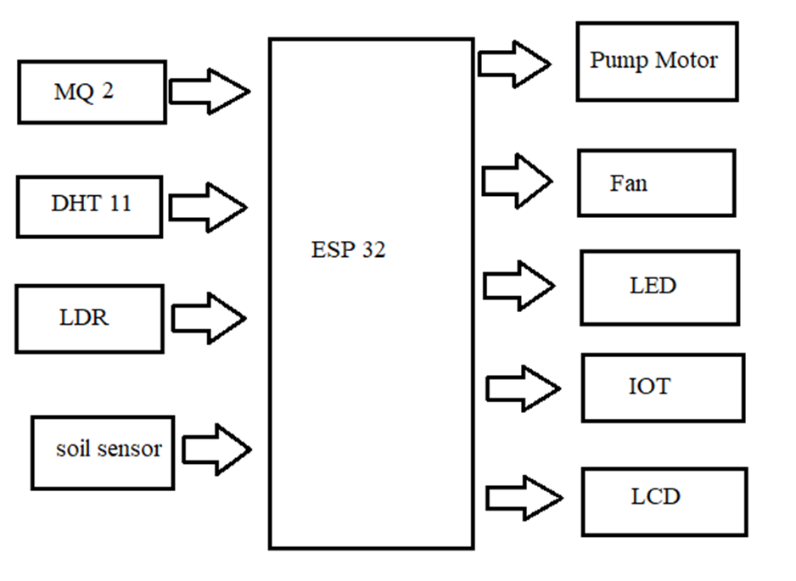

**Figure 1:** ESP 32 Block Diagram.

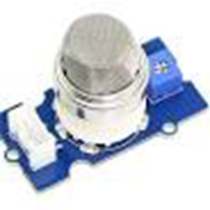

**Figure 2:** MQ 2.

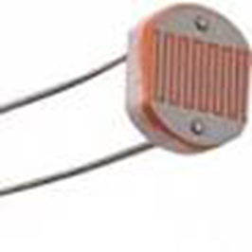

**Figure 3:** LDR.

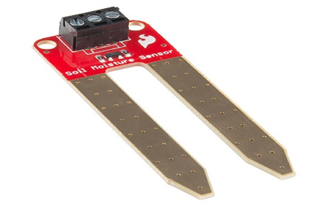

**Figure 3:** SOIL SENSOR.

1. **RESULTS AND DISCUSSION**

The IoT-Based Greenhouse Monitoring and Controlling System was developed and tested to evaluate its effectiveness in maintaining optimal greenhouse conditions. The results demonstrate the system’s ability to monitor environmental parameters in real-time, automate control mechanisms, and enhance overall plant growth conditions.

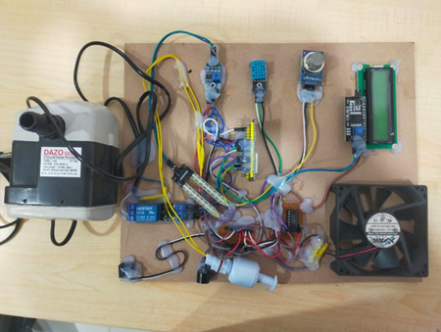

**Figure 2:** Final Project Output

1. **CONCLUSION**

The Arduino-based power and control system for greenhouses is quite sophisticated. In-depth measurements of temperature, humidity, adhesiveness, and light strength were taken using DHT11 and Earth Humidity sensors in addition to the standard LDR sensor. Using a practical smartphone app, this strategy is widely used in child care facilities to track and record environmental metrics. The NodeMCU esp8266 is used to transmit data between mobile devices and computers. Physical exertion is reduced as a result of this method. This device finds widespread use in greenhouses, garden centres, and hardware stores.

1. **REFERENCES**
2. Jayasuriya YP, Elvitigala CS, Wamakulasooriya K, Sudantha BH. Low Cost and IoT Based Greenhouse with Climate Monitoring and Controlling System for Tropical Countries. In2018 International Conference on System Science and Engineering (ICSSE) 2018 Jun 28 (pp. 1-6). IEEE.
3. Shinde D, Siddiqui N. IOT Based environment change monitoring & controlling in greenhouse using WSN. In2018 International Conference on Information, Communication, Engineering and Technology (ICICET) 2018 Aug 29 (pp. 1-5). IEEE.
4. H. Anandakumar and K. Umamaheswari, A bio-inspired swarm intelligence technique for social aware cognitive radio handovers, Computers & Electrical Engineering, vol. 71, pp. 925–937, Oct. 2018. doi:10.1016/j.compeleceng.2017.09.016.
5. R. Arulmurugan and H. Anandakumar, Early Detection of Lung Cancer Using Wavelet Feature Descriptor and Feed Forward Back Propagation Neural Networks Classifier, Lecture Notes in Computational Vision and Biomechanics, pp. 103–110, 2018. doi:10.1007/978-3-319-71767-8_9.
6. Rupali S, Hemant G, Shoaib K, Aaditya I, Deep D. IOT based greenhouse monitoring system. International Journal for Research in Applied Science and Engineering Technology. 2018; 6 (4):2084-.