**Design and Analysis of A Suspension Coil Spring For Emerging Automotive.**

*Mr Pathan A.M1*

*Lecturer at*

*Jaihind Polytechnic Kuran, Narayangaon*

[*ashpakap67@gmail.com*](mailto:ashpakap67@gmail.com)

# Abstract – Suspension coil springs play a crucial role in vehicle suspension systems, ensuring vehicle stability, comfort, and safety by absorbing road shocks and minimizing vibrations. The design and analysis of a suspension coil spring are crucial to optimizing its performance. This paper explores the design of a coil spring for an automotive vehicle, using ANSYS software for Finite Element Analysis (FEA) to evaluate the spring’s mechanical properties, stress distribution, and fatigue resistance under real-world operating conditions. The use of ANSYS allows for a detailed, accurate simulation of the spring's behavior, leading to a more reliable and efficient design. The design and analysis of suspension coil springs play a critical role in determining the overall performance, comfort, and safety of automotive vehicles. The coil spring, an essential component of the suspension system, ensures that the vehicle can absorb road irregularities and maintain optimal contact with the road. This paper outlines the fundamental principles of coil spring design, key factors influencing performance, material selection, and methods of analysis used to ensure durability and safety.

**Keywords*:*** coil springs, primary suspension system, modeling, static analysis, ANASYS 12.0, PRO-E.

**I. Introduction**

1. he automotive suspension system is designed to support the vehicle's weight while absorbing and dampening road shocks. One of the most critical components in this system is the coil spring. It controls the vertical displacement of the vehicle chassis relative to the wheels, ensuring optimal ride quality and handling performance. Suspension coil springs undergo various mechanical stresses, including bending, tension, and torsion, which can lead to fatigue and failure over time if not properly designed.
2. This paper presents a comprehensive approach to designing and analysing suspension coil springs, from material selection to stress and fatigue analysis, ultimately contributing to the development of more reliable and efficient suspension systems.
3. While traditional design methods are widely used, modern computational tools like ANSYS offer powerful simulation capabilities that help in analyzing the spring’s performance, optimizing design parameters, and predicting fatigue life before physical testing. The Finite Element Method (FEM) in ANSYS is used to simulate the coil spring's behavior under load, offering a more efficient and cost-effective approach to design verification.

**II Objectives**

* To design a suspension coil spring for an automotive vehicle.
* To perform static structural analysis using ANSYS.
* To evaluate the stress distribution and deformation under loading conditions.
* To optimize the design for improved performance and durability**.**

**III Design consideration**

The coil spring must be designed with the following parameters:

* Material: High-carbon steel or Chrome-Silicon steel
* Wire Diameter: 8-12 mm
* Coil Diameter: 80-120 mm
* Number of Coils: 6-10
* Spring Constant (k): 20-50 N/mm
* Load Capacity: 1000-2000 N

**IV Methodology**

4.1Modeling the Coil Spring.

* The 3D model of the suspension coil spring will be created using CAD software such as SolidWorks or CATIA.
* The model will be exported in an ANSYS-compatible format (STEP/IGES).

4.2. Finite Element Analysis (FEA) in ANSYS

* Material Selection: Define material properties such as Young’s modulus, Poisson’s ratio, and yield strength.
* Meshing: Apply fine meshing for accurate stress analysis.
* Boundary Conditions: Apply fixed support at one end and load at the other.
* Solution & Post-Processing: Analyse stress distribution, deformation, and factor of safety.

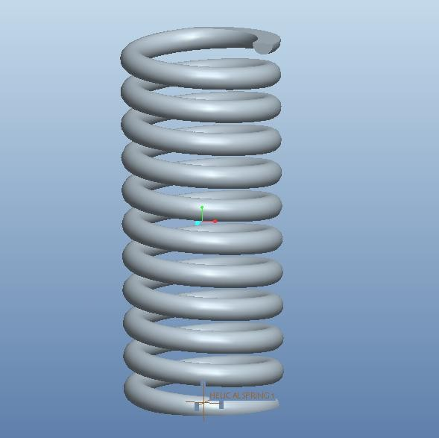

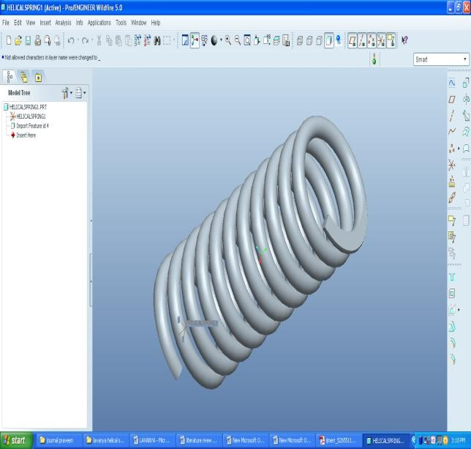

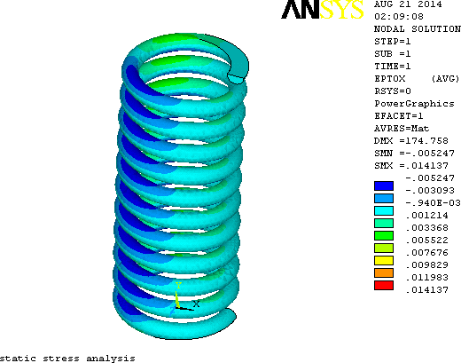

**V Results and Discussion**

* Deformation Analysis: Observing the maximum displacement under applied loads.
* Stress Analysis: Evaluating areas with high stress concentration.
* Factor of Safety: Determining if the spring can withstand operational loads.
* Comparison with Theoretical Calculations: Validate
* simulation results with mathematical modeling.
* FOR Displacements of chrome vanadium helical spring.

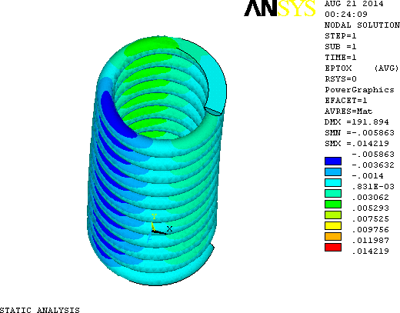

Static Analysis in X direction (strain)

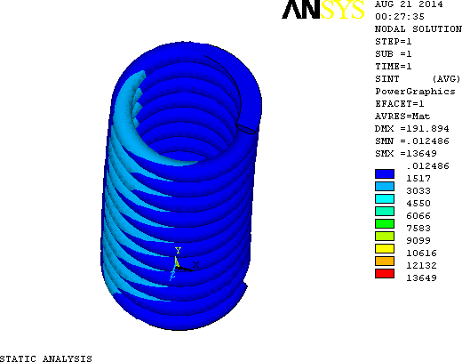

## von mises stress

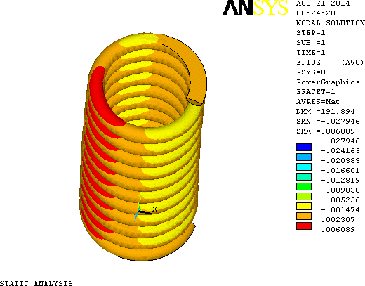

After realising strain in Y direction

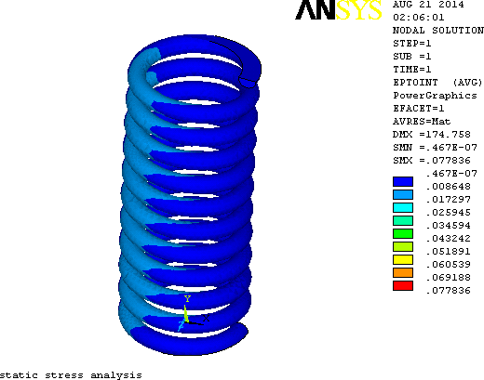

After realising strain in Y direction

* Displacements of low carbon helical spring

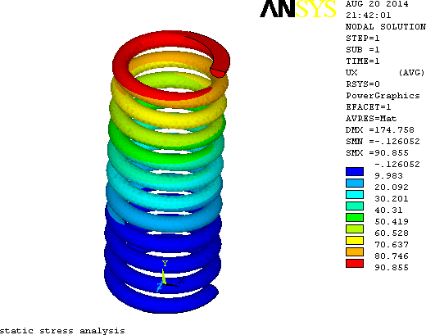

Static Analysis in X direction (strain)

## Table.1 Displacements of helical spring

|  |  |  |  |  |
| --- | --- | --- | --- | --- |
| Chromium vanadium helical compression spring displacement results | | | | |
| Static analysis | | | | |
|  | X  Displacement | Y  Displacement | Z  Displacement | Displacement  vector sum |
| stress | 97.06 | 0.1110 | 0.799 | 180.89 |

|  |  |  |  |  |  |  |
| --- | --- | --- | --- | --- | --- | --- |
| strain | 0.0421 | | 0.0564 | | 0.0060 | -- |
| Low carbon structural steel helical compression spring displacement results | | | | | | |
| Static analysis | | | | | | |
|  | | X  Displacement | | Y  Displacement | Z  Displacement | Displacement vector sum |
| stress | | 91.983 | | 0.126 | 0.6280 | 165.75 |
| strain | | 0.121 | | 0.050 | 0.0064 | -- |

## Table.2 Stress and strains of helical spring

|  |  |  |  |
| --- | --- | --- | --- |
| Comparison of result for two different materials | | | |
| Sr No. | Description | Chrome vanadium  steel | Carbon structural  steel |
| 1 | Von misses  stress in MPa | 13001 | 12040 |
| 2 | Von misses strain | 0.05664 | 0.05552 |
| 3 | Stress  intensity in MPa | 16054 | 12144 |
| 4 | Total mechanical  strain | 0.090332 | 0.055852 |

**VI Conclusion.**

This study will provide insights into the mechanical behavior of the suspension coil spring under loading conditions. The optimized design will ensure durability, improved ride comfort, and vehicle stability.

1.The von mises stress induced in chromo vanadium steel is 13001MPa and for low carbon structural steel is 12040MPa.

2. The von mises strains induced in chromo vanadium steel is 0.0664 and for low carbon structural steel is 0.05552.

3. The stress intensity in chromo vanadium steel is 13649MPa and for low carbon structural steel is 12135MPa.

4. The total mechanical strain induced in chromo vanadium is 0.090332 and for low carbon structural steel is 0.055852.

**VII References**

[1.] K Pavan Kumar, S Praveen Kumar and Mahesh.„*static analysis of a primary suspension spring used in locomotive*‟

IJMERR, Vol. 2, No. 4, October 2013

[2.] Priyanka Ghate, Dr. Shankapal S. R., Monish Gowda M. H. “*Failure Investigation of A Freight Locomotive Suspension Spring and Redesign of the Spring for Durability and Ride Index*”,

[3.] Mehdi and Majid Bakhshesh “*Optimization of Steel Helical Spring by Composite Spring*” (2012)

[4.] N.K. Mukhopadhyay,B. Ravi kumar, D.Bhattacharya “*Failure analysis of passenger car coil spring*”.

[5.] P. Valsange Design of Helical Coil Compression Spring, IJERA,Vol. 2, 6,

November-December 2012.

.

.