Proactive Diagnosis and Precision Grading of Plant Diseases with Tailored Treatment Solutions.

**Harshitha GN 1, Padmashree 2, Sathwik HS 3, Ravikiran C 4  Madhushree 5**

1 2 3 4 Student, Department of Computer Science Engineering, M.S. Ramaiah University of Applied

Science , #470-P, Peenya Industrail Area 4th Phase , Peenya, Bengaluru

5 Assistant Professor, , Department of Computer Science Engineering, M.S. Ramaiah University of Applied Science , #470-P, Peenya Industrail Area 4th Phase , Peenya, Bengaluru

# Abstract

The widespread occurrence of plant diseases poses a serious risk to global food security and agricultural sustainability. This study introduces an advanced system designed for the early detection, severity assessment, and customized treatment of plant diseases. Utilizing sophisticated deep learning models such as ResNet-50, DenseNet-201, VGG16, VGG19 and EfficientNetV2, the system accurately identifies diseases from leaf images, achieving a test accuracy of up to 97.02%. Disease severity is evaluated using an area-based method that categorizes the condition into stages - mild, moderate, severe, and very severe based on the proportion of infected leaf area. The system also incorporates treatment recommendation algorithms that provide targeted solutions based on disease type and severity, encouraging sustainable and efficient farming practices. The framework is trained on the New Plant Diseases dataset, which comprises data for different crops, including tomatoes, apples, and corn and 14 other plants, covering 20 different diseases. Real-time detection capabilities are enabled through an easyto-use platform. The experimental results show the robustness of the system in different environmental conditions, providing a scalable and cost-effective means of reducing crop losses and advancing precision agriculture to support data-driven decision-making and more sustainable farming practices.

**Keywords:** plant diseases, deep learning, ResNet-50, severity grading, treatment recommendation, precision agriculture, New Plant Diseases dataset, real-time detection, sustainable farming.

## I. Introduction

Agriculture is an important sector in sustaining human life and economic development, but it faces great challenges, including plant diseases that reduce crop yields and threaten food security. These diseases can spread rapidly, leading to substantial economic losses and affecting the livelihoods of farmers worldwide. Traditional disease diagnosis methods, which often rely on manual inspection, are timeconsuming and require expert knowledge, making them impractical for farmers, especially in resourcelimited areas.

This solution proposes the design of a website that is very user-friendly in order to assist farmers to upload real-time leaf images for prediction, assessing the severity of disease, and providing treatment suggestions.

The system would rely on powerful deep learning models like ResNet-50, DenseNet-201,VGG and EfficientNetV2 in order to accurately identify diseases afflicting plants and classify the severity as per the leaf area affected. It also provides customized treatment recommendations, encompassing chemical as well as organic solutions, depending on the varying needs of farm practices. The real-time detection system will also help in reducing reliance on harmful chemicals and encourage environmentally friendly and sustainable farming practices. The platform aims to improve agricultural productivity, reduce crop losses, and provide sustainable agriculture for the future through actionable insights empowering farmers.

## II. Literature Survey

Recent studies on plant disease detection have focused on automating the process through machine learning and deep learning methods In [1], a general Convolutional Neural Network (CNN) architecture was employed to detect plant diseases early and achieved more than 95% accuracy in detecting plant diseases. The model demonstrated high accuracy across various plant types, highlighting CNNs' effectiveness in this domain. However, the study lacked practical treatment recommendations, limiting its real-world applicability for farmers seeking actionable solutions.

In [2], the authors fine-tuned pre-trained models, including Inception-v3, ResNet50, and VGG16, to enhance detection accuracy. This approach proved effective in improving model performance. However, the study did not assess disease severity or suggest treatment strategies, leaving critical gaps in providing a comprehensive solution for plant disease management.

In [3], CNNs were used to achieve high accuracy in detecting plant diseases. While the study validated the reliability of CNNs in disease classification, it did not extend its scope to include recommendations for mitigating or managing the diseases, limiting its utility in practical scenarios.

In [4], the k-Nearest Neighbors (KNN) algorithm was applied to classify plant diseases, achieving a classification accuracy of 98.56%. Despite the high performance, the research did not address disease severity assessment or propose treatment strategies, reducing its effectiveness in supporting real-world agricultural practices.

In [5], the authors explored plant leaf disease detection through machine learning techniques. Their study demonstrated the ability of simple algorithms to classify diseases effectively, achieving notable accuracy. However, the research lacked a focus on disease severity analysis and treatment recommendations, making it less applicable for practical agricultural needs.

In [6], the author has done an in-depth review of computational techniques such as machine learning and deep learning for agricultural disease detection. It considered different methodologies and applications, overcoming the challenges such as data quality and scalability. It highlighted the importance of integrated frameworks that deliver actionable insights such as severity assessment and treatment strategies. In [7], the author investigated image-based plant disease detection using deep learning models. Their research highlighted the efficiency of deep learning architectures in achieving high classification accuracy. Despite these advancements, the study noted the lack of solutions addressing the assessment of disease severity and recommendations for disease management.

In [8], the authors combined image processing techniques with deep learning to detect and classify plant leaf diseases. The study showed good accuracy and performance in terms of classification. However, the authors did not extend their work to actionable recommendations or solutions for disease management, thus making it less practical.

In [9], the author surveyed deep learning techniques applied in plant disease diagnosis. The paper pointed out how such techniques would boost detection accuracy and scalability. The authors concluded with recommendations on the design of all-around tools, such as combining detection with estimation of disease severity and advice for treatment to further the applications in reality.

In [10], the author reviewed the transformative potential of computational deep learning in crop disease detection. The study highlighted advancements in detection methodologies and their impact on agricultural productivity. The authors emphasized the importance of bridging the gap between detection systems and practical agricultural applications, such as providing actionable management solutions.

## III. Abbreviations and Acronyms

CNN: Convolutional Neural Network, KNN: K-Nearest Neighbors, ResNet: Residual Nework DenseNet: Dense Convolutional Network**,** VGG: Visual Geometry Group, ML: Machine Learning, DL: Deep Learning.

## IV. Methodology

***i) dataset***

The New Plant Diseases dataset in Kaggle website is chosen which contains over 87,000images of plant leaves from 14 plants, covering 20 different diseases. Each image is labelled with the disease it represents, helping to train models for automatic disease detection. The dataset is split into 70,295 images for training and 17,572 images for validation.

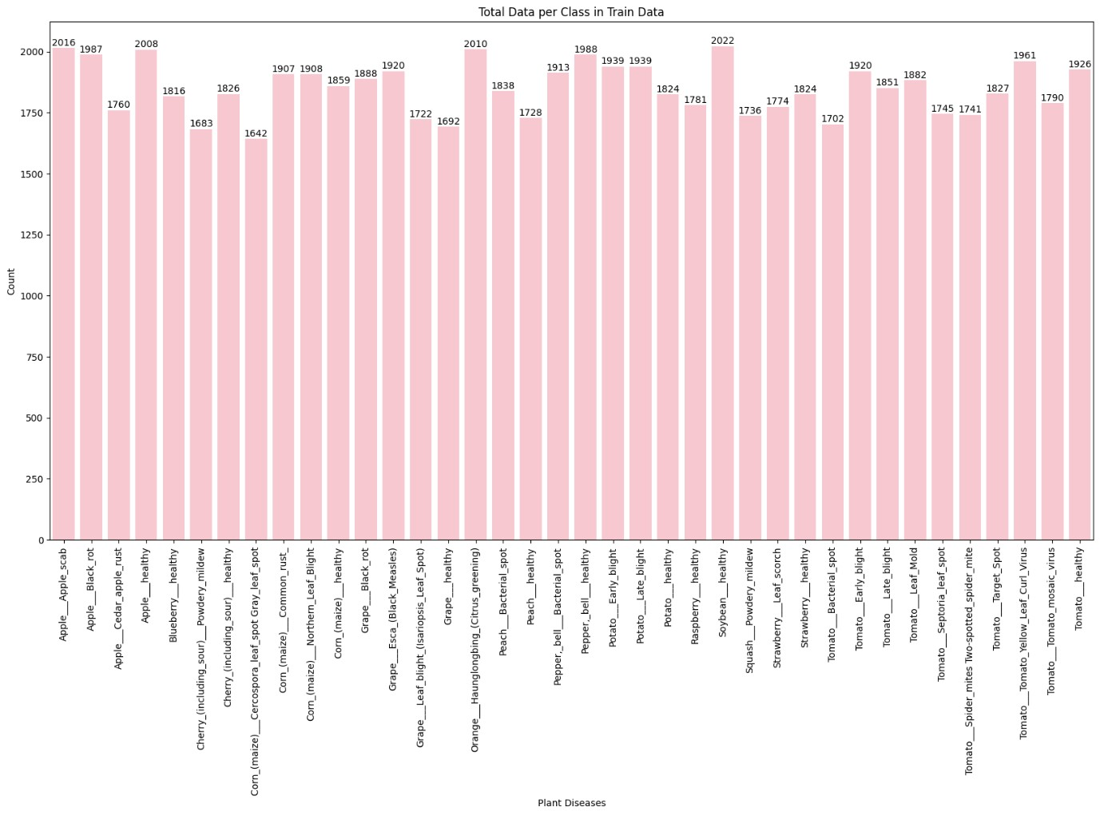

### Figure.1. Dataset Distribution

The "Total Data per Class in Train Data" bar chart [Figure.1] presents a distribution of samples across several plant diseases and healthy states. The x-axis lists all different plant disease classes and healthy states, while the y-axis contains sample counts between around 1600 and 2022, so this is quite an equally balanced data set. Notably, diseases like Late Blight, Early Blight, Bacterial Spot, and Black Rot , among others are occurring in multiple crops, thus are widespread. These balances are crucial while training an unbiased machine learning model to detect any plant disease that may be correct and reliable between different crops.

#### **ii. Data Pre-processing and Model Training**

The various preprocessing techniques that performed are:

1. Resizing: Resizing involved scaling all images to 232 pixels on their shorter side while maintaining the aspect ratio. This step ensured uniform image dimensions, preparing them for further cropping.
2. Data Augmentation: During training, the training images underwent random 45° rotations. This helped in diversifying the training data, allowing the model to generalize better and thus preventing overfitting.
3. Normalization: Each image was normalized by subtracting the mean and dividing by the standard deviation of the ImageNet dataset. This step adjusted the pixel values to align with the model's pre-trained expectations.
4. Batching: The dataset was divided into mini-batches, each containing 32 images. This allowed the model to process multiple images simultaneously during training, speeding up computations and stabilizing weight updates.
5. Shuffling: Images were shuffled in the training stage before forming a batch. It ensured that the model did not learn any unwanted patterns from the sequence of the training data.
6. Multi-Threaded Data Loading: The utility of PyTorch's Data Loader was used to load images using multiple CPU threads. This parallelized data loading, minimizing the time spent waiting for data to be ready during training.
7. Data splitting: data splitting divides the dataset into three parts: training, validation, and test sets. The training set (70,295 images) helps the model learn, while the validation set (17,572 images) checks the model's performance during training. The test set (33 images) is used to evaluate the model after training. This process helps prevent overfitting and ensures the model works well on new data.

#### **iii. Model Training and Evaluation 1. ResNET-50**

Resnet-50 is a deep convolutional neural network, consisting of 50 layers. It was designed specifically for image recognition tasks and brings “residual learning” by shortcut connections that avoid vanishing gradients and improve efficiency.

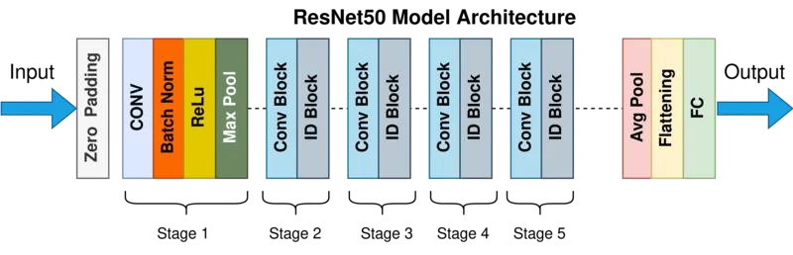

### Figure .2. ResNet-50 Architecture

Using the ResNet-50 architecture, the validation dataset is evaluated at the end of each epoch to compute validation accuracy and assess the model's performance. The ResNet-50 model uses the validation dataset to assess its performance by computing loss and evaluation metrics like accuracy, precision, recall, and F1-score. The model's weights remain unchanged during this phase to prevent overfitting, repeating the process over multiple epochs.

[Figure.3]. shows the model training with 5 epochs. Validation data at each epoch ensures the reliability of the learned weights. Approximately 97.32% Training accuracy is obtained.

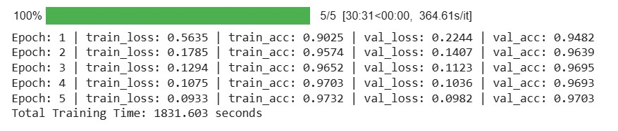

### Figure.3 Model Training using ResNet-50 with 5 epochs

Accuracy and loss graphs are generated, comparing training and validation metrics. These graphs are crucial for evaluating ResNet-50’s performance and determining the most accurate model configuration. [Figure.4.] represents the Training and Validation accuracy curve. [Figure.5.] represents the Training and Validation loss curve.

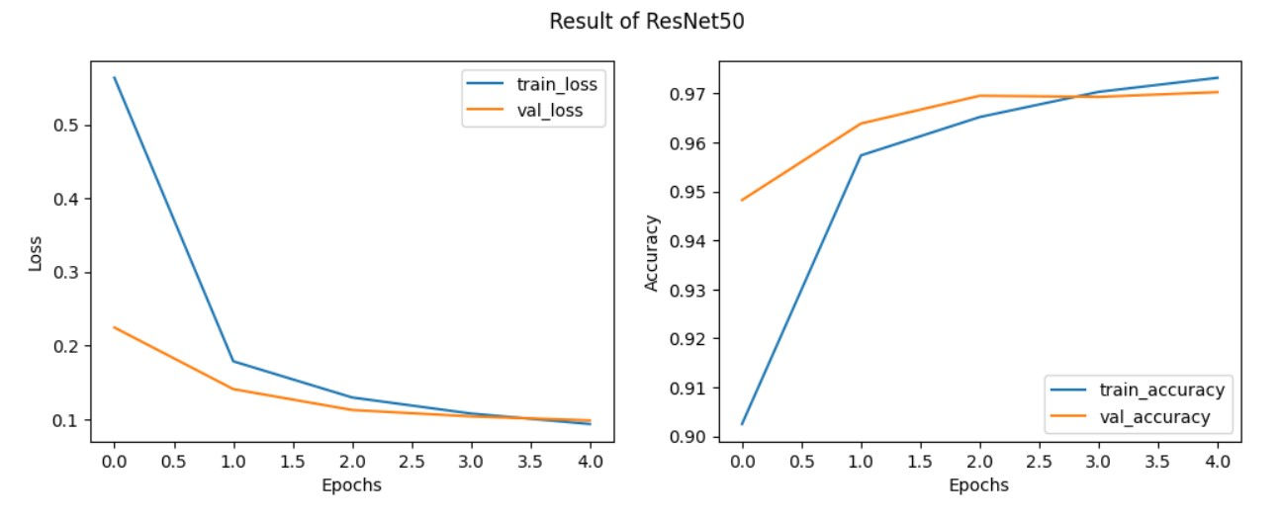

*Figure.4. Training and Validation accuracy curve Figure.5. Training and Validation loss curve*

## 2. DenseNet-201

DenseNet-201 is a deep convolutional neural network with 201 layers. It is characterized by a dense connectivity pattern where each layer is directly connected to every other subsequent layer, which promotes feature reuse and reduces redundancy, improving efficiency and mitigating vanishing gradient issues*.*

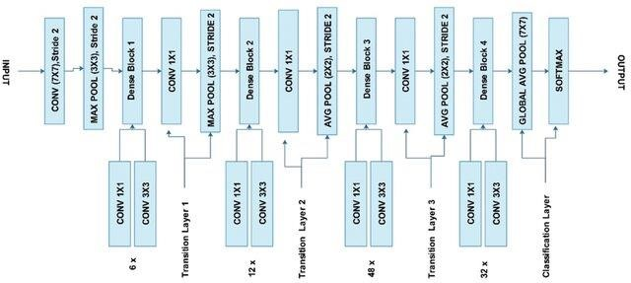

### Figure .5. DenseNet-201 Architecture

Using the DenseNet-201 architecture, the validation dataset is tested at the end of each epoch to calculate validation accuracy and determine how well the model is performing. DenseNet-201 updates its weights with training data; it utilizes its densely connected layers for efficient feature propagation and reuse, repeating this process over multiple epochs.

[Figure.6.] demonstrates the model's training with 5 epochs. Through testing on validation data at every epoch, the learned weights are reliable. Around 96.69% Training accuracy is achieved.

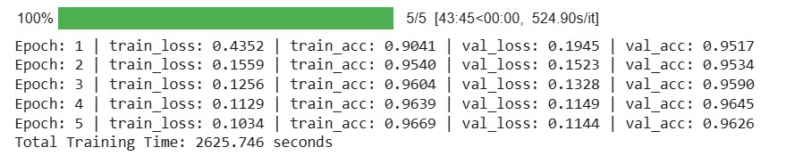

### Figure.6. Model Training using DenseNet-201 with 5 epochs

Accuracy and loss graphs are generated, comparing training and validation metrics. These graphs are crucial for evaluating DenseNet's performance and determining the most accurate model configuration. [Figure.7.] represents the Training and Validation loss curve. [Figure.8.] represents the Training and Validation accuracy curve.

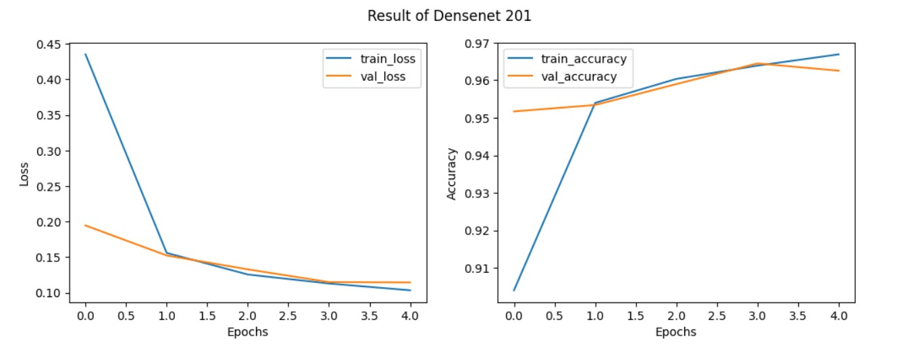

*Figure.7. Training and Validation loss curve Figure.8. Training and Validation accuracy curve*

### **3. VGG16**

Using the VGG 16 architecture, the validation dataset is evaluated at the end of each epoch to compute validation accuracy and assess the model's performance. VGG-16 evaluates the model's performance on the validation set by making predictions based on the learned weights. The predicted labels are compared to the ground truth to compute accuracy and other relevant evaluation metrics, repeating the process over multiple epochs.

[Figure.9.] shows the model training with 5 epochs. Validation data at each epoch ensures the reliability of the learned weights. Approximately 78.38% Training accuracy and 90.69%Test accuracy is obtained.

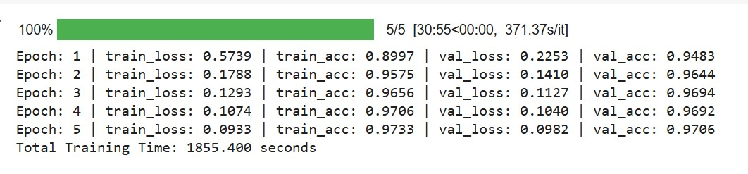

#### Figure.9. Model Training using VGG16 with 5 epochs

Accuracy and loss graphs are generated, comparing training and validation metrics. These graphs are crucial for evaluating VGG16’s performance and determining the most accurate model configuration. [Figure.10.] represents the Training and Validation loss curve [Figure.11.] represents the Training and Validation loss curve.

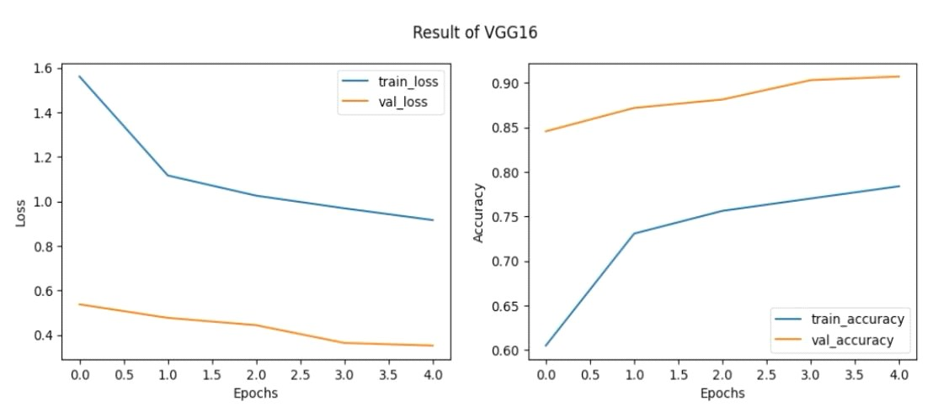

*Figure.10. Training and Validation loss curve Figure.11. Training and Validation accuracy curve*

##### 4. VGG 19

Using the VGG 19 architecture, the validation dataset is evaluated at the end of each epoch to compute validation accuracy and assess the model's performance. VGG-19 model processes the validation images through its deep convolutional layers, generating predictions. These predictions are compared to the true labels to calculate performance metrics such as accuracy and loss, repeating the process over multiple epochs.

[Figure.12.] shows the model training with 5 epochs. Validation data at each epoch ensures the reliability of the learned weights. Approximately 77.06% Training accuracy and 88.68%Test accuracy is obtained.

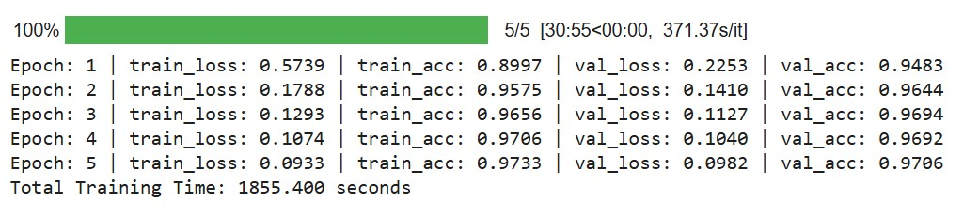

#### Figure.12. Model Training using VGG19 with 5 epochs

Accuracy and loss graphs are generated, comparing training and validation metrics. These graphs are crucial for evaluating VGG19’s performance and determining the most accurate model configuration. [Figure.13.] represents the Training and Validation loss curve [Figure.14.] represents the Training and Validation accuracy curve.

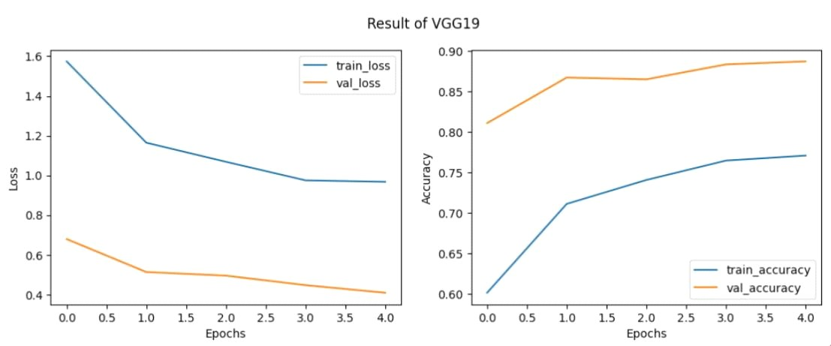

*Figure.13.Training and Validation loss curve Figure.14.Training and Validation accuracy curve*

### **5. EfficientNetV2**

Using the EfficientNetV2 architecture, the validation dataset is evaluated at the end of each epoch to compute validation accuracy and assess the model's performance. EfficientNetV2 was employed for validation by evaluating the model's performance on the validation set, using accuracy, precision, recall, and F1-score as metrics, repeating the process over multiple epochs.

[ Figure.15.] shows the model training with 5 epochs. Validation data at each epoch ensures the reliability of the learned weights. Approximately 88.38% Training accuracy and 90.74%Test accuracy is obtained.

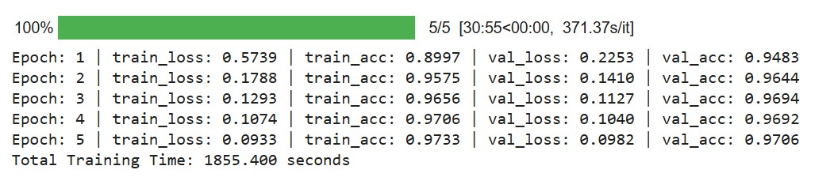

#### Figure.15. Model Training using EfficientNetV2 with 5 epochs

Accuracy and loss graphs are generated, comparing training and validation metrics. These graphs are crucial for evaluating EfficientNetV2’s performance and determining the most accurate model configuration. [Figure.16.] represents the Training and Validation loss curve [Figure.17.] represents the Training and Validation accuracy curve.

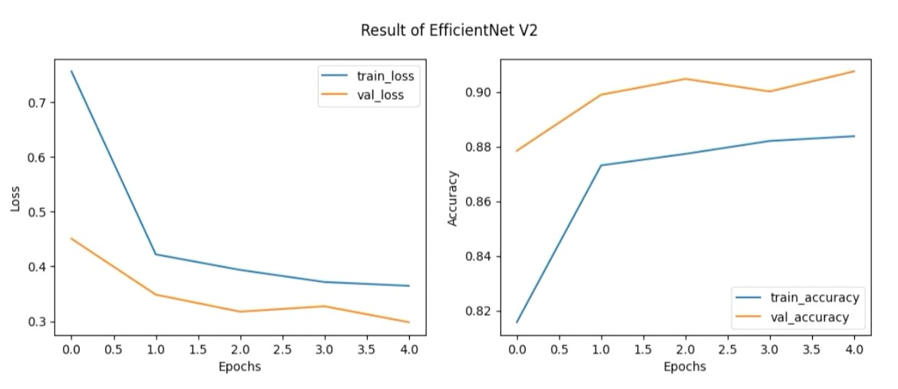

*Figure.16.Training and Validation loss curve Figure.17.Training and Validation accuracy curve*

1. ***Severity Assessment:***

An Area-Based Approach is used to determine the disease severity through calculating percent surface area covered with lesions or other symptoms of disease. Thresholding, this is the process through which the image processing technique evaluates the infected areas; a threshold value must be set in order to classify the infected areas. The area exceeding this threshold will be considered as infected. This is used to determine the level of disease severity based on the percentage of the leaf surface that is affected above the threshold. It is one method that precisely and scalably measures the level of infection.

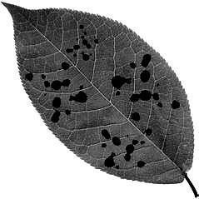

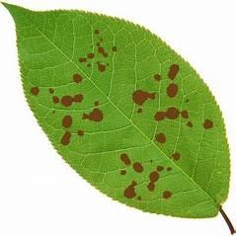

*Figure.18. Grayscale Conversion of leaf for Highlighting Affected Disease Regions*

Based on the severity percentage of the infected area, we classified the disease severity into four categories:

* + If the severity percentage is less than 25%, the severity is classified as Mild.
  + If the severity percentage is less than 50%, the severity is classified as Moderate.
  + If the severity percentage is less than 75%, the severity is classified as Severe.
  + If the severity percentage is greater than or equal to 75%, the severity is classified as Very Severe.

This classification allows us to effectively evaluate the extent of disease and provide appropriate treatment suggestions.

1. ***Treatment recommendation:***

System will also provide treatment which includes both chemical and organic solutions, with an emphasis on the recommendation of the treatment that heals the disease the

fastest according to its severity. For each disease, we have a set of treatments categorized by severity levels: Mild, Moderate, Severe, and Very Severe, with their effectiveness and time to cure. The system compares the curing time for both chemical and organic treatments, prioritizing the one with the shortest time. If both treatments have the same curing time, we suggest the one with the higher effectiveness. This approach ensures that we provide the most efficient treatment, considering both speed and effectiveness, for the predicted disease.

1. ***Website development***

The website is designed that can allow farmers to upload real-time leaf images or even capture images using the camera on their device to detect diseases. Then, the system will make a severity assessment of the disease and classify it as severe, moderate, or mild and provide the farmer with tailored treatment recommendations. These suggestions will include organic and chemical treatment options to ensure that farmers have a range of solutions to effectively manage and treat plant diseases.

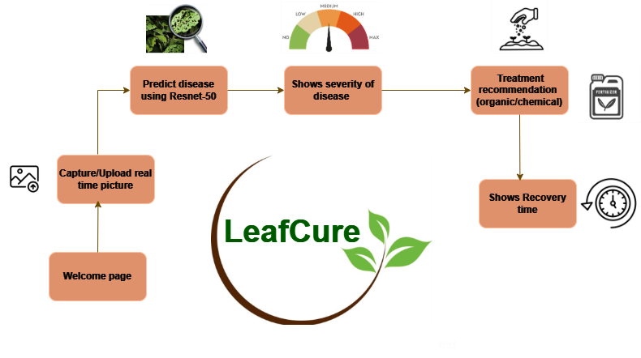

*Figure.19. Workflow and Architecture of the LeafCure Website*

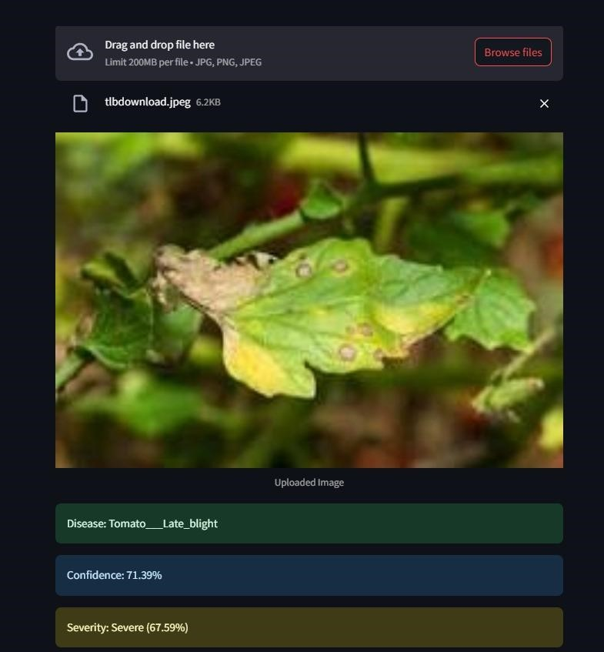

#### Figure.20. Prediction of disease and its severity

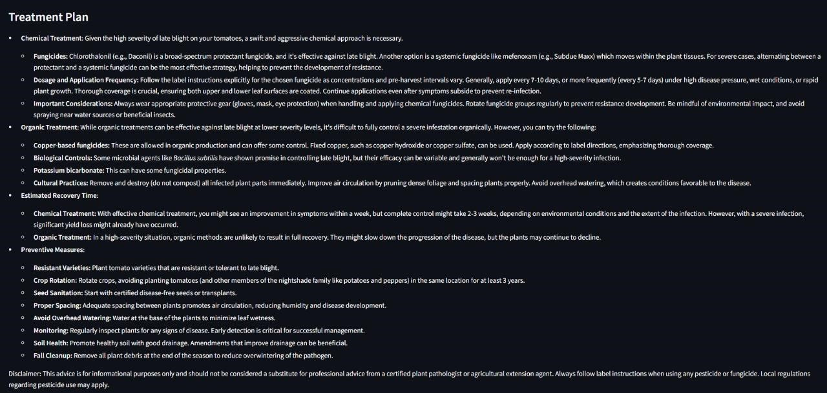

*Figure.21.Treatment Suggestion based on the predicted disease and its severity level*

### **V. Conclusion**

In conclusion, the proposed system is a step forward in plant disease management by combining deep learning techniques with practical solutions for real-time disease detection, severity assessment, and treatment recommendations. The earlier work was able to achieve 95% accuracy in disease detection, while our system, with powerful models like ResNet-50, DenseNet-201, VGG16, VGG19, and EfficientNetV2, has reached up to **97.02%** test accuracy. Key innovations in our work include a method for quantitatively **evaluating disease progression by assessment of its severity**, making monitoring precise and the potential for early interventions, not provided for by the previous works. Our system provides **recommendations of appropriate treatments** depending on the degree of the disease through chemical as well as organic means in accordance with sustainability, which encourages a sustainable practice in agriculture. The real-time capacity and flexibility of the platform for usage with various crops and diseases provide it with utmost relevance across multiple agricultural settings. It is ultimately powerful for farmers through valuable insights about crop losses, with the potential for eco-friendly use, thereby classifying the system as a transforming tool for sustainable agriculture and food security.

### **VI. References**

1. Ahmad, A., Saraswat, D., & El Gamal, A. (2023). A survey on using deep learning techniques for plant disease diagnosis and recommendations for development of appropriate tools. *Smart Agricultural Technology*, *3*, 100083.
2. Li, L., Zhang, S., & Wang, B. (2021). Plant disease detection and classification by deep learning—a review. *IEEE Access*, *9*, 56683-56698.
3. Hirani, E., Magotra, V., Jain, J., & Bide, P. (2021, April). Plant disease detection using deep learning.

In *2021 6th International Conference for Convergence in Technology (I2CT)* (pp. 1-4). IEEE.

1. Militante, S. V., Gerardo, B. D., & Dionisio, N. V. (2019, October). Plant leaf detection and disease recognition using deep learning. In *2019 IEEE Eurasia conference on IOT, communication and engineering (ECICE)* (pp. 579-582). IEEE.
2. Tulshan, A. S., & Raul, N. (2019, July). Plant leaf disease detection using machine learning. In *2019 10th International Conference on Computing, Communication and Networking Technologies (ICCCNT)* (pp. 1-6). IEEE.
3. Wani, J. A., Sharma, S., Muzamil, M., Ahmed, S., Sharma, S., & Singh, S. (2022). Machine learning and deep learning based computational techniques in automatic agricultural diseases detection: Methodologies, applications, and challenges. *Archives of Computational methods in Engineering*, *29*(1), 641-677.
4. Panchal, A. V., Patel, S. C., Bagyalakshmi, K., Kumar, P., Khan, I. R., & Soni, M. (2023). Imagebased plant diseases detection using deep learning. *Materials Today: Proceedings*, *80*, 3500-3506.
5. Jasim, M. A., & Al-Tuwaijari, J. M. (2020, April). Plant leaf diseases detection and classification using image processing and deep learning techniques. In *2020 International Conference on Computer Science and Software Engineering (CSASE)* (pp. 259-265). IEEE.
6. Dhaka, V. S., Meena, S. V., Rani, G., Sinwar, D., Ijaz, M. F., & Woźniak, M. (2021). A survey of deep convolutional neural networks applied for prediction of plant leaf diseases. *Sensors*, *21*(14), 4749. Ngugi, H. N., Ezugwu, A. E., Akinyelu, A. A., & Abualigah, L. (2024). Revolutionizing crop disease detection with computational deep learning: a comprehensive review. *Environmental Monitoring and Assessment*, *196*(3), 302.
7. Ushadevi, G. (2020). A survey on plant disease prediction using machine learning and deep learning techniques. *Inteligencia Artificial*, *23*(65), 136-154.
8. Bhatia, A., Chug, A., & Prakash Singh, A. (2020). Application of extreme learning machine in plant disease prediction for highly imbalanced dataset. *Journal of Statistics and Management Systems*, *23*(6), 1059-1068.
9. Hema, M. S., Sharma, N., Sowjanya, Y., Santoshini, C., Durga, R. S., & Akhila, V. (2021). Plant disease prediction using convolutional neural network. *EMITTER International Journal of Engineering Technology*, *9*(2), 283-293.
10. Monigari, V., Sri, G. K., & Prathima, T. (2021). Plant leaf disease prediction. *International Journal for Research in Applied Science and Engineering Technology*, *9*, 1295-1305.
11. Rubini, P. E., & Kavitha, P. (2021, February). Deep learning model for early prediction of plant disease. In *2021 Third International conference on intelligent communication technologies and virtual mobile networks (ICICV)* (pp. 1104-1107). IEEE.
12. Lijo, J. (2021, April). Analysis of effectiveness of augmentation in plant disease prediction using deep learning. In *2021 5th International Conference on Computing Methodologies and Communication (ICCMC)* (pp. 1654-1659). IEEE.
13. Metagar, S. M., & Walikar, G. A. (2024). Machine learning Models for Plant disease Prediction and Detection: A review. *Agricultural Science Digest*, *44*(4), 591-602.
14. Islam, M. M., Adil, M. A. A., Talukder, M. A., Ahamed, M. K. U., Uddin, M. A., Hasan, M. K., ... & Debnath, S. K. (2023). DeepCrop: Deep learning-based crop disease prediction with web application. *Journal of Agriculture and Food Research*, *14*, 100764.
15. Beyene, H., Joshi, D. N. A., & Kotecha, D. K. (2018). Plant diseases prediction using image processing and machine learning techniques: survey. *Int J Comput Appl*, *1*(8), 226-37.
16. Kumar, S. R., & Kumar, K. R. (2015). A study on paddy crops disease prediction using data mining techniques. *crops*, *1*, 2.
17. Mathew, J., Joy, A., Sasi, D., Jiji, J., & John, J. (2022, April). Crop prediction and plant disease detection using IoT and machine learning. In *2022 6th International Conference on Trends in Electronics and Informatics (ICOEI)* (pp. 560-565). IEEE.