RFID BASED RATION CARD SYSTEM

# Atharva Sachin Takalkar1 Jaid Harun Momin2 Abulfaiz Mainudddin Inamdar3 Shahroz Parwez patel4 Mrs .A.P.Devmore5

**1,2,3,4,5** Department of Computer Engineering

**1,2,3,4,5** Sharad Institute of Technology Polytechnic, Yadrav, Ichalkaranji, Maharashtra, India

# Abstract:

This paper deals with an entirely new perspective to tackle the distribution center of the subsidized food grains utilizing the RFID technology. Ration card system is not always free of the negative factors such as inefficiency, corruption in its operations and lack of transparency. This concept is more efficient than the existing concept since it will reduce the human interference, make the procedures accountable and most important increase the satisfaction of the beneficiaries.

Each of the eligible beneficiaries will be issued an RFID card which contains the particulars of each beneficiary and the ration card. At the time of purchase, the beneficiary’s card will be swiped in order to establish that the accurate beneficiary is making a transaction. The system will then process and authorize the issue of the specified quantity of food grains.

**Keywords**: RFID Based Ration Card System.

# Introduction:

The traditional ration card system, often plagued by inefficiencies, corruption, and lack of transparency, necessitates a modern, technologically advanced solution. This project proposes an RFID- based ration card system that aims to revolutionize the distribution of subsidized food grains, ensuring equitable access, enhancing transparency, and improving overall efficiency.

# The proposed system utilizes Radio Frequency Identification (RFID) technology to streamline the distribution process. Each eligible beneficiary will be issued a unique RFID card containing their personal details and ration card information. These cards will be used in conjunction with point-of-sale (POS) terminals installed at ration shops.

# Methodology:

Instead of traditional paper ration cards, people use cards with tiny electronic chips inside (RFID tags).

These chips hold unique identification information.

At the ration shop, a reader scans the chip, and the system checks the person's details in a computer database.

Here's a step-by-step look:

1. Registration and Card Issuance:

People register for the ration system, providing their personal details (name, address, etc.).

Each eligible person or family gets an RFID card with their information stored on the chip.

This information is also saved in a central computer database.

2.At the Ration Shop:

When someone goes to the ration shop, they present their RFID card.

The shopkeeper uses an RFID reader to scan the card.

The reader sends the card's information to the computer system.

3.Verification and Processing:

The computer system checks the card's information against the database.

It verifies the person's identity and their ration entitlements (how much they are allowed to buy).

The system then can record the amount of goods that the person has taken.

The system can also be set up to update the inventory of the ration shop.

4.Distribution:

If everything matches, the shopkeeper provides the correct amount of rationed goods.

The system can record the transaction, keeping track of who received what.

In some systems, the inventory is also automatically updated.

5. Data Management:

All transaction data is stored in the central database.

This helps with:

Preventing fraud (people claiming more than their share).

Managing inventory and ensuring enough supplies.

Generating reports for government officials.

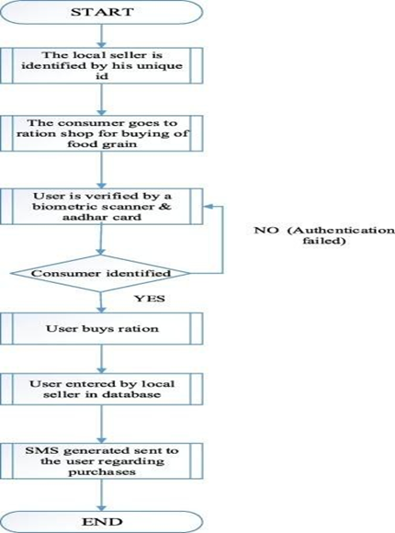

Fig. A)RFID BASED RATION CARD SYSTEM ARCHITECTURE.

# System Overview:

# The system aims to replace the traditional paper-based ration card system with a more efficient, transparent, and secure digital system. By using RFID technology, it streamlines the distribution process, reduces the potential for fraud, and improves overall management of the ration system.

Core Components:

* RFID Cards (Tags):

These are the "smart" ration cards. Each card contains a small chip with unique information about the cardholder.

* RFID Readers:

These are devices used at the ration shops to scan the RFID cards. They pick up the signals from the tags and transmit the data to the central system.

* Central Database:

This is the heart of the system. It stores all the information about:

Registered beneficiaries.

Their entitlements (how much ration they're allowed).

Transaction history.

Inventory levels.

* Computer System/Software:

This is the software that manages the entire process. It:

Processes the data from the RFID readers.

Verifies beneficiary information.

Updates the database.

Generates reports.

* How the System Works:

1. Registration:

Eligible individuals are registered, and their details are entered into the central database.

They are then issued RFID cards.

2. Transaction:

When a person goes to a ration shop, they present their RFID card.

The shopkeeper scans the card with the RFID reader.

The reader sends the card's data to the central computer system.

3. Verification:

The computer system checks the data against the database to verify the person's identity and entitlements.

4. Distribution and Recording:

If the verification is successful, the shopkeeper provides the rationed goods.

The system records the transaction, updating the beneficiary's record and the shop's inventory.

# System Features :

# Secure Identification:

# Each person gets a unique RFID card, making it very hard to fake.

# The system instantly verifies their identity when the card is scanned.

# Automated Entitlement Tracking:

# The system knows exactly how much each person is entitled to receive.

# It automatically calculates and deducts the quantity of goods taken.

# Real-Time Transaction Recording:

# Every transaction is recorded instantly in the central database.

# This provides a clear record of who got what and when.

# Inventory Management:

# The system can track the stock levels at each ration shop.

# This helps to ensure that there are enough supplies available.

# Automatic updates of stock levels when transactions occur.

# Fraud Prevention:

# The system flags any suspicious activity, such as multiple transactions from the same card.

# It makes it much harder for people to claim more than their share.

# Reporting and Analysis:

# The system can generate reports on various aspects of the distribution process.

# This helps authorities to monitor the system and identify any problems.

# User-Friendly Features:

# Easy-to-Use Interface:

# The system should be simple for both ration shop operators and beneficiaries to use.

# Clear instructions and minimal technical complexity.

# Quick Transaction Processing:

# Scanning the RFID card and completing a transaction should be fast.

# This minimizes waiting times at ration shops.

# Administrative Features:

# Centralized Data Management:

# All data is stored in one place, making it easy to access and manage.

# Implementation:

## Overview

# The system aims to replace the traditional paper-based ration card system with a more efficient, transparent, and secure digital system. By using RFID technology, it streamlines the distribution process, reduces the potential for fraud, and improves overall management of the ration system.

1. Planning and Preparation:

1.1 Needs Assessment:

Figure out the current problems with the existing ration system.

Determine the specific goals of the RFID system (e.g., reduce fraud, improve efficiency).

1.2 System Design:

Decide on the type of RFID technology to use.

Design the software and database structure.

Plan the layout of the system at ration shops.

1.3 Pilot Project:

Start with a small-scale pilot project in a limited area.

This allows you to test the system and identify any problems before full implementation.

2. Infrastructure Setup:

2.1 Hardware Installation:

Install RFID readers at all ration shops.

Set up computers and other necessary equipment.

If using them, install POS (Point of Sale) terminals.

2.2. Network Connectivity:

Ensure reliable internet connectivity at all ration shops.

This is crucial for real-time data updates.

2.3.Database Setup:

Create the central database to store beneficiary information.

Configure the database for secure access and data management.

3. Data Collection and Card Issuance:

3.1.Beneficiary Registration:

Conduct a registration drive to collect beneficiary data.

This may involve collecting personal information and biometric data.

3.2.Card Issuance:

Issue RFID cards to all registered beneficiaries.

Ensure that the cards are properly linked to their database records.

4. Software Deployment and Training:

4.1. Software Installation:

Install the ration card management software on all computers.

4.2. User Training:

Train ration shop operators on how to use the RFID readers and software.

Educate beneficiaries on how to use their RFID cards.

5. System Launch and Monitoring:

5.1. Go-Live:

Launch the RFID-based ration card system.

Provide ongoing support to users.

5.2. Monitoring and Evaluation:

Continuously monitor the system's performance.

Collect data on transaction volumes, fraud rates, and other key metrics.

Generate reports, and take action on the reports findings.

5.3. Maintenance and Updates:

Regularly maintain the hardware and software.

Update the system to address any issues or add new features.

5.4. Key Considerations:

Phased Implementation:

Implement the system in phases, starting with a pilot project.

This allows for adjustments and improvements along the way.

5.5. Community Engagement:

Communicate with beneficiaries and address their concerns.

Build trust in the new system.

5.6. Security:

Security must be a priority at every step.

Regularly audit the system for vulnerabilities.

# Result :

* Reduction in Fraud: RFID cards in the hands of the beneficiaries are meant to reduce cases of fraud and ration diversion.
* Target optimization: Those targeted with rations will be the genuine cases needing assistance.
* Higher satisfaction: Users of the system, in this case, beneficiaries, have been able to achieve better satisfaction with the system on its efficiency and lack of bias.
* Greater accountability: The use of RFID technology in ration distribution serves to enhance the level of accountability and honesty in the process.

Fig: 1.

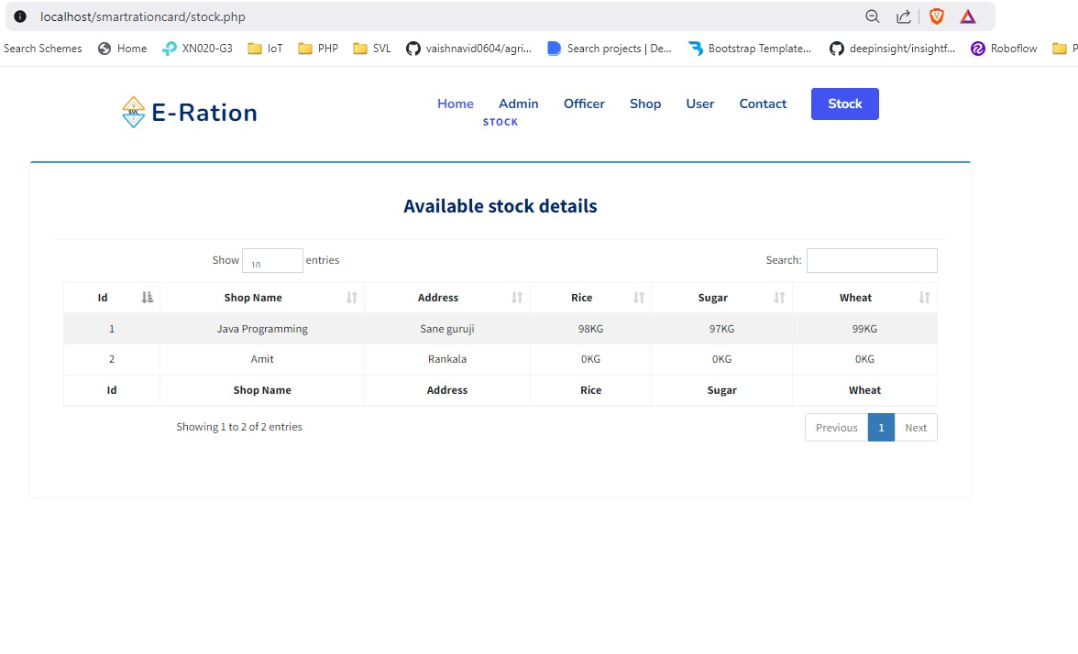

Fig: 2.

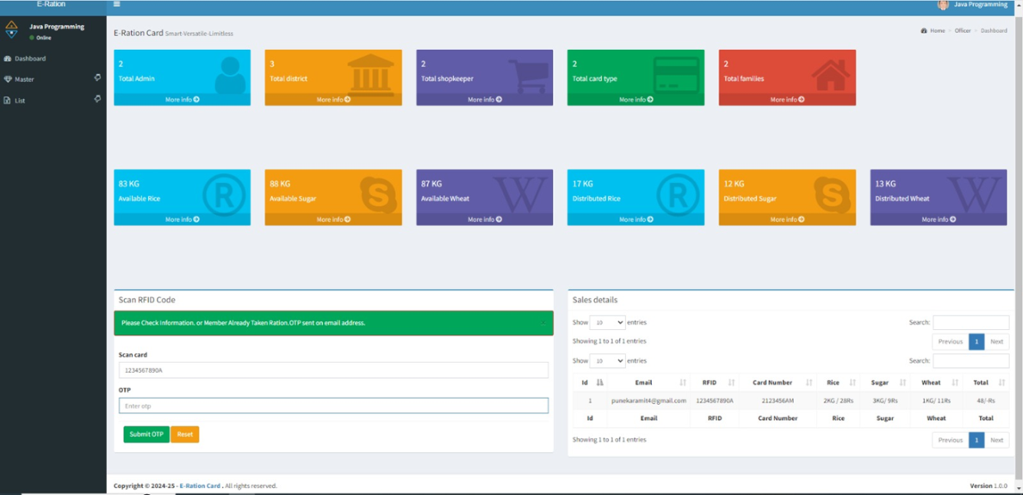

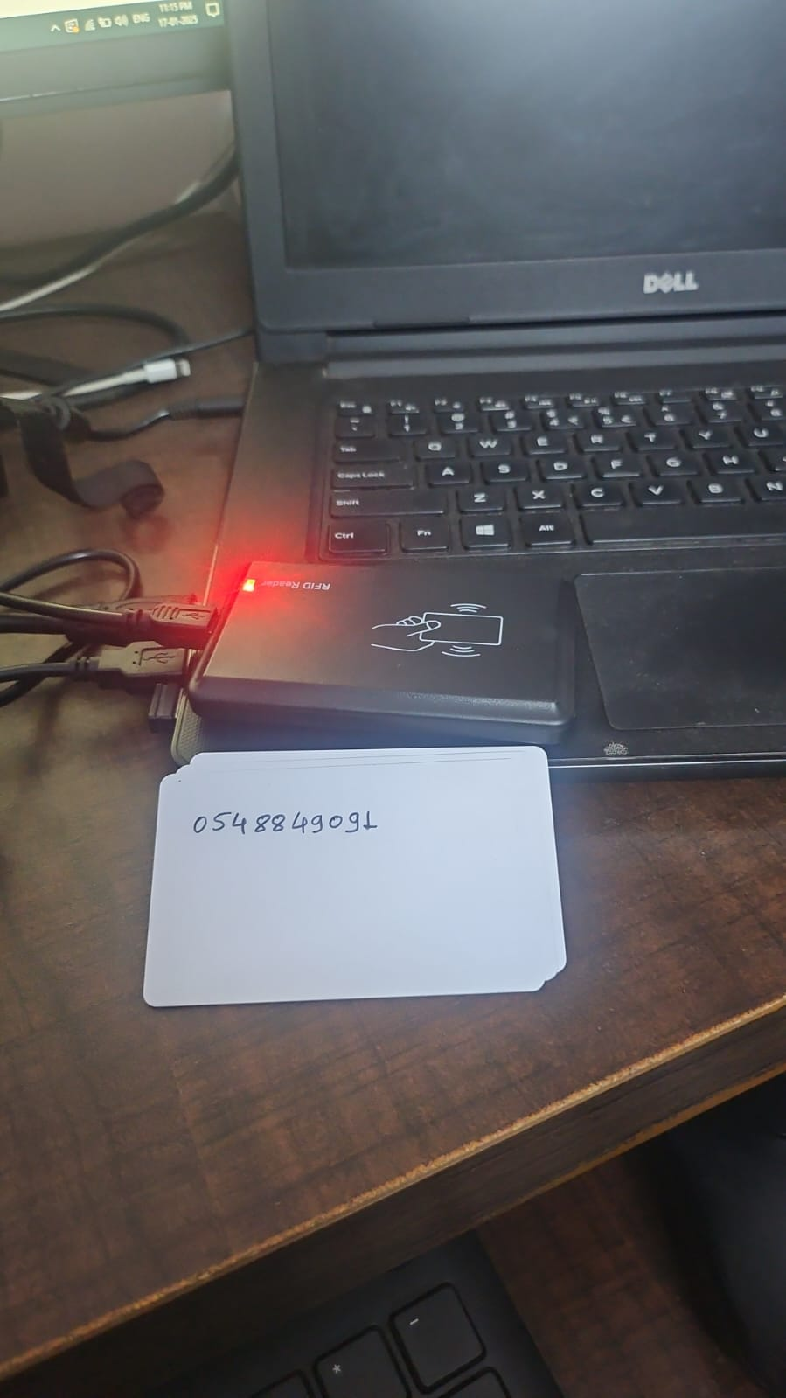

Fig: 3

(Main Hardware system)

# Dataflow :

Data Entry and setting up the System Ration Card Registration:

Provide personal information e.g. (name, address, aadhaar number etc.)

Allow cardholders to generate unique ration Card Id’s.

Each card shall be linked to a family, household or an individual.

Ration Card Registration:

Attach RFID tags to each ration card. Store relevant information details like card ID on tag.

Inventory Management:

Take note the type and quantity of commodities stored in the godown or distribution center.

Make frequent updates in the inventory relational database.

Distribution process Cardholder Validation:

At the distribution center, cardholder has an RFID card and present it to the affixed distribution point.

The RFID reader is used to scan the card to pull out the information in relation to this card.

Authenticate the cardholder from the existing database.

Commodity distribution:

Turn to the ration cardholder to verify his/her entitlement to ration commodities which includes set parameters like income, number of family members e.t.c.

Allocate quantity of commodities to be distributed.

Inventory Update:

Execute remove the previously allocated quantity from inventory database.

# Applications:

# Less Fraud:

# It's harder for people to use fake ration cards or take more than their fair share.

# This means more of the ration reaches the people who really need it.

# Faster Service:

# Scanning the card is quicker than manually checking records, so you spend less time in line.

# Accurate Records:

# The system keeps track of everything, so there are fewer mistakes.

# The system can provide accurate reports about who is recieving rations, and who is not.

# Transparency:

# It's easier to see how much ration is being distributed and where it's going, which helps prevent corruption.

# Reduced Paperwork:

# Less paper based records are needed.

# Better Stock Management:

# The government can track stock levels in real-time, preventing shortages or overstocking.

# Easier Updates:

# If your family situation changes (e.g., a birth or death), updating your ration card details is easier and faster.

# In Everyday Situations

# Imagine an elderly person who has trouble carrying heavy bags. With this system, they can get their ration quickly and efficiently.

# Future Enhancement :

* Artificial Intelligence (AI): Through AI algorithms, consumption patterns could be analyzed and demand could be predicted. With AI, resource allocation and usage can be optimized. Anomalies with possible fraud can be detected.

Functional Upgradation

* Mobile App: A convenient mobile app could be developed where the beneficiary can check ration balance, history of transactions, and problems can be raised.
* Poverty Eradication: The ration card system might ensure fair distribution of basic commodities thus making poverty eradication efforts.
* Sustainable Agriculture: It could also be linked to sustainable agriculture practices, which promote local production and reduce imports.

Disasters: Natural disasters or emergencies can be handled by utilizing the system for prioritization of relief efforts and that all the vulnerable groups get the required help.

# Conclusion:

RFID enabled ration card system is being used as a solution to improve efficiency, transparency and accountability of the public distribution systems. These systems can eliminate corruption, inefficiencies and liminalization errors using technology. Benefits: less waiting, better targeting, cost savings. The hardships of executing RFID based systems with precision are worth than the cost as you gain a lot in long run. These challenges and likely future research directions are discussed here in order that public sector institutions take steps to design more equitable, sustainable systems of food security provision.

# Discussion :

On the other hand, despite the mentioned advantages of implementing an RFID- based ration card system, there are still constraints and limitations-from infrastructure requirements, data security concerns, to even resistance from stakeholders.

* Economical: Although a highly heavy up-front investment is required in order to set up RFID technology and all the related infrastructure, the long-term benefit in terms of efficiency and cost savings may justify this expenditure.
* Scalability. It is easy to scale the system up and cope with an increase in population as well as geographical coverage.

Other government services also can be integrated through RFID-based ration card systems to offer an all-embracing network of social welfare.

# References:

* Sneha Ingale, Payal Paigude, Sneha Gaikwad, Reshm Ade, and M. Rupali Dalvi, “Smart ration in Applied Science and Engineering Technology, Vol. 6, Issue 3, March 2018, pp 2135-2137

card and automatic ration material distribution system using IOT”, International Journal for Research

* Kumar, V., et al. (2016). Development of an RFID-. Based ... (2021). Development of an RFID-. Based Ration Card System using Arduino UNO.
* Rajesh C. Pingle and P. B. Borole, “Automatic Rationing for Public Distribution System Technology Innovations and Research, vol 2, pp.102-111, Mar 2013.
* Mandeep Kaur, Sandhu Manjeet, Mohan Neeraj, and Parvinder, Sandhu S “RFID radio Engineering, February 2011, pp. 1793-8163

frequency identification Technology,” Journal International of Computer as well as Electrical

(PDS) using RFID and GSM Module to Prevent Irregularities,” HCTL Open International Journal of