**Topic: SMART MATERIALS AND ITS APPLICATIONS**

**Sub Topic: How Smart Materials are being used in different fields of engineering.**

Authors: Shakeel Ahmed Shaikh1, Mullaji Mujeebur Rahman Hanif2, Mr. Jamil Talukdar3, Mr. Harun M. Pinjari4

1Anjuman-I-Islam’s Abdul Razzak Kalsekar Polytechnic, Mechanical Engineering TY Student

2Anjuman-I-Islam’s Abdul Razzak Kalsekar Polytechnic, Mechanical Engineering TY Student

3Anjuman-I-Islam’s Abdul Razzak Kalsekar Polytechnic, HOD of Mechanical Engineering Department

4Anjuman-I-Islam’s Abdul Razzak Kalsekar Polytechnic, Lecturer of Mechanical Engineering Department

**ABSTRACT**

This research explores smart materials, their classification, and applications. It includes shape memory alloys, piezoelectric materials, and chromic materials. Shape memory alloys offer shape recovery and damping, while piezoelectric materials convert energy between mechanical and electrical forms. Chromic materials change colour in response to stimuli. Smart materials have applications in automotive, aerospace, medicine, and building technology. As technology advances, smart materials are poised to play a crucial role in shaping the future, offering innovative solutions across various industries.

Keywords: Smart materials, shape memory alloys, piezoelectric, chromic, stimuli.

1. **Introduction**

Smart materials are advanced materials that can respond to external stimuli, such as temperature, pressure, light, or magnetic fields, and exhibit changes in their properties. These materials have found applications in various fields, including aerospace, medicine, civil engineering, and robotics. By adapting to environmental changes, smart materials offer innovative solutions that enhance functionality, performance, and energy efficiency.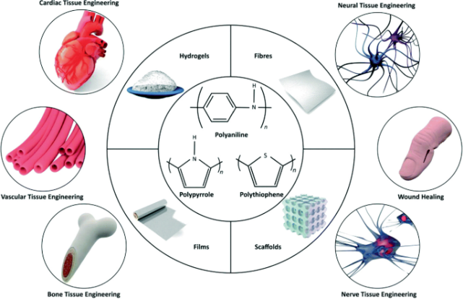Fig.1 Use of smart sensors in biomedical application (Tissue engineering) [1]

1. **Classification of Smart Materials**

Smart materials are categorized on the basis of their properties such as Active and Passive. Active smart materials possess the capability of modifying their geometric and material properties under the application of electric, thermal or magnetic fields thereby acquiring an inherent capacity to transduce energy. Passive smart materials lack inherent capability to transduce energy. The three basic components of smart system are sensors, actuators and processors [1].

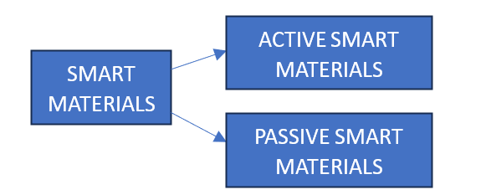

Fig.2 shows the classification of smart materials.

1. **Types of Smart Materials**
   1. Shape Memory Alloys (SMAs)

Shape Memory Alloys (SMAs) are smart materials that have to have at least two different basic phases, which can be transformed from one phase to the other by changing temperature or stress. They able to memorize their shape in austenite phase, and thus when they are deformed, their primary shape can be recovered to the same morph. It has many properties like damping, pseudoelasticity, shape memory effect, etc [2]. These materials exhibit high power volume ratio. Shape memory alloy, such as nitinol [NiTi], an alloy of nickel and titanium, which has a corrosion resistance similar to stainless steel, making it particularly useful for biomechanical applications. Such types of materials can be used in super elastic spectacle frames, stents for veins [3]. One of the advantages using shape-memory alloys is the high level of pseudo-plastic strain that can be induced. The maximum recoverable strain these materials can hold without permanent damage is up to 8% for some alloys (compared with a maximum strain 0.5% for conventional steels). The yield stress for NiTi can reach up to 500 MPa [4].

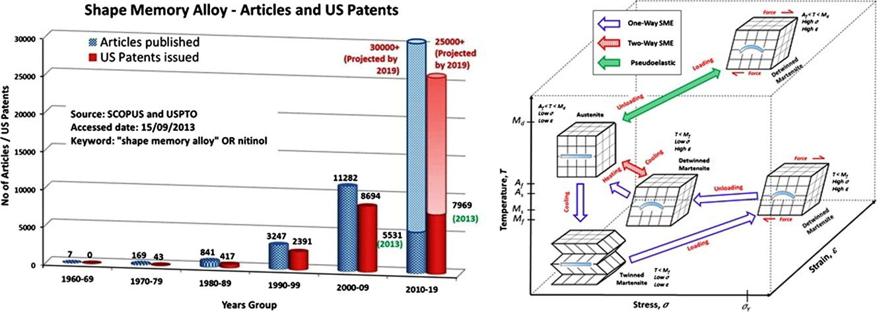

Fig.3 SMA Stress, Strain and temperature parameters. [5]

* 1. Piezoelectric

The piezoelectric effect was first discovered by Pierre and Jacques Curie in 1880. The direct piezoelectric effect consists of the ability of certain crystalline materials (ceramics) to generate an electrical discharge. In proportion to an externally applied force. There are many organic and inorganic materials that have piezoelectricity [4]. In addition, some inorganic ceramic materials can show piezoelectricity such as zinc oxide, ZnO [6], aluminium nitride, AlN [7], lead-zinc-zirconate-titanium oxides (PZT), Pb(Zn, Al)O3 [8], and quartz (i.e. SiO2) [9]. Piezoelectric effect is extensively used to convert the electric energy into mechanical energy and vice-versa i.e. the piezoelectric substances are used as electromechanical transducers. Possibly the best single measurement of the strength of a piezoelectric effect is the electromechanical coupling factor K. When an electric field is applied, it measures the fraction of the electrical energy converted to mechanical energy (or vice versa when a crystal or ceramic is stressed). The actual relationship is in terms of $K^{2}$ [10].

$$k^{2}=\frac{Electrical energy converted in mechanical energy}{Input Electrical energy}$$

$$k^{2}=\frac{Mechanical energy converted in electrical energy}{Input Mechanical energy}$$

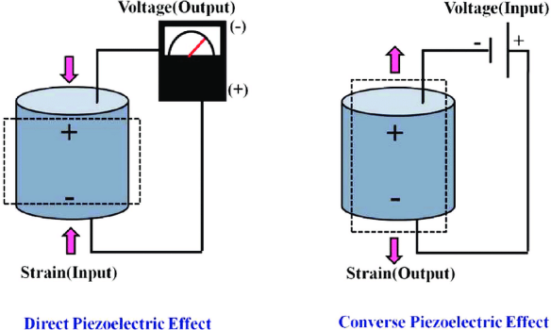

Fig.3 shows Direct (left) and Inverse (right) piezoelectric effect [10]

* 1. Chromic Materials

Among smart materials, a family of materials can be found that change their colour as a response to the variation in the environmental conditions. They can return back to their first colour after that effect is disappeared [11]. For each family, the reversibility of changing colour depends on particular physical parameters. Table 4 gives some groups of chromic materials.

Photochromatic – are sensitive to visible and ultraviolet radiation and give some colours depending upon the heat of the radiation.

Thermochromic – The colour in thermochromic materials is altered by increasing temperature to some predetermined values. They can be produced from some compounds of semiconductor, metals, and liquid crystals.

Electrochromic - Electrochromic materials are fabricated in either transparent or reflective type [12, 13]. The composition of these materials, are sensitive to electrical voltage. In some particular polymers the electrochromic (EC) effect, is due to the transition of metal oxides [14]. Also, inorganic materials can exhibit electrochromic behaviour by separating positive charge and electrons.

|  |  |
| --- | --- |
| Chromic Type | Stimuli Type |
| Photochromic | Absorbing electromagnetic light |
| Thermochromic | Changing of temperature |
| Electrochromic | Applying electric field |
| Magnetochromic | Applying magnetic field |
| Piezochromic | Mechanical loading |
| Solvatechromic | Contact with some liquid |
| Carsolchromic | Bombarding with electron beam |

Table.1 Classification of chromic materials and it’s of stimuli.

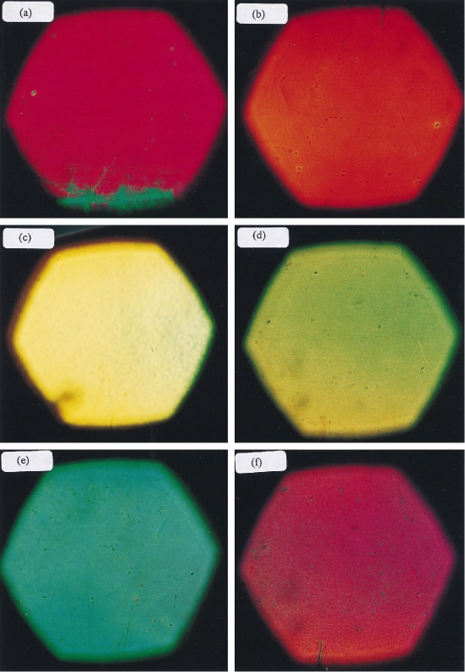

Fig.4 shows Diffracted light from films gives different colours due to varying magnetic field [15]

1. **Applications of Smart Materials**

Today, smart materials have significant role modern civilization, and they are appeared in most area of technology such as, civil engineering and building, biomedical, military, automobile sector, aeronautical

technology, and in some active research groups. In the following sections some applications are discussed [15].

* 1. Shape Memory Alloys (SMAs)

SMA is a versatile material with widespread applications due to its unique properties. In automotive, it's used for actuators, sensors, and valves, improving efficiency and noise reduction. Aerospace benefits from SMA for noise reduction, vibration damping, and jet engine optimization. Civil engineering utilizes SMA in intelligent reinforced concrete for structural integrity and crack detection. Medical applications include orthodontic devices, endodontic files, and fracture treatment. Industrial sectors like petrochemicals, semiconductors, and pharmaceuticals employ SMA for temperature control, piping, and precision engineering. [4]

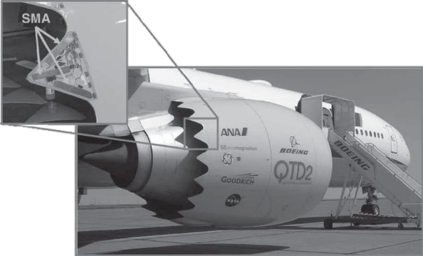

Fig. 5 Variable Jet Nozzle with SMA [16]



Fig.6 Schematic diagram of orthodontic arch wire used for unordered teeth [15]

* 1. Piezoelectric

The increasing demand for cleaner, quieter, and more powerful diesel engines has led to the development of piezoelectric fuel injectors. These injectors use precise fuel control to optimize combustion, reducing emissions and improving performance. Piezoelectric actuators enable rapid and precise valve control, allowing for high-pressure fuel injection. Bosch was the first company to implement piezoelectric fuel injectors, revolutionizing diesel engine emissions reduction and significantly increasing performance [10].

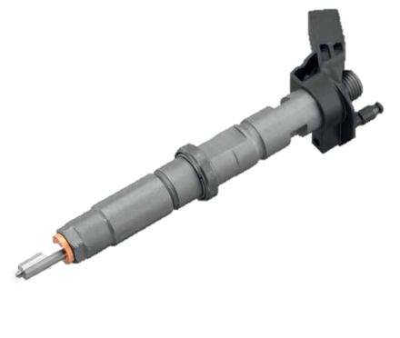

Fig.7 Bosch Piezo Fuel Injector for CR System

Piezoelectric actuators are also used in ultrasonic cleaning. To perform ultrasonic cleaning, objects are immersed in a solvent (water, alcohol, acetone, etc.). A piezoelectric transducer then agitates the solvent. They agitate solvents, breaking up contaminants on objects. This technology is used for cleaning inaccessible surfaces, removing kidney stones, and detecting flaws in materials [10].

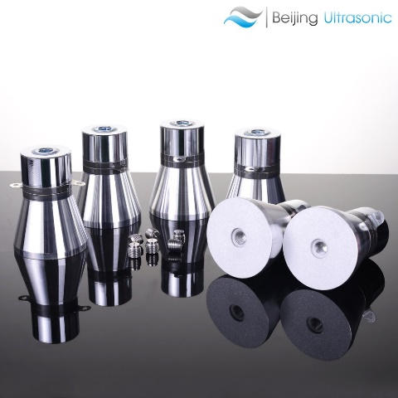

Fig.8 shows Piezoelectric Ultrasonic cleansers

* 1. Chromic Materials

A voltage applied to the mirror causes a chemical reaction, darkening the reflective surface. This technology can also be used in smart windows to control light transmission. These mirrors normally fabricated in seven sputtered thin layers (see Fig.9), which are including a transparent glass, two transparent electrodes (anode and cathode), an ionic storage layer, an electrolyte, an electrochromic layer (e.g. WO3), and a usual mirror. In a normal condition, the electric circuit is opened and approximately all incident light can be reflected from the mirror (Fig.9a). However, an electric field produced between electrodes when the circuit is closed, and thus, electrons from ion storage layer start to follow through electrolyte layer and reach the electrochromic layer. Consequently, the mirrored is turned to dark and accordingly the reflected light decreased with increasing electric potential difference (Fig.9b) [15].

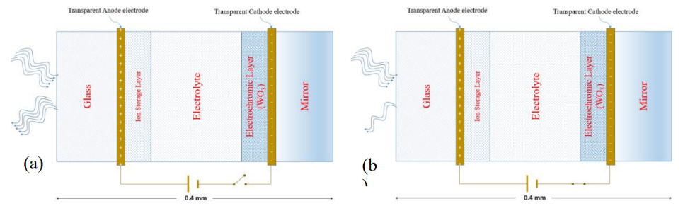

Fig.9 Schematic diagram of electrochromic mirror for (a) open circuit, which approximately all incident light is reflected by a mirror [15].

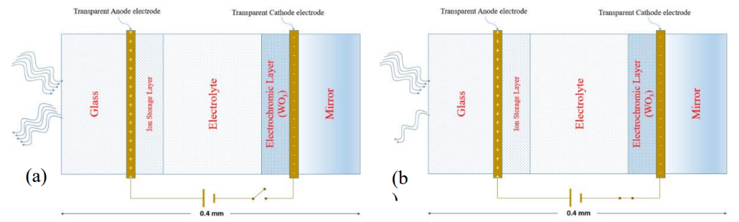

(b) when the potential difference is applied to electrodes, some incident light will be absorbed and thus it causes to decrease reflected light [15].

1. **Benefits of Smart Materials**

* They are self-accommodation with their environment.
* Less energy consumption.
* High sensitivity to stimuli.
* Fast response to different conditions.
* They have smaller size comparable with other automotive systems.

1. **Challenges and Future Decisions**

* In some cases, the cost of preparations is comparably high.
* Ensuring the long-term durability and reliability of smart materials under varying conditions is crucial.
* **Integrating smart materials into existing systems requires careful design, engineering, and validation to ensure compatibility and optimal performance.**

1. **Conclusion**

Smart materials, such as shape memory alloys, piezoelectric materials, and chromic materials, offer innovative solutions across various industries. Their ability to respond to external stimuli and change their properties has led to advancements in fields like automotive, aerospace, medicine, and building technology. While challenges like cost and long-term durability exist, ongoing research and development are addressing these issues. As technology continues to evolve, smart materials are poised to play an increasingly vital role in shaping our future.

1. **References**
2. Fernandes, Cristiana, Geetha B. Heggannavar, Mahadevappa Y. Kariduraganavar, Geoffrey R. Mitchell, Nuno Alves,
3. and Pedro Morouço. "Smart materials for biomedical applications: the usefulness of shape-memory polymers."
4. Applied Mechanics and Materials 890 (2019): 237-247.
5. Fernandes, Cristiana, Geetha B. Heggannavar, Mahadevappa Y. Kariduraganavar, Geoffrey R. Mitchell, Nuno Alves, and Pedro Morouço. "Smart materials for biomedical applications: the usefulness of shape-memory polymers." Applied Mechanics and Materials 890 (2019): 237-247
6. Dye, D., Shape memory alloys: Towards practical actuators. Nature materials, 2015. 14(8): p. 760.
7. Kamila, S., Introduction, classification and applications of smart materials: an overview. American Journal of Applied Sciences, 2013. 10(8): p. 876
8. W. -G. Drossel et al. / Procedia CIRP 36 (2015) 211-216.
9. Qader I. N., Kok M., Dagdelen F., Aydogdu Y. ECJSE 2019 (3) 755-788
10. Yamamoto, T., T. Shiosaki, and A. Kawabata, Characterization of ZnO piezoelectric films prepared by rf planar‐magnetron sputtering. Journal of Applied Physics, 1980. 51(6): p. 3113- 3120
11. Tonisch, K., et al., Piezoelectric properties of polycrystalline AlN thin films for MEMS application. Sensors and Actuators A: Physical, 2006. 132(2): p. 658-663.
12. Fraden, J., Acoustic Sensors, in Handbook of Modern Sensors. 2010, Springer. p. 431-443.
13. Jaffe, B., Piezoelectric ceramics. Vol. 3. 2012: Elsevier.
14. Piezoelectricity and Its Applications DOI: <http://dx.doi.org/10.5772/intechopen.96154>
15. Mattila, H., Intelligent textiles and clothing. 2006: Woodhead Publishing
16. Wang, Z. and P.P. Nguyen, Durable reflection-controllable electrochromic thin film material. 2010, Google Patents.
17. Fuss, E.A., R.W. Phillips, and P.P. Nguyen, Electrical characteristics of electrochromic devices. 2010, Google Patents.
18. Marinella, F. and B. Murat, Materials that Change Color. Smart Materials, Intelligent Design. 2013, Milano, Politecnico di Milano, Springer.
19. Qader I. N., Kok M., Dagdelen F., Aydogdu Y, “A review of smart materials: researches and applications”, El-Cezerî Journal of Science and Engineering, 2019, 6(3); 755-788.
20. Calkins, F., Butler, G., Mabe, J.: Variable Geometry Chevrons for Jet Noise Reduction, AAA-2006-2546, 2th AIAA/CEAS Aeroacoustics Conference, Cambridge MA, May 2006.