**Iot Based Industrial waste water management system**

Mr. R. M. Patil , Dhiraj Sachin Patil* , Ayan Ayaj Sayyad2 , Irfan Shabbir Shaikh2 , Shubham Gopal Urane2 1HOD, Department of Computer Engineering, Sharad Institute of Technology Polytechnic, Yadrav-Ichalkaranji, Kolhapur, Maharashtra, India 2Undergraduate, Department of Computer Engineering, Sharad Institute of Technology Polytechnic, Yadrav-Ichalkaranji, Kolhapur, Maharashtra, India *Corresponding Author: [sayyadayan440@gmail.com*](mailto:sayyadayan440@gmail.com*)

**Abstract:**

Effective waste water management is essential for maintaining industrial sustainability and adhering to environmental regulations. Traditional systems often lack the ability to provide realtime monitoring and immediate response to water quality issues. This paper presents the design and implementation of an IoT-based water monitoring system that continuously measures critical parameters such as pH, turbidity, water levels, temperature, humidity, and harmful gases. The system uses an ESP32 microcontroller integrated with sensors and communicates data to a cloud-based web application via Wi-Fi. The web interface provides real-time data visualization, alert notifications for critical conditions, and dynamic recommendations for optimizing the water treatment process. This solution not only ensures water quality but also improves operational efficiency and safety in industrial environments. Results show the system’s ability to detect and respond to changes in water quality in real-time, offering substantial improvements over traditional methods.

**Keywords**: Iot Based Industrial waste water management system.

**Introduction:**

Water plays an indispensable role in industrial processes, from cooling and cleaning to chemical reactions. However, industrial waste water, if not properly treated, can pose significant environmental risks. Traditional waste water management systems rely on manual sampling and periodic testing, which often lead to delays in detecting harmful conditions like pH imbalances, high turbidity, or gas emissions. These delays can result in untreated waste water being discharged into the environment, posing serious regulatory and ecological concerns.

With the rise of the Internet of Things (IoT), it is now possible to create systems that provide continuous, realtime monitoring of water quality. This paper proposes an IoT-based waste water monitoring system that

automates the process, offering real-time data visualization, alert notifications, and dynamic recommendations to improve decision-making. The system aims to reduce manual intervention, enhance operational efficiency, and ensure regulatory compliance, thus minimizing environmental hazards.

.

**Methodology:**

The system architecture is built around the ESP32 microcontroller, which acts as the central processing unit, collecting data from multiple sensors and transmitting it to a webbased interface. The main components of the system include: **Sensors**:

**pH Sensor**: Measures the acidity or alkalinity of the water, a critical factor in maintaining water quality. **Turbidity Sensor**: Monitors the cloudiness or clarity of the water, indicating the presence of suspended particles or contaminants.

* **Ultrasonic Sensor**: Detects the water level to prevent overflow and ensure an adequate supply.
* **DHT11 Sensor**: Measures temperature and humidity, which can affect water quality in storage and treatment processes.
* **MQ Gas Sensor**: Detects harmful gases such as methane and ammonia, ensuring safety in waste water treatment facilities.
* **ESP32 Microcontroller**: The ESP32 collects data from the sensors and uses its Wi- Fi module to send this data to a cloud-based database & Google Firebase). The microcontroller also triggers a buzzer alert in case of critical conditions like gas leaks or extreme pH levels.
* **Web Application**: The web app visualizes real-time sensor data, sends alerts, and provides recommendations based on predefined thresholds. The user interface is designed to be responsive, ensuring easy access from both desktop and mobile devices.
* **Alert System**: The system is configured to trigger real-time alerts when any sensor reading crosses a critical threshold. Alerts are delivered via a buzzer system on-site and notifications on the web application.

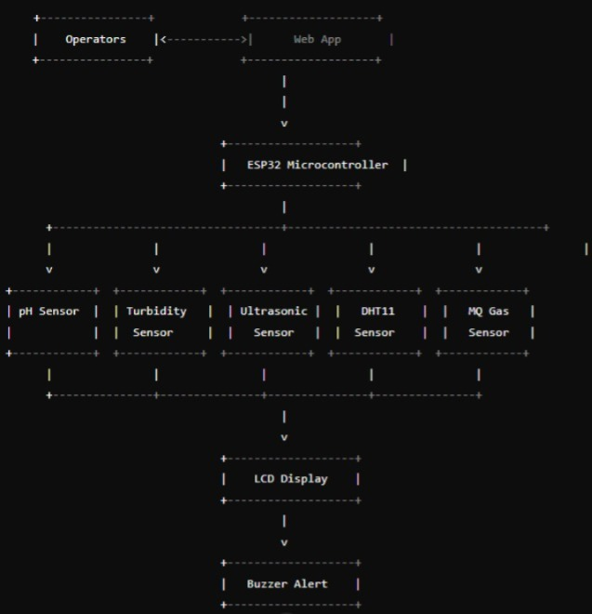

Fig. A) Iot based industrial waste water management system

Architecture.

**System Overview:**

Water is a critical resource, particularly for industries where it plays a vital role in processes such as cooling, washing, and chemical treatments. Effective waste water management is essential to ensure that water quality is maintained, environmental regulations are followed, and resources are used efficiently. However, traditional waste water management systems often suffer from inefficiencies, including delayed responses to water quality issues, limited automation, and high resource wastage. To address these challenges, this project proposes an IoT-based waste water monitoring system that provides real-time data on several key parameters including pH levels, turbidity, water levels, temperature, humidity, and the presence of harmful gases. The system also includes an alert mechanism for notifying users when any parameter exceeds a critical threshold, along with dynamic recommendations to help manage water treatment more effectively. This project will greatly enhance waste water treatment processes by enabling continuous monitoring and immediate responses, reducing the need for manual intervention, improving operational efficiency, and ensuring compliance with environmental standards.

**1. Objective Definition**

* Define the goals of integrating IoT, such as real-time monitoring, predictive maintenance, or process optimization.
* The primary objective of an IoT-based industrial wastewater management system is to enhance the efficiency, monitoring, and treatment of wastewater, ensuring compliance with environmental regulations while minimizing operational costs.

**2. System Architecture**

* **Sensors**: Deploy IoT sensors to measure parameters like pH, temperature, turbidity, dissolved oxygen, and chemical concentrations.
* **Connectivity**: Establish a network (e.g., Wi-Fi, LoRaWAN, cellular) to connect sensors and devices to a central system.
* **Data Processing**: Utilize edge computing or cloud platforms to process and analyze data from sensors.

**3. Data Acquisition and Analysis**

* **Real-time Monitoring**: Implement continuous data collection for immediate insights into wastewater characteristics.
* **Data Analytics**: Use machine learning algorithms to identify patterns, detect anomalies, and predict system performance.

1. **Automated Control Systems** 
   * Integrate IoT with control systems to automate responses based on real-time data (e.g., adjusting chemical dosing or flow rates).
   * Use actuators to manage valves, pumps, and other equipment based on sensor data.

1. **Predictive Maintenance** 
   * Monitor the health of equipment and infrastructure using IoT data to predict failures and schedule maintenance before issues arise.
   * Implement condition-based monitoring to reduce downtime and extend asset life.
2. **User Interface and Dashboards** 
   * Develop user-friendly dashboards for operators and managers to visualize data, monitor system performance, and receive alerts.
   * Incorporate mobile access for on-the-go monitoring and control.

1. **Functionality**

* **Real-Time Monitoring**: Continuous tracking of wastewater parameters allows for immediate detection of anomalies or deviations from set thresholds.
* **Data Analytics**: Historical and real-time data analysis using machine learning to optimize treatment processes, predict equipment failures, and enhance resource management.
* **Automated Alerts**: Notification systems that alert operators to any critical changes in water quality or system performance, facilitating timely interventions.
* **Regulatory Compliance**: Automated reporting tools that help ensure compliance with local environmental regulations through accurate data collection and documentation.

**8. System Components**

* **IoT Sensors**: Devices that monitor various parameters such as pH, turbidity, chemical oxygen demand (COD), temperature, and flow rate in real time.
* **Data Transmission Modules**: Communication technologies (e.g., Wi-Fi, LoRa, or cellular) that facilitate the transfer of data from sensors to the cloud or local servers.
* **Cloud Platform**: A centralized system for data storage, processing, and analytics, enabling real-time visualization and decision-making.
* **User Interface**: Web and mobile applications that provide operators with dashboards for monitoring, control, and alert notifications.

**9. Challenges**

* **Data Security**: Ensuring the protection of sensitive data transmitted over networks.
* **Integration**: Seamlessly integrating IoT technologies with legacy systems can be complex.
* **Maintenance**: Regular maintenance of sensors and IoT devices is essential to ensure accuracy and reliability.

**System Features :**

* **Real-Time Monitoring**:

Continuous tracking of water quality parameters (e.g., pH, turbidity, temperature, dissolved oxygen) using IoT sensors.

* **Data Analytics**:

Utilizes machine learning algorithms to analyze historical data for trend prediction, anomaly detection, and operational optimization.

* **Remote Access and Control**:

Enables operators to monitor and control systems from anywhere, using mobile or web applications.

* **Automated Alerts and Notifications**:

Sends alerts for any deviations from normal operating conditions, such as exceeding pollutant thresholds.

* **Predictive Maintenance**:
* Uses data from sensors to predict equipment failures and schedule maintenance, reducing downtime.
* **Energy Management**:
* Monitors energy usage across treatment processes to optimize consumption and reduce costs.
* **Compliance Tracking**:
* Automatically collects data for regulatory reporting and compliance, ensuring adherence to environmental standards.
* **Wastewater Recycling Monitoring**:
* Tracks the effectiveness of recycling processes and the quality of reused water.

**Implementation:**

**1. Overview**

The **IoT-Based Industrial Wastewater Management System** is an advanced solution designed to monitor, analyze, and manage wastewater from industrial processes efficiently. Utilizing **IoT sensors**, **real-time data analytics**, and **automated controls**, this system ensures compliance with environmental regulations while optimizing water treatment processes.

**Installation and Preparation :**

### **1. Project Planning and Requirement Analysis**

#### **1.1. Define Objectives and Scope**

* **Set Goals**: Understand the specific needs of the wastewater management system. For example:
  + Monitoring and managing wastewater quality and flow.
  + Optimizing chemical use and energy consumption.
  + Complying with regulatory standards for discharge water quality.
  + Providing real-time data for better decision-making.

#### **1.2. Conduct Site Assessment**

* **Site Survey**: Visit the facility and assess the wastewater treatment plant’s layout and operational details. Identify where sensors, control units, and other equipment will be installed.
* **Infrastructure Evaluation**: Check if the existing infrastructure (power supply, internet connectivity, space) supports IoT components.

#### **1.3. Identify Key Performance Indicators (KPIs)**

* Determine the key parameters for the system:
  + Wastewater flow rates.
  + pH, dissolved oxygen, turbidity, and chemical levels.
  + Energy usage.
  + Effluent quality.
  + Equipment status (e.g., pump or valve performance).

#### **1.4. Budget and Resource Planning**

* **Budget**: Allocate resources for sensors, actuators, communication infrastructure, cloud services, and labor.
* **Team Setup**: Assemble the necessary personnel (e.g., engineers, IT specialists, technicians, operators).

#### **2. System Design and Component Selection**

#### **2.1. Selection of IoT Devices and Sensors**

* **Water Flow Meters**: For measuring the volume and rate of wastewater flow.
* **Chemical Sensors**: To monitor parameters like pH, dissolved oxygen (DO), turbidity, and contaminants (e.g., nitrates, oil, heavy metals).
* **Temperature and Pressure Sensors**: To track temperature variations and pressure in pipes or tanks.
* **Toxin/Contaminant Sensors**: Specialized sensors for detecting pollutants such as hydrocarbons or heavy metals.
* **Automated Dosing Equipment**: For chemical dosing based on sensor data.
* **Communication Devices**: Gateways, routers, and wireless communication technologies (e.g., Wi-Fi, LoRa, Zigbee) for transmitting sensor data.
* **Edge Computing Devices**: For local data processing and ensuring smooth data flow between sensors and the cloud.

#### **2.2. Network and Connectivity Setup**

* **Wireless Network Infrastructure**: Choose the appropriate communication protocols (e.g., Wi-Fi, Zigbee, LoRaWAN) depending on the size of the plant and sensor requirements.
* **Cloud Platform**: Select a suitable IoT cloud platform to store, process, and visualize data (e.g., AWS, Azure, or a custom IoT platform).
* **Data Security**: Ensure encryption and secure communication protocols to protect data transmission.

#### **2.3. Design the Data Architecture**

* **Data Flow**: Map out how data will be collected, transmitted, and analyzed (e.g., sensors → gateway → cloud → dashboard).
* **Dashboard and Analytics**: Design a dashboard for monitoring wastewater quality, system health, and generating real-time insights.
* **Reporting Tools**: Plan for automated compliance and operational reports, which should be readily accessible to stakeholders.

#### **3. Installation of Hardware Components**

#### **3.1. Install IoT Sensors**

* **Positioning of Sensors**:
  + Install flow meters at the entry and exit points of wastewater treatment processes.
  + Position chemical sensors in critical areas such as tanks, treatment units, or water discharge points.
  + Install temperature, pressure, and contaminant sensors at relevant locations.
* **Power Supply**: Ensure each sensor has a reliable power supply. This could involve a direct connection to the plant’s electricity grid or using batteries (for wireless sensors).
* **Wiring and Mounting**: Install the necessary wiring or mounting brackets, ensuring secure and stable sensor placement.

#### **3.2. Install Communication Gateways**

* **Placement**: Position the gateways close to sensor clusters to reduce transmission distance and ensure reliable data transfer to the cloud.
* **Connectivity Check**: Ensure the gateways have reliable communication with the sensors, as well as a stable internet connection for cloud data transmission.

#### **3.3. Install Control Equipment and Automation Systems**

* **Automated Dosing Units**: Set up pumps and dosing units for adding chemicals like coagulants or disinfectants based on sensor readings.
* **Control Valves and Pumps**: Install automated valves and pumps that can be controlled based on real-time system data (e.g., flow rates, wastewater quality).
* **Power Backup**: Set up backup power solutions like UPS systems to ensure uninterrupted operation during power outages.

#### **4. System Integration and Configuration**

#### **4.1. Sensor Calibration**

* **Calibrate Sensors**: Test and calibrate sensors to ensure accurate readings. This may involve using known reference solutions for chemical sensors or flow calibration devices.
* **Ensure Sensor Accuracy**: Ensure the sensors' range and accuracy meet the requirements of the wastewater management system.

#### **4.2. Network Configuration**

* **Connect Sensors to Gateways**: Ensure that all sensors are properly paired with communication gateways for data transfer.
* **Check Connectivity**: Verify wireless network connections and ensure that the gateways can successfully communicate with the cloud platform.
* **Set Data Transmission Intervals**: Configure the data collection frequency for each sensor, depending on the criticality of the parameter being monitored.

#### **4.3. Cloud Platform and Dashboard Setup**

* **Configure Cloud Integration**: Set up the IoT cloud platform to receive data from the gateways, store it, and process it for analysis.
* **Build Dashboards**: Develop and configure dashboards that display real-time data on key parameters like flow rate, chemical levels, wastewater quality, and system performance.
* **Set Alerts and Notifications**: Set up automatic alerts for parameters that exceed predefined thresholds, such as pH levels or flow rates.
* **Generate Reports**: Configure automated compliance reports for regulators and internal stakeholders.

#### **5. Testing and Validation**

#### **5.1. Functional Testing**

* **Sensor Testing**: Test all sensors and equipment to ensure they are functioning correctly and transmitting accurate data.
* **System Integration Testing**: Test the integration of all components, from sensors to cloud storage and dashboards. Ensure smooth data transmission and proper system response.

#### **5.2. Pilot Run and Debugging**

* **Pilot Testing**: Run the system for a short period (e.g., 1-2 weeks) under controlled conditions to identify any potential issues.
* **Troubleshooting**: Monitor system behavior during the pilot phase. If any issues are identified (e.g., incorrect data readings, network failures), make the necessary adjustments.
* **Data Validation**: Ensure that the data is being recorded accurately in the cloud and displayed correctly on the dashboards.

#### **6. Training and Handover**

#### **6.1. Operator Training**

* **User Training**: Train the operational staff on how to use the system, interpret data, respond to alerts, and maintain the hardware.
* **Dashboard Training**: Provide training on how to use the visualization dashboard, analyze trends, and generate reports.

#### **6.2. Documentation**

* **User Manuals**: Provide documentation detailing system operation, maintenance, and troubleshooting procedures.
* **Maintenance Schedule**: Create a maintenance plan, specifying routine tasks such as sensor calibration, cleaning, and software updates.

#### **6.3. Final Handover**

* **Final Inspection**: Perform a final inspection and verification to ensure that everything is working as expected.
* **Client Handover**: Provide all relevant documentation and ensure that the client is comfortable operating the system.

#### **7. Ongoing Maintenance and Support**

#### **7.1. Remote Monitoring**

* **Continuous Monitoring**: Use cloud-based platforms to monitor the system's performance remotely and offer continuous support.
* **Regular System Updates**: Periodically update the system software and firmware to ensure the system is running optimally.

#### **7.2. Performance Optimization**

* **Review Analytics**: Continuously analyze the data to identify patterns and improve system efficiency.
* **Optimize Chemical Dosing**: Fine-tune the chemical dosing process to further reduce costs and improve treatment efficacy.

**Result :**

**Mobile Application:** Developing a The IoT -based water monitoring system dedicated mobile app would provide successfully captured real -time data from the easier access to real-time data, alerts, and industrial water treatment process and provided recommendations, allowing operators to continuous updates on water quality parameters. manage the system on the go.

### The system was able to trigger timely alerts in

**Extended Sensor Range:** Incorporating response to critical conditions like high additional sensors for chemical oxygen turbidity, unsafe pH levels, and the presence of demand COD, biological oxygen demand harmful gases. The real-time visualization on BOD, and other chemical contaminants

the web application enabled operators to would offer a more complete water quality monitor and respond to changes in water analysis.

### quality, reducing the risk of untreated waste

**Energy Efficiency:** Solar-powered water being discharged. Additionally, dynamic sensors could be introduced to reduce the recommendations based on sensor data allowed energy consumption of the system, operators to optimize the trea tment process, particularly in remote or off-grid areas. leading to efficient use of chemicals and filtration systems.

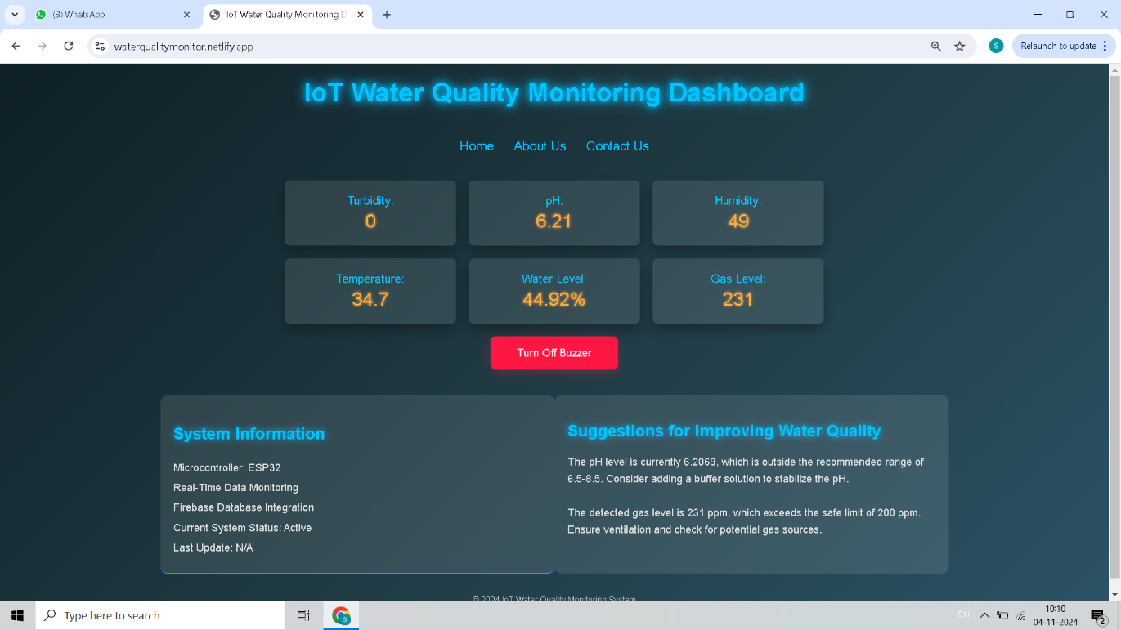

Fig: 1.

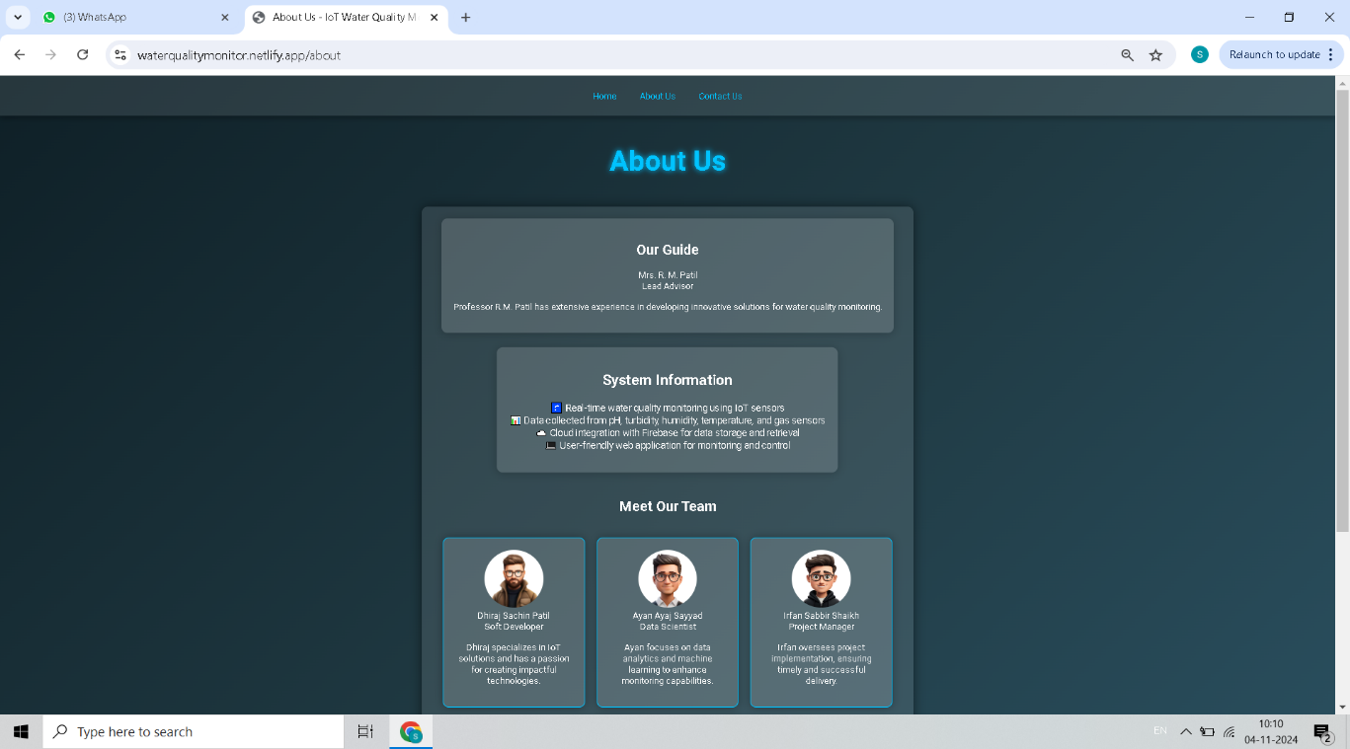

Fig: 2.

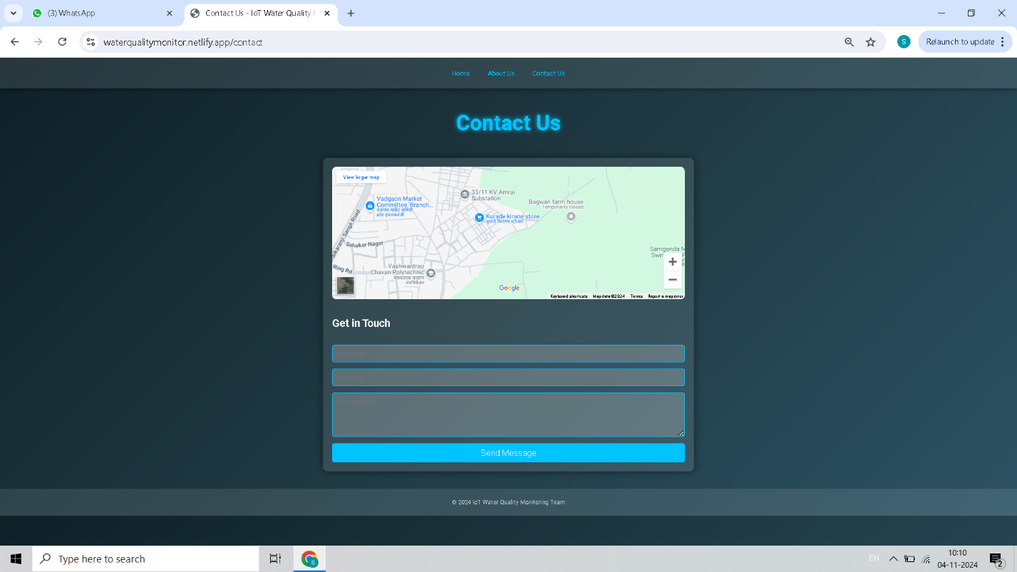

Fig: 3

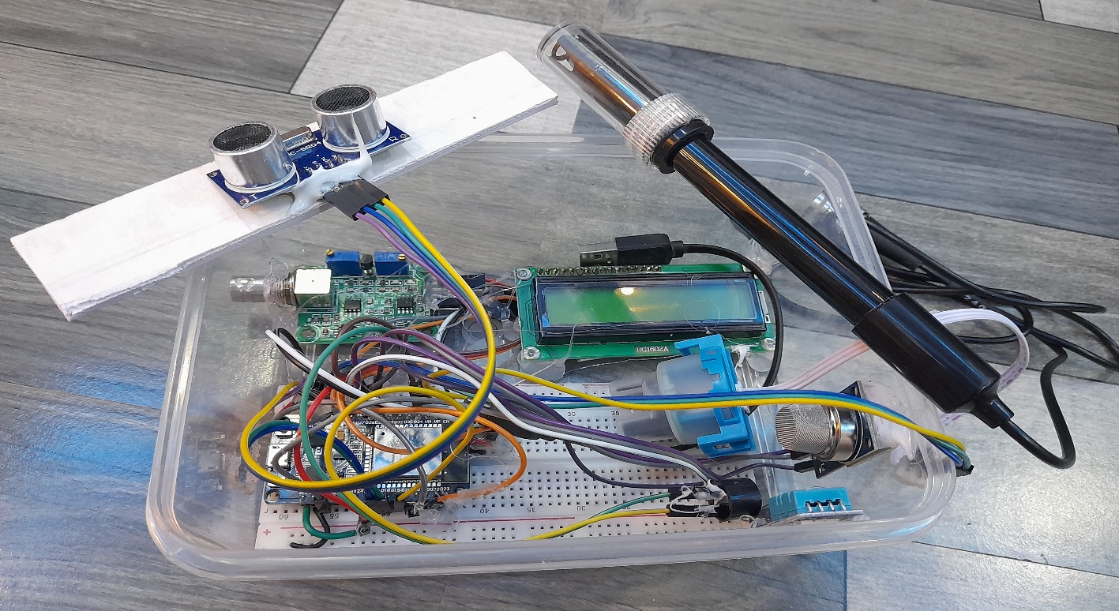

Fig: 4 (Main Hardware system)

**Dataflow :**

The system follows a structured data flow that ensures real-time monitoring and response.

* **Data Collection**: The sensors (pH, turbidity, ultrasonic, DHT11, MQ gas) continuously measure water quality parameters. This data is transmitted to the ESP32 microcontroller.

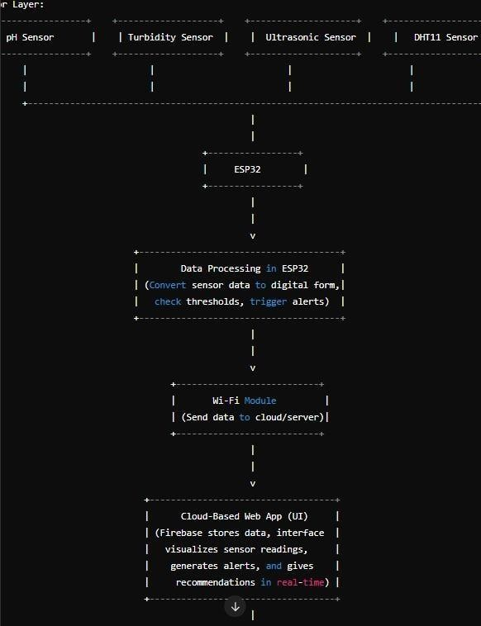

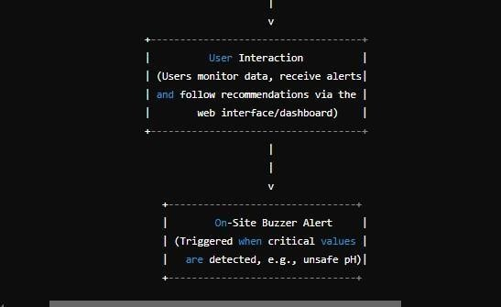

* **Data Transmission:** The ESP32 microcontroller processes the sensor data and transmits it via Wi-Fi to a cloud-based database & Google Firebase).
* **Data Processing**: The web application pulls real-time data from the cloud and visualizes it on a dashboard for the user. Alerts are generated if the data crosses critical thresholds.
* **User Interaction**: The user can interact with the web interface to view realtime data, receive alerts, and follow dynamic recommendations for corrective actions.
* **Action**: Based on the systemʼs recommendations, operators can take corrective measures (e.g., adding chemicals to adjust pH, applying filtration to reduce turbidity).

**Applications:**

#### **1. Manufacturing Industries**

* Monitors and treats wastewater from textile, chemical, pharmaceutical, and food processing plants.
* Ensures compliance with environmental regulations by tracking pH, turbidity, and chemical discharge levels.

#### **2. Oil & Gas Industry**

* Detects oil spills and chemical contaminants in water.
* Enables real-time monitoring of wastewater discharge to prevent environmental hazards.

#### **3. Power Plants**

* Manages cooling tower wastewater by monitoring chemical levels and temperature.
* Optimizes water reuse and recycling for sustainable operation.

#### **4. Mining & Metallurgy**

* Tracks heavy metal contamination in wastewater.
* Helps in safe disposal and treatment of toxic effluents.

#### **5. Municipal and Urban Wastewater Treatment Plants**

* Enhances the efficiency of sewage treatment by automating monitoring and control.
* Predicts equipment failures and optimizes maintenance schedules.

#### **6. Agriculture & Irrigation**

* Monitors water quality in agricultural runoff to reduce pesticide and fertilizer contamination.
* Supports smart irrigation by reusing treated wastewater.

**Future Enhancement :**

Repeat the data collection and alert Predictive Analytics**:** Implementing process continuously to maintain upto- date information on water machine learning algorithms to predict quality. future water quality trends based on historical data could further enhance the systemʼs utility, allowing for proactive intervention.

**Conclusion:**

The IoT-based water monitoring system presented in this paper provides an effective solution for real-time waste water management. By continuously monitoring key water quality parameters, sending real-time alerts, and offering dynamic recommendations, the system enhances operational efficiency, ensures environmental compliance, and reduces the need for manual interventions. Future enhancements could expand the systemʼs capabilities, making it a more comprehensive and predictive tool for water management.

IoT enables predictive maintenance, quick detection of anomalies, and the ability to make data-driven decisions that enhance the overall sustainability of wastewater management. Furthermore, the system ensures compliance with environmental regulations by generating real-time reports and alerts when thresholds are exceeded.

In conclusion, IoT-based industrial wastewater management systems represent a modern, cost-effective solution to traditional waste management challenges, fostering better environmental stewardship, cost savings, and operational optimization.

**Discussion :**

* **Continuous Monitoring:** Connect ESP32 to the internet via Wi-Fi. The systemʼs real-time monitoring Send sensor data to the cloud &Firebase) capabilities represent a significant in real time. advancement over traditional, manual water quality testing methods. Continuous data flow.
* **Alert Mechanism**: allows for immediate detection and response to critical conditions, such as a sudden drop in If any sensor reading crosses a pH or a rise in harmful gases, minimizing the predefined threshold, trigger the buzzer risk of environmental contamination and alert. operational failures.

The web applicationʼs Send a notification to the web application. responsive design makes it accessible from

* **Data Visualization**: any device, ensuring flexibility for operators in remote locations. The web application retrieves realtime data and displays it on a userfriendly However, the system could be further dashboard. enhanced by integrating predictive analytics to forecast water quality trends based on historical data. Additionally, expanding the.
* **Dynamic Recommendations**: system to include more sensors (such as for Based on the sensor data, generate chemical oxygen demand) could provide a real-timerecommendations for corrective more comprehensive understanding of water actions (e.g., adding alkaline substances quality.

**References:**

1. Abdelaziz, E. A., Said, M. A., & Hasan, M. K. (2019). "IoT-based smart system for wastewater treatment process control in industrial applications." Environmental Technology & Innovation, 16, 100485. doi:10.1016/j.eti.2019.100485.
2. Balamurugan, G., Karthik, S., & Kumar, S. A. (2020). "Design of IoT-based monitoring system for wastewater quality in industrial effluents." International Journal of Scientific & Technology Research, 9(3), 689-693.
3. Kumar, A., & Sinha, A. K. (2018). "Internet of Things (IoT) for wastewater treatment systems: A comprehensive review." Journal of Water Process Engineering, 23, 305-317. doi:10.1016/j.jwpe.2018.04.015.
4. Malik, S., & Jain, V. (2021). "An IoT-enabled real-time water quality monitoring system for sustainable development in industrial wastewater management." Sustainable Water Resources Management, 7(4), 1-12. doi:10.1007/s40899-021-00520-9.
5. Manogaran, G., Thota, C., & Lopez, D. (2017). "A hybrid approach for big data processing of IoT-based industrial waste water treatment." IEEE Transactions on Industrial Informatics, 13(2), 507-515. doi:10.1109/TII.2016.2600504.
6. Mehmood, Z., & Rafiq, M. (2022). "Implementation of IoT-based systems in wastewater management for enhanced treatment processes." Water Science and Technology, 85(10), 3021- 3035. doi:10.2166/wst.2022.021.
7. Patil, M. B., & Jadhav, R. D. (2019). "IoT in wastewater management for industrial applications: Real-time monitoring and control." Journal of Environmental Management, 234, 345-354. doi:10.1016/j.jenvman.2019.01.071.
8. Patil, M. B., & Jadhav, R. D. (2019). "IoT in wastewater management for industrial applications: Real-time monitoring and control." Journal of Environmental Management, 234, 345-354.doi:10.1016/j.jenvman.2019.01.071
9. Bhatia, R., & Kaur, M. (2020). "IoT-Based Smart Water Management System: A Review." International Journal of Advanced Research in Engineering and Technology (IJARET)*,* 11(3), 227-239.
10. Ramesh, M., & Chandrasekaran, S. (2021). "Real-Time Monitoring of Industrial Wastewater Using IoT and Cloud-Based System." Journal of Water Process Engineering, 41*,* 101963.
11. Patel, H., & Joshi, D. (2019). "IoT-Based Water Quality Monitoring System for Smart Cities." IEEE Access*,* 7, 65458-65467.