**ANALYSIS AND DESIGN OF (G+5) COMMERCIAL BUILDING USING ETABS**

**Nasuku Reddy Sreekanth1, Dr. L.Thimmaiah2**

1,M.Tech Student, Department of Civil Engineering, Viswam Engineering College,Madanapalli,

2Professor, Department of Civil Engineering, Viswam Engineering College,Madanapalli,

--------------------------------------------------------***------------------------------------------------------------------

**ABSTRACT**

Structural analysis is a field that studies how structures behave or forecasts how various structural elements will react to loads. Every single structure will be exposed to one or more sets of loads, as well as different types of loads. Dead load, live load, earthquake load, and wind load are typically considered. The software ETABS (Extended Three-Dimensional Analysis of Building System) is specifically designed for building analysis and design. It is integrated with all of the main analysis engines, including static, dynamic, linear, and non-linear. Our project is titled "Analysis and Design of Commercial Buildings Using ETABS Software". This study considers a multi-story skyscraper. Analysis is performed using the static approach, and design is done in accordance with IS 456:2000 requirements. Additionally, an attempt was made to design the structural elements manually. AutoCAD is used to create drawings. Revit Architecture is used to create three-dimensional models.

**KEY WORDS:** Auto Cad, ETABS, Revit, bending moment, Shear force, IS codes**,**

**1.INTRODUCTION**

Commercial buildings are those that serve a commercial purpose. Commercial structures include office buildings, retail shops, and warehouses, among others. Commercial property, which also includes multi-family structures like apartment buildings, is a little different from this. This is because commercial buildings are the sites of business, whereas commercial property generates revenue for its owners without necessarily being the site of commerce. In some situations, multi-use buildings with a variety of spaces—such as residences and a retail area—can nevertheless be classified as commercial.

**INTRODUCTION TO ETABS**

ETABS is an analysis and design-based program that is extremely valuable for structural engineers. When high-rise structures are developed using ETABS, the most cost-effective design is obtained. It is the most widely used structural engineer's software program for model production, analysis, and multilateral design. It features an intuitive user-friendly GUI, visualization tools, sophisticated analysis and design capabilities, and seamless connection with a variety of other modeling and design software applications.

**2.LITERATURE REVIEW**

**Chandrasekhar and Rajasekhar (2015):** The multi-story skyscraper was analyzed and designed using ETABS software. For this study, a G+5 story building subjected to the lateral loading effects of earthquakes and wind was taken into consideration. ETABS was used for analysis. They have also taken into account the likelihood that a fire would spread and the significance of using fireproof materials that meet the highest performance and dependability standards. They recommended that ETABS software, which is highly inventive and simple for high-rise buildings, be used extensively to cut down on the amount of time needed for design.

**Balaji and Salvarsan M.E (2016):** ETABS was used to analyze and design a multi-story structure in both static and dynamic loading conditions. In this work, ETABS was used to study the earthquake loads of a G+13- story residential building. They conducted both static and dynamic analyses, assuming that material properties were linear. Severe seismic zones were taken into account when doing the non-linear analysis, and type II soil conditions were used to evaluate the behavior. Plotting and analysis were done on various outcomes, such as displacements and base shear.

**3.METHODOLOGY**

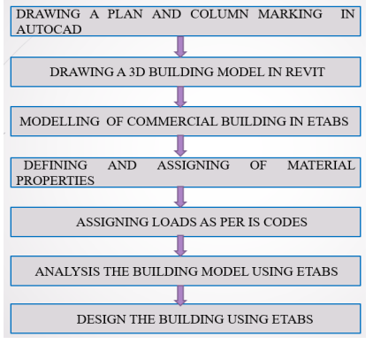

**FIG 3.1: METHODOLOGY FLOWCHART**

**SOFTWARE USED**

The following software are used for the design of G 4 Domestic structure in this design.

1. AUTOCAD Software.

2. ETABS Software.

3. Revit Architecture.

**4**. **PLAN OF THE BUILDING**

The material is used for construction is reinforced concrete with M-30 grade concrete and Fe- 415 grade of steel. Type of the project = Structural Analysis Design of Commercial Building.

Building Type = Commercial Building-shopping mall

Location = Hyderabad, Telangana.

Type of Slab = Two-way slab

Total Built-up Area = 1050 sq.-m. (assumed 42m x 25m)

Method of Analysis = Static Analysis (Linear)

**Material Properties of the structure**:

Beam Sizes = 300mm x 500mm

Column Size = 300mm x 500mm

Slab Thickness = 200 mm

Number of stories = G+3

Height = 15m Live Load = 5 kN/m² and 1.5 kN/m² (as per IS 875 part II2015)

Dead Load = Self -weight of members (as per IS 875 part I-2015)

Seismic Load = Calculated as per IS 1893(part I) – 2016

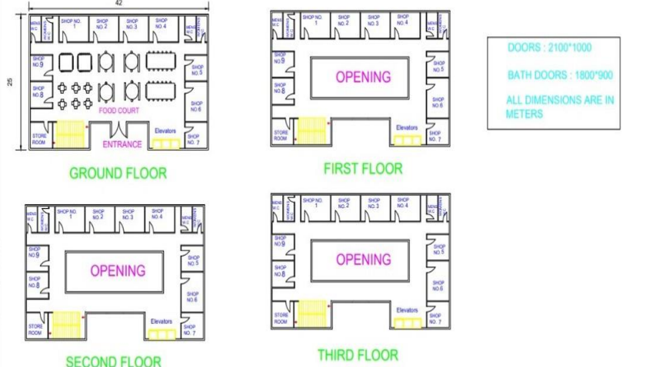

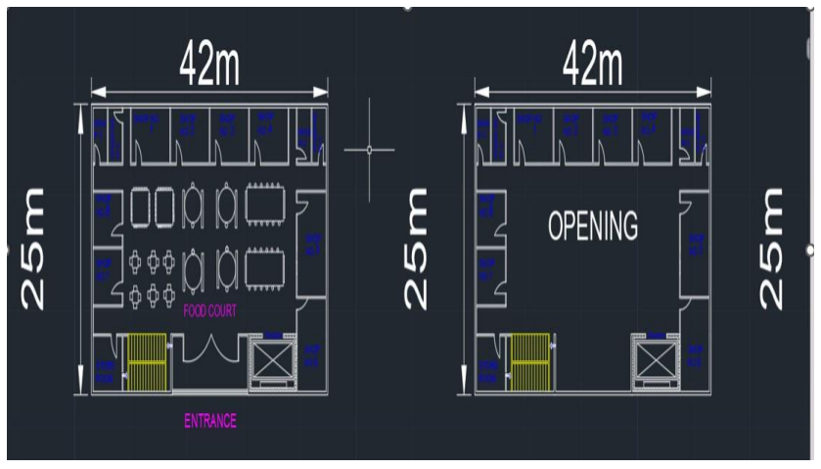 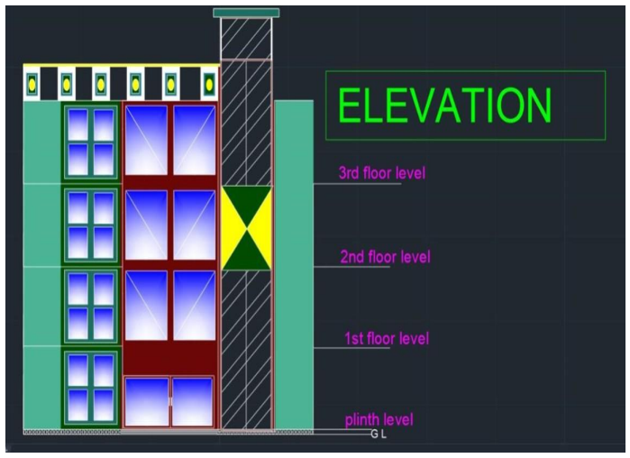

**FIG 4.2 PLAN VIEW FOR GF ,1ST, 2ND,3RD, 4TH AND 5TH FLOOR FIG 4.4: ELEVATION VIEW**

**5. 3D MODEL IN REVIT**

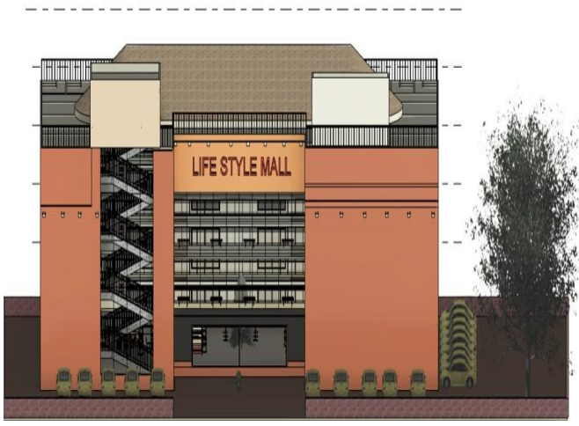 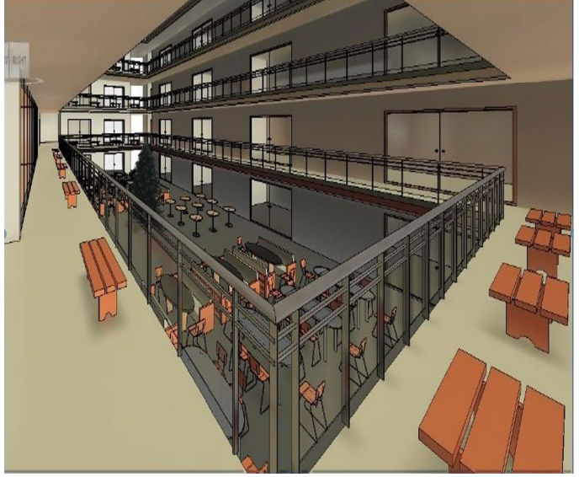

**FIG 5.1: FRONT VIEW FIG 5.2: INSIDE VIEW -2**

**6.LOAD CALCULATIONS**

**6.1 DEAD LOAD AND LIVE LOAD CALCULATIONS**

1.Dead Load External wall = 0.3x3x20 = 18kn/m

Internal wall = 0.15x3x20 = 9kn/m

Load on slab = Self wt of slab=0.2x25 = 5kn/m2

2. Live load = 1.5kn/m2

Floor finishing = 1kn/m2

Unit wt of RCC = 25KN/M3

Self wt of slab = 5kn/m2

**6.2 CALCULATION OF DESIGN WIND SPEED OF ALL STORY’S:**

Story-1,2, 3,and 4

Design wind Speed (Vz)

Vz=Vb x K1 x K2 x K3 x K4 m/s Vb=44m/s

**6.3 SEISMIC ZONE CALCULATION DESIGN**

Calculation of Horizontal Seismic Coefficient:

For 4-story Building Along X=direction Base dimension along x – direction=42m

Height of Building H=16.5m Translational time period Ta=0.075 X h 0.75(Clause7.6.2MRFbuilding)

h = 16.5 Ta = 0.075×h 0.75 Ta = 0.775sec of Sa/gV aluefor0.77secis2.5

Horizontal Seismic Coefficient Ah=[(2/3 x z/2) x (Sa/g)]/(R/I)

Z=0.10 R=5, I=1.0 Sa/G=2.5 Ah=0.025

**7.ANALYSIS, DESIGN & MODELING USING ETABS-20**

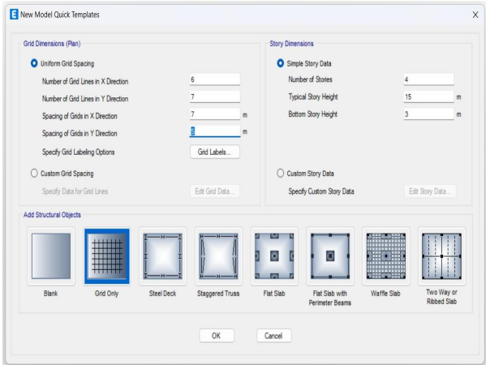 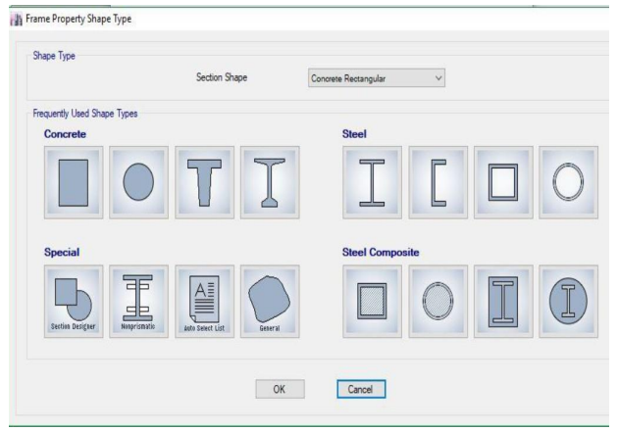

**Fig 7.1 Grid Spacing Fig 7.2 Frame Property**

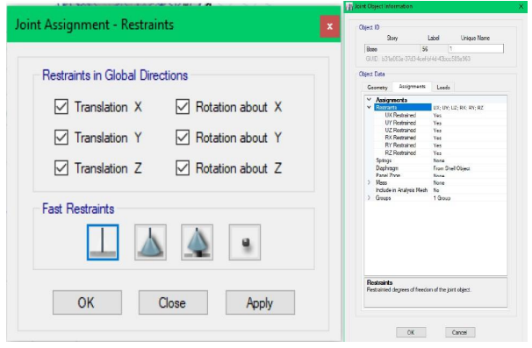 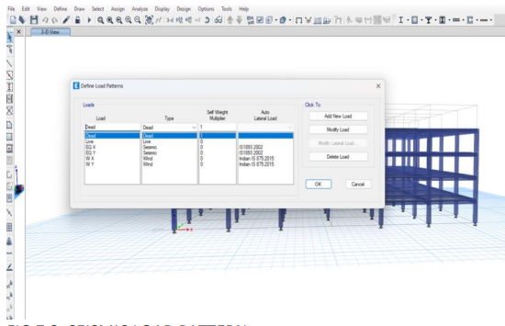

**Fig 7.3 Support Selection Fig 7.4 Load Selection**

**7.2 Results**

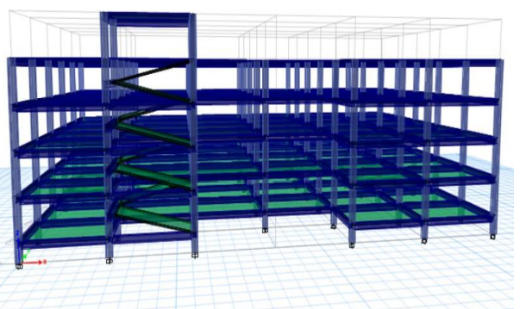 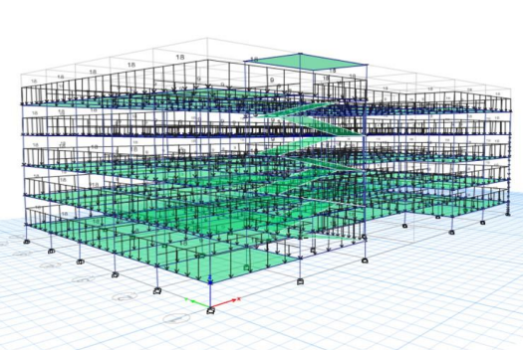

**Fig: 7.4 ASSIGNED PROPERTIES Fig: 7.5 ASSIGING LOADS**

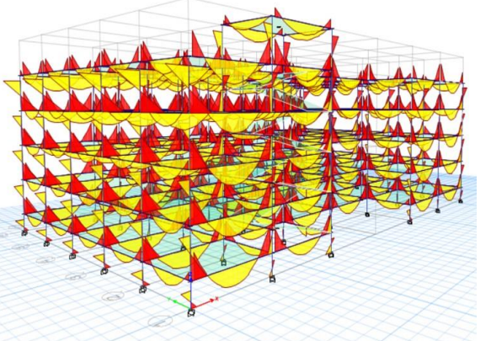 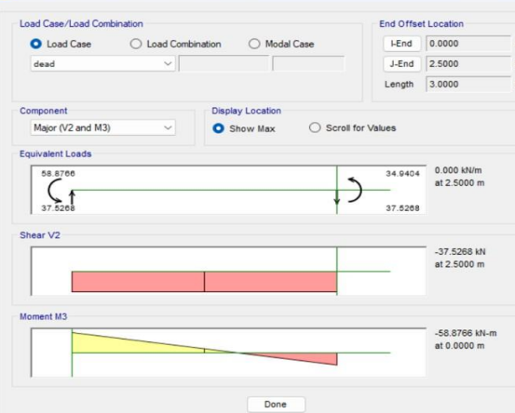

**Fig:7.6 SHEAR FORCE AND BENDING MOMENT DIAGRAMS**

**7.3 COLUMNS RESULT REPORT:**

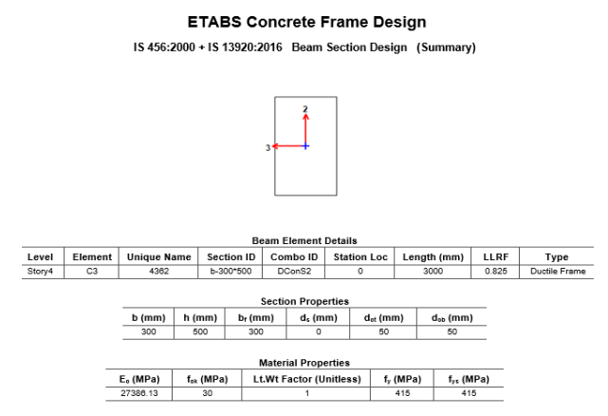

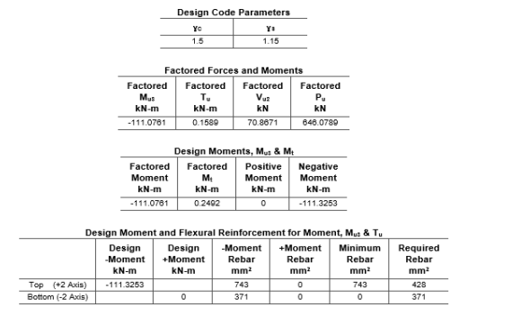

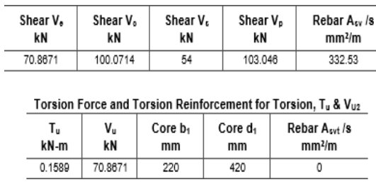

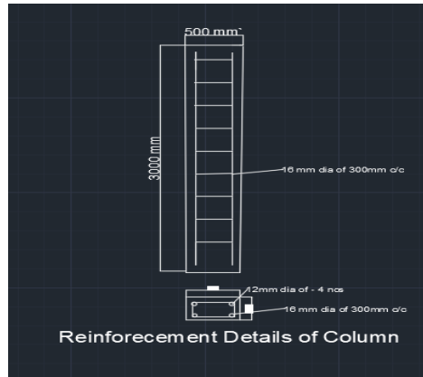

**Fig: 7.7 REINFORCEMENT DETAILS FOR COLUMN**

**7.4 BEAM RESULT REPORT**

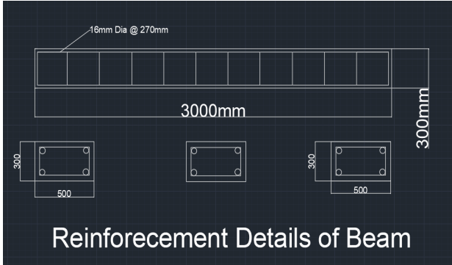

**Fig 7.7 REINFORCEMENT DETAILES FOR BEAM**

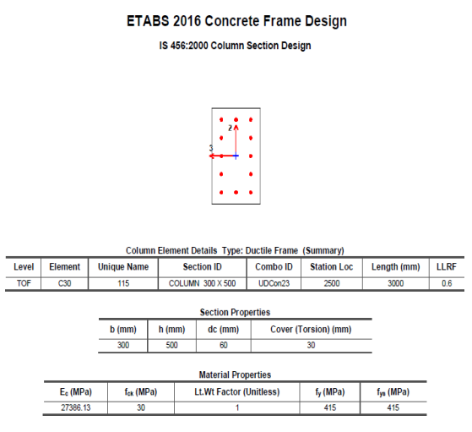

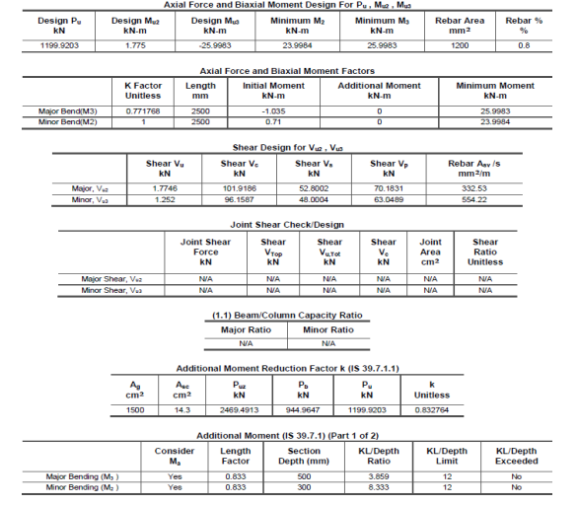

**8.CONCLUSION**

1. The primary focus of this project is the analysis and design of a multi-story commercial structure utilizing ETABS, accounting for all potential load combinations in accordance with IS Code. overcoming the design obstacles are explained conceptually.

2. Using ETABS software, the building's axial force, shear force, and bending moment were examined.

3. We have examined the 3D modelling and design of RCC commercial buildings using the Revit and ETABS software.

4. In addition, rectification in ETABS is as easy as changing the values at the location of the fault, with the results generated in the output.

**REFERENCES**

1. IS: 875 (Part 1) – 2015 for Dead Loads, Indian Standard Code of Practice for Design Loads (Other Than Earthquake) For Buildings and Structures, Bureau of Indian Stan- dards, Manak Bhavan, 9 Bahadur Shah Zafar Marg, New Delhi 110002.

2. IS: 875 (Part 2) – 2015 for Imposed Loads, Indian Standard Code of Practice for Design Loads (Other Than Earthquake) For Buildings and Structures, Bureau of Indian Standards, Manak Bhavan, 9 Bahadur Shah Zafar Marg, New Delhi 110002.

3. IS: 875 (Part 3) – 2015 for Wind Loads, Indian Standard Code of Practice for Design Loads (Other Than Earthquake) For Buildings and Structures, Bureau of Indian Stan- dards, Manak Bhavan, 9 Bahadur Shah Zafar Marg, New Delhi 110002.

4. IS: 875 (Part 5) – 2015 for Special Loads and Combinations, Indian Standard Code of Practice for Design Loads (Other Than Earthquake) For Buildings and Structures, Bu- reau of Indian Standards, Manak Bhavan, 9 Bahadur Shah Zafar Marg, New Delhi 110002.

5. IS 1893 (Part 1)-2016, Indian Standard Criteria for Earthquake Resistant Design of Structures, (Part 1-General Provisions and Buildings), Bureau of Indian Standards, Manak Bhavan, 9 Bahadur Shah Zafar Marg, New Delhi 110002.

6. IS 456-2000, Indian standard code of practice for plain and reinforced concrete (fourth revision), Bureau of Indian Standards, New Delhi, July 2000.

7. Varalakshmi V,G shivakumar and R S Sarma (2014) “Designed and d G+5 residential building by ETABS”, International Conference on Advance in Engineering and Technology.

8. Chandrashekar and and Rajashekar (2015), “Analysis and Design of Multi Storied Building by Using ETABS Software”, International journals of scientific and research vol.4: issue.7: ISSN no. 2277-8179.

9. Balaji and Selvarasan (2016), “Design and Analysis of multi-storeyed building under static and dynamic loading conditions using ETABS”, International Journal of Technical Research and Applications e-ISSN: 2320-8163, www.ijtra.com Volume 4, Issue 4.