THE CONCEPT OF DEVELOPMENT OF THE GREEN ECONOMY AND ITS ESSENCE WORLDWIDE
Yuldasheva Madina Tohir qizi,
"Scientific bases and problems of the development of the economy of Uzbekistan", 2nd stage doctoral student at the Tashkent State University of Economics
E-Mail: medi.yuldasheva@gmail.com
Phone: +998909531535
Abstract: The transition to a green economy has become a crucial global objective, integrating economic growth, ecological sustainability, and social well-being. This paper explores the concept, development stages, and implementation of green economy principles, with a particular focus on Uzbekistan's reforms and the role of fiscal instruments in facilitating sustainable development. Uzbekistan has undertaken significant steps towards green economic transformation by adopting a Green Economy Transition Strategy, strengthening environmental legislation, and engaging in international partnerships with organizations such as the United Nations (UN), World Bank, and Asian Development Bank (ADB). This research emphasizes the importance of adapting international best practices to Uzbekistan’s national context, ensuring an effective fiscal framework that balances economic competitiveness and environmental responsibility. By analyzing global experiences, policy mechanisms, and Uzbekistan’s green economy reforms, this study offers scientifically grounded recommendations for the development and enhancement of fiscal policies to support sustainable economic growth.
Key words: Green economy, fiscal instruments, environmental taxation, Uzbekistan, sustainable development, economic policy, renewable energy, ecological sustainability.

Introduction. The efficient utilization of natural resources, ensuring ecological balance, and improving the standard of living of the population are among the most critical objectives in advancing the global economy. The increasing relevance of implementing green economy principles is no coincidence, as modern sustainable development encompasses closely interrelated processes such as environmental preservation, addressing ecological challenges, enhancing economic potential, and ensuring societal well-being. In this regard, the green economy is considered a promising approach, as it aims to optimize resource utilization, reduce waste, expand the use of renewable energy sources, and safeguard both human health and ecosystems—contrasting with traditional economic models.
Uzbekistan has undertaken significant reforms in this direction in recent years. The country has adopted a Green Economy Transition Strategy, developed environmental legislation, and committed to various international conventions and agreements. Additionally, national programs, "roadmaps," and other regulatory measures have been introduced. These reforms not only contribute to maintaining ecological balance but also seek to enhance the efficiency of the national economy, improve living standards, and create favorable environmental conditions for future generations. Furthermore, the scientific and theoretical foundations of the green economy must be studied comprehensively, and fiscal instruments play a decisive role in their practical implementation. Through specific taxation policies, subsidies, pricing mechanisms for environmentally harmful industries, incentives for waste recycling, and support for energy-efficient technologies, the state can facilitate the green economy's transition into practical application.
Uzbekistan has also taken significant steps towards integrating green economy principles in collaboration with various international organizations and institutions. The country actively partners with entities such as the United Nations (UN), the World Bank, the Asian Development Bank (ADB), the Global Green Growth Institute (GGGI), the United Nations Development Program (UNDP), the World Health Organization (WHO), and the Food and Agriculture Organization (FAO), among others, to implement a range of projects. Additionally, within the framework of the "Roadmap" strategy, Uzbekistan has established priority objectives for 2030, including: Reducing greenhouse gas emissions; Improving energy efficiency; Promoting sustainable water resource management; Increasing environmental awareness in agriculture; Improving waste management practices.
Achieving these goals is closely linked to the effective creation and administration of fiscal instruments within the public governance system. Without clear financial incentives or structured taxation measures, economic actors may fail to recognize the tangible benefits of the green economy in their activities. Consequently, many economists and policymakers emphasize that green reforms should primarily be implemented through carbon taxes, targeted environmental levies, tax incentives, and subsidies.
The factors outlined above highlight the urgency of improving fiscal instruments in Uzbekistan to support the transition to a green economy. A comprehensive study of international best practices, the adaptation of advanced approaches to national conditions, and the adoption of a well-planned strategy will be essential in ensuring significant progress in this field. This research seeks to thoroughly analyze the concept of the green economy, its development stages, international experiences, ongoing reforms in Uzbekistan, and the role of fiscal instruments in these processes, ultimately offering scientifically grounded recommendations and policy suggestions.
The aforementioned factors indicate the urgent need for enhancing and effectively structuring fiscal instruments in the process of implementing the green economy in Uzbekistan. Moreover, by thoroughly examining global best practices, adapting advanced approaches to the national context, and adopting a strategic and well-planned framework, it is possible to achieve sustainable progress in this area. Thus, this research aims to comprehensively analyze the concept of the green economy, its stages of development, international experiences, the ongoing reforms in Uzbekistan, and the role of fiscal instruments in these processes, ultimately proposing scientifically grounded recommendations and policy suggestions.
The green economy is an economic system that integrates economic growth and ecological sustainability, ensuring that resource management is efficient and environmentally friendly while promoting ecological innovations and enhancing human well-being. According to the United Nations Environment Program (UNEP), a green economy is one that enhances human well-being and social equity while significantly reducing environmental risks and ecological scarcity. This model encompasses economic, social, and environmental dimensions, making it a holistic approach to sustainable development.
In economic literature, the modern concept of the green economy is described as an economic model that seeks to improve human well-being and social equity while minimizing the negative environmental impacts of industrial development. This approach emphasizes the use of biologically renewable energy sources and promotes sustainable processes that generate both material and non-material benefits on a global scale. Furthermore, the green economy concept incorporates circular economy principles, distinguishing it from traditional industrial economic models. By adopting circular economic approaches, the green economy fosters resource efficiency, waste reduction, and environmental sustainability, ensuring long-term economic and ecological stability .
Literature review. In economic literature, the modern concept of the green economy is described as an economic model that aims to enhance human well-being and social equity while minimizing the negative environmental impact of industrial development. This approach focuses on utilizing biologically renewable energy sources and creating sustainable processes that generate both material and non-material benefits worldwide. The green economy concept is closely linked to the circular economy, which differentiates it from traditional industrial economic models by emphasizing resource efficiency, waste reduction, and sustainable environmental management.
Adopting green principles allows for the modernization of industrial ecosystems by ensuring the efficient use of resources and minimizing environmental pollution. The principle of universal accessibility in the green economy promotes equitable access to renewable energy sources and green opportunities. This means that green economy products and services—such as renewable energy, energy-efficient technologies, and environmentally friendly products—should be affordable for all. Additionally, these principles emphasize cost reduction in energy and resource consumption, ensuring that natural resources and energy are utilized efficiently and sustainably.
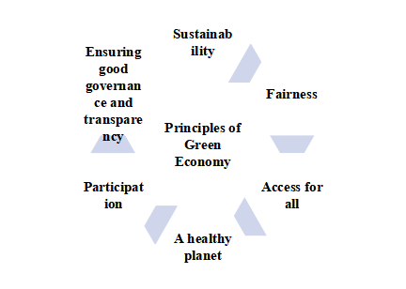
The principle of sufficiency and efficiency underscores the necessity of reducing waste and integrating energy-saving technologies. As a result, economic growth can be achieved without increasing resource consumption. Moreover, avoiding excessive consumption and meeting needs at an optimal level is crucial, as the green economy aims to maximize results while using minimal renewable resources and avoiding environmental degradation.
Figure 1. Principles of Green Economy

The Healthy Planet Principle in the Green Economy is focused on protecting natural ecosystems, preserving biodiversity, and reducing ecological harm. This principle supports ecosystem conservation, biodiversity preservation, waste minimization, and recycling, all of which contribute to global environmental
The difference between a green economy and a traditional economy lies in its approaches, each of which represents a separate direction. Accordingly, the production of harmful substances and the avoidance of pollutants aim to limit or eliminate the production of harmful chemicals and other pollutants. In preserving and restoring biodiversity and ecosystems, it is important for us, as humans, to preserve and restore natural ecosystems and biodiversity, which will help ensure the sustainability of resources and reduce global environmental problems.
Achieving a renewable energy supply requires a shift away from conventional energy sources and towards an energy supply based on renewable energy sources (such as solar, wind and hydropower). In order to replace non-renewable energy sources with sustainable renewable resources, it is important to reduce the use of non-renewable resources and replace them with sustainable renewable resources. The efficient use of non-renewable energy, raw materials and other resources, in turn, involves the conservation and efficient use of resources, preventing their depletion and avoiding damage to the environment. These approaches reflect the main goals and principles of a green economy, which is important for ensuring long-term sustainable development.
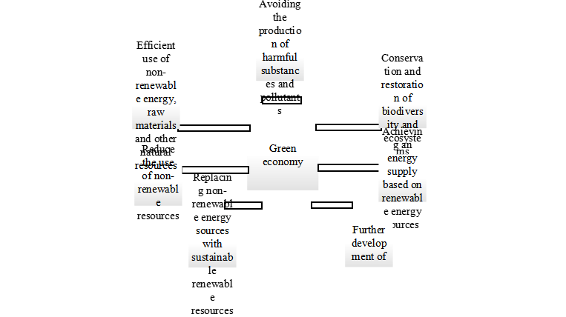
As economist Professor Mohammad Hadi Dehghani analyzes in his scientific research, "The green economy encompasses various sectors, with renewable energy and sustainable agriculture as key areas. Renewable energy sources such as solar, wind, hydro, and geothermal energy are considered environmentally friendly alternatives to traditional fossil fuels . " Indian scholars Verma and Kandpal discuss the relationship between the terms "green economy" and "sustainable development" in their study. According to their explanation, these terms are often used interchangeably for the common goal of conserving the environment and renewable energy sources. Despite the common goals of these two terms, the differences between these two concepts are highlighted. "Sustainable development is described as a broader concept that focuses on natural and human-made capital, encompassing various investments and technological innovations that are important for the economy."
Figure 2. Main approaches to the transition to a green economy system.

According to economist Begüm Özkaynak, “There is a just and equitable relationship between ecology, climate change and the green economy. The integration of the green economy with the principles of environmental justice, environmental governance and environmental justice provides a comprehensive and political perspective for the transition to a greener economy. By combining the ideas of ecological economics, political ecology and social movements, environmental justice offers strategic opportunities for setting transparent and achievable goals at the local and global levels . ”
The concept of a green economy has been analyzed not only by Western scientists, but also by a number of CIS economists in their scientific research. According to the views of Russian economists SN Bobyleva, PA Kiryushina, OV Kudryavtseva, “A green economy is a means of achieving sustainable development, based on equality, intergenerational justice, which protects biodiversity and ecosystems, reduces poverty, ensures well-being, social protection and access to basic services, improves governance and strives for the rule of law. It is a democratic, equitable decision-making system, accountable for results, transparent and sustainable, and uses an integrated approach to decision-making. ”
According to Boris Porfiryev, a significantly narrower interpretation of the green economy can be understood as the production and use of technologies, as well as the control and reduction of pollutant emissions. This, in turn, not only requires energy and renewable energy resource-saving technologies, but also increases the importance of renewable energy .
The green economy, not only the research of foreign scientists, but also the research of our own scientists is of great importance. Our domestic economists MT Askarova, JJ Jamolov and XS Khadjayev define the concept of green economy as follows: “The concept of green economy encompasses scientific ideas in economic disciplines such as economy focused on saving renewable energy resources, ecological economics, environmental economics, green policy, theory of international economic relations, modernization of the economy, and innovative economics.”
According to Vakhobov, “Unlike environmental economics or ecological economics, the “green economy” is of more practical importance and relates to renewable energy sectors (energy, innovation, agriculture, etc.). In addition, from a macroeconomic perspective, the transition to a “green economy” is explained as increasing economic efficiency, increasing national wealth, increasing renewable resources, and reducing environmental risks. ”
Boris Porfiryev's vision of the green economy focuses on the development of technologies, control and reduction of pollutant emissions. According to him, a green economy requires not only the development of energy and resource-saving technologies, but also increases the importance of renewable energy. While this approach ensures the efficient use of resources and the reduction of environmental risks, MT Askarova, JJ Jamolov and XS Khadjayev define the green economy as a system focused on resource-saving, ecological and innovative economy. They see the scientific and practical foundations of the green economy as a complex concept that includes the modernization of the economy and the reduction of environmental impacts. AV Vakhobov defines the green economy as practically significant , since it is related to renewable energy in economic policy and activities, in particular, energy, agriculture and innovation. The transition to a green economy increases economic efficiency, increases national wealth and reduces environmental risks.
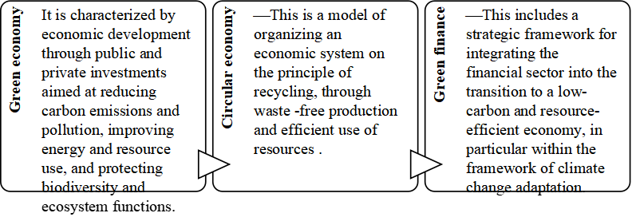

Figure 4. Key concepts specific to a green economic system.

The green economy, in turn, includes the circular economy, i.e. a model of organizing the economic system on the principle of repeated circulation through waste-free production and efficient use of resources, and green finance, i.e. investment and financial mechanisms aimed at protecting the environment and supporting sustainable development. The main goal of the green economy is to achieve sustainable economic growth and ecological balance, which is mainly achieved through taxes, subsidies, and innovative technologies. The circular economy, on the other hand, is aimed at the maximum rational or reuse of existing resources and minimizing waste, while making effective use of recycling and waste-free production technologies. Green finance, on the other hand, provides financial support for projects in this direction and uses instruments such as green bonds, loans, or investments.

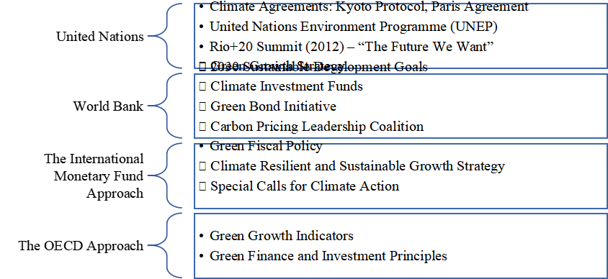
Figure 5. Approaches of international financial organizations to the green economy.
Uzbekistan is a party to many international conventions, protocols, agreements and memoranda of understanding in the field of environmental protection and sustainable development. Uzbekistan has adopted 16 Sustainable Development Goals by 2030 and its position in the global ranking of environmental and human development is steadily improving. In 2023, Uzbekistan ranked 69th out of 166 countries in terms of progress in achieving all 17 MDGs . Uzbekistan has renewed and strengthened its commitments on greenhouse gas emissions within the framework of the Paris Agreement. The country has strategies and programs to ensure the health of the population and access to clean water. At the regional level, Uzbekistan is working with other countries of Central Asia to expand cooperation in the use and introduction of modern energy and resource-saving technologies with low greenhouse gas emissions to support development. Uzbekistan is widely integrating initiatives and projects in the field of environmental protection and sustainable development, contributing to the social, ecological, and economic development of the country.

Table 1.
Important UN initiatives to support the transition to a green economy .
Agreement | Year | Member Countries
Paris agreement | 2015 | 196 countries (all UN member states) countries , Europe Union and others )
Kyoto Protocol | 1997 | 192 countries ( USA member it's not )
Rio+20 Summit  (Earth Summit ) | 2012 | 191 countries (UN member states) countries + others )

The Kyoto Protocol was adopted in 1997 and sets binding targets for industrialized countries to reduce greenhouse gases. Under this protocol, 37 industrialized or developing countries have obligations to reduce the specified gases for developed countries. Through this mechanism, a price is set for each ton of carbon emissions and emissions are traded nationally and internationally. One of the main features of the protocol is that it includes the setting of specific gas reduction targets for each country.
The Paris Agreement was signed in 2015 and has been ratified by 196 countries. The agreement commits each participating country to reducing its emissions. Each country has a period of 5 years to develop their plans, known as their "Nationally Determined Contributions" (NDCs). In these plans, each country sets out specific targets and measures to reduce its carbon emissions.
The Rio Conference (Rio+20) was held in Rio de Janeiro, Brazil, from 20 to 22 June 2012. This conference provided an opportunity to assess the international community's progress in implementing development strategies, to identify the next steps and to make new decisions. The conference was timely, as multifaceted international challenges such as economic, social and environmental issues were emerging. For example, the need to address issues such as food, water, energy, oceans, agriculture and natural disasters was reiterated. Two main themes were identified for the Rio+20 conference: a green economy and an institutional framework for sustainable development. The conference was the subject of much discussion in the run-up to the conference. These differences included the level of legal reform for environmental and sustainable development, the definition of a green economy, planetary boundaries, the provision of financial resources and technologies, sustainable consumption and production, the dissemination of the scientific basis of Rio+10, and the differences between developing and developed countries. Before these challenges could be addressed, it was necessary to understand the issues and create a common framework. A key outcome of the conference was the introduction of the Sustainable Development Goals . This concept encompasses the highest political approaches to social, environmental and economic development . In addition, another important step in this approach was the creation of the United Nations Environment Programme (UNEP).
The United Nations adopted 17 Sustainable Development Goals in 2015, which are reflected in the global agenda for achieving global social, economic and environmental security by 2030. They are proposed for a comprehensive and inclusive partnership between states, international organizations, corporations and civil society, and are essential for ensuring sustainable development. For example, Sustainable Development Goal 1 aims to combat poverty in all its forms, while Goal 2 aims to ensure the full provision of basic food products to all the world's population.
As can be seen from the above analysis, the “green economy” is emerging today as a very important tool not only for mitigating climate change and environmental problems, but also for achieving economic efficiency, increasing social well-being, and preserving natural resources for future generations. In sustainable development, environmental protection and economic growth are promoted as inseparable processes. In Uzbekistan, where programs, legislative frameworks, international agreements, and relevant national strategies are being implemented in this direction, the appropriate development of fiscal instruments can serve as the main foundation for leading our country's economy towards a “green transformation”.
Therefore, the following important aspects can be highlighted as a scientific conclusion:
- In implementing a green economy, tax rates, tax breaks, subsidies, and grants adopted by the state should serve two main purposes: first, to encourage enterprises that use resources rationally, and second, to create a mechanism to increase motivation (or limit them) for producers that cause environmental damage. Through this “reward and punishment” approach, economic entities will be more interested in practical changes;
- In order to mitigate the alarming situation related to environmental pollution, greenhouse gas emissions and excessive use of natural resources, special taxes should be introduced. For example, carbon taxes, group environmental taxes or differentiated charges for waste would be effective in this regard. However, this policy can only be effective if the funds from the revenues are directed to specific purposes, that is, to finance "green projects";
- Targeted subsidies and grants play an important role in the development of environmental projects, such as the introduction of renewable energy sources, waste recycling, and wastewater treatment. This is especially important for sectors where the economic benefits are clearly visible in the long term, but require significant initial investment ;
- In addition to the fact that fiscal instruments are not fully implemented, they will not produce the expected results if they are not accompanied by a clear monitoring system and a solid legal framework. Therefore, no matter how the tax regime is strengthened, continuous monitoring, clear environmental standards and accountability mechanisms will ensure effectiveness;
- It is important to use the experience of developed countries in developing a "green economy" in Uzbekistan. In particular, it is necessary to strengthen cooperation on the European Union's emissions trading system, "green tax" models implemented in South Korea, Japan, Singapore, China or the United States, as well as technical assistance provided by international financial institutions;
- Any tax or subsidy policy should primarily have a positive impact on the well-being of the population. Clear compensation mechanisms should be developed to mitigate the possible price increases or burden on the poorer sections of society that may arise from green economy reforms. This will ensure that citizens benefit from the green economy not only in the long term, but also in the short term.
- The need for green technologies and innovations is growing. In this regard, it is important to establish effective cooperation between research institutes, higher education institutions and the private sector, and to quickly implement advanced scientific developments in this area. In this regard, it is possible to increase the financing of research and innovation projects through fiscal incentives.

List of used literature:
- UNEP, Green Economy Reports: A Preview, 2010, p. 4-5
- Rama Rao Curry, Mohammad Hadi Dehghani. Scientometrics and overview of water, environment, and sustainable development goals, in Water, The Environment, and the Sustainable Development Goals, 2024
- Begum Özkaynak. Environmental justice, climate justice, and the green economy, in Handbook of Green Economics, 2019
- Bobylyov S. N. Ustoychivoe razvitie: paradigm dlya budushchego // Mirovaya ekonomika i mejdunarodnye otnoshenia. 2017. T. 61. No. 3. S. 107–113.
- Porfirev B.N. "Green" economy: reality, perspective and predely rosta // Nauchnye trudy Volnogo ekonomicheskogo obshchestva Rossii. 2012. T. 160. S. 14-37.
- A.V. Vakhabov, Sh.Kh. Khazhibakiev and others. Green Economy: Textbook. -Tashkent.: "Universitet", 2020. -262 p. (14 p.).
- Sachs, J. et al., 2023. Sustainable Development Report 2023: Implementing the SDG Stimulus , SDSN. United States of America. Retrieved from https://coilink.org/20.500.12592/0tpj28 on 14 Feb 2025. COI: 20.500.12592/0tpj28.

UNEP, Green Economy Reports: A Preview, 2010, p. 4-5
Rama Rao Curry, Mohammad Hadi Dehghani. Scientometrics and overview of water, environment, and sustainable development goals, in Water, The Environment, and the Sustainable Development Goals, 2024
Begum Özkaynak. Environmental justice, climate justice, and the green economy, in Handbook of Green Economics, 2019
Bobylyov S. N. Ustoychivoe razvitie: paradigm dlya budushchego // Mirovaya ekonomika i mejdunarodnye otnoshenia. 2017. T. 61. No. 3. S. 107–113.
Porfirev B.N. "Green" economy: reality, perspective and predely rosta // Nauchnye trudy Volnogo ekonomicheskogo obshchestva Rossii. 2012. T. 160. S. 14-37.
A.V. Vakhabov, Sh.Kh. Khazhibakiev and others. Green Economy: Textbook. -Tashkent.: "Universitet", 2020. -262 p. (14 p.).
Sachs, J. et al., 2023. Sustainable Development Report 2023: Implementing the SDG Stimulus , SDSN. United States of America. Retrieved from https://coilink.org/20.500.12592/0tpj28 on 14 Feb 2025. COI: 20.500.12592/0tpj28 .
Collected by the author

