**SMART AUTONOMOUS FIRE-FIGHTING ROBOT WITH GPS-BASED NAVIGATION**

**Dr.S.Vijayabaskar1,Mr.K.Veera Prakash2 ,Mr.P.Venugopal3,Mr.S.Kathirvel4,Mr.R.Suryaprakash5**

*1professor, Dept. of Electrical and Electronics Engineering, P.A. College of Engineering and Technology, pollachi, Coimbatore Tamil Nadu, India,*

*2,3,4,5Student, Dept. of Electrical and Electronics Engineering, P.A. College of Engineering and Technology, pollachi, Coimbatore, Tamil Nadu, India,*

**ABSTRACT**

Fire incidents result in substantial harm to both lives and assets, highlighting the need for swift and effective fire detection and suppression mechanisms. This initiative aims to develop a self-sufficient fire-fighting robot equipped with GPS, flame detectors, and gas sensors to identify and extinguish fires. The robot is engineered to function in high-risk environments where human involvement is hazardous, such as manufacturing facilities, storage units, and wooded regions. By incorporating sensors for fire identification and real-time position tracking, the system ensures a prompt reaction to fire outbreaks. The robot detects fire using flame sensors that recognize infrared emissions from flames and gas sensors that sense smoke and toxic fumes. Upon detecting a fire, the robot evaluates its severity and moves toward the affected zone. Ultrasonic sensors assist the robot in safely navigating and avoiding obstacles while approaching the fire. The GPS module continuously updates the robot’s coordinates.

1. **INTRODUCTION**

Fire outbreaks are one of the most dangerous hazards, causing severe damage to life, property, and the environment. Traditional fire-fighting methods often involve significant risks, as human firefighters must enter hazardous zones to extinguish fires. To overcome these challenges, autonomous fire-fighting robots are emerging as a promising solution to detect, locate, and suppress fires while minimizing human intervention. This project aims to develop a fire-fighting robot equipped with GPS, flame sensors, and gas sensors for real-time fire detection and response. The system integrates sensor-based fire detection, automated navigation, and remote monitoring to enhance fire safety. By using flame sensors, the robot can identify fire sources, while gas sensors detect smoke and toxic gases. The GPS module ensures accurate location tracking, allowing real-time updates for emergency responders. The robot operates autonomously, using ultrasonic sensors to navigate and avoid obstacles while moving toward the fire. Once in position, it activates a fire suppression system, which includes a water pump and adjustable nozzle to extinguish the flames. A communication module enables remote monitoring, allowing users to track the robot’s location and fire status updates through a mobile or web interface. By integrating smart fire detection and suppression capabilities, this fire-fighting robot provides a cost-effective and reliable solution for various applications, including industrial fire prevention, forest fire management, and urban fire safety systems. This innovation enhances emergency response efficiency while reducing the risk to human firefighters, making it a valuable addition to modern fire-fighting technology.

1. **PROBLEM DEFNITION**

Fire accidents are a major threat to human life, infrastructure, and the environment. Traditional fire-fighting methods rely on human firefighters, who often face life-threatening risks when entering hazardous fire zones. In many cases, delayed response times, limited accessibility, and exposure to toxic gases increase the severity of fire-related disasters. Additionally, fires in remote or industrial areas may go undetected for extended periods, leading to widespread damage before intervention. To address these challenges, there is a need for an autonomous fire-fighting system that can detect, locate, and suppress fires without direct human involvement. The proposed solution is a fire-fighting robot equipped with GPS, flame sensors, and gas sensors, designed to identify fire sources, navigate autonomously, and extinguish flames effectively. The system will also provide real-time location updates, ensuring quick response and monitoring. Current fire detection systems are often stationary and rely on alarm-based mechanisms, which may not be effective in suppressing fires immediately. Additionally, manual fire-fighting efforts are limited by human capabilities, making it difficult to access fires in hazardous areas such as chemical plants, forests, or high-rise buildings. A robotic system that can automatically detect fires, move toward the affected area, and activate a suppression mechanism will significantly enhance fire management and safety. The development of this autonomous fire-fighting robot will help reduce response time, prevent human casualties, and improve fire control efficiency. By integrating sensor-based fire detection, GPS tracking, and remote monitoring, the system will provide a cost-effective, scalable, and reliable solution for fire safety in industrial, commercial, and remote environments.

1. **BLOCK DIAGRAM**

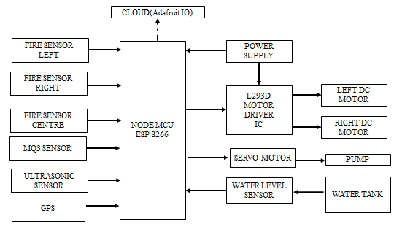. The reference of Fig 1 are at least five interfacing circuits, fire-fighting robot system using the NodeMCU ESP8266 microcontroller. The sytem includes various sensors such as fire sensors (left, right, and center) to detect fire direction, an MQ3 sensor for gas detection, an ultrasonic sensor for obstacle detection, a GPS module for location tracking, and a water level sensor to monitor the water tank. The NodeMCU ESP8266 acts as the central controller, processing sensor data and sending real-time updates to the cloud via Adafurit IO for remote monitoring. The robot’s movement is controlled using an L293D motor driver IC, which operates left and right DC motors for navigation. A servo motor adjusts the direction of the water spray, while a pump is activated to extinguish the fire. The system is powered by a dedicated power supply, ensuring continuous operation. When fire is detected, the robot moves toward the source, sprays water, and avoids obstacles using the ultrasonic sensor. If the water level is low, an alert is sent. This system is designed for autonomous fire detection and suppression, reducing human risk in hazardous situations here the input and output interface can be indicated with the arrow lines with the respective the microcontroller performs with the respective commands and delay which is programmed on IDE software.

**Figure 1:** Block Diagram

1. **SIMULATION DIAGRAM**

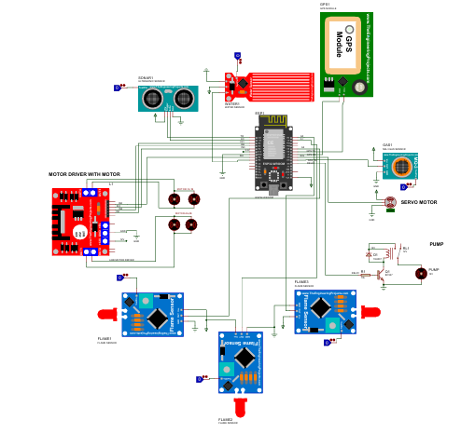This project simulated with help of Proteus software, various components are interfaced with the NodeMCU ESP8266 to replicate real-world functionality. The system includes fire sensors (left, right, and center) to detect fire direction, an MQ3 sensor for gas detection, an ultrasonic sensor for obstacle avoidance, a GPS module for location tracking, and a water level sensor to monitor the water tank. The NodeMCU ESP8266 processes sensor data and controls the movement of the robot using an L293D motor driver, which operates the left and right DC motors. The servo motor adjusts the direction of the water spray, while a relay-based water pump is activated to extinguish the fire. The Proteus simulation enables visualization of sensor inputs, microcontroller processing, and motor control using arrow lines to indicate input and output interactions. The fire detection and suppression mechanism is tested by triggering fire sensors, allowing the robot to navigate toward the fire source while avoiding obstacles using the ultrasonic sensor. The system also sends real-time data updates to a virtual terminal, simulating Adafruit IO cloud services. If the water level sensor detects a low level, an alert is triggered. The Arduino IDE is used to program the microcontroller, ensuring accurate command execution with necessary delays. This simulation provides an effective testing environment for evaluating the autonomous fire-fighting capabilities of the robot before physical deployment.

Figure 2: Simulation Diagram

1. **RESULT AND DISCUSSION**

The results of this Intelligent Fire-Fighting Robot project demonstrate its capability to autonomously detect and extinguish fires while navigating obstacles efficiently. The fire sensors accurately identify the direction of the fire, and the MQ3 gas sensor effectively detects the presence of harmful gases. The ultrasonic sensor ensures obstacle avoidance, allowing the robot to move safely toward the fire source. The L293D motor driver controls the DC motors, enabling smooth navigation, while the servo motor accurately adjusts the water spray direction for effective fire suppression. The water pump activation is reliable, and the water level sensor successfully sends alerts when the water tank is low. The integration of the GPS module provides continuous location tracking, which can be useful for remote monitoring and deployment in large areas. Additionally, real-time data transmission to Adafruit IO ensures that fire incidents can be monitored remotely, enhancing response efficiency. Experimental results confirm that the robot detects fire and smoke swiftly, responds immediately, and 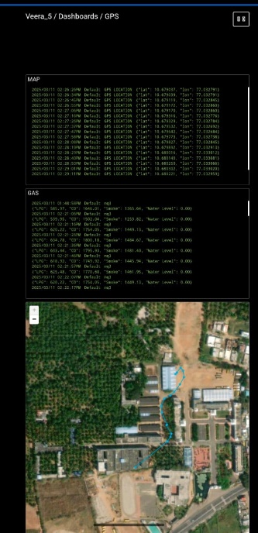effectively extinguishes flames within a short time, making it a valuable tool for fire emergencies in 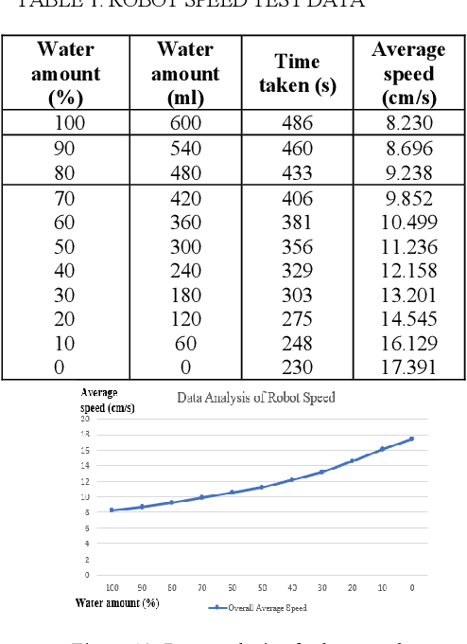hazardous environments.

Figure 3: Output

Figure 5: output graph

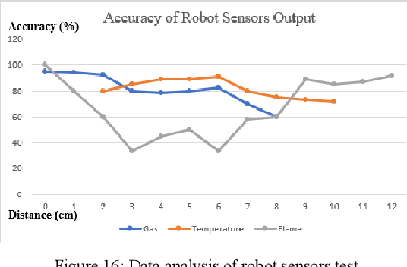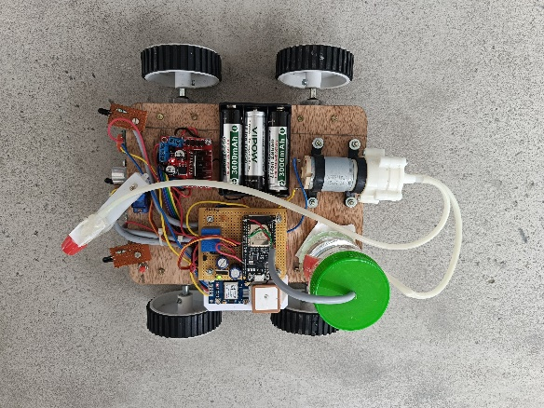

Figure 4: Hardware Figure 6: Accuracy of Robot sensor output

1. **CONCLUSION**

This project introduces an automated fire-fighting robot that moves at a steady speed, detects fire, and extinguishes it using a spraying mechanism. It offers several advantages, including the capability to identify the fire's location autonomously while featuring a compact and lightweight build. Thanks to its small dimensions, the robot can function efficiently in tight spaces or areas with restricted entry points. The system has the potential to assist firefighters and help contain fire hazards. The operator can manage the fire suppression remotely from a safe distance.

1. **REFERENCES**
2. Devi, K. S., Akhileswar, K., Vinayaka, C., Karthik, M., & Viswanadham, Y. K. (2020) “Fire Fighting Robot”, The International journal of analytical and experimental modal analysis, 12(7), 1957-1967.
3. Amano, H. (2002) “Present status and problems of fire fighting robots”, In Proceedings of the 41st SICE Annual Conference, SICE 2002,(Vol. 2, pp. 880-885) IEEE.
4. Rehman, A., Necsulescu, D. S., & Sasiadek, J. (2015) “Robotic based fire detection in smart manufacturing facilities”, IFAC-Papers On Line, 48(3), 1640-1645.
5. Aliff, M., Sani, N. S., Yusof, M. I., & Zainal, A. (2019). Development of fire fighting robot (QROB). International Journal of Advanced Computer Science and Applications, 10(1).
6. Xin, C., Qiao, D., Hongjie, S., Chunhe, L., & Haikuan, Z. (2018, June). Design and implementation of debris search and rescue robot system based on internet of things. In 2018 International Conference on Smart Grid and Electrical Automation (ICSGEA) (pp. 303-307). IEEE.
7. Raju, J., Mohammed, S. S., Paul, J. V., John, G. A., & Nair, D. S. (2017, March). Development and implementation of arduino microcontroller based dual mode fire extinguishing robot. In 2017 IEEE International Conference on Intelligent Techniques in Control, Optimization and Signal Processing (INCOS) (pp. 1-4). IEEE..
8. Rashid, H., Ahmed, I. U., Ullah, A., Newaz, M. F., Robin, M. S. R., & Reza, S. T. (2016, December). Multiple sensors based fire extinguisher robot based on DTMF, bluetooth and GSM technology with multiple mode of operation. In 2016 International Workshop on Computational Intelligence (IWCI) (pp. 41-46). IEEE.
9. Undug, J., Arabiran, M. P., Frades, J. R., Mazo, J., & Teogangco, M. (2015, December). Fire locator, detector and extinguisher robot with SMS capability. In 2015 International Conference on Humanoid, Nanotechnology, Information Technology, Communication and Control, Environment and Management (HNICEM) (pp. 1-5). IEEE.
10. Guruprasad, L., Yashwanth, M. U., Prasad, P. V., & Shreekara, B. V. (2020)“Autonomous Fire Fighting Robot”, International Journal of Research in Engineering, Science and Management, 393-396.
11. Patel, K. K., Doctor, G., Patel, A., & Lingras, P. (2021) “Soft Computing and its Engineering Applications”, Springer Singapore.
12. Wang, Y., & Liu, M. (2021) “Intelligent fire fighting robots”, A review of current developments and future trends, International Journal of Advanced Robotics Systems, 18(1), 1-13.
13. Gupta, A., & Sharma, R. (2022) “Robotic fire fighting systems”, A comprehensive review of technologies and applications, Journal of Fire Protection Engineering, 32(1), 15-30.