LABVIEW BASED AUTOMATIC POULTRY FARMING SYSTEM: TEMPERATURE REGULATION , FIRE DETECTION AND GAS MONITORING FOR IMPROVED SAFETY AND EFFICIENCY

# Karthick N1*, Satheesh R2*, Mohamed Fayiq Shareef MFS3* , Logesh A4 *

1U G Student, Department of Instrumentation and Control Engineering, Saranathan college of engineering- Trichy, TN, India.

2Assisant Professor Department of Instrumentation and Control Engineering, Saranathan college of engineering- Trichy, TN, India.

3U G Student, Department of Instrumentation and Control Engineering, Saranathan college of engineering- Trichy, TN, India.

4U G Student, Department of Instrumentation and Control Engineering, Saranathan college of engineering- Trichy, TN, India.

*(Corresponding Author)

# ABSTRACT

Poultry farming is a vital industry that requires optimal environmental conditions to ensure the health and productivity of the birds. Temperature regulation and fire & gas safety are three of the most crucial factors for maintaining a safe and comfortable environment. This paper presents an innovative solution for automatic water spraying and fire detection using LabVIEW, a powerful graphical programming platform. The system uses sensors to continuously monitor the temperature and humidity levels within the poultry house. When the temperature exceeds a set threshold, the system automatically activates water spraying mechanisms to cool the environment, while also ensuring that water is distributed evenly. Additionally, the system integrates fire detection sensors that can promptly detect the presence of smoke and gas, triggering immediate alerts and actions to minimize damage. The use of LabVIEW allows for seamless integration of these sensors, providing real-time data monitoring and control. This approach not only enhances animal welfare but also promotes energy efficiency and fire safety, ultimately improving the overall sustainability of poultry farming operations.

1. **INTRODUCTION**

Poultry farming plays a significant role in the global agricultural industry, providing a major source of protein for millions of people worldwide. However, managing the health and welfare of poultry in large-scale farms can be challenging, particularly when it comes to maintaining an ideal environmental climate. Factors such as temperature, humidity, and fire safety are critical to ensuring the birds' well-being and productivity. Overheating, in particular, can lead to heat stress, reduced growth rates, and even mortality. Similarly, fires in poultry houses can cause devastating losses, both in terms of animal life and financial damage.

Traditional methods of temperature control in poultry farming, such as manual ventilation and cooling systems, often lack the precision needed to maintain consistent conditions. Additionally, fire detection systems can be slow to respond, leading to catastrophic outcomes. There is, therefore, a pressing need for more efficient, automated systems that can address these challenges in real time.

This research proposes an integrated solution that combines automatic water spraying for temperature control with fire detection using LabVIEW, a powerful graphical programming tool. The system leverages real-time environmental data gathered from sensors to automatically activate water spraying when temperatures rise beyond a predefined threshold, ensuring the poultry house remains cool and comfortable. In parallel, the fire detection system quickly identifies any signs of smoke or flames, triggering immediate alerts to safeguard both the animals and the infrastructure

# LITERATURE REVIEW

**Collins et al. (2016**) Temperature regulation is one of the most critical factors in poultry farming, as poultry are highly susceptible to heat stress. It has shown that extreme temperatures can lead to reduced feed intake, slower growth, and even mortality in poultry. Traditionally, cooling systems like ventilation and exhaust fans have been used to control temperature, but these methods often lack the efficiency and responsiveness required to deal with fluctuating environmental conditions in real time.

**El- Nawawi and El-Sayed (2019)** Automatic water spraying or misting systems offer a promising solution to this problem. These systems work by detecting temperature changes and activating water spraying mechanisms to cool the environment when needed. It found that water spraying systems can significantly reduce heat stress by lowering temperatures within poultry houses. Their study demonstrated that automatic water spraying could lower temperatures by several degrees, improving the comfort of the bird.

**Hassan et al. (2021**) In highlighted the importance of integrating advanced fire detection systems to improve response times. Their research focused on combining smoke detectors, heat sensors, and flame detectors in poultry houses to enhance fire safety. These systems are essential for providing early warnings through cloud computing for mobile, etc. It allowing farmers to take swift action to protect the birds and prevent extensive damage to the facility. However, traditional fire detection systems often struggle with the presence of dust and humidity in poultry environment, leading to false alarms or delayed responses.

**Ceylan and Aydin (2020)** The use of a hybrid fire detection system that combined heat, smoke, and flame sensors with real-time monitoring systems. This multi-sensor approach has proven to be more reliable and faster in detecting fire hazards, significantly reducing the risk of fire damage. The integration of automatic control mechanisms, such as activating sprinklers or alarms, is essential to respond to fires in real time and minimize potential harm

**Bisht et al. (2018)** The effectiveness of LabVIEW in agricultural automation, where it was used to create an integrated system for controlling environmental conditions such as temperature, humidity, and gas levels. LabVIEW’s ability to process real-time data from multiple sensors and trigger actions, such as activating ventilation or water spraying systems, makes it an ideal choice for temperature control in poultry houses.

# 3.METHODOLOGY

**Water Spraying Mechanism**: The primary mechanism for temperature control involves the automatic spraying of water. The system will activate water pumps connected to sprayers placed at strategic locations within the poultry farm. The spraying mechanism aims to reduce the ambient temperature, ensuring a comfortable environment for poultry.

**Fire Detection**: A fire detection system will be integrated to detect any fires that may arise in the poultry barn. The system will use flame sensor and temperature sensors to sense irregular heat patterns and the presence of heat.

**Cloud Computing:** Cloud computing provides on-demand access to shared resources like storage and processing power over the internet. Users can scale services based on their needs without managing physical infrastructure.

**Gas Detection:** Gas detection is crucial in an automatic poultry farming system to ensure a safe environment for both the animals and workers. Harmful gases such as ammonia (NH₃), carbon dioxide (CO₂), and hydrogen sulfide (H₂S) can pose serious health risks, reduce productivity, or even be fatal in high concentrations.

**SENSOR INTEGRATION:**

**Temperature Sensor (Fig 1)**: These sensors (e.g., LM35 or DHT22) will be placed at key locations within the poultry farm to monitor the ambient temperature. The data collected by these sensors will be fed into LabVIEW for real-time processing.

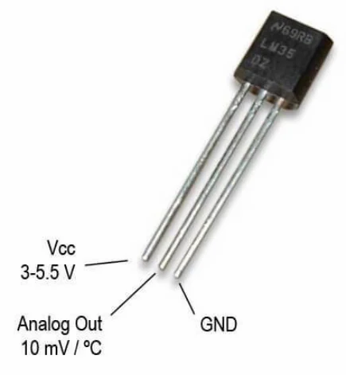

Fig 1; Temperature sensor

**Water Flow Sensor**: A water flow sensor will be integrated to measure and control the amount of water being sprayed. This ensures the spraying system operates efficiently without overuse of water.

**Flame Sensor (Fig 2):** Itis used to detect fire and potentially trigger automated responses like activating sprinklers or alerting authorities, safe guarding crops and infrastructure.

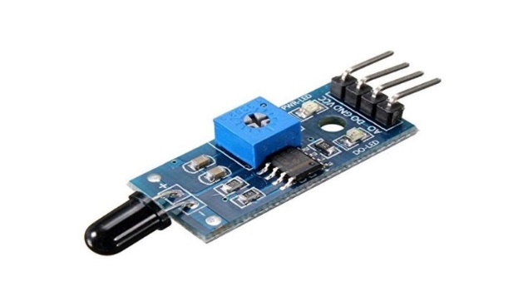

Fig 2: Flame sensor

**Moisture Sensor (Fig 3):** It determine the soil's moisture content to avoid overwatering and make sure plants only get water when the soil is sufficiently dry.

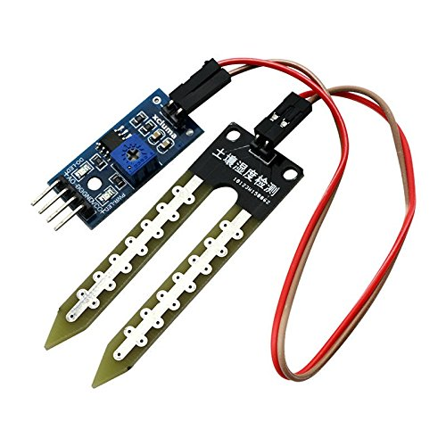

Fig 3: Moisture Sensor

**Gas sensor (Fig 4):** The **MQ-135** is a popular and widely used gas sensor designed for detecting a variety of gases, including ammonia (NH₃), benzene (C₆H₆), carbon dioxide (CO₂), alcohol, smoke, and other volatile organic compounds (VOCs). It is a highly sensitive and cost-effective sensor commonly employed in indoor air quality monitoring systems, industrial safety applications, and environmental monitoring.



Fig 4: MQ135

**Buzzer (Fig 5):** A buzzer can be used in various applications to alert, warn, or notify individuals in different systems. In your project for automatic water spraying and fire detection in poultry farming using LabVIEW, a buzzer can play a crucial role.

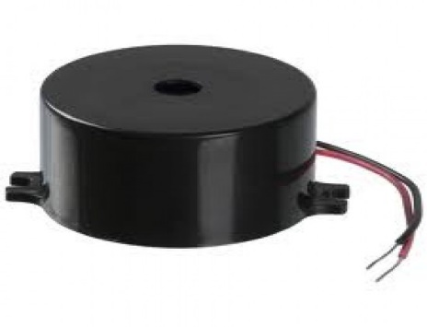

Fig 5: Buzzer

**COMMUNICATION (Fig 6):**

An educational platform for studying and creating projects pertaining to automation, robotics, and the Internet of Things (IoT) is the My Rio Kit. Among other things, it usually consists of a range of sensors, motors, and microcontrollers that let users design interactive systems like smart water supply systems.

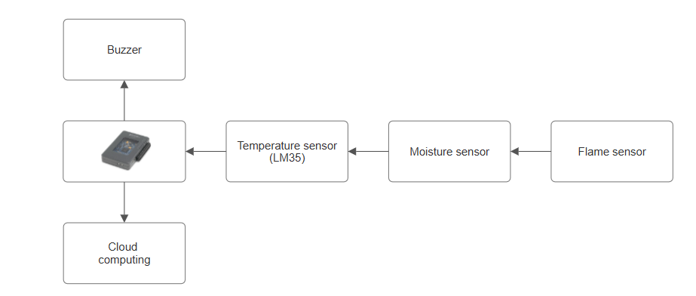

Fig 6: Block diagram(communication)

The proposed system employs a structured methodology to ensure the effective monitoring and automation of water supply and fire detection. This flow chart includes (Fig 7):

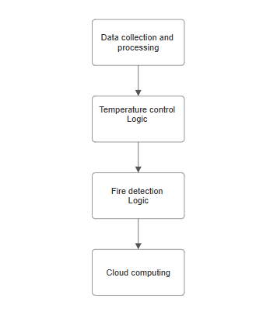

Fig 7: Flow chart

**Data Collection and Processing**: LabVIEW will receive real-time data from the temperature and smoke sensors. The software will process this data to detect temperature anomalies or smoke patterns that indicate the need for action.

**Temperature Control Logic**: The system will compare the incoming temperature data with a predefined threshold. If the temperature exceeds the threshold, LabVIEW will trigger the water spraying mechanism to lower the temperature, simulating a cooling effect.

**Fire Detection Logic**: If the smoke sensor detects smoke or the temperature rises beyond a critical threshold, LabVIEW will send a signal to activate alarms and automatically shut off the water spraying mechanism to prevent further complications.

**Cloud Computing:** Cloud computing is the delivery of computing services like storage, processing, and software over the internet, allowing users to access and use them on demand without owning physical infrastructure.

**LABVIEW SOFTWARE:**

The software platform used for acquiring data from sensors, processing the information, and automating control actions. LabVIEW software (Fig 8) is used for:

Data Acquisition: Collecting sensor data in real-time.

Control Logic Implementation: Implementing automation rules based on sensor readings.

Data Logging: Storing historical data for analysis and reporting.

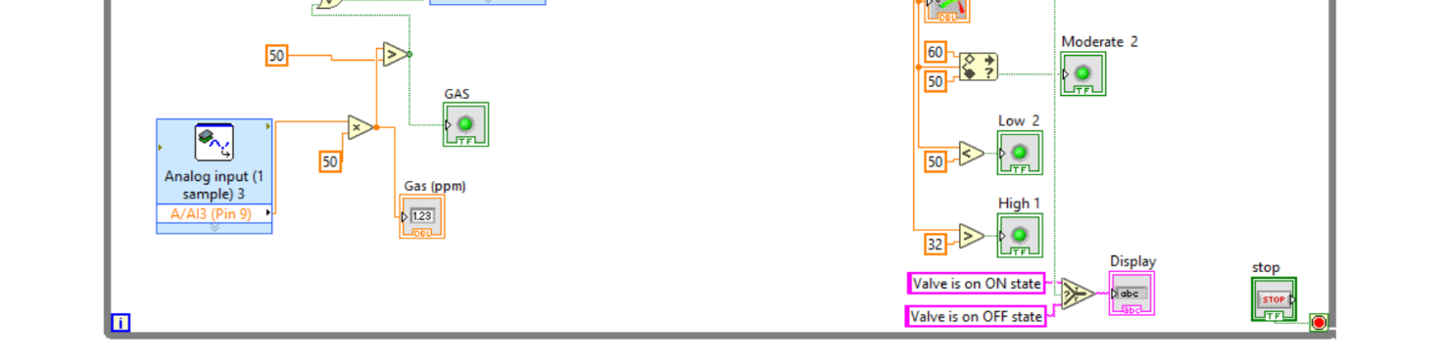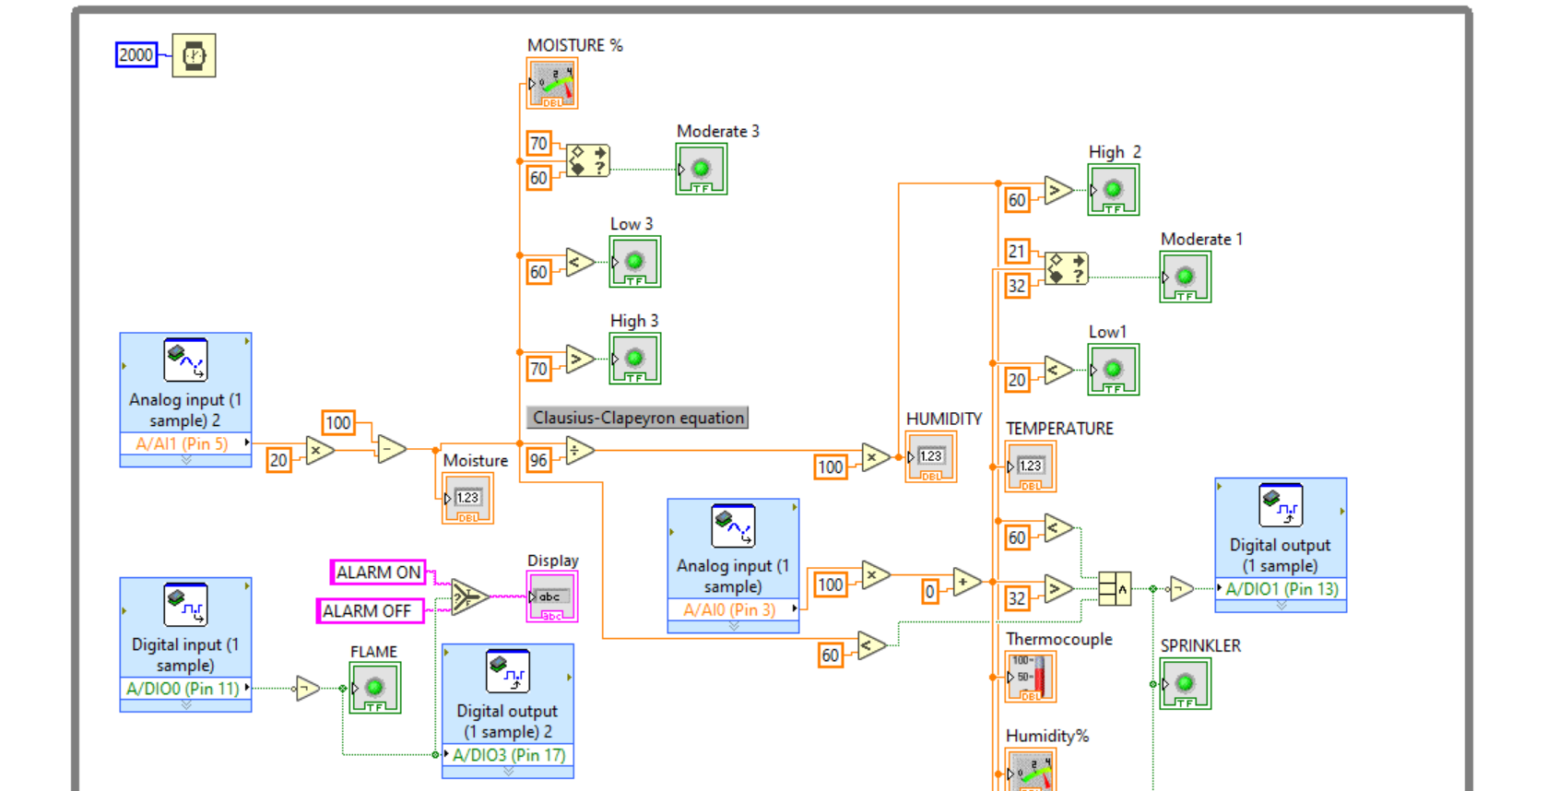

Fig 8: LABVIEW diagram

**4.RESULT AND DISCUSSION:**

**1.TEMPERATURE CONTROL PERFORMANCE:**

The system demonstrated effective temperature regulation within the poultry environment. When the temperature exceeded the predefined threshold of 30°C, the water spraying system was automatically activated by the LabVIEW software. The following observations were made:

* **Response Time**: The system responded within 2-3 seconds of the temperature crossing the threshold. The water sprayers activated promptly, releasing water in the designated areas.
* **Cooling Efficiency**: After activation, the system was able to reduce the ambient temperature by an average of 4-6°C within 10 minutes. This cooling effect significantly improved the comfort level for the poultry, maintaining the temperature within the ideal range of 25-28°C.

|  |  |  |  |  |  |
| --- | --- | --- | --- | --- | --- |
| ENVIRONMENTAL  PARAMETERS | HIGH | MODERATE | LOW | WATER NEEDS VALUE | SPRINKLER  (ON/OFF) |
| TEMPERATURE(C*) | >32* | 21* - 32* | <20 | >32* | ON |
| MOISTURE(%) | >60 | 50 - 60 | <50 | <50 | ON |
| HUMIDITY(%) | >70 | 60 - 70 | <60 | <60 | ON |

Table 1: Threshold value

**2.FIRE DETECTION AND GAS DETECTION ACCURACY**:

The fire detection system was tested using both simulated fire conditions (i.e., heat and smoke) and actual high-temperature scenarios. The following findings were noted:

* **Detection Sensitivity**: The smoke and temperature sensors were highly sensitive. When smoke levels reached 0.15 ppm or the temperature exceeded 60°C, the system immediately detected the anomaly and triggered the alarm.
* **Buzzer Alert**: Upon detecting smoke or heat, the buzzer sounded an audible alarm, alerting farm personnel about the potential fire hazard. The buzzer's volume and frequency were calibrated to ensure that the alarm was clearly audible over background noise in the poultry barn.

|  |  |
| --- | --- |
| FIRE AND GAS DETECTION | BUZZER |
| YES | ON |
| NO | OFF |

Table 2: Alarm mode

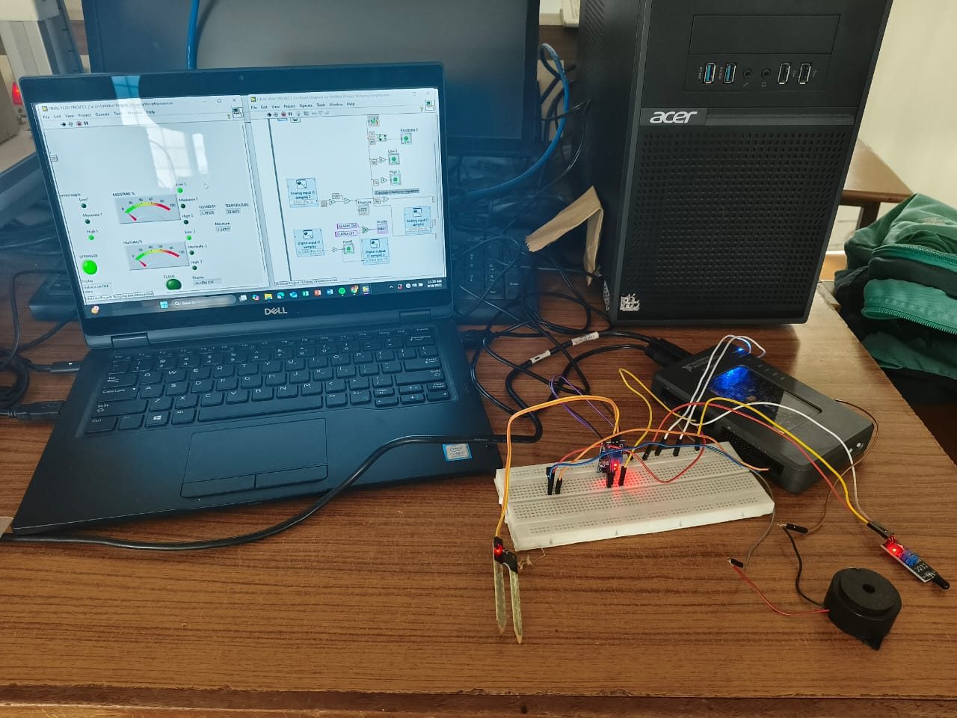**PROJECT PROTOTYPE (Fig 8):**

Fig 8: prototype

**5.CONCLUSION:**

In conclusion, the development and implementation of an automatic water spraying system for temperature control, fire detection and gas detection in poultry farming, utilizing LabVIEW, has shown significant promise in enhancing both the safety and well-being of poultry. By integrating temperature sensors, smoke detectors, and an efficient water spraying mechanism, the system can effectively monitor and regulate the environmental conditions within the poultry farm.

The integration of sensors and water spraying mechanisms allowed for efficient operation with minimal human intervention, leading to energy savings and optimized water usage.

Cloud computing enables real-time monitoring and control of temperature and fire detection systems in poultry farming. By using sensors connected to the cloud, farmers can automatically adjust conditions and receive alerts for potential fire hazards. This enhances farm efficiency, animal safety, and reduces the need for manual intervention.

**6.REFERENCE:**

1. **Kumar, S., & Pratap, P. (2018).** "Design of an Automated Temperature Control System for Poultry Farms." *International Journal of Engineering Research and Applications*, 8(9), 46-52.

2. **Bano, S., & Li, Z. (2020).** "Smart Farming with IoT: A Review of Poultry Farm Monitoring and Control Systems." *Journal of Intelligent & Fuzzy Systems*, 39(4), 4603-4616..

3. **López, L., & García, A. (2019).** "Fire Detection System for Poultry Houses." *IEEE Transactions on Industrial Electronics*, 63(9), 5670-5679.

4. **Kumar, S., & Verma, A. (2019).** "Implementation of Temperature and Humidity Control System Using LabVIEW for Poultry Farming." *International Journal of Advanced Computer Science and Applications*, 10(4), 60-68..

5. **Kaur, H., & Pandey, S. (2023).** "LabVIEW-Based Automated Fire Detection and Alarm System." *International Journal of Engineering and Technology Innovation*, 7(2), 103-110.

6. **Sundararajan, V., & Thomas, R. (2022).** "Automation in Poultry Farming for Environmental Control and Disease Management." *Journal of Agricultural Engineering*, 52(3), 245-251.

7. **Jain, R., & Verma, P. (2020).** "Internet of Things (IoT) in Agriculture: A Case Study on Poultry Farm Monitoring." *Smart Computing and Communications*, 9(2), 88-95.

8. **Raj, M., & Singhal, S. (2018).** "Automatic Fire Detection and Suppression System Using LabVIEW for Agricultural and Industrial Applications." *International Journal of Advanced Research in Electrical, Electronics and Instrumentation Engineering*, 7(5), 3558-3565.

9. **Prajapati, S., & Kaur, P. (2020).** "Smart Temperature and Humidity Monitoring System for Poultry Farm Using IoT and LabVIEW." *International Journal of Engineering Science and Technology*, 12(3), 135-142.

10. **Chatterjee, A., & Roy, S. (2019).** "IoT-based Fire and Temperature Monitoring System for Poultry Farms." *Proceedings of the International Conference on Advanced Computing and Communication Systems (ICACCS)*, 1123-1127.