**IOT BASED POLLUTION MEASUREMENT SYSTEM**

**Divya Dongele1 , Kunal Mahajan2 , Shivam Mourya3 , Prof. Sachin Patel**

Department of Electrical Engineering

Thakur ShivKumar Memorial Engineering College, Burhanpur (Affiliated to RGPV Bhopal),India

--------------------------------------------------------------------------------------------------------------

**Abstract**

The Measurement System Contacts aims to transform air monitoring through IoT technology by utilizing sensors and microcontrollers to provide real-time contamination data. This project addresses key environmental surveillance issues, such as high costs, lack of real data, and limited access, contributing to sustainable development and healthier living. It employs a DSM501A sensor measuring PM2.5 and PM10 particles, with data transmitted via an ESP8266 microcontroller to a MySQL database for secure storage and analysis. The system features a user-friendly interface for data visualization, historical analysis, and notifications for pollution events, enabling informed decision-making. Its modular design allows for additional sensor integration, making it adaptable for various environmental monitoring needs at low operational costs.

**Introduction**

The Internet of things (IOT) has become a Transformative Technology, Innovation Stimulation in various fields, including environmental burning. This project is computing the use of IOT to handle the air pollution, a global challenge that affects health and ecosystem.

For particular (PM2.5 and PM10), it's a big track

and Cardiovascular. Traditional Supervisory systems are often expensive and inaccessible, restrictive Their generalized approval. This project responds to these loads by providing a solution to monitor the real pollution, affordable & accessible. With sensors to collect air quality data and an online display interface, this system allows communities and authority to make decisions informed. Their scale guarantees dazzling to different environments, from urban areas to areas subjected to disasters.

**Literature Review**

Existing research highlights several approaches to pollution monitoring:

**- Traditional Methods:**

- Rely on large, stationary equipment, limiting coverage.

**- IoT-Based Systems:**

- Utilize sensors and microcontrollers for cost-effective solutions.

The gaps in current systems, particularly in terms of real-time accessibility and affordability, provide an opportunity for this project to contribute meaningfully to the field of environmental monitoring.

**System Architecture**

The IoT-Based Pollution Measurement System comprises the following components:

1. DSM501A Sensor:

  - Measures PM2.5 and PM10 concentrations.

2. ESP8266 Microcontroller:

  - Processes data and uploads it via Wi-Fi to a database.

3. MySQL Database:

  - Stores pollution data for analysis and visualization.

4. Web Interface:

  - Built using HTML and PHP to display data in graphical formats, ensuring accessibility from any device.

This modular design enables integration of additional sensors for monitoring other pollutants, such as CO2 and NOx.

## **Node MCU Pinout and Functions:**

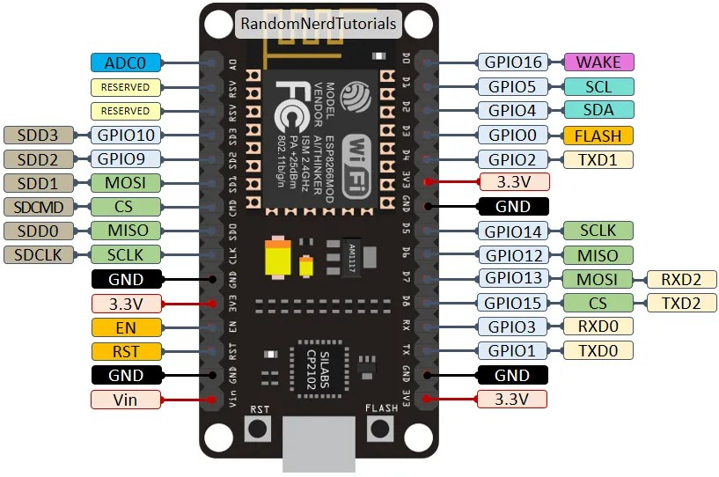

**Fig 1.1** Circuit diagram of ESP8266 Microcontroller

**Elementary diagram**

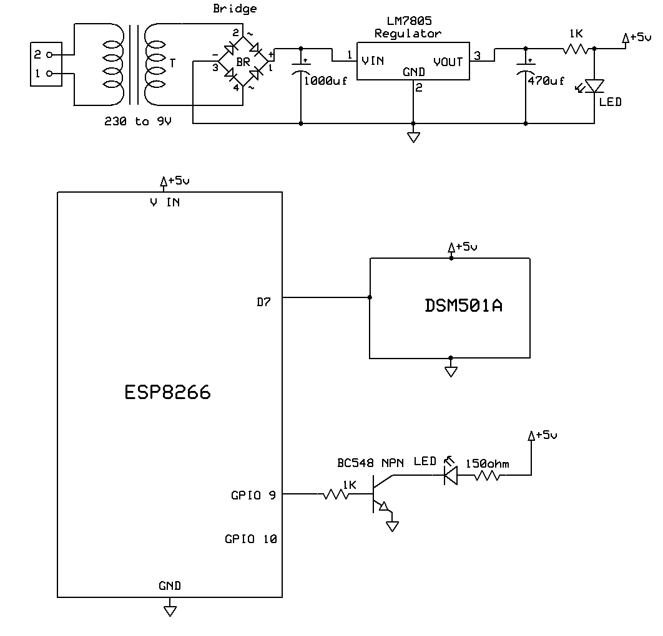

**Fig 1.2** Circuit Diagram of System

**Comprehensive Applications**

**Environmental Monitoring:** Used in cities to track air quality and inform residents about pollution levels.

**Industrial Compliance:** Helps industries monitor emissions to comply with environmental regulations.

**Public Spaces:** Ensures safe air quality in hospitals, schools, and offices.

It can also be deployed in remote or disaster-prone areas to monitor air quality and provide critical data for relief efforts.

It Can be placed in remote areas or under the disasters to monitor the air quality and provide critical data on urgent efforts.

**Limitations**

* Limited to areas with internet connectivity for real-time data transmission.
* Accuracy depends on the placement and maintenance of sensors.
* Requires consistent power supply, which may be challenging in remote locations.
* Potential data privacy concerns with continuous environmental monitoring.
* Limited ability to detect very low concentrations of certain pollutants.
* High dependency on cloud storage, which may incur costs over time.

**Results and Observations**

* **Real-Time Data Tables and Graphs:** Visualizing trends over time.
* **Pollution Alerts:** Indicating periods when air quality drops to unsafe levels.
* **Impact Analysis:** Helps authorities and organizations implement effective control measures.
* Initial tests indicate consistent performance with minimal downtime. The system's visual analytics enable stakeholders to identify pollution hotspots and trends effectively.

**Future Scope**

* Integration of additional sensors for gases like CO2, NOx, and SO2.
* AI-based analytics for predictive modelling and pollution forecasting.
* Development of a dedicated mobile application for enhanced accessibility.
* Solar-powered systems for energy efficiency in remote locations.
* Use of blockchain for secure and transparent data storage.
* Integration with weather stations for comprehensive environmental data.
* Advanced data visualization tools like AR/VR for better understanding.
* Real-time data sharing with emergency response teams for disaster management.

**Conclusion**

This project successfully shows capability and efficiency to use IOT technologies for the monitoring in the right pollution. The decrease in traditional systems limits, missing high cost, lack of families of databases and limiting access - provide an evolution and lucrative solution.   
Integration of DSM501A sensors, Microcontrollers and the data stock of the cloud is away Viewing the quality of real air. Design mode assures adaptability, allowing the inclination of additional sensors to measure the settings as the temperature and harmful gases as CO2 and NOx.   
besides their technical merits, this system underscores the importance of Used environmental data in promoting sustainable communities. Measuring IOT pollution the system represents only a technological sale, but also has the defeat with global effort to fight environmental degradation and promotion of sustainability.

**References**

* Research articles on IoT applications in environmental monitoring.
* DSM501A and ESP8266 datasheets.
* Tutorials on Arduino and MySQL integration.
* System Overview
* DSM501A Sensor
* USB to Serial Converter – CP2102 or CH340G