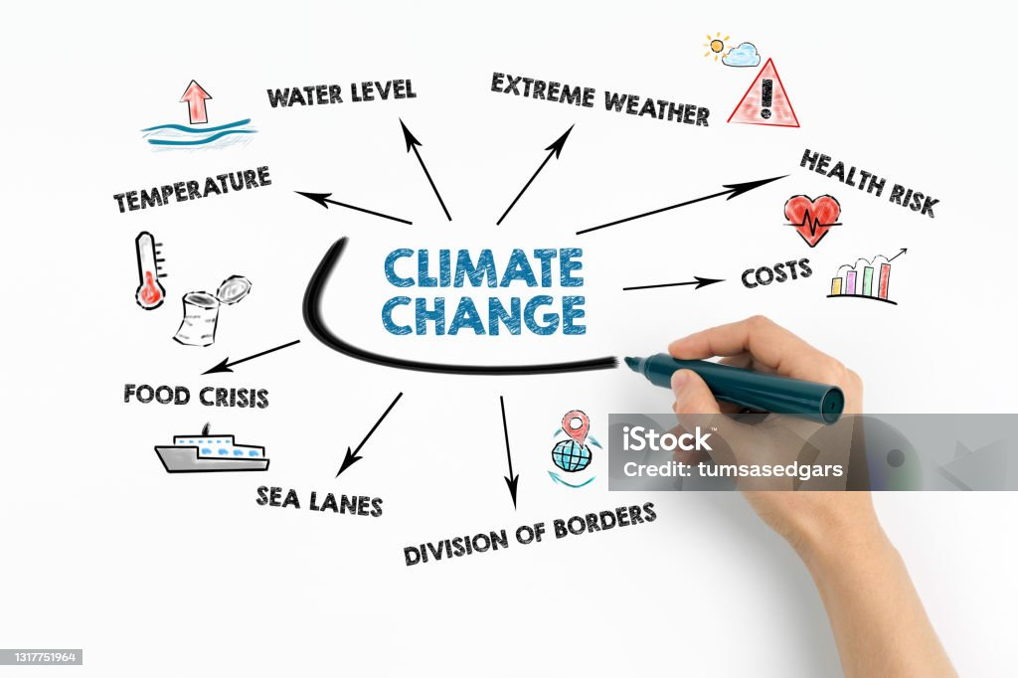

# Abstract

Climate change has a profound impact on extreme environmental events (EEs), increasing their frequency and intensity. Here's a deeper dive into the topic:

1. Types of Extreme Events: Climate change influences a variety of events, including hurricanes, heatwaves, floods, droughts, and wildfires. For instance, warmer ocean temperatures can fuel stronger hurricanes, while higher atmospheric temperatures can lead to more intense heatwaves2.
2. Mechanisms at Play: The rise in greenhouse gases, primarily from burning fossil fuels, traps heat in the atmosphere. This warming affects the water cycle, leading to heavier precipitation in some areas and prolonged droughts in others2.
3. Scientific Evidence: Studies, including those by the Intergovernmental Panel on Climate Change (IPCC), show a clear link between human activities and the increased frequency of extreme weather events. For example, some recent heatwaves would have been nearly impossible without human-induced climate change.
4. Future Projections: As global temperatures continue to rise, the intensity and frequency of these events are expected to escalate. This underscores the urgency of mitigation strategies to reduce greenhouse gas emissions

Keywords: The climate crisis refers to [the urgent need for immediate action](https://www.oxfordlearnersdictionaries.com/definition/english/climate-crisis) to mitigate the impacts of climate change and address the causes of climate change, and prevent serious and permanent damage to the environment.

# Introduction

# Climate change refers to the long-term warming of the planet due to an increase in average global temperatures. This phenomenon is primarily caused by human activities that release greenhouse gases, such as carbon dioxide and methane, into the atmosphere, leading to a trap of heat and a rise in global temperatures.

# Causes of Climate Change

# The main causes of climate change can be attributed to human activities, including:

# 1. Burning of fossil fuels: The burning of coal, oil, and gas for energy releases large amounts of carbon dioxide into the atmosphere.

# 2. Deforestation: The clearance of forests for agriculture, urbanization, and other purposes releases carbon dioxide and reduces the ability of forests to act as carbon sinks.

# 3. Agriculture: The production of meat, especially beef, and other animal products leads to the release of methane and nitrous oxide.

# 4. Industrial processes: The production of cement, steel, and other industrial processes also release large amounts of greenhouse gases.

Effects of Climate Change

Climate change has severe consequences on the environment, human health, and the economy. Some of the effects of climate change include:

1. Rising sea levels: Thawing of polar ice caps and glaciers, leading to sea-level rise and coastal flooding.

2. Extreme weather events: Increased frequency and intensity of heatwaves, droughts, and heavy rainfall events.

3. Water scarcity: Changes in precipitation patterns and increased evaporation due to warmer temperatures, leading to water scarcity.

4. Loss of biodiversity: Climate change alters ecosystems, leading to the loss of biodiversity and extinction of species.

Importance of Addressing Climate Change

Climate change is a pressing global issue that requires immediate attention and action. The importance of addressing climate change cannot be overstated:

1. Mitigating its effects: Reducing greenhouse gas emissions can help mitigate the worst effects of climate change.

2. Protecting human health: Climate change has significant implications for human health, including increased mortality and morbidity.

3. Preserving ecosystems: Climate change can lead to irreversible damage to ecosystems, highlighting the need for conservation efforts.

4. Supporting sustainable development: Addressing climate change is essential for achieving sustainable development and ensuring future.

Waste Generation and Climate Change

Waste generation is a significant contributor to greenhouse gas emissions and climate change. The production, consumption, and disposal of waste result in emissions throughout the entire lifecycle.

Types of Waste

1. Municipal Solid Waste (MSW): Household waste, including food waste, plastics, paper, and glass.

2. Industrial Waste: Waste generated by industries, such as manufacturing, construction, and mining.

3. Agricultural Waste: Waste generated by agricultural activities, including crop waste and animal manure.

4. Hazardous Waste: Waste that poses a threat to human health and the environment, including chemicals, pesticides, and heavy metals.

Climate Change Impacts of Waste Generation

1. Methane Emissions: Decomposition of organic waste in landfills produces methane, a potent greenhouse gas.

2. Carbon Dioxide Emissions: Production and transportation of waste result in carbon dioxide emissions.

3. Nitrous Oxide Emissions: Decomposition of organic waste and industrial processes release nitrous oxide, a greenhouse gas.

4. Water Pollution: Leachate from landfills and industrial waste can contaminate water sources.

Strategies to Reduce Waste-Related Greenhouse Gas Emissions

1. Reduce: Reduce waste generation through sustainable consumption patterns and minimal packaging.

2. Reuse: Reuse products and materials to reduce waste generation.

3. Recycle: Recycle materials to conserve natural resources and reduce waste sent to landfills.

4. Compost: Compost organic waste to reduce methane emissions and produce nutrient-rich soil.

5. Waste-to-Energy: Implement waste-to-energy technologies to generate energy from waste and reduce greenhouse gas emissions.

Policy and Regulatory Frameworks

1. Extended Producer Responsibility (EPR): Encourage manufacturers to take responsibility for waste generated by their products.

2. Waste Management Hierarchy: Establish a waste management hierarchy that prioritizes waste reduction, reuse, and recycling.

3. Landfill Gas Capture: Implement regulations to capture and utilize methane emissions from landfills.

4. Greenhouse Gas Emissions Reduction Targets: Set targets to reduce greenhouse gas emissions from waste generation and management.

# Zero waste is a philosophy and practice that aims to minimize waste generation and maximize resource efficiency. In the context of climate change, zero waste is a critical strategy for reducing greenhouse gas emissions and mitigating the impacts of climate change.

# Principles of Zero Waste

# 1. Prevention: Prevent waste generation by avoiding single-use products, buying in bulk, and choosing products with minimal packaging.

# 2. Reduction: Reduce waste generation by reducing consumption, reusing products, and recycling materials.

# 3. Reuse: Reuse products and materials to reduce waste generation and conserve natural resources.

# 4. Recycling: Recycle materials to conserve natural resources, reduce waste sent to landfills, and decrease greenhouse gas emissions.

# 5. Composting: Compost organic waste to reduce methane emissions, produce nutrient-rich soil, and support sustainable agriculture.

# Benefits of Zero Waste for Climate Change

# 1. Reduced Greenhouse Gas Emissions: Zero waste strategies can reduce greenhouse gas emissions by minimizing waste sent to landfills, reducing energy consumption, and promoting sustainable resource management.

# 2. Conservation of Natural Resources: Zero waste promotes the conservation of natural resources by reducing consumption, reusing products, and recycling materials.

# 3. Reduced Waste Management Costs: Zero waste can reduce waste management costs by minimizing waste sent to landfills and reducing the need for waste treatment and disposal infrastructure.

# 4. Improved Public Health: Zero waste can improve public health by reducing exposure to toxic chemicals, minimizing waste-related pollution, and promoting sustainable resource management.

# Strategies for Implementing Zero Waste

# 1. Conduct a Waste Audit: Conduct a waste audit to identify areas for improvement and develop a zero waste plan.

# 2. Implement Recycling Programs: Implement recycling programs for paper, plastic, glass, and organic waste.

# 3. Promote Reuse and Sharing: Promote reuse and sharing of products and materials to reduce waste generation.

# 4. Support Sustainable Procurement: Support sustainable procurement practices by purchasing products with minimal packaging, made from recycled materials, and designed for recyclability.

# 5. Educate and Engage the Community: Educate and engage the community on the benefits of zero waste and involve them in the development and implementation of zero waste strategies.

# Case Studies and Examples

# 1. Zero Waste Cities: Cities like San Francisco, Vancouver, and Copenhagen have implemented zero waste strategies and achieved significant reductions in waste sent to landfills.

# 2. Zero Waste Businesses: Businesses like Patagonia, REI, and Seventh Generation have implemented zero waste strategies and reduced their environmental footprint.

# 3. Zero Waste Communities: Communities like the Zero Waste International Alliance have developed zero waste plans and implemented strategies to reduce waste generation and promote sustainable resource management.

1. Singh, A Indian Smart Cities Mission: Exploring the potential for Socio- environmental justice. University College London, UK, 2020.
2. United Nations, Department of Economic and Social Affairs, Population Division World Urbanization Prospects: The 2018 Revision, Methodology, 2018.
3. The World Bank. “What a waste: a global review of solid waste Management-The urban development series knowledge papers [WWW document]”, Urban Dev. Local Gov. Unit World Bank, 2012.
4. Demirbas A. Waste management, waste resource facilities and waste conversion processes. Energy Conversion and Management,2011:52(2):1280-1287.
5. Tchobanoglous G, Theisen H, Vigil S. Integrated Solid Waste Management: Engineering Principles and Management Issues. Water Science & Technology Library,1993:8(1): 63-90.
6. Wilson DC. Development drivers for waste management. Waste Management & Research the Journal of the International Solid Wastes & Public Cleansing Association Iswa,2007:25(3):198-207.
7. Vergara SE, Tchobanoglous G. Municipal Solid Waste and the Environment: A Global Perspective. Environment and Resources,2012:37(37):277-309.
8. Beranek W. Solid Waste Management and Economic

Development. Economic Development Review,1992:10:49.

1. Ekmekcioglu S, Ekmekcioglu D. The users' approach to zero waste according to five 'R'. 3rd International Conference on Life and Engineering Sciences. Istanbul, Turkey, 2020.
2. "Zero Waste International Alliance". *zwia.org*.
3. EPA. Managing and transforming waste streams - A tool for communities
4. McDonough W, Braungart M. "The cradle-to-cradle alternative, 2003.
5. "How Communities Have Defined Zero Waste". *EPA*,

Here are some references related to climate change:

Books

1. "The Uninhabitable Earth: Life After Warming" by David Wallace-Wells (2019)

2. "Climate Change: A Very Short Introduction" by Mark Maslin (2014)

3. "This Changes Everything: Capitalism vs. the Climate" by Naomi Klein (2014)

Articles

1. "Global Warming of 1.5°C" by the Intergovernmental Panel on Climate Change (IPCC) (2018)

2. "Climate Change 2021: The Physical Science Basis" by the IPCC (2021)

3. "The Impacts of Climate Change on Human Health" by the World Health Organization (WHO) (2018)

Journals

1. Nature Climate Change

2. Environmental Research Letters

3. Climate Change Research

4. Journal of Climate

5. Global Environmental Change

Online Resources

1. National Oceanic and Atmospheric Administration (NOAA) (link unavailable)

2. Intergovernmental Panel on Climate Change (IPCC)

3. United Nations Framework Convention on Climate Change (UNFCCC)

4. World Meteorological Organization (WMO) Climate

5. Climate Change Research Network (CCRN)

Reports

1. "Climate Change 2021: The Physical Science Basis" by the IPCC (2021)

2. "Global Warming of 1.5°C" by the IPCC (2018)

3. "The Impacts of Climate Change on Human Health" by the WHO (2018)

4. "Climate Change and Land: an IPCC special report" by the IPCC (2019)

5. "The Economics of Climate Change" by the Stern Review (2006)

Data Sources

1. NASA's Goddard Institute for Space Studies (GISS)

2. National Centers for Environmental Information (NCEI)

3. University of East Anglia's Climatic Research Unit (CRU)

4. National Snow and Ice Data Center (NSIDC)

5. Carbon Dioxide Information Analysis Center (CDIAC) [View publication stats](https://www.researchgate.net/publication/358221324)