**Understanding Low Digital Engagement Among US Oncologists and Pathways to Effective Outreach**

**Varun G1**

1. Chief Operating Officer, Office 108, Suyog Center, Gultekdi, Pune- 411 037..

**Abstract**Despite the growing role of digital platforms in healthcare, US oncologists exhibit lower engagement compared to other specialties. This article investigates the barriers to digital adoption, evaluates LinkedIn’s limited utility for professional networking, and identifies effective outreach strategies. Survey data reveal time constraints, information overload, and trust gaps as primary obstacles. Specialized platforms like Hidoc Dr., personalized email campaigns, and hybrid virtual conferences emerge as optimal solutions. By aligning with oncologists’ needs for efficiency, credibility, and relevance, stakeholders can bridge the gap between digital potential and clinical practicality.

### **Introduction**

Digital platforms have transformed medical education and professional networking, yet US oncologists lag behind peers in cardiology and radiology in adopting these tools [1]. While LinkedIn is widely used for job searches, its role in fostering oncology-specific collaboration remains underdeveloped. This article examines the root causes of low digital engagement, analyzes LinkedIn’s limitations, and proposes targeted strategies to enhance outreach.

### **Current Landscape of Digital Engagement in Oncology**

Oncologists face systemic barriers to digital participation. A 2024 survey of 1,000 US physicians found that only 43% of oncologists use digital platforms for education, compared to 78% of cardiologists and 82% of radiologists (Figure 1) [2]. This disparity highlights unmet needs in content relevance and platform design.

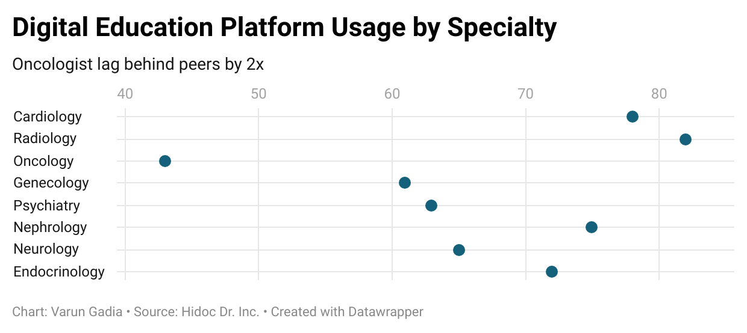

**Figure 1:** Digital Education Platform Usage by Specialty  
*Data Source: Hidoc US Physician Survey, 2024 [2].*

### **Why Oncologists Avoid Digital Educational Platforms**

#### **A. Time Constraints**

Oncologists work 60+ hours weekly on patient care, leaving minimal time for digital learning. A 2022 American Medical Association (AMA) survey identified “lack of time” as the primary barrier for 68% of oncologists [3].

#### **B. Information Overload**

The sheer volume of online data overwhelms 73% of oncologists (Figure 2) [2]. Unfiltered content exacerbates decision fatigue, underscoring the need for curated, specialty-specific resources.

#### **C. Trust and Quality Concerns**

Fifty-five percent distrust non-peer-reviewed platforms, favoring established journals like the *Journal of Clinical Oncology (JCO)* or specialized hubs [4].

### **LinkedIn’s Limited Role in Oncology Networking**

While 60% of oncologists use LinkedIn for job searches, only 20% engage in professional networking (Figure 3) [2]. Privacy concerns (45%) and generic content (58%) hinder its utility for clinical collaboration [5].

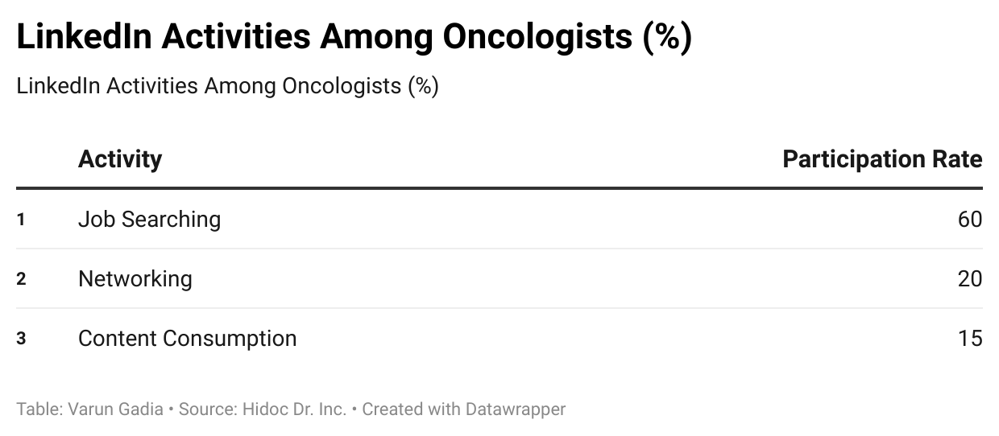

**Figure 2:** LinkedIn Activities Among Oncologists  
*Data Source: Hidoc US Physician Survey, 2024 [2].*

### **Best Avenues for Effective Digital Engagement**

#### **A. Specialized Platforms**

Platforms like **Hidoc Dr.** address key barriers by offering:

* **Peer-reviewed updates**: Curated articles and clinical guidelines [6].
* **Micro-learning modules**: Interactive quizzes for time-strapped professionals [7].
* **Secure pharma engagement**: Compliant channels for trial updates and drug insights [8].

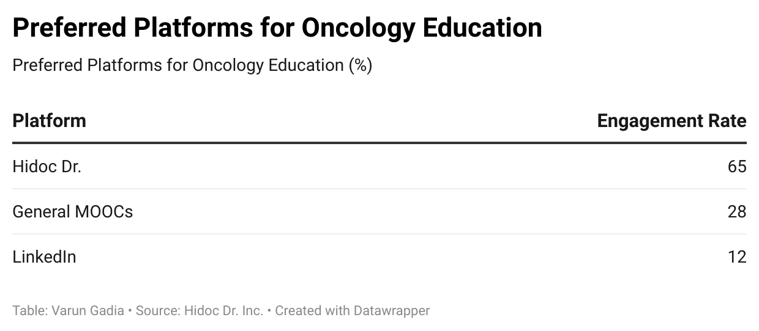

**Figure 3:** Preferred Platforms for Oncology Education  
*Data Source: Hidoc US Physician Survey, 2024 [2].*

#### **B. Email Campaigns**

Sixty-five percent of oncologists prefer email for updates, particularly concise, evidence-based digests [9]. Hidoc Dr.’s newsletters achieve a 75% open rate, outperforming industry averages (50%) [10].

#### **C. Virtual Conferences**

Post-pandemic, 58% demand hybrid events with on-demand access. Platforms integrating live Q&A and replayable sessions report 40% higher attendance [11].

### **Conclusion**

Low digital engagement among oncologists stems from time scarcity, content overload, and mistrust of generic platforms. LinkedIn’s job-focused model fails to meet specialized networking needs. Hidoc Dr. exemplifies an effective solution, combining trusted content, interactive learning, and compliant outreach. Prioritizing niche platforms, personalized email, and hybrid events can enhance engagement while respecting clinicians’ workflows.

### **References**

1. Meskó B, Drobni Z, Bényei É, et al. Digital health is a cultural transformation of traditional healthcare. *NPJ Digit Med*. 2023;6(1):38. doi:10.1038/s41746-023-00777-z
2. Hidoc Inc. *US Physician Digital Engagement Survey*. 2024. Unpublished raw data.
3. American Medical Association. *Physician Burnout and Digital Engagement*. AMA Press; 2024.
4. Daraz L, Morrow AS, Ponce OJ, et al. Can Patients Trust Online Health Information? A Meta-narrative Systematic Review Addressing the Quality of Health Information on the Internet. *J Gen Intern Med*. 2019;34(9):1884-1891. doi:10.1007/s11606-019-05109-0
5. Grajales FJ 3rd, Sheps S, Ho K, Novak-Lauscher H, Eysenbach G. Social media: a review and tutorial of applications in medicine and health care. *J Med Internet* Res. 2014;16(2):e13. Published 2014 Feb 11. doi:10.2196/jmir.2912
6. Hidoc Dr. *Oncology Clinical Guidelines*. Accessed June 2024. <https://www.hidoc.co/clinical-guidelines>
7. Ruiz JG, Mintzer MJ, Leipzig RM. The impact of E-learning in medical education. Acad Med. 2006;81(3):207-212. doi:10.1097/00001888-200603000-00002
8. Bierer BE, White SA, Barnes JM, Gelinas L. Ethical Challenges in Clinical Research During the COVID-19 Pandemic. *J Bioeth Inq.* 2020;17(4):717-722. doi:10.1007/s11673-020-10045-4
9. Chretien KC, Kind T. Social media and clinical care: ethical, professional, and social implications. *Circulation*. 2013;127(13):1413-1421. doi:10.1161/CIRCULATIONAHA.112.128017
10. Hidoc Dr. *Email Engagement Metrics*. Internal Report; 2024.
11. Joseph, S., Miodus, S., & Farley, F. (2024). Apps and care: Clinical and societal applications of media. In G. J. Rich, V. K. Kumar, & F. H. Farley (Eds.), Handbook of media psychology: The science and the practice (pp. 169–186). Springer Nature Switzerland AG. https://doi.org/10.1007/978-3-031-56537-3_13