**A STUDY ON CUSTOMER SATISFACTION IN ONLINE BANKING VS. TRADITIONAL BANKING**

**RINU R**

**24MCOM40**

**Kristu Jayanti College, Bengaluru 560077, india**

[24mcom40@kristujayanti.com](mailto:24mcom40@kristujayanti.com)

**ABSTRACT**

**The swift digitization of financial services has led to a considerable evolution in banking, providing clients with a variety of channels for service access. In order to compare online and traditional banking, this study looks at important aspects like ease, security, accessibility, service quality, and trust. The study defines consumer preferences, expectations, and difficulties related to both banking techniques using primary data gathered through surveys and secondary data gathered from industry reports and scholarly research. According to research, traditional banking is still important because of its individualized services and trustworthiness, even though online banking is preferred for its ease of use. The study ends by suggesting improvements to customer service integration, digital security, and customer support in order to maximize customer happiness across both banking systems.**

**This research further explores how customer demographics influence banking preferences, highlighting the role of age, occupation, and technological proficiency in shaping satisfaction levels. It identifies key pain points in both banking models, such as cybersecurity risks in online banking and long waiting times in traditional banking. The study also examines the role of financial literacy in banking choices, emphasizing the need for improved digital literacy programs to foster confidence in online transactions. The insights from this study contribute to policy recommendations aimed at bridging the gap between traditional and digital banking experiences, ensuring a more seamless and secure banking environment for all customer segments.**

**INTRODUCTION**

**As digital technology has emerged, the banking sector has seen a substantial upheaval. Traditional banking has long been the norm for financial services, mainly including in-person transactions at physical locations. Online banking, on the other hand, has completely changed the market by offering consumers banking alternatives that are quicker, more effective, and simpler to access.**

**While online banking provides convenience, flexibility, and round-the-clock accessibility, traditional banking is frequently preferred for its personalized customer service and perceived security. As digital banking gains traction, customer satisfaction has emerged as a critical factor in determining the success of both online and traditional banking systems. This study compares customer satisfaction levels between these two banking methods by analyzing a number of factors, including convenience, security, service quality, and trust. As a result, banks will be able to improve their services for a better customer experience.**

**Digital technology has revolutionized banking in recent decades, changing the financial services industry. The mainstay of banking services has long been traditional banking, which is defined by face-to-face transactions at physical locations. Customers can now access financial services remotely via digital platforms thanks to the growth of internet banking, which has brought about new levels of efficiency and convenience.**

**The purpose of this study is to investigate and contrast customer satisfaction levels in traditional and online banking systems. It looks into the main elements that affect consumer preferences, such as accessibility, security, convenience, and service quality. The study aims to pinpoint areas for development and provide methods to improve banking services for higher customer satisfaction by examining consumer input and experiences.**

**LITERATURE REVIEW**

**Al Faisal, N., Nahar, J.,** **et, al., (2024),** The study examines the effects of technology advancements, consumer preferences, and external factors like as the COVID-19 pandemic on the adoption of digital banking. It comes to the conclusion that customer satisfaction and loyalty are greatly impacted by user-friendly interfaces, accessibility, and smooth transaction processing. Security protocols and data usage guidelines promote confidence. Although AI and data analytics personalization improves user experience, privacy concerns are raised. Because of market competition, traditional banks are using biometrics, blockchain, and artificial intelligence. Digital infrastructure has improved as a result of the pandemic's acceleration of digital adoption.

**Kim, L., & Yeo, S. F. (2024),** The aim of the research was to examine the relationship between organizational commitment, job stress, and job happiness and the level of customer service that Cambodian bank employees offered. Higher levels of stress and job satisfaction may lead to stronger organizational commitment, according to the study, which surveyed 630 workers. However, banks might improve the caliber of their customer service if there were significant shifts in organizational dedication and work-related stress. The study confirmed that organizational commitment acted as a mediator between work satisfaction and customer service quality and revealed that it was a more significant factor in enhancing customer service quality.

**Mainardes, E. W., & Freitas, N. P. D. (2023),** This study compares fintech’s and traditional banks to examine how perceived value determinants impact customer happiness and loyalty in the banking sector. Information from 792 respondents was collected through online surveys. Customer happiness has a greater influence on loyalty in traditional banks than in fintech’s, according to the data. In conventional banks, pricing and dependability have a greater influence on client satisfaction. Competency, pricing, empathy, and satisfaction all indirectly affect loyalty. Investing in these areas can lead to more repeat business and client loyalty, according to the report.

**Sandhu, S., & Arora, S. (2022),** Examining the utilization of electronic banking services in a multi-channel environment reveals little usage. It suggests that banks may continue to develop technology and reap the benefits of it while also appreciating the worth of their employees. However, the ease and security of electronic banking must be improved in order to eliminate the obstacles to complete reliance on electronic media.

**Arshad Khan, M., & Alhumoudi, H. A. (2022),** Online payments are growing in popularity all around the world since online banking serves both businesses and consumers. Efficiency, reliability, and service quality have a significant impact on customer satisfaction and retention, according to a survey conducted with 287 respondents. The four main e-banking components identified by the study could be helpful to banks and companies entering the Indian market.

**Ikram Ullah Khan (2022),** The study examines how culture influences the uptake of digital banking in Pakistan and China. As theoretical frameworks, it makes use of customer service and the unified model (UTAUT-2). The study found that hedonic motivation, habit, and real-time support were significant factors for Pakistani bank customers, out of 410 main land’s Chinese and 360 Pakistani bank customers. Chinese consumers were attracted to digital banking because of societal influence, cost considerations, habitual work, and bank support systems. The report provides recommendations for banks and regulators on how to improve the digitisation of banking in both countries.

**Nocera and Gloria (2022),** Fintech companies threaten traditional banks by exploiting consumers' mistrust and offering tech-based products. Switzerland's fintech demand surged from 30% in 2017 to 64% in 2019, driven by Generation Z. To restore trust, incumbents must address the banking application of Swiss Neobank Yuh through a case study and literature review.

**Dhurup, M., Surujlal, J., et, al., (2014),** The quality of technology-based banking services was examined in a study conducted in South Africa's Southern Gauteng. Consumer perception has been demonstrated to be influenced by seven factors: certainty, responsiveness, ease of use, accessibility, fulfilment, speed and accuracy, and interaction. The positive impact of these elements on customer satisfaction and loyalty suggests that any bank's strategy should include regular assessments of the quality of the company's online banking services.

**Nimako, S. G., Gyamfi, N. K.,** **et, al., (2013),** Consumer satisfaction with internet banking services (IBSQ) offered by Ghana's banking sector is investigated in this survey. A survey of 200 people found that clients of Merchant Bank, Ghana (MBG) are happier with IBSQ than they are with Ghana Commercial Bank (GCB). Income has an impact on satisfaction as well. The quick responses to their inquiries, the online assistance, the reduced costs, and the fairness of the transaction fees, however, did not satisfy the customers. Despite these limitations, the findings have theoretical and managerial consequences.

**Kadir, H. A., Rahmani, N., et, al., (2011),** The banking sector has been greatly impacted by electronic communications and e-commerce since consumers in industrialized nations demand top-notch service. However, a lot of people, particularly in developing nations, continue to rely on conventional high-street banking arrangements. This study uses a quantitative survey and interviews to investigate the attitudes of Jordanian customers regarding online banking. It shows that the implementation of e-banking benefits Jordanian banks, customer satisfaction, loyalty, and positive word-of-mouth. Following the identification of factors influencing online banking customer satisfaction, recommendations are made to improve the uptake of e-banking in Jordan.

**STATEMENT OF PROBLEM**

The way consumers engage with financial institutions has evolved due to the explosive expansion of online banking. Even while digital banking offers convenience, quickness, and 24/7 accessibility, worries about security, technological difficulties, and customer service still exist. However, because it is trusted, offers individualized attention, and is secure, traditional banking is generally seen as time-consuming. This study examines the advantages and disadvantages of both traditional and online banking in order to determine the major determinants of consumer satisfaction.

Consumer interactions with financial institutions have evolved as a result of the explosive rise of internet banking. There are still worries about security, technological difficulties, and customer service even though digital banking offers convenience, speed, and 24/7 accessibility. On the other hand, traditional banking is favored for security, trust, and individualized service, but it is frequently thought of as time-consuming. In order to evaluate the main determinants of consumer satisfaction in both traditional and online banking, this study will examine the advantages and disadvantages of each approach.

**OBJECTIVES OF THE STUDY**

1. To identify the major concerns and challenges customers face in both banking methods.
2. To assess the impact of convenience, security, and accessibility on customer preference.
3. To analyse the level of customer satisfaction in online and traditional banking
4. To suggest improvements for enhancing customer experience in banking services.

**SCOPE OF THE STUDY**

Customer satisfaction in online and traditional banking is the main emphasis of this study, which examines a number of variables, including trust levels, security concerns, transaction speed, service availability, customer assistance, and simplicity of use. Primary data from 130 respondents of various ages and professions is included in the study. The study is to shed light on user preferences, pinpoint prevalent problems, and make recommendations for enhancements to improve banking experiences. The results will help researchers, banks, and legislators improve banking services for increased client interaction.

This study also looks at how technological developments affect banking practices and assesses the effects of demographic variables like age, income, and occupation on customer satisfaction. It investigates the relationship between consumers' ability to effectively use digital banking services and their degree of financial literacy. Additionally, the study evaluates the efficacy of current banking regulations and customer service tactics, offering suggestions to financial institutions on how to improve their service models. The scope also includes analyzing loyalty programs and customer retention tactics in traditional and online banking with the goal of determining the best practices for building enduring client relationships. This study adds to the continuous transformation of digital banking by offering practical suggestions to enhance customer experience, security, and accessibility.

**METHODOLOGY**

This study employs a quantitative and qualitative research approach to assess customer satisfaction in online and traditional banking. The following methods were used for data collection and analysis:

**Survey Questionnaires**: A structured questionnaire was distributed among 130 respondents who use online and traditional banking services. The survey included multiple-choice and Likert scale questions to assess satisfaction levels, key concerns, and preferences.

**Statistical Analysis**: The collected data was analysed using statistical tools such as SPSS and Excel to identify trends, correlations, and significant factors influencing customer satisfaction.

**Comparative Analysis**: A comparison was made between online and traditional banking services based on customer ratings of security, accessibility, service efficiency, and overall satisfaction.

**Data Analysis Method:**

Descriptive Statistics: Used to summarize and interpret the data effectively.

* Frequency Distribution & Percentage Analysis
* Visualization Tools: Graphs, and tables to present findings.

**LIMITATIONS OF THE STUDY**

* The study is limited to a specific geographic region, which may not reflect global banking trends.
* The sample size of 130 respondents may not fully represent the diverse banking population.
* The rapid evolution of digital banking technologies may render some findings obsolete over time.
* Self-reported data in surveys may be subject to bias or inaccurate responses.
* The study does not consider macroeconomic factors such as inflation, interest rate fluctuations, or regulatory changes that might impact banking preferences.

**ANALYSIS AND INTERPRETATION**

* Majority prefer online banking for 24/7 access and avoiding long queues.
* Trust in online banking varies, with security concerns affecting confidence.
* Traditional banking remains essential for large transactions and customer support.

**TABLE 1: AGE**

|  |  |  |  |
| --- | --- | --- | --- |
| **AGE** | **FREQUENCY** | **PERCENTAGE** | **CUMULATIVE PERCENTAGE** |
| 20 - 30 | 111 | 85.38% | 85.38% |
| Below 20 | 13 | 10.00% | 95.38% |
| 41 - 50 | 4 | 3.08% | 98.46% |
| 31 - 40 | 2 | 1.54% | 100.00% |
| **TOTAL** | **130** | **100%** |  |

Source: Primary Data

The study analysed 130 respondents based on the question "Age group", with four categories: Below 20, 20–30, 31–40, and 41–50. The 20–30 age group dominated (85.38%), indicating that younger adults are the primary users of banking services, likely favoring digital banking for convenience. The Below 20 group (10.00%) represents students and early professionals, who may prefer online banking due to familiarity with mobile technology. In contrast, 31–40 (1.54%) and 41–50 (3.08%) had lower representation, suggesting a preference for traditional banking due to trust and security concerns. These findings highlight the need for banks to enhance digital security, improve mobile banking experiences, and maintain quality traditional services to cater to different age groups effectively.

**TABLE 2: OCCUPATION**

|  |  |  |  |
| --- | --- | --- | --- |
| **OCCUPATION** | **FREQUENCY** | **PERCENTAGE** | **CUMULATIVE PERCENTAGE** |
| Student | 97 | 74.62% | 74.62% |
| Salaried Employee | 27 | 20.77% | 95.38% |
| Others | 3 | 2.31% | 97.69% |
| Business Owner | 2 | 1.54% | 99.23% |
| Retired | 1 | 0.77% | 100.00% |
| **TOTAL** | **130** | **100%** |  |

Source: Primary Data

The occupation analysis reveals that students (71.54%) constitute the majority of respondents, highlighting their strong preference for online banking due to its ease of access, speed, and 24/7 availability. Salaried employees (20.77%) represent the second-largest group, indicating a demand for secure transactions, payroll services, and efficient customer support. The remaining 7.69%, comprising business owners, retirees, and other professionals, suggests a need for more specialized banking solutions catering to business transactions, pensions, and financial management. The cumulative frequency analysis shows that 92.31% of respondents fall within the student and salaried employee categories, making them the most influential groups in shaping banking satisfaction trends.

This emphasizes the necessity for banks to enhance digital banking for students while ensuring security, trust, and personalized services for professionals and other customers to bridge the gap between online and traditional banking experiences.

**TABLE 3: MOST PREFERRED BANKING SERVICE**

|  |  |  |  |
| --- | --- | --- | --- |
| **BANKING SERVICE TYPE** | **FREQUENCY** | **PERCENTAGE** | **CUMULATIVE PERCENTAGE** |
| Online Banking | 75 | 57.69% | 57.69% |
| Both (Online & Traditional) | 44 | 33.85% | 91.54% |
| Traditional Banking | 11 | 8.46% | 100.00 |
| **TOTAL** | **130** | **100** |  |

Source: Primary Data

From the frequency analysis, we can see that Online Banking is the most preferred banking service, with 57.69% of respondents primarily using it. This indicates a significant shift towards digital banking solutions due to their convenience and accessibility.

Additionally, 33.85% of respondents use both online and traditional banking, suggesting that some customers still rely on physical bank branches for specific services. Only 8.46% of respondents use traditional banking exclusively, showing a declining trend in branch-based banking. The cumulative percentage reveals that 91.54% of respondents use some form of online banking (either fully or in combination with traditional banking), reinforcing the growing reliance on digital banking platforms.

1. **Preferred Bank for Primary Financial Transactions:**

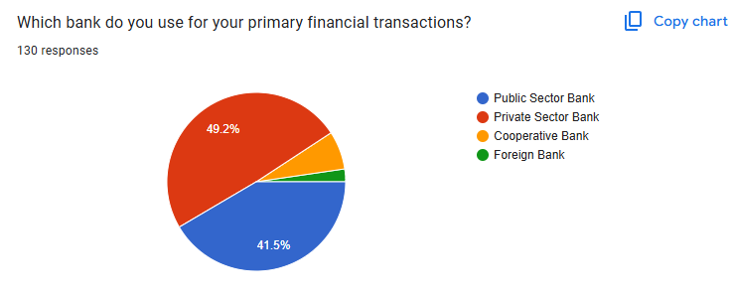

|  |  |  |
| --- | --- | --- |
| **BANK TYPE** | **FREQUENCY** | **PERCENTAGE** |
| Public Sector Bank | 54 | 41.5% |
| Private Sector Bank | 64 | 49.2% |
| Cooperative Bank | 9 | 6.9% |
| Foreign Bank | 3 | 2.3% |

Source: Primary Data

The majority of respondents (49.2%) use private sector banks for their primary financial transactions, followed by 41.5% who prefer public sector banks. Cooperative banks (6.9%) and foreign banks (2.3%) have significantly lower usage. This suggests that while public banks remain popular, private banks are slightly more preferred, possibly due to better customer service, digital banking features, or personalized offerings.

The overall trend highlights the increasing preference for technologically advanced and customer-friendly banking services. Public sector banks, despite their stronghold in the banking industry, may need to enhance their service efficiency and digital offerings to compete with private sector banks. The results also align with the broader industry shift toward modernized banking experiences, emphasizing speed, convenience, and personalized financial services.

1. **Most often online banking services:**

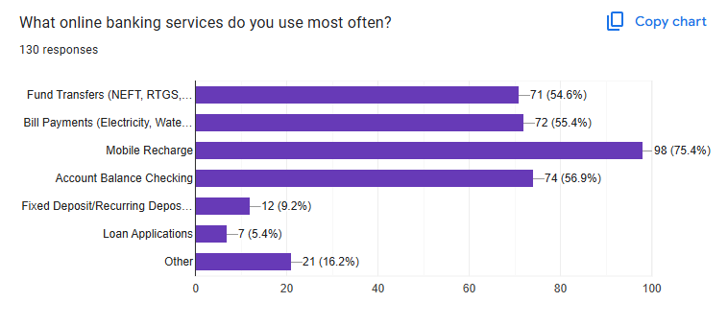

|  |  |  |
| --- | --- | --- |
| **ONLINE BANKING SERVICES** | **FREQUENCY** | **PERCENTAGE (%)** |
| Mobile Recharge | 98 | 75.4% |
| Account Balance Checking | 74 | 56.9% |
| Bills Payments (Electricity, Water, etc.) | 72 | 55.4% |
| Fund Transfer (NEFT, RTGS, etc) | 71 | 54.6% |
| Fixed Deposit / Recurring Deposits | 12 | 9.2% |
| Loan Applications | 7 | 5.4% |
| Other | 21 | 16.2% |
| **TOTAL** | **130** | 100% |

Source: Primary Data

The data shows that mobile recharge (75.4%) is the most frequently used online banking service, followed by account balance checking (56.9%), bill payments (55.4%), and fund transfers (54.6%). These services are widely used due to their convenience and quick processing. On the other hand, fixed deposits (9.2%) and loan applications (5.4%) have lower usage, indicating that customers may still prefer traditional banking for investment and credit-related services. Additionally, 16.2% of respondents selected "Other," suggesting the presence of additional banking needs not covered under standard online banking services.

The findings highlight that while online banking is commonly used for everyday transactions, trust and accessibility concerns may still influence the preference for traditional banking in certain financial decisions. Banks should focus on enhancing digital security, improving customer awareness, and expanding online services to increase adoption in underutilized areas.

1. **Customer Satisfaction with Online Banking Aspects:**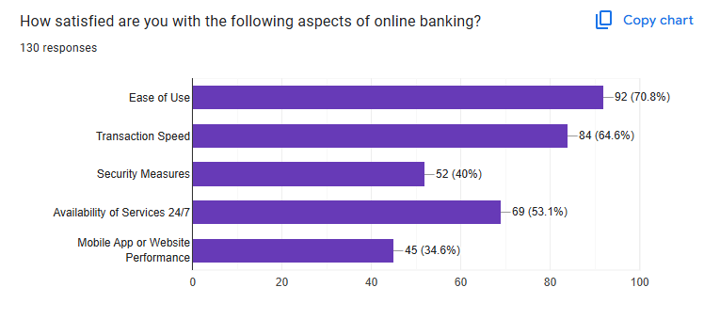

|  |  |  |
| --- | --- | --- |
| **ONLINE BANKING ASPECT** | **FREQUENCY** | **PERCENTAGE (%)** |
| Ease of Use | 92 | 70.8% |
| Transaction Speed | 84 | 64.6% |
| Security Measures | 52 | 40% |
| Availability of services 24/7 | 69 | 53.1% |
| Mobile App or Website Performance | 45 | 34.6% |
| **TOTAL** | **130** | **100%** |

Source: Primary Data

The data indicates that a majority of respondents (70.8%) are satisfied with the ease of use of online banking, making it the most positively rated aspect. Transaction speed follows with 64.6%, highlighting that customer appreciate the efficiency of digital banking. However, security measures received a lower satisfaction score (40%), suggesting concerns about fraud or data protection. 24/7 service availability is rated positively by 53.1% of users, emphasizing the importance of uninterrupted banking access. The lowest-rated aspect is mobile app or website performance (34.6%), indicating potential issues with app reliability or user experience. This analysis suggests that while online banking is valued for its convenience and speed, improvements in security and app performance are needed to enhance customer satisfaction.

1. **Online Banking Issues Faced by Respondents:**

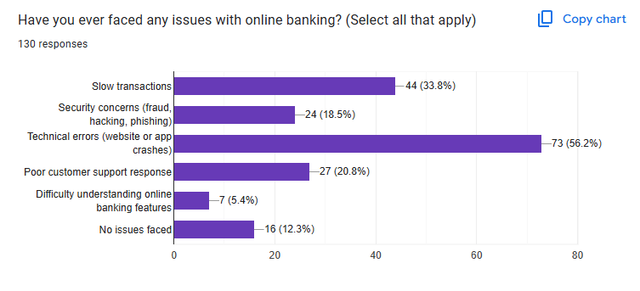

|  |  |  |
| --- | --- | --- |
| **ISSUE TYPE** | **FREQUENCY** | **PERCENTAGE (%)** |
| Technical Errors (Website/APP Crashes) | 73 | 56.2% |
| Slow Transactions | 44 | 33.8% |
| Poor Customer Support Response | 27 | 20.8% |
| Security Concerns (Fraud, Hacking, Phishing) | 24 | 18.5% |
| Difficulty Understanding Online Banking Features | 7 | 5.4% |
| No Issues Faced | 16 | 12.3% |

Source: Primary Data

The analysis indicates that technical errors (56.2%) are the most common issue faced by users, highlighting frequent website or mobile app crashes. Slow transactions (33.8%) are another significant problem, which may lead to frustration among users. Poor customer support (20.8%) and security concerns (18.5%) show that some users struggle with fraud risks and unresponsive service teams. Additionally, 5.4% of respondents find online banking features difficult to understand, suggesting a need for better user education. On a positive note, 12.3% of respondents reported no issues, indicating a satisfactory banking experience for some users. To improve customer satisfaction, banks should focus on enhancing platform stability, optimizing transaction speed, improving customer support responsiveness, and strengthening security measures.

1. **Trust in Online Banking for Large Transactions:**

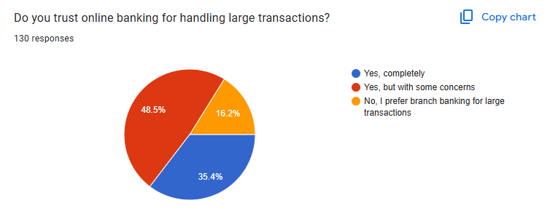

|  |  |  |
| --- | --- | --- |
| **RESPONSE** | **FREQUENCY** | **PERCENTAGE** |
| Yes, completely | 46 | 35.4% |
| Yes, but with some concern | 63 | 48.5% |
| No, I prefer branch for large transaction | 21 | 16.2% |
| **TOTAL** | **130** | **100%** |

Source: Primary Data

The analysis shows that 35.4% of respondents trust online banking completely for handling large transactions. However, the majority, 48.5%, have some concerns about using online banking for high-value transactions, indicating potential issues such as security risks, transaction failures, or lack of confidence in digital banking platforms. Additionally, 16.2% of respondents prefer branch banking for large transactions, highlighting a segment of users who feel safer handling significant financial transactions through traditional methods. These findings suggest that while online banking is widely accepted, there is still a need for banks to enhance security measures, ensure transaction reliability, and educate customers about the safety of digital financial transactions.

1. **Preferred Banking Services to Handle In-Person at a Branch**

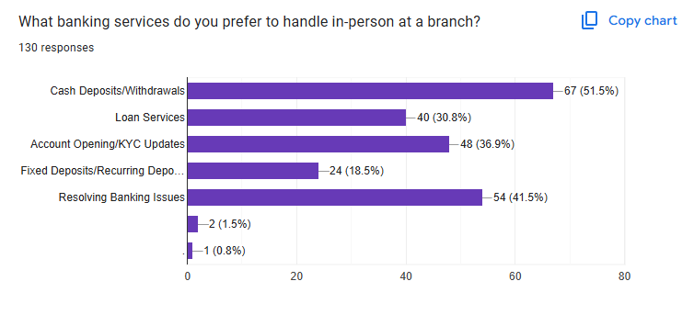

|  |  |  |
| --- | --- | --- |
| **BANKING SERVICE** | **FREQUENCY** | **PERCENTAGE** |
| Cash Deposits/Withdrawals | 67 | 51.5% |
| Loan Services | 40 | 30.8% |
| Account Opening/KYC Updates | 48 | 36.9% |
| Fixed Deposits/ Recurring Deposits | 24 | 18.5% |
| Resolving Banking Issues | 54 | 41.5% |
| Other | 2 | 1.5% |
| No Preference | 1 | 0.8% |

Source: Primary Data

The data reveals that cash deposits/withdrawals (51.5%) are the most frequently handled banking services at physical branches, indicating that customers still prefer in-person transactions for managing liquid cash. Resolving banking issues (41.5%) also ranks high, suggesting that many customers feel more confident addressing concerns directly with bank representatives rather than through digital channels. Account opening and KYC updates (36.9%) and loan services (30.8%) are also common reasons for visiting a branch, highlighting the need for in-person verification and consultation in financial decision-making. Fixed deposits and recurring deposits (18.5%) have a lower preference for in-person handling, indicating that customers may be more comfortable investing digitally.

A small percentage (1.5%) selected other services, while 0.8% had no specific preference, indicating a growing but still limited acceptance of fully digital banking. The overall trend suggests that while online banking is widely used, customers still rely on physical branches for essential and complex financial activities.

1. **Satisfaction with Aspects of Traditional Banking:**

|  |  |  |
| --- | --- | --- |
| **ASPECTS OF TRADITIONAL BANKING** | **FREQUENCY** | **PERCENTAGE (%)** |
| Customer Service at Branch | 58 | 44.6% |
| Transaction Speed | 29 | 22.3% |
| Availability of Bank Staff | 45 | 34.6% |
| Security Measures | 44 | 33.8% |
| Queue Management | 15 | 11.5% |
| Overall Experience | 40 | 30.8% |

Source: Primary Data

The findings indicate that customer service at the branch (44.6%) is the most highly rated aspect of traditional banking, suggesting that in-person interactions remain a strong point. Availability of bank staff (34.6%) and security measures (33.8%) are also positively rated, reflecting customer appreciation for direct assistance and safety in banking transactions. However, transaction speed (22.3%) and queue management (11.5%) received lower satisfaction levels, implying that delays and long waiting times are concerns in traditional banking. The overall experience (30.8%) indicates a moderate level of satisfaction, suggesting that while some customers are content, there is room for improvement in areas like speed and efficiency.

These insights highlight that while traditional banking is valued for personalized services and security, improvements in queue management and transaction speed could enhance customer satisfaction further.

1. **Issues Faced in Traditional Banking**

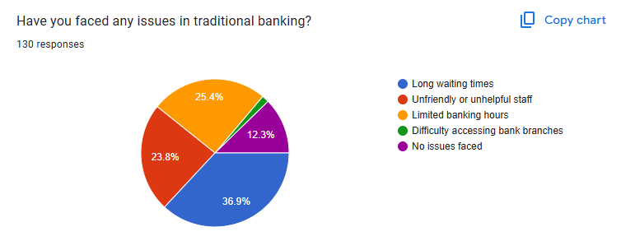

|  |  |  |
| --- | --- | --- |
| **ISSUES IN TRADITIONAL BANKING** | **FREQUENCY** | **PERCENTAGE (%)** |
| Long waiting times | 48 | 36.9% |
| Unfriendly or unhelpful staff | 31 | 23.8% |
| Limited banking hours | 33 | 25.4% |
| Difficulty accessing bank branches | 2 | 1.5% |
| No issues faced | 16 | 12.41% |
| **TOTAL** | **130** | **100%** |

Source: Primary Data

The most common issue faced by customers in traditional banking is long waiting times (36.9%), indicating that efficiency in service delivery is a major concern. Additionally, limited banking hours (25.4%) and unfriendly or unhelpful staff (23.8%) are significant issues, suggesting the need for better customer service and extended working hours. A small percentage of respondents (1.5%) reported difficulty accessing bank branches, showing that accessibility is not a widespread concern. However, 12.3% of customers reported no issues, indicating that a portion of users are satisfied with traditional banking services.

Overall, the findings suggest that improving queue management, staff responsiveness, and flexible banking hours could enhance the customer experience in traditional banking.

1. **Preferred Banking Method for Convenience:**

|  |  |  |
| --- | --- | --- |
| **BANKING METHOD** | **FREQUENCY** | **PERCENTAGE (%)** |
| Online banking | 76 | 58.5% |
| Traditional banking | 30 | 23.1% |
| Both are equally convenient | 24 | 18.41% |
| **TOTAL** | **130** | **100%** |

Source: Primary Data

The majority of respondents (58.5%) prefer online banking as the more convenient option, indicating a strong shift towards digital financial services. This preference highlights the benefits of online banking, such as ease of access, 24/7 availability, and fast transactions. On the other hand, 23.1% of respondents still find traditional banking more convenient, suggesting that some customers value in-person interactions, especially for complex banking needs. A smaller portion (18.5%) considers both online and traditional banking equally convenient, indicating that these users likely balance digital and in-person banking based on their specific needs. Overall, the results emphasize the growing reliance on online banking, though a significant percentage of customers still appreciate the services provided by traditional banking methods. Banks should continue enhancing their digital platforms while maintaining strong branch services for customers who prefer in-person banking.

1. **Reasons for Preferring a Banking Method:**

|  |  |  |
| --- | --- | --- |
| **REASON FOR PREFERENCE** | **FREQUENCY** | **PERCENTAGE** |
| Online Banking: Speed and convenience | 29 | 22.3% |
| Online Banking: 24/7 availability | 61 | 46.9% |
| Online Banking: Avoiding Long Queues | 30 | 23.1% |
| Traditional Banking: Personalized customer support | 4 | 3.1% |
| Traditional Banking: Trust and security | 3 | 2.3% |
| Traditional Banking: Habit or familiarity | 3 | 2.3% |

Source: Primary Data

The majority of respondents (46.9%) prefer online banking for its 24/7 availability, followed by 23.1% who choose it to avoid long queues. Speed and convenience (22.3%) are also key reasons for preferring digital banking. Only a small percentage (7.7%) prefer traditional banking, mainly due to personalized customer support, trust, and familiarity. This indicates a strong shift toward digital banking, with some customers still valuing traditional methods.

1. **Opinions on the Future of Online Banking:**

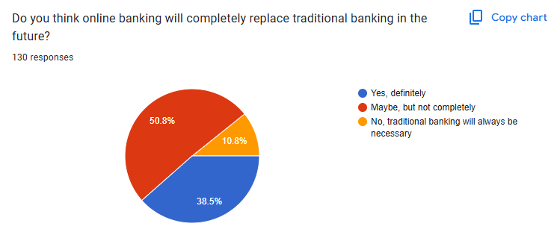

|  |  |  |
| --- | --- | --- |
| **RESPONSE** | **FREQUENCY** | **PERCENTAGE** |
| Yes, definitely | 50 | 38.4% |
| Maybe, but not completely | 66 | 50.8% |
| No. traditional banking will always be necessary | 14 | 10.8% |
| **TOTAL** | 130 | 100% |

Source: Primary Data

A majority of respondents (50.8%) believe that online banking might replace traditional banking but not entirely. Meanwhile, 38.5% think it will completely take over, while 10.8% believe traditional banking will always be necessary. This suggests that while digital banking is gaining strong acceptance, a segment of users still values physical banking services.

**FINDINGS**

The study finds a number of important facts about how satisfied customers are with both traditional and online banking. Because it is convenient, quick, and available 24/7, online banking has become increasingly popular. For activities like money transfers, bill payments, and checking account balances, the vast majority of consumers favor online banking. But many users are still worried about security threats like identity theft, data breaches, and cyber fraud, which makes them less likely to fully embrace digital banking. Poor customer service, system outages, and technical issues all have an effect on how satisfied customers are with online banking.

According to the study, age and occupation have a significant impact on banking preferences, with younger, tech-savvy people more likely to prefer digital banking while older and less tech-savvy people prefer traditional banking. Customers who value personalized service, face-to-face interactions, and a sense of security continue to prefer traditional banking, and many customers still rely on physical branches for complex transactions, large fund transfers, and financial consultations. However, long waiting times, limited banking hours, cumbersome paperwork, and slow service processes negatively affect customer satisfaction.

The study shows that trust, accessibility, and service quality are all strongly related to customer happiness. Consumers anticipate that banks will provide safe, effective, and easy-to-use online services while preserving solid client relationships with branch-based assistance. The results highlight how financial institutions must blend traditional customer service with digital innovation in order to satisfy changing consumer demands.

**SUGGESTIONS**

Banks should concentrate on strengthening online banking security measures by introducing multi-factor authentication, AI-driven fraud detection, and frequent cybersecurity updates in order to increase client happiness. The digital banking experience will be significantly improved by resolving technical issues and guaranteeing continuous access to digital services through improved IT infrastructure and proactive customer support. In order to assist customers, develop confidence in digital transactions, banks should also fund financial literacy initiatives that teach them how to use online banking platforms safely.

The customer experience in traditional banking can be greatly enhanced by cutting back on bureaucratic processes, improving the effectiveness of in-branch services, and expanding operating hours. More flexibility will be provided with the introduction of self-service kiosks, automated cash deposit machines, and hybrid banking models that allow users to alternate between online and offline services. Customers that prefer in-person banking encounters can be retained by improving customer relationship management through loyalty programs, individualized financial planning, and committed advisors.

Future expansion requires a hybrid strategy that integrates the advantages of both banking methods. Banks should concentrate on creating integrated banking solutions that allow users to switch between branch-based and internet services with ease. While traditional branches can develop into advisory centers providing specialized financial services, mobile apps with AI-powered chat help, digital loan approvals, and biometric security measures can enhance the ease of online banking. Banks can maintain long-term client pleasure, build trust, and stay competitive in the changing financial landscape by embracing a customer-centric strategy that places a high priority on security, efficiency, accessibility, and customized service.

**CONCLUSION**

The study on customer satisfaction in online banking versus traditional banking highlights key differences in customer preferences, concerns, and experiences with both banking models. The findings indicate that while online banking is increasingly favored for its accessibility, speed, and 24/7 availability, traditional banking retains significance due to its trustworthiness, personalized customer service, and perceived security. A significant proportion of respondents prefer online banking for routine transactions such as fund transfers, bill payments, and balance inquiries due to its convenience. However, concerns about cybersecurity, technical failures, and impersonal service interactions remain major challenges for digital banking adoption. On the other hand, traditional banking, despite being time-consuming, continues to be the preferred choice for complex transactions, high-value deposits, and personalized financial advice.

The study also shows that demographic characteristics like age, occupation, and level of technological proficiency have an impact on customer satisfaction. While elderly people and those who are less accustomed to digital platforms are hesitant to fully abandon traditional banking services, younger consumers and professionals are more likely to use online banking. Security is still a major concern for both banking methods. Consumers anticipate that banks will increase their investments in data protection, fraud prevention, and cybersecurity measures in order to boost confidence in online banking. In a similar vein, conventional banks must innovate by fusing digital services with their physical locations to provide a hybrid experience that caters to a range of client demands.

There are benefits and drawbacks to both banking structures. By strengthening customer service, merging digital and traditional banking services, and boosting digital security, banks may maximize consumer satisfaction in a balanced manner. The future of banking is a smooth, customer-focused experience that preserves dependability and trust while guaranteeing accessibility, convenience, and security.

**REFERENCES**

1. Al Faisal, N., Nahar, J., Waliullah, M., & Borna, R. S. (2024). The Role of Digital Banking Features in Bank Selection an Analysis of Customer Preferences for Online and Mobile Banking. Frontiers in Applied Engineering and Technology, 1(01), 41-58.
2. Kim, L., & Yeo, S. F. (2024). How stress and satisfaction influence customer service quality in banking industry. Heliyon, 10(11).
3. Mainardes, E. W., & Freitas, N. P. D. (2023). The effects of perceived value dimensions on customer satisfaction and loyalty: a comparison between traditional banks and fintech’s. International Journal of Bank Marketing, 41(3), 641-662.
4. Sandhu, S., & Arora, S. (2022). Customers' usage behaviour of e‐banking services: Interplay of electronic banking and traditional banking. International Journal of Finance & Economics, 27(2), 2169-2181.
5. Arshad Khan, M., & Alhumoudi, H. A. (2022). Performance of E-banking and the mediating effect of customer satisfaction: a structural equation model approach. Sustainability, 14(12), 7224.
6. Khan, I. U. (2022). How does culture influence digital banking? A comparative study based on the unified model. Technology in Society, 68, 101822.
7. Nocera, G. (2022). Fintech revolution and traditional banks-what factors influence members of generation Z to place their trust in Fintech companies, specifically neo banks, over traditional banks as banking and financial service providers? a case study on the banking application of the Swiss neobank Yuh.
8. Dhurup, M., Surujlal, J., & Redda, E. (2014). Customer perceptions of online banking service quality and its relationship with customer satisfaction and loyalty. Mediterranean Journal of Social Sciences, 5.
9. Nimako, S. G., Gyamfi, N. K., & Wandaogou, A. M. M. (2013). Customer satisfaction with internet banking service quality in the Ghanaian banking industry. International journal of scientific & technology research, 2(7), 165-175.
10. Kadir, H. A., Rahmani, N., & Masinaei, R. (2011). Impacts of service quality on customer satisfaction: study of online banking and ATM services in Malaysia. International Journal of Trade, Economics and Finance, 2(1), 1.