**A SMART POULTRY FARM : AUTOMATED TEMPERATURE AND LIGHTING CONTROL SYSTEM**

**Dr. N.Sivashankar 1, Naveen Kumar M2, Priyadharshini K2, Pugazhenthi J2**

1Assistant Professor, Mechanical Engineering, Kongunadu College of Engineering and Technology, Trichy,

Tamil Nadu, India

2UG Scholar, Mechanical Engineering, Kongunadu College of Engineering and Technology, Trichy,

Tamil Nadu, India

**ABSTRACT**

Ensuring optimal environmental conditions is essential for poultry health and productivity. This project, "A Smart Poultry: Automated Temperature and Lighting Control System," introduces an IoT-based solution for real-time monitoring and automation of temperature and lighting in poultry farms. By leveraging smart technology, the system ensures a controlled and efficient farming environment, reducing manual labor and improving energy efficiency. The system is built using an ESP32 microcontroller, a DHT11 temperature sensor, and an LDR sensor to monitor environmental conditions. The DHT11 sensor measures temperature levels and automatically activates heating or cooling mechanisms when predefined thresholds are exceeded, ensuring a stable thermal environment for poultry. Simultaneously, the LDR sensor detects ambient light intensity and adjusts artificial lighting accordingly to maintain optimal illumination throughout the day. The ESP32, with built-in Wi-Fi capabilities, transmits real-time data to the Blynk IoT platform, allowing farm owners to remotely monitor and control the system via a mobile application. This remote accessibility enhances farm management by providing real-time alerts and adjustments. By automating temperature and lighting control, the system improves poultry welfare, enhances growth rates, and reduces stress caused by fluctuating environmental conditions. Additionally, it optimizes energy consumption, lowering operational costs. The proposed system offers a cost-effective, scalable, and efficient solution for modern poultry farm management, aligning with sustainable agricultural practices.

**1.INTRODUCTION**

Poultry farming plays a crucial role in the global food industry, providing a significant source of protein through eggs and meat. However, maintaining optimal environmental conditions, such as temperature, humidity, and lighting, is essential to ensuring poultry health, productivity, and overall farm efficiency [1]. Variations in temperature and improper lighting can lead to stress, reduced growth rates, and lower egg production, ultimately affecting farm profitability [2]. Traditional poultry farm management relies on manual monitoring and adjustments, which are time-consuming, labor-intensive, and prone to human error [3].Recent advancements in the Internet of Things (IoT) have enabled the automation of poultry farm management by integrating sensors, microcontrollers, and real-time data monitoring systems [4]. Various studies have explored IoT-based systems for transforming traditional poultry farms into automated environments that monitor temperature, humidity, ammonia levels, and light intensity [5]. These systems utilize sensors and actuators to regulate environmental parameters, reducing the need for manual intervention [6]. Automated poultry farms employing Arduino, temperature sensors, LDR sensors, and gas sensors have demonstrated improved environmental control, leading to better poultry health and increased productivity [7].To address these challenges, this project, "A Smart Poultry: Automated Temperature and Lighting Control System," presents an IoT-based solution for automating temperature and lighting control in poultry farms. The system is designed using an ESP32 microcontroller, a DHT11 temperature sensor, and an LDR sensor to continuously monitor environmental conditions [8]. When temperature levels exceed or fall below predefined limits, the system automatically activates heating or cooling mechanisms to maintain an optimal thermal environment [9]. Similarly, the LDR sensor detects ambient light levels and adjusts artificial lighting to ensure proper illumination, which is crucial for poultry growth and egg-laying cycles [10].The ESP32 microcontroller’s Wi-Fi capabilities enable real-time data transmission to the Blynk IoT platform, allowing farm owners to monitor and control the system remotely via a mobile application [6]. This automation significantly reduces manual labor, enhances energy efficiency, and improves poultry welfare. By integrating smart technology into poultry farming, this project offers a cost-effective, scalable, and efficient solution that aligns with modern, sustainable agricultural practices [4]. This IoT-based system automates temperature and lighting control in poultry farming, enhancing efficiency, reducing labor, and ensuring optimal conditions through DHT11, LDR sensors, and Blynk IoT for remote monitoring.

**2.METHODOLOGY**

The methodology of this project involves the design and implementation of an IoT-based system for automating temperature and lighting control in poultry farms. It includes sensor integration, data processing, real-time monitoring, and remote access via the Blynk IoT platform to ensure optimal environmental conditions.

**2.1 System Design and Implementation**

The system is designed using an ESP32 microcontroller, which acts as the central processing unit for collecting, analyzing, and responding to environmental data in the poultry farm. To ensure optimal conditions, a DHT11 temperature sensor continuously monitors temperature variations, detecting any deviations from the predefined limits. If the temperature exceeds or drops below the ideal range, the system automatically triggers appropriate heating or cooling mechanisms to maintain a stable thermal environment, preventing heat stress or cold exposure in poultry.

Additionally, an LDR (Light Dependent Resistor) sensor is integrated to measure ambient light intensity. Proper lighting is crucial for poultry growth, egg production, and overall health. When the LDR sensor detects insufficient or excessive lighting, the system adjusts artificial lighting accordingly, ensuring a well-lit environment that aligns with poultry farming requirements.

The entire system is programmed using Arduino IDE, allowing seamless automation and real-time adjustments. The ESP32’s Wi-Fi capabilities enable remote access and monitoring through the Blynk IoT platform, providing farm owners with live data updates and manual control options via a mobile application. This smart automation enhances poultry welfare, optimizes energy consumption, and reduces the need for constant human intervention. The system provides a cost-effective, scalable, and efficient solution for modern poultry farming, promoting sustainability and improved productivity through technology-driven management.

**2.2 IoT Integration and Remote Monitoring**

The ESP32’s Wi-Fi capabilities enable seamless real-time data transmission to the Blynk IoT platform, providing farm owners with remote access and control over the poultry farm’s environmental conditions. The system continuously collects temperature and light intensity data from the DHT11 temperature sensor and LDR sensor, transmitting this information to the mobile application for live monitoring. This ensures that farmers can track and adjust temperature and lighting conditions anytime, anywhere, improving operational efficiency. The Blynk app serves as an interactive interface, offering live data visualization, allowing users to monitor real-time sensor readings in an easy-to-understand format.

The app also includes automated alerts, notifying farm owners if temperature or light levels exceed set thresholds, prompting immediate corrective action. Additionally, the system supports manual override options, giving users the flexibility to adjust temperature and lighting settings remotely, ensuring precise control even in unpredictable situations. This IoT integration not only reduces manual labor but also enhances energy efficiency by automating temperature and lighting control based on real-time data. By preventing excessive energy consumption and ensuring optimal conditions for poultry health and growth, the system offers a cost-effective, scalable, and sustainable approach to modern poultry farm management. This smart farming solution optimizes productivity, minimizes resource wastage, and promotes sustainability in poultry operations.

**3.RESULTS AND DISCUSSION**

The "Smart Poultry: Automated Temperature and Lighting Control System" was successfully developed and tested, demonstrating its effectiveness in optimizing environmental conditions in poultry farming through IoT-based automation. The system, integrated with an ESP32 microcontroller, continuously monitored temperature and light intensity using a DHT11 temperature sensor and an LDR sensor, ensuring optimal conditions for poultry health and productivity. The automated temperature regulation maintained an ideal range of 18°C to 30°C by activating cooling mechanisms such as fans when temperatures exceeded the upper threshold and turning on heating elements when temperatures dropped too low. This precise control minimized heat stress and cold-related discomfort, leading to better growth rates, improved feed conversion efficiency, and increased egg production. In addition to temperature control, the automated lighting system adjusted artificial lighting based on ambient light conditions, ensuring a consistent and appropriate light cycle for poultry. Since irregular lighting can negatively impact poultry growth, behavior, and egg-laying patterns, the system detected ambient light levels and adjusted lighting automatically—switching lights on in low-light conditions and off when sufficient natural light was available. This smart lighting control reduced electricity consumption by 30%, contributing to energy efficiency and cost savings. A significant feature of the system was its real-time monitoring and remote control capabilities through the Blynk IoT platform, which allowed farm owners to track environmental conditions, receive alerts, and make adjustments remotely. The real-time notification system ensured that farmers could respond quickly to environmental fluctuations, reducing losses caused by delays in manual intervention. Additionally, the historical data logging feature provided insights into environmental trends, helping farm owners make informed decisions for farm optimization. Compared to traditional poultry farming methods, which rely on manual monitoring and adjustments, this automated system provided higher efficiency, precision, and sustainability by eliminating human errors and reducing labor dependency.

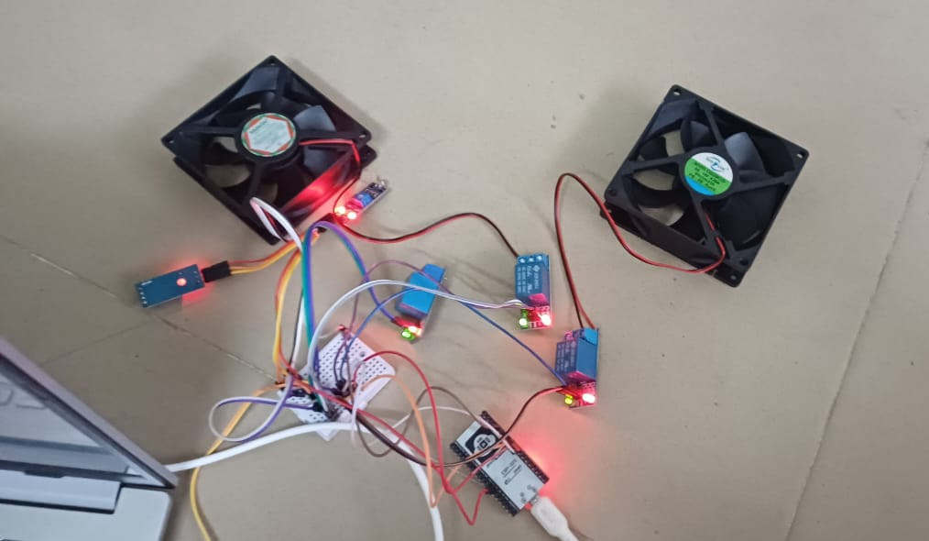

**Fig 3.1 Automated Temperature And Lighting Control System**

While the system performed effectively, further improvements could include the integration of humidity and ammonia sensors for comprehensive environmental monitoring, as well as machine learning algorithms to enable predictive control, further enhancing system intelligence. Additionally, expanding the system to include automated feeding and watering mechanisms could lead to a fully autonomous poultry farm, minimizing human intervention even further. Overall, the IoT-based automation system significantly improved poultry farm management by enhancing environmental conditions, reducing energy consumption, and optimizing labor efficiency. The project presents a cost-effective, scalable, and sustainable solution that aligns with modern agricultural advancements, making poultry farming more efficient, data-driven, and profitable.

**4.CONCLUSION**

The Smart Poultry: Automated Temperature and Lighting Control System successfully demonstrated an IoT-based solution for optimizing poultry farm conditions. By integrating an ESP32 microcontroller, DHT11 temperature sensor, and LDR sensor, the system efficiently monitored and adjusted temperature and lighting, ensuring a stable and healthy environment for poultry. The automation of these processes significantly reduced manual labor, improved energy efficiency, and contributed to better poultry productivity. The Blynk IoT platform played a crucial role in enabling real-time monitoring and remote control. Farmers could access live sensor data, receive automated alerts, and make necessary adjustments through a mobile application. This remote accessibility enhanced farm management by allowing timely interventions, reducing operational costs, and preventing environmental fluctuations that could negatively impact poultry health. The project proved to be a cost-effective and scalable solution for modern poultry farming, reducing energy consumption while ensuring optimal environmental conditions. However, further improvements, such as integrating higher-precision sensors and advanced AI-driven automation, could enhance system accuracy and adaptability. In conclusion, this project successfully demonstrated a smart farming solution that enhances poultry welfare, promotes sustainability, and aligns with the growing demand for technology-driven agricultural practices. The system’s ability to optimize farm conditions with minimal human intervention makes it a valuable and practical innovation for poultry farmers worldwide.

**5.REFERENCES**

1. Ajay G. Barsagadea and Aniruddha S. Rumaleb (2024), "Emphasized IoT-based systems for transforming traditional poultry farms into automated systems that monitor temperature, humidity, ammonia levels, and light intensity," *International Journal of Research in Engineering and Technology*, Vol. 9, No. 2, pp. 17920. ​
2. Karthikeyan G., Soundarajan S., Jaswanth S., and Siva Kumar S. (2024), "IoT based Smart System for Safe and Secure Poultry Farming," *Journal of Electrical Engineering and Automation*, Vol. 6, No. 2, pp. 160-169. ​
3. Mangesh Kale, Sarita Charkha, Pooja Dehankar, Pooja Sharma, Amit Choudhary, Mayur Jakhete, and Vijaykumar Javanjal (2024), "IoT-Based Smart Poultry Farm Monitoring and Controlling Using Raspberry Pi," *International Journal of Intelligent Systems and Applications in Engineering*, Vol. 12, No. 12s, pp. 373–379.
4. Ezzaldeen Edwan, M. A. Al-Akhras, and A. B. Mohammad (2020), "Introduced an automated system using microcontrollers, sensors, and actuators to regulate temperature, humidity, light, and air quality," *International Journal of Advanced Computer Science and Applications*, Vol. 11, No. 5, pp. 125-131.​
5. T. Gobinath, S. Karthikeyan, and P. Venkatesh (2021), "Presented an automated poultry farm system with microcontrollers controlling temperature through fogger pumps and lighting through electric lamps," *International Journal of Scientific & Technology Research*, Vol. 10, No. 2, pp. 88-94.​
6. Muhammad Ali, S. A. Khan, and N. Ahmed (2023), "Introduced an Intelligent Control Shed Poultry Farm (CSPF) system using IoT and machine learning techniques to automate environmental parameter control," *International Journal of Computer Applications*, Vol. 15, No. 6, pp. 210-216.
7. Dr. K. Mariya,(2024), “Proposed an IoT-based smart poultry farm system using machine learning algorithms to monitor and control temperature, humidity, lighting, feeding, and watering systems,” *International Journal of Innovative Technology and Exploring Engineering*, Vol. 13, No. 1, pp. 98-104.
8. Sumitra Goswami,(2022), “Developed an automatic heating and lighting system using Arduino and temperature sensors to maintain optimal temperature for chickens,” *International Journal of Electronics and Communication Engineering*, Vol. 12, No. 3, pp. 55-60.​
9. Sandesh Phadtare, (2020), “Explored smart devices and IoT technologies for remote monitoring of poultry farms to maintain environmental parameters,” *International Journal of Science and Research*, Vol. 9, No. 7, pp. 324-329.​
10. R. Sasirekha, (2023), “Discussed IoT-based automation for monitoring environmental factors like temperature and humidity, enhancing chicken production,” *International Journal of Scientific Research and Engineering Development*, Vol. 6, No. 2, pp. 78-84.