**FABRICATION OF DECOR WINDOWS FROM BROKEN SOLAR PANEL GLASS**

**Manikandan I, Monish S, Rubinraj K**

Student, Mechanical Engineering, Kongunadu College of Engineering and Technology, Trichy, Tamil Nadu, India

Student, Mechanical Engineering, Kongunadu College of Engineering and Technology, Trichy, Tamil Nadu, India Student, Mechanical Engineering, Kongunadu College of Engineering and Technology, Trichy, Tamil Nadu, India

**ABSTRACT**

The increasing accumulation of broken and discarded solar panels poses a significant environmental challenge due to the complexity of recycling their components, particularly the glass. Since solar panel glass is often treated with coatings and embedded with various materials, traditional recycling methods struggle to efficiently separate and repurpose it. As a result, large quantities of broken solar panels end up in landfills, contributing to environmental degradation. This project aims to repurpose broken solar panel glass into decorative windows, providing a sustainable and aesthetically appealing solution for solar waste management. The process involves collecting, cleaning, reshaping, and reinforcing the broken glass to enhance its strength and usability. Various techniques such as texturing, coloring, and lamination will be explored to improve the visual appeal and durability of the final product. Additionally, protective coatings may be applied to increase resistance to weathering and impact. By transforming waste materials into valuable architectural elements, this project promotes circular economy principles and supports eco-friendly construction practices. The use of repurposed solar glass in decorative windows can help reduce energy consumption in glass production, minimize landfill waste, and lower CO₂ emissions associated with traditional glass manufacturing. Furthermore, the project investigates cost-effective and scalable methods to ensure practical commercial applications. Through this innovative approach, it aims to bridge the gap between sustainability and design, offering an environmentally responsible alternative to conventional decorative glass

1. **INTRODUCTION**

Solar energy is a widely recognized renewable source that reduces reliance on fossil fuels and mitigates climate change. However, the rapid adoption of solar photovoltaic (PV) technology has led to a growing concern—the disposal of end-of-life solar panels. With a lifespan of 25 to 30 years, many panels will soon be decommissioned, increasing solar waste. Traditional disposal methods, such as landfill dumping, are unsustainable due to toxic material leakage and resource depletion. Recycling solar panels is challenging due to their complex composition, particularly the glass, which constitutes about 70% of a panel’s structure. Unlike ordinary glass, solar panel glass is treated with anti-reflective coatings and laminations, making conventional recycling inefficient and costly. The presence of hazardous substances further complicates the process. As a result, many decommissioned panels end up in landfills, increasing environmental concerns. A sustainable alternative is repurposing solar panel glass into decorative windows and architectural elements, aligning with circular economy principles. This process involves cleaning, reshaping, and enhancing the glass through techniques such as texturing, lamination, and coloring. Repurposed solar glass reduces landfill waste, lowers energy consumption for new glass production, and promotes eco-friendly construction. Beyond environmental benefits, this approach has economic potential, creating new markets for sustainable building materials and job opportunities in recycling and manufacturing. Governments and industries must support policies and innovations for solar waste management. By integrating sustainability into the entire lifecycle of solar technology, solar energy can remain a truly green solution for the future.

1. **METHODOLOGY**

The methodology for this project involves a structured process to repurpose broken solar panel glass into decorative windows. It includes collection and sorting, cleaning and preparation, design processing, and integration with finishing to enhance durability and aesthetics

**2.1 Collection and Cleaning**

The process begins with the collection of broken or discarded solar panels from various sources, including solar farms, recycling centers, and manufacturers. These panels are carefully sorted based on size, condition, and glass quality to determine their suitability for repurposing. Panels with extensive damage or contamination are set aside for alternative recycling, while those with intact or minimally damaged glass are selected for further processing. Proper handling is crucial to prevent additional breakage during transportation and storage. once collected, the glass undergoes an extensive cleaning process to remove dust, adhesives, and coatings that may interfere with further processing. Mechanical cleaning methods, such as scrubbing, pressure washing, and abrasive techniques, eliminate surface residues. Chemical cleaning involves the use of solvents or mild acids to dissolve tough adhesives, anti-reflective coatings, and encapsulants. This step is essential to restore the transparency and quality of the glass .Following cleaning, the glass is inspected for cracks, scratches, or structural weaknesses. Any heavily damaged sections are either reinforced or removed to ensure only high-quality glass is used. Proper drying techniques, such as air drying or heat treatment, are applied to prevent water stains and improve adhesion for later processing. This meticulous preparation ensures the durability and usability of the repurposed glass for decorative window applications.

* 1. **Design and Finishing**

After cleaning, the glass is carefully cut and shaped into desired decorative window patterns using specialized glass-cutting tools. Precision cutting ensures minimal waste while achieving the required design specifications. The shaping process may involve grinding and polishing the edges to eliminate sharpness, enhancing safety and usability. The design phase incorporates various techniques to improve the aesthetic appeal and structural integrity of the glass. Methods such as texturing, etching, and sandblasting create intricate patterns, while coloring and lamination add visual effects and durability.

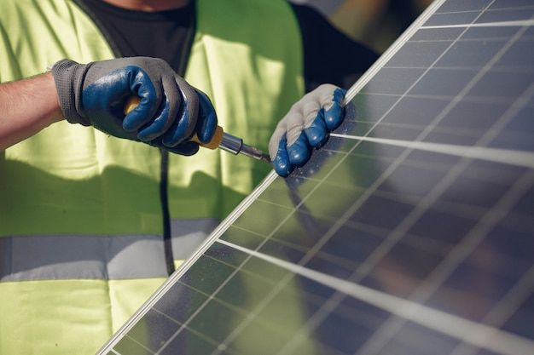

These techniques help in transforming plain glass into an elegant decorative element suitable for architectural applications. Additionally, reinforcement with protective coatings or backing materials enhances impact resistance and longevity. During the finishing stage, the processed glass is integrated into sturdy frames made from materials like metal, wood, or composites to ensure stability and durability. The final step involves applying proper sealing to protect against moisture, UV exposure, and temperature variations, ensuring long-term performance. This meticulous process guarantees that the repurposed solar glass is transformed into a functional, eco-friendly, and visually appealing decorative window, contributing to sustainability and innovative architectural design.

1. **RESULTS AND DISCUSSION**

The transformation of discarded solar panel glass into decorative windows demonstrated significant potential for repurposing decommissioned photovoltaic materials into valuable architectural elements. The study assessed material quality, structural integrity, aesthetic appeal, environmental sustainability, and economic feasibility. Rigorous cleaning and processing effectively restored the glass by removing encapsulants, anti-reflective coatings, and contaminants. Mechanical testing confirmed that the repurposed glass retained its original strength while benefiting from additional reinforcement through lamination, resin filling, and protective coatings.

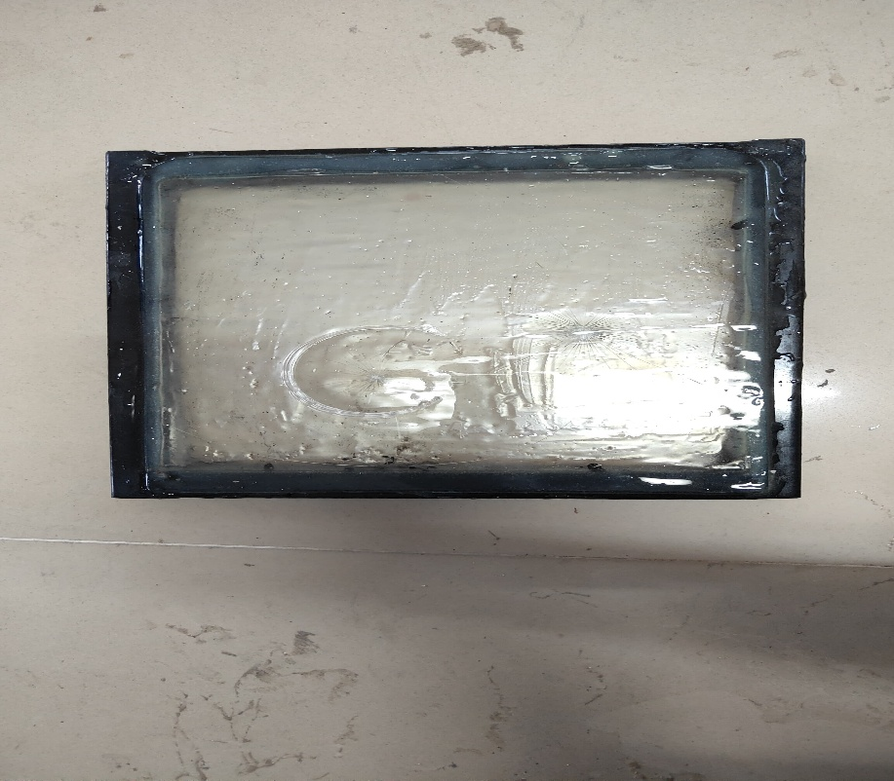

The final product exhibited high impact resistance, flexural strength, and thermal stability, meeting industry standards as a viable alternative to traditional architectural glass. From a design perspective, techniques such as sandblasting, acid etching, and ceramic screen printing produced visually striking effects. Colored films and interlayers enhanced stained-glass aesthetics, while advanced surface treatments like UV-resistant coatings and self-cleaning nano-coatings improved longevity and maintenance efficiency. The resulting glass featured exceptional optical clarity and customization options, making it ideal for architectural designs, interior partitions, and decorative panels. Sustainability played a key role, as the project reduced electronic waste, minimized raw material extraction, and aligned with circular economy principles. However, challenges arose in removing photovoltaic layers and anti-reflective coatings, requiring advanced treatments. Precision cutting and reshaping also demanded specialized equipment to avoid micro-cracks. Despite these challenges, future advancements in processing, automation, and reinforcement technologies could further enhance the feasibility of this approach. Economically, repurposing solar glass reduces costs and supports the growing demand for eco-friendly materials. With continuous research and industry collaboration, this method offers a scalable and sustainable solution for modern construction.

**CONCLUSION**

The research effectively demonstrated the feasibility of repurposing discarded solar panel glass into high-quality decorative windows, offering a sustainable solution for managing end-of-life photovoltaic materials. Through systematic collection, sorting, cleaning, and processing, the glass was restored and transformed into aesthetically appealing and structurally robust architectural elements. Various design techniques, including sandblasting, acid etching, ceramic screen printing, and colored interlayers, enhanced the visual appeal of the final product, making it a viable alternative to conventional glass in modern architecture and interior design. Structurally, the repurposed glass exhibited excellent mechanical properties such as high impact resistance, durability, and thermal stability, ensuring long-term applications. Protective coatings, including UV-resistant layers, self-cleaning nano coatings, and anti-glare treatments, improved performance, reduced maintenance, and enhanced user experience. Despite challenges in processing, such as removing encapsulants and precision cutting, advanced mechanical and chemical treatments successfully addressed these issues. Environmentally, this approach contributes to waste reduction, resource conservation, and carbon footprint minimization by extending the lifecycle of photovoltaic glass. It aligns with global sustainability goals, reducing demand for virgin raw materials and energy-intensive glass production. Economically, repurposing solar glass provides cost-effective alternatives for manufacturers while meeting the rising demand for sustainable materials. With further refinements and industry collaboration, this method has the potential for large-scale implementation. In conclusion, the study showcased a practical, sustainable, and economically viable approach to integrating repurposed glass into modern architecture, paving the way for future advancements in green construction.

.

1. **REFERENCES**

[1] Bohland, J. R., Anspaugh, B. E., & McMahon, T. J. (2000). “A method of economically recovering silicon wafers from x-Si PV modules.”, *13(1)*, pp. 2592.

[ 2] Doi, T., Tsuda, I., Yamashita, M., & Takahashi, S. (2001). “Organic solvent method to recover silicon cells from conventional crystalline silicon PV modules.”, *2(5)*, pp. 576-595.

[3] Chi, X., Streicher-Porte, M., Wang, M. Y. L., & Reuter, M. A. (2014). “Collection channels of waste electrical and electronic equipment (WEEE or e-waste) and household recycling behaviors in Taizhou city of China.”, *34(35)*, pp. 2306162.

[4] Bakhiyi, B., Labrèche, F., & Zayed, J. (2014). “Hazardous materials handled in the PV industry warrants.” *ResearchGate, 4(10)*, pp. 121052.

[5] Berger, W., Simon, F. G., Weimann, K., & Alsema, E. A. (2015). “A sustainable recycling of photovoltaic (PV) thin-film modules.”, *11(1)*, pp. 12456-12481.

[6] Tashtoush, J. M., & Alshobaki, A. (2023). “Atmospheric water harvesting: A review of techniques, performance, renewable energy solutions, and feasibility.” *ResearchGate, 10(1)*, pp. 128186.