**Unpacking Influencer Marketing: Societal Shifts, Ethical Challenges, and Strategic Solutions**

**Anju Panwar**

Research Scholar, Department of Commerce, Punjabi University, Patiala.

Email: [anju_usam23@pbi.ac.in](mailto:anju_usam23@pbi.ac.in)

Phone No.: 8059280480

**Gursimran Kaur**

Research Scholar, School of Applied Management, Punjabi University, Patiala.

Email: [gursimran_rs23@pbi.ac.in](mailto:gursimran_rs23@pbi.ac.in)

**Dr. Jasleen Kaur**

Assistant Professor, School of Applied Management, Punjabi University, Patiala.

Email: [jasleen_bas@pbi.ac.in](mailto:jasleen_bas@pbi.ac.in)

**Abstract**

Influencer marketing is a two-edged sword that can be used to build brands and engage audiences. This study explores the intricate dynamics of influencer marketing by examining the different factors that impact how consumers and businesses are affected by it. The first part of this paper looks at the societal shift that is driving the rise of influencer marketing, and then it looks at the current state of the influencer marketing scene, discussing both the advantages and potential drawbacks. In the end, authenticity and ethical behaviour will determine whether influencer marketing remains a positive force in the digital era. By emphasising media literacy to empower consumers and industry collaboration, as well as responsible practices like transparency and ethical messaging to foster trust, it provides information that helps create ethical procedures and complex tactics in this emerging industry.

***Keywords:*** *Influencer marketing, Positive influences, Negative Influences, Authenticity, Societal shift, Transparency, Responsible practices.*

**1. INTRODUCTION**

Global business and communication have been profoundly changed by the advancement of information and communication technology (ICT). The way we interact and maintain user interactions has been completely transformed by the internet in particular. It is still a potent worldwide media outlet and a major force behind globalisation today. E-marketing is becoming more and more popular in this competitive, globalised corporate climate that is driven by the internet. When compared to traditional approaches, e-marketing gives firms access to a considerably larger consumer base. Influencer marketing, which is akin to celebrity endorsements, has become one of the most rapidly expanding online client acquisition strategies. When used effectively, influencer marketing may be a cheap method to promote products, services, or ideas. It may also help businesses create original content and provide a new way to connect with their target audiences naturally (Peng et al., 2018).

An "influencer" is a person with a sizable social media following who receives compensation from businesses to market their goods to their followers. This compensation can take the form of free merchandise, vacations, or monetary payments made for each promotional post (Landsverk, 2014). Influencers frequently use Instagram, Facebook, Snapchat, and YouTube as their preferred social media platforms. Because of their standing, expertise, authority, or connection to their audience, influencers can sway other people's purchasing decisions. Through compelling narrative and sincere connection, a strategic engagement with influencers enables businesses to reach a specific audience, foster trust and brand recognition, and ultimately increase sales and brand loyalty. It's crucial to remember that these people are social connection assets that organisations may work with to accomplish their marketing goals rather than just basic marketing tools (Olenski, 2017).

Influencer marketing is becoming more popular, but it's not an overnight phenomenon; it's a reaction to a larger change in the way we consume and value information. Social media communities are gaining ground on traditional media institutions, which were formerly regarded as trustworthy sources. Here, regular people meet, bond over shared interests, and develop into reliable sources in their own right—influencers. Customers are drawn to personable characters over impersonal companies because they value authenticity. This tendency is further fueled by social media platforms, especially those like YouTube and Instagram that are centered around visual storytelling. Influencers are masters at creating interesting content that highlights goods in a way that appeals to their followers. Influencers are a relatively new phenomenon, and in the last year, their cooperation with marketing firms has grown significantly. Like any other kind of promotion, influencer marketing has both immediate and long-term advantages for the company and its target audience.

It's crucial to consider a brand influencer's social media following in addition to their quantity of followers. Nevertheless, the influence is not determined by the number of followers. A crucial component is the expertise and credibility that we refer to as "affinity marketing." One essential component is the interaction between influencers and their followers.

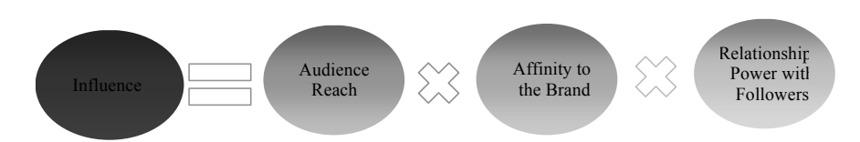

Source: ĎURAČKOVÁ, L.: Význam influencerov v online marketingu. Released on 28th September 2016. [online].

Figure 1: Mathematical expression of the influencer-follower relation

The fastest-growing communication channel for altering advertising stereotypes is influencer marketing (see Figure 1). Based on findings that support influencers and indicate that the target demographic has greater access to positive advertising and is better penetrated, this is being said. Due to the favourable outcome, this causes big businesses' advertising expenses to rise.

Social media has completely changed how we interact, obtain information, and consume media. Influencer marketing is becoming an increasingly significant force in an ever-changing marketplace. Consumer engagement, brand recognition, word-of-mouth, and the purchasing process are all positively impacted by influencer marketing (Hughes et al., 2019; Jin, 2018; Percy & Elliot, 2012; Lue and Yuan, 2019). Through the utilization of influencers' reach and credibility with their audience, businesses can mould customer perception and eventually increase sales. Product match must be evident for influencer marketing to work. When there is a poor match between the products, undesirable impacts begin to show. This phenomenon of influencers is not without its problems. A few potential issues that could erode consumer confidence and damage a business's reputation are the employment of misleading advertising, the potential for negative brand associations, unrealistic portrayals, and the vulnerability of younger audiences (Campbell and Farrell, 2020). Another negative effect of influencer marketing is covert advertising (Gürkaynak & Kama, 2018). By carefully selecting an influencer who exemplifies the attributes of their product and is reliable and honest, brands can lessen the negative effects. Thus, one may effectively manage the influencer-brand interaction environment by accurately detecting marketing possibilities and dangers through influencers.

This introductory chapter will examine the elements that contributed to the growth of influencer marketing, as well as the techniques that businesses are using to adapt to it and maximize its potential. We'll also look at the difficulties this strategy presents as well as the prospects for influencer marketing in the rapidly evolving social media space. Lastly, the necessity of ethical behaviour and responsible creation of content for the long-term viability of influencer marketing initiatives will be covered in this study.

**OBJECTIVES**

* To examine the societal shifts fueling the rise of influencer marketing.
* To contrasting dimensions defining the positive and negative influences of influencer marketing on consumers and brands.
* To list responsible practices and nuanced strategies be developed to address the potential adverse consequences of influencer marketing.

**RESEARCH METHODOLOGY**

The research was undertaken through a secondary mode to investigate the multifaceted dynamics of influencer marketing. A thorough review of relevant research articles and review papers is undertaken to gain comprehensive insights and an attempt is made to provide a summary of all of it. The study is organized into distinct sections to systematically address each research question. Section 2 describes societal shifts fueling the rise of influencer marketing. Section 3, focuses on studying the dimensions defining positive and negative influences of influencer marketing. Section 4 addresses to list and categorize responsible practices that can be employed in influencer marketing.

**2. SOCIETAL SHIFTS FUELING THE RISE OF INFLUENCER MARKETING**

Social media has significantly reshaped modern society, influencing communication, information sharing, and media consumption. This confluence of societal shifts created a perfect storm for influencer marketing. Consumers disillusioned with traditional advertising, turned to trusted online personalities for recommendations. Brands, recognizing the shift, embraced influencer marketing to connect with audiences more authentically and engagingly. By using their accounts to provide content and engage in genuine conversation, companies can cultivate community and brand loyalty through organic social media marketing. With the ability to target users precisely based on their interests and demographics, paid social media advertising has grown in popularity. It includes sponsored posts and display advertisements on sites like Facebook, Instagram, Twitter, and LinkedIn. A notable subcategory of marketing is influencer marketing, which is working with powerful people to connect with pre-existing networks and expand brand awareness. Influencers influence the buying decisions of their audience since they are seen as reliable authorities. This increases brand awareness and leads to sales. Remarkably, influencer marketing has expanded to a $21.1 billion sector, up 29% from the year before.

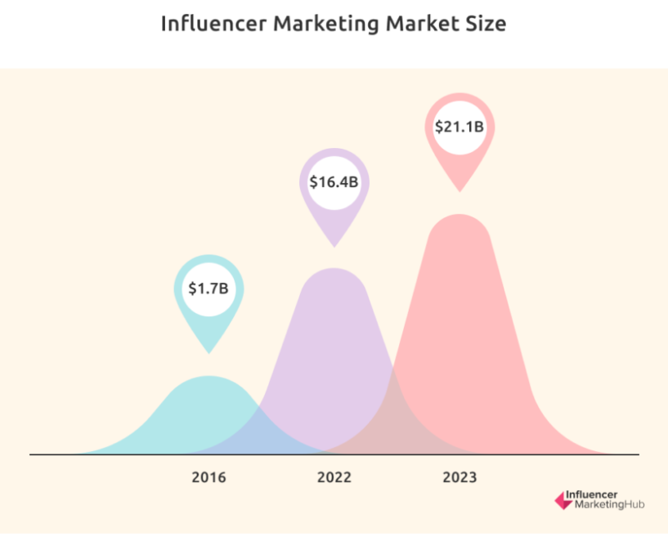

*(Source: - Influencer Marketing Hub, 2024)*

Figure 2: Growing market of influencer marketing

Influencers are a powerful tool for finding new products, particularly for Generation Z. Instagram has the highest ROI, but TikTok is a great place to interact, especially with smaller producers. Because of their accessibility and low cost, marketers are gravitating towards these micro-influencers more and more. The majority of firms still spend less than $50,000 a year on influencer marketing, despite a significant uptick in the field, with 80% of marketers having dedicated budgets (Influencer Marketing Hub, 2024).

According to Da Silva Oliveira & Chimenti (2021), one of the strategies for gaining new customers on the internet that are expanding the fastest is influencer marketing, which opens up new possibilities. When it comes to influencer marketing, 81% of marketers who have utilized it thought it worked (Haran, 2018). The key to success is to match businesses with the right influencer—this is the ideal connection. Success is certain for brands that collaborate with prominent individuals who consistently endorse their products. According to Holotapa et al. (2014), 3% of individuals possess the ability to produce 90% of the impact, which highlights the significance of marketing. Based on Tomson surveys, firms may create an average of $6.50 for every $1 invested in influencer marketing, indicating that influencer marketing offers a significant return on investment. This demonstrates that influencer marketing is both the online marketing channel and the client acquisition technique with the greatest rate of growth (Haran, 2018). According to Influencer Orchestration Network, 71% of buyers are more likely to purchase as a result of a social media reference, demonstrating the enormous impact of social media endorsements. This effect is most noticeable in the beauty sector, where influencers rule YouTube with 86% of the most viewed videos produced by them, compared to just 14% by beauty companies. The fact that views on beauty videos are rising at a rate of 65% annually highlights this tendency even more.

A graph by Statista depicting digital advertising spend in the US from 2017 to 2023 reveals a significant shift towards digital channels. In 2017, traditional advertising held the majority share at 68%, with digital ads following at 32%. However, the trend steadily reversed, with digital ad spending surging to 61% by 2023, while traditional advertising dipped to 39%. This dominance of digital advertising is likely fueled by its advantages like affordability, measurability, and precise audience targeting. This trend shows no signs of slowing down – projections for 2024 suggest digital ads will surpass two-thirds of the entire advertising industry's budget (Buchholz, 2021).

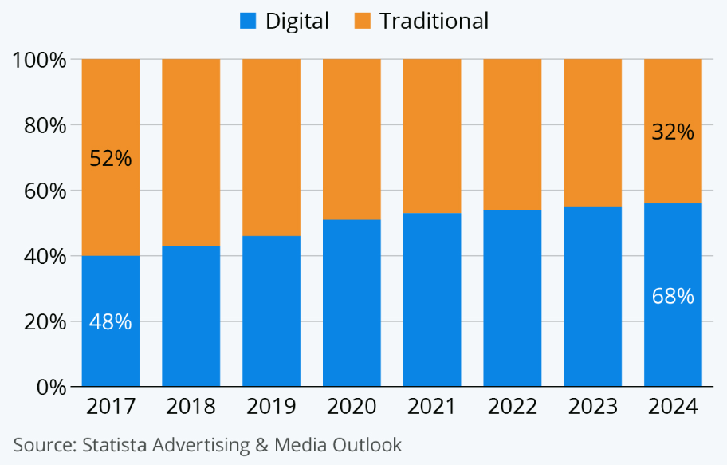

Figure 3: US advertising spend in digital and traditional advertising.

Social media has brought about an immense shift in communication, making it more instantaneous and engaging. anyone may now instantly communicate their ideas with anyone anywhere in the world, creating an unprecedentedly engaged and linked society. The effect on advertising and marketing is significant, with social media platforms playing a key role in customized and targeted efforts. Social media is becoming a crucial part of corporate marketing strategy due to this development. Positive developments brought about by social media include more connectedness and information openness (Giri, 2023). It has brought about issues such as the propagation of false information and the amplification of hate speech, but it has also fostered beneficial improvements like democratizing knowledge and improving global connectedness.

**3. DIMENSIONS DEFINING THE POSITIVE AND NEGATIVE INFLUENCES OF INFLUENCER MARKETING ON CONSUMERS AND BRANDS**

The use of influencers in marketing has two sides. Positively, it raises awareness of a brand through the credibility and reach of influencers, which may raise brand value and encourage customer interaction. Influencers have the power to advance even good causes, such as sustainability. But there are disadvantages. Customers are tricked by covert advertising, firms can be overshadowed by celebrity endorsements, and false representations on social media negatively impact their psychological well-being. Furthermore, influencer pressure breeds inauthenticity, and manipulative strategies put businesses' reputations in danger as well as FOMO (fear of missing out). Complicating matters are the ever-evolving platforms, moral dilemmas, and the susceptibility of younger viewers. Influencers and companies alike need to put transparency, moral behaviour, and ethical content first to succeed.

**3.3 POSITIVE** **INFLUENCES OF INFLUENCER MARKETING**

* **Brand awareness**

According to Percy and Elliott (2012), buyers need to be able to recognise a brand to make a purchase. In terms of memory and familiarity, brand awareness "serves to differentiate the brands" (Aaker & McLoughlin, 2010). Percy and Elliott (2012) distinguish between recognition and recall as the two types of brand awareness. When a customer recognizes a brand on the shelf at the time of sale, they have engaged in recognition. According to Percy and Elliot (2012), recall is the capacity to consider a brand before making a purchase. A brand is more likely to be included in a consumer's consideration set when they are choosing which product to purchase if they can recall it readily and are familiar with it (Nedungadi, 1990). Consequently, companies might gain from working with influencers.

* **Brand equity**

As stated by Kotler and Armstrong (2010), "a brand's ability to elicit consumer preference and loyalty is measured by its brand equity." When a brand has strong brand equity, customers respond to its goods or services more favourably than they do to comparable goods or services from brands that don't. According to Aaker and McLoughlin (2010), brand equity is "a collection of assets and liabilities connected to a brand's name and symbol that increase or decrease the value that a product or service offers to a company and/or that company's clients." Four categories—perceived quality, brand awareness, brand associations, and brand loyalty—can be used to group these advantages and liabilities.

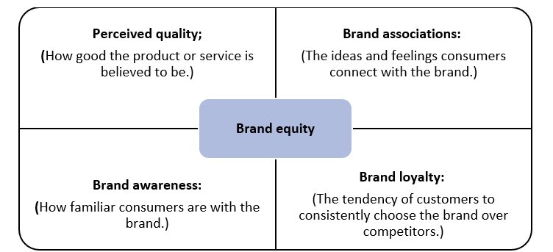

* **Brand associations**

Brands identify with the influencer when they employ influencer marketing to sell their products. Customers may associate the influencer's attributes—both positive and negative—with the brand and decide whether to like or dislike the product as a result (McCracken, 1989). Influencer marketing is thought to be significant to brand associations as well. Anything that a customer associates with a brand, whether directly or indirectly, is referred to as a brand association (Aaker & McLoughlin, 2010). Customers link a company and an influencer when the latter hires the influencer to promote their goods. According to McCracken (1989), the use of celebrities may help a brand become linked with desired attributes. An endorser's attributes are thus linked to the brand when they work with it to market its goods.

* **The buying decision process**

It's critical for businesses marketing to consumers to comprehend the steps customers take when making purchases of goods or services (Harvard Business Review, 2010). According to Jin and Phua's (2014) research, celebrities can significantly influence customers' intentions to make purchases. Nevertheless, the impact of influencer marketing on purchase intention has not received much research attention (Jin, 2018). What is known as the buying decision process is the set of predictable processes people take when determining whether or not to purchase a good or service. The five steps that a customer usually goes through—problem identification, information search, alternative assessment, purchase decision, and post-purchase evaluation—form the basis of the process. Some of the steps can be skipped or reversed by the customer.

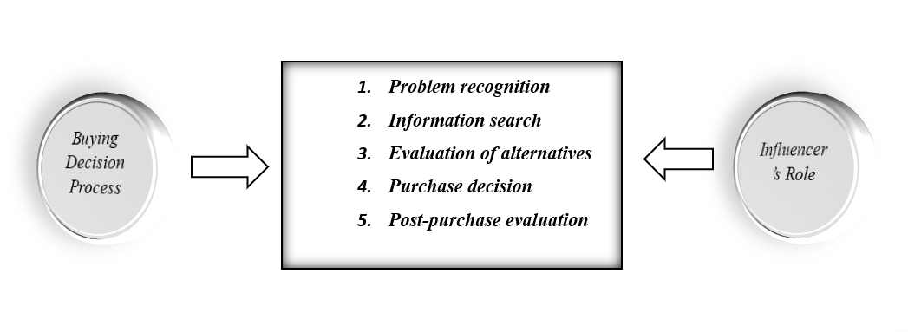

1. ***Problem recognition****:* Customers recognise a gap or need between their ideal and actual states. Advertisements are one type of external stimulus that can cause this, as well as internal ones like hunger and thirst. Influencers may create demand by highlighting goods that customers may not have previously thought about.
2. ***Information Search****:* Information regarding items that meet their demands is actively sought by consumers. This includes paying closer attention to pertinent ads and actively surfing the internet, chatting with friends, or going to stores. Here, brand awareness is important since customers are more inclined to think of well-known businesses. During this phase, influencers might serve as extra information sources.
3. ***Evaluation of Alternatives:*** Customers evaluate choices that fall within their "consideration set." To choose the best product, they evaluate features, advantages, and costs. Influencers may be utilized to draw attention to particular features of products that the participating businesses wish to promote.
4. ***Purchase Decision:*** To purchase the desired item, customers pick a retailer and a mode of payment. When buying low-commitment things (such as well-known food items), customers may bypass previous phases and proceed straight from problem identification to purchase.
5. ***Post-Purchase Evaluation:*** By contrasting their expectations with the product's actual performance, customers evaluate their level of satisfaction. Showcase the product's functionality in real-world situations to perhaps influence the post-purchase assessment.

* **Word of mouth**

Word-of-mouth (WOM) is the term used to describe information that is spread among individuals. As a result of consumers' increased reliance on peer-to-peer communication, influencer marketing is playing a bigger role in businesses' digital marketing strategies (Hughes et al., 2019). Approximately 75% of marketers use influencer marketing to generate word-of-mouth about their products on social media. Opinion leaders with a focus on a certain area are known as influencers. Influencers are typically followed because their actions are meaningful to them, and because of this, their words are more likely to be heeded. As soon as the followers start showing interest in the product, they often tell their twenty-four friends about it, creating word-of-mouth (WOM) that spreads as these friends tell their friends, and so on. Consumers' reliance on electronic word-of-mouth (eWOM) for recommendations of goods and services is growing.

* **Healthy Lifestyle**

According to a recent study, social media influencers—especially those who exemplify a healthy lifestyle, or "real fit influencers"—can have a significant impact on encouraging others to make smart dietary choices. According to the research, people who interact with these influencers tend to develop stronger parasocial connections—one-sided emotional connections—which results in a more favourable attitude towards the healthy food businesses they support and an increased propensity to buy such items. This demonstrates how social media influencers can have a favourable impact on eating behaviours, particularly for young individuals who use these platforms often (Folkvord et al. 2020).

* **Consumer engagement**

Advertisers need to know why consumers connect with brands and influencers on social media to effectively engage them online. According to Tsai and Men's (2013) research, entertainment, social integration, personal identity, and information are the main drivers of consumer participation on social networking platforms. One excellent method of raising customer involvement is through influencer marketing. Because they are interested in what the influencer does, people follow them in the hopes of engaging with them and enjoying their material (Hughes et al., 2019). Influencers frequently maintain close communication with their fans and invite comments on the material they post. Engagement with influencers varies depending on the platform and may be gauged by likes, comments, and the number of followers sharing their content.

**Empowerment:** Tsai and Men (2013) highlight social media as a key tool for consumer empowerment (p. 78). Social media's ease of interaction between consumers, brands, and other users empowers consumers to voice their opinions and demand better products, services, and corporate policies.

***Entertainment:*** Influencers leverage entertainment to keep their audience engaged (Tsai & Men, 2013). This entertainment provides relaxation and escape for followers, making it crucial for influencers to understand what content their audience finds enjoyable.

**Social integration:** Social media use can foster a sense of belonging by creating supportive online communities. Influencers who cultivate connections with their followers can contribute to this sense of community, making their audience feel like part of a larger group (Tsai & Men, 2013).

**Consumer engagement**

**Remuneration:** Muntinga et al. (2011) pinpoint remuneration as a significant motivator for social media participation, especially in online communities. In influencer marketing, this translates to influencers using incentives to encourage audience participation.

**Personal identity:** social media can be a tool for self-discovery and personal identity exploration (Tsai & Men, 2013). social media use can also contribute to self-understanding and a sense of belonging through peer recognition and connection (Muntinga et al., 2011).

**Information:** Social media offers a valuable platform for information seekers (Tsai & Men, 2013). Many influencers cater to this need by providing information relevant to their niche or expertise. Essentially, the information they share aligns with their area of specialization.

* ***Sustainable consumption***

Influencers on social media that promote sustainability in consumption are becoming more and more green. Utilizing many social media channels, such as open-access accounts, these micro-celebrities promote environmentally conscious behaviours and connect with a broad audience. They encourage people to adopt ecologically conscious habits and consumption patterns by exhibiting sustainable living through their content and knowledge. Its impact goes beyond individual decisions and can encourage cooperation between decision-makers and environmental advocates in the introduction of fresh sustainable projects (Yıldırım, 2021).

* **Meaning transfer model**

The McCracken Model (1989) explains how meaning flows from celebrities to products and then to consumers. It's believed this applies to influencers as well, due to their strong connections with followers. The model suggests celebrities build a cultural image through media appearances and roles. Consumers associate certain meanings with them, and if the marketing aligns well, those meanings can transfer to the products they endorse. Customers purchase the goods because of this meaning transfer in the hopes that other people would begin to link similar meanings with them as well (Sertoğlu et al., 2014). When customers haven't given the product any meaning, the brand can collaborate with a celebrity endorser who has the desired connotations the brand wants to attach to the product (Johansen & Guldvik, 2015). At each level, figures depict the three phases of the meaning transmission process.

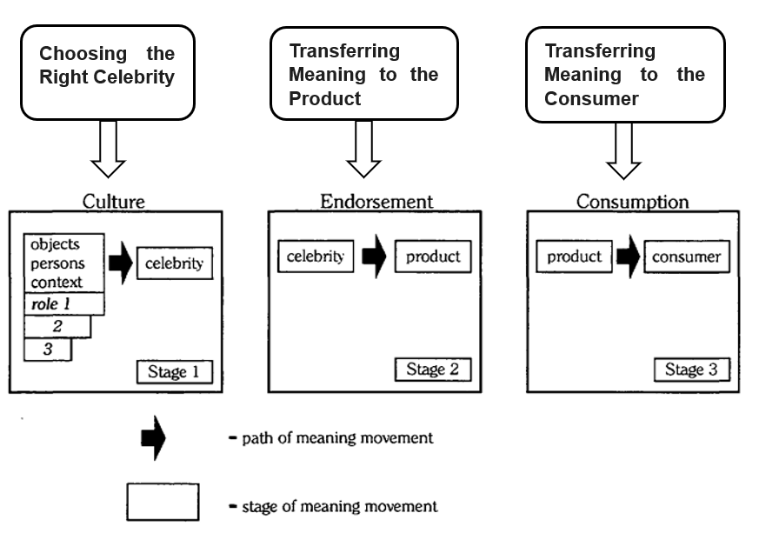

***(Source:*** *Adapted from* ***–*** *McCracken, 1989)*

**3.2 NEGATIVE INFLUENCES OF INFLUENCER MARKETING**

* **Covert advertising**

There is a lot of covert advertising these days because of social media and influencers. These sneaky ads are particularly common on Snapchat and Instagram. When customers don't realize they are interacting with commercial communication, they are subjected to convert (or misleading) advertising. Many individuals are unaware that influencers frequently receive compensation or free goods from businesses in exchange for promoting their goods and services. Customers have the right to choose to see commercial material with their eyes wide open and the right to know whatever content they are viewing is of that kind. The link between the influencer and the brand is unclear when they use covert advertising. Because of this, buyers frequently are unsure of whether influencers are endorsing a product because they truly believe in it or just because they are getting paid to say so (Gürkaynak & Kama, 2018).

* **Vampire effect**

According to Erfgen et al. (2015), the vampire effect is "defined as a decrease in brand recall for an advertising stimulus that features a celebrity endorser versus the same stimulus with an unknown but equally attractive endorser." There is a greater chance that a celebrity will overshadow a brand and that the public will remember the celebrity rather than the product if there is an unclear or absent link between the brand and the celebrity endorser. According to a study by Erfgen et al. (2015), the probability of the vampire effect may be reduced by having a clear compatibility and a strong cognitive association between the endorser and the product. When well-known celebrities are asked to promote a product on behalf of a company, it's critical that the product, not the celebrity, steals the show. Celebrities are very visible and frequently utilised by marketers to capture consumers' attention (Misra & Beatty, 1990). The vampire effect in influencer endorsement was verified by Rosengarten et al. (2017). Therefore, while thinking about influencer endorsement techniques, marketers need to be aware that the vampire effect exists. Only unaided brand recall, though, is directly impacted negatively.

* **Distortion of body image**

**There's a worrying correlation between eating disorders among teenagers and social media, especially concerning influencers on sites like Instagram. Influencers who actively promote athletics and diet items while emphasizing physical discipline to achieve a flawless physique present an ostentatious and false image of health. According to Pilgrim et al. (2019), this advertising may harm youth by promoting false notions of pleasure that are exclusively based on looks, poor body image, and an obsession with reaching unattainable physical objectives. A study by Ferdousi et al. (2023) found that female teens exposed to slimmer or curvier SMI through upward physical body comparison felt less satisfied with their bodies, which made them want to be in shape. According to Deng and Jiang (2023), appearance comparison acts as a mediating factor in the anxiety that followers experience in response to the looks of both actual and virtual influencers.**

* **Mental health deterioration**

Adolescents who are experiencing negative feelings, such as loneliness, may use social media excessively. According to Acar et al. (2020), teenagers use social media as a means of self-reflection or to satisfy their demand for social engagement. People who spend more time on social media are more likely to think that others have happier, more fulfilling lives, and are more successful, which has a detrimental effect on their self-esteem (Stapleton et al., 2017).

* **Social Comparison**

SMIs are well-known role models with large followings who work in niche markets like fashion and cosmetics. According to Dinh and Lee (2022), SMI's followers participate in upward social comparison and see them as being in a higher position than themselves since they customize many parts of their postings, such as how they appear while endorsing a product. Despite people's natural inclination to contrast themselves with others, consumers' comparisons with SMIs and their allegedly idealistic lifestyles on social media may harm their general well-being. Because the SMI cannot be emulated, this comparison may have negative effects, such as a decline in wellbeing (Barari, 2023).

* **Deterioration of authenticity & trust**

Influencers frequently use filters, selective editing, and staged events to present idealized versions of their lives and identities. Audiences find it challenging to establish a true connection with the influencer as a result of this gap between the portrayed reality and the real realities (Lou & Yuan, 2019). Viewers may become suspicious of promotions that are repeated or endorsements that are not genuine. When hidden sponsorships or inflated claims are involved, audiences may feel misled and grow suspicious of the influencer's genuine beliefs.

* **FOMO (Fear of Missing Out)**

SMI often display their lives, belongings, and adventures to their followers, making their audience feel envious and that they're missing out (Tandon et al., 2021). People then experience FOMO because they feel compelled to purchase the influencer's recommended goods to share in their experiences. Followers may feel as though they are missing out on something when they encounter SMI posts that display supposedly ideal lives and experiences while utilising a product (Xi et al., 2022). Their well-being may suffer as a result, even if this may cause them to feel uneasy, insecure, and dissatisfied with their own lives (Dhir et al., 2018).

* **Reputational Risk of Brands**

Because they are well-known, influencers end up representing the companies they collaborate with. They immediately affect how consumers view the brand by their activities and behaviour. Negative conduct linked to influencers or ethical scandals can seriously harm the brand's reputation (Campbell and Farrell 2020). As seen by the Tiger Woods affair, this can result in a decline in customer confidence and possibly large financial damages. Businesses must choose their influencers carefully if they want to reduce these fears. It is important to conduct a comprehensive assessment procedure that takes into account the influencer's prior conduct and personal values. It's also crucial to make sure the influencer's brand and the business's ideals are in sync. The campaign's objectives may be hampered by a mismatch that causes a rift with the intended audience (Backaler 2018).

* **Platform algorithms**

Social media algorithms make influencer visibility tricky. Platforms like Instagram favour visuals while YouTube thrives on longer videos, requiring influencers to pick a primary platform and adapt their content to its format (Haenlein et al., 2020). These platforms constantly change the rules of the game with algorithm updates, forcing influencers to stay on top of trends and platform-specific tactics (like hashtags). Even external trends can impact platform use (Harrigan et al. 2021). This creates challenges for brand collaborations, as campaign success hinges on navigating these ever-shifting dynamics. To ensure their message reaches the intended audience, both influencers and brands need to be constantly adapting.

* **Lack of Transparency & Disclosure**

Influencers must disclose when a business is paying for their content. This openness is essential since it has a direct impact on the audience's perception of the content. Since it suggests the brand values the influencer's work, revealing the brand and outlining the relationship might help the influencer become more credible (Stubb et al. 2019). Influencers who violate ethical standards may face serious repercussions from their followers. According to Martínez-López et al. (2020), one ethical rule is to disclose the financial support that businesses provide. Numerous nations have regulations requiring influencers to reveal to their followers, in specific forms, the financial backing of the content they make (Feng et al. 2021). Influencers who violate ethical standards may face serious repercussions from their followers. According to Martínez-López et al. (2020), one ethical rule is to disclose the financial support that businesses provide. Numerous nations have regulations requiring influencers to reveal to their followers, in specific forms, the financial backing of the content they make (Feng et al. 2021).

* **Parallel Advertising by Influencers**

One of the challenges businesses have when collaborating with influencers is lessening the influencer's ability to promote several products. Different fields are worked by influencers. Businesses battle with influencers who concurrently promote other products (a practice known as parallel advertising; see Haenlein et al. 2020). As a result, the message of each brand is less powerful. The product category determines the severity. For many cosmetic manufacturers, the problem might not be as serious. To lessen the negative consequences of rival advertising, firms should take into account the product category and maybe look for exclusive partnerships (particularly for long-term campaigns) (Taylor, 2020).

* **Content Saturation**

Setting boundaries for your advertising messaging is crucial to preserving the impact of the influencer's message. The impact of the influencer's message on the audience will be diminished if they participate in a series of advertising campaigns for various businesses to eliminate the regular and unsupported material. Hence, brands must consider that influencers should refrain from persistently disseminating advertisements to their network and that a healthy balance should be struck between the creation of non-promotional and promotional content. Failure to do so could weaken the influencer's message, cause disengagement, and erode trust. (2020 Taylor).

* **Children's Vulnerability**

Children now have a wide variety of digital entertainment alternatives. According to De Veirman et al. (2019), YouTube and Instagram have supplanted conventional entertainment channels like television. Young influencers become a powerful tool for youngsters to make decisions, gain knowledge, and develop opinions (Schouten et al. 2020). The audience of children affected by influencers who promote unhealthy habits is significantly larger than that of those who promote healthy ones. According to Coates et al. (2019), influencers can encourage youngsters to consume unhealthy and fast food by advocating it, but healthy food marketing has no such effect. Children are particularly impacted by the internet; if they are exposed to unsuitable material, their capacity for critical thought will be severely limited, making them extremely impressionable.

**4. RESPONSIBLE PRACTICES AND STRATEGIES TO ADDRESS ADVERSE CONSEQUENCES OFINFLUENCER MARKETING**

This article dives into solutions for curbing the negative impacts of influencer marketing. Transparency, ethical and authentic content creation, and prioritizing child safety online will be explored as key areas for improvement. The importance of collaboration through consumer awareness initiatives and industry regulations to foster a safe and ethical online environment will also be discussed. Finally, media literacy's role in empowering individuals to become discerning consumers and navigate the influencer marketing landscape with a critical eye will be examined. By addressing these concerns, we can work towards a future where influencer marketing thrives on authenticity and ethical practices, ultimately benefiting both brands and consumers.

* **Transparency and Disclosure:**

As per the Federal Trade Commission's 2017 guidelines, influencer-led branded posts are required to uphold transparency and adhere to standards that facilitate consumers in identifying advertising posts on Instagram. The Federal Trade Commission (FTC, 2017) regulations stipulate that an explicit sponsorship disclosure statement must hash-tag "advertising," "sponsored," or "paid review" to identify the relationship between the influencer and the company. An implicit sponsorship disclosure is considered to have occurred if one of the hash tags—" ad," "sp," or "featured"—reveals the objective behind the advertising. Respecting the advertising disclosure guidelines of each platform guarantees adherence and keeps users from being misled. Influencers who get payment for their posts must declare any brand affiliations or financial support.

* **Content Authenticity and Ethics:**

Influencers' brand identities and relationships with their audiences are prioritized by an ethics of authenticity. While authenticity is discussed in influencer studies (Duffy & Hund, 2015).In influencer marketing, authenticity is seen as the leading ethical guideline. Influencers make decisions based on the idea of authenticity, which guides them as they think about how to collaborate with commercial businesses to make money while still building a close-knit community with their followers. Encouraging goods and services that fit the influencer's beliefs and way of life promotes authenticity and keeps recommendations from being deceptive. Responsible messaging should always come first in content, especially when aimed at younger audiences. It is not appropriate to promote harmful behaviours or unattainable beauty standards. Influencers and corporations alike want to aim for natural content production that stays away from dramatic scenes or heavy editing.

* **Protecting Children**

According to Sternreichisches et al. (2018), influencer marketing has many detrimental effects on children's consumption patterns as well as the formation of character traits and attitudes. It may encourage kids to buy certain brands and increase their materialistic tendencies, which might eventually cause financial hardship. Inappropriate content or inaccurate representations of body image can also have a detrimental effect on their growth. Parents may have frank conversations about sponsorships and promote critical thinking about internet material to shield kids from the pressure and inflated images of influencer marketing. Furthermore, laws mandating transparent disclosure and moral marketing from companies and platforms might guarantee a safer online environment where kids can learn media literacy and make wise decisions.

* **Collaborative Efforts:**

We need to take two steps to make the internet a safer place. In the first place, consumer awareness campaigns may educate everyone on the value of media literacy and enable parents to have frank conversations with their kids about sponsorships and prejudices. With greater openness from platforms and brands as a result of this informed audience's demands, sponsored content will be clearly labelled. Clear limits can also be established by industry rules. In particular, programming aimed at minors is shielded from deceptive practices by requiring explicit sponsorship notice. To protect kids from skewed images and overly commercial content, laws might also forbid the advertising of unhealthy or improper items and promote moral marketing techniques. Children can use the internet in a healthy environment if industry players and consumers collaborate.

* **Promoting Media Literacy:**

Media literacy makes you a shrewd social media navigator in the era of influencer marketing. You'll pick up skills to identify unseen sponsorships, sharpen your critical thinking to challenge spurious suggestions and identify sales-influencing strategies. This gives you the power to select your followers based on their morals, cut back on wasteful spending, and eventually take charge of your internet life. By putting in place educational initiatives in schools and communities, people—especially younger audiences—can acquire the critical thinking abilities needed to identify influencer bias, distinguish sponsored material, and behave ethically online. Promoting the use of reliable fact-checking sources can enable people to independently confirm the information provided by influencers and stop the spread of false information.

* **Addressing Mental Health Concerns**

Encouragement of body positivity, particularly concerning mental health, may be a potent weapon in the fight against the detrimental effects of influencer marketing. Influencer marketing frequently presents highly Photoshopped images of beauty, which can cause problems with body image and poor self-esteem. Campaigns for body positivity combat this by endorsing a greater variety of body shapes and highlighting the value of individuality. Regardless of size or form, seeing realistic body portrayals can help people feel good about their bodies. This can greatly enhance mental health and lessen appearance-related worry. Influencer marketing may become more approachable and inclusive by featuring a variety of bodies and experiences. Everyone may enjoy a more favourable online environment as a result.

**IMPLICATIONS OF THE STUDY**

The study's exploration of an ethical influencer marketing environment reveals several advantages. Rebuilding customer trust through more openness might result in a more sincere relationship between influencers and companies. Prioritising child protection ensures that online spaces are safe for younger viewers, while an emphasis on authentic content development may improve the quality of campaigns. Effective rules and consumer awareness campaigns may be established by cooperative efforts between consumers, regulators, and companies, promoting an ecosystem of responsible influencer marketing. Ultimately, media literacy enables customers to critically assess this environment and make well-informed judgements about what to buy. Influencer marketing may develop into a potent instrument based on ethics, safety, and trust by adopting these strategies, which will benefit both customers and companies. The significance of ethical principles for influencer marketing's sustained success is emphasised by this study. It's crucial to establish trust through openness and moral influencer alliances. Influencers should put more emphasis on authentic connections and transparent disclosure, while brands should prioritise authenticity and ethical metrics. By establishing precise rules and safeguarding susceptible audiences, regulators may contribute. Equipped with media literacy, consumers can demand openness and hold all parties involved responsible. Influencer marketing, when combined, has the potential to be a positive force in the digital space.

**CONCLUSION**

As a weapon in the modern marketer's toolbox, influencer marketing has two sides. Its efficacy depends on prudent procedures that minimise possible dangers, notwithstanding its enormous potential for audience engagement, brand growth, and sales acceleration. This essay has carefully considered all sides of the debate, analysing influencer marketing's effectiveness while also emphasising its necessity for careful application. In the current marketing landscape, influencer marketing has become a potent instrument. Through the utilisation of social media celebrities' reach and trust, companies may establish authentic relationships with their target audiences and cultivate a favourable brand image. This essay has looked at the many facets of influencer marketing and considered both its advantages and disadvantages.

In the always-changing digital world, influencer marketing has the power to positively affect brand perception, increase sales, and cultivate favourable brand associations. Influencer marketing may continue to be a potent force for good if we embrace ethical behaviour, encourage cooperation between stakeholders, and provide consumers with media literacy. Influencer marketing will eventually flourish in ethics and genuineness thanks to this cooperative strategy, which will benefit both customers and companies in the long run.

**LIMITATIONS AND FUTURE SCOPE**

Although there are several limitations, this study examined the possibilities of influencer marketing. The research prioritised theory over real-world applicability. Since influencer marketing is a dynamic industry, new ideas could come up that need more research. Notwithstanding these drawbacks, there are plenty of interesting topics for more study. It's critical to develop techniques for calculating influencer marketing programmes' return on investment (ROI). It's also critical to comprehend how influencer marketing affects customer behaviour and brand perception over the long run. More research should be done on the ethical ramifications, particularly concerning child protection and misleading advertising. Lastly, further research is necessary to determine how influencer marketing is impacted by artificial intelligence, virtual influencers, and new social media platforms. We can learn more about the role influencer marketing plays in the always-changing marketing landscape by resolving these constraints and following these prospective study opportunities.

**REFERENCES:**

Aaker, D. A., & McLoughlin, D. (2010). *Strategic Market Management: Global Perspectives*. John Wiley & Sons.

Acar, İ. H., Avcılar, G., Yazıcı, G., & Bostancı, S. (2020). The roles of adolescents’ emotional problems and social media addiction on their self-esteem. *Current Psychology*, *41*(10), 6838–6847. <https://doi.org/10.1007/s12144-020-01174-5>

Backaler, J. (2018). *Digital influence: Unleash the Power of Influencer Marketing to Accelerate Your Global Business*. Springer.

Barari, M. (2023). Unveiling the dark side of influencer marketing: how social media influencers (human vs virtual) diminish followers’ well-being. *Marketing Intelligence & Planning*, *41*(8), 1162–1177. <https://doi.org/10.1108/mip-05-2023-0191>

Buchholz, K. (2021). *Almost Two Thirds of Ad Spending Is Digital*. Statista. <https://www.statista.com/chart/22286/ad-spend-us-digital-traditional-split/>

Campbell, C., & Farrell, J. R. (2020). More than meets the eye: The functional components underlying influencer marketing. *Business horizons*, *63*(4), 469-479. <https://doi.org/10.1016/j.bushor.2020.03.003>

Coates, A. E., Hardman, C. A., Halford, J. C., Christiansen, P., & Boyland, E. J. (2019). Social media influencer marketing and children’s food intake: a randomized trial. *Pediatrics*, *143*(4). [https://doi.org/10.1542/peds. 2018-2554](https://doi.org/10.1542/peds.%202018-2554)

Da Silva Oliveira, A. B., & Chimenti, P. (2021). “Humanized Robots”: A proposition of categories to understand virtual influencers. *Australasian Journal of Information Systems*, *25*. <https://doi.org/10.3127/ajis.v25i0.3223>

De Veirman, M., Hudders, L., & Nelson, M. R. (2019). What is influencer marketing and how does it target children? A review and direction for future research. *Frontiers in psychology*, *10*, 498106. [https://doi.org/10.3389/fpsyg.2019. 02685](https://doi.org/10.3389/fpsyg.2019.%2002685)

Deng, F., & Jiang, X. (2023). Effects of human versus virtual human influencers on the appearance anxiety of social media users. *Journal of Retailing and Consumer Services*, *71*, 103233. <https://doi.org/10.1016/j.jretconser.2022.103233>

Dhir, A., Yossatorn, Y., Kaur, P., & Chen, S. (2018). Online social media fatigue and psychological wellbeing—A study of compulsive use, fear of missing out, fatigue, anxiety and depression. *International Journal of Information Management*, *40*, 141–152. <https://doi.org/10.1016/j.ijinfomgt.2018.01.012>

Dinh, T. C. T., & Lee, Y. (2021). “I want to be as trendy as influencers” – how “fear of missing out” leads to buying intention for products endorsed by social media influencers. *Journal of Research in Interactive Marketing*, *16*(3), 346–364. <https://doi.org/10.1108/jrim-04-2021-0127>

Duffy, B., & Hund, E. (2015). “Having it All” on Social Media: Entrepreneurial Femininity and Self-Branding Among Fashion Bloggers. *Social Media + Society*, *1*(2), 205630511560433. <https://doi.org/10.1177/2056305115604337>

ĎURAČKOVÁ, L.: Význam influencerov v online marketingu. Released on 28th September 2016. [online]. [2018-07-28].

Erfgen, C., Zenker, S., & Sattler, H. (2015). The vampire effect: When do celebrity endorsers harm brand recall? *International Journal of Research in Marketing*, *32*(2), 155–163. <https://doi.org/10.1016/j.ijresmar.2014.12.002>

Federal Trade Commission. (2017, April 19). FTC staff reminds influencers and brands to clearly disclose relationship [Press Release]. Federal Trade Commission. [https://www.ftc.gov/newsevents/news/press-releases/2017/04/ftc-staff-reminds-influencers- brands-clearly-disclose-relationship](https://www.ftc.gov/newsevents/news/press-releases/2017/04/ftc-staff-reminds-influencers-%20brands-clearly-disclose-relationship)

Feng, Y., Chen, H., & Kong, Q. (2021). An expert with whom I can identify: The role of narratives in influencer marketing. *International Journal of Advertising*, *40*(7), 972-993. <https://doi.org/10.1080/02650487.2020.1824751>

Ferdousi, J. S., Bradley, G. L., & Carlini, J. (2023). Through thick and thin: exposure to Instagram advertisements and willingness to engage in Appearance-Altering practices. *The Journal of Psychology*, *157*(6), 367–388. <https://doi.org/10.1080/00223980.2023.2221014>

Giri, K. (2023). The Impact Of Social Media On Society. *LinkedIn*. <https://www.linkedin.com/pulse/impact-social-media-society-krishna-giri/>

Gürkaynak, G., & Kama, Ç. O. (2018). Navigating the uncharted risks of covert advertising in influencer marketing. *Business Law Review*, *39*(Issue 1), 17–19. <https://doi.org/10.54648/bula2018004>

Haenlein, M., Anadol, E., Farnsworth, T., Hugo, H., Hunichen, J., & Welte, D. (2020). Navigating the new era of influencer marketing: How to be successful on Instagram, TikTok, & Co. *California management review*, *63*(1), 5-25. <https://doi.org/10.1177/0008125620958166>

Haran, R. (2018). How to grow your business with influencer marketing. *Retreived May*, *27*, 2018. <https://www.linkedin.com/pulse/how-you-can-grow-your-business-influencer-marketing-step-singh>

Harrigan, P., Daly, T. M., Coussement, K., Lee, J. A., Soutar, G. N., & Evers, U. (2021). Identifying influencers on social media. *International Journal of Information Management*, *56*, 102246. <https://doi.org/10.1016/j.ijinfomgt.2020.102246>

Harvard Business review. (2010). Understanding marketing. Boston: Harvard Business Review Press. <https://hbr.org/2010/12/branding-in-the-digital-age-youre-spending-your-money-in-all-the-wrongplaces>

HOLOTA, T. et al.: Teória obmedzení – moderný nástroj riadenia kvality. In Kvalita, technológie, diagnostika v technických systémoch, 2014, Vol. 1, No. 1, p. 47.

Hughes, C., Swaminathan, V., & Brooks, G. (2019). Driving brand engagement through online social influencers: An Empirical investigation of sponsored blogging campaigns. *Journal of Marketing*, *83*(5), 78–96. <https://doi.org/10.1177/0022242919854374>

Influencer Orchestration Network. [online]. [2018-07-19]. Available at: <https://www.ion.co/>

Iskiev, M. (2023). *HubSpot’s 2023 Social Media Marketing Report [Data from 1000+ Global Marketers]*. Hubspot. <https://blog.hubspot.com/marketing/hubspot-blog-social-media-marketing-report>

Jin, S. A. (2018). “Celebrity 2.0 and beyond!” Effects of Facebook profile sources on social networking advertising. *Computers in Human Behavior*, *79*, 154–168. <https://doi.org/10.1016/j.chb.2017.10.033>

Jin, S. A., & Phua, J. (2014). Following celebrities’ tweets about brands: the impact of Twitter-Based electronic Word-of-Mouth on consumers’ source credibility perception, buying intention, and social identification with celebrities. *Journal of Advertising*, *43*(2), 181–195. <https://doi.org/10.1080/00913367.2013.827606>

Johansen, I. K., & Guldvik, C. S. (2017). *Influencer marketing and purchase intentions : how does influencer marketing affect purchase intentions?* <https://brage.bibsys.no/xmlui/handle/11250/2453218>

Kotler, P., & Armstrong, G. (2010). *Principles of marketing*. Pearson Education.

Landsverk, K. H. (2014). *The Instagram Handbook: 2014 Edition*. PrimeHead Limited.

Lou, C., & Yuan, S. (2019). Influencer Marketing: How message value and credibility affect consumer trust of branded content on social media. *Journal of Interactive Advertising*, *19*(1), 58–73. <https://doi.org/10.1080/15252019.2018.1533501>

Martínez-López, F. J., Anaya-Sánchez, R., Esteban-Millat, I., Torrez-Meruvia, H., D’Alessandro, S., & Miles, M. (2020). Influencer marketing: brand control, commercial orientation and post credibility. *Journal of marketing management*, *36*(17-18), 1805-1831. <https://doi.org/10.1080/0267257X.2020.1806906>

McCracken, G. (1989). Who is the Celebrity Endorser? Cultural Foundations of the Endorsement Process. *Journal of Consumer Research*, *16*(3), 310. <https://doi.org/10.1086/209217>

Misra, S., & Beatty, S. E. (1990). Celebrity spokesperson and brand congruence. *Journal of Business Research*, *21*(2), 159–173. <https://doi.org/10.1016/0148-2963(90)90050-n>

Muntinga, D. G., Moorman, M., & Smit, E. G. (2011). Introducing COBRAs. *International Journal of Advertising*, *30*(1), 13–46. <https://doi.org/10.2501/ija-30-1-013-046>

Nedungadi, P. (1990). Recall and Consumer Consideration Sets: Influencing Choice without Altering Brand Evaluations. *Journal of Consumer Research*, *17*(3), 263. <https://doi.org/10.1086/208556>

Olenski, S. (2017). The Impact of Live Streaming on Influencer Marketing. *Released on 25th September*. <https://www.forbes.com/sites/steveolenski/2017/09/25/the-impact-of-live-streaming-on-influencer-marketing/?sh=2d1d63b8e607>

Peng, S., Zhou, Y., Cao, L., Yu, S., Niu, J., & Jia, W. (2018). Influence analysis in Social Networks: a survey. *Journal of Network and Computer Applications*, *106*, 17–32. <https://www.sciencedirect.com/science/article/abs/pii/S1084804518300195>

Percy, L., & Elliott, R. (2012). *Strategic Advertising Management* (4th edition). Oxford University Press, USA.

Pilgrim, K., & Bohnet-Joschko, S. (2019). Selling health and happiness how influencers communicate on Instagram about dieting and exercise: mixed methods research. *BMC Public Health*, *19*(1). <https://doi.org/10.1186/s12889-019-7387-8>

Rosengarten, K. K., & Luzzi, L. (2017). The Slender Line from Valentine to Vampire - An experimental study about the appearance of an overshadowing effect on brand recall with the use of influencers. <https://lup.lub.lu.se/studentpapers/record/8919568/file/8919575.pdf>

Santora, J. (2024). *17 Key influencer marketing Statistics to fuel your strategy*. Influencer Marketing Hub. <https://influencermarketinghub.com/influencer-marketing-statistics/>

Schouten, A. P., Janssen, L., & Verspaget, M. (2021). Celebrity vs. Influencer endorsements in advertising: the role of identification, credibility, and Product-Endorser fit. In *Leveraged marketing communications* (pp. 208-231). Routledge. https:// doi.org/10.1080/02650487.2019.1634898

Sertoğlu, A. E., Çatlı, Ö., & Korkmaz, S. (2014). examining the effect of endorser credibility on the consumers’ buying intentions: an empirical study in Turkey. *DOAJ (DOAJ: Directory of Open Access Journals)*. <https://doaj.org/article/97f7b00c2357476f96d0adfb121d6afd>

Stapleton, P., Luiz, G., & Chatwin, H. (2017). Generation Validation: The role of social comparison in use of Instagram among emerging adults. *Cyberpsychology, Behavior, and Social Networking*, *20*(3), 142–149. <https://doi.org/10.1089/cyber.2016.0444>

Stubb, C., Nyström, A. G., & Colliander, J. (2019). Influencer marketing: The impact of disclosing sponsorship compensation justification on sponsored content effectiveness. *Journal of communication management*, *23*(2), 109-122. <https://doi.org/10.1108/JCOM-11-2018-0119>

Tandon, A., Dhir, A., Talwar, S., Kaur, P., & Mäntymäki, M. (2021). Dark consequences of social media-induced fear of missing out (FoMO): Social media stalking, comparisons, and fatigue. *Technological Forecasting and Social Change*, *171*, 120931. <https://doi.org/10.1016/j.techfore.2021.120931>

Taylor, C. R. (2020). The urgent need for more research on influencer marketing. *International Journal of Advertising*, *39*(7), 889-891. <https://doi.org/10.1080/02650487.2020.1822104>

Tsai, W. S., & Men, L. R. (2013). Motivations and antecedents of consumer engagement with brand pages on social networking sites. *Journal of Interactive Advertising*, *13*(2), 76–87. <https://doi.org/10.1080/15252019.2013.826549>

Xi, Y., Huo, J., Zhao, X., Jiang, Y., & Yang, Q. (2022). The effects of fear of missing out on social media posting preferences. *European Journal of Marketing*, *56*(12), 3453–3484. <https://doi.org/10.1108/ejm-10-2021-0814>

Yıldırım, S. (2021). Do green women influencers spur sustainable consumption patterns? Descriptive evidences from social media influencers. *Ecofeminism and Climate Change*, *2*(4), 198–210. <https://doi.org/10.1108/efcc-02-2021-0003>