**IOT Based Prepaid Energy Meter Over Power Theft Alert System Using GSM.**

**Prof. D. R. Joshi, Mr. Asmit. S. Badhe, Mr. Mayur. P. Gosavi, Mr. Rushikesh. N. Shekokar, Mr. Sahil. N. Zambare, Miss. Sakshi. S. Lande, Miss. Bhumika. S. Thate,**

**Mr. Shaikh Tanvir Shaikh Akil**

Department of Electrical Engineering, (Polytechnic)

Padmshri Dr. V. B. Kolte college of Engineering (polytechnic), Malkapur, Buldhana, 443101

**Abstract:**

This paper presents the Improved Short Message Service (SMS) for the Prepayment Energy Meter Monitoring System for Consumers and Utility Services. This has become necessary, as consumers want to be able to keep track of their meters, especially usage, and the utility companies also want to monitor their wireless power meters in terms of the power assessment and other actions that may require control. An Energy Meter that contains PC817 will record the pulses in energy meter. The recorded pulses will then be sent to the Atmega328P, which will act as the main controller of this system for the application to be updated every second. This controller also controls the unit as per consumption and other functionalities of the meter. The SMS-enabled service will be capable of linking with the Atmega360 coupled with a SIM900 Global System for Mobile Communications (GSM) module. The system has also got a server containing Atmega328P module and SIM900 GSM, which allows company access of the meter. The server is then connected to a PC which used by the administrative and administrative platform. The SMS communication command is upgraded to C++ to achieve metered system monitoring functionality. Test shows that SMS command reliability is as high as 100% true and has 5.88% high failure. The SMS duration test shows an average of 32.7 seconds, with a standard deviation of 13.71. To open a new source of energy meter monitoring, the results obtained show that GSM-Based SMS can be a good source of energy meter monitoring.

Keywords: - GSM-Based SMS system, Prepayment Energy Meter, Atmega Microcontroller and SMS Command, Theft Alert System.

**INTRODUCTION**

In recent years, with the rising demand for control over energy consumption and costs, smart prepaid energy meters are increasingly becoming an accepted system for energy management.

On the other hand, smart prepaid energy meters also include features that prevent electricity theft or tampering, and these offences might cost the utility dearly. This system warns the consumers about meter tampering and overload.

* Smart Prepaid Energy Meter Introduction:

Smart prepaid energy meters are pitched for being accurate and giving control over energy consumption, but they are not theft-proof or overload-proof. Smart prepaid energy meters are equipped with advanced monitoring and control features for limiting the amount of energy drawn from the grid at any one time so that overloading could be avoided. Smart prepaid energy meters are designed to detect such tampering and can raise an alarm to the utility in case of any non-consensual activity.

* Advantages of Smart Prepaid Energy Meters:

1). Theft Prevention: Smart prepaid energy meters are designed to detect any tampering attempts or any attempt to bypass the meter. This means that actual energy consumption will be recorded and billed, thereby reducing losses in accountability due to theft.

2). Overload Prevention: Smart prepaid energy meters will help in overload prevention by restricting the amount of energy that can be drawn from the grid at any given time. This will avoid blackouts and brownouts due to overload.

3). Improved Billing Accuracy: Smart prepaid energy meters will be better at billing because energy actually consumed by users will be billed. This will minimize billing disputes and increase customer satisfaction.

4). Enhanced reliability: Smart prepaid energy meters enhance reliability with advanced monitoring technologies that detect energy supply failures and report on them, thus reducing response time leading to improved service reliability.

**LITERATURE SURVEY**

1. **Some research end have been targeted at the field of Smart Metering technology to maximize energy efficiency and transparency. These studies encapsulate the essence of minimizing energy wastage, thanks to the features of real-time feedback and remote control.**
2. **Prepaid energy meters, as a scheme, have been studied by researchers in order to try to ensure timely payments and thus prevent loss of non-payment. Various implementations, as RFID and mobile prepaid meters, are proposed to suit the accessibility angle.**
3. **IoT technology has been adopted into smart grid solutions to allow real-time communication between meters and users. There are indications that IoT will mitigate improvement in measurement and control for energy distribution systems.**
4. **Research concerning electricity theft has basically investigated different methods, such as anomaly detection, AI-based analytics, and machine-learning models. A study has proven that current sensors and data logging mechanisms are effective in identifying unauthorized usage.**
5. **GSM modules were extensively used in remote monitoring and in alerting mechanisms for various industrial applications. It is seen that GSM-based communication makes power theft awareness and prevention actions very quick.**
6. **Research on cloud computing regarding energy management could conclude that cloud storage enhances data accessibility and security. Cloud integration allows for improved analytics optimization of energy consumption patterns.**
7. **Several papers discuss the challenges such as high installation costs, cyber security risks, and problems of network connectivity. Some of the proposed solutions include blockchain for secure transaction and AI-based energy forecasting for integrated management.**

**PROBLEM IDENTIFICATION**

* Electricity theft:

Essentially any usage which is unauthorized, by means of meter tampering or illegal connections to free electricity, denies remedy of any revenue for the utility providers.

* Poor Billing:

The post-paid system causes delays in payment, disputes, and avoidable overhead costs.

* No Real-Time Monitoring:

Traditional meters do not grant the user or the provider access to real-time data on energy consumption.

* Manual Meter Reading Problems:

Intensive process with inefficiencies and which allows a lot of human error, resulting in incorrect billing.

* Limited Knowledge of Users:

The consumers were largely unaware of their energy consumption action, resulting in excessive consumption and costs.

**COMPONENTS(TOOLS)**

**Arduino UNO (Microcontroller):**

Operating based on load, power theft, and GSM based, inputs to monitor the operation of Prepaid meter and control it.

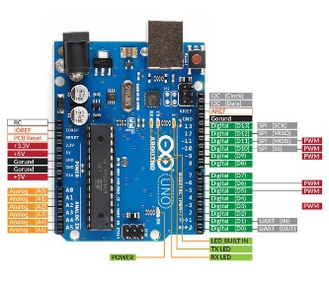

Fig.1. Micro Controller

**Relay:**

This prevents the power Theft when they sense the power theft the relay turn off the supply.

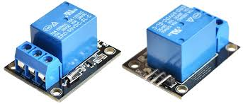

Fig.2. Relay

**GSM:**

`Since the GSM module can be used for communication between the energy meter and the remote server or mobile device over the GSM network in smart prepaid energy metering systems, therefore some applications of the GSM300 in smart prepaid energy metering systems are:

* + Real-time data transmission
  + Prepaid energy metering
  + Remote control and monitoring
  + Alarm and alert notification Current and Voltage Sensors

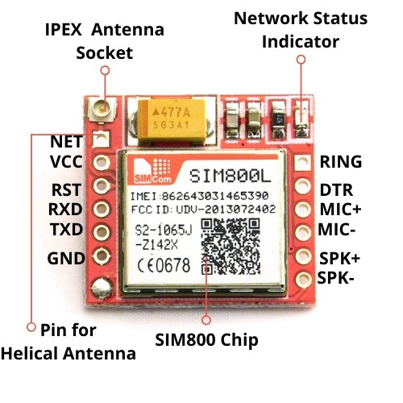

**Current sensor:**

It helps to track overloads in the motor circuit or faults in it by measuring the current.

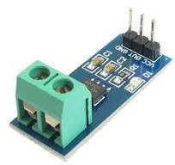

Fig.3. Current Sensor

**LDRs (Light Dependent Resistor):**

does not measure electricity consumption directly through energy meters but it can serve as tampering or bypass detection device for the energy meter. Since it can measure light levels around the meter, it can help identify any unauthorized attempts to cover the energy meter or alter its readings.

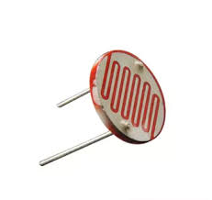

**Power Electronics Components**:

**Transistor:**

Used in soft starters for controlling the voltage and current supplied to the motor.

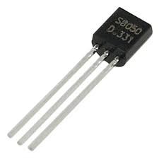

Fig.7.Transistor

**Diodes and Rectifiers:**

For converting AC to DC in the motor drive system.

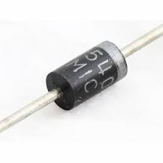

Fig.8. Diode

**Arduino exe software:**

For programming of Micro controller (Arduino IDE)

**Alarm System:**

Provides visual or audible warnings when a fault is detected, such as overload, over-temperature, or phase failure.

**RESULT**

The integration of a smart prepaid energy meter equipped with overvoltage and tampering detection features can bring about several significant advantages for both providers and consumers alike. First, billing accuracy can be improved because it can detect tampering attempts and alert users about it. This makes sure billing can be accurately calculated and minimizes losses in revenues due to fraud. Second, the smart prepaid energy meters improve safety as they detect overvoltage and alert users about it. This ensures the meter is not damaged and gives very little chance of electrical fire occurring or any other hazards. Thirdly, the meter brings in more control over energy consumption for the users because now they can monitor how and when they used energy and therefore can identify places to cut down on consumption and save a few bucks on their electricity bills.

Finally, the implementation of a smart prepaid energy meter will indeed save expenses for energy suppliers and consumers. Energy suppliers can offset revenue losses due to tampering, while consumers are expected to reduce energy consumption and save bills. In summary, the acceptance of a smart prepaid energy meter with overvoltage and tampering detection features could yield several significant advantages, including increased billing accuracy, improved safety, enhanced control over energy consumption, and cost savings for energy providers and users.

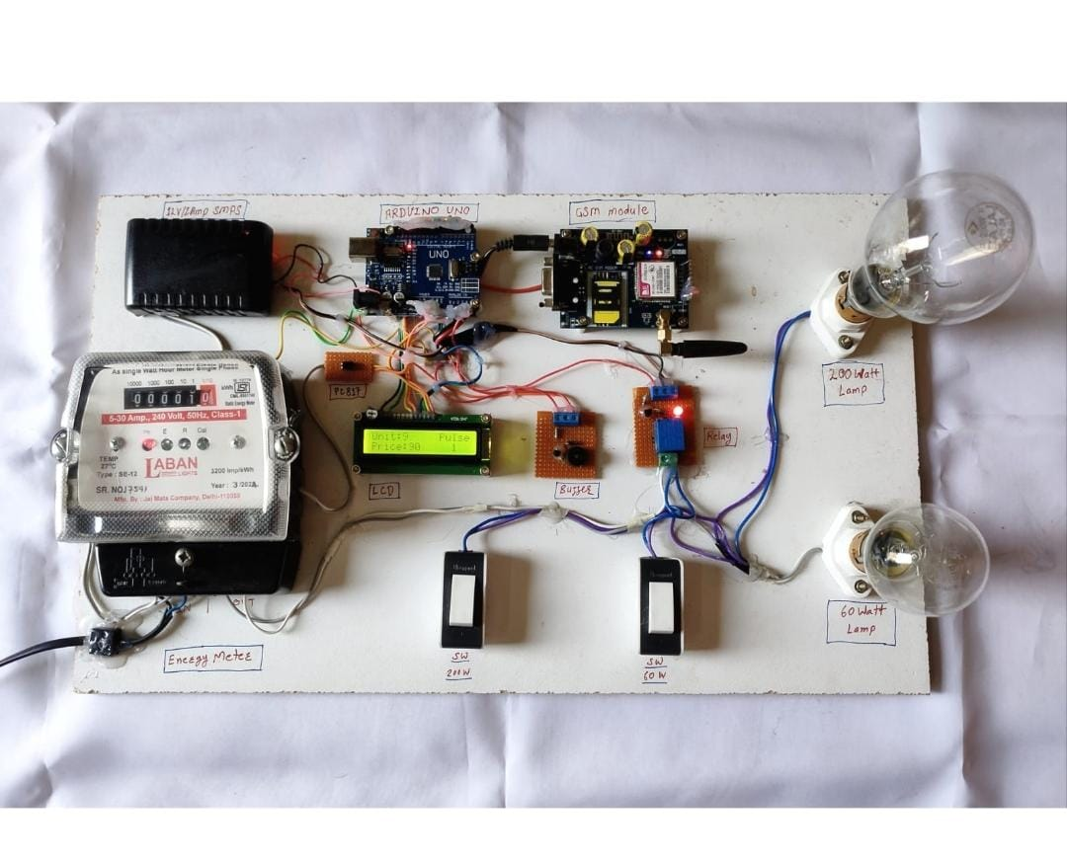

**CONCLUSION AND FUTURE SCOPE**

**Conclusion:**

In short, the smart prepaid energy meter with overvoltage and tampering detection features can greatly improve conditions for both energy providers and consumers. The meter can enhance safety and avoid damage by detecting overvoltage and letting users know when it has become an issue. The meter can strengthen the billing process by detecting attempts of tampering and informing users of the consequence, thereby reducing revenue loss from tampering. The meter also consoles users about their electricity consumption and empowers them to minimize energy consumption, hence reducing electricity bills.

The process of putting a smart prepaid energy meter with overvoltage and tampering detection features into operation encompasses hardware selection, software development for overvoltage and tampering detection, software testing, installation of the meter, and monitoring and maintaining it for proper functioning.

The broad implementation of a smart prepaid energy meter with overvoltage and tampering detection features can result in some of the many positive results, including improved accuracy in billing, increased safety, increased control over energy consumption, and cost savings for energy providers and consumers.

**Future scope:**

* Integrating Renewable Power Sources:

The system will now be issued to solar and wind energy sources with the aim of sustainable power management.

* Blockchain for Secure Transactions:

Secure and tamper-proof billing and energy transaction management using blockchain technology.

* AI Based Load Forecasting:

Artificial Intelligence is now used to display the load pattern of energy consumption and improves the grid efficiency by load forecasting.

* Mobile Application for Enhanced User Control:

Dedicating a mobile application that would allow the user to monitor, control, and recharge the energy balance from just about anywhere.

* Advanced Theft Detection Mechanisms:

Use of AI and machine learning algorithms in detecting and preventing a lot more subtle methodologies that have been proven successful at power theft.

* Expansion to Industrial and Commercial Sectors:

Making the energy management system useful for applications at a huge scale, in sectors like industries and commercial activity.

* Integration with Smart Home Automation:

Linking smart prepaid meters with IoT-based smart home devices for more efficient energy use.

* 5G and Edge Computing Implementation:

Increased speed of data processing with real-time energy analytics due to incorporation of 5G and edge computing.

**REFERENCE**

1. "Design and implementation of a smart prepaid energy meter system with overvoltage and tampering detection features" by O.M. Oluwadare and A.O. Adekunle. (Journal of Electrical and Electronics Engineering Research, 2015).
2. Ciftci, E., Yigit, A., & Ozturk, B. (2019). An IoT Based Smart Prepaid Energy Metering System with Real-Time Data Collection and Billing. Journal of Electronic Science and Technology, 17(3), 220-228.
3. Marimuthu, R., & Muthukumar, K. (2016). A review on smart energy metering system. International Journal of Innovative Research in Science, Engineering and Technology, 5(2), 1034- 1041.
4. Singh, A., Garg, N., & Gupta, A. (2020). Smart Energy Meter: An Overview of Technologies and Communication Protocols. In Advances in VLSI, Communication, and Signal Processing (pp. 311-318). Springer, Singapore.
5. Daras, N. J., & Asadi, S. (2019). Design and implementation of a smart prepayment energy meter. Journal of Energy Storage, 26, 100972.
6. "Design of a smart prepaid energy meter system with overvoltage and tampering detection features" by A. Amadi, M. O. Agu, and P. C. Ugwuoke. (International Journal of Scientific and Research Publications, 2016).
7. Sumanth, S. K., Gopinath, R., & Raja, P. V. (2018). Design and implementation of a smart prepaid energy meter using Internet of Things. International Journal of Engineering and Technology (UAE), 7(4.38), 501-504.
8. Patel, R. (2018). Smart Prepaid Energy Meter using GSM Technology. International Journal of Engineering and Technology, 7(2), 224-227.
9. "Development of smart prepaid energy meter with overvoltage and tampering detection features" by M.O. Olukotun and O.A. Adedokun. (International Journal of Electrical and Computer Engineering, 2017).
10. "Smart prepaid energy meter system with overvoltage and tampering detection using GSM technology" by S. Ravi Kumar and S. Suresh Kumar. (International Journal of Innovative Research in Science, Engineering and Technology, 2015).