Study and Analysis of the Industrial Processing of Molasses, Bagasse, and Press Mud

Mr.K.Periasamy ^{*1}, M.Rajakumar^{*2}, D.Sanjai ^{*3}, R.Thenram selvam^{*4}
¹Professor, Dept of Mechanical Engineering,
^{2,3,4,}Dept of Mechanical Engineering
,Kongunadu college of engineering and technology

ABSTRACT
The sugar industry plays a crucial role in the global economy, producing not only sugar but also a variety of by products that hold significant industrial and environmental value. Among these by products, molasses, bagasse, and press mud are particularly important due to their multiple applications in various sectors, including energy, agriculture, and biotechnology. Molasses as a key raw material in bio refineries, contributing to the development of bio fuels and renewable chemicals. Modern processing techniques, such as fermentation, distillation, and enzymatic hydrolysis, are explored to enhance efficiency and optimize molasses utilization. Bagasse, the fibrous residue left after sugarcane crushing, is a major biomass resource with high calorific value. Traditionally used as a fuel for cogeneration plants, bagasse contributes crucially to the energy needs of sugar mills, reducing dependence on fossil fuels. Press mud, the solid residue obtained during the juice clarification process, is a nutrient rich organic material widely utilized in bio composting, organic fertilizers, and biogas production. Rich in calcium, phosphorus, and organic matter, press mud enhances soil fertility and promotes sustainable agriculture.
Keywords: Molasses Processing, Bagasse Utilization, Press Mud Management, Sugarcane By-products, Renewable Energy.

INTRODUCTION
India is the second largest producer of sugar in the world after Brazil and produces more of cane sugar. In India, 78 percent of sugarcane is used for sugar production, 15 percent of the crop is used to produce various other sweets and the remaining is used for bio fuel production. Sugar production in India is concentrated in nine major states with Maharashtra and Uttar Pradesh leading with 27 percent and 30 percent of the total production. The Sugar Production in India is shown in figure 1. More than 50 million farmers and their families are dependent on sugarcane for their livelihood.
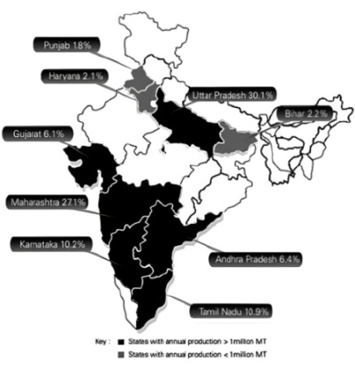
Figure 1 Sugar Production in India
Explored the potential of press mud ash as an adsorbent for treating stabilized landfill leachate. Landfill leachate is a highly contaminated liquid generated from waste decomposition in landfills, containing high concentrations of organic matter, heavy metals, and persistent pollutants. The treatment of stabilized landfill leachate is particularly challenging due to its complex composition and the presence of recalcitrant compounds that resist conventional biological treatment. Adsorption is one of the most effective methods for removing pollutants from leachate, and researchers have been investigating various low cost and sustainable adsorbents to improve treatment efficiency.

The sugar industry caters to an estimated 12 percent of rural population in these nine states through direct and indirect employment. Effectively, each farmer contributes to the production of 2.9 MT of sugar every year. Globally, [2] Explored the potential of improving press mud through organic amendments and its impact on soil quality and the growth performance of Capsicum annum. we have seen high correlation between sugar production and sugarcane productivity. Several countries improved sugar recovery rate by increasing yield of sugarcane. In India, sugarcane productivity is low. As evident from the figure below, while, India is amongst the largest producer of sugarcane, average yield of sugarcane is amongst the lowest globally. The landholding size of 10 hectares or more is present in only 25 percent of the area under sugarcane cultivation.
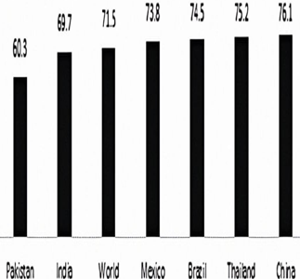
Figure 2 Average Yield of Sugarcane in India
The bulk of the land under sugarcane is between 1 and 10 hectares. The Average Yield of Sugarcane in India is shown in figure 2. This land holding structure is a key structural feature of the sugar industry in India. The small land holding limit the extent of mechanization and reduces the ability of farmers to invest in farm productivity. The ability of a farmer to sustain himself in the event of a crop failure or lack of crop off take or nonpayment of dues is also limited by the size of the land holding. [3] explores the co-digestion of press mud, distillery wastewater, and sugarcane bagasse for improved biogas production. Press mud, a byproduct of sugar mills, is rich in organic matter, making it a potential feedstock for anaerobic digestion. However, its high solid content and slow degradation rate pose challenges for efficient biogas generation. Distillery wastewater, another byproduct from sugarcane-based ethanol production, contains high concentrations of organic compounds and nutrients that can enhance microbial activity during anaerobic digestion. Sugarcane bagasse, the fibrous residue left after juice extraction, provides structural support and helps maintain the balance between solid and liquid phases in the digestion process. Several studies have investigated the anaerobic digestion of sugar industry waste, emphasizing the potential of co-digestion to improve biogas yield. [4] explored the potential of press mud as a renewable resource for hydrocarbon and chemical production through thermal pyrolysis. Press mud, a byproduct of the sugar industry, is rich in organic matter, making it a promising feedstock for energy recovery and value added chemical production. Thermal pyrolysis is a process that decomposes organic materials in the absence of oxygen, breaking down complex molecules into simpler hydrocarbons, bio char, and gaseous products. This technique has gained attention as a sustainable waste management strategy, offering an alternative to fossil fuels while reducing the environmental impact of organic waste disposal. The study examined the pyrolysis behavior of press mud under different temperature conditions to optimize the yield of liquid hydrocarbons. The results indicated that press mud undergoes significant thermal degradation, producing bio oil with a composition similar to conventional petroleum-derived fuels.
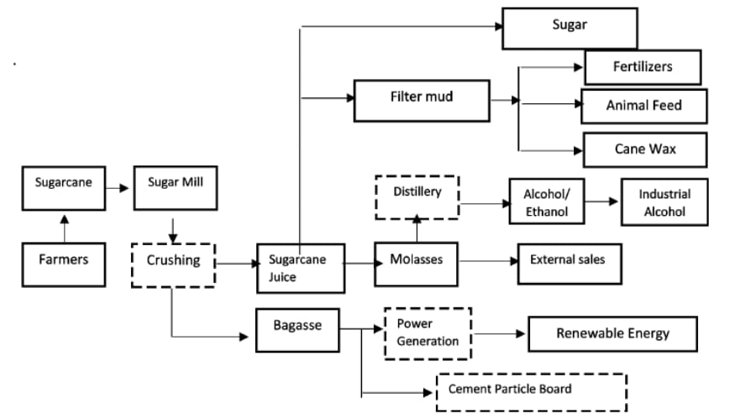
Figure 3 Commercial Uses Sugarcane

2. MANUFACTURING PROCESS OF MOLASSES
Molasses is a thick, viscous by product obtained during the sugar manufacturing process from sugarcane or sugar beets. The process begins with the harvesting and crushing of sugarcane, where large mills extract the sugar rich juice. This juice contains impurities such as soil particles, fibers, and organic matter, which must be removed before further processing. The crushed sugarcane also produces bagasse, a fibrous residue that is often used as a fuel source for boilers in sugar mills. Once the juice is extracted, it undergoes clarification, where it is heated and treated with lime (calcium hydroxide) to neutralize acidity and aid in the removal of unwanted impurities. This process helps in coagulating and settling out non sugar substances, which are then removed through filtration or sedimentation. The clarified juice, now free from most impurities, is directed to evaporators, where it is concentrated by removing excess water.
Manufacturing Process of molasses is classified into three stages,
- Fermentation
- Distillation and
- Effluent treatment and disposal
1. Fermentation
Fermentation is carried out in the fermentation vessels under controlled conditions of temperature and PH. The propagated yeast biomass is transferred to the main fermenters keeping volume at 10 to 15% of the total fermenter volume. The rest is filled with diluted molasses. After filling the fermenter, it is left for fermentation. This process occurs under anaerobic condition. Under these conditions, the glucose molecule breaks down to produce ethyl alcohol and carbon dioxide.
The fermentation process is understood to be completed when the effervescence stops. The Fermentation Flow Chart is shown in figure 4. Other measurement like specific gravity etc., are also taken to assess the completion of fermentation process. Fermentation is an exothermic reaction. Hence, the temperature rises during the fermentation process. To maintain the temperature at 36 degree celsius., the fermenter vessels are required to be cooled with fresh water, through plate type heat exchanger. The yeast sludge along with solids present in molasses is collected at the bottom of the fermenter vessels.

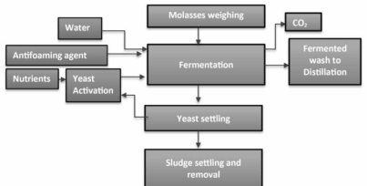

Figure 4 Fermentation Flow Chart

2. Distillation
The first operation, which is carried out on molasses is dilution. In dilution operation molasses, from the storage tank is diluted with raw water. The diluted molasses is used for subsequent unit operations yeast propagation & fermentation. The dilution ratios required for yeast propagation and fermentation are different. For requirement of yeast propagation, molasses is diluted to keep the sugar percentage of 8 – 9% while for fermentation molasses is diluted to keep the sugar 16-18%. The distillation consists of following column.

- Analyzer Column
- Degasifying Column
- Extractive distillation column
3. Effluent treatment and disposal
The molasses manufacturing process, a by product of sugar production, generates significant amounts of wastewater and effluent containing organic and inorganic contaminants. If not treated properly, these effluents can lead to severe environmental pollution, affecting soil, water bodies, and aquatic life. Effluent treatment and disposal in molasses based industries are critical for maintaining environmental sustainability and regulatory compliance.

3. MANUFACTURING PROCESS OF BAGASSE
Bagasse is the fibrous byproduct left after sugarcane is crushed to extract juice in sugar mills. It primarily consists of cellulose, hemi cellulose, and lignin, making it a valuable raw material for various industries. Instead of being discarded as waste, bagasse is widely used for power generation, paper production, biodegradable packaging, and even bio ethanol production. The manufacturing process of bagasse begins with the crushing of harvested sugarcane, where juice is extracted for sugar production. The remaining fibrous material, bagasse, is separated and typically contains around 45-50% moisture. To enhance its usability, it undergoes drying or further processing based on its intended application. One of the most significant uses of bagasse is as a bio fuel. Sugar mills burn it in boilers to produce steam, which powers turbines for electricity generation. This helps sugar industries become self sufficient in energy and reduces reliance on fossil fuels.
Manufacturing Process of bagasse is classified into four stages,
- Sugarcane Crushing
- Bagasse Separation
- Drying and Processing
1. Sugarcane Crushing
After harvesting, sugarcane is transported to the sugar mill via trucks, tractors, or conveyor belts. The transportation process must be quick, as any delay can lead to sugar deterioration due to fermentation. Upon arrival, the sugarcane is weighed to record the total quantity received. The Sugarcane Arrival and Unloading at the Mill is shown in figure 5.
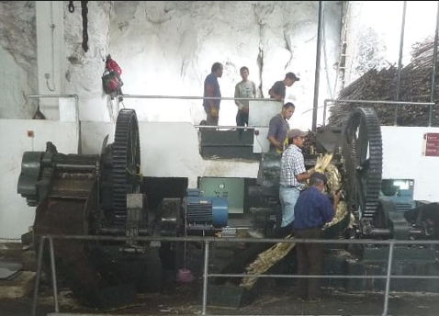
Figure 5 Sugarcane Arrival and Unloading at the Mill
2. Bagasse Separation Process in Sugar Mills
The bagasse separation process is a crucial stage in sugar production, where the fibrous residue left after juice extraction is efficiently separated and processed for various applications. This process begins immediately after the multiple stage crushing of sugarcane, where the cane passes through several milling units to extract the maximum possible juice.
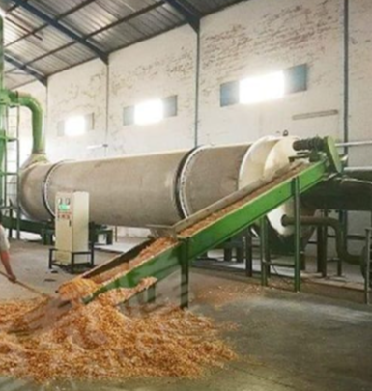
Figure 6 Separation Process in Sugar Mills
Once the cane has undergone the final crushing stage, the bagasse emerges as a fibrous, moist material with a moisture content of around 45-50%. To further reduce moisture and improve handling efficiency, the bagasse is passed through dewatering mills, where additional pressure is applied to remove excess liquid.
3. Bagasse Drying Process in Sugar Mills
The bagasse drying process is a critical step in ensuring the efficient utilization of bagasse as a fuel source, raw material for paper production, and biodegradable product manufacturing. Bagasse, the fibrous residue left after sugarcane crushing, typically retains 45-50% moisture, which reduces its calorific value and limits its efficiency as a combustion fuel. Drying bagasse helps improve its burning efficiency, storage stability, and usability in various industries. The Drying Process in Sugar Mills is shown in figure 4.4.

4. MANUFACTURING PROCESS OF PRESS MUD
Press mud, also known as filter cake, is a byproduct of the sugarcane industry, primarily generated during the clarification of sugarcane juice in sugar mills. It is a rich organic material containing a mixture of fibrous residue, coagulated colloids, inorganic impurities, and other suspended matter removed from cane juice. The manufacturing process of press mud begins with sugarcane crushing, where the extracted juice undergoes purification using lime and other clarifying agents.
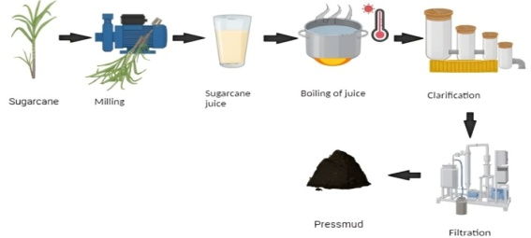
Figure 7 Manufacturing Process of Press Mud

The Manufacturing Process of Press Mud is shown in figure 7. With increasing emphasis on sustainable agricultural practices and waste utilization, press mud plays a crucial role in promoting eco-friendly and circular economy models in the sugar industry.
1. Sugarcane Crushing & Juice Extraction
Freshly harvested sugarcane is sent to mills or crushers for juice extraction. The crushing process involves multiple rollers mill that press the sugarcane stalks to extract the maximum juice. The crushed sugarcane, known as bagasse, is separated and used for power generation or paper production. The extracted juice contains a high amount of impurities, including.
- Soil particles
- Wax
2. Juice Clarification & Precipitation
The process of press mud formation begins with the extraction of sugarcane juice during sugar production. When sugarcane is crushed in the mill, the raw juice obtained contains various impurities, including fine cane fibers, soil particles, wax, and non sugar organic matter. To remove these impurities, the juice undergoes a clarification process. In this step, lime (calcium hydroxide) and other chemical coagulants such as phosphoric acid or sulfur dioxide are added to neutralize acidic components and help precipitate unwanted materials.
3. Filtration & Separation
Once the juice clarification process is complete, the next step is the filtration and separation of press mud from the sugarcane juice. The sedimentation sludge, now rich in organic matter, calcium, phosphates, and fibrous residues, is processed through filtration systems to remove excess liquid. Various filtration methods are employed, including vacuum rotary drum filters, gravity based filters, or pressure filters, depending on the mill's technology.
4. Drying & Processing
After separation, the press mud is still in a semi solid state with high moisture content, which requires further drying to improve its handling and usability. The drying process can be done through natural sun drying or mechanical drying. In open field drying, press mud is spread in large areas where sunlight and wind help reduce moisture content over time. However, this method is weather dependent and can take several days.
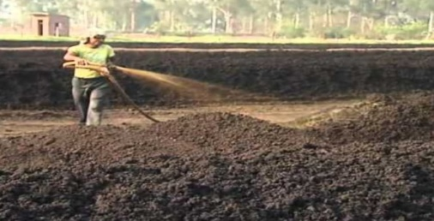
Figure 8 Drying and Processing
Mechanical drying reduces moisture content more efficiently, making the press mud easier to store and transport. Once dried, the press mud becomes a valuable byproduct used in various industries. The Drying and Processing is shown in figure 8. In agriculture, it serves as a nutrient rich organic fertilizer, enhancing soil fertility due to its high organic carbon, nitrogen, and phosphorus content. It is also used in biogas production, where its organic matter undergoes anaerobic digestion to produce methane rich biogas, a renewable energy source. Additionally, some industries process press mud into briquettes or pellets for use as an alternative fuel. Through proper drying and processing, press mud becomes a sustainable and eco friendly resource.

CONCLUSION
The industrial processing of molasses, bagasse, and press mud has transformed the sugar industry into a more sustainable and economically manageable sector. These by products, once considered waste, are now essential to various industries, including bio fuels, energy production, agriculture, and manufacturing. Their proper utilization reduces waste, conserves resources, and enhances industrial efficiency, contributing to a circular economy. Molasses has emerged as a key raw material for ethanol production, playing a crucial role in the bio fuel sector. Bagasse, known for its high calorific value, serves as a primary fuel source for cogeneration plants, allowing sugar mills to generate their own electricity and even supply excess energy to the grid.

REFERENCES

- Almendrala, M., (2019). “Co digestion of press mud and distillery waste water with sugarcane bagasse for enhanced biogas production”., Vol 15, No.4, pp. 46–51.

- Azme, N., (2018). “Treatability of stabilize landfill leachate by using press mud ash as an adsorbent”., Vol 11, No.6, pp. 94–101.

- Ansari, K., (2014). “ Press mud as an alternate resource for hydrocarbons and chemicals by thermal pyrolysis” ., Vol 22, No.6, pp. 45–75.

- Bhosale, P., (2017). “Improvisation of press mud by organic amendment and its effect on soil quality and growth of chilli, Capsicum annum”., Vol 14, No.9, pp. 849–857.

- Dotaniya, M., (2014). “Impact of bagasse and press mud on availability and fixation capacity of phosphorus in an Inceptisol of north India”., Vol 18, No.11, pp. 109–112.

- Rocha, S., (2011) “Dilute mixed-acid pretreatment of sugarcane bagasse for the ethanol production. Biomass Bio energy”., Vol 35, No.5, pp. 663–670.

- Rajukannu, K., (1996) “Use of distillery and sugar industry wastes in agriculture” Vol 43, No.8, pp. 93–101.

- Sarwar ,S .,(2010) “Appraisal of press mud and inorganic fertilizers on soil properties, yield and sugarcane quality” Vol 33, No.4, pp.1361–1367.

- Yadav, RL., (2006) “Potential of developing sugarcane by-product based industries in India” Vol 3, No.7, pp.104–111.

- Shukla, S ., (2016) “Soil microbial biomass nitrogen, in situ respiration and crop yield influenced by deep tillage, moisture regimes and N nutrition in sugarcane-based system in subtropical India”., Vol 14, No.51, pp. 10–12.

