**e-ISSN :**

**INTERNATIONAL JOURNAL OF PROGRESSIVE 2583-1062**

**RESEARCH IN ENGINEERING MANAGEMENT**

**AND SCIENCE (IJPREMS) Impact**

|  |  |  |
| --- | --- | --- |
| **www.ijprems.com editor@ijprems.com** | Vol. 04, Issue 01, January 2024, pp : xx-xx | **Factor : 5.725** |

**Real Estate Marketing And Sales**

**Shelke Kajal Santosh ,Jadhav Trupti Sanjay ,Bhor Shivani Nilesh, Jadhav Rutuja Raghunath,Auti.S.S.**

Student, Department of Computer Engineering , Samarth polytechnic, Belhe , pune, India

Student, Department of Computer Engineering , Samarth polytechnic, Belhe , pune, India

Student, Department of Computer Engineering , Samarth polytechnic, Belhe, pune, India

Student, Department of Computer Engineering , Samarth polytechnic, Belhe , pune,India

Guide, Department of Computer Engineering , Samarth polytechnic, Belhe , pune,India

**ABSTRACT**

The current generation sees digital selling as an integral element in selling anything from a house to a service. Realty includes all-new construction with selling houses and the common class is single-family homes: Land, residential real estate, Residential, commercial, industrial, real estate investment trust, raw land, and vacation homes. In this highly charged and competitive realty arena, agents are required to do a lot more than just acquire a license. The main idea is to invest in a home, either for living or to leverage. This option enables an individual to lead financially-happy life now and beyond. The real estate market as an industry capitalizes maximally from digital marketing. The buildings may be used for research, which includes production, storage, and a distribution hub for related goods. For years, real estate has benefited almost exclusively from the utilization of traditional marketing methods, such as print and cold calling. Still, though these traditional methods are also today present in the industry, over the past decades, with the growth of the internet, agents have been shifting gradually from old-school marketing techniques to digital ones. This thesis would expatiate on different types of digital means of advertisement, such as social media marketing, email marketing campaigns, web design, and video production. Furthermore, it shall justify why these are the best marketing tools and why it is critical for real estate agents to use them in maximizing their success.

## INTRODUCTION

## The term “real estate” has a double meaning: it refers to both land and any buildings that sit on them, all of their natural resources, such as crops, minerals, or water; it is primarily urban property of large, immovable dimensions; and any vested interest in this (another) category concerning building or housing altogether. This has also meant the business of real estate: the profession of buying, selling, or renting land, buildings, or houses. It is a legal term used in those legal systems whose matrix is derived from English common law: India, the United Kingdom, the United States, Canada, Pakistan, Australia, and New Zealand. Turning to India, real estate is a $12 billion industry, going through rapid transition in recent years. 100% FDI is allowed in real estate development over minimum scale limits of 25 acres for serviced plots or integrated townships or 50,000 sq. mtr. of built-up area for constructional development projects. Commercial and office complexes mushrooming in major Indian metros present a minefield of opportunities. 20 million new housing units need to be developed in next five years. The real estate market was projected to grow to $50 billion by 2010. The sector is expected to grow at a CAGR of over 30% p.a. in the next five years. The demand for commercial and office space primarily from the rapidly growing retail, IT, and hospitality sectors and the Urban Infrastructure Renewal Mission will provide the kick to this sector.

# LITERATURE REVIEW

The Literature Survey Chapter generally deals with different synthesize and research made in the field of one's interest and summarizes the previously published results, keeping in mind the various parameters of the project as well as the limitation posed by it.

**@International Journal Of Progressive Research In Engineering Management And Science Page | 1**

**e-ISSN :**

**INTERNATIONAL JOURNAL OF PROGRESSIVE 2583-1062**

**RESEARCH IN ENGINEERING MANAGEMENT**

**AND SCIENCE (IJPREMS) Impact**

|  |  |  |
| --- | --- | --- |
| **www.ijprems.com editor@ijprems.com** | Vol. 04, Issue 01, January 2024, pp : xx-xx | **Factor : 5.725** |

## METHODOLOGY

### In order to ensure successful transactions and satisfied clients, the methodology of real estate sales and marketing comprises several steps and strategies. Among the essential parts are:

### 1. Prospecting and Lead Generation: Finding likely clients from various channels like online listings and referrals, networking, etc.

### 2. Initial Client Meeting and Needs Analysis: Getting familiar with the client's requirements, preferences, budget, and duties for search tailoring.

### 3. Listing and Marketing of Property for Sale: Preparation of the property for sale, including staging, professional photography, and compelling listings.

### 4. Offers Handling and Negotiating: Presenting offers to the clients, negotiating the terms of their acceptance, overcoming objections with a problem-solving attitude.

### 5. Property Showings and Open Houses: Showing the property to buyers and organizing open house days.

### 6. Closing the Deal: Making sure that documentation is filled out correctly, working on documents with counterparts, and formalizing the sale.

### 7. Follow-up after Sale: Continuation of relations with clients to encourage referrals and repeat business. Real Estate Marketing Strategies

**4.FUTURE SCOPE**

Integration of AI with data-based decisions for predicting market trends and personalized targeting; Digital and Augmented Reality for Virtual tours of properties and lesser physical showing; With Blockchain Technology seamless transaction occurs, minimizing chances for fraud at lower transaction costs; Omni channel Marketing would be the seamless integration of the other marketing channels; Sustainability and Social Responsibility Eco-Friendly Practices; Content Marketing and SEO-once again important for attracting and educating buyers; more and more in the use of nano and micro-influencers.

# 5.LIMITATION

• Market Volatility: There are a lot of uncertainties in the real estate market; factors include economic conditions, interest rates, and various government policies.

• High Competition: It's super competitive, with many other agents fighting for the same buyer or seller without a unique selling point.

• Regulatory Hurdles: Following so many local, state, or federal regulations can be difficult and time-consuming.

• Technological Challenges: Variable cost structure and easy to rise in the market with the addition of technological needs to monitor all the process.

• Changing Consumer Preferences: It generally proves challenging to satisfy an evolving gathering of buyers, each with different needs and preferences.

**@International Journal Of Progressive Research In Engineering Management And Science Page | 2**

**e-ISSN :**

**INTERNATIONAL JOURNAL OF PROGRESSIVE 2583-1062**

**RESEARCH IN ENGINEERING MANAGEMENT**

**AND SCIENCE (IJPREMS) Impact**

|  |  |  |
| --- | --- | --- |
| **www.ijprems.com editor@ijprems.com** | Vol. 04, Issue 01, January 2024, pp : xx-xx | **Factor : 5.725** |

**6. ARCHITECTURAL DIAGRAM**

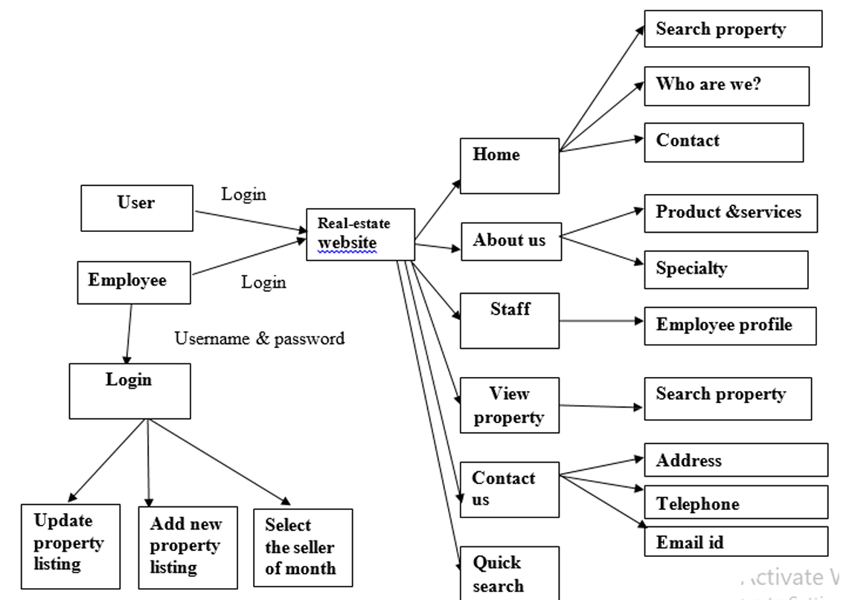

1. **CONCLUSION**

This Real Estate Web App refers to an ordinary type of web application created using the Django framework with Postgres SQL. It is basically developed in a client/server architecture that uses the HTTP protocol. It is developed using the VS Code editor within the Python programming environment. The purpose of the buyer is to perform a search for the property listings using the criteria of a Zip code, or City, or State in the search textbox. The business logic tier interacts with the database tier to obtain the results of the query that it sent. The results received from the database are displayed on the data grid by refreshing the grid only rather than refreshing the entire web page. The application becomes more efficient by utilizing this sort of high-level framework for pixel web development. This particular application is fairly tested over many scenarios so that the application is to be evaluated. Some ways in which this system could be enhanced with additional functionalities are discussed in the section.

**@International Journal Of Progressive Research In Engineering Management And Science Page | 3**

**e-ISSN :**

**INTERNATIONAL JOURNAL OF PROGRESSIVE 2583-1062**

**RESEARCH IN ENGINEERING MANAGEMENT**

**AND SCIENCE (IJPREMS) Impact**

|  |  |  |
| --- | --- | --- |
| **www.ijprems.com editor@ijprems.com** | Vol. 04, Issue 01, January 2024, pp : xx-xx | **Factor : 5.725** |

## 6. REFERENCES

1. Lan Ziyong, The Analysis Of Main Factors Influencing The Real Estate Marketing Strategy, Chongqing, China:Chongqing University, 2006.

2. Yang Pao, Research On Real Estate Enterprise Marketing Strategy Innovation, Nanchang: University, 2010.

3. You-Cai Yang, Wl Jh Real Estate Project Marketing Planning Scheme, Changchun, China: Jilin University, 2013.

4. Li-Xia Yan, “The Application Of The Experience Marketing In Real Estate Marketing,” Journal Of Enterprise Economic, Pp.69-70, Nov. 2005.

5. Guo-Jun Liu, A Company's Marketing Strategy Of Real Estate Project Research, Changsha, China: Hunan Normal University, 2014.

6. Zhang Gengquan, “Design And Implementation Of The Theory Of Real Estate Marketing Planning Scheme,” Journal Of Commercial Economy, Vol. 10, Pp. 31-59,Oct. 2011.

7. Lei Chen, Ma Dejun, “Introduction To Real Estate Marketing Strategy And Innovation,” Journal Of Information Science And Technology, Vol. 20, Pp. 477-478,Oct, 2010.

8. Various Real- Estate Websites like (www.zameen.com, www.makaan.com) .

9. Book - Test-Driven Development with Djangeyo Kevin Harv .

10. Django Framework (<https://www.djangoproject.com/>)

11. Search Engine - Google ([www.google.com](http://www.google.com))

12. Scribd.com

13. Udemy.com

14. ASP.NET and Web Development Overview, https://learn.microsoft.com/en-us/previous versions/4w3ex9c2(v=vs.140)?redirectedfrom=MSDN .

15. Microsoft SQL Server 2005, https://en.wikipedia.org/wiki/Microsoft_SQL_Server .

**@International Journal Of Progressive Research In Engineering Management And Science Page | 4**