(Review Paper On)

AUTO BILLING SHOPPING CART

1Atharav Gomase, 2Sanskar Barbude, 3Shyam Shelke, 4Vedant Mangalkar,

5Suyash Shingne and 6Kumar Gale.

7S.R.Molke 1,2,3,4,5,6Students, Electronic Engineering. 7Lecturer, Electronics Engineering,

Dr. Panjabrao Deshmukh Polytechnic, Amravati, Maharashtra, India.

***Abstract: -***

## This paper presents an IoT-based Smart Trolley with Automatic Billing System designed to gate more advance for shopping, and to get easy to shopping. The system is designed to make shopping easier and faster by automatic the billing process. Each product in the store has a RFID tag, and the trolley is equip with a scanner or RFID reader. When a customer adds a product to the trolley, it is automatically scan, and the price is add to the bill. A display on the trolley shows the total amount in real-time. Once shopping is complete, customers can pay directly without waiting in long queues. This system saves time, reduces manual errors, and improves the overall shopping experience.

***Keywords—* IoT-based*; Smart* Trolley*;* RFID tag; Billing process.**

# INTRODUCTION

Technology has transformed many aspects of our lives, including shopping. Traditional shopping often has problems like long checkout lines, limited product details, and the hassle of paying with cash. To solve these issues, we are creating a smart shopping cart that makes shopping easier and more efficient.

This smart cart will use advanced tools like RFID (Radio Frequency Identification), weight sensors, and mobile connectivity. The cart will scan items automatically when placed inside and show the total bill and product details on the shopper’s phone. This removes the need to scan items at the checkout, saving time and making shopping more convenient.

For store owners, this cart offers benefits like reducing labor costs, avoiding billing mistakes, and improving inventory management. It also helps collect useful data to better understand customer preferences and optimize store operations.

By combining technology with shopping, this smart cart can make shopping faster, easier, and more enjoyable for everyone.

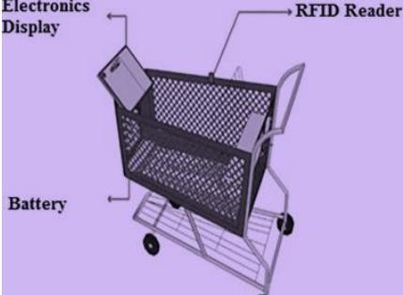

Figure A: Prototype of Smart trolley

# LITERATURE REVIEW

In research done by Himani Pangasa[1] shows that the RFID-based smart trolleys for automated billing in malls. Systems with RFID readers scan items and update bills on LCDs, reducing checkout time,etc.

In research done by Devasis Pradhan[2] shows that trolley designed to enhance the shopping experience. The system uses sensors to track the customer's path, enabling the trolley to follow them automatically. A tablet is fixed to the front of the trolley to log and display the goods selected by the customer.

In research done by Rahul S Bedare[3] simplifies shopping by using RFID technology. Each product has an RFID tag, and customers use an RFID card to scan items. Once scanned, the product's details, like name and price, appear on a screen attached to the shopping cart. This eliminates the need for manual billing and reduces waiting times at checkout. It improves security by tracking products and provides a faster, more convenient shopping experience. Ideal for malls, supermarkets, and shopping complexes, it ensures efficiency and user-friendly shopping for customers.

Technology evolves continuously, bringing new advancements. This project uses RFID technology to improve shopping in malls. An RFID card allows secure access to products, and when items are added to the cart, their details and total cost are displayed. This research done by Prof. Pushpendra Singh.[4]

In research done by Shashi Kumar[5] system for shopping malls where each trolley is equipped with an RFID reader and every product has an RFID tag. The trolley itself performs the billing, displaying the product name and price on an LCD screen. At checkout, the total bill is wirelessly transmitted to a computer via a Radio Frequency (RF) module.

A research done by Mukund Wani[6] uses an Arduino Nano processor to create a low-cost, easy-to-use prototype that utilizes RFID technology for product identification and billing. This system aims to enhance shopping in malls, saving time, energy, and money. Future upgrades could include larger displays, GPS tracking for products, and internet connectivity for browsing offers, further improving the consumer experience

Myint Moe[7]says that the system includes both customer and counter-side implementations. Product barcodes are checked against ASCII codes, displaying the product name and price on an LCD. The shopping cart data is sent to the billing counter via a wireless ZigBee module. A database at the counter stores product information. The system allows users to query product details before purchase and pay the bill confidentially at the counter after buying.

Ganesh P Nischay[8] says that billing system for supermarkets and malls, displaying the total cost of products to customers. It ensures that removed items are also removed from the bill and supports online transactions. By introducing smart carts, it reduces the hassle of offline shopping, minimizes paper waste, and shortens time spent in queues. Additionally, it makes operations more cost-effective by requiring fewer staff.

Shishir Patil[9] says system uses an LCD to display product information, including cost and weight, and is user-friendly, requiring no special training. It reduces manpower and saves time spent in billing queues, allowing multiple customers to be served simultaneously.

# METHODOLOGY

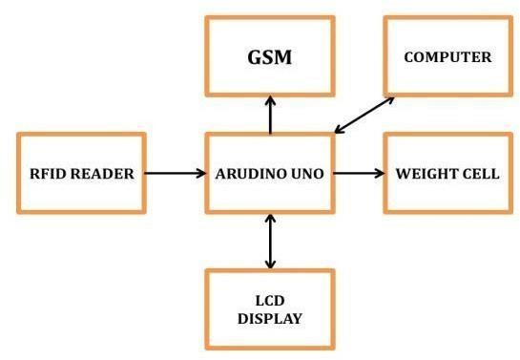Figure B:Block Diagram of Auto Billing Shopping Cart

1. System Design and Architecture

The first step in the project was to design the overall system architecture. This included:- Identifying Key Components: The main components of the system included the RFID reader, weight sensors, microcontroller, and mobile application.

* + System Layout: Designing the physical layout of the shopping cart to accommodate all the components without hindering the shopping experience.
  + Data Flow: Mapping out the data flow from the RFID tags on the products to the billing system.

1. Selection of Components

Choosing the appropriate hardware and software components was critical:

* + RFID Technology: Selecting high-frequency RFID readers and tags to ensure accurate and quick scanning of products.
  + Weight Sensors: Incorporating precision weight sensors to measure the weight of the items placed in the cart.
  + Microcontroller: Using a powerful microcontroller (such as Arduino or Raspberry Pi) to process data from the sensors and communicate with the mobile application.

1. System Integration

Integration of the various components was carried out to ensure seamless operation:

* + Hardware Integration: Connecting RFID readers, weight sensors, and the microcontroller in a cohesive manner.
  + Software Development: Writing the software code to process the data from RFID tags and weight sensors, and to update the mobile application in real- time.
  + Communication Protocols: Implementing communication protocols such as Bluetooth or Wi-Fi to connect the shopping cart with the mobile application.

1. Data Analysis and Optimization

Analyzing the data collected during testing to optimize the system:

* + Identifying Issues: Analyzing test results to identify any recurring issues or areas for improvement.
  + System Optimization: Making necessary adjustments to the hardware and software to enhance performance and reliability.
  + Final Validation: Conducting final validation tests to ensure the system meets all design requirements and user expectations.

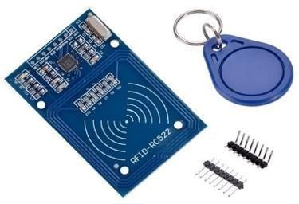

Figure C: RFID Reader or RFID Scanner

## Components :

1. Micro-controller-

A micro-controller is a compact integrated circuit designed to govern a specific operation in an embedded system.

It typically includes a processor, memory, and input/output peripherals on a single chip.It is basic micro-controller, AT89S52 is a low power, high-performance CMOS 8-bit micro-controller with 8K bytes of in-system programmable Flash memory.

1. 4.0V to 5.5V Operating Range.
2. 8K Bytes of In-System Programmable (ISP) Flash Memory
3. Power supply-

A power supply is an electronic device that provides electric power to an electrical load. It converts electrical energy from a source into the correct voltage, current, and frequency to power the load.

It is used to supply power to all the modules. It gives the supply of 12volts, 1A.

The different modules and micro-controller required different supply. Hence it is regulated

by using IC 7805 and IC 7809.

1. LCD display-

An LCD (Liquid Crystal Display) is a flat-panel display technology used in screens for devices

It displays the vital information to the users. We use the display 16 x 2 i.e., 32 bit display.

It requires power supply of 5 v.

1. RFID Reader-

An RFID (Radio Frequency Identification) Reader is a device used to read and write data from RFID tags. These tags store data electronically and communicate using radio waves.

radio frequency identifier. It reads the information from the RFID readers and sends the data in the form of packets to the micro-controller.

1. RFID Tags-

RFID Tags are devices used in RFID systems to store data and communicate with RFID readers using radio waves.

RFID is used for the unique identification. It is a broad term for technologies that use radio

waves to automatically identify objects. The antenna enables the chip to transmit the identification information to a reader.

1. Zigbee module-

A ZID Module typically refers to a specific hardware or software component used in electronic systems

It sends the wireless message through the transmitter and receive through the receiver in

the form of packets. It requires power supply of 3.3 v and range of 100m.

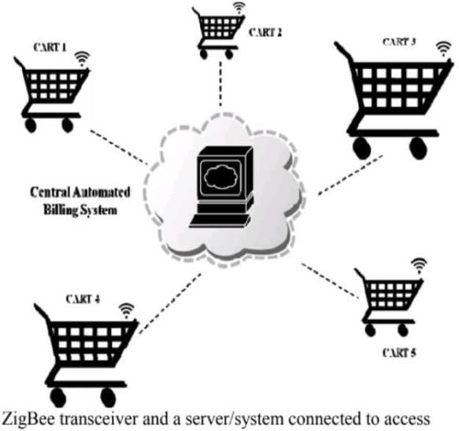

## Conclusions :-

The IoT based Smart Trolley with Automatic Billing System using Arduino represents a cutting-edge solution designed to enhance the shopping experience for both customers and retailers. By incorporating RFID technology, sensors, and an Arduino micro-controller, the System automates the process of item to the

identification and billing. As customers place items in the trolley, the RFID reader instantly detects and records the products, automatically calculating the total bill in real time.

This system significantly improves efficiency by eliminating the need for manual scanning, reducing checkout times, and preventing human errors commonly associated with traditional methods. Customers benefit from a smoother, faster shopping experience, while retailers can streamline operations, reduce long queues, and ensure accurate transactions.

Moreover, additional features such as payment integration and real-time alerts for discrepancies can further enhance the functionality of the smart trolley, making it a versatile tool for modern retail environments.

## Refernces:

1. Himani Pangasa,Nathi Chauhan [A STUDY ON AUTOMATIC SHOPPING CART IN MEGA MALL] p.no.2-5 IOP

Publishing(2019) doi:10.1088/1757- 899X/691/1/012072

1. DevasisPradhan,ShivikaSrivastava1[IoT based Human Guided Smart Shopping Cart System for Shopping Center] p.no.2-4 DOI: 10.36348/sjet.2020.v05i06.004

Published: 28.06.2020

1. Rahul S Bedare [Smart Shopping Cart with Automated Billing System]p.no.2-6, ISSN: 2278- 0181IETE – (2020) Dept of ECE, MIT, Mysore,

Karnataka, India

1. Prof. Pushpendra Singh Chouhan, Assistant professor[RFID BASED AUTOBILLING SHOPPING CART] p.no.3-7,pp:1031-1034April 2023, e-ISSN: 2583-1062
2. Shashi Kumar,[A Review on Automated Billing for Smart Shopping System Using IOT] p.no.2- 5,https://doi.org/10.18280/rces.060101,Received: 20

December 2018

1. Mukund Wani,Neha Keswani, Snehal Neel, [AUTOMATIC BILLING TROLLEY] p.no.3-7,ISBN No.978-1-4799- 3834-6/14/$31.00©2014 IEEE ICICES2014
2. Mrs. Myint Moe,Department of Electronic Engineering, Mandalay Technological University, Mandalay [Automated Billing System using Smart Shopping Cart] p.no.2-5,e-ISSN: 2395 - 0056 ,Apr -2017
3. Ganesh P Nischay,Dept. of Information Technology, National Institute of Technology Karnataka, Surathkal[Smart Shopping Cart with Automatic Billing System] p.no.2-6,May-Jun 2019 Available Online: [www.ijtsrd.com](http://www.ijtsrd.com/) e- ISSN: 2456 - 6470
4. Shishir Patil, Shridhar N. Mathad, S.S.Gandhad Electrical and Electronics Department, K.L.E DR MSSCET, Belagavi,[Smart Trolley with Automatic Billing System using Arudino]p.no.2-8,e-ISSN: 2395- 0056 Oct 2022 [www.irjet.net](http://www.irjet.net/) p-ISSN: 2395-

0072