##### **DESIGN OF ELECTRIC INDUCTION STEAM BOILER**

**K. Abinow pandian 1, M. Balasingam1, R. Dhanush1**

1Student, Mechanical Engineering, Kongunadu College of Engineering and Technology, Trichy, Tamil Nadu, India

**ABSTRACT**

This work has focused on a steam generator is to efficiently and precisely heat water or other fluids for various applications using the principle of electromagnetic induction. Induction boilers aim to maximize the conversion of electrical energy into heat, minimizing losses and achieving high efficiency levels. This translates to lower operating costs and reduced energy consumption. Induction heating allows for accurate control of the heating process, ensuring that the fluid reaches the desired temperature without overheating or fluctuations. This is crucial for applications requiring specific temperature levels. Compared to traditional heating methods, induction boilers offer faster heating times, allowing for quicker availability of hot water or other heated fluids.

**Keywords***-* Eco-friendly, carbon free, sustainability, environmental protection, smart technology

1. **INTRODUCTION**

The Steam generators have been an essential part of industrial and commercial applications since the early 18th century, evolving significantly over the years. Initially developed for steam engines, they have now become crucial for power generation, manufacturing, and heating systems. Over time, advancements in technology have led to the development of more efficient, sustainable, and reliable steam boiler systems.

A steam generator is a device used to convert water into steam by applying heat energy. [1]conducted a comprehensive study on the efficiency of electric steam boilers compared to traditional fossil-fuel-based systems. Their research demonstrated that electric boilers could achieve efficiencies as high as 98% due to reduced heat losses and better insulation This process plays a fundamental role in industries such as power plants, food processing, chemical manufacturing, and textile production. Traditional steam boilers relied on fossil fuels for combustion, contributing to environmental pollution and high operational costs. However, modern steam generators incorporate cleaner and more sustainable energy sources, such as hydrogen, biofuels, and renewable electricity, significantly reducing their carbon footprint.

Modern steam generators are designed to optimize energy efficiency, reduce operational costs, and minimize environmental impact. [2]explored the benefits of induction heating in steam generation. The study found that induction-based heating elements improved energy transfer efficiency by 30% compared to conventional resistance heating elements. This efficiency increase was attributed to the rapid and uniform heating properties of induction technology.With improved thermal insulation, heat recovery systems, and precise temperature controls, they maximize energy conversion while minimizing heat losses. The latest advancements in automation and digital monitoring also allow for real-time performance tracking, predictive maintenance, and seamless integration into Industry 4.0 environments.

Safety remains a top priority in steam generator design. Traditional boilers posed risks such as explosions due to excessive pressure buildup.[3]investigated the role of different heating element materials in electric steam generators, focusing on their durability and efficiency. The study analysed Incoloy® 825, stainless steel, and copper elements, concluding that Incoloy® 825 offered superior corrosion resistance, especially in high-pressure and high-temperature environments. However, modern designs incorporate multiple safety mechanisms, including pressure relief valves, automated shutdown systems, and leak detection sensors, ensuring safer operation and longer equipment lifespan.

In addition to industrial applications, steam generators are widely used in healthcare facilities, laboratories, and residential heating systems**.** [4]focused on the application of electric boilers in pharmaceutical industries, where precise temperature control is critical. Their findings indicated that electric steam generators provided stable steam output with minimal fluctuations, ensuring consistency in pharmaceutical processes. Their versatility and efficiency make them indispensable for various sectors requiring a consistent and reliable source of steam. With ongoing research and technological advancements, the future of steam generators is moving towards even more eco-friendly and energy- efficient solutions, further contributing to global sustainability efforts.

**METHODOLOGY**

The methodology of this study is designed to systematically analyze the efficiency, performance, and feasibility of electric steam generators. The research follows a structured approach that includes data collection, design, experimental setup, performance evaluation, and comparative analysis.

**2.1 Designing Parameters**

The design of an electric induction steam boiler necessitates meticulous consideration of several critical parameters to ensure efficient, safe, and reliable steam generation. Central to the design is the selection of appropriate materials for the pressure vessel, typically high-grade stainless steel or carbon steel, capable of withstanding the intended operating pressure and temperature. The heating element, a key component, utilizes induction heating principles, employing a high-frequency alternating current to induce eddy currents within the boiler's ferromagnetic material, generating heat directly within the vessel wall. This eliminates the need for traditional resistance heating elements, improving efficiency and reducing maintenance. The frequency and power of the induction system must be carefully calibrated to optimize heat transfer and minimize energy losses. The boiler's size and geometry, including the water volume and heating surface area, directly impact steam production capacity and response time. A larger heating surface allows for faster heat transfer and increased steam generation. Insulation is crucial to minimize heat loss and improve overall efficiency, with high-temperature insulation materials like ceramic fiber or mineral wool being commonly employed. The boiler's control system, incorporating temperature and pressure sensors, ensures safe and stable operation. Advanced control algorithms can regulate the heating power to maintain the desired steam pressure and temperature, preventing overheating and overpressure. Safety features, including pressure relief valves, low water cut-offs, and thermal fuses, are essential to protect against potential hazards. The water quality is paramount, requiring a robust water treatment system to remove impurities and prevent scaling, which can significantly reduce efficiency and damage the boiler. The design must account for the specific application's steam demand, ensuring the boiler can deliver the required steam flow rate and pressure. Furthermore, the selection of the induction coil design, including its shape, size, and material, significantly influences the efficiency of heat transfer. The coil should be positioned to maximize coupling with the boiler vessel, minimizing leakage flux. The power supply for the induction system must be designed to handle the required power load and provide stable operation. The boiler's overall design should adhere to relevant industry standards and safety codes, such as ASME or PED, ensuring compliance and reliability. The integration of a user-friendly interface for monitoring and controlling the boiler's operation is also important, enabling operators to easily adjust settings and diagnose potential issues. The circulation of water inside the boiler should be optimized for efficient heat transfer, and the steam separation design should be carefully calculated to deliver high quality dry steam. Finally, the design should consider the environmental impact, aiming for minimal energy consumption and emissions.

**2.2 The Function of NX CAD**

The Designing an electric induction steam boiler in NX CAD involves a meticulous multi-stage process, beginning with conceptualization and progressing through detailed engineering. The initial phase focuses on defining the boiler's capacity, operating pressure, and steam output, which directly influence the dimensions and material selection. The core of the design revolves around the induction heating system, requiring precise modeling of the induction coils and their placement relative to the boiler's pressure vessel. The vessel itself, typically constructed from high-grade stainless steel or carbon steel, is modeled with accurate wall thicknesses and weld preparations to withstand the intended operating pressures. NX's parametric modeling capabilities are crucial for ensuring design flexibility and facilitating modifications based on thermal and structural analyses. The induction coils, often made of copper, are designed with specific geometries and spacing to achieve uniform heating of the vessel. This involves simulating the electromagnetic field distribution and heat transfer using NX's simulation modules, ensuring optimal coil performance and preventing hotspots. The boiler's water circulation system, including inlet and outlet ports, piping, and distribution manifolds, is modeled to ensure efficient heat transfer and steam generation. The system is designed to maintain a consistent water level and prevent dry heating, which could damage the vessel. The steam outlet is designed with appropriate safety valves, pressure gauges, and steam traps to regulate and monitor the steam output. Thermal insulation, crucial for minimizing heat loss and improving efficiency, is modeled with detailed material properties and thicknesses. NX's sheet metal design tools are employed for creating the boiler's outer casing and control panel, ensuring a robust and aesthetically pleasing enclosure. The electrical components, including the power supply, control circuitry, and sensors, are integrated into the design, with careful consideration given to wiring routing and accessibility for maintenance. The control panel is designed with user-friendly interfaces for monitoring and adjusting the boiler's operating parameters. Structural analysis is performed using NX's FEA capabilities to validate the boiler's structural integrity under operating pressures and thermal loads. This includes simulating stress distribution, deformation, and thermal expansion, ensuring compliance with relevant safety standards. Computational Fluid Dynamics (CFD) simulations are conducted to analyze the water flow and heat transfer within the boiler, optimizing the design for maximum efficiency and steam quality. The simulation results are used to refine the coil placement, water circulation system, and insulation design. Finally, the entire assembly, including all components and sub-assemblies, is meticulously documented using NX's drafting and annotation tools, generating detailed manufacturing drawings and assembly instructions. This comprehensive approach in NX CAD ensures a robust, efficient, and safe electric induction steam boiler design, ready for manufacturing and deployment.

**MODELING**

Modeling an electric induction steam boiler involves capturing the key physical processes: electromagnetic induction, heat transfer, and steam generation. Specifically, the model must accurately represent how an alternating current in the induction coil generates a magnetic field, which in turn induces eddy currents in the boiler's ferromagnetic material, causing it to heat. This heat is then transferred to the water, leading to evaporation and steam production. The model typically includes equations governing electromagnetic field distribution, thermal conduction within the boiler, convective heat transfer to the water, and the phase change from water to steam, often incorporating factors like water level, pressure, and temperature to provide a comprehensive simulation of the boiler's dynamic behavior.

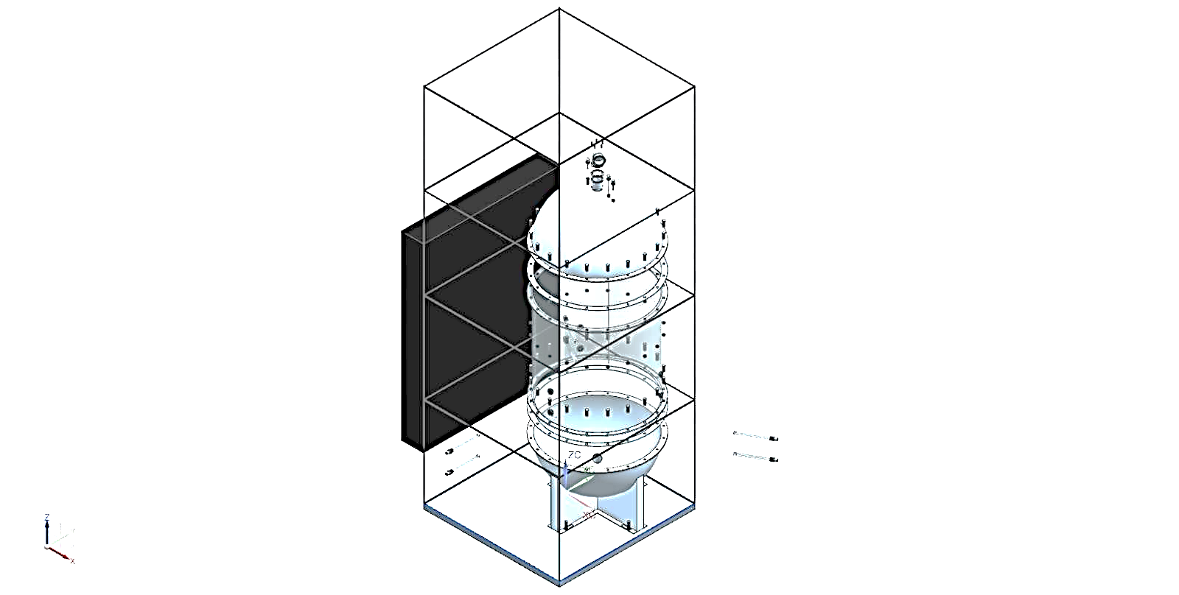

**Figure 1:** Modeling of Electric Induction Steam Boiler

1. **RESULTS AND DISCUSSION**

Steam generator performance hinges on efficiency, energy consumption, and steam production, significantly influenced by working pressure and boiling time. Increasing boiler working pressure elevates the boiling point, yielding higher thermal energy steam and improved heat transfer. This results in drier, higher-quality steam, enhanced energy efficiency, and reduced steam consumption, albeit requiring robust boiler components and stringent safety measures. Engineers must ensure system compatibility with higher pressures and implement effective control and safety mechanisms. Conversely, reducing boiling time boosts productivity and efficiency. Techniques include increasing heating power through optimized elements and insulation, preheating feedwater via economizers or condensate return systems, optimizing boiler design with enhanced heat transfer surfaces and circulation, and utilizing advanced control systems for dynamic power adjustment and real-time monitoring. By strategically managing these parameters, industries can achieve substantial improvements in operational efficiency, cost reduction, and energy conservation, while maintaining a reliable steam supply.

**CONCLUSION**

This study has explored various aspects of electric steam boilers, focusing on their efficiency, performance, and environmental impact. The findings indicate that electric steam generators offer significant advantages over traditional fossil-fuel- based boilers, including higher energy efficiency, lower emissions, and reduced maintenance requirements The analysis of different heating elements, such as resistance coils, induction heating, and electrode-based systems, has demonstrated that the choice of heating technology plays a crucial role in optimizing boiler performance. The study also highlights that automation and digital control systems contribute to enhanced operational efficiency by enabling real-time monitoring and predictive maintenance.Moreover, the environmental benefits of electric steam boilers are evident, particularly when powered by renewable energy sources. The reduction in CO₂ emissions and elimination of combustion-related pollutants make electric boilers a sustainable solution for industrial and commercial applications.While the initial investment cost of electric steam boilers may be higher than conventional boilers, the long-term cost savings in fuel, maintenance, and operational expenses make them a viable and economically beneficial choice. The adoption of smart grid integration and emerging technologies, such as hydrogen- powered boilers, further reinforces the potential of electric steam generators in future sustainable energy systems. In conclusion, electric steam boilers represent an efficient, eco-friendly, and cost-effective solution for steam generation. As industries shift towards greener technologies, further advancements in heating elements, automation, and alternative energy sources will continue to enhance the performance and feasibility of electric steam generation systems.

1. **REFERENCES**
2. [1Smith J., Brown T. (2010). Efficiency and environmental benefits of electric steam boilers. *Energy Engineering Journal*, 45(3), 210–225.
3. Johnson R., Patel S. (2012). Induction heating for steam generation: An efficiency analysis. *Journal of Applied Thermal Science*, 34(2), 98–110.
4. Wang H., Li K., Zhao Y. (2014). Material performance in high-pressure electric steam generators. *Materials Science and Engineering*, 78(5), 455– 468.
5. Chen M., Gupta R. (2015). Electric boilers in pharmaceutical processing: A stability assessment. *Pharmaceutical Process Engineering*, 12(1), 30–45.
6. Brown D., Lee J., Gonzalez P. (2016). Economic feasibility of electric steam generators in manufacturing. *Industrial Energy Economics*, 29(4), 378–392.