USE OF STEEL SLAG AS FINE AND COARSE AGGREGATE IN CONCRETE

1Adarsh Gautam,2Dr.RAKESH PATEL,3Prof.Deepak Garg

Department of Civil Engineering, OIST, Bhopal

**Abstract**

An effects on concrete by replacement of sand and coarse aggregate as steel slag on properties such as compressive strength, split tensile strength, flexural strength, are studied. The natural sand was replaced withsteelslagby0%,10%,20%,30%,40%,and50%byweightandcoarseaggregatewasreplacedwith

steelslagby0%,20%,40%,60%,80%,and100%byweightatfixedwater-cementratio0.48.

**Keywords:** CoarseAggregate,DesignMix,Plastisizer,SteelSlag,Sand,Slumpvalue,workabilityetc.

# Introduction

The building industry is the biggest user of natural materials and also a large amount of wastes resulted from the demolition of constructions. The construction process is responsible for 40% to 50%of the greenhouse gas generated. The bi-products from industries are slag, rice husk ash, bagasse, fly ash, cement dust, brick dusk, blast furnace slag, sludge, glass, tires, sandpaper, silica fume, etc. The above-listed waste materials represent a major problem for the environment because the dust and fine particles spread in the atmosphere which causes air pollution and leaching toxic chemicals like lead, cobalt, etc. also when they are dumped in landfills, quarries, rivers or oceans they cause a serious damage on the water in which animals and humans can consume it and lead to a health problem.

As the demand for coarse aggregate in the makingof cement concrete is increasing day by day the search for alternative material has become a crying need. Stone chip is the most widely used coarse aggregate in India and the continuous spreading of the brick industries are hampering the environment to a great extent. Moreover the price of brick aggregate is also going higher as its demand gets higher. Stone can be used as a replacement of brick aggregatebutithaslow availability andhigher price. In this existing condition the waste materials such as steelslagcanbeconsideredasapossibilitywhich

can be used instead of conventional coarse aggregates.

Steel slag is a byproduct obtained either from conversion of iron to steel in a Basic Oxygen Furnace (BOF), or by the melting of scrap to make steel in the Electric Arc Furnace (EAF). The molten liquid is a complex solution of silicates and oxides thatsolidifies on cooling and forms steel slag. Steel slagis defined by the American Society for Testing and Materials (ASTM) as ìa non-metallic product, consisting essentially of calcium silicates and ferrites combined with fused oxides of iron, aluminum, manganese, calcium and magnesium that are developed simultaneously with steel in basic oxygen, electric arc, or open hearth furnacesî.

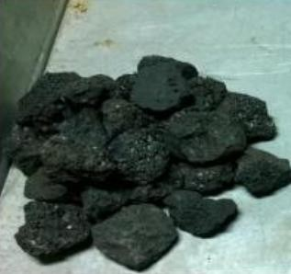

**Figure1**:SteelSlagSample

***Objectivesofthestudy***

The various objectives of the study is to study the fresh and hardened properties of concrete madewith steel slag as partial replacement of coarse aggregate, to find out mechanical properties of concrete by partially replacing fine aggregate with steel slag, to compare mechanical properties of concrete made with conventional aggregate andsteel slag aggregateand to find out thepossibility of utilization of Steel slag in concrete as partial replacement.

# Methodology

In this study, Steel Slag obtained from Bhilai Steel Plant, Durg, Chhattisgarh, a part of National SAIL, located in Chhattisgarh state, India is used. It is very famousfor steel inIndia witha capacityof2600MW. The natural sand was replaced with steel slag by 0%, 10%, 20%, 30%, 40%, and 50% by weight and coarse aggregate was replaced with steel slag by 0%, 20%, 40%,60%,80%,and100%byweightatfixedwater-

cementratio0.48.

Effects on concrete by replacement of sand and coarse aggregate as steel slag on properties such as compressive strength, split tensile strength, flexural strength,arestudied.Inthisslumpwaskeptconstant 100 ± 10 mm respectively and achieve the required slump Plastizer were used as directed by the manufacturer, for this work dosage was 0.21% to 0.25%

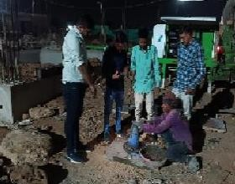

**Figure2**:SlumpconeTest

# Results

Resultsofthevariousexperimentalinvestigationsare reportedanddiscussed.MixdesignofM25gradeof

concrete is given and mix proportioning of different concrete mixes is fixed.

**Table-1:**CompressivestrengthofsamplecontainingSteel Slag as Fine aggregate

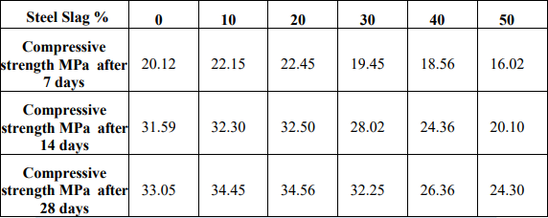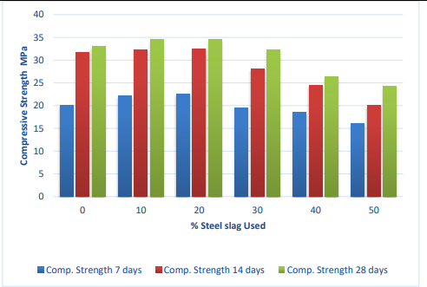

**Chart-1**:CompressivestrengthofsamplecontainingSteel Slag as Fine aggregate

**Table-2:**CompressivestrengthofsamplecontainingSteel Slag as coarse aggregate

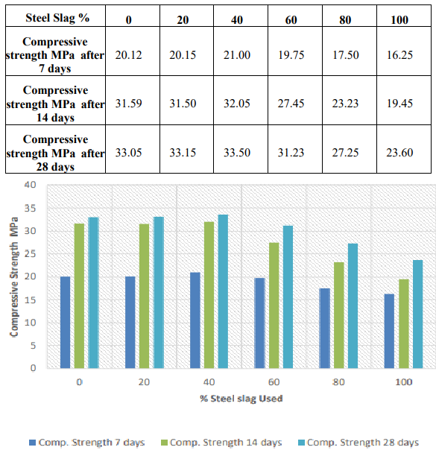

**Chart-2**:CompressivestrengthofsamplecontainingSteel Slag as Coarse aggregate

Here 0% to 50% of steel slag was replaced with sand and optimum percentage of replacement was found at20%replacementofsteelslagwithsand.For

controlled concrete the compressive strength was found for 7, 28, and 56 days. It was observed that for 20%sandreplacementthecompressivestrengthwas increased as compared with controlled concrete. Thenafterthatcompressivestrengthweredecreased from 30% to 50% replacement. The steel slag concrete gains strength at a slower rate in the initial period and acquires strength at faster rate.

# Conclusion

In this report experimental results are presented to evaluate the possibility of utilizing of pond ash as sand in concrete with compressive strength of 25 MPa.

After the review of all properties of steel slag it can be concluded that steel slag has properties similar to Indian standard sand and coarse aggregate hence it can be used as fine aggregate and coarse aggregate in construction. While replacing fine aggregate with steel slag The compressive strength for 7,14 & 28days was increased up to 20% replacement and after that compressive strengths were decreasedfrom 30% to 50% replacement. Replacing coarse aggregate with steel slag The compressive strength for 7,14 & 28days was increased up to 40% replacement and after that compressive strengths were decreased from 50% to 100% replacement.

Therefore, the conclusions of all these tests suggest that the mixture containing 40% steel slag may be used as a suitable replacement for coarse aggregate and 20% steel slag may be used as a suitable replacement for fine aggregate in concrete in moderate environments without compromising the strength.

# Acknowledgements

This work is the result of guidance and support of various people at Oriental institute of science and technology, without whom all my effort would have been directionless and fruitless. I express myheartfelt and profound gratitude to **Dr. RAJESH K. SHUKLA** Director OIST Bhopal for his valuable suggestions at all stages of my research work.

# References

1. Demissew, A. Comparative Analysis of Selected ConcreteMixDesignMethodsBasedon CostEffectiveness. Adv. Civ. Eng. 2022, 2022, 4240774. [Google Scholar] [CrossRef]
2. De Brito, J.; Francisco, A. New Trends in Eco-Efficient and Recycled Concrete; Woodhead Publishing: Cambridge, UK, 2019; pp. 169–190. [Google Scholar]
3. Beaumont, P.W.R.; Zweben, C.H. Comprehensive Composite Materials II; Elsevier: Amsterdam, The Netherlands, 2018; pp. 464–481. [Google Scholar]
4. Kumar, S.; Dhara, S.; Kumar, V.; Gupta, A.; Prasad, A.; Keshari, K.; Mishra, B. Recent trends in slagmanagement & utilization in the steel industry. Miner. Met. Rev. 2019, 2019, 94–102. [Google Scholar]
5. Nippon Slag Association. Iron and Steel Slag Products; Nippon Slag Association: Tokyo, Japan,2003. [Google Scholar]
6. National Slag Association. Iron and Steel Making Slag Environmentally Responsible Construction Aggregates; Environmental Technical Bulletin; Nippon Slag Association: Tokyo, Japan, 2003; p. [Google Scholar]
7. Lin, W.-T.; Tsai, C.-J.; Chen, J.; Liu, W. Feasibility and Characterization Mortar Blended with High-Amount Basic Oxygen Furnace Slag. Materials 2019, 12, 6. [Google Scholar] [CrossRef] [PubMed][Green Version]
8. Netinger, I. Concrete Containing Stee Slag Aggregate Performance after High Temperature Exposure. In Concrete Repair, Rehabilitation and Retrofitting III; Taylor & Francis Group: London, UK, 2012; pp. 1347– 1352. ISBN 978-0-415-89952-9. [Google Scholar]
9. Jigar, P.P. Broader Use of Steel Slag Aggregates in Concrete. Master’s Thesis, Cleveland State niversity, Cleveland, OH, USA, 2008; p. 401. [Google Scholar]
10. Weiwu,Weide Zhang, Guowei Ma, Optimum contentof copper slag as a fine aggregate in high strength