A Study on the Effects of Internet Banking on Customer Satisfaction with Financial Services Provided by Federal Bank

Abstract
The financial sector has experienced a profound transformation due to the rise of internet banking, fundamentally altering the delivery of banking services to clients. Internet banking allows users to access a diverse array of financial services online, such as transferring funds, paying bills, applying for loans, and managing investments. Federal Bank, a prominent private-sector bank in India, has taken proactive steps to incorporate digital banking solutions aimed at enhancing customer experience, boosting operational efficiency, and promoting financial inclusion.
This research paper investigates the effects of internet banking on the financial services offered by Federal Bank, with a particular emphasis on customer satisfaction, operational advantages, security challenges, and barriers to adoption. The study utilizes a mixed-methods approach, integrating both quantitative and qualitative research techniques. A survey was conducted with 70 customers of Federal Bank to evaluate their experiences and concerns regarding internet banking, while in-depth interviews with bank officials provided valuable insights into the operational aspects of digital banking.

Introduction
The banking sector has undergone a significant transformation with the advent of digital technology, resulting in the widespread embrace of internet banking. In the past, customers were required to visit physical bank branches for transactions, which often resulted in lengthy wait times and restricted banking hours. The rise of internet banking, however, has empowered customers to conduct financial transactions conveniently from their homes, utilizing computers and mobile devices.
Federal Bank, a leading private-sector bank in India, has taken a pioneering role in digital banking innovation. The bank provides a variety of internet banking services, such as online fund transfers, utility bill payments, digital loans, and investment options. By harnessing cutting-edge technologies like artificial intelligence (AI), blockchain, and biometric authentication, Federal Bank has improved the efficiency and security of its online banking services. Nevertheless, the shift to internet banking presents certain challenges. Concerns related to cybersecurity, gaps in digital literacy, and customer hesitance to embrace new technologies remain significant barriers to the comprehensive digital transformation of the banking industry.

Significance of the Study

The increasing dependence on online banking has significantly altered the operational dynamics of financial institutions. While digital banking brings forth various benefits, including enhanced efficiency, reduced costs, and greater convenience for customers, it also introduces challenges that banks need to confront. Analyzing the effects of internet banking on Federal Bank’s financial services is essential for pinpointing areas for enhancement and boosting customer satisfaction.
This research holds importance for several reasons:
- It assesses the role of internet banking in enhancing customer convenience and operational effectiveness.
- It highlights security issues related to digital banking and investigates strategies to mitigate these risks.
- It explores customer attitudes towards internet banking and the elements that affect adoption rates.
- It offers recommendations for Federal Bank to improve its digital banking offerings and foster greater customer trust.

Literature Review
The advent of internet banking has revolutionized the financial services industry, providing customers with convenience and accessibility that was previously unattainable. This literature review examines various studies and reports related to the impact of internet banking on financial services, with a focus on Federal Bank.
Ikram Ullah Khan (2022), The study examines how culture influences the uptake of digital banking in Pakistan and China. As theoretical frameworks, it makes use of customer service and the unified model (UTAUT-2). The study found that hedonic motivation, habit, and real-time support were significant factors for Pakistani bank customers, out of 410 mainlands Chinese and 360 Pakistani bank customers. Chinese consumers were attracted to digital banking because of societal influence, cost considerations, habitual work, and bank support systems. The report provides recommendations for banks and regulators on how to improve the digitisation of banking in both countries.
Nocera and Gloria (2022), Fintech companies threaten traditional banks by exploiting consumers' mistrust and offering tech-based products. Switzerland's fintech demand surged from 30% in 2017 to 64% in 2019, driven by Generation Z. To restore trust, incumbents must address the banking application of Swiss Neobank Yuh through a case study and literature review.
Sandhu, S., & Arora, S. (2022), Examining the utilization of electronic banking services in a multi-channel environment reveals little usage. It suggests that banks may continue to develop technology and reap the benefits of it while also appreciating the worth of their employees. However, the ease and security of electronic banking must be improved in order to eliminate the obstacles to complete reliance on electronic media
Singh, S. (2019) The objective of this consider is to degree the e-service quality of web keeping money and the relationship with client fulfilment in India. Numerous Relapse Investigation was utilized to test the relationship with e-service quality measurements and client fulfilments of web managing an account. These discoveries can be utilized by banks to progress the benefit quality of their web managing an account benefit and in this manner to fulfill their clients.
Firdous, S., & Farooqi, R. (2017). The rise of electronic service delivery has transformed businesses by eliminating geographical, regulatory, and industrial barriers, leading to a shift in the banking sector. This has prompted banks to offer internet banking or e-banking, which is more compatible with the electronic marketplace. However, no significant effort has been made to understand customer satisfaction and demographic characteristics of those adopting this technology in India. Research scholars have developed various models to measure e-service quality in the services sector.
Rashidi, E., & Mansoori, D. E. (2015). The study investigates the impact of internet banking on customer satisfaction at Melli Bank locations in southern West Azerbaijan. The research involved 34,250 customers who activated their Melli card's internet services. A survey questionnaire was used, with a high reliability score of 0.86. Data analysis revealed a significant positive correlation between internet banking and customer satisfaction, as well as a correlation between satisfaction and demographic factors like age, profession, education level, and gender.
Sakhaei, S. F., Afshari, A. J., et., al (2014). This study investigates service quality indexes in Internet Banking in Iran, using a descriptive-surveying approach. It proposes a hybrid model with six dimensions: reliability, efficiency, responsiveness, fulfillment, security/privacy, and website design. Data was collected through a 5-Point Likert scale questionnaire. The study found that reliability has the most significant relationship with customer satisfaction, while website design has the least. The findings suggest that service quality factors significantly impact customer satisfaction in Internet Banking.
George, A., & Kumar, G. G. (2014). This research examines the dimensions of service quality in Internet Banking within the State of Kerala (India) and looks into the impact of these dimensions on customer satisfaction. The service quality dimensions recognized included Website features, Reliability, Responsiveness, Fulfillment, Efficiency, and Privacy and Security. It was discovered that all dimensions, with the exception of efficiency and website features, had an effect on customer satisfaction. The results of the research hold managerial significance for banks to enhance the promotion of Internet Banking to their customers by improving these service quality dimensions.
Sharma, G., & Malviya, S. (2014). The main objectives of this empirical study is to explore internet banking service quality factors and also analyze its impact on customer satisfaction through Multiple-Regression statistical techniques. Using factor analysis five dimensions for internet service quality were extracted and to analyze its impact on customer satisfaction regression method was used by the researcher. Researcher found that there is a positive impact of service quality dimensions on customer satisfaction.
Kaur, J., & Kaur, B. (2014). The purpose of this term paper has been to examine the degree of approval through the relative centrality among the five dimensions of online banking service quality scale derived from Gupta and Bansal (2012) scale that influence customer satisfaction metrics adopted from Basker and Ramesh (2010) scale within the banking sector in India.

Statement of the Problem
As internet banking has gained popularity, customer satisfaction is now an important determinant of the success of electronic financial services. Although internet banking is convenient, accessible, and secure, the question remains if these aspects truly contribute to customer satisfaction. Are customers more satisfied depending on how frequently they use internet banking, its ease of access, or feeling secure? Do these have a major impact on customer experience, or are there other factors at play?
This research seeks to examine the influence of internet banking on customer satisfaction with Federal Banks financial services in terms of usage frequency, accessibility and security perception. The study will determine which of these factors have a significant influence on satisfaction, offering insights for improving the bank's digital services and customer experiences.

Research Objectives

The primary objectives of this study are:
1. To analyze how internet banking has improved customer convenience at Federal Bank.
2. To identify security risks and challenges associated with digital banking.
3. To assess customer adoption patterns and the factors influencing their trust in internet banking.

Hypotheses for the Study
Dependent Variable:
- Customer Satisfaction with Internet Banking
Independent Variables:
- Usage Frequency of Internet Banking
- Improved Accessibility of Financial Services
- Perceived Security of the Platform

H₀ (Null Hypothesis): The independent variables (usage frequency, accessibility, and security perception) do not significantly impact customer satisfaction.
H₁ (Alternative Hypothesis): At least one independent variable significantly impacts customer satisfaction.

Scope of the Study

This research analyzes the influence of internet banking on satisfaction of customers with the banking services offered by Federal Bank. Three primary variables - frequency of use, availability of services, and perceived safety of the bank's internet platform - are the focus of the present study. Through an examination of these variables, the research seeks to establish their contribution towards customer satisfaction and find out areas where digital banking services could be developed.
The sample only includes Federal Bank customers who frequently use internet banking, so the results are pertinent to the digital service plans of the bank. Quantitative analysis via regression modeling is used, which gives statistical information on the factors that are significant in shaping satisfaction. External variables like service charges, customer care, or mobile banking services are not analyzed, though these might also be important in influencing satisfaction.
The results can be used to strengthen Federal Bank's internet banking service through an emphasis on drivers of satisfaction. Moreover, the study offers directions for future research in order to identify other determinants of customer experience in online banking

Research Methodology
This section outlines the research methods used to study the impact of Internet Banking on Financial Services Provided by Federal Bank. The study is based on primary data collection and analysed using descriptive statistics.

1. Research Design
The study follows a quantitative research design, using primary data collected from customers of Federal Bank to assess the impact of internet banking services.
2. Data Collection Method
- Primary Data: Data is collected through questionnaires with Federal Bank customers.
- Sampling Method: A random sampling technique is used to ensure diverse respondent representation.
- Sample Size: 70 customers of Federal Bank
- Data Collection Tools: Google forms

3. Data Analysis Method
Descriptive Statistics: Used to summarize and interpret the data effectively.
- Frequency Distribution & Percentage Analysis
- Visualization Tools: Charts, graphs, and tables to present findings.
Regression Analysis: to determine the relationship between independent variables and customer satisfaction.

Limitations of the Study
- Limited Variable Scope – The research only measures usage frequency, availability, and security perception, while other critical variables such as transaction speed, usability, customer service, and mobile banking experience were not included.
- Sample Size and Representation – The results are drawn from the opinions of Federal Bank customers, and these may not be representative of the wider banking sector or clients of other financial institutions.
- Focus on a Single Bank – As the research is restricted to Federal Bank, the findings may not be extrapolated to other banks with varied digital banking approaches and customer profiles.

Analysis and Interpretations
Based on the responses from 70 participants, here is the analysis and interpretation of the impact of Internet Banking on Financial Services Provided by Federal Bank:
1. Demographic Analysis
Category | Frequency | Percentage (%)
Age Group
20-30 | 60 | 85.7%
31-40 | 4 | 5.7%
41+ | 6 | 8.6%
Gender
Male | 34 | 51.4%
Female | 36 | 48.6%
Occupation
Student | 54 | 77.1%
Salaried Employee | 15 | 21.4%
Self-Employed | 1 | 1.5%

2. Internet Banking Usage & Frequency

Category | Frequency | Percentage (%)
Do you use Internet Banking?
Yes | 70 | 100%
Most Used Services
Fund Transfers (NEFT, RTGS, IMPS) | 36 | 51.4%
Bill Payments | 37 | 52.9%
Account Statements | 34 | 48.6%
Usage Frequency
Daily | 26 | 37.1%
Weekly | 26 | 40%
Rarely | 10 | 25%

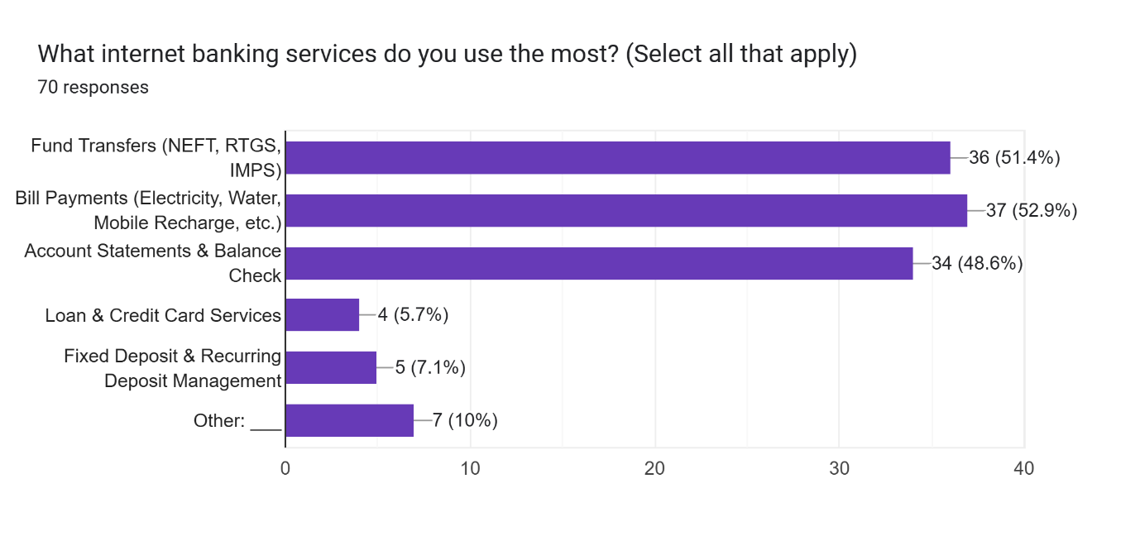

3. Benefits of Internet Banking

Benefit | Frequency | Percentage (%)
Time-Saving | 55 | 78.6%
24/7 Access | 49 | 70%
Better Financial Management | 21 | 30%
Lower Transaction Cost | 17 | 24.3%

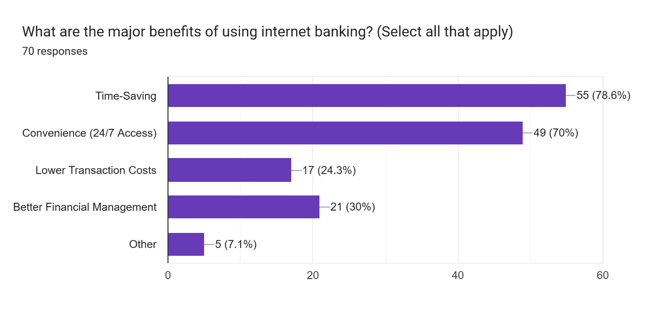

Interpretation: Customers highly value the time-saving and convenience factors of internet banking.

4. Challenges & Security Concerns

Challenge | Frequency | Percentage (%)
Technical Issues (Slow Transactions, Downtime) | 57 | 81.4%
Security Concerns | 14 | 20%
Difficulty in Navigation | 7 | 10%
Lack of Customer Support | 3 | 4.3%
other | 6 | 8.6%

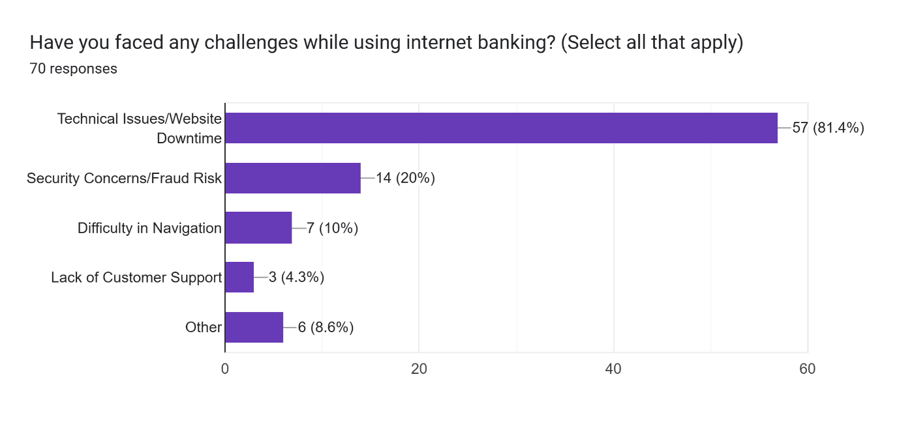
Security Issues Faced (Fraud, Phishing, etc.) | Frequency | Percentage (%)
Yes | 12 | 17.1%
No | 58 | 82.9%

Interpretation: While most users feel Federal Bank’s internet banking platform is secure, some technical issues and minor security concerns remain.

5. Suggestions for Improvement
Suggested Improvement | Frequency | Percentage (%)
Better User Interface | 16 | 22.9%
Faster Transactions | 17 | 24.3%
More Customer Support | 11 | 15.7%
Enhanced Security Features | 18 | 25.7%
Other | 8 | 11.4%

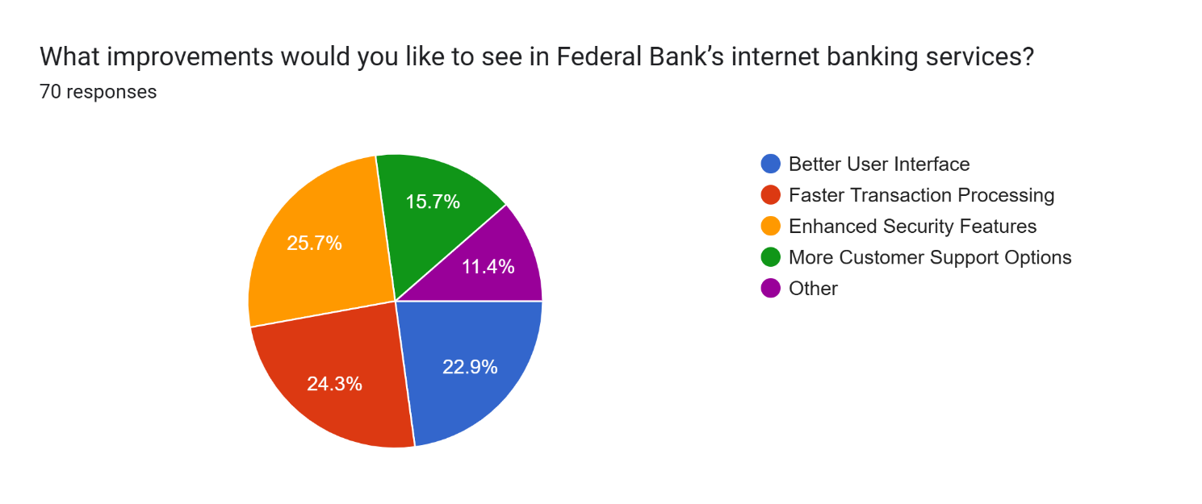

6. Recommendation of Internet Banking
Would you recommend Federal Bank’s Internet Banking? | Frequency | Percentage (%)
Yes | 61 | 87.1%
No | 9 | 12.9%

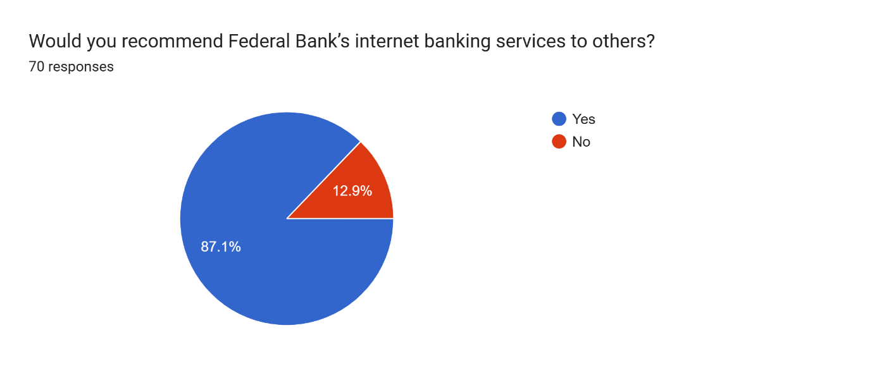

Regression Analysis

Predictor | B (Unstandardized Coefficient) | Beta (Standardized Coefficient) | t-value | p-value (Sig.)

(Constant) | 2.968 | — | 7.164 | 0.000

How often do you use internet banking? | 0.204 | 0.285 | 2.348 | 0.022

Has internet banking improved accessibility? | 0.071 | 0.019 | 0.150 | 0.881

Do you feel the platform is secure? | 0.539 | 0.211 | 1.635 | 0.107

H1: Effect of Internet Banking Usage Frequency on Satisfaction
- H₀: "How often do you use internet banking?" does not significantly affect customer satisfaction.
- H₁: "How often do you use internet banking?" positively affects customer satisfaction.
Result: Since p = 0.022 (< 0.05), we reject H₀ and conclude that usage frequency significantly impacts satisfaction.
H2: Effect of Improved Accessibility on Satisfaction
- H₀: "Has internet banking improved accessibility?" does not significantly affect customer satisfaction.
- H₁: "Has internet banking improved accessibility?" positively affects customer satisfaction.
Result: Since p = 0.881 (> 0.05), we fail to reject H₀, meaning accessibility does not significantly impact satisfaction.

H3: Effect of Perceived Security on Satisfaction
- H₀: "Do you feel Federal Bank's internet banking is secure?" does not significantly affect customer satisfaction.
- H₁: "Do you feel Federal Bank's internet banking is secure?" positively affects customer satisfaction.
Result: Since p = 0.107 (> 0.05), we fail to reject H₀, meaning security perception does not significantly impact satisfaction.

Conclusion

The research conducted on the influence of internet banking on the financial services offered by Federal Bank indicates that digital banking has become a vital component of financial transactions, providing customers with convenience, efficiency, and accessibility. A substantial majority of participants reported regular use of internet banking, primarily for activities such as fund transfers, bill payments, and monitoring account balances. The results show that most users engage with these services frequently, with a significant number utilizing them on a daily or weekly basis.
The purpose of this research was to evaluate the effect of internet banking on customer satisfaction with Federal Bank's financial services. Regression analysis was used to identify the significance of services in terms of three determinants: frequency of usage, ease of accessibility and perceived security in shaping customer satisfaction. The findings of the coefficient table indicated that usage frequency of internet banking is the sole statistically significant predictor of satisfaction (p =0.022). What this indicates is that customers frequently using Federal Bank's online bank platform report a higher degree of satisfaction.
In summary, internet banking has revolutionized financial services, but its effect on satisfaction is mostly determined by the usage frequency of customers and not merely by accessibility or security. Federal Bank needs to enhance usability, boost engagement, and offer a seamless digital interaction to enhance customer experience.

References
- Federal Bank. (2023). Annual report on digital banking growth. https://www.federalbank.co.in
- Khan, I. U. (2022). How does culture influence digital banking? A comparative study based on the unified model. Technology in Society, 68, 101822.
- Nocera, G. (2022). Fintech revolution and traditional banks-what factors influence members of generation Z to place their trust in Fintech companies, specifically neobanks, over traditional banks as banking and financial service providers? a case study on the banking application of the Swiss neobank Yuh.
- Sandhu, S., & Arora, S. (2022). Customers' usage behaviour of e‐banking services: Interplay of electronic banking and traditional banking. International Journal of Finance & Economics, 27(2), 2169-2181.
- Firdous, S., & Farooqi, R. (2017). Impact of internet banking service quality on customer satisfaction. Journal of Internet Banking and Commerce, 22(1).
- Nguyen, T., & Singh, M. (2004). Impact of Internet banking on customer satisfaction and loyalty: A conceptual model.
- Rashidi, E., & Mansoori, D. E. (2015). Discussing the effects of internet banking on customer satisfaction. Rashidi and Mansoori (2015), Indian Journal of Fundamental and Applied Life Sciences, 5, S2.
- Sakhaei, S. F., Afshari, A. J., & Esmaili, E. (2014). The impact of service quality on customer satisfaction in Internet banking. Journal of mathematics and computer science, 9(1), 33-40.
- George, A., & Kumar, G. G. (2014). Impact of service quality dimensions in internet banking on customer satisfaction. Decision, 41, 73-85.
- Sharma, G., & Malviya, S. (2014). Internet banking service quality and its impact on customer satisfaction in Indore district of Madhya Pradesh. International Journal of Business and Management Invention, ISSN (Online), 2319-8028.
- Kaur, J., & Kaur, B. (2014). Determining internet banking service quality and customer satisfaction in India. Envision Journal of Commerce Department of ACFA, 8.
- Singh, S. (2019). Measuring E-service quality and customer satisfaction with internet banking in India. Theoretical Economics Letters, 9(2), 308-326.

