**TRANSMISSION LINE FAULT DETECTION SYSTEM**

**Miss. Kokate Monali C 1, Mr. Algat Narendra A 2, Mr. Jadhav Prem K 3 , Mr. Kharate Om S 4 ,**

**Mr. Jagzap Tejas B 5**

1, Lecturer, Department of Electrical Engineering, Santosh N Darade Polytechnic, Yeola,Maharashtra, India.

2, 3, 4, 5 Students, Department of Electrical Engineering, Santosh N Darade Polytechnic, Yeola,Maharashtra, India.

**ABSTRACT**

In this project we will monitor transmission line fault. The steady state operating mode of a power system is balanced 1-phase ac. However, due to sudden external or internal changes in the system, this condition is disrupted. When the insulation of the system fails at one or more points or a conducting object comes in contact with a live point, a short circuit or fault occurs. The causes of faults are numerous, e.g., lighting, heavy winds, trees falling across lines, vehicles colliding with towers or poles, birds, line breaks, etc. A fault involving all the three phases is known as symmetrical fault while one involving only one or two phases is known as unsymmetrical fault .we are working on monitoring these faults during occurring on transmission line. In this project we indicate the fault on LCD. These faults are monitoring by using microcontroller. We used 16*2 LCD display to indicate fault. We used Microcontroller 8051. 8051 is 8 bit single chip CPU. It contains inbuilt 8 kb ROM and 256 byte RAM.8051 is 40 pin IC having four ports p0, p1, p2 and p3. Benefit on using 8051 is low cost. We can design PLC-programmable logic controller using 8051. We detected different types of faults and checked fault at different locations. We display faults at LCD. We connected LCD 16*2 at port0. We connected RS,R Wand EN at pin p2.5, p2.4 and p2.3 respectively. We first of all step down the voltage then will give to rectifier. For rectification purpose we will use IN4007diode. After rectification we filtered DC supply. After rectification we will convert12 v to 5v using LM7805. 78 indicate +ve voltage and 5v.For the regulated power supply we use IC 7805 as a regulator to provide a fix 5 volt power supply

.**Keywords:** Monitor transmission line fault, LCD Display, Microcontroller 8051, power supply.

1. **INTRODUCTION**

In this project we will monitor transmission line fault. The steady state operating mode of a power system is balanced 3-phase ac. However, due to sudden external or internal changes in the system, this condition is disrupted. When the insulation of the system fails at one or more points or a conducting object comes in contact with a live point, a short circuit or fault occurs. The causes of faults are numerous , e.g., lighting, heavy winds, trees falling across lines, vehicles colliding with towers or poles, birds, line breaks, etc. A fault involving all the three phases is known as symmetrical fault while one involving only one or two phases is known as unsymmetrical fault we are working on monitoring these faults during occurring on transmission line. In this project we indicate the fault on LCD. These faults are monitoring by using microcontroller.  
We used 16*2 LCD display to indicate fault. We used Microcontroller 8051. 8051 is 8 bit single chip CPU. It contains inbuilt 8 kb ROM and 256 byte RAM. 8051 is 40 pin IC having four ports p0, p1, p2 and p3. Benefit on using 8051 is low cost. We can design PLC-programmable logic controller using 8051. We detected different types of faults and checked fault at different locations. We display faults at LCD. We connected LCD 16*2 at port0. We connected RS, RW and EN at pin p2.5, p2.4 and p2.3 respectively. We first of all step down the voltage then will give to rectifier. For rectification purpose we will use IN4007 diode. After rectification we filtered DC supply. After rectification we will convert 12 v to 5v using LM7805. 78 indicate +ve voltage and 5v.For the regulated power supply we use IC 7805 as a regulator to provide a fix 5 volt power supply.

1. **BASIC COMPONENTS**

There are number of basic components, using in this project these are -

(i). Power Supply for the circuit.

(ii). Voltage regulator

(iii). Diode

(iv). Rectifier

(v). Transformer.

(vi). Resistors.

(vii). Capacitors.

(viii). Micro controller 8051

(ix). LCD display

1. **FAULT (POWER ENGINEERING)**

In an electric power system, a fault is any abnormal flow of electric current. For example a short circuit is a fault in which current flow bypasses the normal load. An open circuit fault occurs if a circuit is interrupted by some failure. In three phase systems, a fault may involve one or more phases and ground, or may occur only between phases. In a "ground fault" or "earth fault", current flows into the earth. The prospective short circuit current of a fault can be calculated for power systems. In power systems, protective devices detect fault conditions and operate circuit breakers and other devices to limit the loss of service due to a failure.

In a polyphase system, a fault may affect all phases equally which is a "symmetrical fault". If only some phases are affected, the "asymmetrical fault" requires use of methods such as symmetrical components for analysis, since the

1. **COMPONENT OF ATTACHMENT**

* Transformer
* Rectifier
* Poles
* Resistor
* Capacitor
* Led Display
* Microcontroller 8051

1. 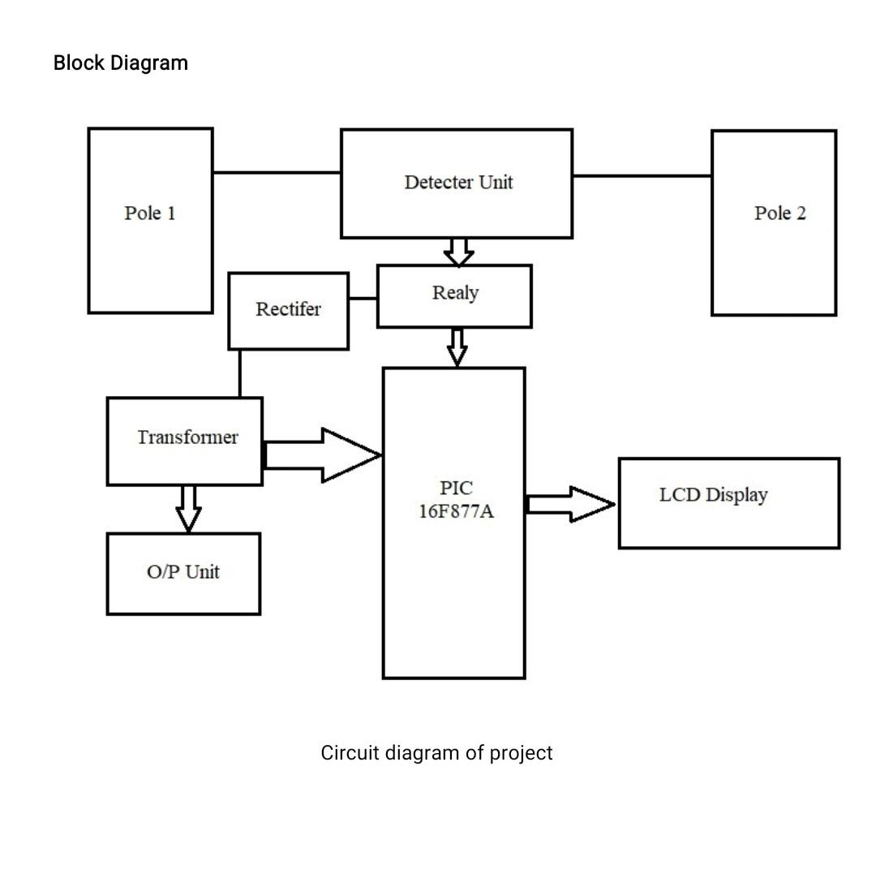**BLOCK DIAGRAM**

**Fig:** Circuit Diagram of project

1. **WORKING OF THE PROJECT**

(Fault)

In a system, a fault is any abnormal flow of current. For example circuitous a fault in which current flow bypasses the normal load. An open circuit fault occurs if a circuit is interrupted by some failure. In three phase systems, a fault may involve one or more phases and ground, or may occur only between phases. In a "ground fault" or "earth fault", current flows into the earth. The current of a fault can be calculated for power systems. In power systems, protective devices detect fault conditions and operate circuit and other devices to limit the loss of service due to a failure. In system, a fault may affect all phases equally which is a "symmetrical fault". If only some phases are affected, the "asymmetrical fault "requires use of methods such as components for analysis, since the simplifying assumption of equal current magnitude in all phases is no longer applicant.

1. **FUTURE SCOPE**

We can have a global positioning system (GPS) connected to it will send accurate location (latitude and longitude) of fault occur in transmission.

1. **ADVANTAGES**

1) It is all types' two pole wiring system.

2) It is accurate display and light control.

3) The system is used directly 12V operated.

4) Cost is less.

5) Circuit is very simple and Suitable.

6) Smooth steeples variation in the output voltage

1. **APPLICATION**
2. Microcontroller and LCD display
3. Relay detection system
4. Arduino-based project
5. **CONCLUSION**

Transmission line faults can disrupt the power supply, so it’s important to have effective methods to detect and isolate them.

**REFERENCE**

[1]. Singh, Manohar, B. K. Panerai, and R. P. Maheshwari. (2011) "Transmission line fault detection and classification." -International Conference on Emerging Trends in Electrical and Computer Technology. IEEE, 2011.

[2]. Mishra, Debani Prasad, and Papia Ray. (2018) "Fault detection, location and classification of a transmission line." -Neural Computing and Applications 30: 1377-1424.

[3]. Adhikari, Shuma, Nidul Sinha, and ThingamDorendrajit. (2016) "Fuzzy logic based on-line fault detection and classification in transmission line."-SpringerPlus 5.1 1-14.