# E-commence Website: Sopsy

**HOD. Mr. G. L. Girhe**

Computer Engineering

Department,

SRPCE, Nagpur

Maharashtra, India

**Email id:-Gaurishankar00733@gmail.com**

**Purva P. Sahare**

UG Student

Computer Engineering

Department ,

SRPCE ,Nagpur,

Maharashtra, India

**Email id:-purvasahare2@gmail.com**

**Pranjali P. Gajghate**

UG Student Computer Engineering

Department,

SRPCE ,Nagpur,

Maharashtra ,India

**Email.com:-pranjaligajghate658@gmail.com**

## Abstract

This paper discusses the implementation of an e-commerce website, focusing on the technologies, design patterns, and deployment strategies used. The project follows a modern web development approach, integrating a secure backend, dynamic frontend, and a scalable database.

**KEYWORD:** Express.js, React, Node.js, user authentication, shopping cart, inventory management, order processing, product filtering, responsive design.

## Introduction

E-commerce websites have revolutionized the way people shop. This implementation paper describes the development process of an online shopping platform, detailing the chosen technologies, architecture, and deployment strategy.

The development of modern e-commerce websites requires the integration of multiple technologies to ensure seamless user experiences and scalable back-end infrastructures. The "Sopsy" project, built using the MERN stack—comprising MongoDB, Express.js, React, and Node.js—seeks to address these challenges by creating a dynamic, scalable, and responsive platform. In addition to the core MERN technologies, the project integrates Redux for state management, Razorpay for secure payment gateways, and Material-UI (MUI) and Tailwind CSS for effective UI/UX design.

In the digital age, e-commerce has emerged as a transformative force in the global economy, offering businesses and consumers alike unparalleled convenience, access to a wider marketplace, and more personalized experiences. The rapid growth of the internet and advancements in technology have enabled companies to establish an online presence, driving their ability to reach customers across geographic boundaries. As a result, the implementation of e-commerce websites has become a critical factor for the success of businesses in various industries.

An e-commerce website allows businesses to facilitate the online buying and selling of goods or services. This platform not only supports online transactions but also integrates multiple features such as product catalogs, secure payment gateways, user management, order tracking, and customer service functionalities. A well-designed e-commerce website can provide an efficient, user-friendly shopping experience, resulting in enhanced customer satisfaction and increased sales.

This paper aims to explore the process of implementing an e-commerce website, from conceptualization to deployment. It will discuss the essential components and technologies that make up the foundation of a successful e-commerce platform, including front-end and back-end development, payment systems, security considerations, and responsive design. Furthermore, it will analyze key factors that businesses need to consider when selecting an e-commerce platform, and the challenges and solutions involved in creating a robust and scalable online store.

By providing insights into the technical, operational, and strategic aspects of e-commerce website implementation, this paper serves as a comprehensive guide for organizations seeking to establish or enhance their digital presence in the competitive e-commerce market.

### Objectives

## • Streamline Product Sales: The website should allow businesses to easily list, sell, and promote products or services to customers, reaching a global audience.

## • Enhance Customer Experience: Provide an intuitive and user-friendly interface, making it easy for customers to browse products, make purchases, and interact with customer support.

## • Secure Online Transactions: Ensure a safe and seamless transaction process with secure payment gateways and encryption to protect customer information.

## • Inventory Management: Implement systems to efficiently manage stock levels, track sales, and update product availability in real-time.

## • Increase Market Reach: Offer a platform that is accessible 24/7, enabling businesses to reach customers anywhere and at any time, leading to increased sales opportunities.

## • Brand Visibility: Provide a space to showcase the company’s brand, values, and unique selling points, which helps in building brand awareness and trust among customers.

## • Customer Analytics: Collect valuable data regarding customer behavior, preferences, and purchasing patterns to improve marketing strategies and product offerings.

## • Cost Efficiency: Reduce operational costs related to physical stores, such as rent and utilities, by transitioning sales to an online platform.

## • Mobile Optimization: Ensure the website is mobile-friendly to cater to the increasing number of customers shopping via smartphones and tablets.

## • Integration with Marketing Tools: Enable integration with email marketing, social media, and other digital marketing strategies to promote products and engage with customers effectively.

## 2. System Architecture

The architecture follows the MVC (Model-View-Controller) pattern and consists of the following layers:

1. Frontend (Client-side) – Built using React.js (or Angular/Vue.js)

2. Backend (Server-side) – Developed with Node.js and Express (or Django, Spring Boot, etc.)

3. Database – Uses MongoDB (NoSQL) or MySQL/PostgreSQL (SQL)

4. Hosting – Deployed on AWS, Firebase, or DigitalOcean

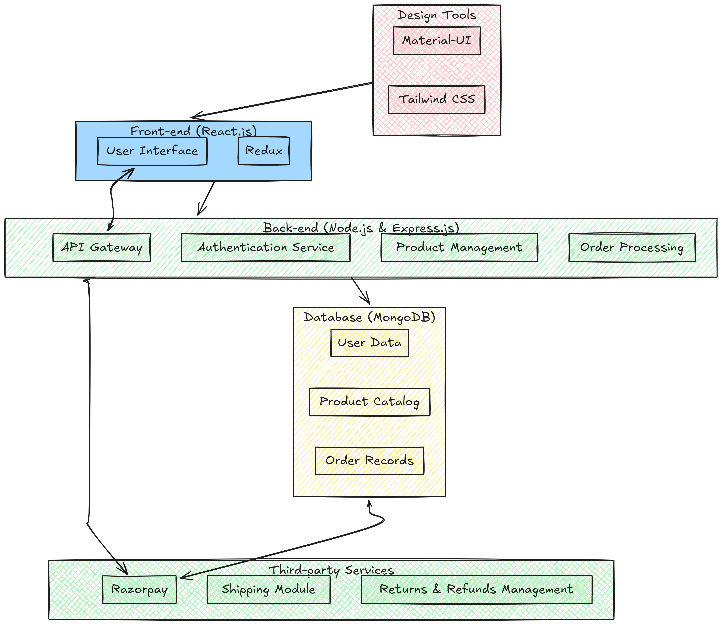

## 3. Technology Stack

|  |  |  |  |  |  |  |  |  |  |  |  |  |  |
| --- | --- | --- | --- | --- | --- | --- | --- | --- | --- | --- | --- | --- | --- |
| |  |  | | --- | --- | | Component | Technology Used | | Frontend | React.js ,Bootstrap | | Backend | Node.js ,Express.js | | Database | MongoDB | | Authentication | Firebase Auth | | Payment Gateway | Stripe ,Razorpay | |  |
|  |  |
|  |  |
|  |  |
|  |  |
|  |  |
|  |  |

## 4. Database Design

### 4.1 User Table

|  |  |  |
| --- | --- | --- |
| Field | Type | Description |
| user_id | INT | Primary Key |
| Name | VARCHAR | User's name |
| Email | VARCHAR | Unique email ID |
| Password | HASH | Encrypted password |

### 4.2 Product Table

|  |  |  |
| --- | --- | --- |
| Field | Type | Description |
| product_id | INT | Primary Key |
| Name | VARCHAR | Product name |
| Price | FLOAT | Product price |
| Stock | INT | Available stock |

### 4.3 Order Table

|  |  |  |
| --- | --- | --- |
| Field | Type | Description |
| order_id | INT | Primary Key |
| user_id | INT | Foreign Key (User) |
| product_id | INT | Foreign Key (Product) |
| Status | ENUM | Pending/Completed/Cancelled |

## 5. Security Measures

- User Authentication: JWT-based authentication for secure login.

- Data Encryption: Passwords stored using bcrypt hashing.

- Secure Payments: Stripe API for handling transactions.

- CSRF & SQL Injection Protection: Using security middleware in Express.js.

## 6. Implementation Steps

1. Frontend Development: UI created using React.js and Tailwind CSS.

2. Backend Development: REST API endpoints built using Express.js.

3. Database Integration: Using MongoDB with Mongoose ORM.

4. Authentication: Firebase Auth and JWT for login/logout.

5. Payment Integration: Implementing Stripe for transactions.

6. Testing & Debugging: Using Jest and Postman for API testing.

7. Deployment: Hosting on AWS (EC2, S3) and frontend on Vercel.

## 7. Testing & Performance Optimization

- Unit Testing: Using Jest for backend and React Testing Library for frontend.

- Load Testing: Using Apache JMeter for performance analysis.

- Caching: Implemented Redis for session caching.

- Image Optimization: Using Cloudinary for storing and serving images.

## 8. Deployment Strategy

+1. Frontend Deployment: Hosted on Vercel/Netlify.

2. Backend Deployment: Deployed on AWS EC2 with a load balancer.

3. Database Hosting: MongoDB Atlas for cloud storage.

4. CI/CD Pipeline: GitHub Actions for automated deployment.

Result And Discussions

**Shopping Card Module**

The **Shopping Cart Module** enables users to add, update, or remove items from their cart while displaying real-time pricing and totals. It ensures a seamless transition to checkout with cart persistence across sessions for logged-in users.

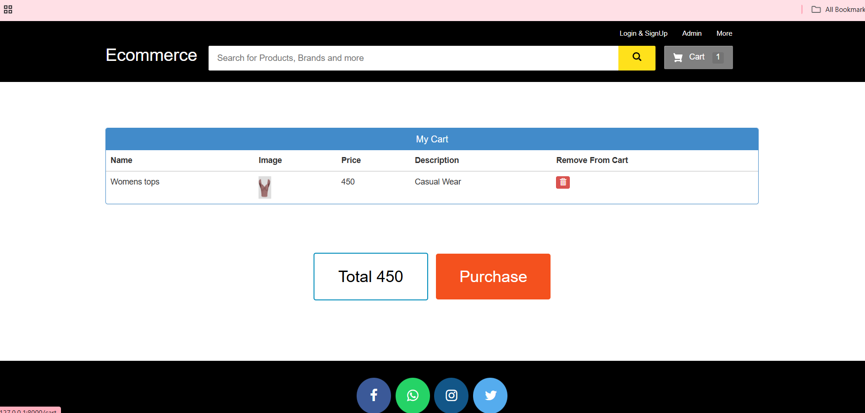

**Product Catalog Module**

The Product Catalog Module allows users to browse products easily with categories, filters, and detailed product information. It ensures smooth navigation, real-time inventory management, and supports promotions to enhance the shopping experience.

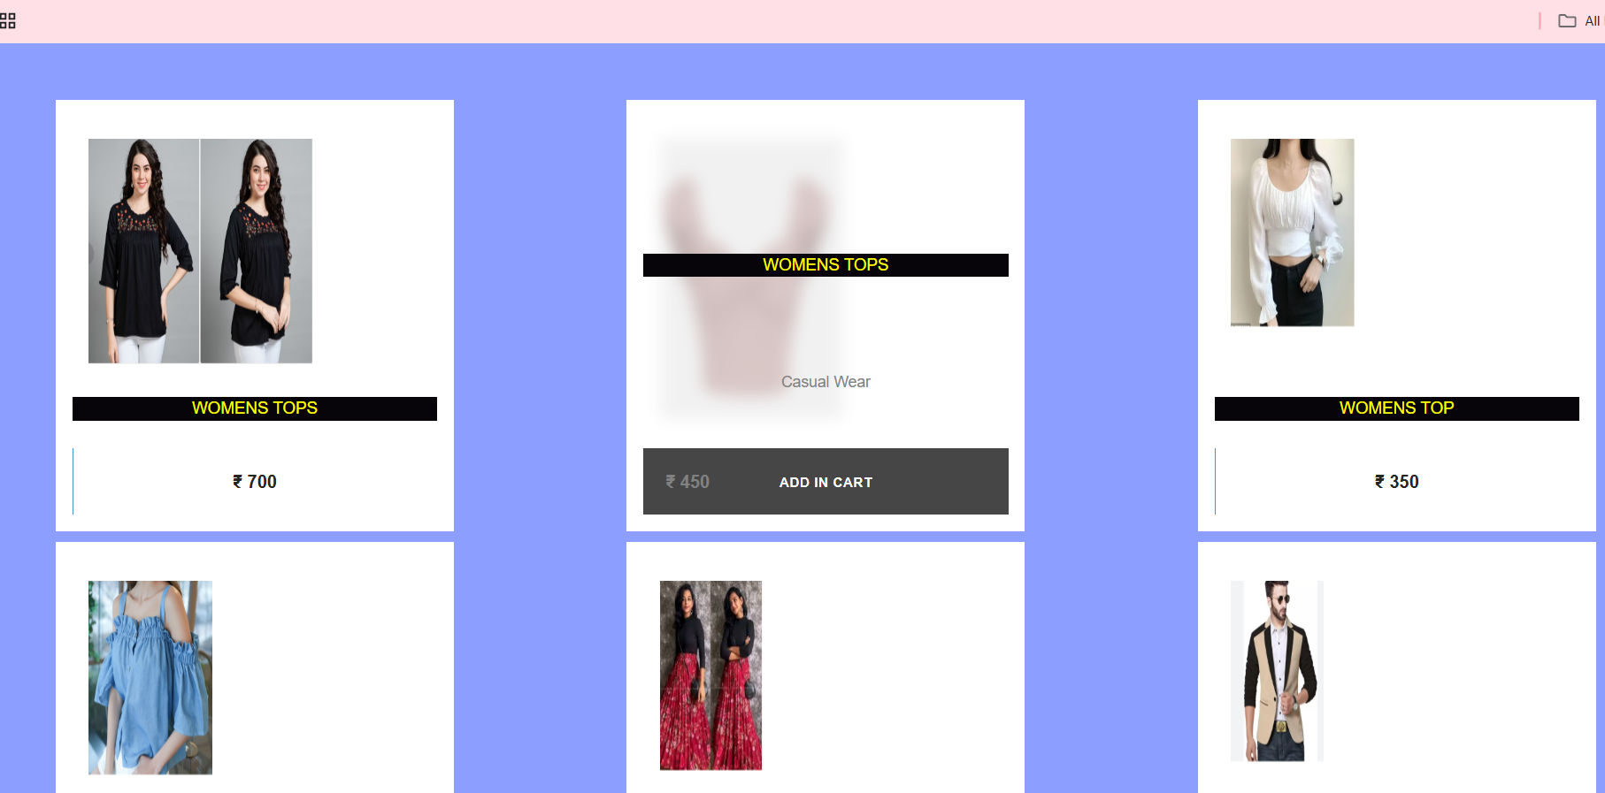

**Checkout and Payment Module**

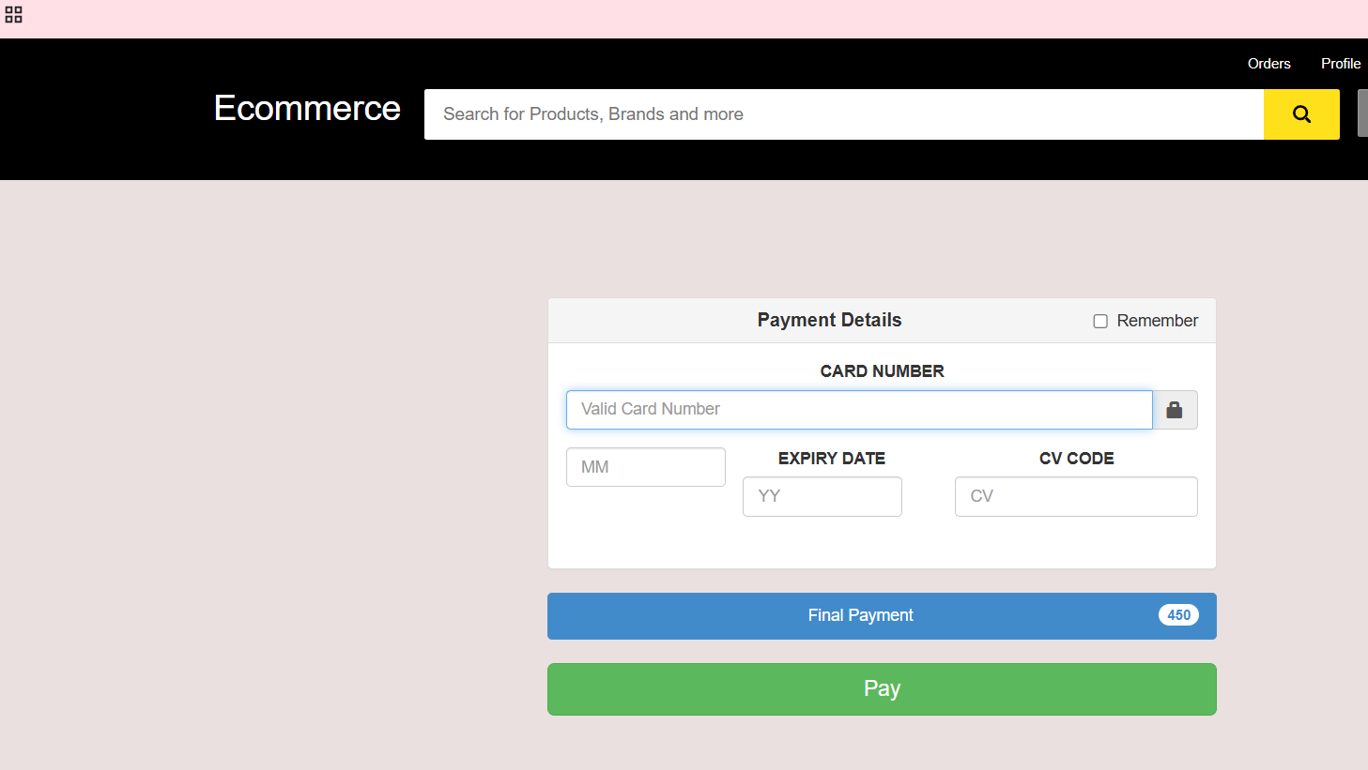The **Checkout and Payment Module** streamlines the process of collecting shipping details and securely handling payments through integrated gateways. It provides users with a clear order summary and generates receipts upon successful purchase.

## 9. Conclusion

The e-commerce website was successfully implemented using a modern tech stack. The system ensures scalability, security, and efficiency, making it suitable for real-world applications. Future improvements may include AI-based recommendations and progressive web app (PWA) support.

**REFERENCES**

[1] B. Wilson, *Full Stack Development with MongoDB, Express, React, and Node: Build powerful full-stack applications using the most popular JavaScript framework*, Packt Publishing, 2024.

[2] A. Sornam and V. Kanimozhi, "E-Commerce Platform Implementation Using MERN Stack," *International Journal of Computer Science and Mobile Applications*, vol. 9, no. 3, pp. 65-72, 2023.

[3] P. Symeonidis and E. Theodoridis, *Learning Redux: Build consistent web apps with Redux by managing state*, Packt Publishing, 2023.

[4] J. M. Schopf and A. K. Gopalan, "The Role of Deployment and Orchestration in Modern Cloud Computing Environments," *IEEE Cloud Computing*, vol. 9, no. 2, pp. 46-55, 2023.

**[**5**]Laudon, K. C., & Traver, C. G. (2021).** *E-commerce: Business, Technology, Society.* 15th Edition. Pearson.

* This book provides a comprehensive overview of e-commerce principles, technologies, and business models, making it an excellent resource for foundational knowledge.

[6]**Turban, E., King, D., Lee, J. K., & Chung, M. (2018).** *Electronic Commerce: A Managerial and Social Networks Perspective.* Springer.

* This resource focuses on e-commerce management and the impact of social networks on business, offering both practical strategies and theoretical frameworks.

[7]**Chaffey, D. (2019).** *Digital Marketing: Strategy, Implementation, and Practice.* 7th Edition. Pearson Education.

* While focusing on digital marketing, this book offers valuable insights into integrating e-commerce with marketing strategies, which is critical for website implementation.

[8]**Liu, L., & Li, G. (2019).** *Exploring the Integration of Artificial Intelligence in E-Commerce Web Design.* International Journal of Information Technology and Web Engineering, 14(2), 39-58.

* This journal article explores how artificial intelligence can be integrated into e-commerce websites for improving customer experience and personalization.