**e-ISSN :**

**INTERNATIONAL JOURNAL OF PROGRESSIVE 2583-1062**

**RESEARCH IN ENGINEERING MANAGEMENT**

**AND SCIENCE (IJPREMS) Impact**

|  |  |  |
| --- | --- | --- |
| **www.ijprems.com editor@ijprems.com** | Vol. 04, Issue 01, January 2024, pp : xx-xx | **Factor : 5.725** |

**Online Event Management System**

**Tamboli payal Sandeep, Vishwarao snehal Balu, Pansare Sanskruti Sachin, Auti Siddhi Suresh,Bugde.S.B**

Student, Department of Computer Engineering , Samarth polytechnic, Belhe , pune, India

Student, Department of Computer Engineering , Samarth polytechnic, Belhe , pune, India

Student, Department of Computer Engineering , Samarth polytechnic, Belhe, puneIndia

Student, Department of Computer Engineering , Samarth polytechnic, Belhe , pune, India

Guide, Department of Computer Engineering , Samarth polytechnic, Belhe , pune, India

**ABSTRACT**

This paper presents an online event management system. It is a web-based product that seeks to make it easier to organize, handle and attend to events. With an online system, the event organizer will be able to create, manage, and promote events. Participants will be able to register and view event details as well as be updated about the happenings of the event. It will feature scheduling of events, ticket booking, attendee management, interfaces for payment, and real-time notifications. It will be user-friendly for event organizers as well as attendees to ensure proper coordination between the two parties. The primary aim of this system is on saving overheads in administrative work and the promotion of the whole event experience with a much better two-way communication between the organizers and the participants. It can also be applied to any kind of event, like conferences, webinars, workshops, concerts, and social gatherings, even a concert.

**Key words-** Event planning, Registration-Online, Virtual events, Ticketing system, Event scheduling, Event analytics.

## INTRODUCTION

An online event management system is an event management system that will provide efficiency in event management. It allows planning, managing, and executing events from a remote location with maximum ease. All aspects of event organization, such as registration, ticketing, scheduling, and engagement of attendees, are done online through the interface that will be user-friendly to those who use the computer system. Whether it's a web conference, a webinar, an online trade show, or even a hybrid event, an OEMS offers a pack of features including livestreaming integration, interactive session holding, attendee networking, and real-time analytics. It streamlines all the process-from planning to post-event analysis and, therefore, results in efficiency, flexibility, and hassle-free for the organizers as well as participants, all irrespective of their location.

# LITERATURE REVIEW

An online event management system is known as OEMS, that digital platform created to ease the management process of organizing, planning, and executing events. These systems often take care of activities such as event registration, sales in terms of tickets, scheduling, attendee management, and real-time communications, which significantly enhance the efficiency

of managing an event. This literature review consolidates the recent academic and industry research on OEMS, thereby highlighting the advancements, challenges, and best practices in the field.

## 3. METHODOLOGY

Developing an online event management system (OEMS) involves various stages, from planning and design to development, deployment, and post-launch activities.

1. User Management:-User Profiling, Authentication, Role-based Access Control.
2. Event Management:-Event Creation & Customization, Event Details.
3. Registration & Ticketing:-Registration Forms, Payment Integration
4. Agenda & Session Management:-Session Scheduling, Session Registration.
5. Video Streaming with Virtual Platforms integration of Live Q&A / Polling features.

**@International Journal Of Progressive Research In Engineering Management And Science Page | 1**

**e-ISSN :**

**INTERNATIONAL JOURNAL OF PROGRESSIVE 2583-1062**

**RESEARCH IN ENGINEERING MANAGEMENT**

**AND SCIENCE (IJPREMS) Impact**

|  |  |  |
| --- | --- | --- |
| **www.ijprems.com editor@ijprems.com** | Vol. 04, Issue 01, January 2024, pp : xx-xx | **Factor : 5.725** |

**4.FUTURE SCOPE**

The future scope for an online event management system is vast and dynamic, growing thanks to the fast increasing requirements of digital transformation, global connectivity, and shifting user experience.

# 5.LIMITATION

Event management, although essential for any type of event organization and its performance, has various constraints and challenges. They are determined by the scope, scale, and complexity of the event. It may be viewed as a series of challenges that constitute the digitalization of traditional practice in events.

**6. USE CASE DIAGRAM**

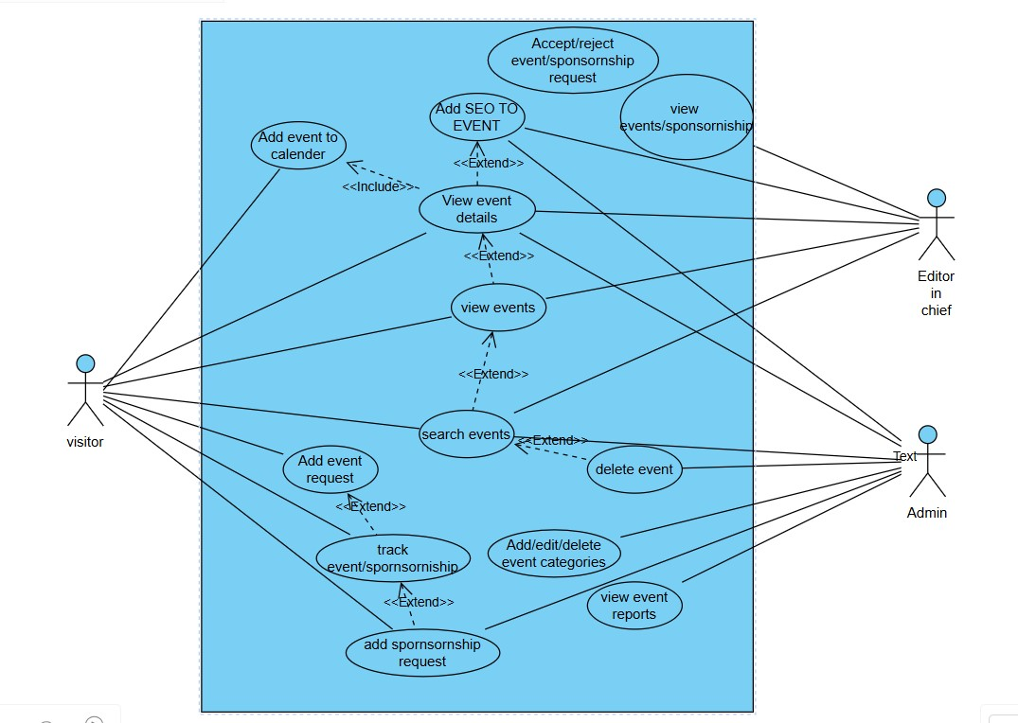

**@International Journal Of Progressive Research In Engineering Management And Science Page | 2**

**e-ISSN :**

**INTERNATIONAL JOURNAL OF PROGRESSIVE 2583-10**

**RESEARCH IN ENGINEERING MANAGEMENT**

**AND SCIENCE (IJPREMS) Impact**

|  |  |  |
| --- | --- | --- |
| **www.ijprems.com editor@ijprems.com** | Vol. 04, Issue 01, January 2024, pp : xx-xx | **Factor : 5.725** |

## 5. CONCLUSION

An online event management system offers a comprehensive solution for streamlining the planning, coordination, and execution of events. By leveraging digital tools, organizers can efficiently handle tasks such as registration, ticketing, scheduling, and communication, all in one platform. This not only reduces the administrative burden but also builds better attendee experiences. The ability to track data and analyse event performance gives organizers a big plus in making good decisions for improvements in the future. The more and more advanced technology moves, the more online event management systems will play a more critical role in the success of virtual as well as in-person events with potential for being more flexible, scalable, and convenient.

## 6. REFERENCES

1. Allen, J., O'Toole, W., Harris, R., & McDonnell, I.( 2011). Festival and Special Event Management. John Wiley & Sons.
2. Baker, M. J., & Crompton, J. L.( 2000). Quality, Service, and Satisfaction A operation Perspective for Event directors. International Journal of Hospitality Management.
3. Burridge, G.( 2007). Event Design and Management. Routledge.
4. Chaudhry, N. I.( 2016). Sustainability in Event Management. International Journal of Event and Festival Management.
5. Cohen, S. A., & Abrahamic, Y.( 2004). Event planning and operation A review. Journal of Hospitality & Tourism Research.
6. Davidson, R. 2012. Event operation proposition and Practice. Routledge.
7. Getz, D.( 2008). Event Tourism description, elaboration, and Research. Tourism Management.

8. Getz, D.( 2013). Event Studies proposition, exploration and Policy for Planned Events. Routledge.

9) Ludwig, D., & Gilbert, D.( 2018). Social Media Role in Event Marketing. Journal of Event Marketing.

10). Mari, J., & Jago, L.( 2010) The part of Sustainability in Event Management. Event operation.

1. Masteman, G. Strategic Sports Event Management. Butterworth- Heinemann. 2004.
2. Pinto, J. K., & Slevin, D. P.( 1988). Project Success Delineations and Measurement ways. Project Management Journal.
3. Schmitt, B.( 2012). Experiential Marketing A New Paradigm for Future Marketing. Journal of Marketing Research. 14) Silvers, J. R.( 2012). Professional Event Coordination. Pearson Higher Education.
4. Silvers, J. R.( 2012). Professional Event Coordination. Pearson Higher Education.
5. Tassiopoulos, D. 2010. Event Management A Professional and Developmental Approach. Oxford University Press. 16) Yamamoto, M.( 2021). The Impact of Virtual and mongrel Events on the Assiduity. International Journal of Event Studies.

**@International Journal Of Progressive Research In Engineering Management And Science Page | 3**